Question 4 – BA Approach Strategy for Framing Questions
Answers:
- 5W1H : This approach basically talks about what are the question we will be asking stakeholder this includes :
    - who : will be the stakeholders
    - what : kind of requirements will be there
    - when : will this project gets completed
    - where : will it be delivered or executed
    - why : are we doing this project
    - how : we will address or solve current problems
- SMART:
  - Specific: Are the requirement s specific to the project goals are aligned.
  - Measurable: Within the specific timeline this project could be completed or not.
  - Attainable: Is this project achievable within the timeline given to us.
  - Relevant: Is this project relevant, specific and exact to the environment.
  - Time-bound: Within the given timeframe can this project can be completed.
- RACI :
  - Responsible
  - Accountable
  - Consulted
  - Informed
This helps to define roles and responsibilities within the team for each task.
4) UML (Unified Modelling Language):
It helps bridge communication between team and other members by creating diagrams and other software systems. It helps for specifying, visualising, constructing and documenting software systems.
This includes static and dynamic diagrams like: Use-case, Sequence, Activity diagrams.

5) Handling change request:
1. Understand the Change Request (CR):
- What exactly is being requested?
- Who raised the change request?
- What problem or opportunity triggered this request?
- Is this a correction, enhancement, or new feature?
- Is there supporting documentation or examples?
2. Assess Business Impact
- Evaluate the business rationale and potential implications.
- What is the business value of this change?
- What business processes will be affected?
- What happens if we don’t implement this change?
- Are there any regulatory or compliance needs driving this?
- What departments or users will be impacted?
3. Assess Technical Impact (with Tech Teams)
- Collaborate with technical teams to understand feasibility and risks.
- Will this affect existing architecture or integrations?
- What systems/modules/data flows are impacted?
- How much development and testing effort is required?
- Are there any performance, security or scalability concerns?
4. Assess Technical Impact (with Tech Teams)
- Collaborate with technical teams to understand feasibility and risks.
- Will this affect existing architecture or integrations?
- What systems/modules/data flows are impacted?
- How much development and testing effort is required?
- Are there any performance, security or scalability concerns?
5. Document and Communicate
- Ensure clarity and alignment across stakeholders.
- Create a Change Request Document including:
- Summary of the request
- Business justification
- Impact analysis
- Risk assessment

Question 10 – Use Case Diagram
Answer:
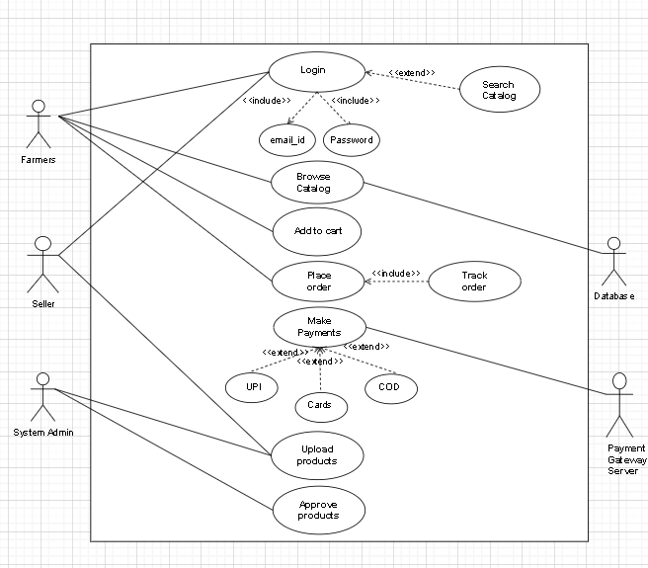

Question 12 – Activity Diagram
Answer:
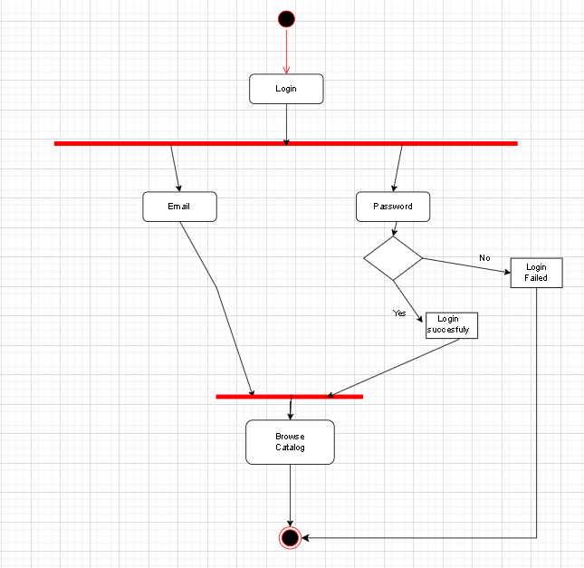

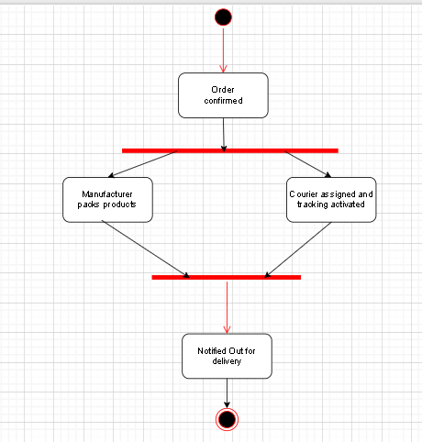
Parallel Order Fulfilment & Delivery Tracking

Farmer Browses & Buys Products
