Mock-up Part-4
Assignment- 1

Q.1) Please make a BRD which can be presented to the client along with complete development and resource plan.
Ans.
Project Title: Integrated Inventory Management and Delivery Optimization System
Client: Dairy Manufacturing Company Name
Prepared by: Business Analyst- Ruchita Pawar
Date: 29- Oct- 2025
1. Introduction
The client operates multiple manufacturing plants and warehouses across the country, producing ice-cream and milk products. The current operations face challenges in tracking inventory and ensuring timely deliveries to customers.
This BRD proposes a centralized software solution to:
- Manage real-time inventory across all locations.
- Optimize delivery routes to ensure fastest and freshest product delivery.
- Improve operational efficiency and reduce wastage.

2. Business Objectives
- Inventory Accuracy: Maintain real-time stock visibility across all plants and warehouses to minimize wastage, stockouts, and overstocking.
- Faster Deliveries: Optimize warehouse-to-customer routing and assign the nearest dispatch centers to reduce delivery time by 25–30%.
- Operational Efficiency: Integrate production, warehouse, and logistics data in one system to reduce manual tracking efforts and errors.
- Customer Satisfaction: Ensure timely delivery of fresh products to increase repeat orders and improve brand trust.
3. Current Challenges
- Lack of real-time visibility of inventory across plants and warehouses, leading to stock imbalances and wastage.
- Manual and disconnected inventory tracking processes cause delays and data inaccuracies.
- No optimized delivery routing, resulting in longer delivery times and higher logistics costs.
- Difficulty maintaining cold-chain requirements during transport due to limited tracking and monitoring
4. Proposed Solution
- Centralized web & mobile application.
- Real-time inventory tracking (raw materials, WIP, finished goods).
- Route optimization & delivery tracking using GPS.
- Demand forecasting & automated restocking alerts.
- Dashboard & analytics for management.
- Integration with ERP & logistics APIs.

5. Functional Requirements
Req ID | Description | Priority
FR-01 | Maintain item master including SKU, batch, and expiry date. | High
FR-02 | Track inventory by plant, warehouse, and vehicle. | High
FR-03 | Automatically decrement stock on dispatch and increment on production completion. | High
FR-04 | Generate alerts for low stock, nearing expiry, and overstocked items. | High
FR-05 | Allow order placement through sales team or customer portal. | High
FR-06 | Automatically assign orders to the nearest warehouse. | High
FR-07 | Track order status until delivery completion. | High
FR-08 | Identify nearest dispatch location using geo-location. | Medium
FR-09 | Optimize delivery routes using Google Maps API or Mapbox. | Medium
FR-10 | Provide a mobile app for delivery personnel with live tracking and proof of delivery. | Medium
FR-11 | Generate inventory aging reports. | Medium
FR-12 | Perform wastage and expiry analysis. | Medium
FR-13 | Provide delivery time efficiency metrics. | Medium
FR-14 | Provide demand forecasting dashboard. | Medium

6. Non-Functional Requirements
NFR ID | Description | Priority
NFR-01 | The system should handle 10,000+ transactions per day with response time under 2 seconds. | High
NFR-02 | The system should support addition of new plants or warehouses without major reconfiguration. | Medium
NFR-03 | Implement role-based access control, data encryption, and maintain audit logs. | High
NFR-04 | Ensure 99.9% system uptime with cloud deployment. | High
NFR-05 | Provide an intuitive user interface requiring minimal training. | Medium
NFR-06 | Comply with FSSAI regulations and applicable data protection guidelines. | High

7. Assumptions & Constraints
- All warehouses and plants have reliable internet connectivity.
- GPS-enabled delivery vehicles are available.
- Existing ERP has API access for integration.
Constraints
- Budget and timeline may restrict advanced AI-based forecasting in Phase 1.
- Real-time delivery tracking may depend on mobile network coverage.
8. Risk
- Integration failure with ERP: High impact – Mitigation: Conduct integration testing early.
- Data inconsistency: Medium impact – Mitigation: Implement real-time synchronization and validation.
- Network issues during tracking: Medium impact – Mitigation: Provide offline data sync option.
9. Dependencies
- Integration required with existing ERP, accounting, and logistics systems for seamless data flow.
- Dependence on reliable internet connectivity across remote plants and warehouses for real-time updates.
- Coordination with third-party logistics partners for live tracking and route optimization data.
- Adequate training and user adoption across all locations to ensure effective system use.
10. Success Criteria
- 90% reduction in manual inventory updates.
- 25–30% improvement in delivery time.
- 95% accuracy in stock and dispatch data.
- 100% customer delivery tracking visibility.
11. Approval
Name | Designation | Signature | Date
[Client Representative] | Director - Operations
[BA/Project Manager] | Project Lead

Q.2) Prepare process flow diagram using your imagination.
Ans.
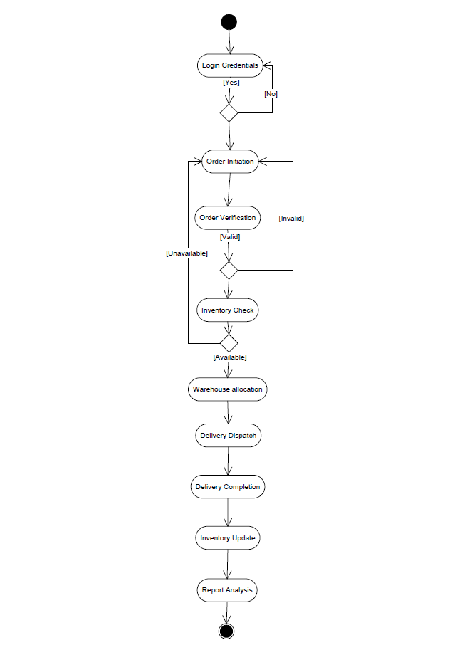

Assignment- 2

Q.1) Write an introduction letter to a client introducing yourself as a business analyst in charge of working with the client and his team to start the business understanding process.
Ans.
Subject: Introduction – Business Analyst
Dear XYZ,
I hope this message finds you well.
My name is Ruchita Pawar, and I am the Business Analyst assigned to work with you and your team on the [Project Name "ABC"]. I will be your primary point of contact for understanding business needs, gathering requirements, and ensuring that our solution aligns perfectly with your operational goals.
Over the coming days, I’ll be collaborating closely with your team to:
- Understand your current business processes, challenges, and goals.
- Identify key functional and technical requirements for the new system.
- Define project priorities, timelines, and expected outcomes.
Our objective is to ensure that the solution we develop not only meets your current requirements but also supports future scalability and efficiency.
Please let me know a convenient time for a short kick-off or requirement understanding session so we can initiate this phase smoothly. I’m looking forward to working closely with you and your team to make this project a success.
Thank you, and I’m excited to begin this collaboration.
Warm regards,
Ruchita Pawar
Business Analyst

Q.2) Prepare a brief BRD and SRS for a project- Horoscope or Ticketing system or online store.
Ans. Business Requirement Document (BRD)
Project Title: Online Ticket Booking System
Prepared by: Ruchita Pawar- Business Analyst
Date: 29- Oct- 2025

1. Introduction
The Online Ticket Booking System aims to simplify the process of booking tickets for movies, events, and travel. The current manual or third-party processes are time-consuming and often lack real-time availability.
This project will automate ticket booking through a web and mobile-based platform, ensuring real-time seat selection, secure payment, and instant confirmation.
2. Business Objectives
- Automation: Eliminate manual booking and queues to reduce operational load and errors.
- Convenience: Offer a user-friendly online platform for faster and smoother bookings.
- Real-Time Updates: Show live ticket or seat availability for better transparency.
- Secure Payments: Use reliable gateways to minimize transaction failures and fraud.
3. Current Challenges
- Lack of centralized platform to manage products, inventory, and customer orders.
- Manual order tracking and payment handling cause errors and delays.
- Limited visibility into sales trends, making demand forecasting difficult.
- No real-time order status updates for customers, leading to poor user experience.
4. Proposed Solutions
- Develop an integrated online platform to handle product listing, orders, payments, and delivery tracking.
- Automate inventory management to ensure real-time stock updates and reduce manual errors.
- Enable secure online payments with multiple payment gateway integrations.
- Provide order tracking, notifications, and personalized dashboards for customers and admin.

5. High-Level Functional Requirements
Req ID | Requirement Description | Priority
FR001 | Users can create and manage accounts | High
FR002 | System displays available events/movies with dates and times | High
FR003 | Real-time seat map for selection | Medium
FR004 | Integration with multiple payment options (UPI, Cards, Net Banking). | High
FR005 | Automatic ticket confirmation and email/SMS notifications | Medium
FR006 | Admin dashboard for managing listings, pricing, and bookings | High

6. Assumptions & Constraints
- All events, shows, or transport schedules will be provided and updated by the organizers.
- Internet connectivity will be available for real-time booking and confirmation.
- Payment gateways will support all major payment methods (UPI, cards, wallets).
- Users will receive digital tickets via email or SMS.
Constraints
- Real-time seat availability depends on synchronization with venue or service provider systems.
- Refunds and cancellations subject to organizer or service provider policies.
- The system must maintain high uptime during peak booking hours.
- Compliance with financial transaction and data security regulations is mandatory.
7. Risk & Dependencies
- Double Booking Risk: Synchronization failure between platform and event/transport system may cause duplicate bookings.
- Payment Failure Risk: Transaction interruptions may result in incomplete
- bookings or refunds.
- Data Privacy Risk: User data exposure due to weak security protocols.
- Peak Load Risk: High demand periods may overload the system, causing downtime.
Dependencies
- Real-time access to event or seat availability databases.
- Integration with payment gateways for transactions and refunds.
- SMS/email gateways for ticket confirmations and notifications.
- Coordination with event organizers or transport operators for scheduling and updates.
8. Success criteria
- Users can search, book, and receive tickets seamlessly within 3 minutes end-to-end.
- Booking accuracy rate (no duplicate or failed bookings) maintained above 99%.
- System supports real-time seat availability and processes at least 1,000 concurrent bookings without downtime.
- Customer satisfaction and support ticket resolution time improve by 30% post-implementation.
- Successful integration with payment gateways and event partner systems with minimal transaction failures (<1%).

9.Approvals
Name | Designation | Signature | Date
[Client Representative] | Director - Operations
[BA/Project Manager] | Project Lead

Software Requirement Specification (SRS)
Project: Online Ticket Booking System
Introduction- The system allows users to browse, select, and book tickets online for movies, concerts, or travel. It provides real-time updates on seat availability, secure payment processing, and instant digital ticket generation.

Functional Requirements
Req ID | Description | Priority
FR001 | User should be able to register, log in, and log out securely. | High
FR002 | User should be able to view all available shows/events | High
FR003 | User should be able to select seats and make online payments. | High
FR004 | User should receive e-tickets via email or SMS after successful payment. | High
FR005 | Admin should be able to add, edit, or delete events/movies. | High
FR006 | Admin should be able to manage pricing and show time slots. | Medium
FR007 | Admin should be able to generate booking and sales reports. | Medium
FR008 | Admin should be able to manage user accounts and handle cancellations. | High
FR009 | System should support payments via credit/debit cards, UPI, and wallets. | High
FR010 | System should validate all transactions in real time. | High
FR011 | System should process refunds automatically for valid cancellations. | Medium
FR012 | System should send booking confirmation via email/SMS. | High
FR013 | System should send alerts for cancellations or schedule changes. | Medium

Non-Functional Requirements
NFR ID | Description | Priority
NFR001 | The system should respond to each user request within 3 seconds. | High
NFR002 | The system should handle up to 10,000 concurrent users without performance degradation. | High
NFR003 | Ensure SSL encryption, OTP verification, and PCI DSS compliance for secure transactions. | High
NFR004 | Maintain a minimum of 99.9% uptime to ensure continuous service. | High
NFR005 | Interface should be responsive and accessible on web and mobile platforms. | Medium
NFR006 | Follow modular code structure for easy updates and maintenance. | Medium
NFR007 | All user data must be backed up daily and stored securely. | Medium
NFR008 | System should be able to integrate with third-party APIs without performance impact. | Medium
NFR009 | Provide audit logs for all critical actions and transactions for accountability. | Medium
NFR010 | Error handling should be consistent, with clear messages and logging for debugging. | Medium

Q.3) Make an ERD of creating a support ticket/Ticketing life cycle.
Ans.
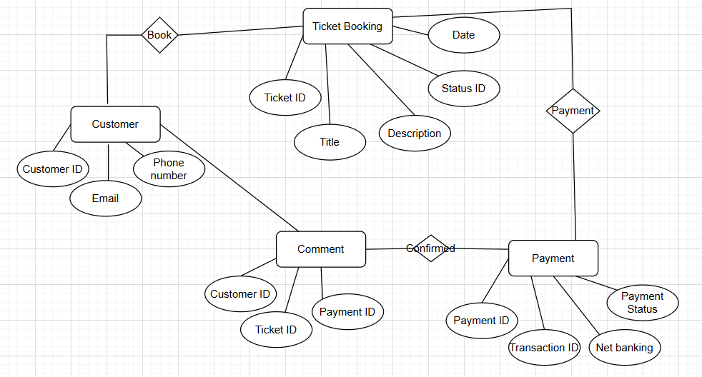

Q.4) User story of shopping from ecommerce.
Ans.
User Story No: 1  Browse Products | Task: 1 | Priority: High
Value Statement:
As a customer, I want to browse products by category or search by name so that I can easily find what I’m looking for.

BV: 500 | CP: 8
Acceptance Criteria:
- User can browse by category.
- Search bar available and functional.
- Products show image, name, price, and rating.

User Story No: 2  View Product Details | Task: 2 | Priority: Medium
Value Statement:
As a customer, I want to view detailed information about a product so that I can make an informed decision before purchase.

BV: 200 | CP: 5
Acceptance Criteria:
- Product details page displays description, image, and price.
- User can view ratings and reviews.
- User can select product variants (color, size).

User Story No: 3  Add to Cart | Task: 3 | Priority: High
Value Statement:
As a customer, I want to add selected products to my cart so that I can buy multiple items at once.

BV: 500 | CP: 8
Acceptance Criteria:
- User can add items to cart from list/detail view.
- System updates cart count and total automatically.
- User receives feedback (e.g., toast message).

User Story No: 4  Manage Shopping Cart | Task: 4 | Priority: Medium
Value Statement:
As a customer, I want to modify or remove items in my cart so that I can manage my purchase before checkout.

BV: 200 | CP: 5
Acceptance Criteria:
- User can update quantity or remove items.
- Cart total updates instantly.
- Discounts or taxes are recalculated automatically.

User Story No: 5  Checkout & Payment | Task: 5 | Priority: High
Value Statement:
As a customer, I want to enter shipping details and pay securely so that I can complete my purchase.

BV: 500 | CP: 8
Acceptance Criteria:
- User can enter address and choose saved ones.
- Payment options: Card, UPI, Wallet, COD.
- Successful payment redirects to confirmation page.

User Story No: 6  Order Confirmation | Task: 6 | Priority: High
Value Statement:
As a customer, I want to receive confirmation of my order so that I have proof of purchase.

BV: 500 | CP: 8
Acceptance Criteria:
- Order confirmation displayed with order ID.
- Email/SMS confirmation sent.
- Summary includes payment and delivery details.

User Story No: 7  Track Order | Task: 7 | Priority: Medium
Value Statement:
As a customer, I want to track my order status so that I know when it will be delivered.

BV: 200 | CP: 5
Acceptance Criteria:
- System displays order status (Processing, Shipped, Delivered).
- Tracking link active once shipped.
- Status updates in real time.

User Story No: 8  Cancel/Return Order | Task: 8 | Priority: Medium
Value Statement:
As a customer, I want to cancel or return my order so that I can manage issues or change my mind.

BV: 200 | CP: 5
Acceptance Criteria:
- User can cancel before shipping.
- Return request available post-delivery.
- Refund process initiated as per policy.

User Story No: 9  Review Product | Task: 9 | Priority: Low
Value Statement:
As a customer, I want to give feedback and rate products so that I can help others with my experience.

BV: 100 | CP: 3
Acceptance Criteria:
- User can rate (1–5 stars) and write a comment.
- Reviews display username and date.
- Review appears post-admin moderation (if applied).

User Story No: 10  Admin Product Management | Task: 10 | Priority: High
Value Statement:
As an admin, I want to add, update, or delete products so that I can manage the catalog effectively.

BV: 500 | CP: 8
Acceptance Criteria:
- Admin can CRUD products.
- Validation for mandatory fields.
- Changes reflect instantly on customer interface.

