Capstone Project – Prep1 – Part 3
Question 1 – Functional Requirements - 15 Marks Identify minimum 20 functional requirements
Example: Functional requirement: When an order is fulfilled, the local printer shall print a packing slip.
Non-Functional Requirement: Packing slips shall be printed on both sides of 4”x 6” white paper, the standard size for packing slips used by local printers.
Functional Requirements – Online Agriculture Products Store
Definition:
A Functional Requirement describes the behavior or capabilities that a solution must have in terms of the features, functions, and interactions it provides to its users.
These requirements specify what the system should do the actions, tasks, or services the solution must perform.
FR ID | FR Name | FR Description
FR001 | User Registration | The system shall allow farmers and manufacturers to register using a valid email ID, password, and basic details.
FR002 | User Login | The system shall allow registered users to securely log in using their credentials to access their respective dashboards.
FR003 | Product Browsing | The system shall allow farmers to browse the catalog of fertilizers, seeds, and pesticides by categories and subcategories.
FR004 | Product Search | The system shall allow users to search for products using keywords, product names, or manufacturer names.
FR005 | Product Upload | The system shall allow manufacturers to upload, update, and delete product listings with images, price, and description.
FR006 | Product Details Display | The system shall display complete product details such as image, description, price, manufacturer, and available stock.
FR007 | Add to Cart | The system shall allow farmers to add selected products to a shopping cart for purchase.
FR008 | Save for Later | The system shall allow farmers to save selected products to a wishlist or buy-later list.
FR009 | Cart Management | The system shall allow farmers to view, update quantity, or remove products from the shopping cart before checkout.
FR010 | Checkout Process | The system shall allow farmers to proceed to checkout, confirm delivery address, and select payment options.
FR011 | Payment Gateway | The system shall support multiple payment options including COD, Credit/Debit Cards, and UPI payments.
FR012 | Order Confirmation | The system shall generate a unique order ID and send an email confirmation to the farmer after successful order placement.
FR013 | Order Tracking | The system shall allow farmers to track the current status of their orders, such as ordered, packed, shipped, and delivered.
FR014 | Order History | The system shall allow farmers to view their past orders and download invoices if required.
FR015 | Manufacturer Dashboard | The system shall allow manufacturers to view product performance, stock levels, and sales data.
FR016 | Admin Management | The system shall allow the admin to manage users, approve manufacturer accounts, and remove inactive or fraudulent listings.
FR017 | Reports and Analytics | The system shall allow the admin to generate reports on total sales, top-selling products, and customer data.
FR018 | Product Reviews & Ratings | The system shall allow farmers to rate and review purchased products to help other users.
FR019 | Notifications & Alerts | The system shall send email/SMS notifications for order status updates such as order shipped, delivered, or canceled.
FR020 | Helpdesk / Customer Support | The system shall provide a helpdesk module where users can raise tickets or contact support for issues.

Non-Functional Requirements – Online Agriculture Products Store
Definition:
A Non-Functional Requirement describes the quality attributes, environmental conditions, or constraints under which the solution must operate.
These define how well the system performs its functions, rather than what functions it performs.
NFR ID | NFR Name | NFR Description
NFR001 | Performance | The system shall respond to all user actions within 3 seconds under normal network conditions.
NFR002 | Availability | The application shall be available 24/7 with at least 99.5% uptime, excluding scheduled maintenance.
NFR003 | Scalability | The system shall be able to support up to 50,000 concurrent users without performance degradation.
NFR004 | Security | All user data, including login credentials and payment details, shall be encrypted using SSL/TLS protocols.
NFR005 | Usability | The user interface shall be simple, intuitive, and suitable for farmers with minimal technical knowledge.
NFR006 | Compatibility | The application shall work seamlessly across modern browsers (Chrome, Firefox, Safari, Edge) and Android/iOS mobile devices.
NFR007 | Maintainability | The system architecture shall allow easy updates and maintenance with minimal downtime.
NFR008 | Data Backup & Recovery | The system shall automatically back up data daily and support full recovery in case of system failure.
NFR009 | Localization | The application shall support multiple languages, including English and at least one regional language.
NFR010 | Reliability | The system shall ensure that all successful transactions are recorded accurately even during network interruptions.
NFR011 | Privacy | User personal information and transaction data shall not be shared with third parties without consent.
NFR012 | Accessibility | The system shall meet accessibility standards (WCAG 2.1) to support users with disabilities.
NFR013 | Load Handling | The system shall handle peak loads during seasonal demand periods without system crashes.
NFR014 | Audit Trail | The system shall maintain detailed logs of user activities, including product uploads, orders, and payments.
NFR015 | Response Time | The system shall display the homepage and product catalog within 5 seconds even under high user load.

Question 2–Minimum 5 page designs - Make wireframe and prototypes
PAGE 1: Home Page
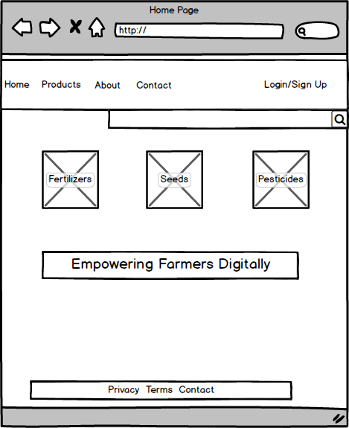

PAGE 2: Product Catalog Page
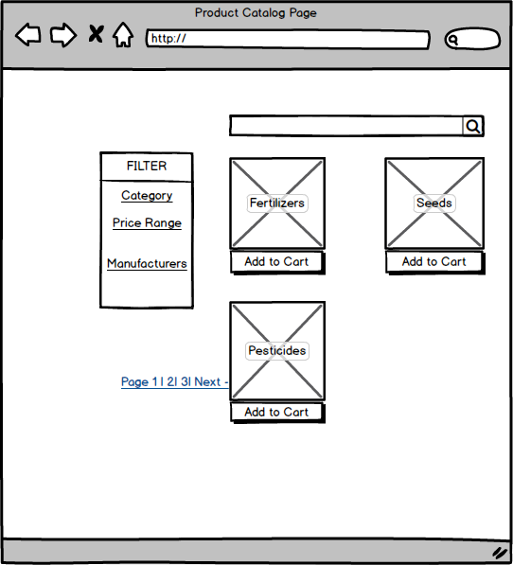

PAGE 3: Product Details Page
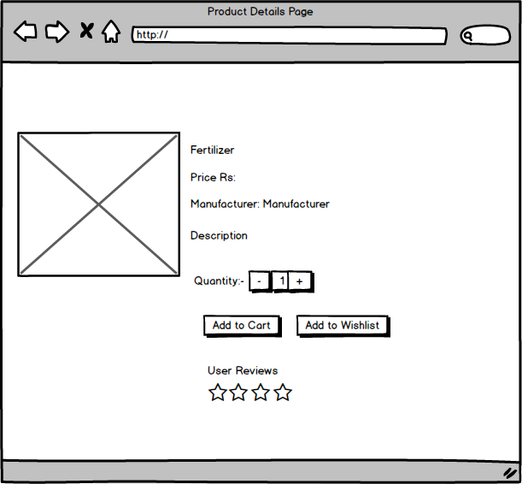

PAGE 4: Checkout and Payment Page
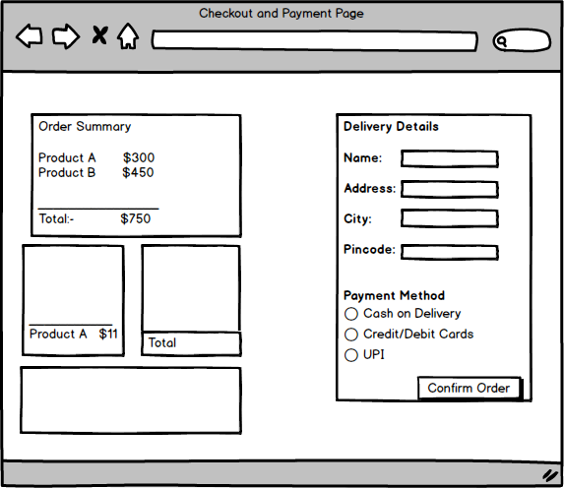

PAGE 5: Order Tracking Page
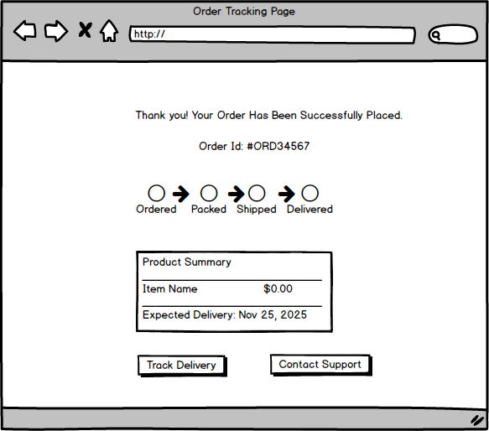

Question 3 – Tools (Visio, Balsamiq) - Make a note of the Tools, which you are using for above concepts.
- Balsamiq was used for low-fidelity wireframes to visualize page layouts and user interfaces quickly. It helps in brainstorming and communicating ideas in a simple, sketch-style format.

- Microsoft Visio was used to create system flow diagrams, process charts, and use case mappings to represent logical workflows between different modules.

- Axure RP was used for building interactive, high-fidelity prototypes that simulate real user interactions such as navigation, button clicks, and form submissions. Using these three tools together ensured clear communication of design, functionality, and workflow to both stakeholders and developers.

Question 4 – RTM
The Requirements Traceability Matrix (RTM) is used to track that every requirement functional or non-functional is properly implemented, designed, tested, and validated throughout the project.
As a Business Analyst, when Mr. Henry (Sponsor) and Peter (Farmer stakeholder) approach you for project status, you can show them this RTM to demonstrate progress and traceability of each requirement from initiation to testing.
Requirements Traceability Matrix (RTM)
Project: Online Agriculture Products Store
Req ID | Req Name | Req Description | Design | Code | Unit Testing | Component Testing | System Testing | SIT | UAT
FR0001 | Farmer Registration | Farmers should be able to register with the application using email ID and password. | Completed | Completed | Passed | Passed | Passed | Passed | Approved
FR0002 | Farmer Search for Products | Farmers should be able to search for available products in fertilizers, seeds, and pesticides. | Completed | Completed | Passed | Passed | Passed | Passed | Approved
FR0003 | Product Upload (Manufacturer) | Manufacturers should be able to upload and display their products with details. | Completed | Completed | Passed | Passed | In Progress | In Progress | Pending
FR0004 | Payment Gateway | The system shall support COD, Credit/Debit Card, and UPI payment options. | Completed | Completed | Passed | Passed | Passed | In Progress | Pending
FR0005 | Order Tracking | Farmers should be able to track the order status (Ordered → Packed → Shipped → Delivered). | Completed | Completed | Passed | Passed | Passed | Passed | Approved
FR0006 | Add to Cart | Farmers should be able to add products to cart and update quantity before purchase. | Completed | Completed | Passed | Passed | Passed | Passed | Approved
FR0007 | Checkout & Order Confirmation | Farmers should be able to review orders and confirm purchase. | Completed | Completed | Passed | Passed | Passed | Passed | Approved
FR0008 | Notifications & Email Alerts | Farmers should receive email/SMS confirmation after successful order. | Completed | Completed | Passed | Passed | Passed | Passed | Approved
FR0009 | Product Reviews & Ratings | Farmers should be able to rate and review products after delivery. | Completed | Completed | Passed | Passed | In Progress | In Progress | Pending
FR0010 | Helpdesk / Customer Support | The system should allow users to raise tickets or contact support. | Completed | Completed | Passed | Passed | In Progress | In Progress | Unapproved
NFR0101 | Page Loading Time | Each page should load within 2 seconds under normal network conditions. | Completed | Completed | Passed | Passed | Passed | Passed | Approved
NFR0102 | WCAG 2.1 Accessibility | The system must meet WCAG 2.1 accessibility guidelines. | Completed | Completed | Passed | Passed | Passed | Passed | Approved
NFR0103 | Security & Data Protection | All sensitive user data must be encrypted and securely stored. | Completed | Completed | Passed | Passed | Passed | Passed | Approved
NFR0104 | System Availability | The application should maintain 99.5% uptime excluding maintenance. | Completed | In Progress | In Progress | Not Tested | Pending | Pending | Incomplete

Question 5 – 10 Test Case Documents - Prepare 10 Test Case Documents
Test Case 1
Test case ID | TC001 | Test case Name | Farmer Registration
Project ID | P001 | Project Name | Online Agriculture Products Store
PM ID | PM001 | PM Name | Mr. Vandanam
Test strategy ID | TS001 | Tester ID | T001
Test plan ID | TP001 | Tester Name | Mr. Jason
Test schedule ID | SCH001 | Date of Test | 12/11/2025
Scenario: Farmer registers using valid email and password
Link to that page: Registration Page
Input Data | Expected Behaviour | Actual Behaviour | Comments | Result (Pass/Fail)
Email: peter@gmail.com  Password: Peter@123 | Farmer account created successfully and redirected to login page | Works as expected | Account created successfully | Pass

Test Case 2
Test case ID | TC002 | Test case Name | Farmer Login
Project ID | P001 | Project Name | Online Agriculture Products Store
PM ID | PM001 | PM Name | Mr. Vandanam
Test strategy ID | TS002 | Tester ID | T002
Test plan ID | TP001 | Tester Name | Ms. Alekya
Test schedule ID | SCH002 | Date of Test | 12/11/2025
Scenario: Farmer logs in with valid credentials
Link to that page: Login Page
Input Data | Expected Behaviour | Actual Behaviour | Comments | Result (Pass/Fail)
Email: peter@gmail.com  Password: Peter@123 | Redirected to dashboard after successful login | Login successful | Functionality working fine | Pass

Test Case 3
Test case ID | TC003 | Test case Name | Search for Products
Project ID | P001 | Project Name | Online Agriculture Products Store
PM ID | PM001 | PM Name | Mr. Vandanam
Test strategy ID | TS003 | Tester ID | T003
Test plan ID | TP001 | Tester Name | Mr. Jason
Test schedule ID | SCH003 | Date of Test | 13/11/2025
Scenario: Search products using keyword
Link to that page: Product Catalog
Input Data | Expected Behaviour | Actual Behaviour | Comments | Result (Pass/Fail)
Keyword: Fertilizer | Displays fertilizer products list | Displays 20 fertilizer items | Works fine | Pass

Test Case 4
Test case ID | TC004 | Test case Name | Add Product to Cart
Project ID | P001 | Project Name | Online Agriculture Products Store
PM ID | PM001 | PM Name | Mr. Vandanam
Test strategy ID | TS004 | Tester ID | T004
Test plan ID | TP001 | Tester Name | Ms. Alekya
Test schedule ID | SCH004 | Date of Test | 13/11/2025
Scenario: Add product to cart
Link to that page: Product Details Page
Input Data | Expected Behaviour | Actual Behaviour | Comments | Result (Pass/Fail)
Product: GreenGrow Fertilizer | Product added to cart successfully | Added correctly | Quantity updated in cart | Pass

Test Case 5
Test case ID | TC005 | Test case Name | Checkout Order
Project ID | P001 | Project Name | Online Agriculture Products Store
PM ID | PM001 | PM Name | Mr. Vandanam
Test strategy ID | TS005 | Tester ID | T005
Test plan ID | TP001 | Tester Name | Mr. Jason
Test schedule ID | SCH005 | Date of Test | 13/11/2025
Scenario: Farmer proceeds to checkout
Link to that page: Checkout Page
Input Data | Expected Behaviour | Actual Behaviour | Comments | Result (Pass/Fail)
Product: 2 items  Payment: COD | Order placed successfully | Order confirmed | Confirmation email received | Pass

Test Case 6
Test case ID | TC006 | Test case Name | Make Payment (UPI)
Project ID | P001 | Project Name | Online Agriculture Products Store
PM ID | PM001 | PM Name | Mr. Vandanam
Test strategy ID | TS006 | Tester ID | T006
Test plan ID | TP001 | Tester Name | Ms. Alekya
Test schedule ID | SCH006 | Date of Test | 14/11/2025
Scenario: Farmer pays using UPI method
Link to that page: Payment Page
Input Data | Expected Behaviour | Actual Behaviour | Comments | Result (Pass/Fail)
UPI ID: kevin@upi | Payment processed and confirmation shown | Payment successful | Working as expected | Pass

Test Case 7
Test case ID | TC007 | Test case Name | Track Order
Project ID | P001 | Project Name | Online Agriculture Products Store
PM ID | PM001 | PM Name | Mr. Vandanam
Test strategy ID | TS007 | Tester ID | T007
Test plan ID | TP001 | Tester Name | Mr. Jason
Test schedule ID | SCH007 | Date of Test | 14/11/2025
Scenario: Farmer tracks an order
Link to that page: Order Tracking Page
Input Data | Expected Behaviour | Actual Behaviour | Comments | Result (Pass/Fail)
Order ID: ORD12345 | Order status displayed correctly | Shows “Shipped” | Works correctly | Pass

Test Case 8
Test case ID | TC008 | Test case Name | Add Product by Manufacturer
Project ID | P001 | Project Name | Online Agriculture Products Store
PM ID | PM001 | PM Name | Mr. Vandanam
Test strategy ID | TS008 | Tester ID | T008
Test plan ID | TP001 | Tester Name | Ms. Alekya
Test schedule ID | SCH008 | Date of Test | 14/11/2025
Scenario: Manufacturer adds a new product
Link to that page: Manufacturer Dashboard
Input Data | Expected Behaviour | Actual Behaviour | Comments | Result (Pass/Fail)
Product Name: AgroMax | Product uploaded successfully | Works as expected | Product visible in catalog | Pass

Test Case 9
Test case ID | TC009 | Test case Name | Product Review Submission
Project ID | P001 | Project Name | Online Agriculture Products Store
PM ID | PM001 | PM Name | Mr. Vandanam
Test strategy ID | TS009 | Tester ID | T009
Test plan ID | TP001 | Tester Name | Mr. Jason
Test schedule ID | SCH009 | Date of Test | 15/11/2025
Scenario: Farmer submits a product review
Link to that page: Product Details Page
Input Data | Expected Behaviour | Actual Behaviour | Comments | Result (Pass/Fail)
Rating: 5 Stars  Comment: Excellent quality | Review posted successfully | Posted correctly | Functionality verified | Pass

Test Case 10
Test case ID | TC010 | Test case Name | Page Load Performance
Project ID | P001 | Project Name | Online Agriculture Products Store
PM ID | PM001 | PM Name | Mr. Vandanam
Test strategy ID | TS010 | Tester ID | T010
Test plan ID | TP001 | Tester Name | Ms. Alekya
Test schedule ID | SCH010 | Date of Test | 15/11/2025
Scenario: Test page loading performance
Link to that page: Home, Catalog, Checkout Pages
Input Data | Expected Behaviour | Actual Behaviour | Comments | Result (Pass/Fail)
Load Test: 100 users | Pages load within 2 seconds | Average load time: 1.8s | Performance optimal | Pass

Question 6 – DB Design
After the requirements are thoroughly explained to the entire project team by business analyst, the Database architects have decided to do the database design and also to represent the in-flow and out-flow of data.
- DB Schema + Entity Relationship Diagram = DB Design
A database schema describes how data is organized, stored, and connected inside a database.
- It acts as a foundation for developers and architects to design, build, and manage the entire database system.
An ERD is a diagram that shows how tables in a database are related to each other.
- It helps stakeholders understand the data model before database development begins and ensures data consistency, integrity, and proper system design.
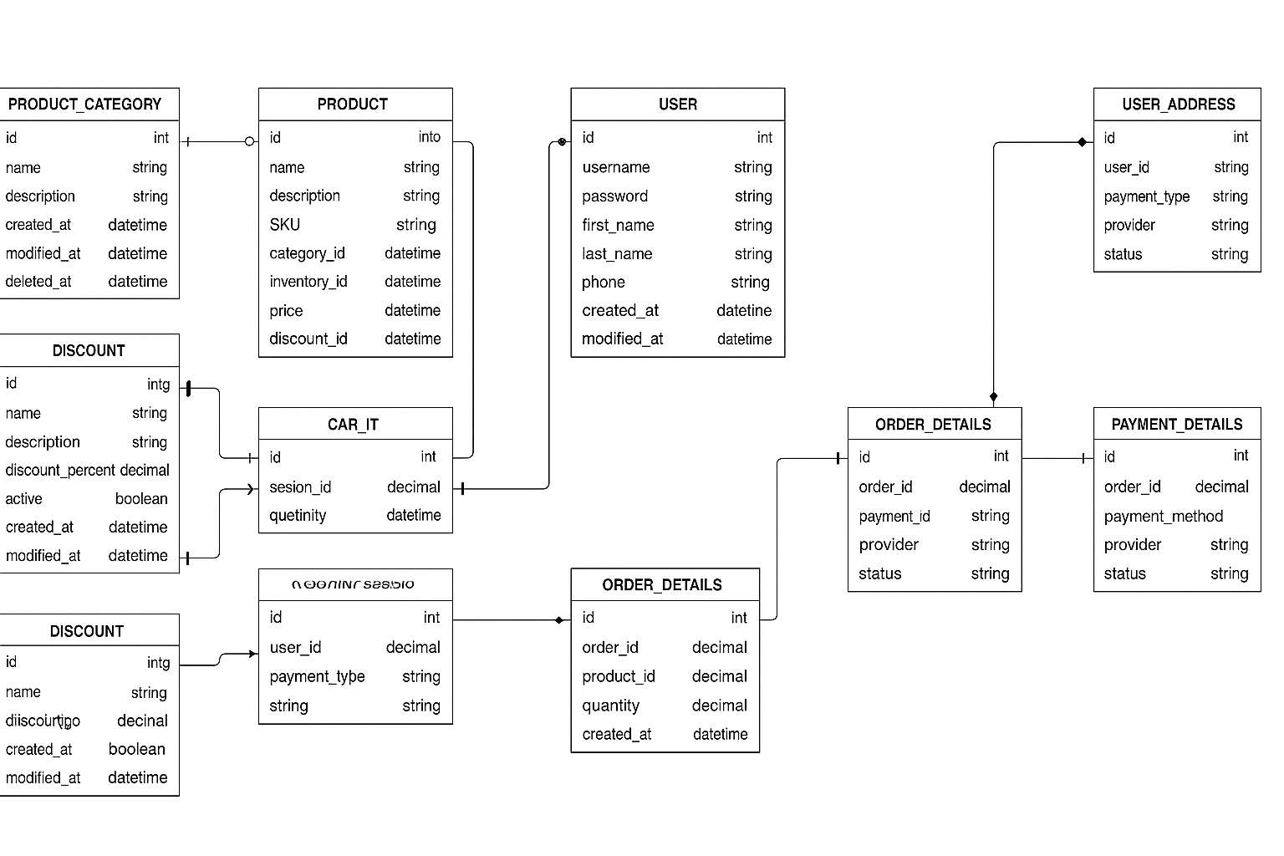Question 7 – Data Flow Diagram
What is a data flow diagram? Draw a data flow diagram to represent the in-flow and out-flow of data when a Farmer is placing an order for the product
A Data Flow Diagram (DFD) is a graphical representation of how data moves through a system showing where data comes from (inputs), how it is processed, and where it goes (outputs).
It focuses on how data flows between:
- External Entities (like Farmer, Manufacturer, Payment Gateway)
- Processes (like Login, Place Order, Payment Processing)
- Data Stores (like Product Database, Order Database)

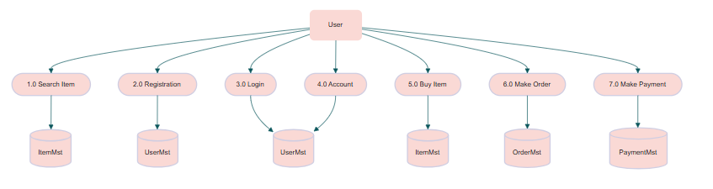

Question 8 – Change Request
Due to change in the Government Taxation structure . we should change the Tax structure How do you handle change requests in a project?
How Do You Handle Change Requests in a Project?
As a Business Analyst, handling a Change Request follows a structured Change Control Process.
1. Receive & Document the Change Request
The client (SOONY Committee or Mr. Henry) submits a request stating:
“Government taxation rules have changed. Update the tax calculation logic in the system.”
I document it in a Change Request Form (CRF) including:
- CR ID
- Description
- Reason for change
- Impacted modules (Product pricing, Checkout, Order summary, Invoice, Payment)
- Requester name
- Date

2. Analyse the Impact (Impact Analysis)
I conduct Impact Analysis with the project team (PM, developers, testers, architect).
We evaluate:
A. Business Impact
- Pricing of seeds, fertilizers, and pesticides will change
- Farmers must see updated tax values
- Manufacturers may need to update tax inputs
- Reports and invoices will be affected
B. Technical Impact
- Affects database fields
- Affects pricing API
- Affects product catalog service
- Affects payment summary module
C. Testing Impact
- Unit testing
- Regression testing
- UAT with farmers/stakeholder representatives
D. Timeline & Cost Impact
- Additional development time
- Testing time
- Possible extension of project timeline
- Revised budget if necessary
A detailed Impact Analysis Report is created.

3. Get Approval from the Change Control Board (CCB)
The CCB includes:
- Mr. Henry (Client)
- Mr. Pandu (Finance Head)
- Mr. Dooku (Project Coordinator)
- Project Manager (APT IT Solutions)
They review:
- Impact Analysis
- Additional cost
- Additional time required
- Risks
Only after formal approval, the change is allowed.

4. Update Project Documents
Once approved, I update all impacted documents:
- BRD (Business Requirement Document)
- SRS (Software Requirements Specification)
- Functional Requirements
- Use Cases
- Test Cases
- Database schema (if required)
- Process flow diagrams
- Release plan

5. Communicate the Change to the Team
I conduct a Change Review Meeting with:
- Developers
- Testers
- PM
- QA Lead
- Architects
Everyone is made aware of:
- What changed
- Why it changed
- How it impacts their work
- Deadlines for delivery

6. Implement the Change
Development team updates:
- Tax calculation logic
- Order summary
- Payment module
- Invoice generation system
Database team updates any tax-related fields.

7. Testing the Change
QA performs:
- Unit testing
- Integration testing
- Regression testing
- System testing
- UAT (User Acceptance Testing)
UAT is done by Peter, Kevin, Ben, or their representatives to ensure farmers understand new tax values.

8. Deployment & Release
Once approved, the change is deployed to:
- Staging environment
- Production environment
Release notes include details of the new tax logic.

9. Post-Deployment Monitoring
After release, I monitor:
- Whether correct tax values appear
- Any complaints from farmers
- Any issues in order totals
- Notifications and invoices accuracy

10. Close the Change Request
Once stakeholders confirm everything works:
- CR is marked as Closed
- Final documentation is updated
- Version number is upgraded

Question 9 – Change Request Vs an Enhancement
As the project is in process, Ben and Kevin have contacted you. The reason is to inform you that they want the Farmers to sell their crop yields through this application i.e. Farmers should be able to add their crop yields or products and display to general public and should be able to sell them. They also want to introduce Auction system for their Crop yields. As a BA, what will be your response?
Is this a change request or an enhancement???
Thank you, Ben and Kevin, for your suggestions.
The features you’re requesting — allowing farmers to sell their crop yields and introducing an auction mechanism — are significant additions to the original project objective.
These are not modifications to existing requirements but new features, which makes this request an enhancement.
I will document your enhancement request, perform Impact Analysis, and present it to the Change Control Board (CCB) for review.
Based on the business value, estimated cost, and timeline impact, the CCB will decide whether we can include these enhancements in the current release or plan them for a future phase.
I will prepare:
- Enhancement Request Document (ERD)
- Scope Impact Analysis
- Timeline & Budget impact
- Technical and Functional impact and share it with the project stakeholders for next steps.”

Question 10 – Estimations - 6 Marks
Come up with estimations – How many Manhours required

PROJECT ESTIMATION – FULL ANALYSIS BEFORE CALCULATING MANHOURS
We first analyse the project type, size, modules, timeline, and team structure.
Below is the complete structured analysis.

1. PROJECT ANALYSIS BASED ON CASE STUDY
A. Understanding the Project Scope
The Online Agriculture Product Store includes:
Farmer Features
- Registration & Login
- Search products
- View product catalog
- Cart & Checkout
- Multiple payment methods
- Order tracking
- Email/SMS notifications
Manufacturer Features
- Upload products
- Manage inventory
- Manage pricing & discount
Admin / Internal Functions
- User management
- Product approval
- Payment report
- Order management
Additional Requirements in Future
- Farmer selling their crops (Enhancement)
- Auction system (Enhancement)
Technical Requirements
- Database schema
- ER diagram
- Secure login
- Payment gateway integration
- Cloud hosting
- Delivery tracking integration

B. Based on Features → What Kind of Project Is This?
This is NOT a small project, because it includes:
✔ 3 user types (Farmers, Manufacturers, Admin)
✔ Product management
✔ Order & payment modules
✔ Notifications
✔ Full e-commerce workflow
✔ Delivery tracking
✔ Database of 12+ tables
✔ 18 months’ timeline (given in case study)
✔ Budget INR 2 Crores
Conclusion: This is a MEDIUM to LARGE SIZE PROJECT
Reasons:
- Multi-module
- Multi-user roles
- Complex workflows
- Integrations (Payment, Delivery API)
- Custom backend development
- CSR initiative but full-scale functionality
✔ Scale = Medium–Large
✔ Effort = High
✔ Architecture = Multi-tier (UI + API + DB)
✔ SDLC = Waterfall or Agile (recommended)

2. TEAM SIZE ANALYSIS
From the case study:
APT IT Team
- 1 Project Manager (Mr. Vandanam)
- 1 Senior Developer (Ms. Juhi)
- 4 Java Developers
- 1 DB Admin
- 1 Network Admin
- 2 Testers
- 1 BA (You)
Total Team Size = 10 members
This is ideal for a medium-large enterprise application.

3. TIMELINE ANALYSIS
Case study clearly states:
Budget: 2 Crores INR
Time Duration: 18 months
This is realistic because:
Initial 6 Months
- Requirements
- Analysis
- Design
- Architecture
- First prototype
Next 8 Months
- Full development
- Integrations
- Module testing
Final 4 Months
- UAT
- Performance testing
- Bug fixes
- Deployment
- Go-live support
Final Delivery Timeline = 18 Months

4. WHAT IS REQUIRED vs WHAT IS NOT REQUIRED
A. Required
✔ Login & Registration
✔ Product catalog & search
✔ Add to cart
✔ Checkout & payments
✔ Order tracking
✔ Manufacturer upload
✔ Inventory & Discount management
✔ Notifications
✔ Database design
✔ Security and encryption
✔ Delivery APIs
B. Not Required in Phase 1 (Future Enhancements)
❌ Farmer selling crops
❌ Auction system
❌ Marketplace for public buyers
❌ Subscription model
❌ Mobile app version (only web mentioned)
These are enhancements for Phase 2.

5. NOW – MANHOUR ESTIMATION (BA + PM style)
Since the project is Medium-Large, with 18 months, we estimate accordingly.

PHASE-WISE MANHOUR ESTIMATION
1. Requirements & Analysis (BA + PM)
- Requirement meetings: 40 hrs
- BA documents (BRD, SRS, FR): 50 hrs
- UML, DFD, ERD: 36 hrs
- PM planning: 24 hrs
Total = 150 hrs

2. Design Phase (Architect + BA + UI/UX)
- System Design: 40 hrs
- UI Wireframes: 80 hrs
- Database Schema + Normalization: 40 hrs
- Review cycles: 20 hrs
Total = 180 hrs

3. Development Phase
Frontend Development (2 developers)
- Homepage, Login: 40 hrs
- Product search/catalog: 60 hrs
- Cart & Checkout: 80 hrs
- Order tracking: 60 hrs
- Notifications: 30 hrs
Frontend Total = 270 hrs
Backend Development (3 developers)
- Auth module: 60 hrs
- Product & Inventory APIs: 100 hrs
- Checkout & Order APIs: 120 hrs
- Payment Integration: 80 hrs
- Email/SMS services: 40 hrs
- Admin panel: 80 hrs
Backend Total = 480 hrs
Database Engineer
- DB design: 40 hrs
- Procedures/queries: 40 hrs
- Optimization: 20 hrs
DB Total = 100 hrs
Networking / Hosting
- Server setup: 40 hrs
- Security & SSL: 20 hrs
Network Total = 60 hrs
Development + DB + Network = 910 hrs

4. Testing Phase (2 testers)
- Test plan: 40 hrs
- Test case preparation: 60 hrs
- Functional testing: 80 hrs
- Regression testing: 40 hrs
- UAT testing: 40 hrs
Testing Total = 260 hrs

5. Deployment Phase
- Staging deployment: 20 hrs
- Production deployment: 40 hrs
- Post go-live support: 40 hrs
Deployment Total = 100 hrs

📌 FINAL MANHOUR CALCULATION
Phase | Manhours
Requirements | 150 hrs
Design | 180 hrs
Development + DB + Network | 910 hrs
Testing | 260 hrs
Deployment | 100 hrs
Total | 1600 Manhours

FINAL ESTIMATION → 1600 MANHOURS
Fits perfectly into:
- Team Size: 10 members
- Timeline: 18 months
- Project Category: Medium–Large
- Budget: 2 Crores INR

Question 11 – UAT Project has finally completed all the stages i.e., design, development, testing etc. Now, it is the role of a business analyst to contact the client for testing of the final product and have to successfully complete it. How are you going to handle this situation? And once it is done, what will be the process to close the project?
Explain UAT Acceptance process
🔹 UAT Planning
- The BA prepares the UAT plan, scope, timelines, test scenarios, and required test data.
- UAT environment is arranged to mirror production.
- Access credentials and instructions are prepared for end users.

🔹 UAT Designing
- The BA creates detailed UAT test cases based on real end-to-end business flows.
- Scenarios include search, product selection, checkout, payment, and order tracking.
- Expected results are clearly documented for each test case.

🔹 UAT Testers Identification
- The BA coordinates with the client to select UAT testers (e.g., Peter, Kevin, Ben).
- Testers represent real farmers and manufacturers.
- BA provides training, test documents, and system walkthroughs before testing starts.

🔹 Bug Fixing & Support
- BA and QA log any defects raised by UAT testers.
- Issues are prioritized (critical/high/medium/low).
- Developers fix defects, BA retests them, and QA verifies closure.
- Daily sync-up meetings ensure continuous progress.

🔹 UAT Sign-Off
- Once all UAT test cases pass and no major issues remain, BA prepares the UAT Sign-Off document.
- Client reviews and formally approves the system.
- Sign-off confirms the product meets all business requirements and is ready for deployment.

Question 12 – Project Closure Document
Explain Project closure document

- A Project Closure Document is a formal record created at the end of the project to confirm that all project activities have been completed, all deliverables have been handed over, and the client has officially accepted the final solution. It ensures that the project is formally closed in a controlled and documented manner.

- The document summarizes the entire project lifecycle — what was delivered, what was not delivered, lessons learned, final approvals, and the release of project resources. It also contains closure details like UAT sign-off, financial settlement, handover notes, and post-deployment support arrangements.

Project Closure Document Usually Contains
- Project summary
- Deliverables completed
- UAT sign-off
- Any outstanding issues or change requests
- Final budget and timeline summary
- Client acceptance and approval
- Lessons learned
- Handover checklist (documents, manuals, credentials)
- Post-production support details
- Closure signatures (Client + Project Manager)
1. Project Summary
This section provides a brief overview of the project objectives, scope, key functionalities developed, and the final outcome. It summarizes what the project aimed to achieve and the overall results delivered to the client.

2. Deliverables Completed
List all the deliverables successfully completed and handed over, such as:
- Functional modules
- UI/UX design
- Database schema & ER diagrams
- Test cases
- User manuals & admin manuals
- Deployment package
This confirms all items in the approved scope are completed.

3. UAT Sign-Off
Document the confirmation received from the client that User Acceptance Testing (UAT) has been conducted and all business scenarios have passed. Include the UAT approval date and signatories.

4. Outstanding Issues or Change Requests
List any pending issues or enhancements that were not part of the initial scope but may be considered for future phases.

5. Final Budget and Timeline Summary
Provide a summary comparing:
- Planned vs. actual budget
- Planned vs. actual timeline
Highlight whether the project was delivered within scope, budget, and time.

6. Client Acceptance and Approval
This section contains a formal statement that the client accepts the completed project. It confirms that the final product meets all business requirements and expectations.

7. Lessons Learned
Capture the key learning points from the project, including:
- What went well
- Challenges faced
- Improvements for future projects
This helps improve future project execution.

8. Handover Checklist
List all items handed over to the client:
- Source code
- System access credentials
- Technical documentation
- User manuals
- Test reports
- Deployment instructions
This ensures a complete and transparent handover.

9. Post-Production Support Details
Describe the support provided after go-live, including:
- Duration of support (e.g., 30/60/90 days)
- Support team contact details
- Types of issues covered (bug fixes, small tweaks)

10. Closure Signatures
Include signatures from:
- Project Manager
- Business Analyst
- Client / Stakeholder
with the date, confirming the project is officially closed.

