Question 1 – Functional Requirements
This describes the specific behaviors, functions, or operations of a system. They describe what the system do, outlining the necessary tasks, actions, or activities, must perform to achieve its objectives.
- User Registration:
The system allows the new users to register with unique credentials.
- User Login:
The system allows the users to login using their credentials.
- Profile Management:
User shall be able to view and update their profile information.
- Password Recovery:
The system shall provide the users to a mechanism to reset forgotten pawords.
- Browse Product Catalog:
User shall be able to browse products by category and search keywords.
- Product Search:
The system shall allow searching for products by name, category or manufacturer.
- View Product details:
User shall view detailed information for each product, including price, description and availability.
- Add to cart:
User shall be able to add selected products to a shopping cart.
- Edit Cart:
User shall be able to update quantities, remove products and view their carts.
- Wishlist/Buy Later:
User shall be able to add products to a wishlist for a future purhcases.
- Place Order:
User shall place orders for products in their cart.
- Order Confirmation:
System shall send the confirmation to the user via email/SMS etc.
- Manage Shipping details:
User able to add, edit and delete their shipping address.
- Secure Payment:
The system allows the user to pay through multiple payment options (CC,DC,UPI & COD)
- Order tracking:
User shall be able to track the real-time status of their products.
- Manufacturer Product Uploads:
Manufacturer shall upload and manage product listings.
- Admin Product Validation:
Admin shall validate and approve the products before display.
- Inventory Management:
When an order is fulfilled, the system shall decrease the product stock by sold quantity.
- Product Reviews and ratings:
User shall submit review and rating for products.
- Report Generation:
Admin shall generate reports for sales, users and orders.

Non Functional Requirements:
This describes the quality and constraints under which the system much operate-not specific features or functions.
Performance: ( Response time < 2 sec)
Scalability: Handle many users concurrently.
Availability: 99.9% (uptime-System)
Security: Data encryption, multi-factor authentication.
Usability: Complete registration in 2 minutes.
Maintainability: Bug fixes (Quick time)
Portability: Mobile and Desktop.

Question 2–Minimum 5 page designs
Make wireframe and prototypes

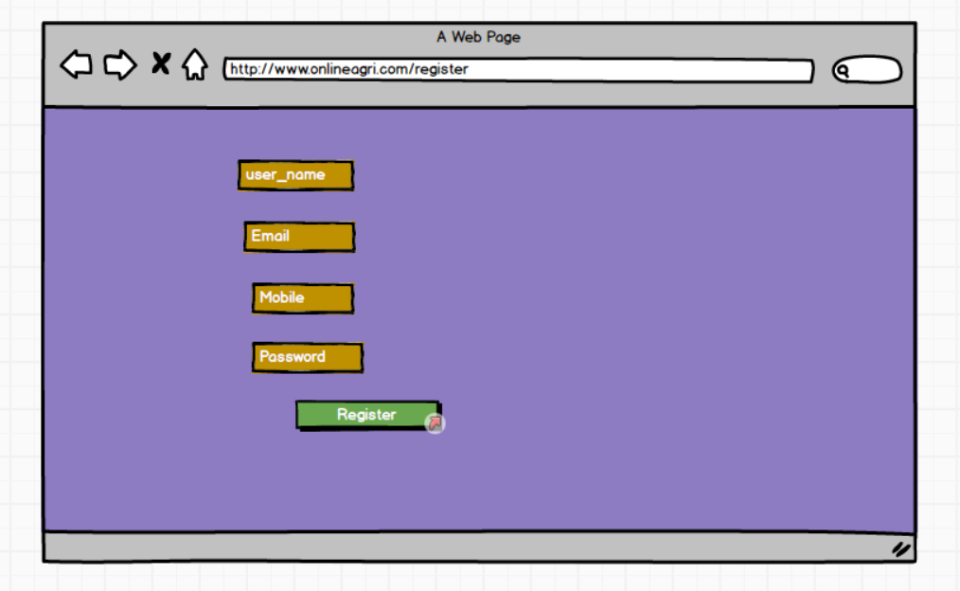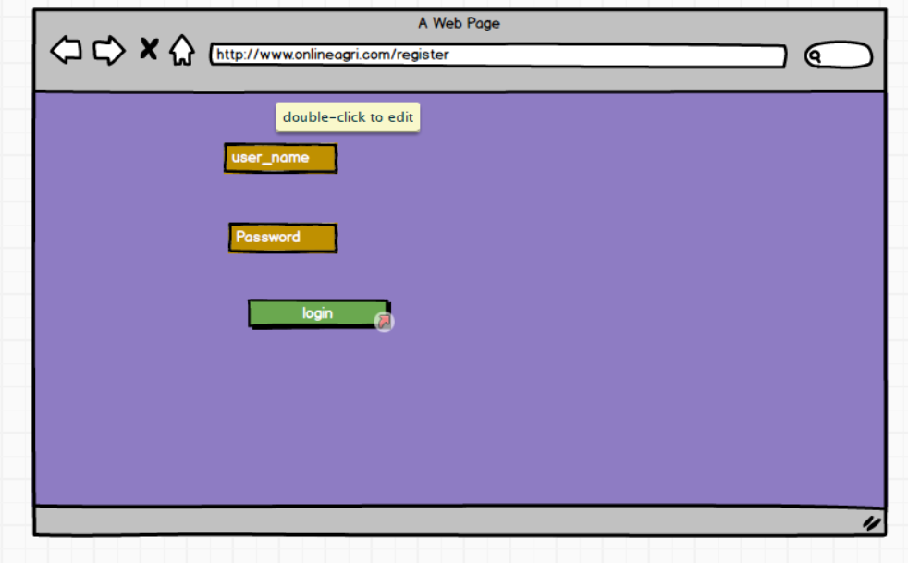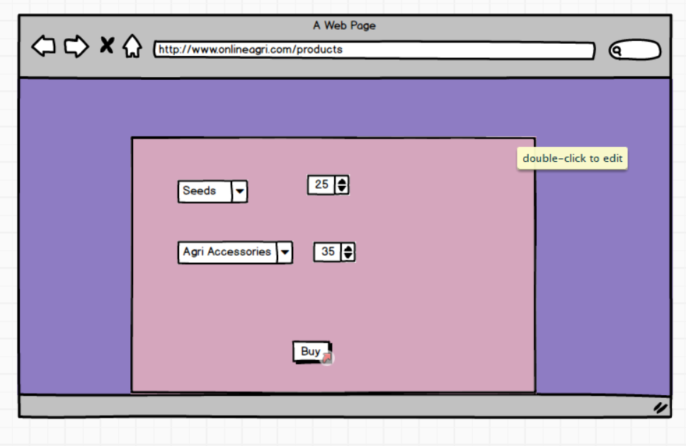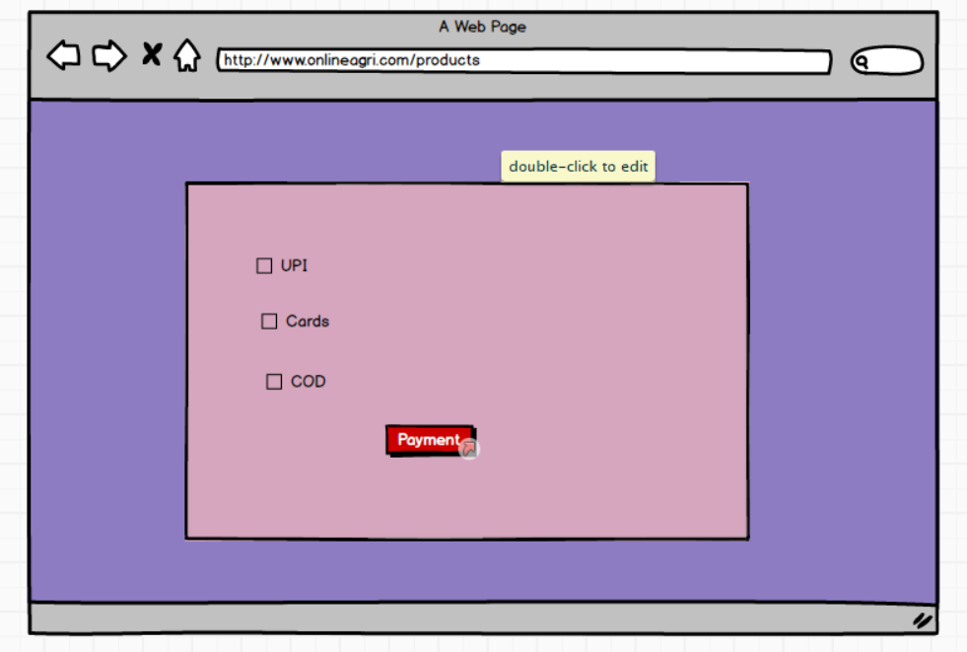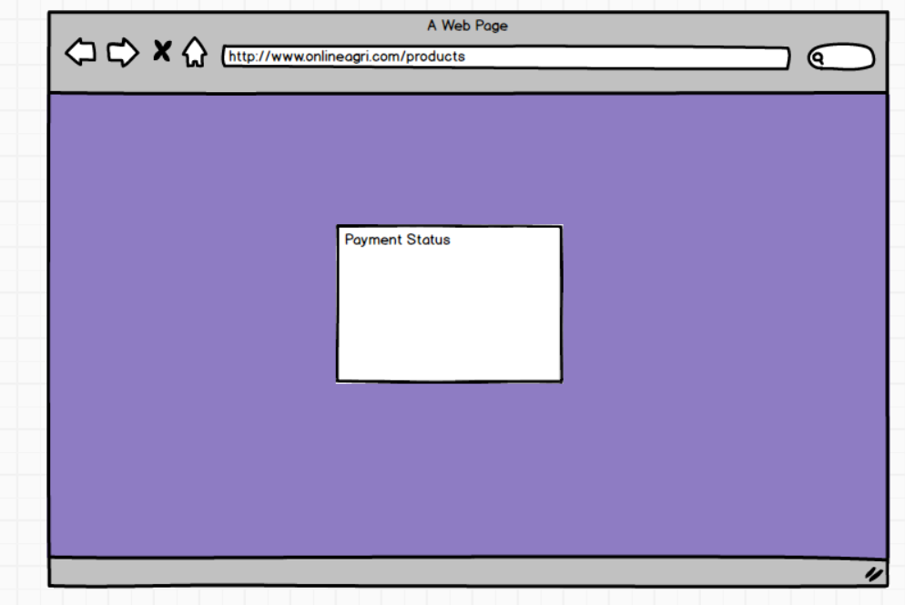

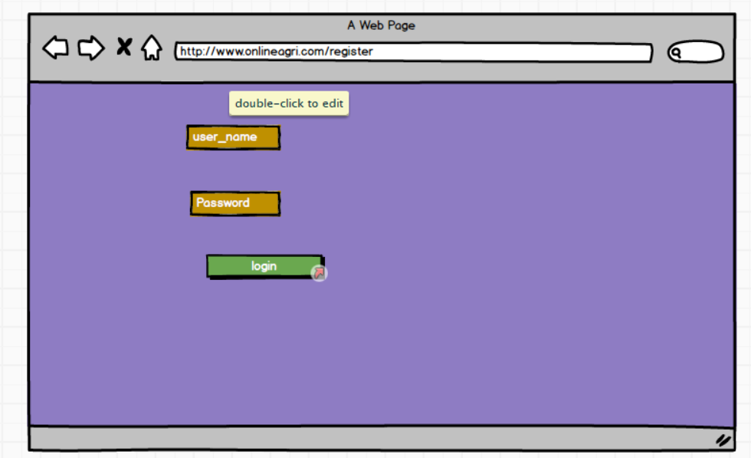
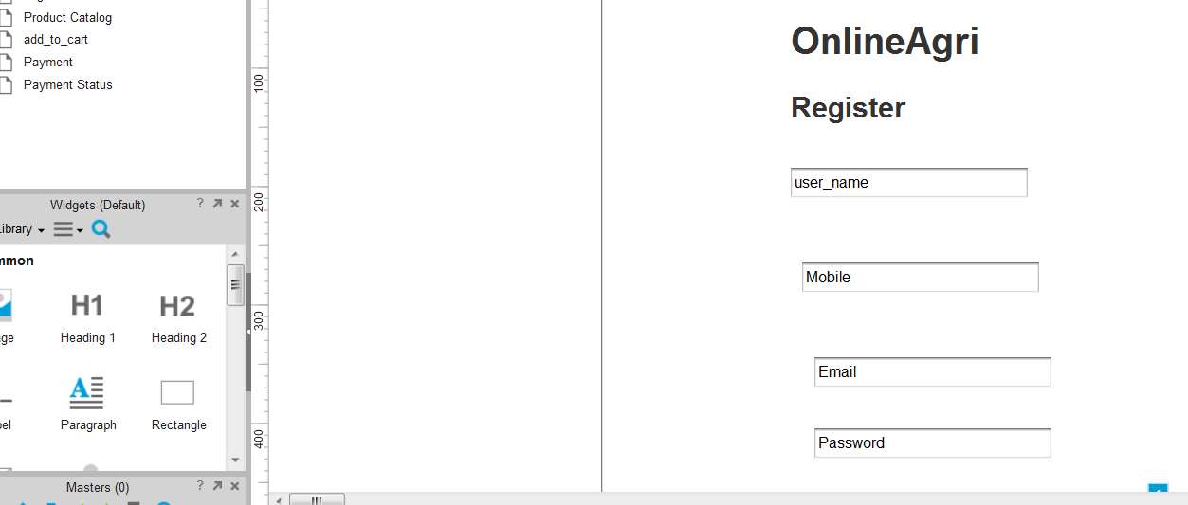

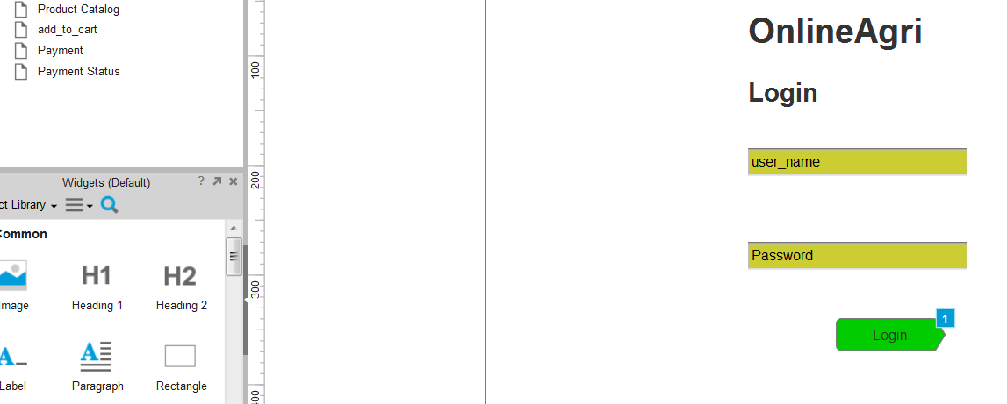

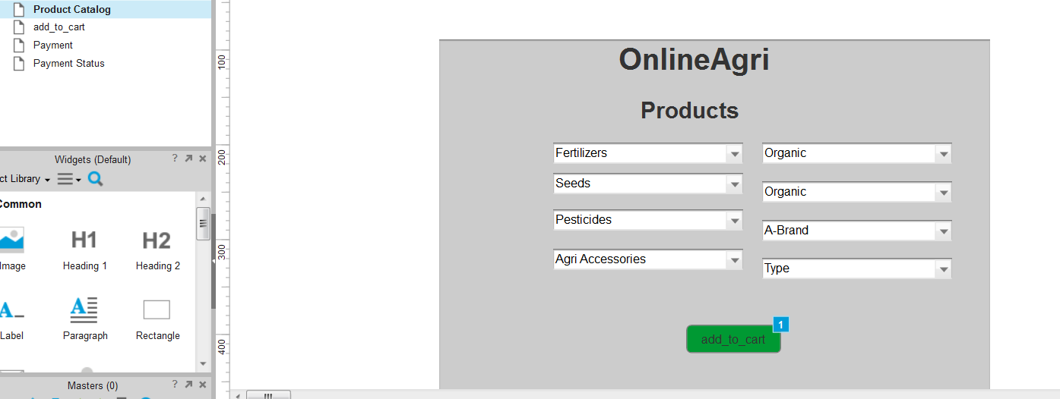

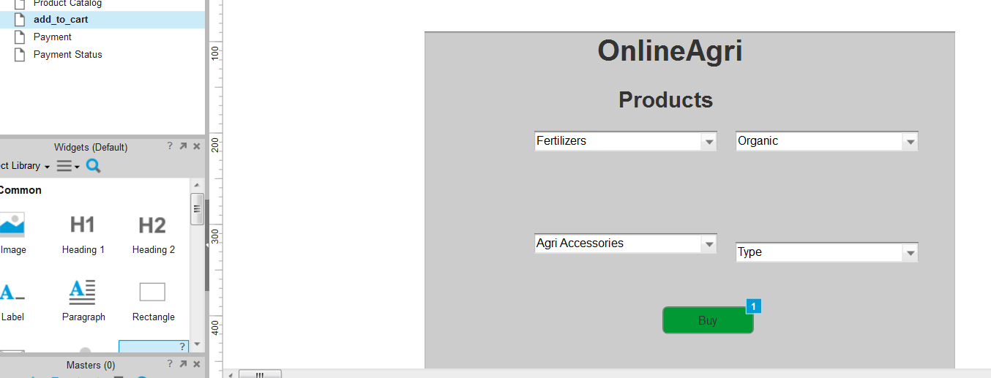
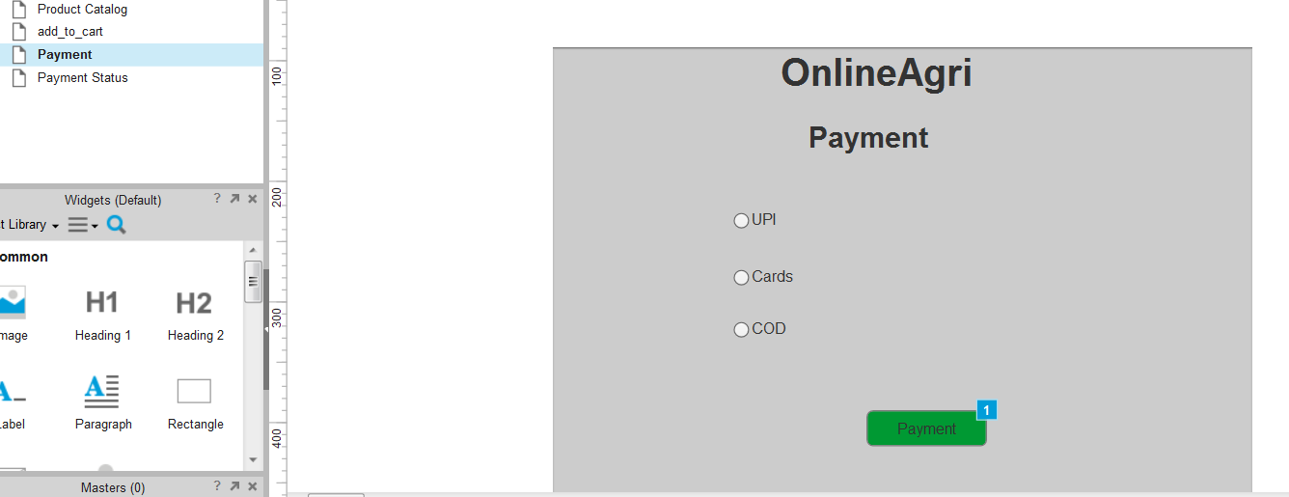
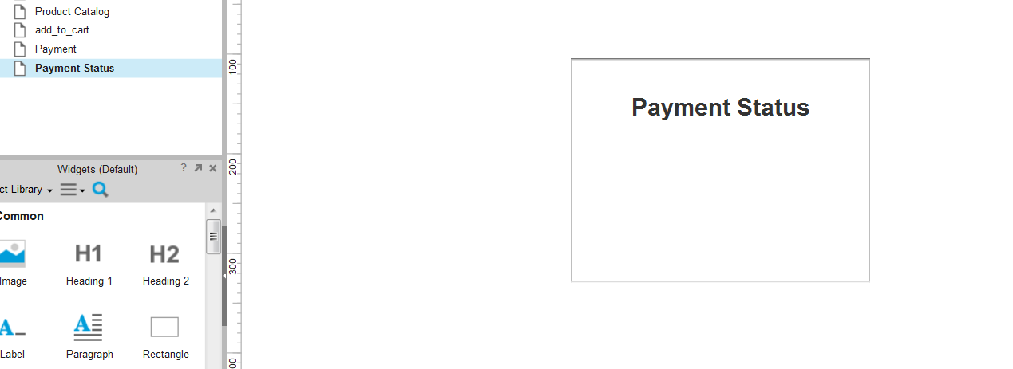

Question 3 – Tools (Visio, Balsamiq)

Microsoft Visio:
Used for Data flow diagrams, ER Diagrams, Use Case Diagrams, Activity Diagrams, Process Flowcharts, System Architecture Diagrams.

Industry standard tool for formal, professional diagrams.
Offers rich shapes, connectors and templates.
Suitable for BRD documents.

Balsamiq:
Used for Wireframes, UI/UX sketches and Low fidelity mockups.
Very quick to sketch screen layouts.
Helps visualize UI before real development.
Useful during requirement discussions with stakeholders.

4. RTM:

To track documents throughout the project lifecycle, ensuring that they are met and that no requirements are overlooked.

Req id | Req Name | Description | Design | Code | UT | CT | ST | SIT | UAT
FR001 | User reg | User-self reg | Comp | Comp | Comp | Comp | Comp | Comp | Comp
FR002 | Search Products | able to search products | Comp | Comp | Comp | Comp | Incomp | Incomp | Incomp
FR003 | User request for detailed products | able to request details of the products | Comp | Comp | Comp | Comp | Incomp | Incomp | Incomp
FR004 | Add product to cart | able to add the products to the cart | Comp | Comp | Comp | Comp | Incomp | Incomp | Comp
FR005 | Buy the products | able to buy the products | Comp | Comp | Comp | Comp | Incomp | Incomp | Incomp
Req id | Req Name | Description | Design | Code | UT | CT | ST | SIT | UAT
NFR001 | Page loading time | Each page shoild load within 2 sec | Comp | Comp | Comp | Comp | Comp | Comp | Incomp
NFR001 | WCAG 2.1 | System must meet web content accessibility | Comp | Comp | Comp | Comp | Comp | Comp | Incomp

5 – 10 Test Case Documents
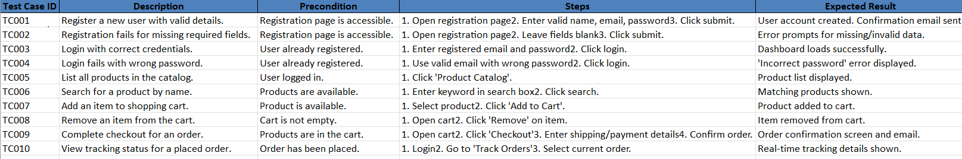

Question 6 – DB Design

After the requirements are thoroughly explained to the entire project team by business analyst, the Database architects have decided to do the database design and also to represent the in-flow and out-flow of data. Draw database schema and ER diagram.

DB Schema: It’s a blueprint that outlines the structure of a database, including its tables, fields, relationships, constraints and other characteristics.

ERD: is a visual representation of the relationships between the entities in the database. It represents the entities, attributes and relationships between them.

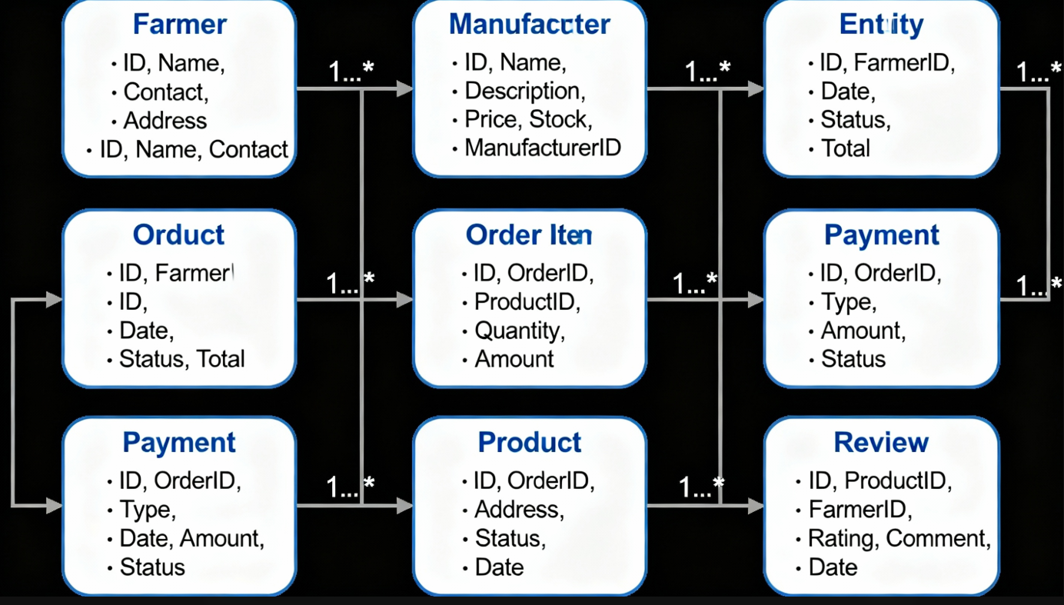

Question 7 – Data Flow Diagram
What is a data flow diagram? Draw a data flow diagram to represent the in-flow and out-flow of data when a Farmer is placing an order for the product

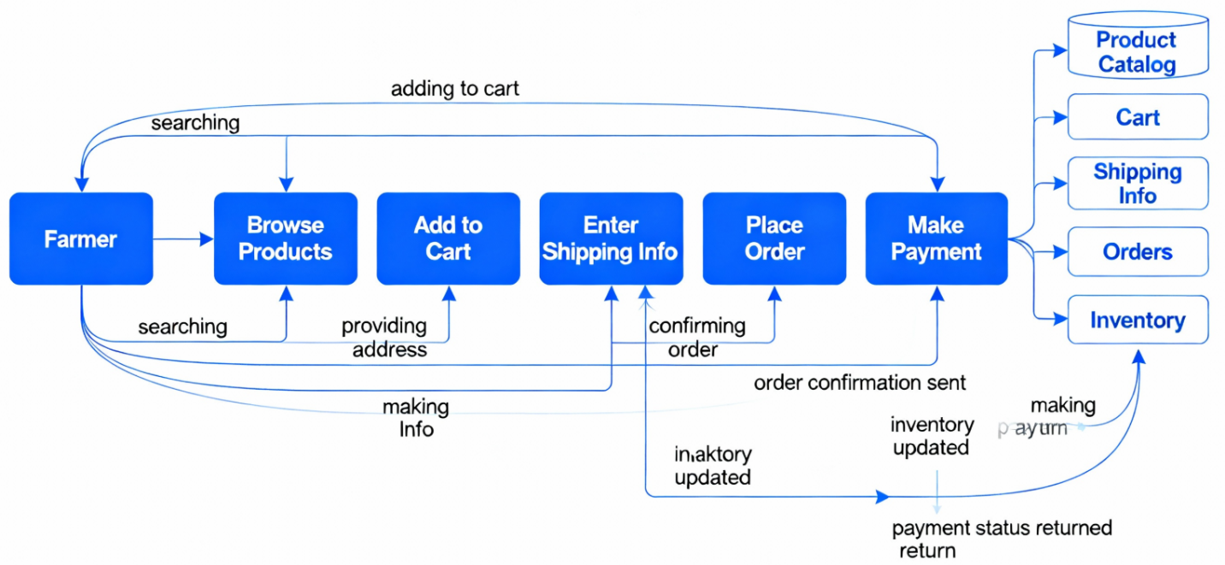

Question 8 – Change Request :
Due to change in the Government Taxation structure . we should change the Tax structure How do you handle change requests in a project?

Change request is a formal proposal to alter a system, product or project.
- Understand the scope of the change request and document them.
- Do the impact analysis-project scope, schedule, budget, resources and risks.
- Prior to the change requests based on urgency, important and impact on project.
- Seek approval from the project sponsor for the change request.
- Communicate the change request and its potential impacts to all relevant stakeholders including the project team.

Question 9 – Change Request Vs an Enhancement

Change request is when someone ask to addd, modify or remove something in the project after the work has already started.
It usually affects the scope, time or cost, so it must go through approval/
Enhancement is a small improvement to an existing feature that doesn’t change the main scope. It makes something better but doesn’t add a completely new module.

This is the change request. This is a formal change request.
Carry out impact and feasibility analysis (Time, Cost, Tech)
Update requirements, RTM, IU mockups.
Present to change control board/Stakeholders for review and approval.
Drive development and testing as per new scope once approved.
Ben and Kevin request introduces major new system capabilities ( farmer selling + auctions) this must be processed as a change request not an enhancement.
10. Come up with estimations – How many Manhours required
This estimation covers end to end requirements, design, development, integration, QA and delivery.
Adjustments will depend on team size, tech stack and changes during development.

There are different categories, small, medium and large and lets take this as a medium according to module of the given project.

Here we need to give breakups to each department involved (Development, Testing, QA etc). This means calculating how many hours each task in the project will take. We break the work into small parts, estimate the hours for each task and then add them to get the total effort.

11. UAT:
Planning: Here the documents are made to implement UAT testing for every feature that needs to test and minimum standards for accepting the test.
Designing: Here the test cases are designed to hide all the possibilities of software packages in a real world environment.
UAT Testers: Testing team consists of a end users that meet the criteria for implementing testing. They should know the test cases to run and understand the functionalities.
Bug Fixing: Whatever the bugs found in the UAT testing, the development team should be work on them and make the system error free.
Sign off: After all the bugs, the testing team indicates acceptance of the completion of the bugs. In this phase, all the stakeholders come to conclusion that the system is ready to GOLIVE and it sign off successfully.

After development & testing are complete, I prepare the UAT plan, contact the client and support them during the testing process. Once the client is satisfied and gives UAT sign-off, I prepare the project closure document, handover everything to support, conduct the closure meeting and officially close the project.
12. Explain Project closure document:

This is the final check, approval and sign off to confirm the project is finished and handover to the client.
- Make sure everything is done
- Get Client approval
- Handover
- Finish Paperwork
- Wrap up with team
- Officially close.
S.No | Points to Include | Details | References Links
1 | Did the client sign off on the UAT |  | xxx
 | Date of the signoff | DD-MM-YYYY
 | Name of the resource | Mr/Ms | xxx
2 | Objectives of the project
 | User friendliness | Achieved
 | Customer satisfaction | ROI
 | More categories | Achieved
3 | More categories
 | Secure payment processing | Achieved
 | Categories | Achieved
4 | Infrastructure
 | Software Installed | Achieved
 | System Purchased | Achieved | xxx
5 | Funding
 | Amount approved | 2 Cr
 | Amount used | 1.5 Cr | xxx
6 | Overall Project Information
 | Escalations
 | Customer satisfaction | High
7 | Value to the company
 | Positive/Negative | Company in Gain, new clients, New pipelined projects etc

