Waterfall Model Documents 2/2

Document 6- Please prepare a use case diagram, activity diagram and a use case specification document.

1. Use Case: Login to INTACT Platform
Use Case Description:
This use case describes how IT support staff log in to the INTACT platform to access incident and audit data.
Actors:
- Primary: IT Support Staff
- Secondary: Authentication Server
Basic Flow:
- User navigates to the login page.
- Enters username and password.
- System validates credentials.
- Upon success, user is redirected to the dashboard.
Alternate Flow:
- User clicks on "Forgot Password" and goes through reset process.
Exceptional Flows:
- Invalid credentials.
- Server unavailable.
Pre-Conditions:
- User must be registered.
Post-Conditions:
- User is authenticated and session is active.
Assumptions:
- Valid users exist in the system.
Constraints:
- Session times out in 15 mins.
Dependencies:
- SSO/Authentication service.
Inputs/Outputs:
- Inputs: Username, Password
- Outputs: Dashboard Access
Business Rules:
- Only registered users can log in.
Miscellaneous:
- Login attempts logged for 1 year.

USE CASE DIAGRAM
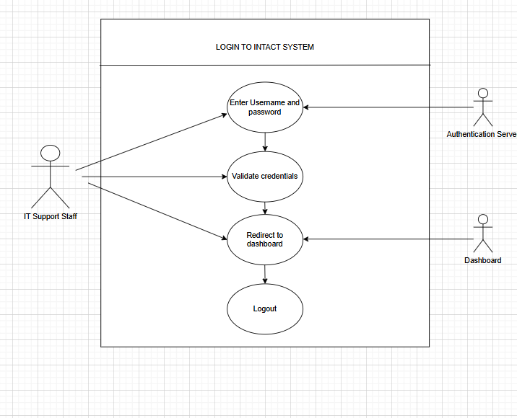

Activity Diagram
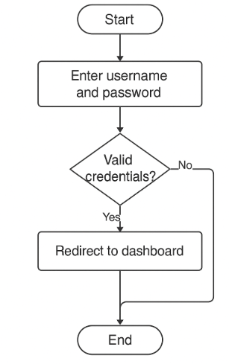

2. Use Case: Report Incident
Use Case Description:
Allows users to report a new incident related to infrastructure or system issues.
Actors:
- Primary: IT Support Staff
- Secondary: Incident Database
Basic Flow:
- Click on “Report Incident.”
- Fill form (issue type, priority, description).
- Submit the incident.
- System assigns unique ID and stores the data.
Alternate Flow:
- User saves draft before final submission.
Exceptional Flows:
- Network timeout before submission.
Pre-Conditions:
- User is logged in.
Post-Conditions:
- Incident created in DB.
Assumptions:
- DB connection is stable.
Constraints:
- Mandatory fields must be filled.
Dependencies:
- Backend services and DB.
Inputs/Outputs:
- Input: Incident details
- Output: Confirmation, ID
Business Rules:
- All incidents must be assigned within 15 mins.
Miscellaneous:
- Email notification is triggered on submission.

USE CASE DIAGRAM:
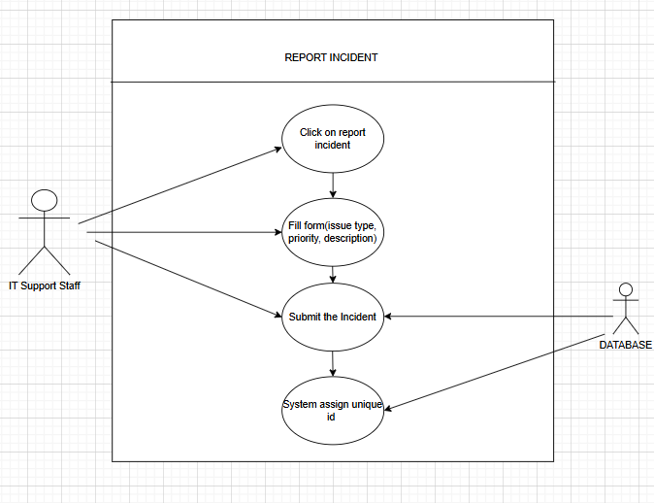

Activity Diagram:
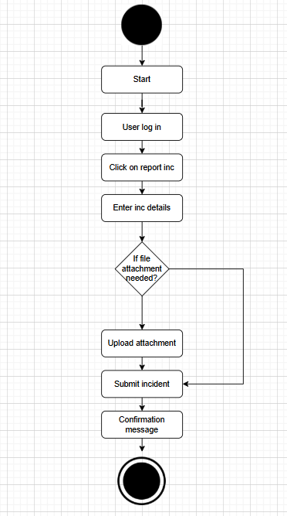

3. Use Case: Update Incident
Use Case Description:
Describes how staff can update an incident’s status or description.
Actors:
- Primary: IT Support Staff
- Secondary: Incident Database
Basic Flow:
- Search for incident by ID.
- View incident details.
- Update status/comments.
- Submit update.
Alternate Flow:
- User adds attachments.
Exceptional Flows:
- Another user has locked the incident.
Pre-Conditions:
- User must have edit access.
Post-Conditions:
- Updates saved in audit trail.
Assumptions:
- User role permits editing.
Constraints:
- Comments must be 50+ characters.
Dependencies:
- Incident system live.
Inputs/Outputs:
- Input: Update data
- Output: Confirmation, log
Business Rules:
- High severity incidents must be reviewed hourly.
Miscellaneous:
- Timestamped logs are maintained.

USE CASE DIAGRAM:
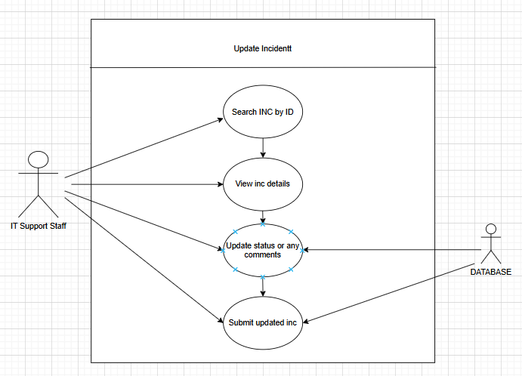

Activity diagram:
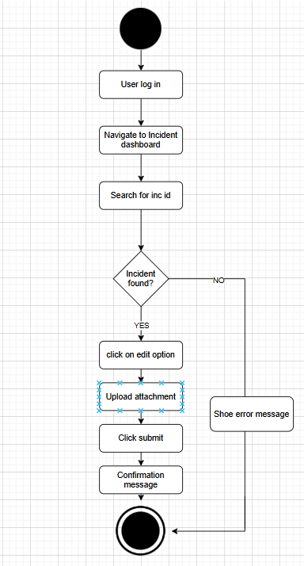

4. Use Case: View Audit Reports
Use Case Description:
User can view historical audit logs of all system and user activities.
Actors:
- Primary: Compliance Officer
- Secondary: Audit Log Service
Basic Flow:
- Navigate to Audit Report section.
- Select filters (date, user, module).
- View generated report.
Alternate Flow:
- Export report to CSV or PDF.
Exceptional Flows:
- No data found for given filter.
Pre-Conditions:
- Logged in with audit role.
Post-Conditions:
- Audit report is generated.
Assumptions:
- Audit logs are current.
Constraints:
- Export file size <10MB.
Dependencies:
- Log storage system.
Inputs/Outputs:
- Inputs: Filter criteria
- Outputs: Report data
Business Rules:
- Reports older than 1 year are archived.
Miscellaneous:
- UI must show logs in tabular format.

USE CASE:
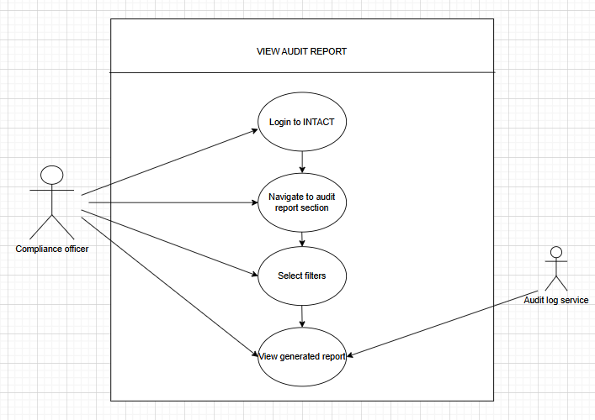
Activity diagram:
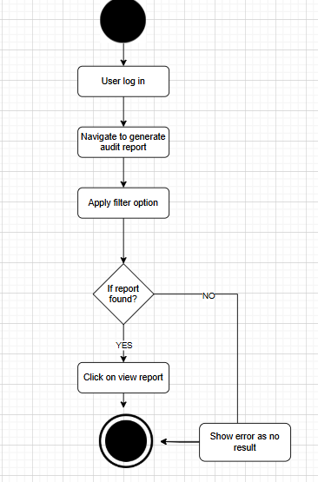

5. Use Case: Logout
Use Case Description:
Allows user to safely terminate the session.
Actors:
- Primary: IT Support Staff
Basic Flow:
- Click on “Logout.”
- System confirms session end.
- User is redirected to login.
Alternate Flow:
- Session auto logs out after 15 minutes.
Exceptional Flows:
- Network interruption during logout.
Pre-Conditions:
- User session active.
Post-Conditions:
- Session terminated.
Assumptions:
- User wants to end session.
Constraints:
- No partial logout allowed.
Dependencies:
- Session manager module.
Inputs/Outputs:
- Input: Logout click
- Output: Login screen
Business Rules:
- Logout logs must be maintained.
Miscellaneous:
- Logout reason (optional) can be capture

USE CASE DIAGRAM:
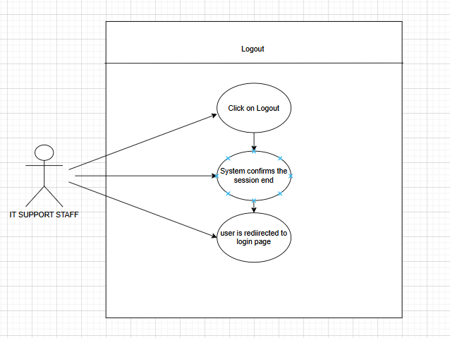

Activity Diagram:
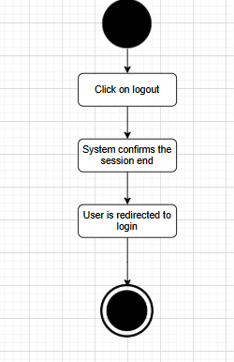
Document 7- Screens and pages:
  - Homepage
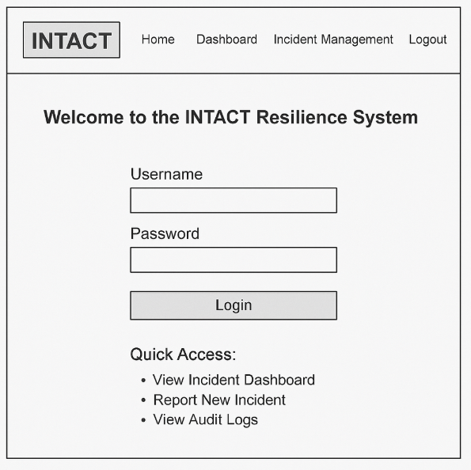

  - Login Page

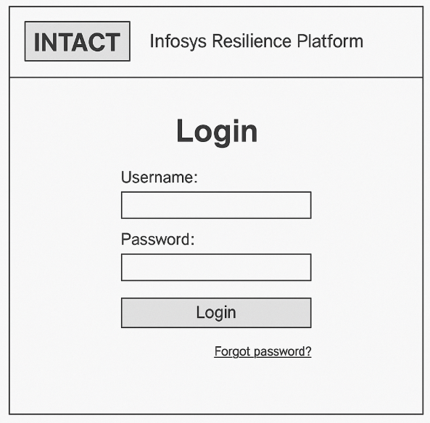

  - Incident Management
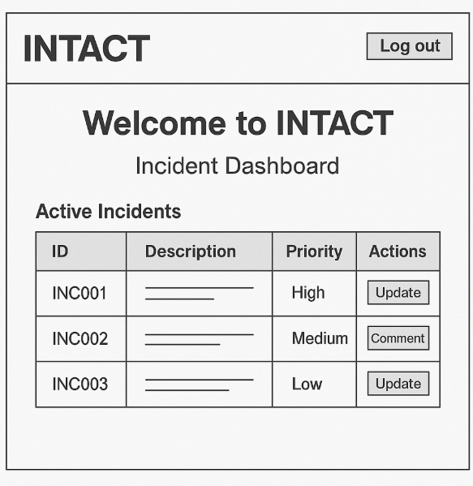

  - Incident Dashboard
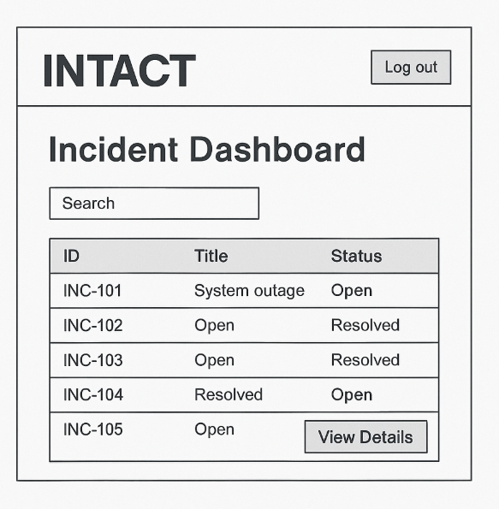

  - Incident update page
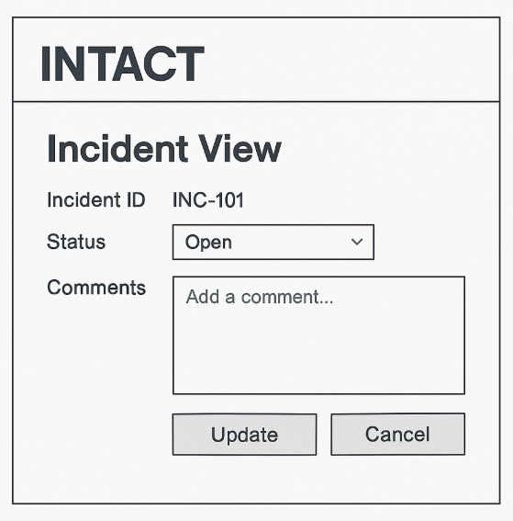

  - Audit Report
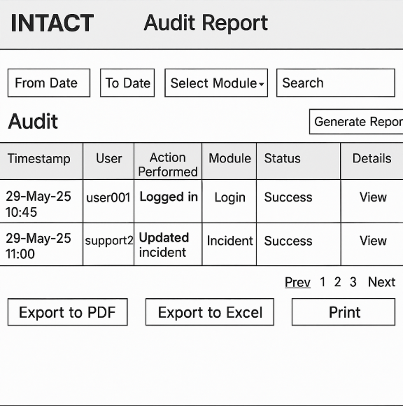

7.Logout page
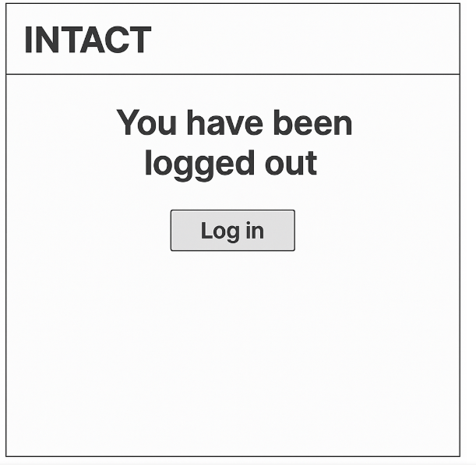

Document 8- Tools-Visio and Axure
Write a paragraph on your experience using Visio and Axure for the project.
As part of the INTACT – Data Resilience System project, I had the opportunity to extensively use Microsoft Visio and Axure RP (along with Balsamiq) to support the Business Analysis and UI/UX design phases. These tools played a crucial role in visualizing the system structure, documenting requirements, and presenting interactive user interface designs that guided the development process effectively.
Visio was primarily used for creating various UML diagrams, such as the use case diagram, activity diagram, and system architecture diagrams. Visio's intuitive drag-and-drop interface made it easy to build clean and professional diagrams that accurately captured the workflows and user interactions with the INTACT platform. It allowed me to structure the use cases for different actors, visualize the step-by-step flow of activities, and align them with the project’s functional requirements. These diagrams were helpful not only for documentation but also served as an essential communication bridge between business stakeholders and the technical team.
For designing the front-end experience, I used Axure RP and Balsamiq to create wireframes and interactive prototypes of the application. Axure provided advanced prototyping features that allowed me to simulate page navigation, user interactions, and conditional logic, giving a real-time feel of how the system would function. I developed a series of mockups starting from the home page, followed by the login page, incident dashboard, incident update and comment pages, audit report dashboard, and finally the logout confirmation page. This sequential development helped in visualizing the entire user journey from login to logout.
In the initial stages, I used Balsamiq to create low-fidelity wireframes to gather quick feedback from the team. Its simplicity and sketch-like appearance made it ideal for brainstorming sessions and discussions. Once the layout was finalized, I transitioned to Axure to develop high-fidelity prototypes with clickable elements, interactive buttons, and transitions to closely replicate the actual system behavior.
Overall, using Visio and Axure significantly improved the clarity, accuracy, and efficiency of the project documentation and UI/UX design. These tools enabled better stakeholder collaboration, reduced ambiguity in requirements, and ensured that the development team had a clear understanding of what needed to be built. This experience has enhanced my proficiency in industry-standard tools and strengthened my ability to bridge the gap between business needs and technical implementation.

Document 9- BA experience
My experience as BA in following phases:
Requirement Gathering Phase

1. Requirement Gathering Overview
As a Business Analyst for the INTACT – Incident Management System project, I was actively involved in the Requirement Gathering Phase, which formed the foundation for a successful solution design and implementation. My role included identifying stakeholders, eliciting accurate requirements, validating them, and managing changes effectively.

2. Techniques Used

a. MoSCoW Prioritization Technique
To ensure alignment with business goals and technical feasibility, I used the MoSCoW technique to categorize the requirements into:
- Must Have – Essential features like Login, Incident Creation, Audit Logs.
- Should Have – Search filters, Dashboard Widgets.
- Could Have – Print to PDF, Theme Customization.
- Won’t Have (for now) – Integration with 3rd party monitoring tools (deferred).

b. Stakeholder Unavailability & Alternate POCs
The client was not always available during this phase. As a proactive measure:
- I identified alternate points of contact (POCs) from the client team.
- Scheduled quick sync calls or asynchronous communications (emails, shared documents) to avoid project delays.
- Ensured proper sign-offs from authorized personnel.

c. Requirement Validation using FURPS Framework
Each requirement was validated using the FURPS model to ensure completeness:
- Functionality: Feature behavior like login, incident update.
- Usability: User-friendliness of the UI screens.
- Reliability: Success of login/audit tracking modules.
- Performance: Response time of dashboards and report generation.
- Supportability: Ease of future enhancements and support.

d. Duplicate Requirement Cleanup
- During the documentation process, I observed repetitive or redundant requirements.
- Collaborated with technical and QA teams to merge or eliminate duplicates to avoid scope bloat and confusion.

e. Prototyping for Clarity
- Developed low-fidelity wireframes and screen mockups using tools like Balsamiq and Figma.
- Walked stakeholders through the UI prototypes to help them visualize the final system.
- This led to clearer, more specific requirements, reducing changes later in the SDLC.

3. Outcome of Requirement Gathering
- A refined and validated requirements list documented in the Business Requirement Specification (BRS) and Software Requirement Specification (SRS).
- Reduced ambiguities and changes in later phases.
- Gained stakeholder trust and improved communication.

2. Requirement Analysis:

Overview
In the Requirement Analysis Phase, I translated the gathered business needs into clear, structured documentation and visuals to guide the development and testing teams. The objective was to ensure a shared understanding of the requirements among all stakeholders and technical teams.

1. UML Diagrams for Requirement Visualization
To effectively represent the system’s behavior and structure, I created UML diagrams, including:
- Use Case Diagrams – Showed user interactions with modules like Login, Incident Management, and Audit Report.
- Class Diagrams – Modeled the data structure for entities such as User, Incident, Module.
- Sequence Diagrams – Illustrated interactions between front-end users and backend processes.
- Activity Diagrams – Mapped out the process flow for:
  - Logging in
  - Creating and updating incidents
  - Generating audit reports
These diagrams helped in visualizing the system and identifying missing logic or exceptions early.

2. Activity Diagrams for Process Flow
I created activity diagrams to:
- Clearly outline step-by-step process flows.
- Assist developers and testers in understanding expected system behavior.
- Provide a base for user training documentation.
Example activities diagrammed:
- Incident Lifecycle: Create → Assign → Update → Close
- Logout Process
- Report Generation (PDF/Excel)

3. Collaborative Review & Iteration
- The diagrams and documented flows were presented to development and QA teams in walkthrough sessions.
- Some team members raised feedback or suggestions based on technical constraints or enhancements.
- As a BA, I incorporated relevant feedback while ensuring alignment with business goals.
- Updated diagrams and documentation were version-controlled and shared with the team for transparency.

4. Preparation of BRS and SRS

Business Requirement Specification (BRS)
- Describes high-level business needs and goals.
- Includes stakeholder identification, business context, and the scope of the system.
- Written in non-technical language to ensure understanding by business users.

Software Requirement Specification (SRS)
- Converts BRS into detailed functional and non-functional requirements.
- Includes:
  - Functional Requirements (e.g., login authentication, audit log retrieval)
  - Non-Functional Requirements (e.g., performance, usability)
  - System Interfaces
  - Data Flow Diagrams and Models
- This document served as the blueprint for developers and testers.

Outcome
- Complete and validated UML diagrams and activity flows.
- Reviewed and updated documentation after team feedback.
- Finalized BRS and SRS documents, signed off by stakeholders.
- Provided a clear foundation for the design, development, and testing phases.

3. Design Phase:

Overview
During the Design Phase, my role as a Business Analyst extended beyond requirement documentation. I ensured that the solution design was testable, traceable, and aligned with business goals. This phase involved close collaboration with development, QA, and client stakeholders.

1. Test Case Preparation from Use Case Diagrams
- Extracted test scenarios directly from use case diagrams.
- For each use case (e.g., Login, Incident Update, Audit Report Generation), I created:
  - Positive Test Cases – validating correct flows (e.g., valid credentials).
  - Negative Test Cases – validating error handling (e.g., incorrect login, expired session).
- Ensured full coverage of basic, alternate, and exceptional flows defined in the use case specification document.

2. Client Communication on Design and Solution Documents
- Shared initial solution design documents (UI mockups, data models, architecture diagrams) with the client.
- Scheduled walkthrough sessions to:
  - Explain design choices based on business requirements.
  - Capture feedback and approval on workflows and visuals.
- Documented any changes or refinements proposed by the client.

3. Exhaustive Test Case Coverage
- Ensured that no test case was missed, including edge cases like:
  - Session timeouts after 15 minutes
  - Audit log not updating due to DB issues
  - Unauthorized users accessing admin-only features
- Highlighted in team meetings that missing test cases at this stage can lead to defects in UAT or production, affecting cost and timelines.

4. Test Data Preparation
- Prepared realistic and diverse test data sets for:
  - Valid login credentials
  - Various incident statuses (Open, In Progress, Resolved, Closed)
  - User roles and permissions (Support Staff, Admin)
- Ensured edge cases and error scenarios were testable (e.g., special characters in incident comments, large datasets).

5. Updating Requirements Traceability Matrix (RTM)
- Updated the RTM to map each:
  - Requirement → Corresponding Test Case(s)
  - Design Element → Verified via Functional Tests
- Ensured 100% traceability from BRS → SRS → Design → Test Cases
- RTM served as the control mechanism to ensure all requirements were tested and validated.

Outcome
- Full set of positive and negative test cases created.
- Test data prepared to cover real-world and edge cases.
- Client feedback on design documents successfully incorporated.
- RTM updated and maintained throughout the design lifecycle.
- Quality assurance team received a complete and validated base for starting the test execution phase.

4. Development Phase:

Overview
In the Development Phase, my role as a Business Analyst was to facilitate seamless coordination between the technical team and stakeholders, ensure clarity in implementation, and help maintain team collaboration. I worked closely with developers to clarify requirements, interpret diagrams, and ensure alignment with business goals.

1. Conducting JAD (Joint Application Development) Sessions
- Organized JAD sessions involving the client, business users, and development team.
- The purpose was to:
  - Finalize functional expectations
  - Address technical feasibility
  - Resolve misunderstandings early
- Created and shared session agendas and summaries post-discussion for tracking.

2. Clarifying Queries During Coding
- Maintained an open communication channel (via Teams/Slack/email) for real-time developer queries.
- Provided:
  - Use case clarifications
  - Edge-case explanations
  - Reference to activity/UML diagrams and SRS
- Ensured business rules and constraints were well understood (e.g., role-based incident updates, session timeouts).

3. Managing Team Conflicts During Sessions
- Handled situations where some team members disagreed with design/requirements or were uncooperative.
- Took a professional and empathetic approach by:
  - Conducting 1-on-1 discussions
  - Explaining the project impact of missed collaboration
  - Reinforcing the importance of team alignment
- Successfully fostered a healthy, collaborative working environment.

4. Reference of Diagrams to Aid Development
- Encouraged developers to refer to prepared UML and activity diagrams for:
  - Workflow understanding (e.g., Login, Audit Generation)
  - Input/output mapping
  - Process logic implementation
- Ensured these visuals served as a quick-reference toolkit for consistent development.

5. Regular Meetings with Technical Team and Client
- Scheduled regular sync-up calls for development progress tracking.
- Challenges faced:
  - Team member unavailability
  - Time zone differences
- Solution:
  - Recorded sessions and shared with absentees
  - Conducted follow-up discussions individually to ensure alignment

Outcome
- JAD sessions bridged the gap between business and tech teams.
- All technical queries were clarified promptly, preventing rework.
- Team harmony was maintained through active communication and conflict resolution.
- Developers had clear direction from BA artifacts, resulting in smooth unit development.
- Regular client and team meetings kept all stakeholders aligned on progress and blockers.

5. Testing:

Overview
In the Testing Phase, my responsibilities as a Business Analyst included ensuring that the product was tested against the defined requirements, supporting the QA team, and preparing the client for User Acceptance Testing (UAT). I ensured that traceability, data readiness, and communication with stakeholders were maintained at all stages.

1. Test Case Preparation from Use Cases
- Created test cases based on the use case specification document, including:
  - Positive test cases (e.g., successful login, incident update by authorized user)
  - Negative test cases (e.g., login with invalid credentials, unauthorized access attempts)
- Mapped these cases directly to requirements for comprehensive coverage.

2. Performed High-Level Testing
- Involved in high-level (sanity and functional) testing of the application.
- Verified whether the developed modules aligned with business needs:
  - Login functionality
  - Incident dashboard behavior
  - Incident status updates
  - Logout functionality
  - Audit trail verification

3. Requested Test Data from Client
- Identified and documented the test data requirements (user credentials, sample incident records, roles).
- Coordinated with the client or admin team to obtain realistic and anonymized test data for a meaningful test cycle.
- Ensured edge cases and boundary scenarios were included in test data.

4. RTM (Requirements Traceability Matrix) Update
- Continuously updated the RTM to ensure that:
  - Every business requirement was tested.
  - Every test case had a corresponding requirement.
- Used RTM to track the status of each requirement across the SDLC, ensuring nothing was missed.

5. Client Signoff
- Conducted demo sessions to showcase tested modules to the client.
- Documented and addressed client feedback before final delivery.
- Ensured the client reviewed and signed off the final UAT checklist and verified:
  - Business rules were followed
  - Reports and audit logs were accurate
  - System security met expectations

6. UAT Preparation
- Educated the client on how to perform User Acceptance Testing by:
  - Providing step-by-step UAT scripts and expected results
  - Assisting in UAT environment setup
  - Being available to resolve issues and answer questions
- Ensured UAT feedback was collected, analyzed, and documented for closure.

Outcome
- Complete test case suite prepared and executed with full traceability.
- All client requirements validated, leading to confident signoff.
- Client was well-prepared and supported during UAT, ensuring smooth transition to production.
- No gaps found between documented requirements and delivered functionality.

5. Development Phase:

Overview
As a Business Analyst in the Deployment Phase, my responsibility was to ensure the smooth handover of the project to the client and end users by managing documentation, training, and final client coordination. This phase involved wrapping up the project with formalities, ensuring usability, and preparing users for real-time adoption.

1. Forwarding RTM for Project Closure
- Shared the final Requirements Traceability Matrix (RTM) with the client.
- The RTM was:
  - Reviewed and verified for 100% requirement coverage
  - Attached to the project closure document as evidence of fulfillment
- This helped ensure transparency and traceability from requirements to deployment.

2. Coordinated End User Manual Preparation
- Worked with the documentation and technical team to:
  - Create user-friendly end user manuals
  - Include step-by-step instructions, screenshots, and FAQs
- Ensured the manuals covered all critical features:
  - Logging in
  - Managing incidents
  - Accessing audit reports
  - Logging out

3. Planned and Organized Training Sessions
- Scheduled training sessions for end users to familiarize them with the system.
- Responsibilities included:
  - Creating training agendas and schedules
  - Preparing training decks, walkthroughs, and use-case demonstrations
  - Ensuring technical readiness (login credentials, sandbox environment)

4. Ensured 100% Attendance
- Communicated with stakeholders to confirm attendance of all necessary participants.
- If any end users were unavailable:
  - Shared session recordings
  - Conducted follow-up 1-on-1 sessions to ensure everyone was trained
- Collected feedback forms post-training to improve future sessions.

Outcome
- Successfully completed deployment documentation and closure formalities
- All users were properly trained and equipped to use the system independently
- RTM submission and training support helped achieve final client sign-off and satisfaction

