Q1: 4 Quarterly Audits are planned Q1 , Q2, Q3, Q4 for this Project What is your knowledge on how these Audits will happen for a BA ?

Q1- Requirement Gathering & Documentation Review
Q2- Design Validation, Traceability Check
Q3- Test Case Review, Defect Analysis
Q4-UAT Support, Deployment Readiness & Post-Go-Live Review.
Q2-Before the Project is going to Kick Start, The Committee asked Mr Karthik to submit BA Approach Strategy Write BA Approach strategy (As a business analyst, what are the steps that you would need to follow to complete a project – What Elicitation Techniques to apply, how to do Stakeholder Analysis RACI/ILS, What Documents to Write, What process to follow to Sign off on the Documents, How to take Approvals from the Client, What Communication Channels to establish n implement, How to Handle Change Requests, How to update the progress of the project to the Stakeholders, How to take signoff on the UAT- Client Project Acceptance Form ) Your Team Project Manager - Mr Vandanam Senior Java Developer - Ms. Juhi Java Developers - Mr Teyson, Ms Lucie, Mr Tucker, Mr Bravo Network Admin - Mr Mike DB Admin - Mr John. Testers - Mr Jason and Ms Alekya BA - You Technical Team have assembled to discuss on the Project approach and have finalised to follow 3-tier architecture for this project.

Business Analyst (BA) Approach Strategy
1. Elicitation Techniques
To gather requirements effectively from stakeholders (Mr. Henry, Peter, Kevin, Ben, Committee members, technical team, etc.), I will apply:
- Interviews – One-on-one discussions with farmers, manufacturers, and committee members.
- Workshops – Joint workshops with SMEs, developers, and testers.
- Questionnaires/Surveys – To reach larger groups of farmers in remote locations.
- Observation/Shadowing – Understand farmers’ buying patterns and challenges.
- Document Analysis – Review existing purchase/distribution records, if any.

2. Stakeholder Analysis (RACI / ILS)
- Responsible (R): BA, Developers, Testers (do the work).
- Accountable (A): Project Manager (Mr. Vandanam).
- Consulted (C): Committee (Mr. Henry, Mr. Pandu, Mr. Dooku), Farmers (Peter, Kevin, Ben).
- Informed (I): Technical team, CSR board.
ILS (Interest, Level of Influence, Support) mapping will be prepared to identify decision-makers vs influencers.

3. Documentation to be Prepared
- Business Requirements Document (BRD)
- Functional Requirements Document (FRD)
- System Requirements Specification (SRS)
- Process Flow Diagrams & Use Case Diagrams
- Data Models
- Test Scenarios & Traceability Matrix

4. Process for Document Sign-off
- Draft document and circulate internally.
- Conduct review meetings with stakeholders.
- Incorporate feedback.
- Share final version with the committee.
- Obtain formal sign-off (email/DocuSign).

5. Client Approval Process
- Present finalized BRD/FRD to Mr. Henry’s Committee.
- Record committee’s suggestions/changes.
- Implement changes and get written approval.

6. Communication Channels
- Weekly status meetings with committee and PM.
- Daily stand-ups with project team.
- Email updates for key decisions.
- Project collaboration tool (like JIRA/MS Teams).
- Status reports to stakeholders at milestone completion.

7. Handling Change Requests
- Log request in Change Request Register.
- Perform Impact Analysis (on scope, budget, timeline, resources).
- Review with PM and Committee.
- Update BRD/FRD if approved.
- Communicate to development & testing teams.

8. Updating Project Progress
- Prepare Weekly Status Reports with: completed tasks, in-progress work, risks/issues, next steps.
- Share to Committee & Technical team.
- Monthly review presentations for higher management.

9. UAT & Client Project Acceptance
- Support testers and farmers during UAT.
- Create UAT Test Scenarios mapped to requirements.
- Collect Defect logs and resolutions.
- Once passed, prepare Client Project Acceptance Form.
- Obtain formal UAT sign-off from Mr. Henry’s Committee.

10. Technical Approach
- Team has decided on 3-Tier Architecture:
  - Presentation Layer (Web/Mobile UI – Farmers & Manufacturers).
  - Application Layer (Business logic in Java).
  - Data Layer (Database managed by DB Admin John).
- This architecture ensures scalability, security, and separation of concerns.
Q3-Explain and illustrate 3-tier architecture?

3-Tier Architecture Explanation
1. Presentation Layer (UI Layer)
- This is the user interface farmers and manufacturers interact with.
- Examples for this project:
  - Farmers: Mobile/Web App (browse seeds, fertilizers, pesticides, place orders).
  - Manufacturers: Web Portal (upload product details).
- Technologies: HTML, CSS, JavaScript, React/Angular, Mobile UI frameworks.

2. Application Layer (Business Logic Layer)
- The middle layer where rules and logic are executed.
- Responsibilities in this project:
  - Authenticating farmers/manufacturers.
  - Processing orders.
  - Validating product availability.
  - Handling communication between UI & Database.
- Technologies: Java (Spring Boot), APIs, Middleware.

3. Data Layer (Database Layer)
- Responsible for data storage, management, and security.
- For this project:
  - Store farmer profiles, product catalogs, manufacturers, order details, delivery tracking.
- Technologies: MySQL / Oracle / PostgreSQL.
- Managed by DB Admin (John).

How it Works in This Project
- Farmer logs in via app (Presentation Layer).
- Request goes to Application Layer for processing (Java logic).
- Application Layer queries Database Layer for product/stock details.
- Database sends response back → Application Layer → Presentation Layer (farmer sees results).
┌──────────────────────────┐
│ Presentation Layer │
│ (UI – Web/Mobile App) │
│ - Farmers │
│ - Manufacturers │
└──────────▲────────────────┘
│
▼
┌──────────────────────────┐
│ Application Layer │
│ (Business Logic – Java) │
│ - Order Processing │
│ - Authentication │
│ - Communication via APIs │
└──────────▲────────────────┘
│
▼
┌──────────────────────────┐
│ Data Layer │
│ (Database – MySQL/Oracle) │
│ - Products Catalog │
│ - Farmers Data │
│ - Orders & Deliveries │
└──────────────────────────┘
✅ In summary:
- Presentation Layer = Farmers & Manufacturers Interface
- Application Layer = Core Business Logic in Java
- Data Layer = Database storing all details
Q4-Business Analyst should keep What points in his/her mind before he frames a Question to ask to the Stakeholder ( 5W 1H – SMART – RACI – 3 Tier Architecture – Use Cases, Use case Specs, Activity Diagrams, Models, Page designs)
1. 5W + 1H Technique
- Who is involved? (Farmers, Manufacturers, Committee, IT Team)
- What is the requirement/problem? (Buying seeds, pesticides, fertilizers online)
- When is it needed? (Timelines, urgency, seasonal needs)
- Where will it be used? (Remote villages, online access, mobile/web)
- Why is it needed? (Accessibility, ease of procurement, farmer empowerment)
- How should it function? (Process flows, usability, integration with backend)
👉 This ensures the BA covers all angles of the requirement.

2. SMART Principle
Questions must be:
- Specific – Clear and not ambiguous.
- Measurable – Can the outcome be measured (e.g., number of farmers using app)?
- Achievable – Is it realistic for the system to deliver?
- Relevant – Aligned to business goals (helping farmers buy inputs easily).
- Time-bound – Linked to project timelines.

3. RACI Awareness
Before asking questions, the BA should know:
- Who is Responsible (developers, testers)?
- Who is Accountable (Project Manager, Committee)?
- Who should be Consulted (Farmers, SMEs)?
- Who needs to be Informed (CSR board, wider teams)?
👉 This avoids asking the wrong questions to the wrong person.

4. 3-Tier Architecture Understanding
The BA should frame questions in alignment with the technical approach:
- Presentation Layer (UI): “How should farmers see products? Mobile-friendly?”
- Application Layer (Logic): “What rules should apply for discounts or delivery?”
- Data Layer (Database): “What details must we store for orders and tracking?”

5. Use Cases & Use Case Specifications
- BA should prepare draft use cases before asking questions (e.g., “Farmer places order for seeds”).
- Ask clarifying questions around actors, preconditions, triggers, steps, and outcomes.

6. Activity Diagrams & Models
- BA should visualize workflows and validate them with stakeholders.
- Example: Order Placement → Payment → Delivery → Confirmation.
- Questions should confirm whether these flows match the real farmer’s process.

7. Page Designs (Wireframes/Mockups)
- Having basic screen mockups helps stakeholders visualize the system.
- BA should ask:
  - “Do farmers prefer icons or text-based navigation?”
  - “What languages should UI support?”

✅ Summary
Before framing questions, a BA should:
- Apply 5W1H to cover scope.
- Ensure questions follow SMART principles.
- Know stakeholder roles (RACI).
- Align with 3-tier architecture design.
- Use Use Cases, Specs, Activity Diagrams, and Wireframes to guide discussions.
Q5- As a Business Analyst, What Elicitation Techniques you are aware of? ( BDRFOWJIPQU)
Elicitation Techniques (BDRFOWJIPQU)
- B – Brainstorming
  - Group activity to generate ideas/solutions.
  - Example: Farmers + Manufacturers + Project Team to list all possible features.
- D – Document Analysis
  - Reviewing existing documents, records, manuals, or reports.
  - Example: Check existing procurement records, invoices, or distribution methods.
- R – Requirements Workshop
  - Structured group meetings with stakeholders to discuss requirements.
  - Example: Workshop with Committee (Mr. Henry, Pandu, Dooku) + SMEs (farmers).
- F – Focus Group
  - Guided discussion with a selected group of stakeholders.
  - Example: Invite 10 farmers from different regions to discuss needs.
- O – Observation
  - Shadowing or watching stakeholders perform their work.
  - Example: Observing how farmers currently buy seeds from local shops.
- W – Workshop / JAD (Joint Application Development)
  - Interactive sessions between stakeholders and technical teams.
  - Example: Collaborative design workshop with PM, Devs, and Farmers.
- J – Job Shadowing
  - Closely observing end users in their real work environment.
  - Example: Sit with a farmer during crop planning season to understand challenges.
- I – Interview
  - One-on-one or small group sessions to gather detailed insights.
  - Example: Interviewing manufacturers about product catalog updates.
- P – Prototyping
  - Creating mock-ups/wireframes of the system and getting feedback.
  - Example: Prototype of mobile app screens for farmers.
- Q – Questionnaire / Survey
- Sending structured questions to a larger audience.
- Example: Survey to 200 farmers about their top buying challenges.
- U – Use Case / Scenarios
- Capturing how users will interact with the system in different situations.
- Example: Use Case – “Farmer places an order for seeds online and tracks delivery.”
Q6- Which Elicitation Techniques can be used in this Project and Justify your selection of Elicitation Techniques? Prototyping Use case Specs Document Analysis Brainstorming Fertilizers, seeds, pesticides details from the manufacturers and should be able to display them to the Farmers. To gather the business requirements from the client, you went to SOONY and met Mr. Henry. When Mr. Henry was asked about the project and what are they expecting from the project, Mr. Henry stated that he is expecting to have a login for all its users (fertilizers, seeds, pesticides manufacturers and Farmers) , a product catalog of fertilizers, seeds, pesticides, a search option to search for products, payment process, and delivery tracking. After doing the stakeholder analysis, you have found out that Peter, Kevin, Ben are the key stakeholders and you have scheduled an appointment to meet them. After meeting with them and trying to gather the stakeholder requirements, Kevin said that, a Farmer should be able to browse through the products catalog once they visit the website and need to have a search option so that they can search for any product they need. Peter said that, if a farmer wants to buy any product or add them to buy-later list, they need to login
first using their email id and password. If it is a new user, then they can create a new account by submitting their email ID and creating a secure password. Ben added saying that, Farmers needs to have an easy-to-use payment gateway which should include cash-on-delivery (COD), Credit/Debit card and UPI options so that the user’s experience should be better. Kevin mentioned that, a user gets an email confirmation regarding their order status. A delivery tracker to track the whereabouts of their order. Identify Business Requirements (which includes Stakeholder Requirements) BR001 – Farmers should be able to search for available products in fertilizers, seeds, pesticides BR002 – Manufacturers should be able to upload and display their products in the application
Which Elicitation Techniques can be used in this Project and Justify your selection of Elicitation Techniques?
Why Prototyping?
- The primary users (farmers and manufacturers) may not be very technical or familiar with formal requirement discussions.
- They can easily understand and give feedback when they see screens/wireframes rather than abstract documents.
- Helps validate usability requirements like:
  - Login flow (new user registration, login for existing users).
  - Product catalog display (seeds, fertilizers, pesticides).
  - Search option (simple, keyword-based).
  - Payment gateway (COD, cards, UPI).
  - Delivery tracking screen.
How it will be applied in this project
- BA prepares simple wireframes/mockups of the application (homepage, catalog, cart, payment, tracker).
- These are shown to stakeholders (Henry, Peter, Kevin, Ben, manufacturers).
- Stakeholders visualize and confirm whether the system meets their expectations.
- Iterative refinement of requirements happens before actual development starts.
Benefits
- Reduces misunderstandings.
- Captures UI/UX needs effectively (important for farmers in rural areas).
- Saves time and cost by identifying issues early.
- Builds confidence in stakeholders that the solution will be user-friendly.
Business Requirements Identified
Based on discussions with stakeholders:
- BR001 – Farmers should be able to search for available products in fertilizers, seeds, and pesticides.
- BR002 – Manufacturers should be able to upload and display their products in the application.
- BR003 – Farmers should be able to create an account and log in securely (new/existing users).
- BR004 – Farmers should be able to add products to a cart or “buy-later” list.
- BR005 – Farmers should be able to make payments via COD, Credit/Debit Card, UPI.
- BR006 – Farmers should receive an email confirmation about order status.
- BR007 – Farmers should be able to track the delivery status of their orders in real-time.
- BR008 – Application should provide a user-friendly interface suitable for farmers in remote areas.

Q7-Make suitable Assumptions and identify at least 10 Business Requirements
Assumptions
- Farmers will access the platform via web and mobile (Android/iOS).
- The application must be available in multiple regional languages for rural accessibility.
- Internet connectivity in rural areas may be low-speed, so the system should be lightweight.
- Both farmers and manufacturers require secure login and role-based access.
- Payment options must support COD, UPI, debit/credit cards, and net banking.
- The system should generate email/SMS notifications for orders.
- Manufacturers are responsible for keeping their product details updated.
- The platform should support product categorization (fertilizers, seeds, pesticides).
- Delivery will be handled by logistics partners integrated into the system.
- The system must comply with CSR budget limitations and be user-friendly for first-time users.

Business Requirements (BRs)
- BR001 – User Login & Registration
Farmers and Manufacturers should be able to register and log in securely with email/mobile number and password.
- BR002 – Role-based Access
Manufacturers should have access to upload/update products, while farmers should only view, search, and purchase products.
- BR003 – Product Catalog Management
The system should display categorized product listings (fertilizers, seeds, pesticides) with details like name, price, and description.
- BR004 – Search Functionality
Farmers should be able to search for products by category, name, or keyword.
- BR005 – Shopping Cart & Buy Later
Farmers should be able to add products to a shopping cart or save them for later purchase.
- BR006 – Payment Gateway Integration
The system should allow farmers to pay using COD, UPI, Debit/Credit Cards, and Net Banking.
- BR007 – Order Confirmation & Notifications
Farmers should receive order confirmation and status updates via SMS/email.
- BR008 – Delivery Tracking
Farmers should be able to track their orders until delivery using a real-time tracker.
- BR009 – Multi-language Support
The application should support multiple regional languages to improve farmer accessibility.
- BR010 – Reports & Analytics for Manufacturers
Manufacturers should be able to view sales reports, product demand trends, and stock levels.
Q8-List your assumptions
- • Accessibility – Farmers and manufacturers will access the application via Web and Mobile (Android/iOS).
- • Connectivity – Internet connectivity in rural areas may be low-bandwidth, so the system must be lightweight and optimized.
- • Languages – The application should support multiple regional languages to cater to farmers from different states.
- • User Base – Both Farmers (buyers) and Manufacturers (sellers) will use the same platform but with different roles and permissions.
- • Security – Secure login and registration (via email/phone OTP and password) is mandatory for all users.
- • Payments – Payment gateway will support COD, UPI, Debit/Credit Cards, and Net Banking.
- • Product Details – Manufacturers will be responsible for uploading and maintaining accurate product information (price, stock, description).
- • Notifications – System will send order confirmations and updates through SMS and Email.
- • Delivery – A logistics/delivery partner will be integrated into the system for tracking and order fulfillment.
- • Budget & CSR – The project will be executed within the approved budget of 2 Crores INR under the CSR initiative.
- • User-friendliness – Since many farmers are first-time users of digital platforms, the UI will be simple and easy-to-use.
- • Data Security & Privacy – Farmers’ and manufacturers’ personal and financial data will be stored securely in compliance with data protection norms.
- • Project Timeline – The application will be delivered in 18 months, with phased development and testing.
- • Support & Training – Basic training and help guides will be provided to farmers and manufacturers for smooth adoption.
Q9-Give Priority 1 to 10 numbers ( 1 being low priority – 10 being high priority) to these Requirements after discussions with the stakeholders Req ID Req Name Req Description Priority BR001 Farmer Search for Products Farmers should be able to search for available products in fertilizers, seeds, pesticides 8 BR002 Manufacturers upload their Products Manufacturers should be able to upload and display their products in the application 8 Once the requirements are finalized, as a business analyst, one of the major roles is to act as a liaison between the client and the project team. To gather the requirements correctly from the client side and then to deliver those requirements to the project team in a way they understand. To make the project team understand the requirements, you need to convert those requirements into UML diagrams and screen mock-ups.

Requirement Prioritization
Based on stakeholder discussions (Mr. Henry, Committee, Farmers, and Manufacturers), we assign priorities from 1 (Low) to 10 (High).
Req ID | Req Name | Req Description | Priority
BR001 | Farmer Search for Products | Farmers should be able to search for available products in fertilizers, seeds, pesticides. | 8
BR002 | Manufacturers Upload Products | Manufacturers should be able to upload and display their products in the application. | 8
BR003 | User Login & Registration | Farmers and Manufacturers should be able to register/login securely. | 10
BR004 | Shopping Cart / Buy Later List | Farmers should be able to add products to cart or buy later. | 7
BR005 | Payment Gateway | Farmers should be able to pay via COD, UPI, Debit/Credit Card, Net Banking. | 10
BR006 | Order Confirmation Notifications | Farmers should receive email/SMS confirmation about their order status. | 9
BR007 | Delivery Tracking | Farmers should be able to track the delivery status of their orders. | 9
BR008 | Multi-language Support | Application should support multiple regional languages. | 6
BR009 | Reports & Analytics (Manufacturers) | Manufacturers should view sales reports, demand insights, and stock details. | 5
BR010 | User-Friendly UI | Simple, easy-to-use design considering farmers with limited technical knowledge. | 10

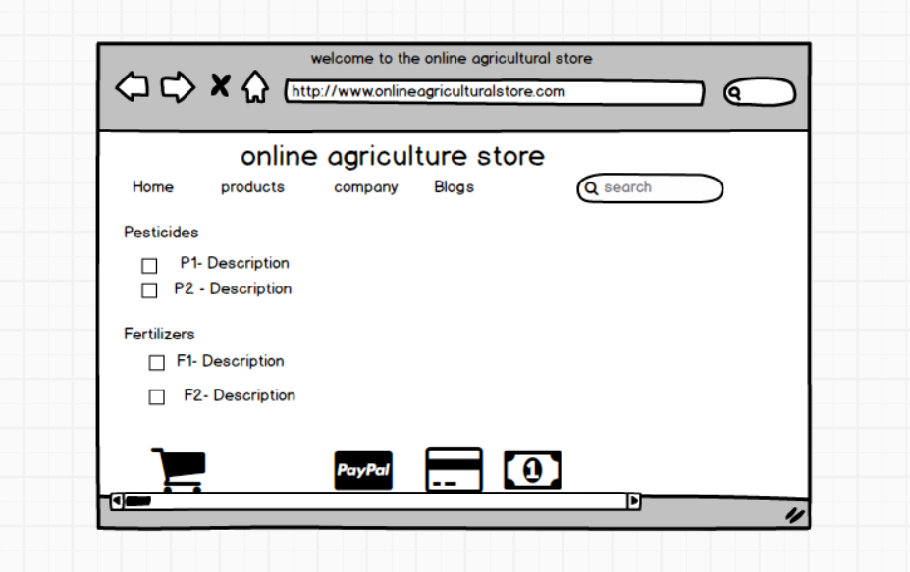

Q-10 Draw use case diagram
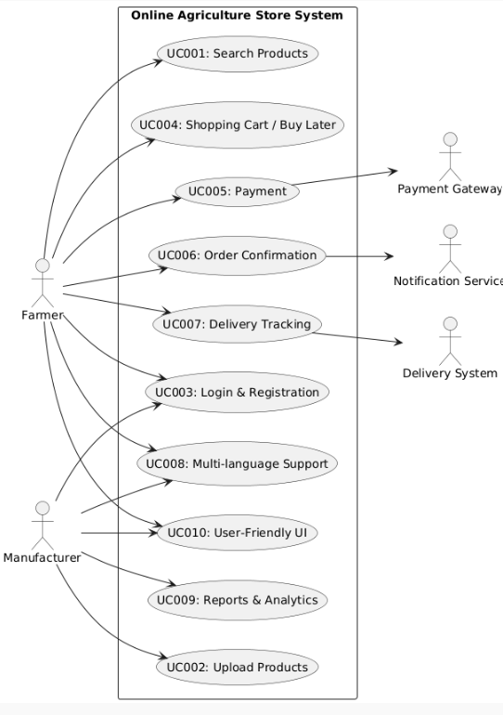

Q-11 Prepare use case specs for all use cases
Use Case ID | Use Case Name | Actors | Preconditions | Trigger | Main Flow | Postconditions | Exceptions
UC001 | Search Products | Farmer | Farmer logged in / on homepage | Farmer wants to search product | 1. Enter keyword → 2. System retrieves → 3. Display results | Products displayed | No products found → Show “No results”
UC002 | Upload Products | Manufacturer | Manufacturer logged in | Upload product | 1. Enter details → 2. Validate → 3. Save & display | Product visible to Farmers | Invalid fields → Error message
UC003 | Login & Registration | Farmer, Manufacturer | User has access | Click Login/Register | 1. Enter credentials → 2. Verify → 3. Access granted | User authenticated | Invalid login → Error
UC004 | Shopping Cart / Buy Later | Farmer | Farmer logged in | Add to cart/buy later | 1. Browse → 2. Add product → 3. Update cart | Cart updated | Out of stock → Notification
UC005 | Payment | Farmer, Payment Gateway | Cart has products, Farmer logged in | Checkout | 1. Select option → 2. Redirect → 3. Confirm → 4. Update order | Order placed | Payment fails → Retry
UC006 | Order Confirmation Notifications | Farmer, Notification Service | Order placed successfully | System updates status | 1. Generate confirmation → 2. Send Email/SMS | Farmer notified | Notification fails → Retry
UC007 | Delivery Tracking | Farmer, Delivery System | Order dispatched | Click “Track Order” | 1. Request tracking info → 2. Show status | Status displayed | No data → “Tracking unavailable”
UC008 | Multi-language Support | Farmer, Manufacturer | User opens app | Select language | 1. User selects language → 2. Reload UI | UI in preferred language | Language unavailable → Default to English
UC009 | Reports & Analytics | Manufacturer | Manufacturer logged in | Select “Reports” | 1. Request report → 2. Generate → 3. Display/download | Reports available | No data → Show “No report”
UC010 | User-Friendly UI | Farmer, Manufacturer | User logged in or visiting | User interacts with UI | 1. Navigate app → 2. System provides simple and intuitive experience | Easy navigation | Complex UI → Feedback loop

Q-12 Activity diagrams

