Document 6- Please prepare a use case diagram, activity diagram and a use case specification document

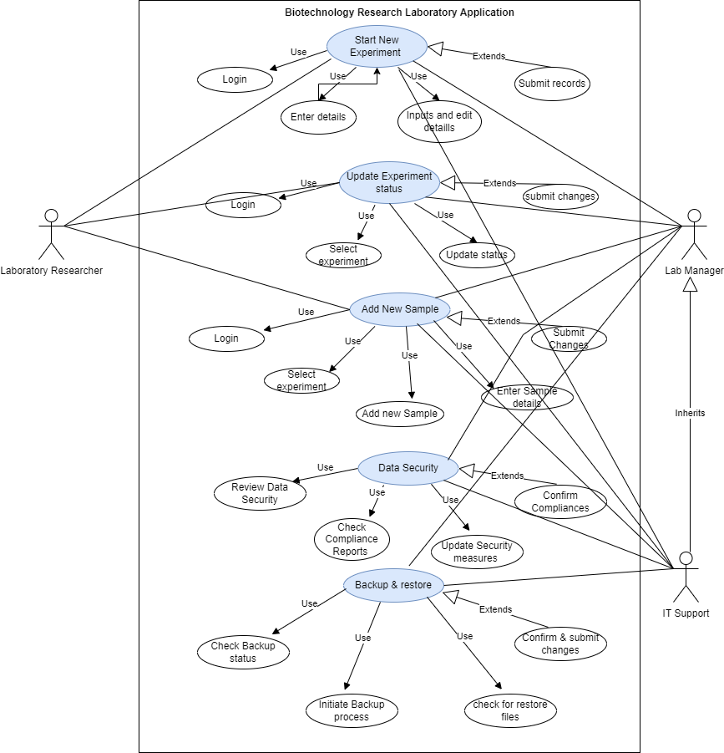

Use Case Specification Document
1. Use Case Name: Start New Experiment
Use Case Description: Allows a laboratory researcher to initiate a new experiment, including setting up necessary parameters and recording initial details.
Actors:
- Primary Actor: Laboratory Researcher
- Secondary Actors: Lab Manager
Basic Flow:
- Researcher logs into the system.
- Researcher selects the option to start a new experiment.
- System prompts researcher to enter experiment details (e.g., name, objectives, start date).
- Researcher inputs required details and submits the form.
- System creates a new experiment record and confirms successful creation.
Alternate Flows:
- If required fields are missing, the system prompts the researcher to complete the information.
Exceptional Flows:
- If the system fails to save the experiment, an error message is displayed, and the researcher is asked to retry.
Pre-Conditions:
- Researcher must be authenticated.
- Required permissions must be granted.
Post-Conditions:
- A new experiment record is created in the system.
Inputs and Outputs:
- Inputs: Experiment details (name, objectives, start date).
- Outputs: Confirmation of experiment creation.

2. Use Case Name: Update Experiment Status
Use Case Description: Enables a researcher to update the status of an ongoing experiment.
Actors:
- Primary Actor: Laboratory Researcher
- Secondary Actors: Lab Manager
Basic Flow:
- Researcher logs into the system.
- Researcher selects the experiment to update.
- System displays current status and options for status updates.
- Researcher selects a new status and provides additional information if needed.
- System updates the experiment status and confirms the change.
Alternate Flows:
- If status cannot be updated due to validation errors, the system alerts the researcher to correct the issue.
Exceptional Flows:
- If the experiment ID is incorrect, the system notifies the researcher to verify the ID.
Pre-Conditions:
- Experiment must be in an updatable state.
Post-Conditions:
- The experiment status is updated in the system.
Inputs and Outputs:
- Inputs: Experiment ID, new status, additional information.
- Outputs: Confirmation of status update.

3. Use Case Name: Track Experiment Progress
Use Case Description: Allows researchers to monitor and track the progress of ongoing experiments.
Actors:
- Primary Actor: Laboratory Researcher
- Secondary Actors: Lab Manager, IT Support
Basic Flow:
- Researcher logs into the system.
- Researcher selects the experiment to track.
- System displays the current progress and status of the experiment.
- Researcher reviews progress and updates status if necessary.
- Researcher generates a progress report if required.
- System produces and displays the report.
Alternate Flows:
- If the experiment is completed, the researcher directly views the final report.
Exceptional Flows:
- If the experiment cannot be found, the system prompts the researcher to check the experiment ID or contact support.
Pre-Conditions:
- The experiment must be registered and in progress.
Post-Conditions:
- Progress report is generated and available.
Inputs and Outputs:
- Inputs: Experiment ID.
- Outputs: Experiment progress information, progress report.

4. Use Case Name: Generate Experiment Report
Use Case Description: Allows users to generate detailed reports on experiments for analysis and documentation.
Actors:
- Primary Actor: Laboratory Researcher
- Secondary Actors: Lab Manager
Basic Flow:
- Researcher logs into the system.
- Researcher selects the option to generate a report.
- System prompts for report parameters (e.g., experiment ID, report type).
- Researcher inputs parameters and requests the report.
- System generates and displays the report.
Alternate Flows:
- If parameters are incomplete or invalid, the system prompts the researcher to correct them.
Exceptional Flows:
- If the report generation fails, an error message is displayed, and the researcher is asked to retry.
Pre-Conditions:
- The experiment data must be complete and up-to-date.
Post-Conditions:
- The report is generated and available for review.
Inputs and Outputs:
- Inputs: Report parameters (experiment ID, report type).
- Outputs: Generated report.

5. Use Case Name: Add New Sample
Use Case Description: Allows researchers to add new samples to the system, including entering sample details.
Actors:
- Primary Actor: Laboratory Researcher
- Secondary Actors: Lab Manager
Basic Flow:
- Researcher logs into the system.
- Researcher selects the option to add a new sample.
- System prompts for sample details (e.g., sample ID, description, associated experiment).
- Researcher inputs sample details and submits the form.
- System records the new sample and confirms successful addition.
Alternate Flows:
- If required fields are missing, the system prompts for completion.
Exceptional Flows:
- If the sample cannot be added due to system errors, an error message is displayed.
Pre-Conditions:
- Researcher must have appropriate permissions.
Post-Conditions:
- New sample is added to the system.
Inputs and Outputs:
- Inputs: Sample details (ID, description, associated experiment).
- Outputs: Confirmation of sample addition.

6. Use Case Name: Schedule Equipment Use
Use Case Description: Allows researchers to schedule the use of laboratory equipment for experiments.
Actors:
- Primary Actor: Laboratory Researcher
- Secondary Actors: Lab Manager
Basic Flow:
- Researcher logs into the system.
- Researcher selects the equipment to schedule.
- System displays equipment availability.
- Researcher selects a time slot and submits the request.
- System schedules the equipment and confirms the reservation.
Alternate Flows:
- If the equipment is unavailable, the system prompts the researcher to select a different time slot.
Exceptional Flows:
- If the scheduling request fails, an error message is displayed.
Pre-Conditions:
- Equipment must be available for scheduling.
Post-Conditions:
- Equipment is scheduled for use.
Inputs and Outputs:
- Inputs: Equipment ID, desired time slot.
- Outputs: Confirmation of equipment reservation.

7. Use Case Name: Ensure Data Security Compliance
Use Case Description: Ensures that the system adheres to data security standards and compliance requirements.
Actors:
- Primary Actor: IT Support
- Secondary Actors: Lab Manager
Basic Flow:
- IT Support logs into the system.
- IT Support reviews data security policies and compliance requirements.
- System is checked for compliance with these standards.
- IT Support updates security measures as needed.
- System confirms compliance status.
Alternate Flows:
- If non-compliance is detected, IT Support initiates corrective actions.
Exceptional Flows:
- If security measures cannot be updated, an error message is displayed.
Pre-Conditions:
- Security policies and compliance requirements must be defined.
Post-Conditions:
- System is compliant with data security standards.
Inputs and Outputs:
- Inputs: Security policies, compliance requirements.
- Outputs: Compliance status report.

8. Use Case Name: Backup and Restore System Data
Use Case Description: Provides functionality to back up and restore system data to prevent data loss.
Actors:
- Primary Actor: IT Support
- Secondary Actors: Lab Manager
Basic Flow:
- IT Support logs into the system.
- IT Support initiates a backup process.
- System creates a backup of all relevant data.
- IT Support confirms backup completion.
- IT Support can restore data from a backup if needed.
Alternate Flows:
- If backup fails, IT Support is notified and retries the process.
Exceptional Flows:
- If data restoration fails, an error message is displayed.
Pre-Conditions:
- Backup and restoration tools must be available.
Post-Conditions:
- Data is backed up and can be restored if needed.
Inputs and Outputs:
- Inputs: Backup request.
- Outputs: Backup confirmation, restored data.

9. Use Case Name: Integrate with Existing Laboratory Systems
Use Case Description: Enables integration with other laboratory systems to ensure seamless data flow and operational efficiency.
Actors:
- Primary Actor: IT Support
- Secondary Actors: Lab Manager
Basic Flow:
- IT Support reviews integration requirements.
- IT Support configures the system to integrate with existing laboratory systems.
- Data flow between systems is tested and verified.
- Integration is confirmed to be working correctly.
Alternate Flows:
- If integration issues are detected, IT Support troubleshoots and resolves the issues.
Exceptional Flows:
- If integration fails, an error message is displayed.
Pre-Conditions:
- Integration requirements must be defined and systems must be compatible.
Post-Conditions:
- Systems are integrated and data flows seamlessly.
Inputs and Outputs:
- Inputs: Integration requirements, system configurations.
- Outputs: Integration confirmation, operational data flow.

10. Use Case Name: Provide User Training
Use Case Description: Facilitates training for users on how to effectively use the system and its features.
Actors:
- Primary Actor: Lab Manager
- Secondary Actors: IT Support
Basic Flow:
- Lab Manager schedules training sessions.
- IT Support prepares training materials and resources.
- Users attend the training sessions.
- Users complete training and are provided with resources for future reference.
Alternate Flows:
- If users need additional training, extra sessions are scheduled.
Exceptional Flows:
- If training materials are missing or incomplete, additional materials are prepared.
Pre-Conditions:
- Training materials must be prepared.
Post-Conditions:
- Users are trained and knowledgeable about the system.
Inputs and Outputs:
- Inputs: Training schedule, materials.
- Outputs: Trained users, feedback on training.

Activity Diagram for UC001 - Register

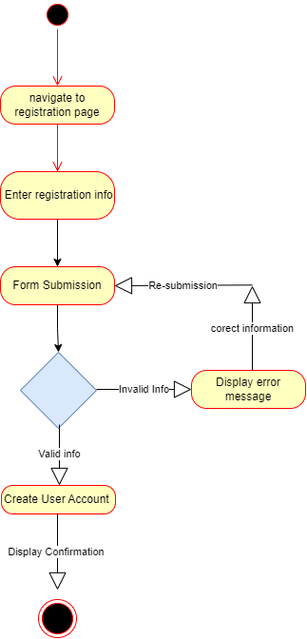

Activity Diagram for UC002 - Login

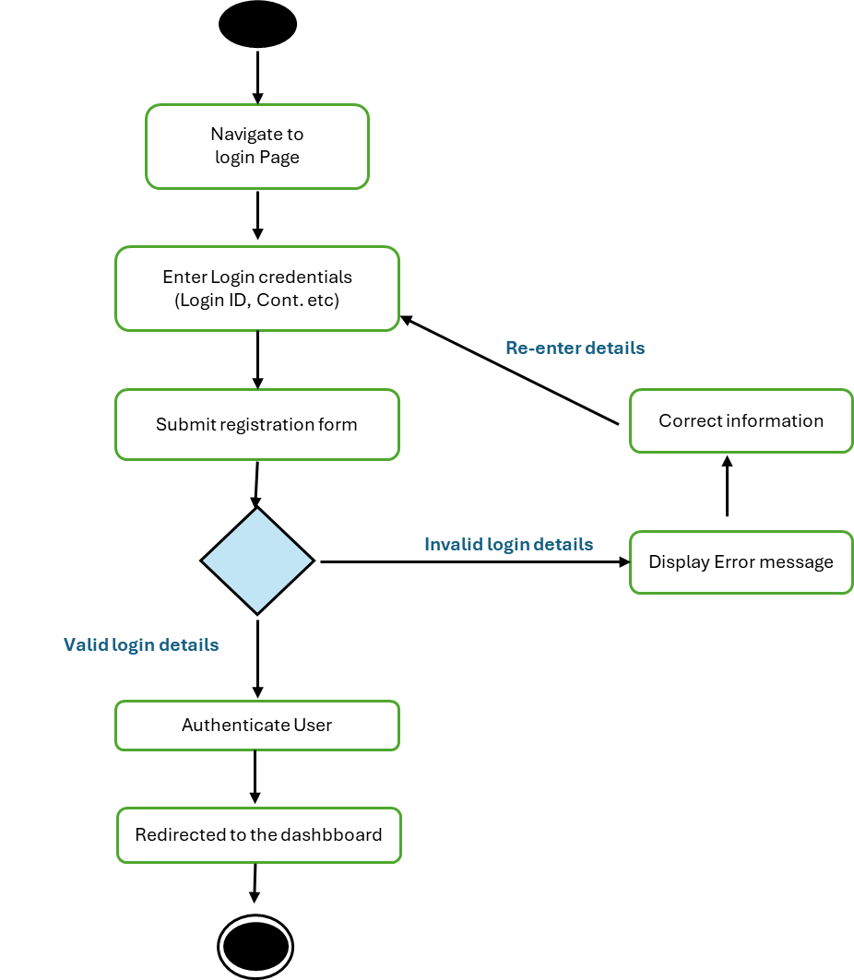

Activity Diagram for UC003 – Enter experiment Details

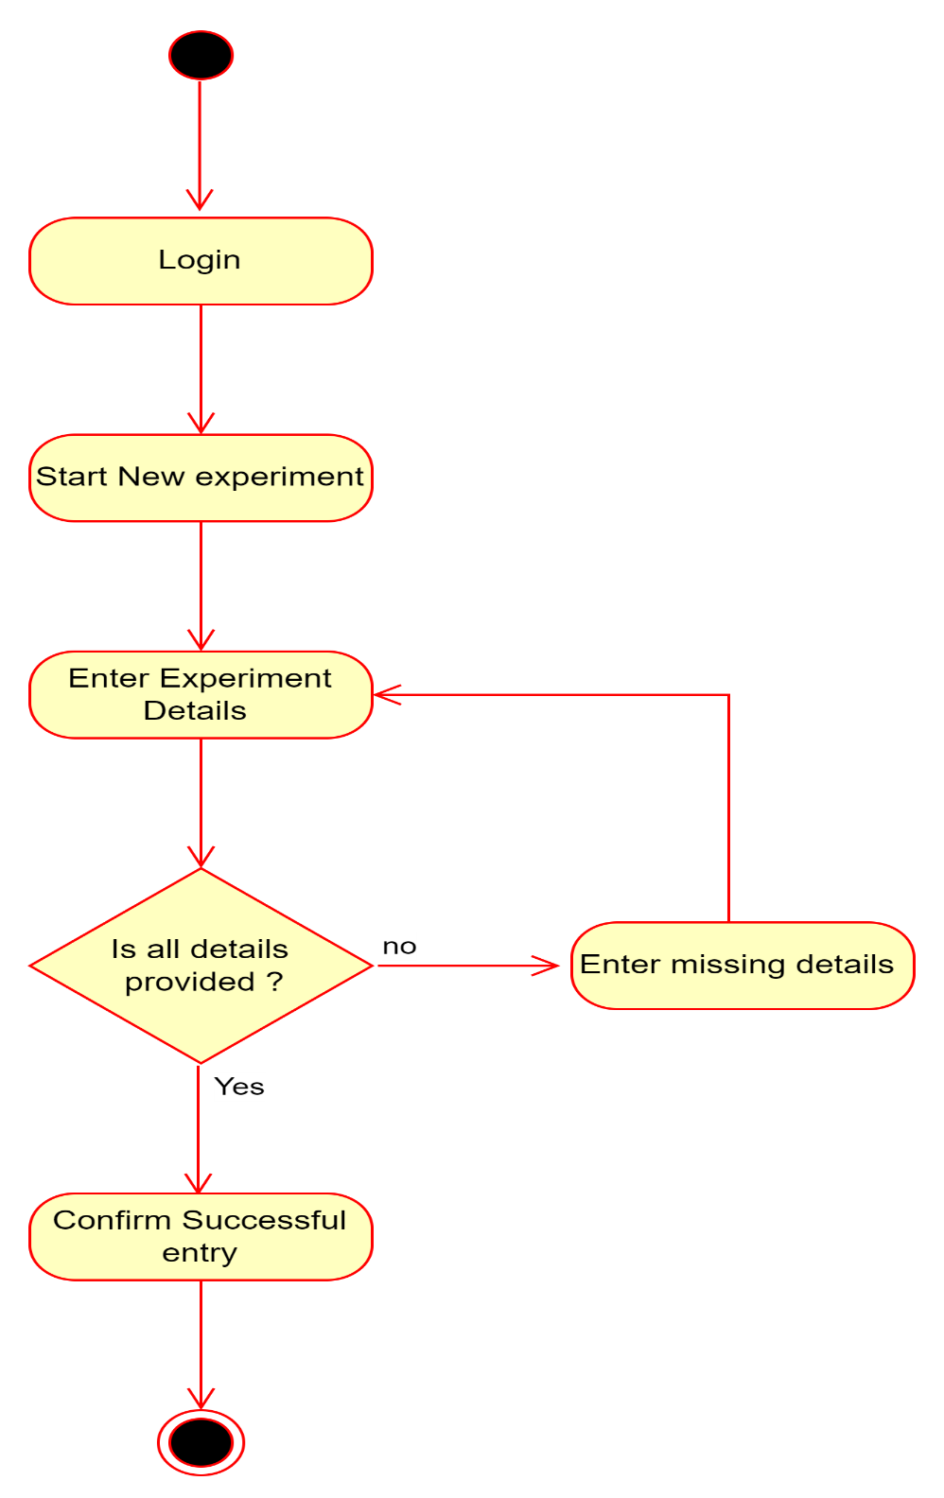

Activity Diagram for UC004 – Display Current Status

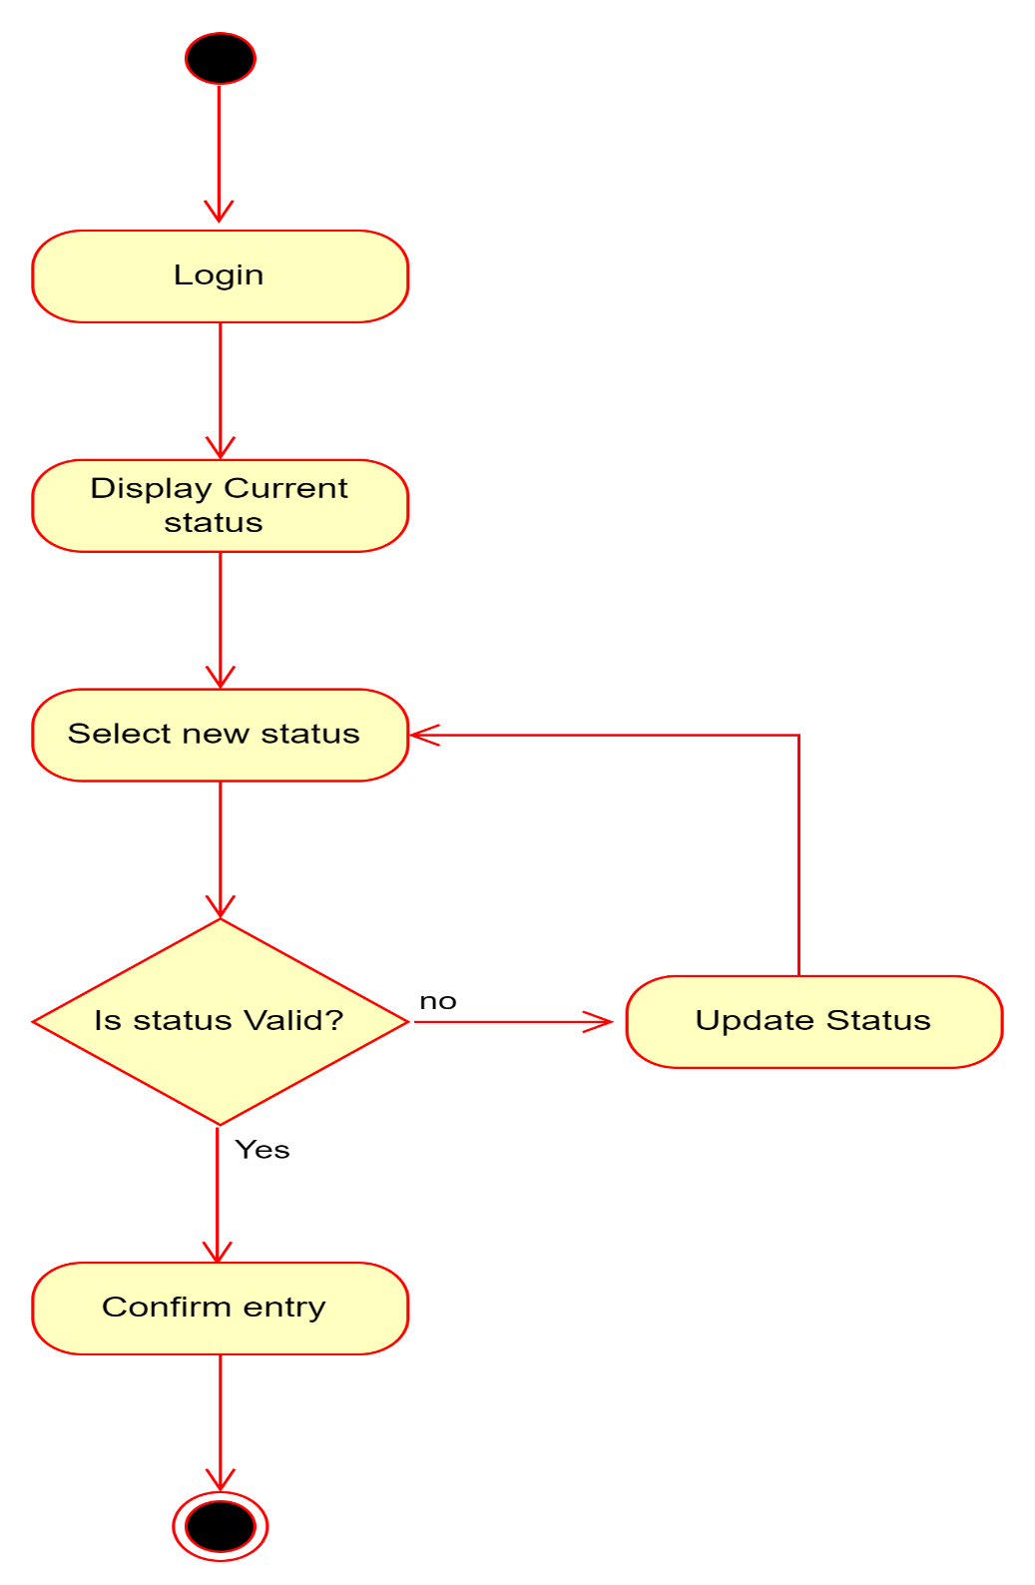

Activity Diagram for UC005 – Search experiment

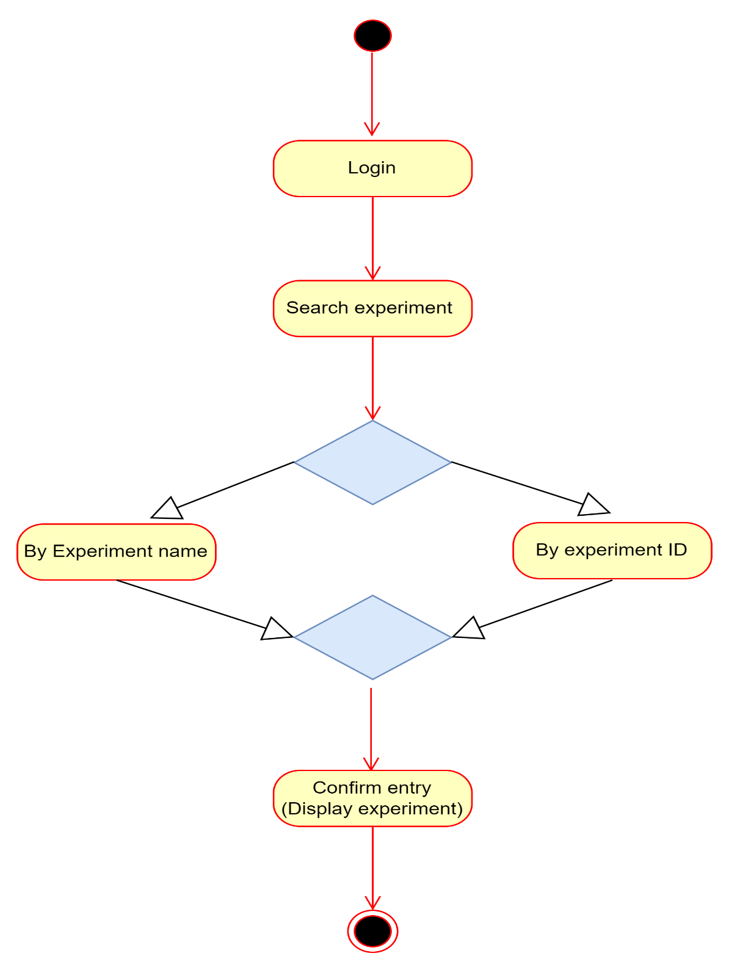

Activity Diagram for UC003 – Track Project Status

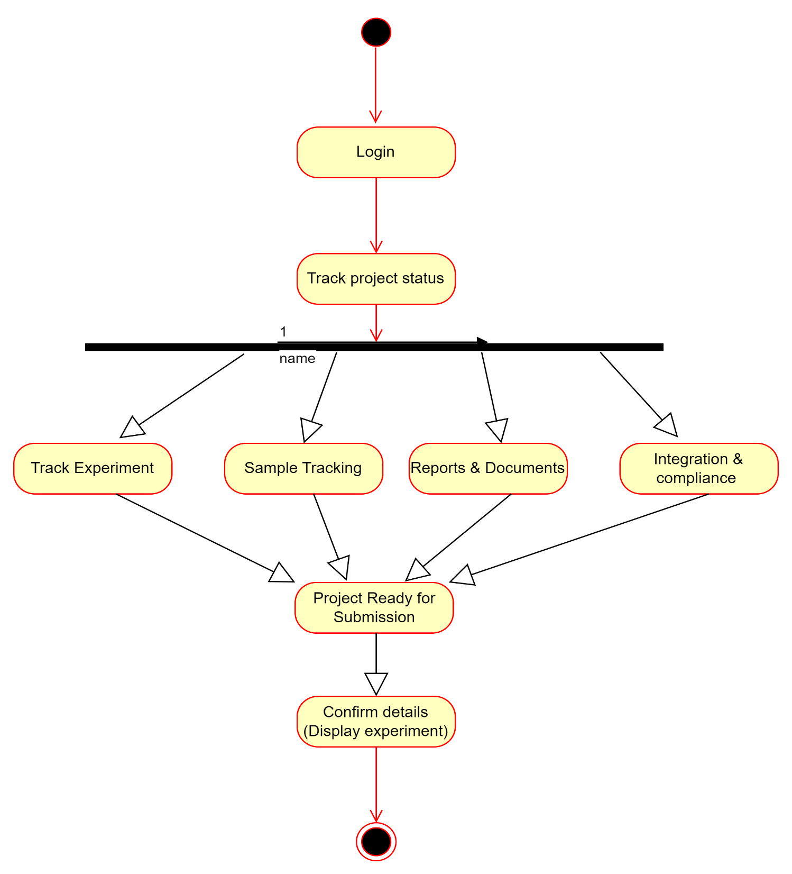

Document 7- Screens and pages

Register Page
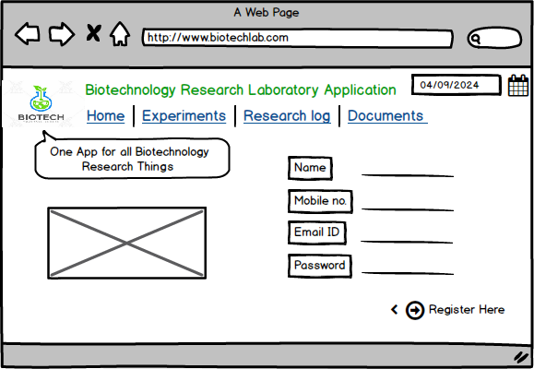

Login Page

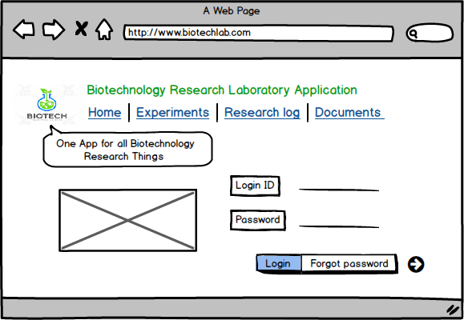

Category Search Page

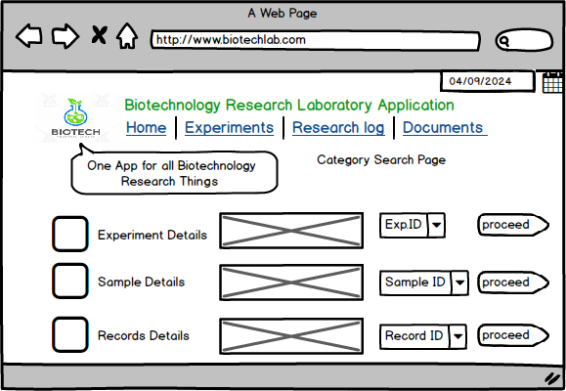

Enter Experiment Detail

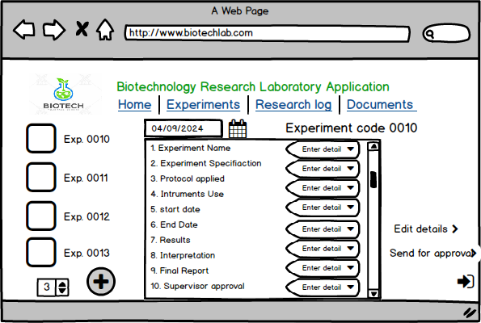

Select and View Experiment details

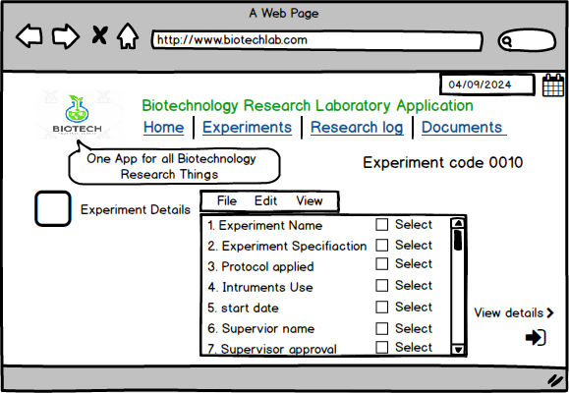

Enter Report Details

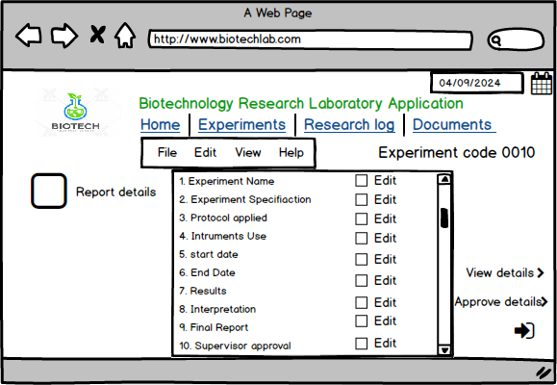

Document 8- Tools-Visio and Axure

In my role as a Business Analyst for the Biotechnology Research Laboratory application, I extensively utilized Microsoft Visio and Axure to enhance various aspects of the project, ensuring clarity and efficiency across multiple phases.
Microsoft Visio
- UML Diagrams: I used Visio to create detailed UML (Unified Modeling Language) diagrams that were essential for mapping out the application's structure and interactions. For example:
  - Class Diagrams: These diagrams represented the key entities such as experiments, samples, chemicals, and equipment, along with their attributes and relationships. This helped in designing the database schema and understanding how different components interacted within the system.
  - Sequence Diagrams: I illustrated the sequence of interactions between users and the system for various scenarios like initiating an experiment or scheduling equipment. This provided a clear view of how processes flow and ensured that all interactions were properly defined and understood.
- Activity Diagrams: I developed activity diagrams to visualize the workflows associated with laboratory processes. For instance:
  - Experiment Tracking: I mapped out the steps involved in tracking an experiment from setup through completion, including sample collection, data entry, and results analysis.
  - Sample Management: These diagrams detailed the lifecycle of samples, including logging, storage, tracking, and disposal, which helped in ensuring that sample handling was efficient and compliant with laboratory standards.
- Flowcharts: Used to depict the decision-making processes and operational procedures in the lab, such as compliance checks and equipment maintenance schedules. These flowcharts helped in simplifying complex processes and ensuring that all steps were documented and followed correctly.
Axure
- Interactive Prototypes: Axure was instrumental in creating interactive prototypes that allowed stakeholders to experience the application's user interface and functionality before development. Key areas included:
  - Experiment Tracking Interface: Developed clickable prototypes that simulated the user experience of tracking experiments, including setting up experiments, entering data, and reviewing results. This helped in gathering feedback on usability and ensuring that the interface met user needs.
  - Sample Management: Created interactive mockups for managing samples, including features for logging new samples, tracking their status, and managing inventory. Stakeholders could interact with these prototypes to validate the functionality and flow of sample management processes.
- Wireframes: I used Axure to design detailed wireframes for various components of the application:
  - Equipment Scheduling: Designed wireframes that depicted the scheduling interface for laboratory equipment, allowing users to book equipment, view availability, and manage schedules. This helped in refining the user experience and ensuring that scheduling functionalities were intuitive.
  - Compliance Management: Developed wireframes for compliance tracking features, including documentation and reporting tools. These wireframes ensured that compliance requirements were addressed effectively and that the application provided the necessary tools for regulatory adherence.
- Dynamic Content: Leveraged Axure’s capabilities to include dynamic content and interactions in the prototypes, such as:
  - Conditional Logic: Incorporated conditional interactions to simulate real-world scenarios, such as varying responses based on user inputs or data conditions. This was crucial for validating complex workflows and ensuring that the application handled different scenarios correctly.
  - Data Interactions: Created prototypes that demonstrated how the application would interact with data, such as querying sample information or generating reports. This provided a realistic view of how data would be managed and accessed within the system.
By integrating Visio and Axure into the project, I ensured that every aspect of the Biotechnology Research Laboratory application was thoroughly documented and validated. Visio’s diagrams provided a clear, visual representation of system requirements and processes, while Axure’s interactive prototypes enabled effective user engagement and feedback, leading to a well-designed and functional application.

Document 9- BA experience
My experience as BA in following phases:

1. Requirement Gathering
- MOSCOW Technique: I applied the MOSCOW (Must have, Should have, Could have, Won't have) technique to prioritize and categorize the requirements for the Biotechnology Research Laboratory application. This approach helped ensure that critical functionalities such as experiment tracking and sample management were given top priority.
- Client Availability: During periods when the client was unavailable, I proactively identified alternative points of contact from their team to gather essential information and keep the project on track.
- FURPS Technique: I utilized the FURPS (Functionality, Usability, Reliability, Performance, Supportability) technique to validate requirements, ensuring that the application would comprehensively address all functional and non-functional needs, including data security and compliance.
- Duplicate Requirements: I identified and eliminated duplicated or redundant requirements to streamline the requirements list, which helped in maintaining clarity and focus on the unique needs of the laboratory.
- Prototyping: I developed prototypes to provide stakeholders with visual representations of the application’s features, facilitating more precise and specific requirements.
2. Requirement Analysis
- UML Diagrams: I created UML (Unified Modeling Language) diagrams, including class and sequence diagrams, to visually represent the requirements for managing laboratory experiments, samples, and equipment.
- Activity Diagrams: I developed activity diagrams to illustrate the process flows within the laboratory, such as experiment tracking and equipment scheduling, which helped in understanding how different processes interact.
- Team Communication: I communicated the diagrams and requirements to the team, addressing any disagreements or feedback from team members and making necessary modifications to ensure alignment and accuracy.
- BRS and SRS: I prepared the Business Requirements Specification (BRS) and System Requirements Specification (SRS) documents to formalize and communicate the detailed requirements of the laboratory.
3. Design
- Use Case Diagrams: I derived test cases from use case diagrams to ensure that all functionalities related to experiment tracking, sample management, and compliance were thoroughly covered.
- Client Communication: I reviewed and discussed the design and solution documents with laboratory stakeholders to confirm that the design met their needs and expectations.
- Test Cases: I created both positive and negative test cases to thoroughly validate the application’s features, ensuring robustness and reliability.
- Test Data Preparation: I organized and prepared test data to simulate real laboratory conditions, which was crucial for accurate and effective testing.
- RTM Updates: I updated the Requirements Traceability Matrix (RTM) to ensure that all laboratory-specific requirements were being addressed and tested as planned.
4. Development
- JAD Sessions: I organized Joint Application Development (JAD) sessions with laboratory staff and the technical team to align on the application’s features and ensure they supported laboratory operations effectively.
- Query Clarification: I addressed and clarified queries from the technical team during the coding phase to ensure accurate implementation of features like sample management and equipment scheduling.
- Team Cooperation: I managed situations where team members were reluctant or uncooperative by holding one-on-one discussions, explaining the impact of their actions on the project, and fostering a collaborative environment.
- Diagram Reference: I referred to design diagrams to guide the development of key features, ensuring that the system was built according to the specified requirements.
- Regular Meetings: I conducted regular meetings with both the technical team and laboratory stakeholders, handling challenges such as team member availability by recording sessions and providing updates to those who missed the meetings.
5. Testing
- Test Case Preparation: I developed test cases based on laboratory use cases to ensure comprehensive testing of all application functionalities.
- High-Level Testing: I performed high-level testing to validate the application’s overall performance and functionality, including critical aspects such as data security and compliance.
- Test Data Requests: I coordinated with laboratory staff to obtain the necessary test data, ensuring that the application was tested under realistic and relevant conditions.
- RTM Updates: I continued to update the RTM to track the status of requirement fulfillment throughout the testing phase.
- Client Signoff: I obtained formal signoff from laboratory stakeholders, confirming that the application met their requirements and was ready for deployment.
- UAT Preparation: I prepared laboratory staff for User Acceptance Testing (UAT), providing guidance on how to evaluate the application’s functionality and ensure it met their operational needs.
6. Deployment
- RTM Documentation: I forwarded the RTM to the client as part of the project closure documentation, ensuring that all requirements were met and documented.
- End User Manuals: I coordinated the creation and distribution of end user manuals tailored to the laboratory’s operational processes and application features.
- Training Sessions: I planned and organized training sessions for laboratory staff, ensuring that all users were effectively trained on the new system.
- Attendance Assurance: I ensured that all designated laboratory staff attended the training sessions, addressing any scheduling conflicts to maximize participation and training effectiveness.

