Capstone project 3.1
A customer can make a payment either by Card or by Wallet or by Cash or by Net banking.
Q1. Draw a Use Case Diagram?
A.1: The Below diagram shows that the customer interacts with the main "Make Payment" use case, which then extends to the four specific payment methods.
1. Actor (Customer and Admin):
The customer initiates the payment process and Admin Approves at back end.
2. Primary Use Case (Make Payment):
This represents the overarching functionality for processing a payment.
3. Extend Relationships:
The Make Payment use case is extended by the four payment modes:

- Pay by Card: The customer selects this option to process payment using a credit/debit card.
- Pay by Wallet: The customer selects this option to process payment via a digital wallet (Paytm, PhonePe, Gpay).
- Pay by Cash: The customer selects this option for cash on delivery.
- Pay by Net Banking: The customer selects this option to process payment through net banki q2ng by redirecting to the bank’s portal.
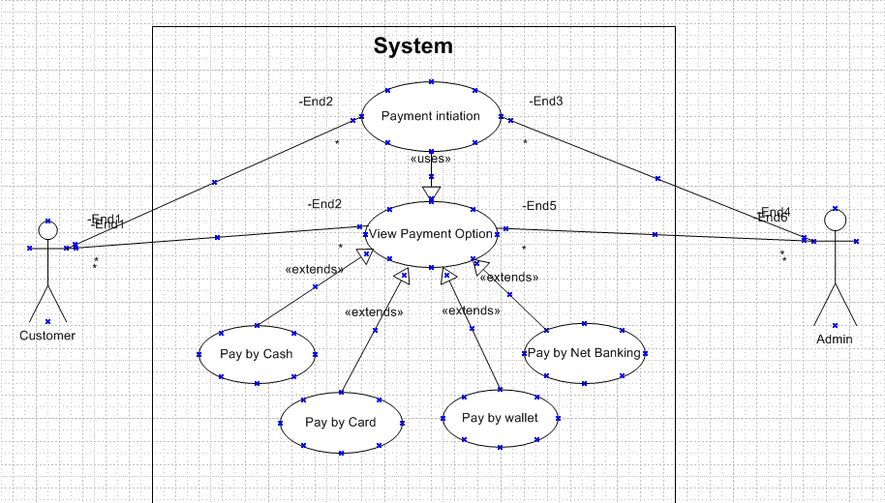

Q2. Derive Boundary Classes, Controller classes, Entity Classes?
A3. Boundary Classes: These represent interfaces between the system and external actors (users).
Boundary Class | Description
PaymentoptionBoundary | UI page where the customer chooses payment method.
CardPaymentBoundary | Form to enter card details.
WalletPaymentBoundary | Form to choose and authenticate wallet.
CashPaymentBoundary | UI to confirm Cash on Delivery option.
NetBankingPaymentBoundary | Form to select bank and enter credentials.
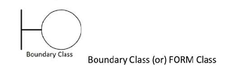
2. Controller Classes (Logic/Processing Layer): These handle inputs from UI, coordinate between boundary and entity classes.
Controller Class | Responsibility
PaymentinitiatedController | Manages the overall payment workflow.
CardPaymentController | Validates card, initiates payment transaction.
WalletPaymentController | Validates wallet, authenticates user, initiates transfer.
CashPaymentController | Confirms Cash on Delivery logic.
NetBankingPaymentController | Coordinates with selected bank gateway.
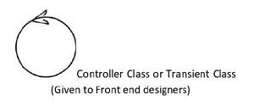
3. Entity Classes (Data/Model Layer): These represent business data and persistent entities.
Entity Class | Description
Customer | Contains customer details (name, address, etc.).
Payment | Holds payment ID, amount, status, method.
Card | Stores card number, expiry, CVV (securely).
Wallet | Contains wallet type, balance.
BankAccount | Bank account number, IFSC, account holder.
Transaction | Payment transaction record, status, timestamp.
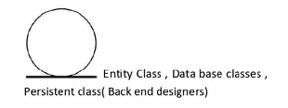

Q3. Place these classes on a three tier Architecture?
A3. Let’s place the identified classes into a Three-Tier Architecture (Presentation Tier, Application/Logic Tier, Data Tier):
- Presentation Tier: Boundary Class
- PaymentoptionBoundary
- CardPaymentBoundary
- WalletPaymentBoundary
- CashPaymentBoundary
- NetBankingPaymentBoundary

- Application/Logic Tier: Controller Class
- PaymentinitiatedController
- CardPaymentController
- WalletPaymentController
- CashPaymentController
- NetBankingPaymentController

- Data Tier: Entity Class
- Customer
- Payment
- Card
- Wallet
- BankAccount
- Transaction

Q4. Explain Domain Model for Customer making payment through Net Banking?
A4. A Domain Model is a visual representation of real-world entities (objects) and their relationships within a business process. It helps in understanding system requirements before design or coding begins. In this scenario, the domain model captures the entities and relationships involved when a customer makes a payment using Net Banking.

- Customer initiates a Payment through Net Banking Services.
- The customer’s Account is linked with a Bank.
- Authentication verifies the identity.
- Once approved, the Transaction is generated and logged.

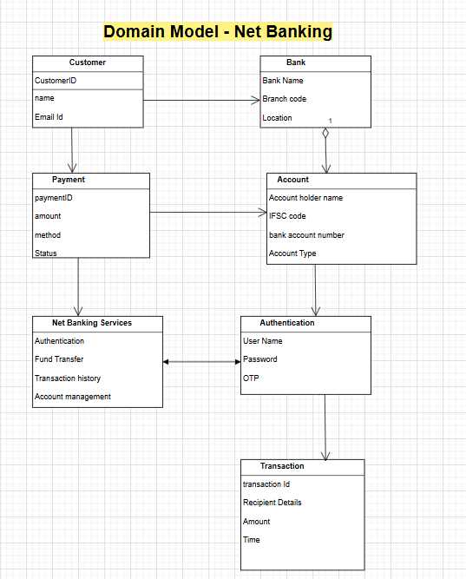

Q5. Draw a sequence diagram for payment done by Customer Net Banking?

A5.

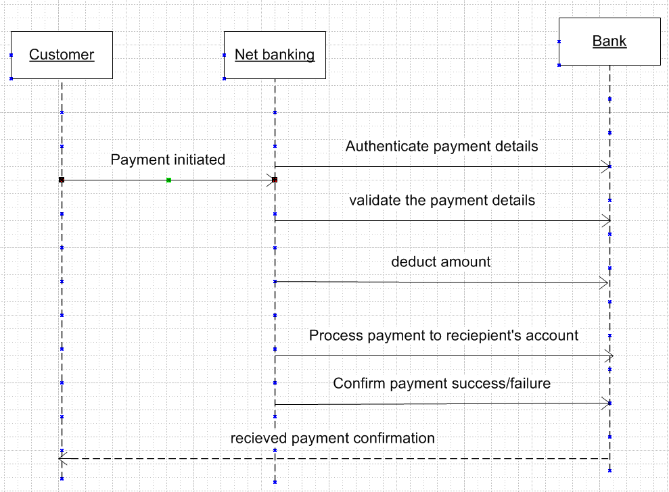

Q6. Explain Conceptual Model for this Case?
A6. A Conceptual Model represents the high-level structure of the system in terms of real-world entities, their attributes, and relationships without getting into technical implementation. It is platform-independent and often visualized as a Class Diagram (simplified version).

“In the conceptual model for Net Banking Payment, we identify the key real-world elements. A Customer initiates a Payment, which includes details like amount and status. Before payment goes through, the customer must authenticate—so we use an authentication entity with things like username and OTP. This is verified using the Net Banking Service, which connects to the bank. The actual money is debited from the Customer’s Bank Account, and once the payment is successful, a Transaction record is created. All of this is at a high level, without worrying about the system’s technical details.”

Q7. What is MVC architecture? Explain MVC rules to derive classes from use case diagram and guidelines to place classes in 3-tier architecture?

A7. MVC (Model-View-Controller) is a software design pattern used to separate the application logic into three interconnected components:

MVC Architecture: To identify Classes from use case Diagram, we apply MVC rules on each use case to derive Classes.

1) Model:
The model class knows about all the data that need to be displayed. It is the model who is aware about all the operations that can be applied to transform that class. It only represents the data of an application. The model represents enterprise data and the business rules that govern access to and updates of this data. This represents Database (Tables in DB). All Model Classes are represented as Entity Classes.

2) View:
The view represents the presentation of the application. The view class refers to the model. It uses the query methods of the model to obtain the contents and renders it. The view is not dependent on the application logic. It remains same if there is any modification in the business logic. View Class is the data required by the query. View Class is represented as Boundary Class or Form Class.

3) Controller:
Whenever the user sends a request for something then it always goes through the controller. The controller is responsible for intercepting the requests from view and passes it to the model for the appropriate action. After the action has been taken on the data, the controller is responsible for directing the appropriate view to the user. In GUIs, the views and the controllers often work very closely together.

The Controller class is working based on the user's command. It understands the command/request given by user through boundary/form class.

MVC Architecture Rules
- Combination of One Actor and one-use case results in one Boundary class
- Combination of Two Actors and one-use case results in two Boundary classes
- Combination of Three Actors and one-use case results in three Boundary classes and so on…
Note: Only one primary actor is to be considered with a use case
- Use case will result in a controller class
- Each Actor will result in one entity class
- Placing Classes in 3-Tier Architecture
3-Tier Layer | What It Contains | MVC Classes Mapped | Examples
Presentation Layer | UI components | Boundary (View) | LoginForm, PaymentPage
Business Logic Layer | Application flow and coordination | Controller | PaymentController, AuthHandler
Data Access Layer | Data storage and retrieval | Entity (Model) | Customer, Transaction, Account

Q8. Explain BA contributions in project (Waterfall Model – all Stages)?
A8. The Waterfall model is one of the traditional approaches to software development. The project flows in a sequential manner from one phase to the next where Each phase must be completed before next phase.
1. Requirement Gathering & Analysis
- BA’s Role:
  - Interacts with stakeholders, users, and customers to gather business needs.
  - Conducts interviews, workshops, surveys.
  - Prepares detailed Business Requirement Document (BRD) or SRS (Software Requirement Specification).
  - Validates and gets approvals on requirements.
Contribution: Ensures the project starts with clear, complete, and agreed-upon requirements.

2. System Design
- BA’s Role:
  - Supports system architects/designers by clarifying functional and non-functional requirements.
  - Provides use case models, process flows, mockups, and business rules.
  - Participates in design reviews to ensure alignment with business needs.
Contribution: Helps translate business needs into technical system designs.

🔹 3. Implementation (Coding)
- BA’s Role:
  - Acts as a bridge between development and business teams.
  - Clarifies doubts developers have about requirements.
  - Ensures the functionality being built is aligned with user needs.
Contribution: Reduces miscommunication, saves rework time by being available for quick clarifications.

🔹 4. Testing
- BA’s Role:
  - Helps QA team prepare test cases, test data, and scenarios based on requirements.
  - Performs User Acceptance Testing (UAT) with business users.
  - Validates that system meets the business needs.
Contribution: Ensures system behaves as expected and is ready for business use.

5. Deployment
- BA’s Role:
  - Supports in preparing user guides, release notes, and training documents.
  - Coordinates with stakeholders to ensure smooth transition to production.
  - Provides support in rollout communication.
Contribution: Ensures stakeholders are trained and system is accepted by end users.

6. Maintenance
- BA’s Role:
  - Gathers feedback and identifies enhancements or issues.
  - Logs change requests or defect reports.
  - Works on impact analysis for future updates.
Contribution: Maintains ongoing alignment of the system with business goals.

Q9. What is conflict management? Explain using Thomas – Kilmann technique?
A9. Conflict Management is the process of identifying and handling conflicts in a constructive and efficient way. It aims to resolve disagreements between individuals or teams while maintaining positive relationships and ensuring project or organizational goals are not negatively impacted.

Thomas–Kilmann Conflict Management Technique
The Thomas–Kilmann Conflict Mode Instrument (TKI) is a popular model that helps people understand how they handle conflict. It is based on two dimensions:
- Assertiveness – how strongly you try to satisfy your own needs.
- Cooperativeness – how strongly you try to satisfy the other person's needs.
Based on these, there are five conflict management styles:

1. Competing (High Assertiveness, Low Cooperativeness)
- "I win; you lose" approach
- Used when quick, decisive action is needed (e.g., emergencies).
- Can be forceful and may harm relationships.
Example: A manager enforces a rule despite employee disagreement.

2. Avoiding (Low Assertiveness, Low Cooperativeness)
- "Ignore the conflict" approach
- Used when the issue is minor or when more information is needed.
- Risk: Problem may escalate if ignored too long.
Example: Avoiding confrontation between team members over a small misunderstanding.

3. Accommodating (Low Assertiveness, High Cooperativeness)
- "You win; I lose" approach
- Used when preserving relationships is more important than the issue itself.
- Can lead to being taken advantage of if overused.
Example: Letting your colleague choose the project tool even if you disagree.

4. Compromising (Medium Assertiveness, Medium Cooperativeness)
- "Win some, lose some" approach
- Each party gives up something to reach a middle ground.
- Useful when both parties have equal power and time is limited.
Example: Agreeing to split work 50/50 even if one prefers a different division.

5. Collaborating (High Assertiveness, High Cooperativeness)
- "Win-win" approach
- Best for long-term relationships and solving complex problems.
- Requires open communication and mutual respect.
Example: Two departments working together to create a solution that benefits both.
Summary Table
Style | Assertiveness | Cooperativeness | Goal
Competing | High | Low | Win
Avoiding | Low | Low | Delay or withdraw
Accommodating | Low | High | Yield
Compromising | Medium | Medium | Middle Ground
Collaborating | High | High | Win-Win Solution

Q10. List down the reasons for project failure?
Projects can fail for several reasons. Below are the most common and critical reasons for project failure across industries:
1. Unclear or Incomplete Requirements
- Requirements are not properly gathered, documented, or understood.
- Leads to rework, scope creep, or delivery of the wrong product.

2. Lack of Stakeholder Involvement
- Stakeholders are not actively engaged or consulted.
- Leads to mismatched expectations and dissatisfaction with the final product.

3. Poor Communication
- Gaps between business, development, and testing teams.
- Misunderstandings cause delays, bugs, and incorrect functionality.

4. Scope Creep
- Uncontrolled changes or continuous additions to project scope.
- Increases budget, timeline, and team pressure without proper planning.

5. Inadequate Planning
- Poor project scheduling, unclear roles, or weak risk assessment.
- Causes confusion, resource conflicts, and deadline overruns.

6. Lack of Skilled Resources
- Insufficient or underqualified team members.
- Affects quality, productivity, and innovation.

7. Unrealistic Timelines and Budgets
- Projects are set up for failure when constraints are not feasible.
- Results in pressure, burnout, or incomplete deliveries.

8. Weak Risk Management
- No proactive identification or mitigation of risks.
- Leads to surprises during execution (e.g., technical issues, vendor delays).
9. Ineffective Leadership or Governance
- Project managers or sponsors fail to provide direction or support.
- Leads to lack of accountability and decision-making bottlenecks.

10. Lack of User Acceptance
- Final product does not meet user needs or is difficult to use.
- Users reject the system after deployment.
Q11. List the Challenges faced in projects for BA?
A11. Business Analysts (BAs) play a critical role in bridging the gap between business and technical teams. However, they often face several challenges during the project lifecycle. Here are the key challenges:

1. Unclear or Changing Requirements
- Stakeholders may not know exactly what they want.
- Requirements keep changing due to evolving business needs.
- Difficult to maintain a stable scope.

2. Lack of Stakeholder Engagement
- Stakeholders may not be available for timely input or approvals.
- Leads to delays and misunderstandings.

3. Communication Gaps
- Miscommunication between business users and technical teams.
- Leads to incorrect interpretations or missed requirements.

4. Managing Conflicting Stakeholder Interests
- Different stakeholders have different (sometimes opposite) goals.
- BA must balance and prioritize needs diplomatically.

5. Time Constraints
- Limited time for requirement gathering and analysis.
- Impacts the quality of documentation and understanding.

6. Technical Constraints or Limitations
- Business expectations may not be feasible due to system limitations.
- BA must translate business needs into practical solutions within constraints.

7. Scope Creep
- Continuous addition of new features outside the agreed scope.
- Difficult for BA to manage expectations and timeline.

8. Lack of Domain Knowledge
- If the BA is new to the domain, understanding complex business processes becomes challenging.
- Requires additional time and effort to gain subject matter expertise.

Q12. Write about Document Naming Standards?
A12. Document Naming Standards are predefined rules used to name project-related documents consistently. They help in easy identification, version tracking, searchability, and maintaining professionalism in project documentation.

General Structure of a Naming Standard:
- [ProjectName]_[DocumentType]_[Author/Team]_[Version]_[Date]

Ex: AgriStore_BRD_BA_v1.0_20250604.docx

Q13. What are the Do’s and Don’ts of a Business analyst?
A13. Below are the key Do’s and Don’ts that ensure effective analysis and communication:

Do’s of a Business Analyst
- Listen Actively
– Understand stakeholder needs clearly before documenting.
- Ask the Right Questions
– Use open-ended questions to uncover hidden or implicit requirements.
- Document Requirements Clearly
– Ensure all requirements are detailed, unambiguous, and approved.
- Facilitate Communication
– Act as a bridge between business users and the technical team.
- Perform Requirement Validation
– Regularly validate with stakeholders to ensure alignment with business goals.
- Adapt to Change
– Be flexible and ready to accommodate changing business priorities.

Don’ts of a Business Analyst
- Don’t Make Assumptions
– Always clarify unclear points; assumptions may lead to incorrect solutions.
- Don’t Ignore Stakeholders
– Engage all relevant stakeholders, not just primary ones.
- Don’t Use Technical Jargon with Business Users
– Communicate in simple business language to avoid confusion.
- Don’t Skip Documentation
– Verbal agreements can lead to scope disputes; documentation is crucial.
- Don’t Delay Feedback Cycles
– Get early and continuous feedback to avoid rework later.
- Don’t Be Biased
– Remain neutral; analyze facts rather than personal opinions or preferences.

Q14. Write the difference between packages and sub-systems?
A14. Packages: are used to organize related model elements logically, mainly for readability.
Sub-systems: are higher-level components that represent independent, functional parts of a system with defined interfaces.”

Difference Between Packages and Sub-systems are following:
Aspect | Packages | Sub-systems
Definition | Logical grouping of related classes or elements | A system or component that performs a specific major task
Purpose | Organizes large models for readability and structure | Represents a self-contained module with defined behaviour
Used In | UML class diagrams, use case models | UML component or deployment diagrams
Visibility | Mostly for code/model organization | Defines interfaces and interactions with other systems
Example | com.user.payment, com.bank.account | Inventory Management, Payment Gateway
Level | Lower-level, used mainly by developers and designers | Higher-level, represents a system’s major logical parts

Q15. What is camel-casing and explain where it will be used?
A15. Camel casing is a naming style where the first word is in lowercase and each new word begins with a capital letter. It is used in programming, API design, and UML modelling for naming variables, methods, and objects to improve readability and maintain consistency.
camelCase is for variables and functions
1. Programming Languages:
- Used for naming variables, functions, methods, and objects in Java, JavaScript, Swift, etc.
- Example: calculateTotalAmount(), userId
2. API/JSON Naming:
  - Used in RESTful APIs and JSON responses for property keys.
  - Example: { "firstName": "Suman", "lastName": "Samaiya" }
3. Naming Conventions in UML/Modelling:
  - In UML class diagrams, attribute and method names often use camelCase.
4. Coding Guidelines and Style Guides:
  - Many organizations and platforms recommend camelCase for consistency and readability.
Q16. Illustrate Development server and what are the accesses does business analyst has?
A16. A Development Server is an environment where software developers build, test, and integrate code before it moves to testing or production.
It is:
- Used internally by the dev team.
- Not accessible to end users.
- Contains unstable or in-progress features.
Qde3ed3
Purpose of Development Server:
- Test new code changes.
- Integrate features and fix bugs.
- Collaborate on modules under development.
- Run early unit and integration tests.

Business Analyst’s (BA) Access on Development Server:
A BA does not usually develop code, but can have limited or read-only access for the following tasks:

Access Type | Purpose for BA
Read-only access to UI | Review and verify if UI matches requirements
Access to Logs (optional) | Help identify business rule errors during testing
Database Read Access | View data entries and structure for analysis (optional)
Issue/Bug Tracker | Raise issues or confirm fixes in early stages
No Code Access | BA does not change code – only observes or reports
Access to API Endpoints | Test or review API outputs if applicable

Q17. What is Data Mapping?
A17. Data Mapping is the process of matching fields from one data source to another. It is used when transferring, integrating, or transforming data between systems or formats.

- Ensures accurate data transfer between systems (e.g., during migration or integration).
- Helps maintain data consistency and correctness.
- Used in ETL (Extract, Transform, Load), system integration, reporting, and database migrations.
- Where It Is Used:
Scenario | Example
Data Migration | Mapping old system field Cust_Name to new system field CustomerFullName
API Integration | Mapping frontend form field emailID to backend field email_address
Reporting and BI Tools | Mapping sales data fields from Excel to a Tableau dashboard
ERP/CRM Integration | Mapping OrderID in SAP to SalesOrderID in Salesforce

- Who uses: Data mapping is used by BAs, data engineers, developers, and testers during data integration, migration, or reporting to ensure data flows correctly between systems and satisfies business needs.

- Main Purposes of Data Mapping
1. Data Migration: Move data from one system to another (e.g., from legacy to modern system).
2. Data Integration: Combine data from different systems (e.g., CRM + ERP).
3. Data Transformation: Convert data formats, units, or values to fit the target system.
4. Ensuring Data Accuracy and Consistency: Prevents data mismatches, loss, or duplication during transfer.
5. Enabling Business Intelligence and Reporting: Map raw data to reporting fields
6. Regulatory and Compliance Needs: Helps ensure that personal and sensitive data is transferred or integrated according to privacy laws (e.g., GDPR, HIPAA).

Q18. What is API. Explain how you would use API integration in the case of your application Date format is dd-mm-yyyy and it is accepting some data from Other Application from US whose Date Format is mm-dd-yyyy?

A18. An API is Application Programming Interfaced which is a set of rules and protocols that allows one software system to communicate with another. It acts like a messenger between two systems, helping them exchange data and services.

Key Features of an API:
- Enables data sharing across applications.
- Promotes reusability and modularity.
- Can be REST, SOAP, GraphQL, etc.
- Uses common formats like JSON or XML.

Scenario: Date Format Conflict Between Systems
Problem:
- Your application expects dates in dd-mm-yyyy format.
- A US-based external system sends dates in mm-dd-yyyy format via API.
- Direct integration would result in incorrect or invalid dates (e.g., 03-08-2025 could be Aug 3 or Mar 8).

API Integration Solution:
Step-by-Step Approach:
Step | Description
1. API Request Received | system receives data via API in mm-dd-yyyy format. Example: 08-03-2025 (Aug 3).
2. Input Validation | Check if the incoming date is in the expected format using validation logic.
3. Data Transformation Layer (Middleware) | Convert the incoming date format to dd-mm-yyyy using a date formatter in the backend.
4. Save in Correct Format | After transformation, save 03-08-2025 to the database.
5. Send Response | If needed, convert the date back to the original format for response or logs.

Actors/Objects:
- ClientApp (US System)
- API Gateway (Your app's API entry point)
- DateParserService (Middleware to convert date)
- Database (Stores the correct format)

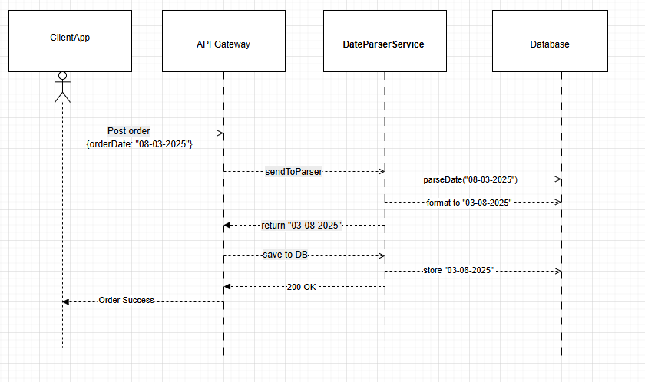

Explanation of Each Step:
- ClientApp sends order data using US format (mm-dd-yyyy).
- API Gateway receives the request and forwards the date to a transformation service.
- DateParserService parses and reformats the date.
- The correct format (dd-mm-yyyy) is returned to the API Gateway.
- API Gateway stores the correct date in the Database.
- A success response is returned to the US system.

