Case Study 1 (Q1-Q6 24 Marks)
A customer can make a payment either by Card or by Wallet or by Cash or by Net banking.
Q1. Draw a Use Case Diagram - 4 Marks
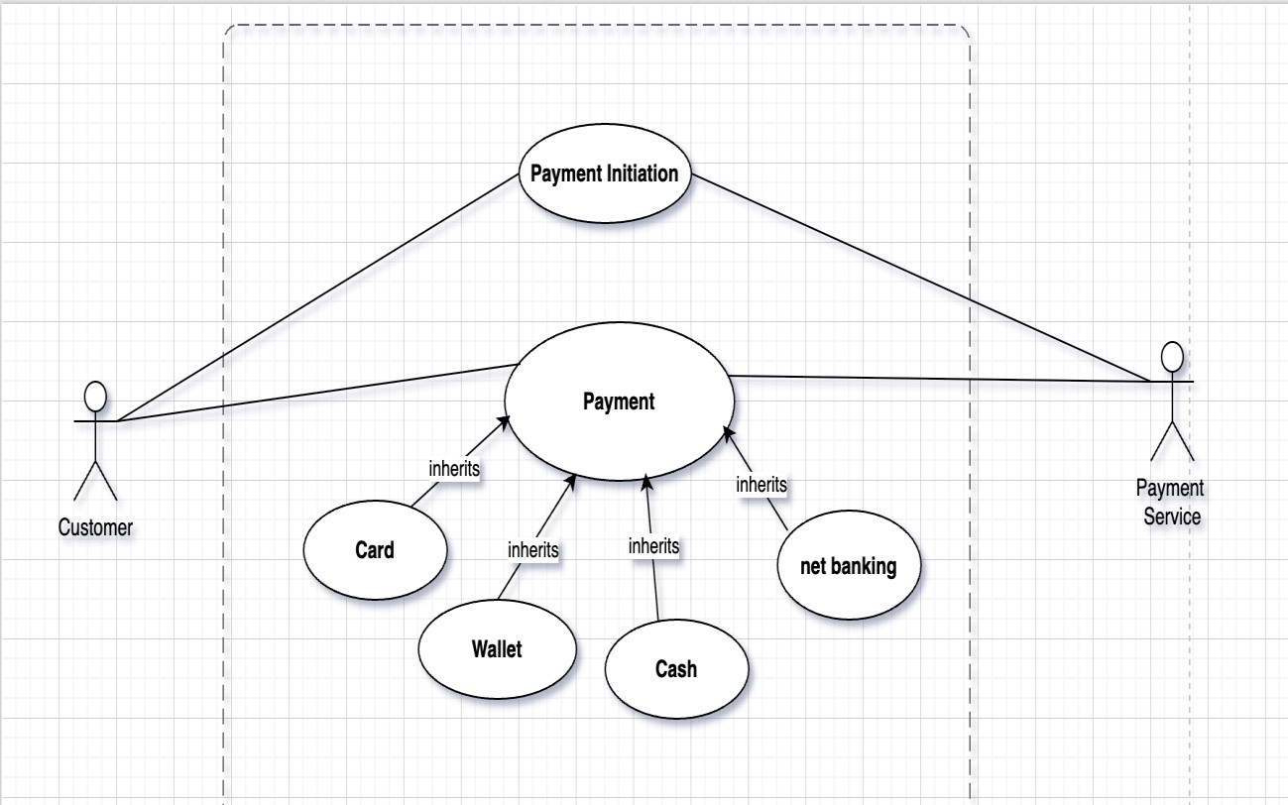
Q2. Derive Boundary Classes, Controller classes, Entity Classes. - 4 Marks 1) Boundary Classes
Boundary classes model the interaction between a system and its external actors (users, external systems, devices, etc.). They serve as interfaces, insulating the core system from changes in the environment or user requirements. In practice, boundary classes manage communication with the outside world, such as user interfaces, API gateways, or external service facades.
Example:

- In a banking app, Login Screen (for user interaction) or PaymentGatewayAPI (for connecting to an external payment service) are boundary classes.

Controller classes
Controller classes orchestrate the system’s operations by mediating between boundary and entity classes. They handle the logic of use cases, process commands from boundaries, coordinate workflow, and update entities as needed. Controllers are responsible for the flow of control in the application, not for storing data or presenting information.

Example:

  - In an online shopping system, Order Controller processes a user's order request: it receives input from the UI (boundary), validates it, updates the order status (entity), and returns a result to the UI.

Entity Classes :
Entity classes represent the core business objects and data of the system. They encapsulate information and business rules that are typically persistent and central to the domain. Entities are usually mapped to database tables or core data structures, and multiple instances of an entity class can exist.
Example:
  - In a library management system, Book, Member, and Loan are entity classes, each holding data and rules relevant to their domain (e.g., a Book has a title, author, and status).

Q3. Place these classes on a three tier Architecture. - 4 Marks

Application Layer:
Payment Method Selection Boundary Card Payment Boundary

Business Logic:
Payment Controller Wallet Controller

Data Tier:
Customer Entity Class) Payment (Entity Class)

Q4. Explain Domain Model for Customer making payment through Net Banking - 4 Marks

A Domain Model is a conceptual representation that defines the structure, relationships, and behaviors of entities within a specific problem domain.

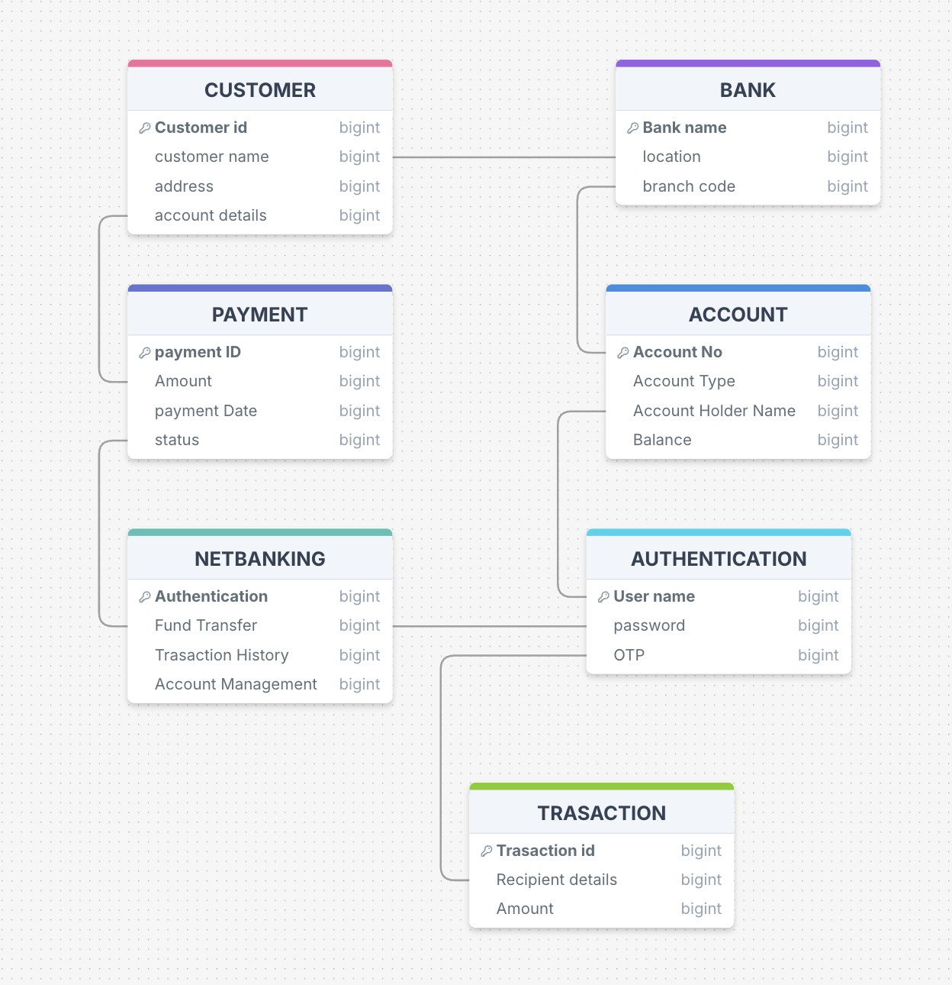

Q5. Draw a sequence diagram for payment done by Customer Net Banking - 4 Marks

A sequence diagram is a type of interaction diagram used in software engineering and systems design to illustrate how processes operate with one another and in what order.

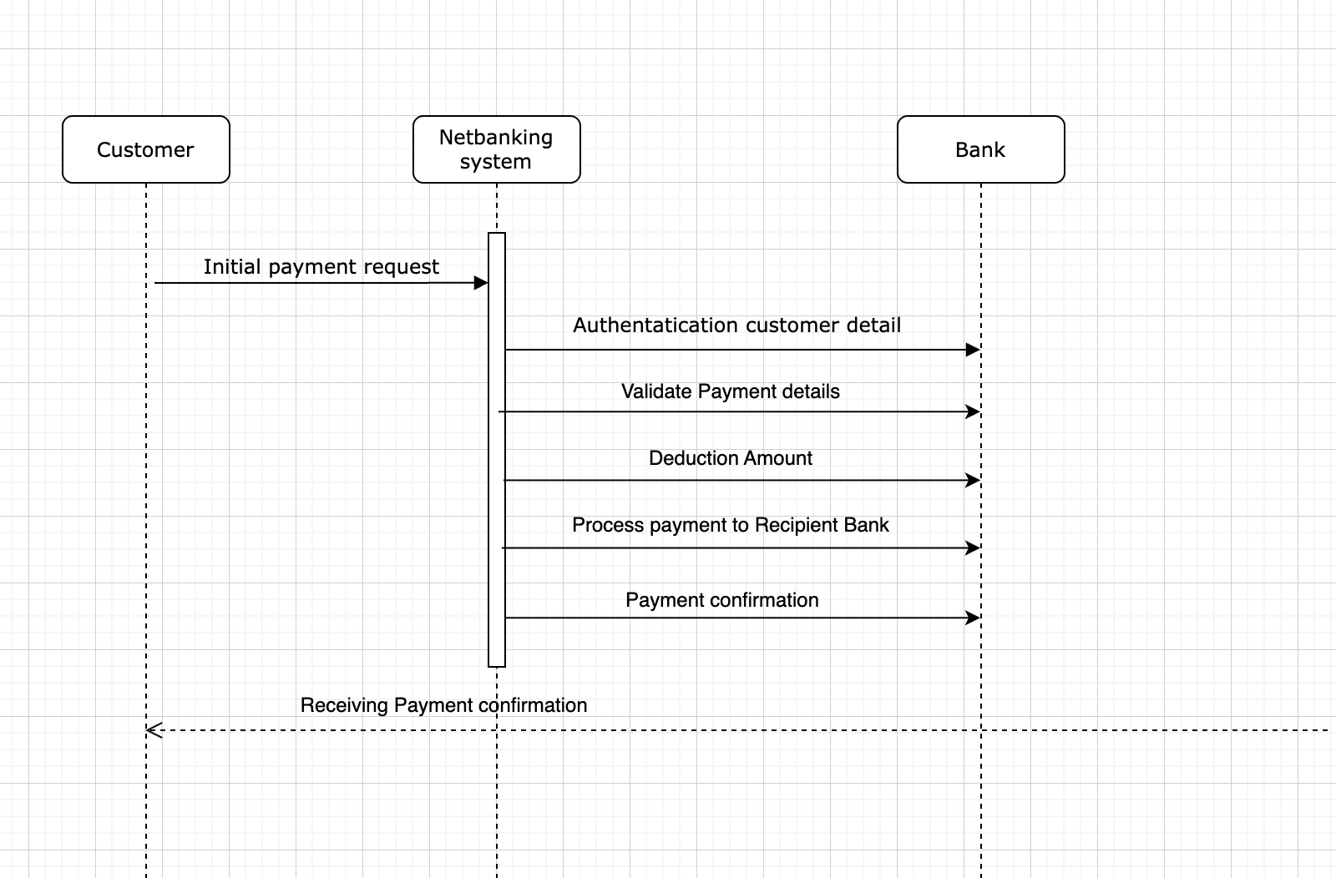

Q6. Explain Conceptual Model for this Case - 4 Marks

  - A conceptual model is a high-level representation of a system that helps in understanding, visualizing, and communicating the essential aspects of a domain.
  - Its Provides a clear and simplified view of the domain, making it easier to understand.
  - Key Elements of a Conceptual Model:
- Entities - Customer, Product, Order & Payment
- Attributes - customer id, name, email, phone Number.
- Relationships - For example, a customer places an Order.

Q7. What is MVC architecture? Explain MVC rules to derive classes from use case diagram and guidelines to place classes in 3-tier architecture - 8 Marks

The Model-View-Controller (MVC) framework is an architectural pattern that separates an application into three main logical components Model, View, and Controller.
  - View - Represents the presentation layer of the application.
  - Model - Represents the data and the business logic of the application.

  - Controller - Acts as an intermediary between Model and View.

MVC Architecture rules Guidelines to place identified MVC Classes in a 3 Tier Architecture in detail.

- Combination of One Actor and a use case results in one Boundary class
- Combination of Two Actors and a use case results in two Boundary classes
- Combination of Three Actors and a use case results in Three Boundary classes and so on....
Note: only one primary actor is to be considered with a use case.
Use case will result in a controller class
5. Each Actor will result in one entity class

Q8. Explain BA contributions in project (Waterfall Model – all Stages) – 8 Marks

Stage | Activities | Artifact & Resources
Pre project
Planning
Project initiation
Requirement Gathering
Requirement Analysis
Design
Development
Testing
UAT

Q9. What is conflict management? Explain using Thomas – Kilmann technique – 6 Marks
Conflict management is the process of resolving conflicts or disagreements between individuals or groups in a constructive manner
Thomas Kilmann technique is a widely used tool for assessing conflict resolution styles & guiding individuals in selecting appropriate strategies to manage conflicts

5 steps of conflict management -
- Identify the conflict
- Discuss the details.
- Agree with the root problem.

- Check for every possible solution for the conflict
- Negotiate the solution to avoid future conflicts

Q10. List down the reasons for project failure – 6 Marks
- Poor Planning
- Unclear Objectives and Requirements
- Inadequate Risk Management
- Poor Communication
- Scope Creep
- Lack of Stakeholder Engagement
- Resource Constraints
- Technical Challenges

Q11. List the Challenges faced in projects for BA – 6 Marks
- Unclear or Changing Requirements
- Managing Stakeholder Expectations
- Scope Creep and Scope Management
- Time and Resource Constraints
- Quality Assurance and Testing
- Documentation and Knowledge Management
- Technology Constraints and Complexity

Q12. Write about Document Naming Standards – 4 Marks

A document numbering standard is a systematic approach to assigning unique identifiers to various documents created and used throughout the development process.

Ex. Suppose we have a project with the ID "PROJ123," and we're working with a Requirements Specification Document.

Project ID: PROJ123 Document Type: REQ Version: 1.0

Date: 2024-05-26
The document identifier could be: PROJ123-REQ-1.0-2024-05-26

Q13. What are the Do’s and Don’ts of a Business analyst – 6 Marks
.

S.NO | DO | DONT
1 | Consult an SME for clarifications in requirements. | Never say NO to the client.
2 | Go to the client with a plain mind with no assumptions.  Listen carefully and completely until the client is done, and then you can ask queries | There is no word as "By  default”
3 | Try to extract maximum leads to the solution from the client himself | Never imagine anything in terms of GUI.
4 | Concentrate on the important requirements. | Don't interrupt the client when he is giving you the problem.
5 | Question about the existence of existence. Question everything | Never try to give solutions to the client straight away with your previous experience and assumptions.

Q14. Write the difference between packages and sub-systems – 4 Marks

Packages: Collection of components which are not reusable in nature.
A package is a UML element used to group and organize related model elements, like classes or interfaces, similar to a folder in a file system. It helps manage complexity by logically organizing parts of a system but does not provide any behavior itself.

Ex: Application development companies work on Packages.

Sub systems: Collection of components which are reusable in nature.

A sub-system is a specialized group of model elements that together provide specific behavior or services to the rest of the system through defined interfaces. Sub-systems

encapsulate their internal details, making them modular and replaceable units within a larger system.

Ex: Product development companies work on Sub systems

Q15. What is camel-casing and explain where it will be used- 6 Marks

Camel casing is a writing style used in programming where multiple words are combined into one phrase without spaces, and each word after the first starts with a capital letter.

For example, myVariableName is written in a camel case.

This style improves code readability by clearly separating words within variable, function, or class names, making it easier for programmers to understand and maintain code.

Camel case is widely used in languages like Java, JavaScript, and C#, and helps maintain consistency and clarity in naming conventions across codebases.

Q16. Illustrate Development server and what are the accesses does business analyst has?

A development server is a dedicated environment where developers build, test, and debug software before deploying it to production. It acts as a safe, isolated space that mimics the production environment, allowing changes and experiments without risking the stability of the live application or impacting end-users.
A business analyst typically has limited access to the development server, focused on tasks that support requirements validation and user acceptance testing, rather than direct code changes.

Application Access:
Can log in to the development version of the application to review new features, validate requirements, and perform user acceptance testing.

Test Data Management:
May create, edit, or review test data to simulate real-world scenarios and ensure business rules are correctly implemented.

Reporting and Feedback:
Can access logs, reports, or dashboards to monitor application behavior and provide feedback to the development team.

Documentation Review:
May review technical or user documentation generated during development.

No Code-Level Access:
Generally does not have permission to modify source code, deploy builds, or change server configurations—these tasks are reserved for developers and DevOps.

Q17. What is Data Mapping 6 Marks

Data mapping is the process of matching and connecting data fields from one system or database to those in another, ensuring that data can be accurately transferred, integrated, or analyzed across different platforms.

This step is essential for data migration, data integration, and data warehousing, as it helps standardize and transform data from various sources into a consistent format suitable for business analysis or operational use.
For example, if one system stores a state as "Illinois" and another as "IL," data mapping defines how these fields correspond, so information moves correctly between systems.
Effective data mapping reduces errors, promotes data consistency, and provides a clear understanding of how data flows and transforms within an organization.

Q18. What is API. Explain how you would use API integration in the case of your application Date format is dd-mm-yyyy and it is accepting some data from Other Application from US whose Date Format is mm-dd-yyyy 10 Marks.
An API, or Application Programming Interface, is a set of rules and tools that allow different software applications to communicate with each other.
how to handle API integration when your application uses dd-mm-yyyy date format and receives data from a US application using mm-dd-yyyy format:

- Receive date data via API from the US system where dates are in mm-dd-yyyy format.
- Parse the incoming date string using the source format (mm-dd-yyyy) with appropriate date parsing functions in your programming language.
- Convert the parsed date to your application’s required format (dd-mm-yyyy)
before further processing or storing.
- Implement the conversion logic in the API layer or middleware to automate date format transformation for all incoming data.
- Validate the converted date to ensure correctness and avoid errors like swapping day and month.
- Use standardized date formats internally (e.g., ISO 8601) where possible, converting only at the boundaries (input/output).
- Leverage built-in date/time converters or libraries (e.g., Java SimpleDateFormat, Python datetime, Oracle JET converters) for reliable formatting.
- Test thoroughly with edge cases such as single-digit days or months to ensure robust conversion.
- Document the date format of expectations clearly for both systems to avoid
confusion during integration.
- Ensure consistent date handling across the application to maintain data integrity and user experience.

