BA Mock 4
Case Study
Assignment 1

- Please make a BRD which can be presented to the client along with a complete development and resource plan.
Business Requirement Document (BRD)
Project Name: Inventory Management and Delivery Optimization System
Date | Version Number | Document Changes
11/1/2025 | 1.0 | Initial draft created with project requirements and objectives.
11/15/2025 | 1.1 | Added detailed functional requirements and use cases.
 | 1.2 | Updated non-functional requirements and revised RTM
  11/22/2025

ROLE | NAME | TITLE | SIGNATURE | DATE
Project Sponsor | Mr Krishna | Head of Inventory |  | 11/25/2025
Business Owner | Mr John | Director of Operations |  | 11/25/2025
Project Manager | Mr Aditya | Project Manager |  | 11/25/2025
System Architect | Ms Sherley | System Architect |  | 11/25/2025
Development  Lead | Ms Jane | Lead Developer |  | 11/25/2025
User Experience  Lead | Mr Joe | UX Designer |  | 11/25/2025
Quality Lead | Ms kamala | QA Manager |  | 11/25/2025
Content Lead | Mr Arjun | Content Strategist |  | 11/25/2025

Name | Position | * | Responsible | Accountable | Supports | Consulted | Informed
Mr Krishna | Project Sponsor | A |  |  |  |  | I
Mr Aditya | Project manager |  | R | A | S | C | I
Ms Jane | Development  Lead |  |  |  | S | C | I
Mr John | Business owner | A |  |  |  | C | I

- Introduction
The purpose of this document is to outline the requirements for developing a software system that manages inventory across multiple manufacturing plants and warehouses while optimizing delivery routes for ice-cream and milk products.
2. Business Goals
- Improve operational efficiency through accurate inventory management.
- Enhance customer satisfaction by ensuring timely delivery of products.
3. Business Objectives
- Real-time visibility into stock levels across locations.
- Reduce order processing and delivery time.
- Minimize inventory holding and transportation costs
4. Business Rules
- Inventory must be updated in real-time for every transaction.
- Orders must be routed to the nearest warehouse with sufficient stock.
- Delivery must prioritize perishable items.
5. Background
The company operates multiple manufacturing plants and warehouses across the country to produce and distribute ice cream and milk products. However, the current processes and systems face several challenges, including:
- Inefficient Inventory Management:
  - Lack of real-time stock updates across warehouses leads to overstocking in some locations and stockouts in others.
  - Manual tracking processes result in data discrepancies and delays in identifying inventory levels.
- Delivery Delays:
  - Delivery routes are manually determined without optimization, causing increased transit times and higher logistics costs.
  - Perishable items often fail to reach customers in time, leading to spoilage and customer dissatisfaction.
- Limited Visibility:
  - Decision-makers lack access to detailed, real-time reports on stock movements and delivery performance.
  - Poor integration between inventory and logistics systems hinders coordination.
- High Operational Costs:
  - Inefficient inventory distribution and unoptimized delivery routes increase fuel and storage expenses.
  - Lack of predictive insights leads to last-minute decisions, increasing operational inefficiencies.

6.Project Objective
The primary objective of this project is to design and implement a centralized software solution that efficiently manages inventory and optimizes delivery operations for the company’s ice cream and milk product distribution network. The system will align with the business objectives of improving operational efficiency, reducing costs, and enhancing customer satisfaction.
High-Level Product Goals:
- Comprehensive Inventory Management:
  - Provide real-time tracking of stock levels across manufacturing plants and warehouses.
  - Enable automated alerts for low stock levels, expirations, and reorder requirements.
- Delivery Optimization:
  - Implement a route optimization engine to minimize delivery times and costs.
  - Ensure timely delivery of perishable products to prevent spoilage and customer dissatisfaction.
- Integrated Reporting and Analytics:
  - Generate insights into stock movements, sales trends, and delivery performance.
  - Enable data-driven decision-making through interactive dashboards and reports.
Alignment with Business Objectives:
- Objective 1: Operational Efficiency:
Streamline inventory processes and minimize manual interventions to reduce errors and waste.
- Objective 2: Cost Reduction:
Optimize delivery routes and reduce transportation costs.
- Objective 3: Customer Satisfaction:
Enhance delivery speed and reliability, improving overall service quality and brand reputation.
Requirements for Interaction with Other Systems:
- ERP Integration:
  - Seamless integration with the company’s existing ERP system to sync financial, procurement, and production data.
- Logistics Partner Systems:
  - Connect with third-party logistics systems for vehicle tracking and delivery status updates.
- Notification and Alert Systems:
  - Integration with email and SMS gateways for automated alerts to stakeholders.

7.Project Scope
In-Scope Functionality
The following functionalities will be included in the current project:
- Real-time tracking of inventory across manufacturing plants and warehouses.
- Automated alerts for low stock levels and expiration of perishable goods.
- Delivery route optimization for faster and more cost-effective logistics.
- Integration with third-party logistics systems for real-time delivery tracking.
- Centralized dashboard for reporting and analytics (stock levels, delivery efficiency).
- Role-based access for administrators, logistics teams, and warehouse staff.
Out-of-Scope Functionality
The following functionalities are excluded from the current project:
- Mobile application for end customers.
- Integration with external e-commerce platforms.
- Advanced AI-based demand forecasting.
- Vendor management and supplier tracking.

Assumptions
- All warehouses and manufacturing plants will have stable internet connectivity.
- Accurate initial data migration will be provided for inventory levels.
- The existing ERP system supports integration through APIs.
- Users will receive adequate training to use the new system.

8. Constraints
- Budget limitations may restrict the addition of certain advanced features.
- The project must be completed within six months.
- The system must be compatible with existing legacy infrastructure.
- Limited time for stakeholder availability during the requirement gathering phase

9. Risks
Technological Risks
- Risk: Integration challenges with legacy systems.
  - Likelihood: Medium
  - Impact: High
  - Strategy: Mitigate by conducting a technical feasibility study and building a robust integration layer.
- Risk: System downtime during migration or deployment.
  - Likelihood: Low
  - Impact: High
  - Strategy: Mitigate by scheduling migration during non-peak hours and maintaining a backup plan.
Skills Risks
- Risk: Shortage of skilled developers for new technology implementation.
  - Likelihood: Medium
  - Impact: Medium
  - Strategy: Mitigate by hiring consultants or upskilling existing team members.
Political Risks
- Risk: Resistance to change from internal stakeholders.
  - Likelihood: Medium
  - Impact: Medium
  - Strategy: Mitigate through stakeholder engagement and change management practices.
Business Risks
- Risk: Failure to meet delivery timelines, affecting customer satisfaction.
  - Likelihood: Medium
  - Impact: High
  - Strategy: Mitigate by setting realistic milestones and contingency planning.
Requirements Risks
- Risk: Misinterpretation of business requirements during the initial phase.
  - Likelihood: Medium
  - Impact: High
  - Strategy: Avoid by conducting multiple requirement validation workshops.
Other Risks
- Risk: Vendor delays in providing necessary software licenses.
  - Likelihood: Low
  - Impact: Medium
  - Strategy: Mitigate by procuring licenses in advance and having alternate vendors.

10.Business Process Overview
The Inventory and Delivery Management System is designed to streamline and optimize the company's operations, addressing the challenges faced in inventory tracking and delivery logistics. Below is an overview of the current business process (AS-IS) and the proposed system (TO-BE).
Legacy System (AS-IS)
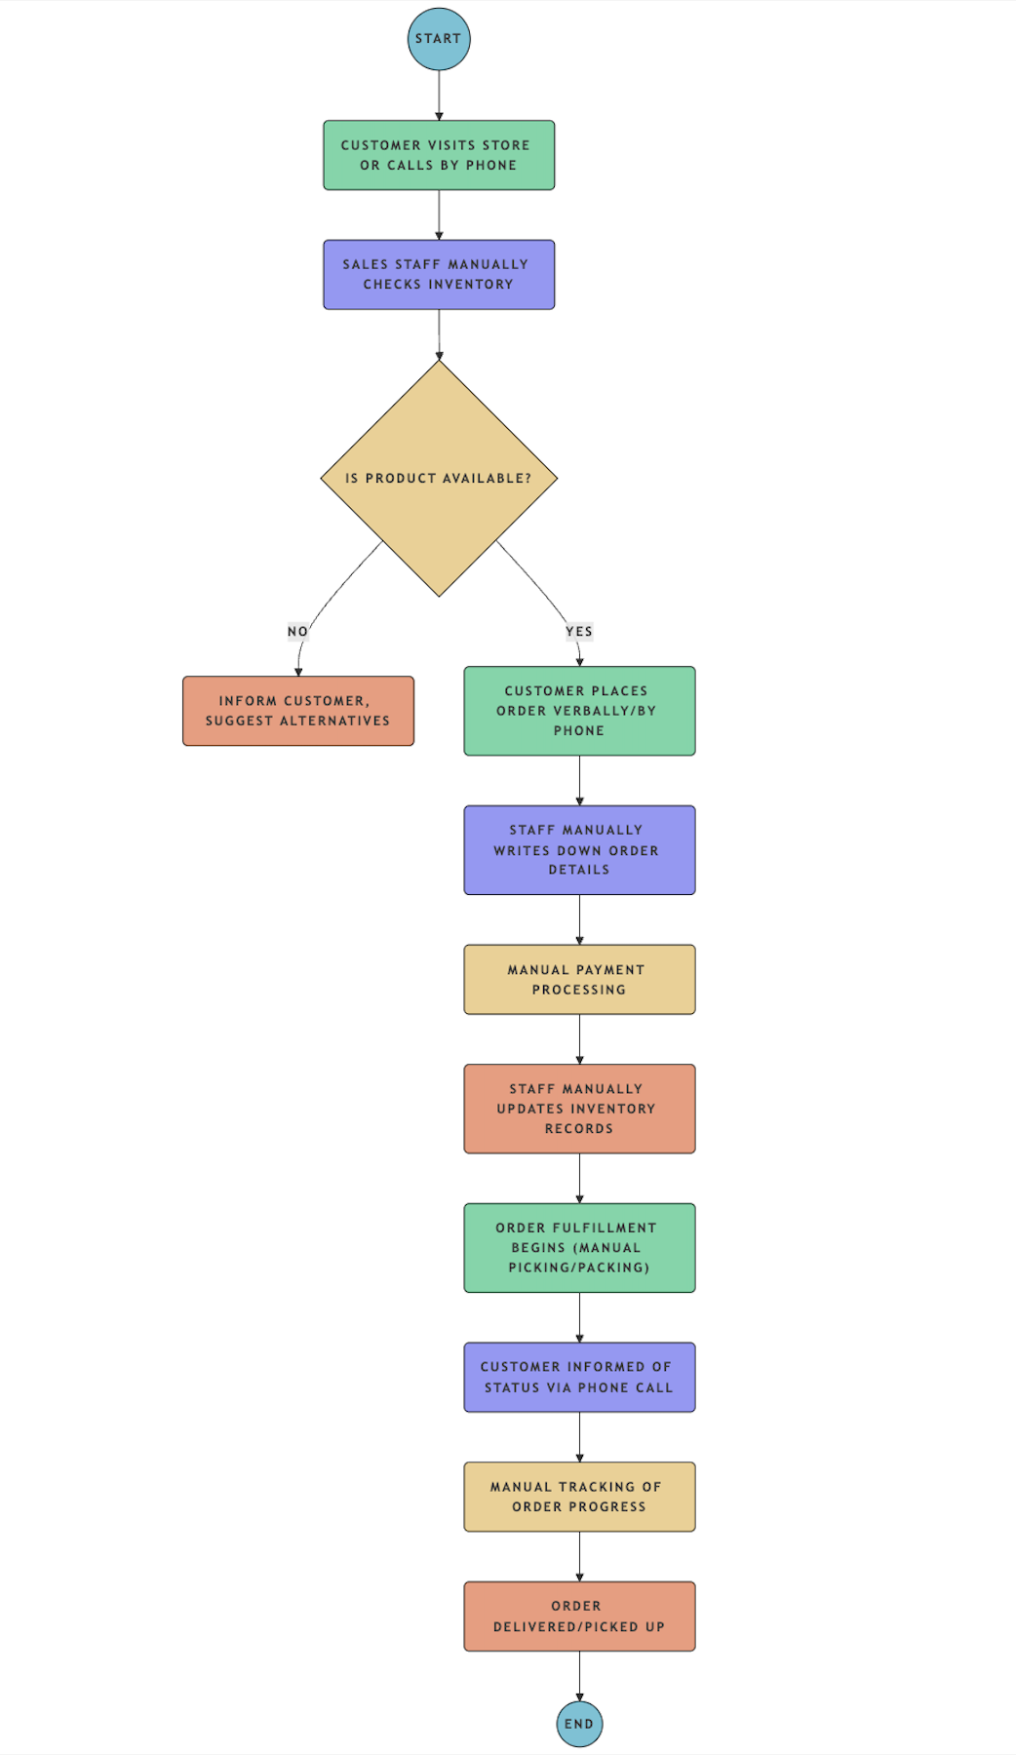

Proposed Recommendations (TO-BE)
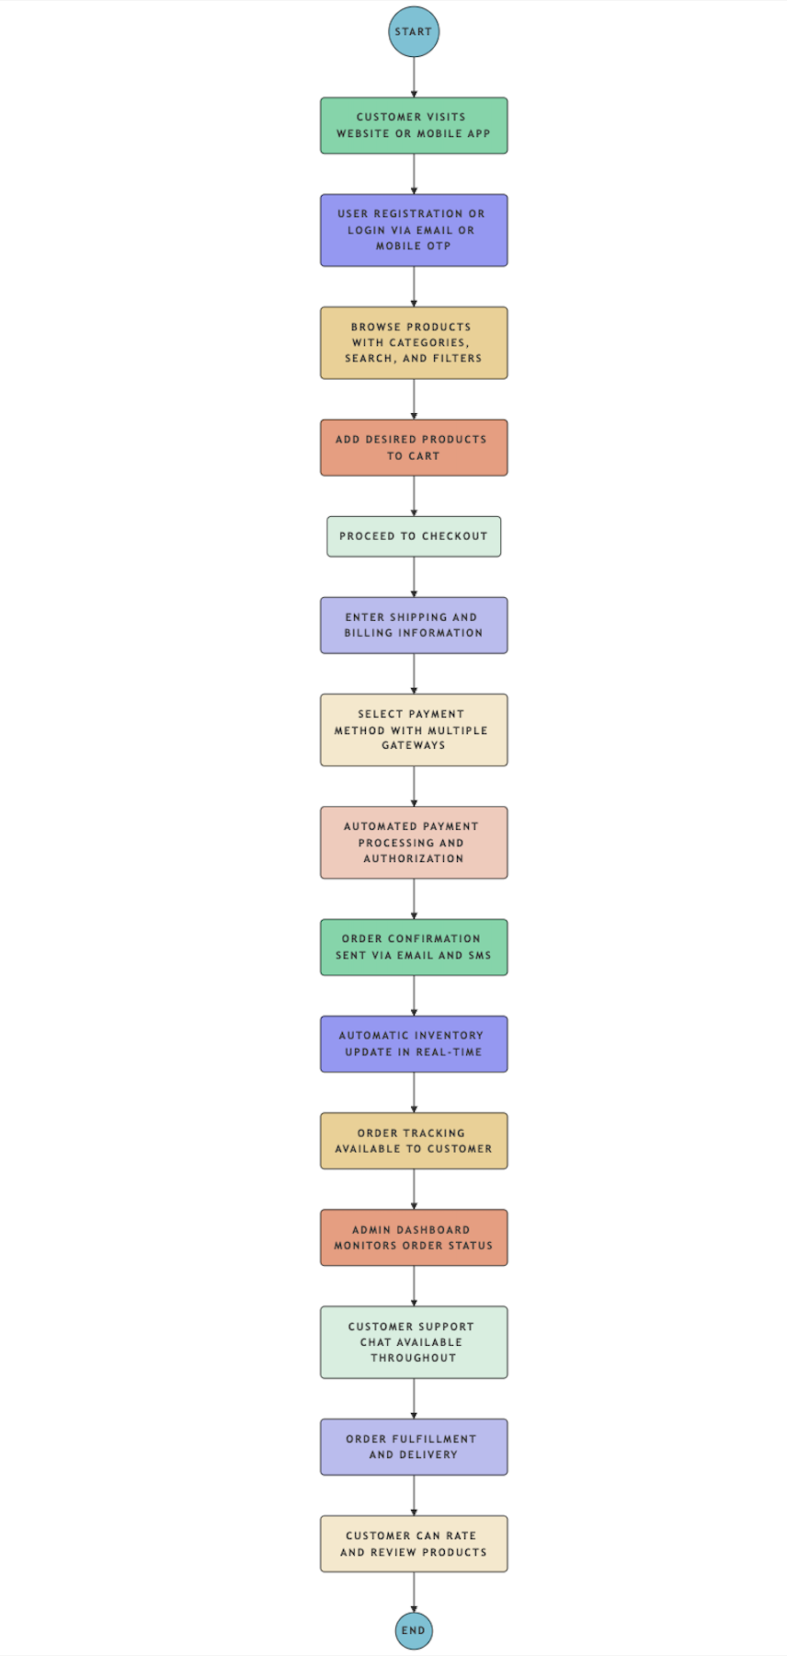
Challenges in AS-IS Process:
- Lack of real-time inventory visibility.
- Inefficient delivery route planning.
- High operational costs due to overstocking or understocking.
- Poor coordination between manufacturing plants and warehouses

Benefits of TO-BE Process:
- Improved accuracy in inventory tracking.
- Faster, more reliable delivery of products.
- Reduced spoilage and logistics costs.
- Enhanced decision-making through actionable insights.

Business Requirements
Req Id | Req name | Req Description | Priority
BR001 | Real-Time Inventory Tracking | Enable real-time tracking of inventory levels across manufacturing plants and warehouses. | 10
BR002 | Automated Reorder Alerts | Generate automated alerts for low stock levels, impending expirations, and reorder points. | 9
 | Delivery Route Optimization | Use an AI-based route optimization tool to minimize delivery times and costs while considering real-time traffic data. | 9
  BR003
BR004 | Integration with Logistics Systems | Integrate the system with third-party logistics tools to enable real-time delivery vehicle tracking and status updates. | 8
BR005 | Centralized Reporting Dashboard | Provide a dashboard for real-time visibility into inventory levels, delivery metrics, and sales trends. | 9
BR006 | Demand Forecasting | Use predictive analytics to forecast inventory demand based on historical sales and seasonal trends. | 8
BR007 | User Role Management | Implement role-based access control for administrators, warehouse staff, and delivery teams. | 9
BR008 | Compliance Tracking | Ensure the system adheres to food safety and industry compliance standards for inventory and delivery operations. | 7
BR009 | Order Allocation Automation | Automate order allocation by identifying the nearest warehouse with sufficient stock for quicker processing. | 6
BR010 | Scalability and Future Readiness | Ensure the system can scale to accommodate additional warehouses, delivery routes, and users as the business grows. | 8

- Prepare process flow diagram using your imagination

Inventory management

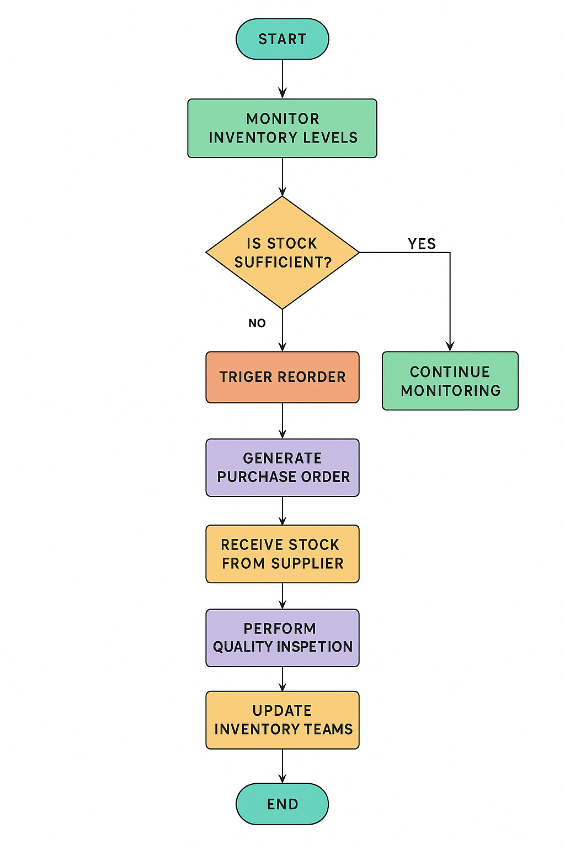

Delivery management

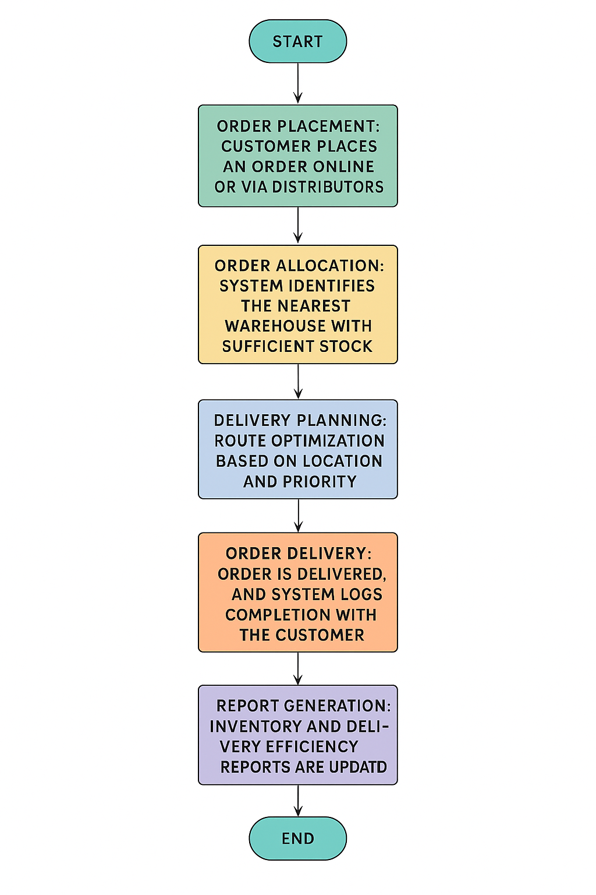

Assignment 2:

1. Write an introduction letter to a client introducing yourself as a business analyst in charge of working with the client and his team to start the business understanding process
Subject: As Your Business Analyst for the project 2.0
Dear xyz,
I hope this message finds you well. My name is Sai Krishna, and I am the Business Analyst assigned to collaborate with you and your team. My primary role is to ensure a seamless understanding of your business requirements and objectives, acting as the bridge between your vision and the technical implementation.
We will begin the engagement with a comprehensive business understanding process to capture your goals, challenges, and expectations. This will enable us to design and deliver a solution tailored precisely to your needs. I look forward to working closely with you and am confident that together, we can achieve outstanding results.
Please feel free to share your availability for an initial discussion. You can reach me at sai.abc@gmail.com or +919090909090.
Looking forward to a successful collaboration.
Warm regards,
Sai Krishna
Business Analyst
ABC

2. Prepare a brief BRD and SRS for a project- Horoscope or Ticketing system or online store.
Project Name: Online Store Development
Date | Version Number | Document Changes
11/1/2025 | 1.0 | Initial draft created with project requirements and objectives.
11/15/2025 | 1.1 | Added detailed functional requirements and use cases.
 | 1.2 | Updated non-functional requirements and revised RTM
  11/22/2025

ROLE | NAME | TITLE | SIGNATURE | DATE
Project Sponsor | Mr Krishna | Head of Project |  | 11/25/2025
Business Owner | Mr John | Director of Operations |  | 11/25/2025
Project Manager | Mr Aditya | Project Manager |  | 11/25/2025
System Architect | Ms Sherley | System Architect |  | 11/25/2025
Development  Lead | Ms Jane | Lead Developer |  | 11/25/2025
User Experience  Lead | Mr Joe | UX Designer |  | 11/25/2025
Quality Lead | Ms kamala | QA Manager |  | 11/25/2025
Content Lead | Mr Arjun | Content Strategist |  | 11/25/2025

Name | Position | * | Responsible | Accountable | Supports | Consulted | Informed
Mr Krishna | Project Sponsor | A |  |  |  |  | I
Mr Aditya | Project manager |  | R | A | S | C | I
Ms Jane | Development  Lead |  |  |  | S | C | I
Mr John | Business owner | A |  |  |  | C | I

1. Introduction
The Online Store Development Project aims to build a robust e-commerce platform to enable customers to browse, search, purchase, and track orders seamlessly. The system will also empower the business to manage inventory, sales, and customer data effectively.
2. Business Goals
- Establish a scalable e-commerce platform to increase online sales revenue.
- Provide customers with an engaging and intuitive shopping experience.
- Streamline inventory management and order processing.

3. Business Objectives
- Enable secure online transactions and order tracking.
- Provide personalized product recommendations to customers.
- Ensure seamless integration with payment gateways and logistics partners.

4. Background
Current Issues/Problems:
- Lack of an online presence limits customer reach.
- Manual order handling is prone to errors and inefficiencies.
- Inventory management challenges lead to stockouts or overstocking.
- Difficulty in tracking customer preferences and generating actionable insights.

5. Project Objective
The objective of this project is to develop a user-friendly online store that aligns with the company's goals of expanding market reach, improving operational efficiency, and enhancing the overall customer experience. The system will interact seamlessly with existing inventory, logistics, and CRM tools.

6. Project Scope
6.1. In-Scope Functionality:
- Product browsing, search, and filtering features.
- Secure customer registration and login.
- Online payment integration with multiple gateways.
- Real-time inventory updates and stock availability.
- Order placement, tracking, and management.
- Personalized product recommendations using AI.
- Analytics dashboards for sales and inventory.
6.2. Out-of-Scope Functionality:
- Offline retail operations.
- Custom mobile app (optional in the current phase).
- Integration with third-party loyalty programs.
7. Assumptions
- Internet connectivity will be available to customers and the business.
- Existing product data is accurate and up-to-date for initial system setup.
- All necessary APIs from payment and logistics partners are functional and accessible.
8. Constraints
- The project must be completed within a six-month timeline.
- Budget limitations restrict the inclusion of certain advanced features.
- The system must be scalable but start with a defined inventory size and customer base.

9. Risks
Technological Risks
- Risk: Integration with payment gateways or third-party logistics APIs may fail.
  - Likelihood: Medium
  - Impact: High
  - Mitigation: Conduct integration testing early in the development cycle; ensure APIs have robust documentation.
- Risk: Performance issues with the online store under high traffic.
  - Likelihood: Low
  - Impact: Medium
  - Mitigation: Implement load testing and scalable infrastructure during development.

Skills Risks
- Risk: Lack of expertise in AI-based recommendation system development.
  - Likelihood: Medium
  - Impact: Medium
  - Mitigation: Provide training or hire external consultants for specialized tasks.
- Risk: Resource unavailability during critical project phases.
  - Likelihood: High
  - Impact: High
  - Mitigation: Ensure resource allocation is secured and cross-train team members.

Political Risks
- Risk: Changes in business priorities or leadership decisions.
  - Likelihood: Medium
  - Impact: High
  - Mitigation: Align project goals with long-term business strategies and secure executive sponsorship.
- Risk: Regulatory changes affecting online sales.
  - Likelihood: Low
  - Impact: Medium
  - Mitigation: Monitor regulatory updates and adjust compliance strategies as needed.

Business Risks
- Risk: Low adoption of the online store by customers.
  - Likelihood: Medium
  - Impact: High
  - Mitigation: Conduct market research and usability testing to ensure customer satisfaction.
- Risk: Project delay due to extended decision-making cycles.
  - Likelihood: Medium
  - Impact: High
  - Mitigation: Establish clear approval workflows and timelines.

Requirements Risks
- Risk: Misalignment between business goals and documented requirements.
  - Likelihood: Medium
  - Impact: High
  - Mitigation: Conduct regular stakeholder reviews and maintain a requirements traceability matrix.
- Risk: Incomplete requirement captures during discovery phase.
  - Likelihood: High
  - Impact: High
  - Mitigation: Use comprehensive elicitation techniques like workshops and interviews.

Other Risks
- Risk: Vendor delays in providing tools or software dependencies.
  - Likelihood: Low
  - Impact: Medium
  - Mitigation: Establish contracts with clear deadlines and penalties for delays.

10. Business Process Overview
AS-IS Process Flow Diagram

Proposed Recommendations (TO-BE):

Business Requirements
Req Id | Req name | Req Description | Priority
BR001 | User Registration | The system must allow users to register and create personalized accounts with secure authentication methods. | 10
BR002 | Product Catalog | The system must display all available products with details such as price, description, and stock availability. | 9
 | Search and Filter | Users must be able to search for products using keywords and apply filters (e.g., category, price range, brand). | 9
  BR003
BR004 | Cart Management | The system must allow users to add, remove, or update items in their cart before checkout. | 8
BR005 | Order Placement | Users must be able to place orders, with the system validating stock availability and providing an estimated delivery date. | 9
BR006 | Payment Integration | The system must support multiple secure payment options, including credit/debit cards, wallets, and UPI. | 8
BR007 | Real-Time Inventory Update | The system must update inventory levels in real-time as orders are placed or cancelled. | 9
BR008 | Delivery Tracking | Customers must be able to track their orders in real-time with updates on estimated delivery times. | 7
BR009 | Customer Feedback and Support | The system must provide a ticketing mechanism for customers to report issues, give feedback, or request support. | 6
BR010 | Discounts and Promotions | The system must allow the application of discount codes or promotional offers during checkout. | 8

Software Requirement Specifications (SRS)
1. Introduction
The Online Store Development Project aims to build a robust e-commerce platform to enable customers to browse, search, purchase, and track orders seamlessly. The system will also empower the business to manage inventory, sales, and customer data effectively.
2. Business Goals
- Establish a scalable e-commerce platform to increase online sales revenue.
- Provide customers with an engaging and intuitive shopping experience.
- Streamline inventory management and order processing.

3. Business Objectives
- Enable secure online transactions and order tracking.
- Provide personalized product recommendations to customers.
- Ensure seamless integration with payment gateways and logistics partners.
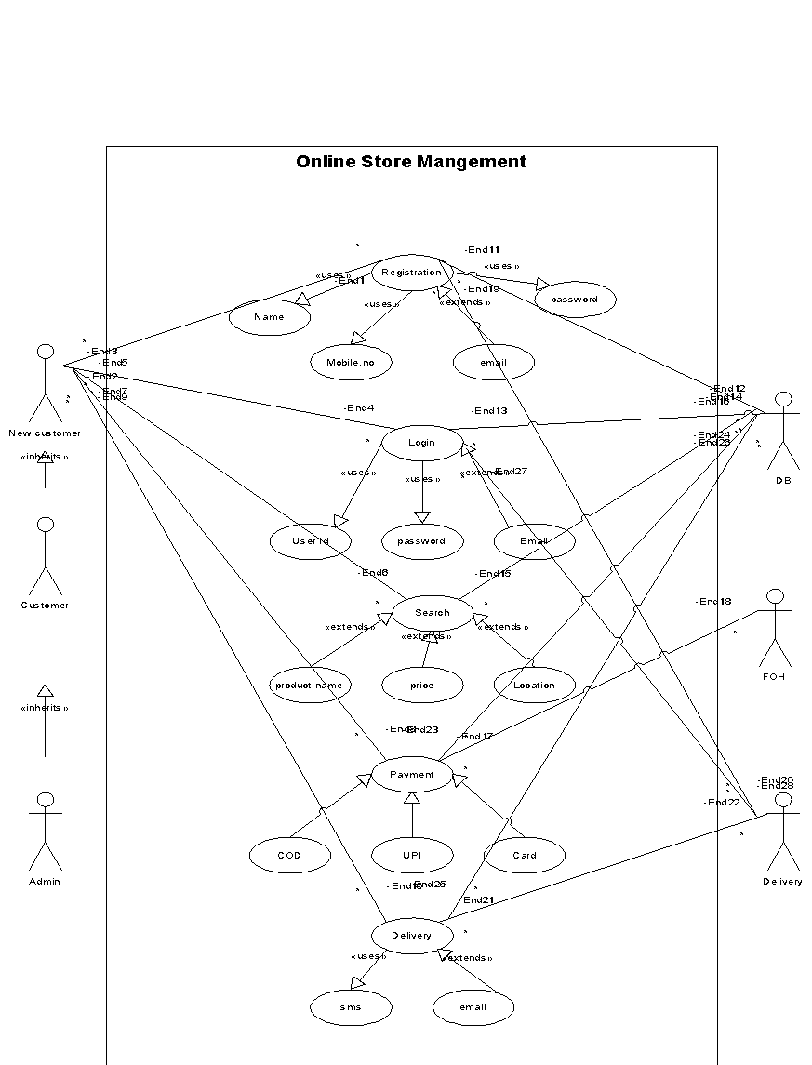
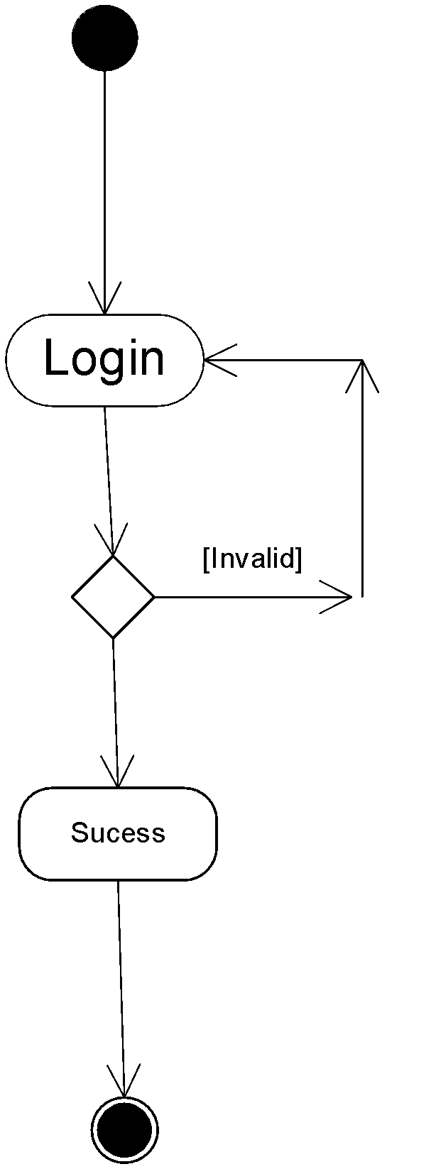

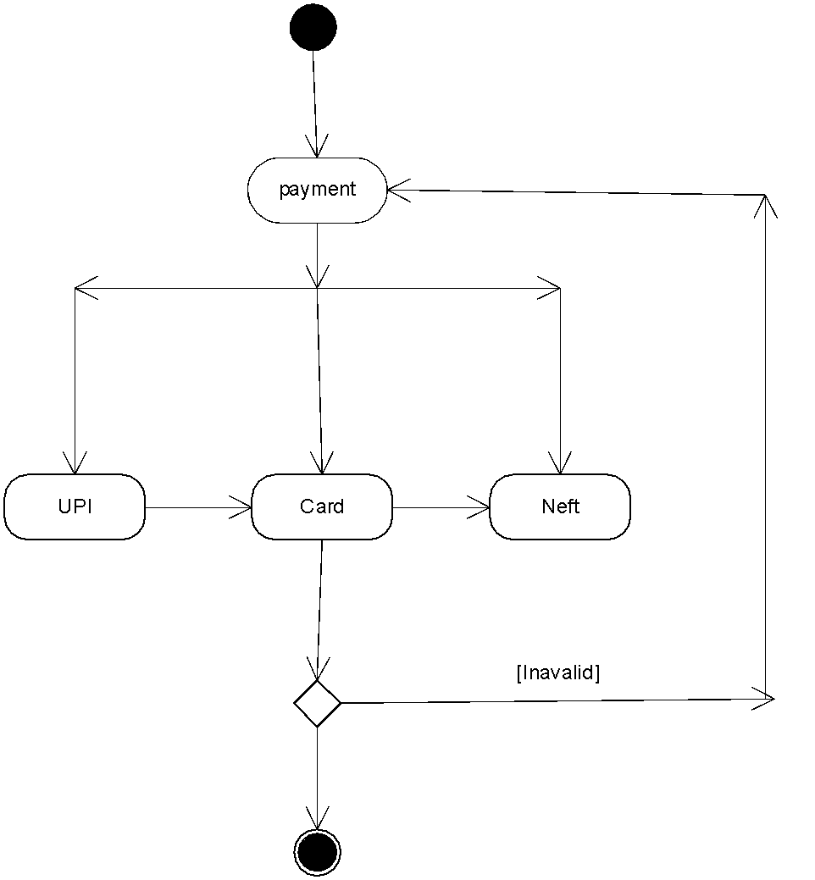

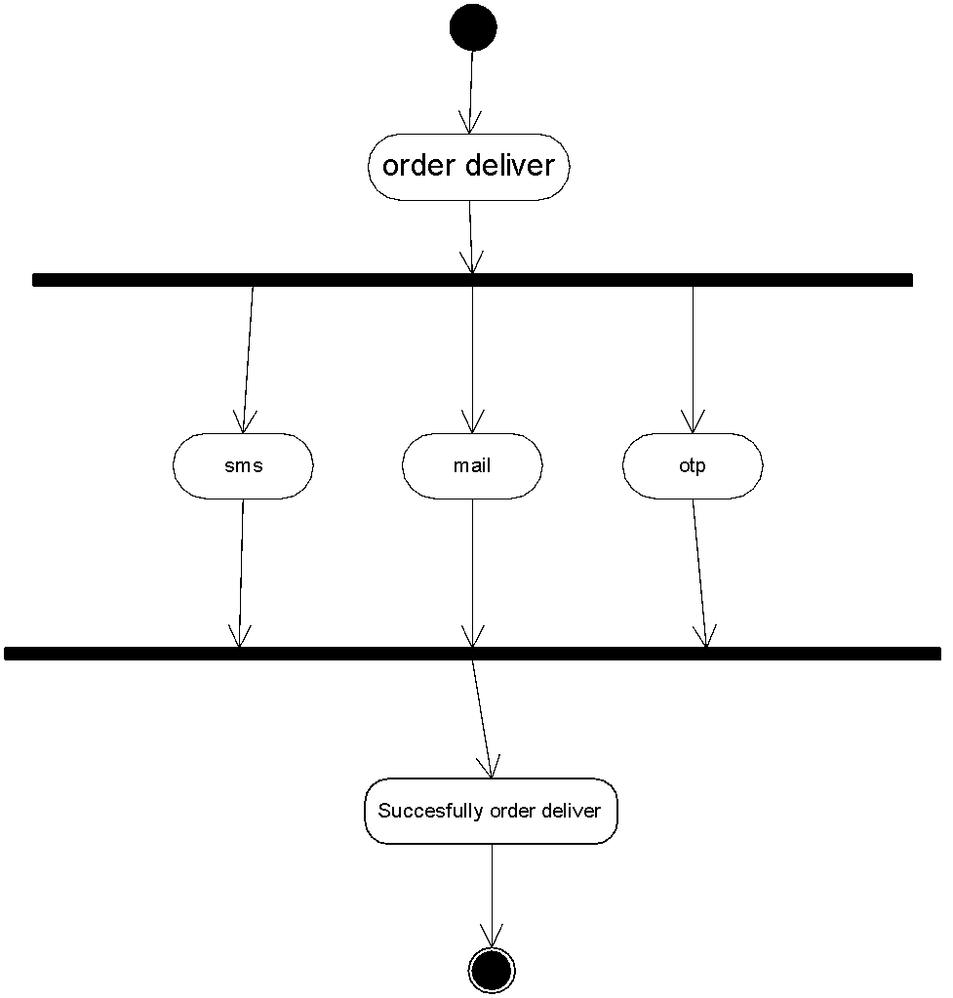

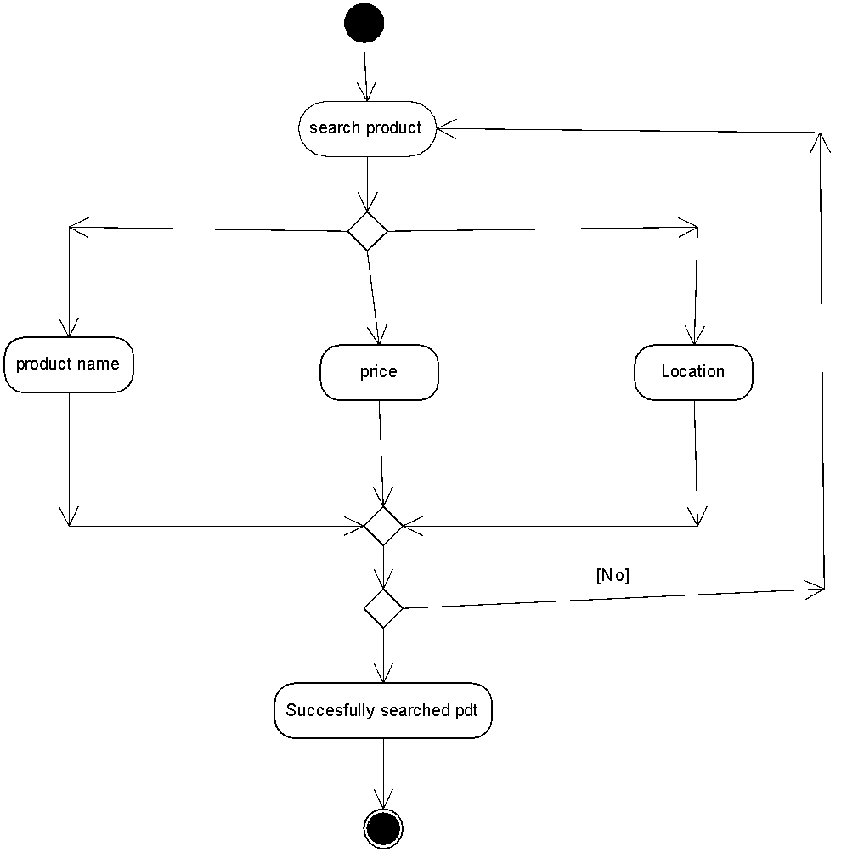

    - Use case spec- Registration

- Description- username, password
- Actors- Customers, Website
- Preconditions- active internet condition
- Description- username, password
- Actors- Customers, Website
- Preconditions- active internet condition
- Description- username, password
- Actors- Customers, Website
- Preconditions- active internet condition
- Description- username, password
- Actors- Customers, Website
- Preconditions- active internet condition
- Description- username, password
- Actors- Customers, Website
- Preconditions- active internet condition
Description- Name, Mobile no, password
Actors- Customers, Website,
Preconditions- active internet condition and Browser compatible
- Post condition- home page should be displayed
- Basic flows: username and password is correct.
Post condition- The user account is successfully created and verified.
Basic flows: The user selects the "Sign Up" option and the user fills in the required details and submits the form.
Alternate Flow: If any data is invalid, the system displays an error message, prompting the user to correct it.
Assumptions: users have basic computer knowledge, English
Constraints: username cannot be special character
Dependents: user should exist-registered done
Inputs: Name, Mobile no, password
Output: user account is successfully created
Business rules- username should use valid mail id password should use special character
MIS information- interactive design and browser compatible.

    - Use case spec- login
- Description- add to cart, purchase
- Actor- Customer, website
- Preconditions: Active internet connection, browse through different products
- Postcondition: able to add items to cart and directed to payment page.
- Basic flow- items selected are correctly captured while adding to cart.
- Exceptional flow- while adding to cart different pages pop out not directing to payment page.
- Assumptions: users should know how to add product to cart.
Description- User Login
Actor- Customer, website
Preconditions: Active internet connection, browse through different products
Postcondition: The user is logged into the system.
Basic flow- The user selects "Login." The system validates the credentials. If valid, the user is granted access to their account dashboard
Exceptional flow- f the system fails to validate due to server issues; an error message is shown. Assumptions: users have basic computer knowledge, English
Input-username and password.
Output- logged into home page
Business rules- username should use valid mail id password should use special character
MIS info- interactive design and browser compatible.

    - Search Products

Descriptions- search for products on the platform.
Actor- customer and website
Precondition- active internet and have Gmail account
Post condition- The customer has viewed product options based on their search criteria.
Basic flow- enters a search term The Customer can filter results by price, ratings, and availability.
Alternate flow- If no products match the search term, the system displays a message and suggests alternative keywords or categories.
Exceptional flow If the system fails to retrieve products due to a network error, the system displays an error message.
Assumption- initiates a search query for products.
Input- search product
Output- shows results of search products
Business rules-username should use valid mail id password should use special character.
MIS information- interactive design and browser compatible.

    - Use case spec- payment

Description- card details, payment option
Actors- customer, website
Precondition- the item to be in cart.
Postcondition- the Customer to be able to make payment through upi card or cod
Basic flow- able to make payment
Alternate flow- not able to make payment
Exceptional flow- card blocked, upi not registered
Assumption- have basic knowledge about using cards, know how to make upi payments.
Inputs- card details
Output- payment gateway or error page
Business rule- card should be either visa or maestro
MIS information- interactive design and browser compatible

    - Delivery
Description: Products purchased by the Customer are delivered to their specified location.
Actors: Customer, Delivery Service
Preconditions: The Customer must have successfully placed an order and entered a valid delivery address.
Postconditions: The Customer successfully receives the purchased products.
Basic Flow: The system forwards the order and delivery details to the delivery service. The products are delivered to the Customer’s specified location.
Alternate Flow: If the delivery fails (e.g., incorrect address), the system notifies the Customer and requests updated information.
Exceptional flow: If delivery services are unavailable (e.g., due to weather), the Customer is notified of the delay.
Assumptions: The Customer successfully receives the purchased products.
Input: order and delivery detail
Output: Customer successfully receives the purchased products.

Functional Requirements
Req ID | Req Name | Req Description | Priority
FR001 | Customer Registration | Application should allow to register with and login to the application. | 8
FR002 | Product Catalogue | Customers should be able to search for the products available (Fertilizers, seeds, pesticides) | 8
FR003 | Shopping cart | Should allow Customers after logging in to add the products to the shopping cart (buy now /buy later) | 9
FR004 | Payment Processing | Application should be able to manage multiple payment gateways to facilitate secure and convenient transactions. | 10
FR005 | Order History | Should allow to view the past history including the orders list, and status of the order. | 9
FR006 | Order confirmation | Users should get confirmation details like order quality, colour, delivery timeline on the specified ordered products. | 9
FR007 | Tracking details | Users get email confirmation with a delivery tracker to track the status of the order in real time. | 5
FR008 | Customer service | Should allow customer support to either chat, phone, call option. | 9
FR009 | Return and refund Policy | Should allow users to avail for a refund or a return if the product is damaged or doesn’t meet the criteria. | 8
FR010 | Manufacturer registration | Allow manufacturers to register and login | 9
FR011 | Manufacturer Product Listing | Should allow manufacturers to able to list their products | 8
FR012 | Wishlist | Show allows customers to add the products to Wishlist to buy later. | 5
FR013 | Product reviews | Allow users to provide ratings to the products they have purchased | 10
FR014 | Account management | Should allow users to manage their account via/ profile settings, password changes and email preferences. | 3
FR015 | Product Filtering | Should allow users to filter the product according to their needs. | 4

Non Functional Requirements
Req ID | Req Name | Req Description | Priority
NFR0101 | Page loading time | Each Page should load within 2 seconds time. | 9
NFR0102 | WCAG 2.1 | The system must meet Web Content Accessibility Guidelines WCAG 2.1 | 8
NFR0103 | Internet speed | Required internet speed to run the application | 7
NFR0104 | Maintenance | Maintenance of the application | 8
NFR0105 | Compliance | Adherence of law, regulations, industry standards etc | 8
NFR0106 | Security | The system must ensure secure data transmission using SSL/TLS encryption and protect user credentials through encryption and hashing techniques. | 10
NFR0107 | Scalability | The system should efficiently handle increased loads, users, and transactions without impacting performance. | 9
NFR0108 | Reliability | The system should maintain a minimum uptime of 99.9% to ensure continuous service availability. | 9
NFR0109 | Usability | The application interface should be intuitive, easy to navigate, and require minimal user training. | 8
NFR0110 | Data Backup and Recovery | The system should automatically back up data daily and allow for quick recovery in case of system failures. | 9
NFR0111 | Browser Compatibility | The application should function smoothly on major browsers, including Chrome, Firefox, Safari, and Edge. | 7
NFR0112 | Mobile Responsiveness | The application must be responsive and fully accessible across different devices such as mobiles and tablets. | 8
NFR0113 | Localization | The system should support multiple languages and regional settings to cater to diverse user bases. | 6
NFR0114 | Audit and Logging | All major system and user activities must be logged securely and available for audit and monitoring purposes. | 9
NFR0115 | Performance Monitoring | The system should integrate monitoring tools to track metrics like response time, uptime, and server load. | 8

3. Make an ERD of creating a support ticket/Ticketing life cycle.

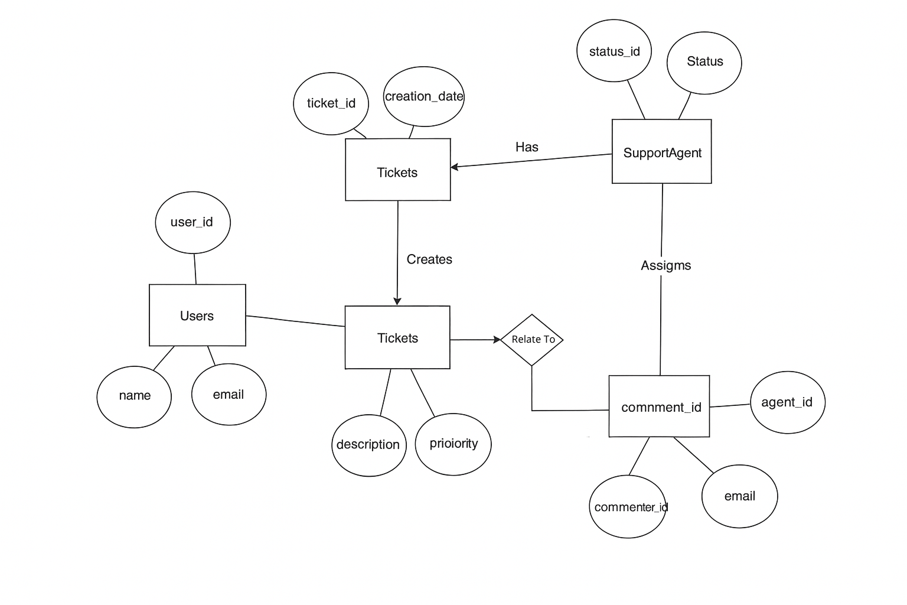

4. User story of shopping from ecommerce.

User Story no: 1 | Tasks:3 |  | Priority: Highest
As a user,
I want to register an account,
so that I can securely log in and shop.
BV:50 |  | CP:05
Acceptance criteria:
- The registration form includes name, email, password, and phone number.
- A verification email is sent and must be confirmed before login.
- Password must meet complexity rules (min 8 chars, 1 special char)

User Story no: 2 | Tasks:2 |  | Priority: Highest
As a user,
I want to log in with my credentials,
so that I can access my account.
BV:50 |  | CP:02
Acceptance criteria:
- Login is successful with a valid email and password.
- Error message is displayed for invalid credentials.

User Story no: 3 | Tasks:3 |  | Priority: Highest
As a user,
I want to search for products by name,
so that I can find what I am looking for quickly.
BV:20 |  | CP:08
Acceptance criteria:
- Search results display relevant products.
- Results update within 1 second of user input.
- No results message appears if no matches are found.

User Story no: 4 | Tasks:3 |  | Priority: Medium
As a user,
I want to filter products by price, category, and rating,
so that I can narrow down my choices.
BV:50 |  | CP:08
Acceptance criteria:
- Filters must dynamically update product lists.
- Selected filters should be highlighted.

User Story no: 5 | Tasks:3 |  | Priority: Medium
As a user,
I want to view product details,
so that I can decide whether to purchase them.
BV:50 |  | CP:03
Acceptance criteria:
- Product page includes name, description, images, price, and reviews.
- Users can zoom product images.
- Similar products are suggested below.

User Story no: 6 | Tasks:2 |  | Priority: Highest
As a user,
I want to add products to my cart,
so that I can purchase them later.
BV:100 |  | CP:03
Acceptance criteria:
- Items are added to the cart with a quantity selector.
- Confirmation message appears after adding.

User Story no: 7 | Tasks:2 |  | Priority: Highest
As a user,
I want to view my cart,
so that I can review the items before purchasing.
BV:100 |  | CP:05
Acceptance criteria:
- Cart displays product name, price, quantity, and total.
- Users can edit or remove items.

User Story no: 8 | Tasks:2 |  | Priority: Highest
As a user,
I want to update quantities in the cart,
so that I can buy the exact amount I need.
BV:20 |  | CP:03
Acceptance criteria:
- Cart updates automatically with quantity changes.
- Subtotal adjusts with quantity changes.

User Story no: 9 | Tasks:2 |  | Priority: Medium
As a user,
I want to remove items from the cart,
so that I can manage my purchases.
BV:10 |  | CP:02
Acceptance criteria:
- Items are removed when delete is clicked.
- Total is recalculated after removal.

User Story no: 10 | Tasks:2 |  | Priority: Highest
As a user,
I want to proceed to checkout,
so that I can complete my purchase.
BV:100 |  | CP:08
Acceptance criteria:
- Clicking “Checkout” redirects to secure payment page.
- Cart summary and delivery address appear on checkout screen.
- Total amount includes taxes and shipping.

User Story no: 11 | Tasks:3 |  | Priority: Highest
As a user,
I want to add multiple delivery addresses,
so that I can choose where my orders are sent.
BV:50 |  | CP:08
Acceptance criteria:
- Address book allows adding, editing, and deleting addresses.
- Selected address is highlighted during checkout.

User Story no: 12 | Tasks:2 |  | Priority: Medium
As a user,
I want to choose a delivery method,
so that I can decide between standard or express shipping.
BV:20 |  | CP:05
Acceptance criteria:
- Delivery charges update based on the selected method.
- Estimated delivery dates are shown.

User Story no: 13 | Tasks:2 |  | Priority: Highest
As a user,
I want to apply coupon codes,
so that I can get discounts.
BV:50 |  | CP:08
Acceptance criteria:
- Valid coupon reduces the order total.
- Error message for expired or invalid coupons.

User Story no: 14 | Tasks:3 |  | Priority: Highest
As a user,
I want to pay online securely,
so that I can complete my order.
BV:100 |  | CP:13
Acceptance criteria:
- Supports multiple payment methods (credit card, UPI, wallets).
- Payment gateway is secure and encrypted.
- Users receive a confirmation email upon payment.

User Story no: 15 | Tasks:2 |  | Priority: Highest
As a user,
I want to track my order,
so that I know the delivery status.
BV:50 |  | CP:05
Acceptance criteria:
- Order status updates include “Processing,” “Shipped,” and “Delivered.”
- Tracking link redirects to courier service.

User Story no: 16 | Tasks:2 |  | Priority: Medium
As a user,
I want to cancel an order,
so that I can avoid receiving items I don’t need.
BV:20 |  | CP:05
Acceptance criteria:
- Orders can be cancelled if not yet shipped.
- Refund confirmation is sent for prepaid orders.

User Story no: 17 | Tasks:2 |  | Priority: Medium
As a user,
I want to view my order history,
so that I can see past purchases.
BV:10 |  | CP:03
Acceptance criteria:
- Order history includes product name, order date, and status.
- Clicking an order shows its detailed invoice.

User Story no: 18 | Tasks:2 |  | Priority: Highest
As a user,
I want to add products to a Wishlist,
so that I can save them for future purchases.
BV:20 |  | CP:05
Acceptance Criteria:
- Wishlist persists even after logging out.
- Items can be added to the cart from the Wishlist.

User Story no: 19 | Tasks:2 |  | Priority: Medium
As a user,
I want to write reviews,
so that I can share feedback on products.
BV:10 |  | CP:08
Acceptance criteria:
- Reviews include ratings (stars) and comments.
- Only verified buyers can leave reviews.

User Story no: 20 | Tasks:3 |  | Priority: Medium
As a user,
I want to receive order notifications,
so that I am updated about my purchases.
BV:20 |  | CP:05
Acceptance criteria:
- Notifications are sent for order confirmation, shipping, and delivery.
- Notifications are sent via email and SMS.

User Story no: 21 | Tasks:2 |  | Priority: Low
As a user,
I want to upload my profile picture,
so that my account is personalized.
BV:50 |  | CP:03
Acceptance criteria:
- Profile picture uploads successfully in supported formats.
- Picture is displayed on the user profile page.

User Story no: 22 | Tasks:2 |  | Priority: Highest
As a user,
I want to save payment methods,
so that I can check out faster.
BV:50 |  | CP:13
Acceptance criteria:
- Saved cards are securely encrypted.
- Users can add, edit, or delete payment methods.

User Story no: 23 | Tasks:2 |  | Priority: Medium
As a user,
I want to receive refund updates,
so that I know when to expect my money.
BV:20 |  | CP:05
Acceptance criteria:
- Refund status includes “Initiated,” “Processed,” and “Completed.”
- Notifications are sent via email

User Story no: 24 | Tasks:2 |  | Priority: Highest
As a user,
I want to report issues,
so that I can resolve any problems with my orders.
BV:20 |  | CP:08
Acceptance criteria:
- Support tickets can be created with order details.
- Confirmation email is sent upon ticket submission.

User Story no: 25 | Tasks:2 |  | Priority: Highest
As a user,
I want to get push notifications for price drops,
so that I can purchase items at the best price..
BV:500 |  | CP:02
Acceptance criteria:
Price drop notifications are triggered when prices decrease by 5% or more.
Notifications include the product name and new price.

User Story no: 26 | Tasks:3 |  | Priority: Highest
As a user,
I want to register an account,
so that I can securely log in and shop.
BV:50 |  | CP:13
Acceptance criteria:
- Registration form must include name, email, password, and phone number.
- A confirmation email is sent after successful registration.

User Story no: 27 | Tasks:2 |  | Priority: Highest
As a user,
I want to save items for later,
so that I can decide to buy them later.
BV:20 |  | CP:05
Acceptance criteria:
- "Save for Later" option moves items from the cart to a separate list.
- Saved items persist after logging out.

User Story no: 28 | Tasks:2 |  | Priority: Highest
As a user,
I want to get estimated delivery dates before checkout,
so that I know when to expect my items.
BV:50 |  | CP:08
Acceptance criteria:
- Estimated delivery date is shown based on location and shipping method.
- Delivery estimate updates dynamically for express and standard shipping.

User Story no: 29 | Tasks:2 |  | Priority: Medium
As a user,
I want to view customer reviews on a product page,
so that I can make informed decisions.
BV:10 |  | CP:08
Acceptance criteria:
- Reviews are displayed with ratings, comments, and verified buyer tags.
- Users can filter reviews by rating or date.

User Story no: 30 | Tasks:2 |  | Priority: Highest
As a user,
I want to see trending products,
so that I can discover popular items.
BV:10 |  | CP:08
Acceptance criteria:
- Trending products are shown on the homepage.
- Clicking a product takes users to its details page.

User Story no: 31 | Tasks:2 |  | Priority: Low
As a user,
I want to sort products by delivery time,
so that I can find items that arrive sooner.
BV:50 |  | CP:05
Acceptance criteria:
- Delivery time is displayed for each product.
- Sorting updates the product list dynamically.

User Story no: 32 | Tasks:2 |  | Priority: Highest
As a user,
I want to see personalized product recommendations,
so that I can discover items I might like.
BV:100 |  | CP:13
Acceptance criteria:
- Recommendations are based on browsing and purchase history.
- Recommendations update dynamically for returning users.

User Story no: 33 | Tasks:3 |  | Priority: Medium
As a user,
I want to check product availability by pin code,
so that I know whether the product can be delivered to my location.
BV:20 |  | CP:03
Acceptance criteria:
- Delivery availability is displayed after entering the pin code.
- A message appears if the product is unavailable.

User Story no: 34 | Tasks:2 |  | Priority: Highest
As a user,
I want to update my cart items automatically if the product goes out of stock,
so that I don’t face availability issues
BV:20 |  | CP:02
Acceptance criteria:
- Cart items are flagged as out of stock if unavailable.
- Users can remove or replace out-of-stock items.

User Story no: 35 | Tasks:2 |  | Priority: Low
As a user,
I want to report product issues,
so that I can notify the platform about defects.
BV:10 |  | CP:05
Acceptance criteria:
- Product issue reporting includes reason and optional images.
- Confirmation message appears after submission.

User Story no: 36 | Tasks:2 |  | Priority: Highest
As a user,
I want to set price alerts for specific products,
so that I am notified when prices drop.
BV:20 |  | CP:13
Acceptance criteria:
- Price alert setup requires the user to specify a target price.
- Notification is sent when the price drops below the target.

User Story no: 37 | Tasks:2 |  | Priority: Low
As a user,
I want to select gift wrapping for my order,
so that I can send gifts directly to others.
BV:50 |  | CP:05
Acceptance criteria:
- Gift wrapping options appear during checkout.
- Users can add a custom message with the gift.

User Story no: 38 | Tasks:2 |  | Priority: Medium
As a user,
I want to download my invoices,
so that I can keep records of my purchases.
BV:10 |  | CP:03
Acceptance criteria:
- Invoice download option is available in the order history.
- Invoice is in PDF format and includes all purchase details.

User Story no: 39 | Tasks:3 |  | Priority: Highest
As a user,
I want to verify my identity during high-value purchases,
so that my transactions are secure.
BV:100 |  | CP:13
Acceptance criteria:
- OTP verification is triggered for orders exceeding a set threshold.
- Transactions proceed only after OTP confirmation.

User Story no: 40 | Tasks:2 |  | Priority: Highest
As a user,
I want to view customer reviews on a product page,
so that I can make informed decisions.
BV:100 |  | CP:08
Acceptance criteria:
- Reviews are displayed with ratings, comments, and verified buyer tags.
- Users can filter reviews by rating or date.

