Nurturing Process – Agile Deliverables –V2D2 August 2024
Agile Documents
Document 1: Definition of Done
Document 2- Product Vision
Document 3: User stories
Document 4: Agile PO Experience
Document 5: Product and sprint backlog and product and sprint burn down charts
Document 6: Sprint meetings
Answers:
Document 1: Definition of Done (DoD)
Project Name: CRM Salesforce for Banking
Prepared by: Lolabhattu Surya Lipkhitha
Date: 25/07/2025
Definition of Done Overview
The Definition of Done ensures that all work items (user stories, tasks, features) meet agreed quality and value standards before being considered “complete.” This aligns the development team, Product Owner, and stakeholders around clear expectations.
DoD Checklist – User Story Level
Criteria Category | Definition/Activity
Functional Completion | • Code implemented for user story functionality  • All acceptance criteria met
Testing | • Unit tests written and passed  • Functional testing by QA completed  • Feature tested on target devices/browsers
Design Approval | • UI/UX design reviewed and signed off by UX Designer
Code Quality | • Peer code review completed  • Code refactored as per coding standards
Deployment | • Feature deployed to staging/test environment
Documentation | • Technical and user documentation updated
Product Validation | • Reviewed and approved by Product Owner  • Linked tasks closed in Jira
Configuration | • Any new config/build changes documented

DoD Checklist – Sprint Level
Criteria Category | Definition/Activity
Sprint Planning | Sprint goals clearly defined and committed
Demo Readiness | All stories complete and demo-ready
Regression Testing | Completed for impacted features
Sprint Review | Conducted with stakeholders
Sprint Retrospective | Completed with documented improvement points

DoD Checklist – Release Level
Criteria Category | Definition/Activity
Integration | Successfully integrated with core banking APIs
UAT Completion | UAT conducted and signed-off by business users
Training | RM onboarding/training completed
Go-Live Readiness | Final deployment verified on production-like environment
Support Readiness | Post-release support plan and issue resolution process in place

DoD Checklist for Each User Story
The following checklist represents the agreed-upon criteria that must be fulfilled before any user story is marked as “Done”
S No | DoD Criteria | Status
1 | Produced code for all presumed functionalities of the user story | ☐
2 | Assumptions and conditions of the user story are met | ☐
3 | Project builds successfully without any errors | ☐
4 | Unit tests are written and all tests are passing | ☐
5 | Feature is deployed on a test environment identical to the production platform | ☐
6 | Tests passed on all devices/browsers listed in project assumptions | ☐
7 | UX designer has reviewed and approved the UI/UX design | ☐
8 | QA team has tested the feature and all reported issues are resolved | ☐
9 | Feature is validated against the defined acceptance criteria | ☐
10 | Feature has been reviewed and approved by the Product Owner | ☐
11 | Necessary refactoring has been completed to improve code quality | ☐
12 | All relevant configuration or build changes are documented | ☐
13 | Required documentation (user manuals, tech docs, etc.) is updated | ☐
14 | Peer code review has been completed and any suggested improvements are implemented | ☐

- This checklist is used by the Scrum Team during the Sprint Review and/or before a release deployment.
- A story is considered “Done” only when all items are checked.
- The checklist promotes transparency, shared accountability, and consistent delivery quality.
Document 2- Product Vision
Scrum Project Name | CRM Salesforce for Banking
Venue | Conference Room / Virtual
Date : 25/07/2025 | Start time : 10:00 AM | End Time : 12:00 PM | Duration : 2 hours
Client | COEPD BANK ltd
Stakeholder list | Project Sponsor, Product Owner, Relationship Managers, IT Head
Scrum Team
Scrum Master | Varshini
Product Owner | Likhitha
Scrum Developer 1 | Sai
Scrum Developer 2 | Srija
Scrum Developer 3 | Praneetha
Scrum Developer 4 | Veera
Scrum Developer 5 | Aditya

Vision
Target Group | Needs | Product | Value
Relationship Managers (RMs) in the banking sector. Mid- to large-sized banks seeking better customer engagement. | RMs struggle to track calls, log remarks, and follow up with customers. Manual methods lead to missed leads and poor customer service. | A Salesforce-based CRM platform to manage RM portfolios, track customer interactions, and improve service delivery. Real-time, mobile-compatible, and integrated with core banking systems. | Increases lead conversions via SA/CA references. Reduces manual work by 50%. Boosts customer satisfaction and transparency. Aligns with business goals to enhance productivity and cross-selling.

Document 3: User stories
EPIC 1: Portfolio Management
User story No : US001 | Task: 2 |  | Priority : Highest
AS A Relationship Manager,
I WANT TO view my customer portfolio,
SO THAT I can prepare before calls.
BV : 100 |  | CP : 02
ACCEPTANCE CRITERIA
Customer list loads with names and engagement levels

User story No : US002 | Task: 2 |  | Priority : Highest
AS A Relationship Manager,
I WANT TO filter customers by account type,
SO THAT I can prioritize follow-ups.
BV : 200 |  | CP : 02
ACCEPTANCE CRITERIA
Filter for SA/CA and engagement score

User story No : US003 | Task: 2 |  | Priority : Medium
AS A Relationship Manager,
I WANT TO search customers by name or ID,
SO THAT I can access them faster.
BV : 200 |  | CP : 01
ACCEPTANCE CRITERIA
Search bar returns exact match with suggestions

User story No : US004 | Task: 2 |  | Priority : Medium
AS A Relationship Manager,
I WANT TO tag key customers,
SO THAT I can track priority accounts.
BV : 200 |  | CP : 02
ACCEPTANCE CRITERIA
Add custom tags to profiles

User story No : US005 | Task: 2 |  | Priority : Highest
AS A Relationship Manager,
I WANT TO group customers by location,
SO THAT I can plan in-person visits.
BV : 500 |  | CP : 02
ACCEPTANCE CRITERIA
Grouping option by branch or region

EPIC 2: Call Logging
User story No : US006 | Task: 2 |  | Priority : Medium
AS A Relationship Manager,
I WANT TO log details of customer calls,
SO THAT I can track conversations.
BV : 300 |  | CP : 02
ACCEPTANCE CRITERIA
Mandatory remarks field and timestamp

User story No : US007 | Task: 2 |  | Priority : Medium
AS A Relationship Manager,
I WANT TO assign follow-up dates,
SO THAT I never miss a callback.
BV : 100 |  | CP : 02
ACCEPTANCE CRITERIA
Follow-up calendar field available

User story No : US008 | Task: 2 |  | Priority : Highest
AS A Relationship Manager,
I WANT TO choose the purpose of the call,
SO THAT call types are categorized.
BV : 200 |  | CP : 01
ACCEPTANCE CRITERIA
Options like Inquiry, Complaint, Lead

User story No : US009 | Task: 2 |  | Priority : Medium
AS A Relationship Manager,
I WANT TO attach documents during call logging,
SO THAT records are complete.
BV : 200 |  | CP : 02
ACCEPTANCE CRITERIA
Attach PDF, image, or notes

User story No : US010 | Task: 2 |  | Priority : Medium
AS A Relationship Manager,
I WANT TO view past call logs,
SO THAT I can check history before next calls.
BV : 500 |  | CP : 02
ACCEPTANCE CRITERIA
List of past calls with date and outcome

EPIC 3: Reference Tracking
User story No : US011 | Task: 2 |  | Priority : Medium
AS A Relationship Manager,
I WANT TO log SA/CA references,
SO THAT I can generate leads.
BV : 500 |  | CP : 02
ACCEPTANCE CRITERIA
Input for referred name, contact, and type

User story No : US012 | Task: 2 |  | Priority : Highest
AS A Relationship Manager,
I WANT TO track the status of each reference,
SO THAT I know progress.
BV : 100 |  | CP : 02
ACCEPTANCE CRITERIA
New, Contacted, Converted

User story No : US013 | Task: 2 |  | Priority : Medium
AS A Relationship Manager,
I WANT TO assign a reference to a team member,
SO THAT they can follow up.
BV : 200 |  | CP : 01
ACCEPTANCE CRITERIA
Assignee field in form

User story No : US014 | Task: 2 |  | Priority : Highest
AS A Relationship Manager,
I WANT TO view a report of my references,
SO THAT I can monitor performance.
BV : 500 |  | CP : 02
ACCEPTANCE CRITERIA
Report by status and date

User story No : US015 | Task: 2 |  | Priority : Medium
AS A Manager,
I WANT TO view top-performing RMs by references,
SO THAT I can reward achievements.
BV : 200 |  | CP : 02
ACCEPTANCE CRITERIA
Dashboard view with RM-wise count

EPIC 4: Reporting & Dashboard
User story No : US016 | Task: 2 |  | Priority : Highest
AS A Manager,
I WANT TO view RM call stats,
SO THAT I can evaluate productivity.
BV : 100 |  | CP : 02
ACCEPTANCE CRITERIA
Daily, weekly, monthly call counts

User story No : US017 | Task: 2 |  | Priority : Medium
AS A Manager,
I WANT TO view conversion rates from references,
SO THAT I can track lead success.
BV : 200 |  | CP : 02
ACCEPTANCE CRITERIA
Total vs. converted reference graph

User story No : US018 | Task: 2 |  | Priority : Medium
AS A Manager,
I WANT TO export reports,
SO THAT I can share with stakeholders.
BV : 100 |  | CP : 01
ACCEPTANCE CRITERIA
Export as PDF/Excel

User story No : US019 | Task: 2 |  | Priority : Medium
AS A Manager,
I WANT TO filter reports by date range,
SO THAT I can analyze trends.
BV : 200 |  | CP : 01
ACCEPTANCE CRITERIA
Date filter with custom range option

User story No : US020 | Task: 2 |  | Priority : Highest
AS A Manager,
I WANT TO view missed follow-ups,
SO THAT I can coach RMs better.
BV : 500 |  | CP : 02
ACCEPTANCE CRITERIA
List of overdue actions

Document 4: Agile PO Experience
Project Name: CRM Salesforce for Banking
Product Owner: Lolabhattu Surya Likhitha
Date: 25/07/2025
The Role of the Product Owner
As the Product Owner (PO) for the CRM Salesforce for Banking project, my role was central to the product’s success. I acted as a bridge between stakeholders and the development team, making sure the product vision remained aligned with business goals and market needs. I translated business requirements into user stories and collaborated closely with cross-functional teams through every sprint.
Responsibilities of a Product Owner (PO)
1. Market Analysis
- I analyzed the needs of relationship managers (RMs) in the banking sector who were manually managing customer portfolios.
- Through competitive analysis, I reviewed existing CRM solutions like Zoho and Microsoft Dynamics to identify Salesforce’s edge in integration, flexibility, and usability.
- I validated the market demand by engaging with the bank’s leadership team and conducting interviews with RMs and IT teams. This helped justify the investment and feature selection.
2. Enterprise Analysis
- I performed due diligence by identifying integration feasibility with the bank’s core systems (e.g., customer master database, telephony, lead tracking tools).
- Explored regulatory compliance and customer data privacy issues to ensure product readiness.
- I assessed the ROI potential by estimating time saved, lead conversion improvement, and operational efficiency.
3. Product Vision and Roadmap
- I crafted a clear product vision: “To enable seamless customer engagement and lead tracking for Relationship Managers using CRM Salesforce.”
- I structured a 12-week product roadmap divided into 6 sprints. Each sprint focused on delivering value incrementally:
  - Sprint 1–2: Portfolio view setup
  - Sprint 3–4: Call logging and follow-ups
  - Sprint 5–6: Lead tracking and reporting dashboards
  - Sprint 7: UAT and Go-Live
4. Managing Product Features
- I collaborated with stakeholders (Branch Managers, IT Heads, and RMs) to gather detailed functional needs.
- I prioritized Epics and features based on business urgency, effort estimates (CP), and business value (BV).
- I ensured that all features directly tied back to user goals and business objectives—such as tracking SA/CA references or improving RM productivity.
5. Managing Product Backlog
- I created and maintained the Product Backlog in Jira, updating it weekly after backlog grooming meetings.
- I ensured stories were well-defined and INVEST-compliant (Independent, Negotiable, Valuable, Estimable, Small, Testable).
- Based on changing stakeholder inputs and sprint reviews, I frequently reprioritized stories and epics.
6. Managing Overall Iteration Progress
- I conducted Sprint Planning meetings, where I presented top-priority stories and clarified doubts from developers and testers.
- I participated in Daily Scrum meetings to unblock the team and monitor progress.
- During Sprint Reviews, I demoed features to stakeholders and gathered feedback.
- In Sprint Retrospectives, I reviewed what went well and what could be improved alongside the Scrum Master and BA.
- I collaborated in backlog refinement meetings to keep the pipeline ready for upcoming sprints.
Key Learnings from this Project
- I learned how to write effective User Stories that included:
  - Story Number
  - Business Value (BV) & Complexity Points (CP)
  - Tasks
  - Acceptance Criteria
- I understood how to maintain transparency with stakeholders and adjust the product scope without derailing sprint commitments.
- I practiced using Agile estimation techniques, such as story pointing and relative sizing with the Scrum Team.
- I gained hands-on exposure to CRM Salesforce, Jira for backlog management, and Postman for API testing.
- I also improved my skills in conflict resolution, stakeholder communication, and collaborative sprint delivery.

Agile PO’s Strategic Contribution
In Scrum, the Product Owner is the voice of the customer. I served as a liaison across business, development, and testing teams, ensuring that the team delivered a product that was:
- Technically feasible
- Business relevant
- User-friendly
- Agile in adaptation
My role involved continuously communicating changes, addressing business needs, and converting them into technical requirements that could be executed in an iterative fashion.
Document 5: Product and Sprint Backlog – CRM Salesforce for Banking
Product Backlog
User story ID | User story | Tasks | Priority | BV | CP | Sprint
US001 | View customer portfolio | Load customer data, design table | High | 300 | 2 | 1
US002 | Log call remarks | Create input form, DB entry, test logging | High | 280 | 2 | 1
US003 | Log SA/CA references | Reference form, status tracker | Medium | 250 | 2 | 2
US004 | View RM performance reports | Reporting module, filter setup | Medium | 220 | 2 | 3
US005 | Search customers | Search bar UI, DB query, result handling | High | 200 | 1 | 2
US006 | Assign follow-up dates to calls | Calendar integration, validation | Medium | 260 | 2 | 1
US007 | Categorize call types | Dropdown list, DB tagging | Medium | 240 | 1 | 1
US008 | Attach documents to call log | File upload UI, DB linking | High | 280 | 2 | 1
US009 | View past call logs | History UI, search past logs | Medium | 300 | 2 | 1
US010 | Group customers by region | Region tags, grouping logic | Medium | 270 | 2 | 2
US011 | Track reference status | Status field, update logic | Medium | 250 | 2 | 2
US012 | Assign references | Assignee dropdown, role mapping | Low | 220 | 1 | 2
US013 | Reference performance report | Dashboard chart, filters | Medium | 280 | 2 | 3
US014 | Top RM by references | Count by RM, leaderboard view | High | 300 | 2 | 3
US015 | Tag key customers | Custom tags, visual marker | Medium | 260 | 2 | 2
US016 | Daily/weekly call stats | Call count logic, filter | High | 300 | 2 | 3
US017 | Conversion report from references | Ratio chart, filter | Medium | 250 | 2 | 3
US018 | Export reports | Export as PDF/Excel | Medium | 220 | 1 | 3
US019 | Date filter for reports | Date picker, filter function | Medium | 280 | 2 | 3
US020 | Missed follow-up list | Overdue query, alert highlight | High | 300 | 2 | 3

Sprint Backlog
User story ID | User story | Tasks | Owner | Status | Estimated effort
US001 | View customer portfolio | Load customer data, design table | Dev1 | To Do | 4 hrs
US002 | Log call remarks | Create input form, DB entry, test logging | Dev2 | In Progress | 6 hrs
US003 | Log SA/CA references | Reference form, status tracker | Dev3 | Completed | 8 hrs
US004 | View RM performance reports | Reporting module, filter setup | Dev4 | To Do | 4 hrs
US005 | Search customers | Search bar UI, DB query, result handling | Dev5 | In Progress | 6 hrs
US006 | Assign follow-up dates to calls | Calendar integration, validation | Dev1 | Completed | 8 hrs
US007 | Categorize call types | Dropdown list, DB tagging | Dev2 | To Do | 4 hrs
US008 | Attach documents to call log | File upload UI, DB linking | Dev3 | In Progress | 6 hrs
US009 | View past call logs | History UI, search past logs | Dev4 | Completed | 8 hrs
US010 | Group customers by region | Region tags, grouping logic | Dev5 | To Do | 4 hrs
US011 | Track reference status | Status field, update logic | Dev1 | In Progress | 6 hrs
US012 | Assign references | Assignee dropdown, role mapping | Dev2 | Completed | 8 hrs
US013 | Reference performance report | Dashboard chart, filters | Dev3 | To Do | 4 hrs
US014 | Top RM by references | Count by RM, leaderboard view | Dev4 | In Progress | 6 hrs
US015 | Tag key customers | Custom tags, visual marker | Dev5 | Completed | 8 hrs
US016 | Daily/weekly call stats | Call count logic, filter | Dev1 | To Do | 4 hrs
US017 | Conversion report from references | Ratio chart, filter | Dev2 | In Progress | 6 hrs
US018 | Export reports | Export as PDF/Excel | Dev3 | Completed | 8 hrs
US019 | Date filter for reports | Date picker, filter function | Dev4 | To Do | 4 hrs
US020 | Missed follow-up list | Overdue query, alert highlight | Dev5 | In Progress | 6 hrs
Sprint Burn down charts:
Sprint : Sprint 1|||| Estimation level : Story Point
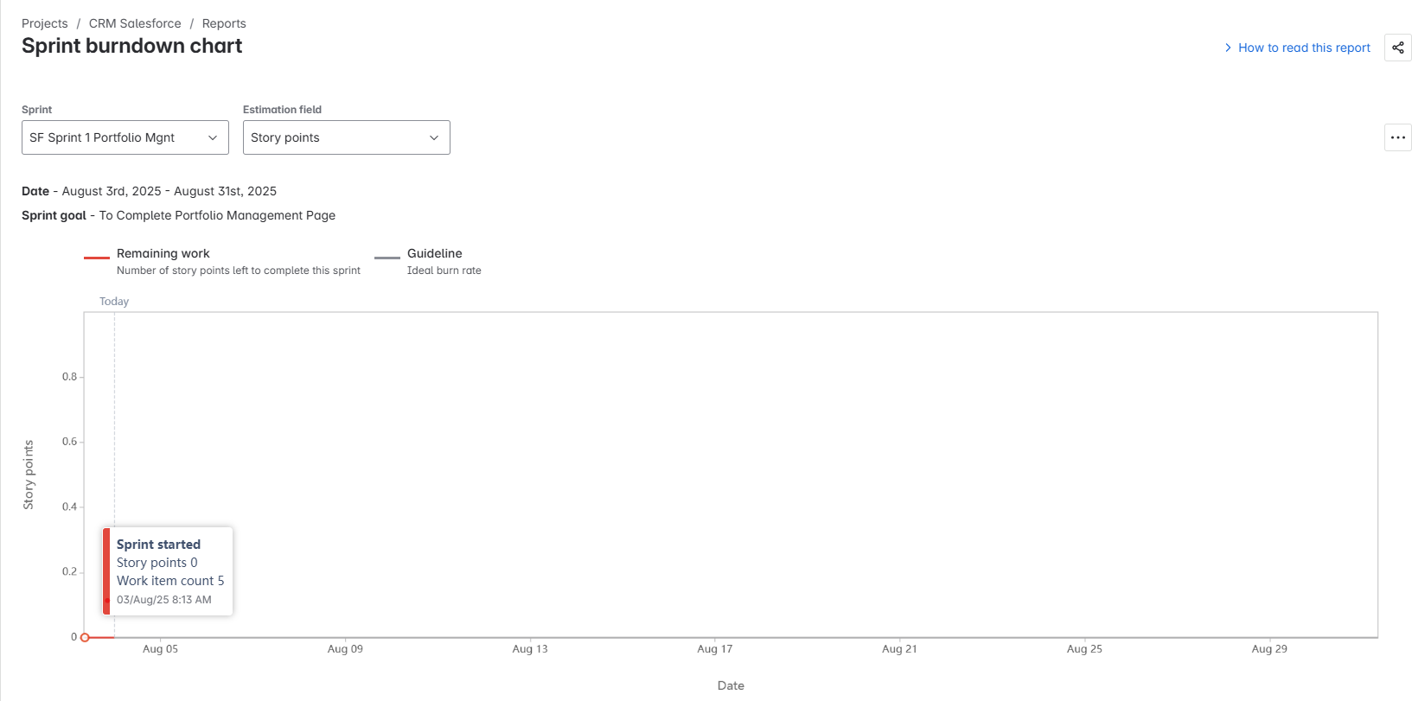
Sprint : Sprint 1|||| Estimation level : Work Item Count
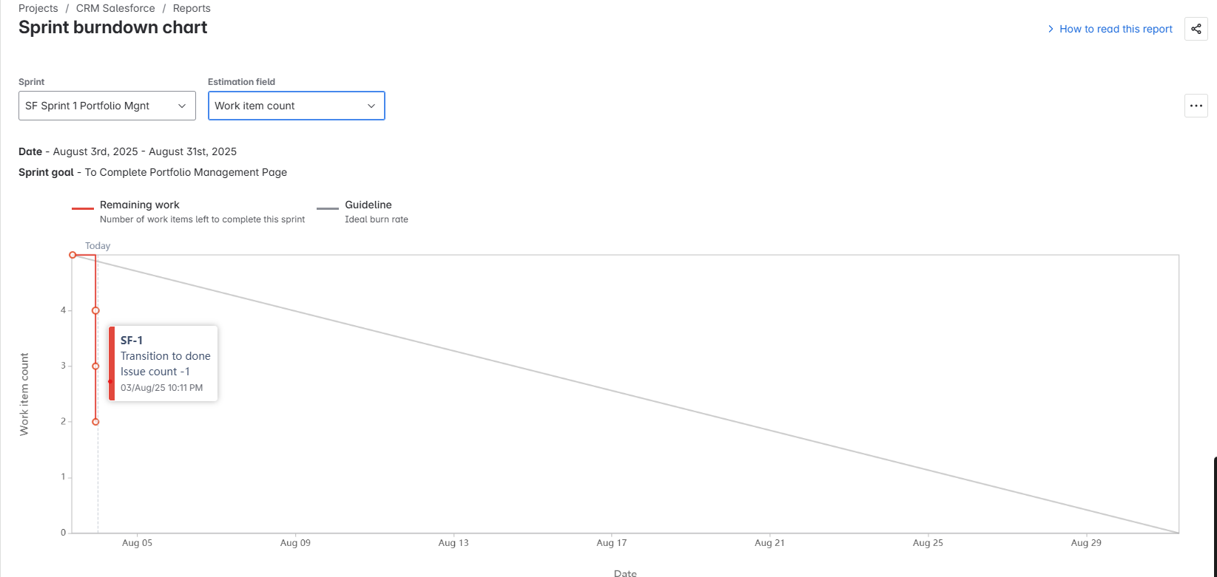

Sprint : Sprint 1|||| Estimation level : Time
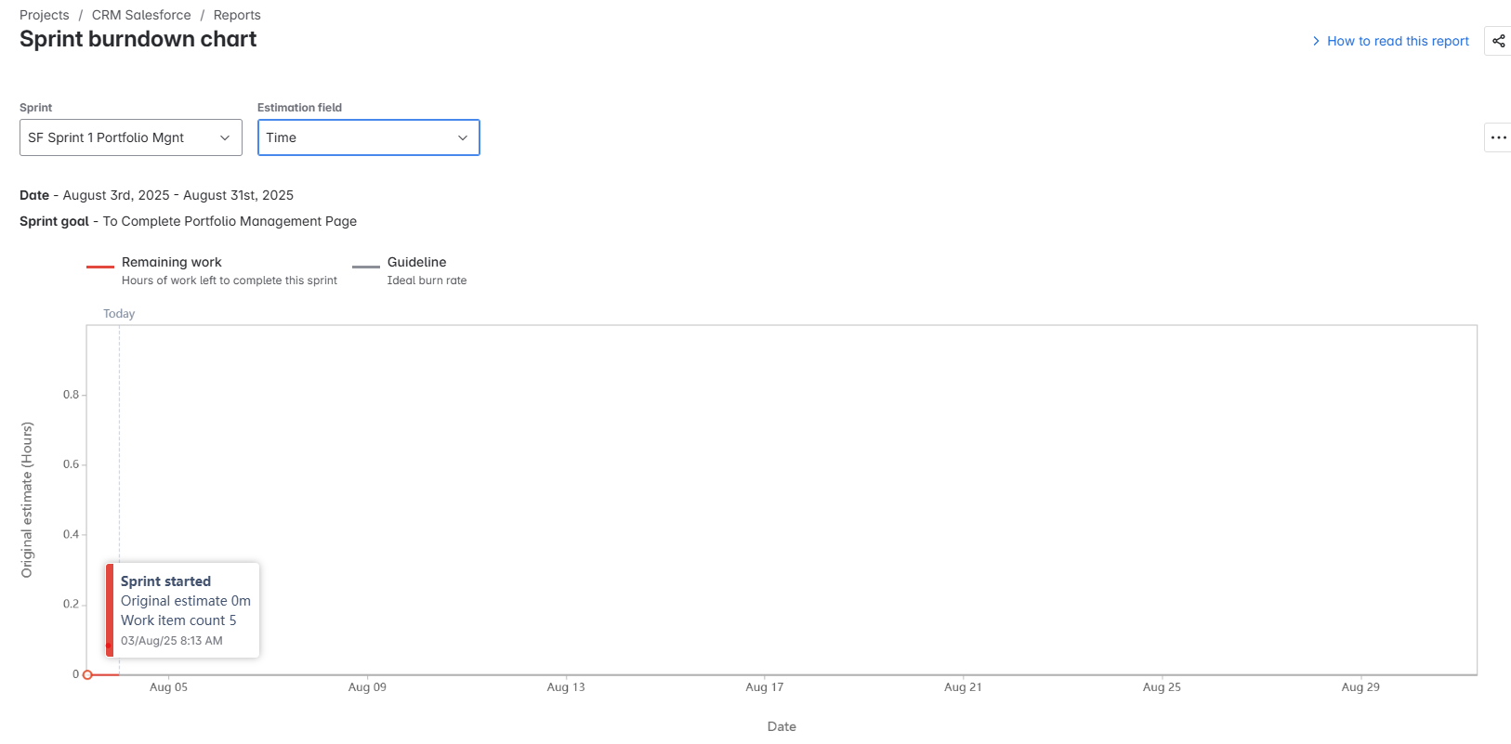
Sprint : Sprint 2|||| Estimation level : Story Points
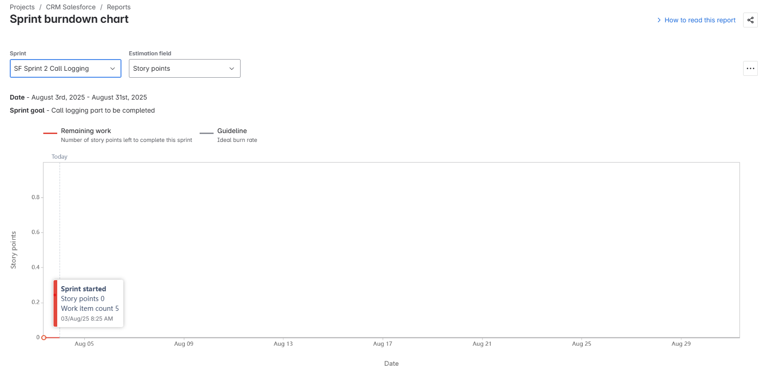
Sprint : Sprint 2|||| Estimation level : Work Item Counts
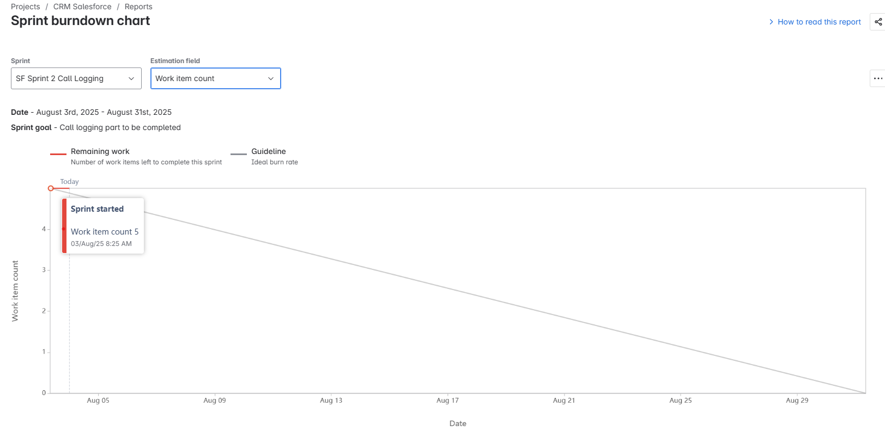
Sprint : Sprint 2|||| Estimation level : Time
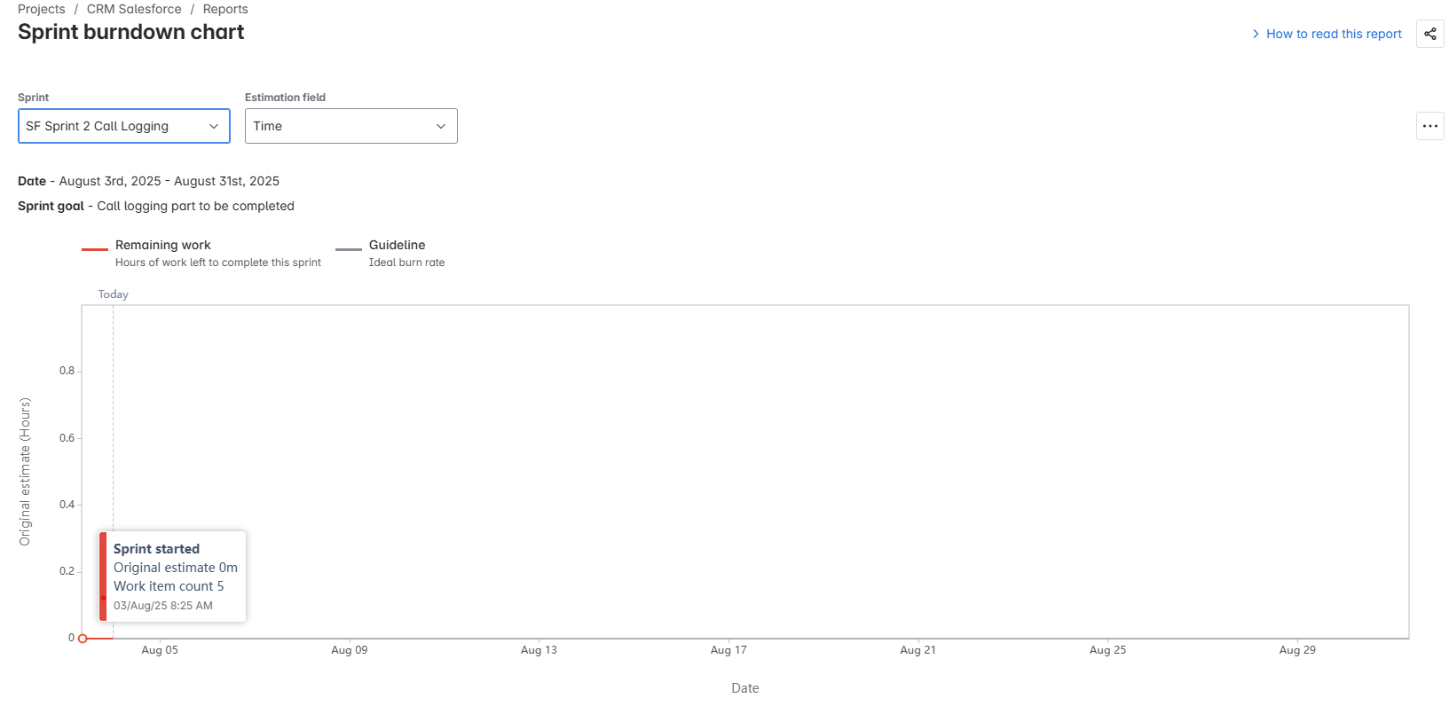
Sprint : Sprint 3|||| Estimation level : Story Points
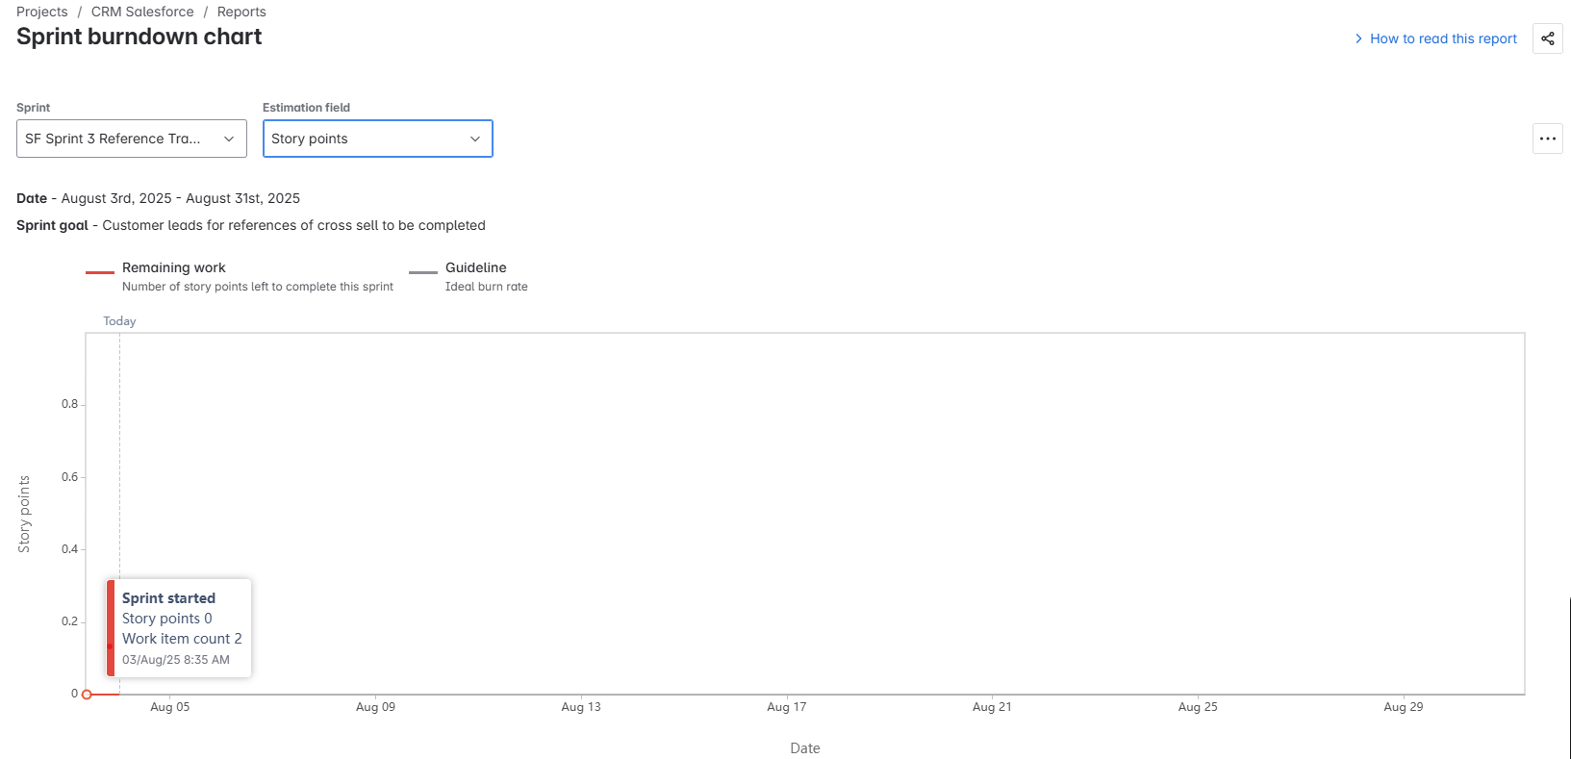
Sprint : Sprint 3|||| Estimation level : Work Item Count
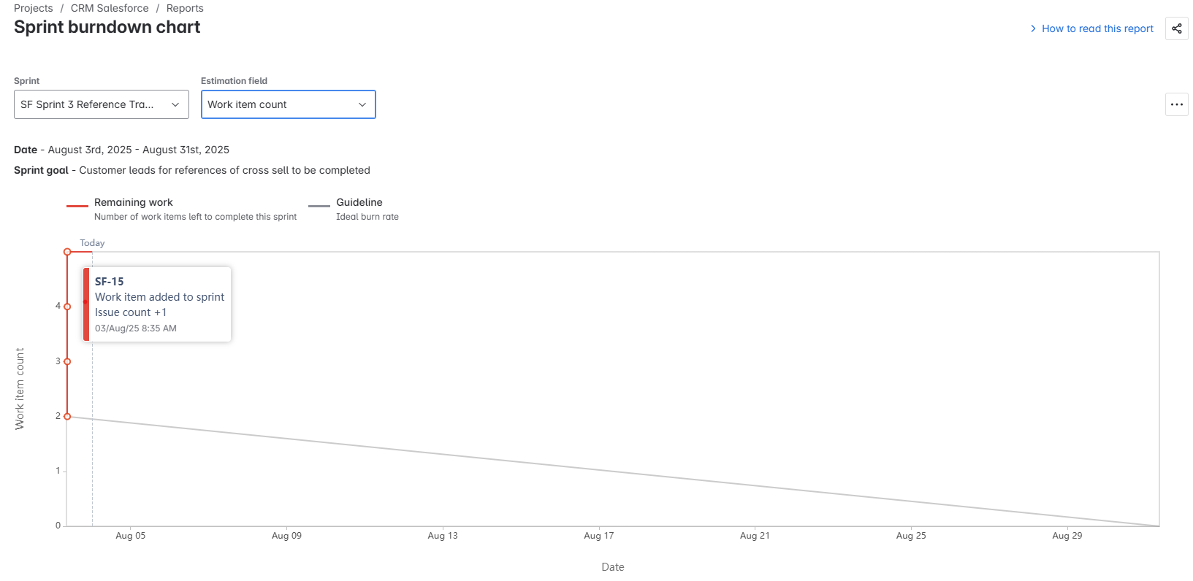
Sprint : Sprint 3|||| Estimation level : Time
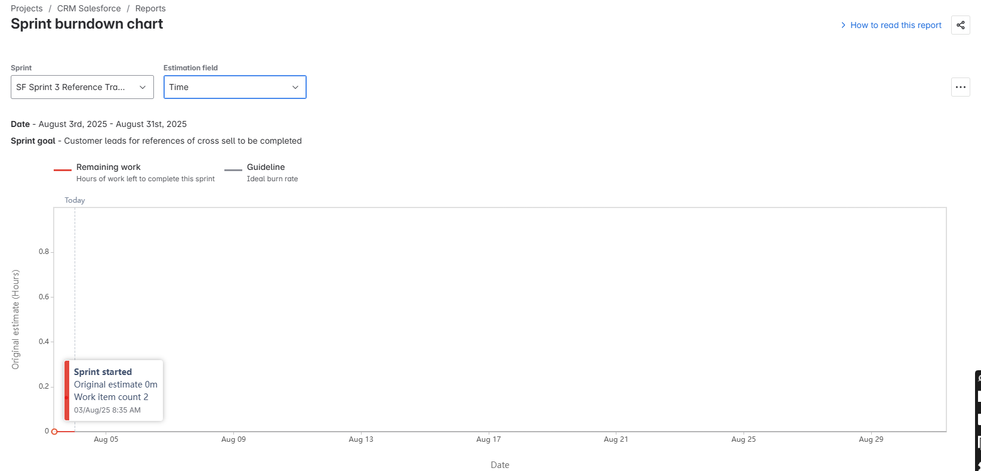
Sprint : Sprint 4|||| Estimation level : Story points
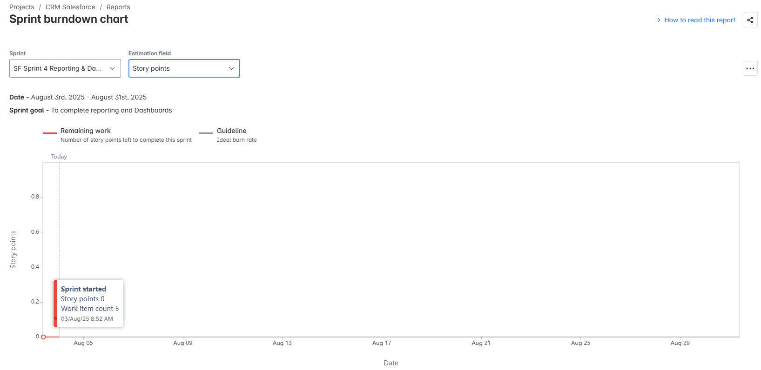
Sprint : Sprint 4|||| Estimation level : Work Item Count
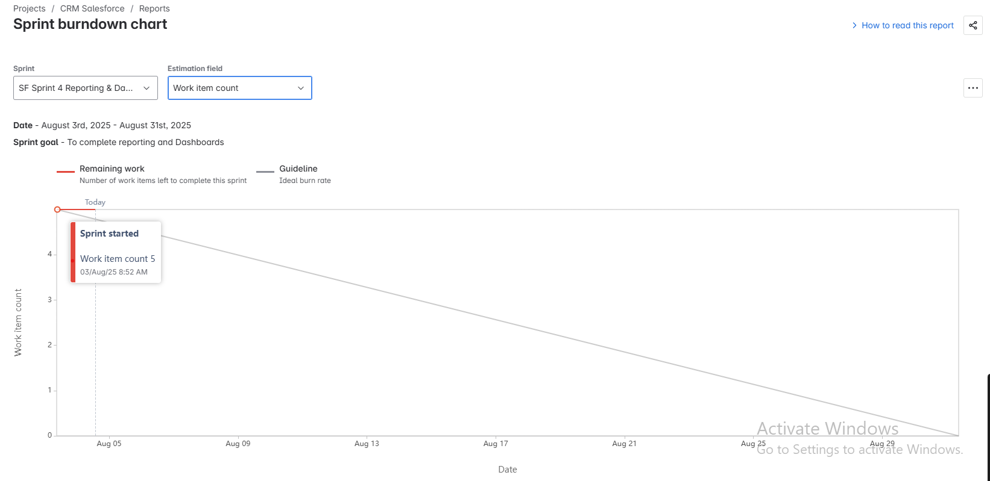
Sprint : Sprint 4|||| Estimation level : Time
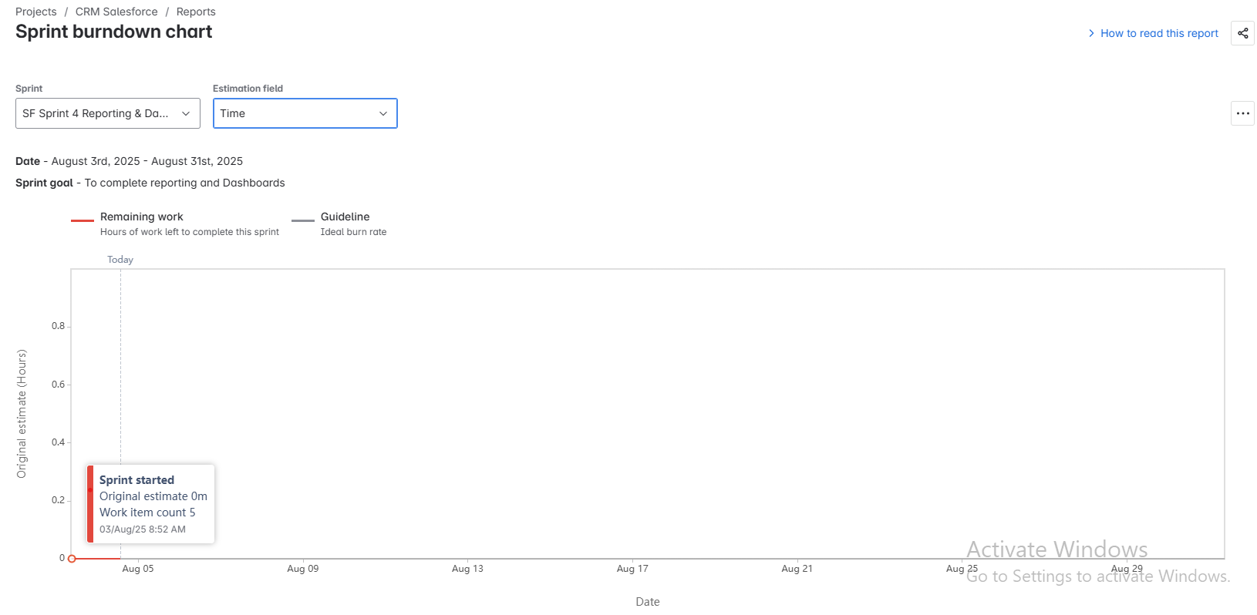

Product Backlog:
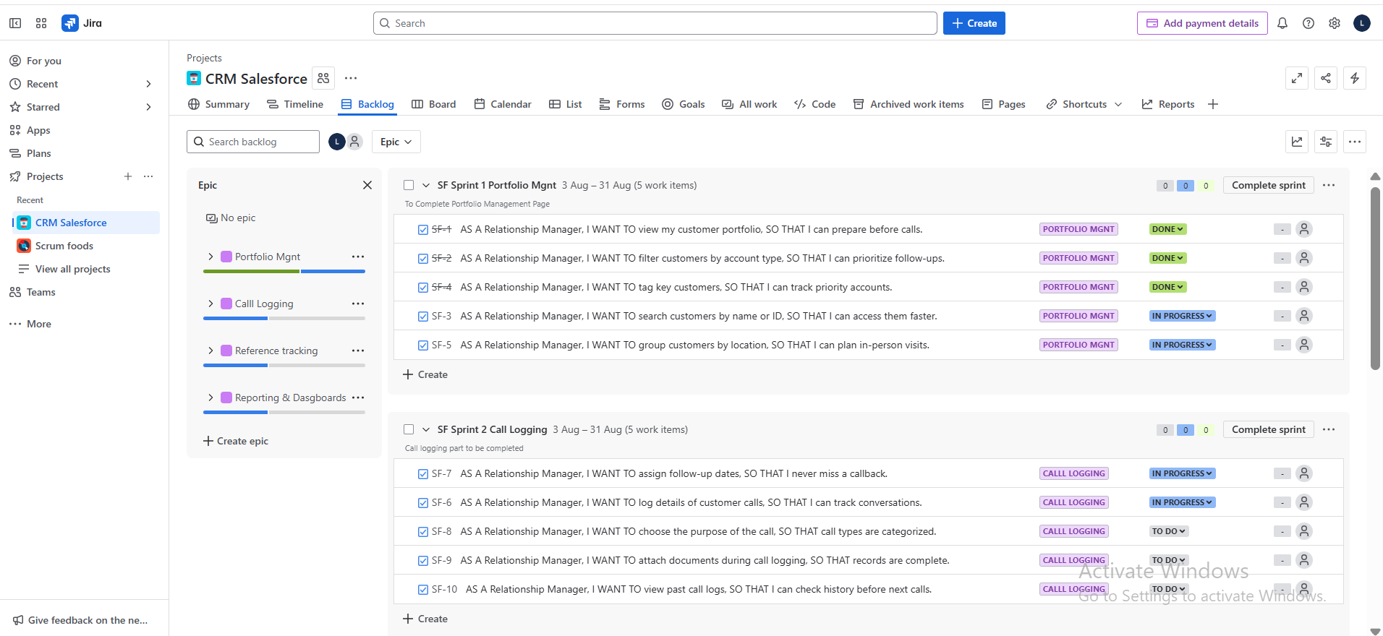

Product Backlog Board:
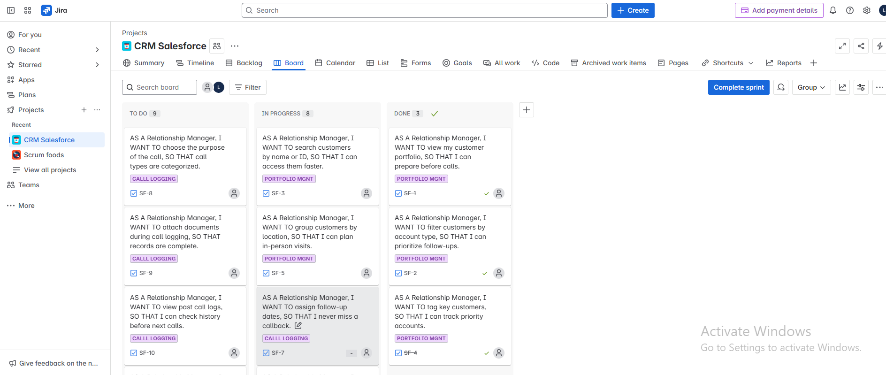
Document 6: Sprint Meetings
Meeting Type 1: Sprint Planning Meeting
Field | Details
Date | 5-Aug-25
Time | 10:00 AM – 11:30 AM
Location | Conference Room B / MS Teams
Prepared By | Surya Likhitha (Business Analyst)
Attendees | Scrum Master, Product Owner, Development Team, QA, BA

Agenda Topics
Topic | Presenter | Time Allotted
Review of Product Backlog | Product Owner | 20 mins
Sprint Goal Finalization | Scrum Master | 15 mins
Story Point Estimation (Planning Poker) | Scrum Team | 30 mins
Task Breakdown & Assignment | Development Team | 20 mins
Final Q&A / Clarifications | Entire Team | 5 mins
Other Information
Observers | Mr. Ravi (IT Head), Mr. Henry (Client Representative)
Resources | Jira board access, CRM Salesforce sandbox, sprint backlog
Special Notes | Sprint 1 to focus on Portfolio Viewing & Call Logging module
Meeting Type 2: Sprint Review Meeting
Field | Details
Date | 19- Aug- 2025
Time | 11:00 AM – 12:00 PM
Location | MS Teams / Conference Room A
Prepared By | Surya Likhitha (Business Analyst)
Attendees | Product Owner, Scrum Master, Development Team, QA, Stakeholders
Sprint Summary Table
Sprint Status | Things to Demo | Quick Updates | What’s Next
Sprint 1 completed successfully; 6/7 stories done | 1. Portfolio view screen  2. Customer detail popup  3. Add remark functionality | Minor UI enhancements requested by POBug fixed in remarks auto-save | Begin Sprint 2:- Reference Tracking module- Call logging analytics
Meeting Type 3: Sprint Retrospective Meeting
Field | Details
Date | 21-Aug-25
Time | 3:00 PM – 4:00 PM
Location | MS Teams / Agile War Room
Prepared By | Surya Likhitha (Business Analyst)
Attendees | Scrum Master, Product Owner, Dev Team, QA, Stakeholder Rep
Agenda Table
Agenda | What went well | What didn’t go well | Questions | Reference
Sprint 1 Review | Clear sprint goal and good collaboration across roles | Minor delays in UI integration due to late API responses | Can API dependencies be finalized earlier in Sprint 2? | Sprint Backlog Item #CRM-SP1-03
Retrospective Feedback | Product Owner appreciated RM portfolio demo | Few bugs discovered late due to skipped mid-sprint QA reviews | Can we add a mid-sprint QA check going forward? | QA Bug Tracker Entry #BUG-122
Planning Improvements | Estimations using Planning Poker were accurate and well-timed | No time buffer for last-minute change requests | Should we include buffer in sprint capacity planning? | Sprint Planning Doc – 05 Aug 2025
Meeting Type 4: Daily Stand-up meeting
Date | 22-Aug-25
Time | 10:00 AM – 10:15 AM
Location | MS Teams / Daily Scrum Channel
Prepared By | Surya Likhitha (Scrum Team Member)
Attendees | Scrum Master, PO, Dev Team, QA
Team Member Updates Format
Name | What I did yesterday | What I will do today | Blockers
Developer 1 | Completed Portfolio API integration | Start UI binding for Portfolio screen | Awaiting endpoint test access
Developer 2 | Created database schema for Call Log and Reference Data | Begin backend logic for saving remarks and references | Clarification needed on SA/CA flow
Developer 3 | Completed login and user authentication module | Integrate user session into dashboard access | Waiting for UI mockups confirmation
QA Analyst | Wrote test cases for Call Logging module | Begin functional testing | None
Product Owner | Reviewed Sprint 1 progress with stakeholders | Prepare demo notes for Sprint Review | Need final input on reference logic
BA (Likhitha) | Updated user stories and clarified acceptance criteria | Participate in sprint review prep | None

