Document 6 – Prepare a Use Case Diagram, Activity Diagram and a Use Case Specification document.
Use Case Diagram
LMS Use Case Diagram

Activity Diagrams
Access Course Material Activity Diagram

Student Book Evaluation Slot Activity Diagram

Trainer Evaluation Activity Diagram

Use Case Specification Document.
Use Case ID | UC001
Use Case Name | Book Evaluation Slot
Actors | Student (Primary), Trainer, System Administrator
Description | This use case describes how a student books a project evaluation slot through the LMS platform. The system displays available slots based on trainer availability, prevents scheduling conflicts, and sends notifications upon confirmation.
Pre - Condition | Student must be registered and logged into the LMS. Trainer’s availability schedule should be active in the system.
Post - Condition | The evaluation slot is successfully booked, notifications are sent to student and trainer, and booking details are updated in the system dashboard.
Basic Flow | Step 1: Student logs into the LMS.  Step 2: Navigates to the “Evaluation Slot Booking” section.  Step 3: System displays available slots from the trainer’s schedule.  Step 4: Student selects the preferred slot (date and time).  Step 5: System checks slot availability and confirms the booking.  Step 6: Confirmation message is displayed to the student.  Step 7: System sends email/SMS notifications to both student and trainer.  Step 8: Booking details are stored in the LMS database.  Step 9: Student can view booked slot under “My Schedule.”  Step 10: Basic flow ends here.
Alternate Flows | Step 1: If a selected slot is unavailable, the system displays “Slot not available, please choose another.”  Step 2: If no slots are available, the system provides a “Join Waitlist” option.  Step 3: Student can modify or cancel a booked slot before 24 hours of the evaluation time.
Exceptions | EF-1: Network disconnection during booking — system displays “Check your internet connection.”  EF-2: Database or server failure — system logs the error and notifies the administrator.  EF-3: Session timeout — user redirected to login page.
Frequency of Use | Medium to High (used by students for each course evaluation cycle).
Assumptions | - It is assumed that trainers regularly update their available time slots.  - It is assumed that students have stable internet access.  - It is assumed that notifications are properly configured in the LMS.

Use Case ID | UC002
Use Case Name | Attempt Assessment
Actors | Student (Primary), Trainer, System
Description | This use case describes how a student attempts an online assessment or quiz in the LMS. The system displays the assessment, evaluates objective questions automatically, and saves the submission for trainer review.
Pre - Condition | Student must be logged into the LMS and enrolled in the respective course. The assessment must be active and available.
Post - Condition | Student’s responses are successfully submitted, stored, and marked as “Completed.” System triggers auto-evaluation for objective questions.
Basic Flow | Step 1: Student logs into the LMS.  Step 2: Navigates to the “Assessments” section under their course.  Step 3: System displays list of available assessments.  Step 4: Student selects an active assessment and clicks “Start.”  Step 5: System loads questions one by one with a timer.  Step 6: Student answers and clicks “Submit.”  Step 7: System auto-evaluates objective questions and stores the results.  Step 8: Submission is marked as complete and sent to the trainer for review.
Alternate Flows | AF-1: If the student’s internet disconnects mid-assessment, the system auto-saves progress and allows resume.  AF-2: If time expires, the system auto-submits the assessment.  AF-3: If the student exits intentionally, the attempt is marked as “Incomplete.”
Exceptions | EF-1: Database or system crash — error logged and admin notified.  EF-2: Assessment not found — display “Assessment unavailable or expired.”
Frequency of Use | High — used frequently during course progression and evaluations.
Assumptions | - Student understands LMS navigation.  - Trainer has configured assessment questions correctly.  - System timer and auto-save functions are active.

Use Case ID | UC003
Use Case Name | View Feedback
Actors | Student (Primary), Trainer (Secondary), System
Description | This use case describes how a student views feedback and scores given by the trainer after evaluation. It helps students identify areas of improvement and track performance.
Pre - Condition | Trainer must have completed the evaluation and submitted feedback. Student must be logged into the LMS.
Post - Condition | Student successfully views the feedback, including grades, comments, and suggestions.
Basic Flow | Step 1: Student logs into the LMS.  Step 2: Navigates to the “Feedback” section under their course.  Step 3: System displays a list of completed assessments.  Step 4: Student selects an assessment to view detailed feedback.  Step 5: System displays trainer’s comments, marks, and overall grade.  Step 6: Student can optionally download or print feedback.  Step 7: Basic flow ends.
Alternate Flows | AF-1: If trainer feedback is not yet submitted, system shows “Feedback pending.”  AF-2: If student clicks an invalid assessment, show “No feedback available.”
Exceptions | EF-1: Network failure during fetch — display “Connection error.”  EF-2: Database fetch failure — system logs error and alerts admin.
Frequency of Use | Moderate — after each assessment or evaluation cycle.
Assumptions | - Trainer submits feedback in proper format.  - Student accesses feedback after evaluation completion.  - LMS has secure and updated records of grades.

Document 7- Learning Management System with Screens and pages by using Balsmiq Wireframes
- LMS Homepage
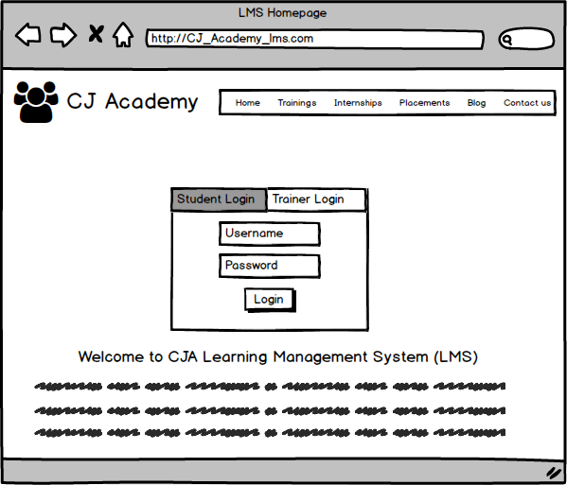
- My Course Page
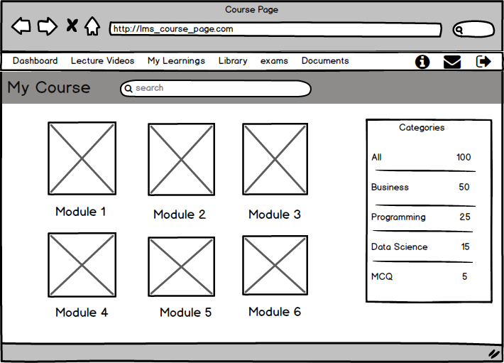
- Student Dashboard Page
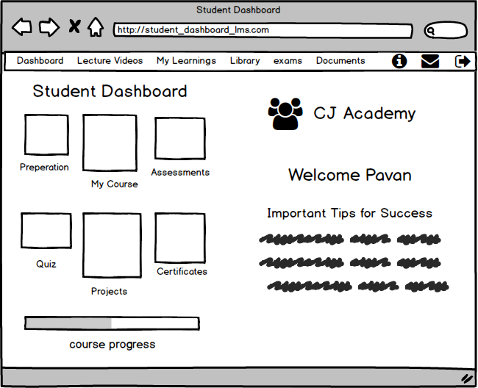

- Student Profile Page
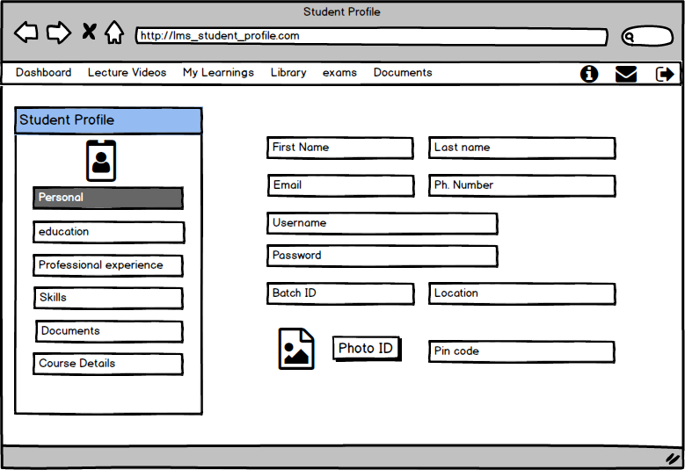

- Trainer Dashboard Page

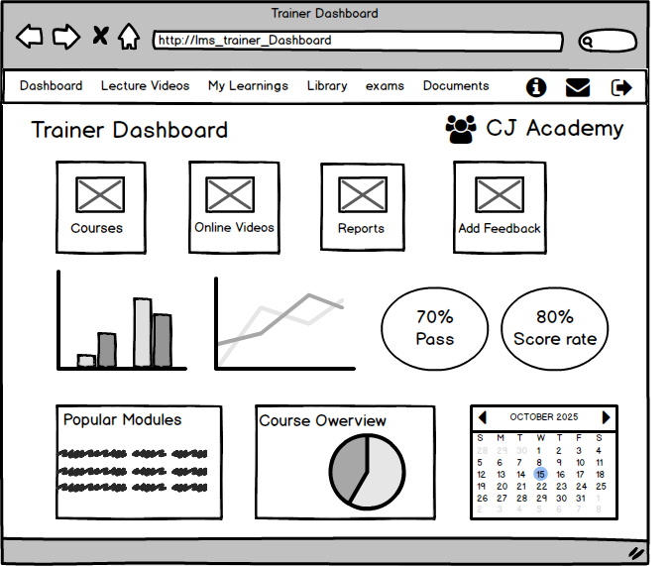

Document 8 – Tools Microsoft and Axure RP
Tools - Visio & Axure
Microsoft Visio and Axure RP were used in the design and planning phases of the LMS application. Microsoft Visio was primarily used to create UML diagrams, such as the Use Case Diagram and Activity Diagram. These diagrams helped in visually communicating the system’s functional flow to both technical and non-technical stakeholders. Visio's drag-and-drop interface and standardized UML shapes made it easier to accurately represent the interaction between users such as students, instructors, and administrators and the system. This visual clarity also helped the development and testing teams to better understand the process logic and user behavior, and it served as a valuable reference throughout development.
Axure RP was used to create basic wireframes for the LMS application, mainly to illustrate key screens like the homepage, course enrollment, content delivery, assessments, and grading. Although its use was limited, Axure helped provide a visual reference for stakeholders to understand the interface and overall navigation flow. This made it easier for them to give feedback on the layout and usability before development began.
Together, these tools supported clearer communication and better planning. Feedback from instructors, students, and other stakeholders could be quickly incorporated into the Visio diagrams or Axure wireframes, enabling iterative improvements. This ensured that the LMS design aligned with user expectations and educational requirements. By combining Visio’s structured modeling capabilities with basic interactive visualization in Axure, the team could effectively plan, demonstrate, and validate the system before actual development.

Document 9 – BA Experience
My Experience as a Business Analyst in LMS Project Phases
1. Requirement Gathering
- Used the MoSCoW prioritization technique to identify and classify LMS business needs into Must-Have, Should-Have, Could-Have, and Won’t-Have categories.
- During this phase, the client was not available at times. I proactively identified alternative Points of Contact (PoCs) from the client’s team, such as instructors and administrators, to continue gathering requirements without delays.
- To validate the quality of requirements, I used the FURPS model, ensuring LMS requirements met Functionality, Usability, Reliability, Performance, and Supportability criteria.
- Identified and removed redundant and duplicate requirements related to course management, assessments, and grading workflows to maintain clarity and avoid confusion.
- Used basic prototyping to present early-stage visual models of LMS interfaces and workflows, which helped stakeholders better understand functionalities such as course enrollment, content delivery, and assessment management.
2. Requirement Analysis
- Created UML diagrams (Use Case, Activity, Sequence diagrams) to visually represent and validate LMS system processes and interactions, including student enrollment, course progression, and grading.
- Developed Activity Diagrams to clearly show process flows and logic across different LMS modules, such as course creation, content publishing, and assessment tracking.
- Shared these diagrams with the internal team; collected feedback in case of disagreements or suggestions and iterated accordingly.
- Based on finalized requirements, prepared both the Business Requirements Specification (BRS) and System Requirements Specification (SRS) documents specifically for LMS functionalities.
3. Design Phase
- Translated use cases into test cases to validate that all LMS functionalities were covered.
- Maintained communication with the client to verify the proposed LMS solution design and clarified any points related to UI/UX for student and instructor interfaces.
- Developed both positive and negative test cases to ensure robustness of features like course enrollment, assessments, and reporting.
- Ensured no test case was missed, knowing that missed scenarios in LMS features could lead to major issues like incorrect grading or access problems.
- Developed test data for functional (e.g., course assignments) and non-functional validation (e.g., load testing for multiple users).
- Updated the Requirement Traceability Matrix (RTM) consistently to map each LMS requirement with corresponding test cases and ensure complete coverage.
4. Development Phase
- Conducted Joint Application Development (JAD) sessions involving both LMS stakeholders (administrators, instructors) and the development team for better alignment.
- Addressed developer queries efficiently and provided quick clarifications regarding LMS workflows and functional logic.
- Managed team conflicts or lack of cooperation through one-on-one discussions, emphasizing the impact on LMS project timelines and outcomes.
- Frequently referred to UML diagrams and SRS to ensure development aligned with agreed LMS requirements.
- Shared meeting recordings and conducted follow-ups for team members who missed sessions to ensure everyone stayed aligned.
5. Testing Phase
- Prepared test cases directly from approved LMS use cases.
- Participated in functional and high-level testing, checking system behavior, data integrity, and user experience for students, instructors, and administrators.
- Coordinated with the client to gather test data, such as sample course content, student records, and assessment results, for realistic testing scenarios.
- Updated RTM regularly to reflect testing progress and coverage.
- Obtained formal sign-off from the client upon successful validation of LMS functionalities.
- Prepared and guided the client team through User Acceptance Testing (UAT), ensuring all key LMS features—like course enrollment, content access, assessment submission, and grading—were tested before deployment.
6. Deployment Phase
- Submitted the updated RTM along with the Project Closure Document to the client.
- Coordinated preparation and delivery of End User Manuals tailored for students, instructors, and administrators for smooth adoption.
- Organized training sessions for end users, covering LMS features, navigation, and best practices.
- Ensured all relevant users attended the training and clarified any remaining doubts post-training to enable effective LMS usage.

