Live Project: Waterfall Deliverables – Part -2
Document 6- Please prepare a use case diagram, activity diagram and a use case specification document.
Ans : Use Case diagram -

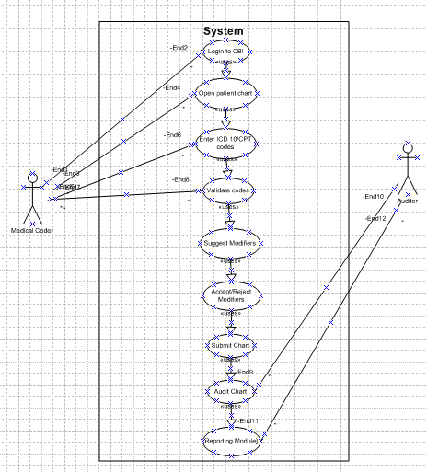
Activity diagram –
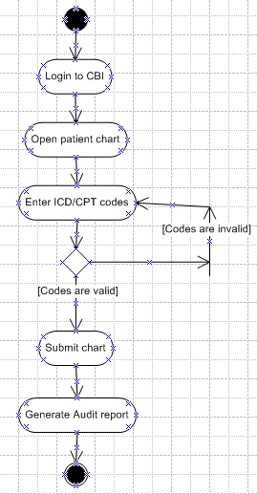

Use Case Specification Document – CBI Software

Section | Details
1. Use Case Name | Validate and Submit Patient Chart
2. Use Case Description | This use case describes how a medical coder uses the CBI system to enter ICD-10 and CPT codes, validate them, apply modifiers, and submit the chart. The system assists with real-time validation and suggestions.
3. Actors | Primary: Medical Coder  Secondary: CBI System, Auditor
4. Basic Flow | 1. Coder logs into the CBI system.  2. Opens a patient chart.  3. Enters ICD-10 and CPT codes.  4. System validates codes.  5. System suggests modifiers.  6. Coder accepts modifiers.  7. Submits chart.  8. Audit record is generated.
5. Alternate Flow | AF1: If coder rejects modifiers, they can override or request help.  AF2: System may suggest alternate modifiers.
6. Exceptional Flows | EF1: If invalid codes are entered, system shows an alert and prevents submission.  EF2: If session times out, user must re-login.
7. Pre-Conditions | - Coder must be logged in.  - Chart data must be available.
8. Post-Conditions | - Chart submitted for audit.  - Audit record saved.
9. Assumptions | - Coder is trained on CBI.  - Code database is updated.
10. Constraints | - Must follow healthcare coding standards.  - System must be online.
11. Dependencies | - Depends on CBI validation engine.  - Submission triggers audit workflow.
12. Inputs and Outputs | Inputs: ICD-10, CPT codes, chart info  Outputs: Validation results, modifier suggestions, submission status, audit log
13. Business Rules | - Modifiers must match guidelines.  - Codes must validate before submission.  - No duplicate chart allowed.
14. Miscellaneous Info | - All activity is logged.  - System sends notifications.

