CAPSTONE PROJECT-1 PART-2
Question 1: 4 Quarterly Audits are planned Q1, Q2, Q3, Q4 for this Project What is your knowledge on how these Audits will happen for a BA?
Answer: A quarterly audit is a financial or operational review conducted every three months to accesses the accuracy, performance and compliance of an organisation’s financial records, internal processes and systems.
It is performed to identify and address issues early, helping mitigating risks before they become larger problems.
Stage | Quarter 1- Audit Report  (Requirement Gathering phase)
Completed | 6 weeks (week 1 to week 6)
Check list | BRD (Business Requirements Document) template  Elicitation results report  Duplicate requirements report  Stakeholder Analysis  Initial Use cases / User stories  Gap Analysis Document

Stage | Quarter 2- Audit Report  (Requirement Analysis phase)
Completed | 5 weeks (week 6 to week 10)
Check list | FRD (Functional Requirement Document)  Prioritization Matrix  Traceability Matrix  Assumptions and Constraints  Feasibility Analysis Report  Stakeholder feedback Report

Stage | Quarter 3- Audit Report  (Design phase)
Completed | 6 weeks (week 11 to week 16)
Check list | UI/UX design Document  System Architecture Document  DFD (Data Flow Diagram)  Technical Design Specifications  Prototypes  Design Review Report  Risk Analysis Document

Stage | Quarter 4- Audit Report  (Development phase)
Completed | 10 weeks (week 17 to week 26)
Check list | Development Progress Report  Code Review Report  Integration Test Plan  Feature freeze sign-off  Deployment Plan  System Configuration Document

Stage | Quarter 1- Audit Report  (Testing phase)
Completed | 8 weeks (week 27 to week 34)
Check list | Test Cases & test Plan  UAT (User Acceptance Testing)  Bug Report & Issue Log  Performance Testing Report  Final Regression Testing Report  Deployment Checklists & Go-Live Sign-off  End-user Documentation

Question 2: Before the Project is going to Kick Start, The Committee asked Mr Karthik to submit BA Approach Strategy Write BA Approach strategy (As a business analyst, what are the steps that you would need to follow to complete a project – What Elicitation Techniques to apply, how to do Stakeholder Analysis RACI/ILS, What Documents to Write, What process to follow to Sign off on the Documents, How to take Approvals from the Client, What Communication Channels to establish n implement, How to Handle Change Requests, How to update the progress of the project to the Stakeholders, How to take signoff on the UAT- Client Project Acceptance Form )
Answer: A Business Analyst (BA) gathers requirements analyses business processes and facilitates communication between stakeholders. They help design solutions, document requirements, manage changes and assists in testing. BAs ensures the project aligns with business goals, supports implementation and provides ongoing monitoring to ensure the solution delivers.
A Business Analyst approaches strategy by:
- What Elicitation to apply?
- Interviews: Conduct one-to-one sessions with key stakeholders (farmers, manufactures) to gather detailed requirements.
- Questionnaires/Surveys: Distribute to a broader group of farmers to understand common points and needs.
- Workshops: Collaborative sessions with the committee (formed by Mr Henry, Mr Pandu, Mr Dooku), developers and stakeholders to define core features and functionality.
- Observation: Visit farms to observe workflows and identify areas where the application can provide value.
- Document Analysis: It reviews existing reports, manuals and any relevant documents from stakeholders like manufacturers or suppliers.
Why we do it:
To understand current processes, identify gaps, and extract requirements without starting from scratch.

- How to do Stakeholder Analysis RACI / ILS?
The RACI matrix is a project management tool that defines roles and responsibilities. It outlines who is Responsible (R), Accountable(A), Consulted(C) and Informed(I) for each task, ensuring clear communication and accountability among team members and stakeholders.
Responsible (R): Who does the work
Accountable(A): Who owns the outcome
Consulted(C): Who provides input
Informed(I): Who needs updates

Tasks | Mr Henry  (Sponsor) | Mr Pandu  (Functional Head) | Mr Dooku  (Project Coordinator) | Developers  (APT IT Solutions) | Farmers | PM  (APT IT Solutions)
Requirement Gathering | C | I | A | R | R | I
Functional Requirements | A | C | R | C | I | I
Design Approval | A | I | C | R | C | C
Development | I | I | I | R | I | A
User Testing | C | I | A | C | R | I
Go-live Approval | A | C | R | C | I | C

ILS (Integrated Logistic Support) is a management approach that ensures all support activities (like maintenance, training and documentation) are planned and coordinated to keep a system operational throughout its entire lifecycle.
- What documents to write?
The documents to write for this case study are:
- BRD (Business Requirement Document) – It clearly outlines the high-level business goals, objectives and the value the project will deliver.
- FRD (Functional Requirements Document) – It specifies the functionality of the system in detail, usually from the perspective of the users.
- NFRD (Non- Functional Requirements Document) – It covers performance, security, usability and scalability aspects.
- Wireframes/Prototypes- It provides a visual representation of the user interface.
- DFD (Data Flow Diagrams)- It is a visual representation of how data moves within the system.
- User Acceptance criteria- It defines the conditions under which the system will be accepted by stakeholders.
- Change management plan- This document outlines how changes to the project’s scope, requirements or deliverables will be managed.
- Risk Management Plan- Identifies potential risks and outlines strategies for mitigating them.
- Traceability Matrix- Ensures that all requirements are mapped to their corresponding deliverables and tests.
- Test Plan- Defines the testing approach and criteria for validating system functionality.
- Deployment Plan- Describes how the system will be rolled out to end users.

- What process to follow to sign off on the documents?
Sign-off is a critical part of ensuring all stakeholders are aligned and agree on the scope, expectations and deliverables outlines in the documents. The sign-off process formalizes the approval of the documentation and ensures that the project moves forward with everyone’s consent. The process for signing off on documents are:
- Prepare Final Draft: Ensure the document is complete, accurate and clear. Conduct internal review with project team.
- Circulate for Review: Distribute the finalizes document to stakeholders and set a clear review period.
- Collect Feedback: Collect feedback after review and make revisions, if needed.
- Approval Request: Send final version with clear due date for sign-off to stakeholder who is accountable.
- Get formal Sign-off: Use tools like DocuSign, email confirmation to get approver’s approval. Confirm they have reviewed and accepted the document as final.
- Archive: After approval, keep signed document in a secured, shared location (e.g., Share point) and make it accessible to all relevant team members for reference.

- How to take approvals from the client?
Taking approvals from the client is a critical part of the project lifecycle, especially when it comes to ensuring that the project meets expectations and stays on track. There are few approaches to take approvals effectively:
- Establish Clear Communication
- Define approval process from the start
- Prepare for approvals with documents (like BRD, FRD, UI/UX mock-ups)
- Ensure Client’s concerns are addressed
- Get written approvals
- Client Sign-off for Each stage
- Manage Risks and Delays
- Closure of the approval process

- What communication Channels to establish in implement?
To implement an effective communication strategy for a project, it’s important to establish clear and reliable communication channels that allow smooth interactions between all stakeholders, including the client (Mr Henry and the committee), internal team members (APT IT Solutions), and any other key participants.
- Project Management Tools like Jira
- Email communication
- Instant Messaging like Microsoft Teams, Virtual Meetings like Zoom, Teams, Google meet
- Document Sharing & Collaboration tools like Google Drive,
- Issue Tracking & Bug Reporting Tools
- Weekly/Monthly Status Reports
- Client Feedback Tools like Google Forms

- How to handle change request?
A Change Request is a formal proposal to modify a project’s scope, requirements, timeline or deliverables after approval. It goes through review, impact analysis and approval before being implemented. The steps to handle change request are:
- Capture Request: Use a simple form to record the change details
- Acknowledge the request: Confirm receipt and set a feedback timeline.
- Evaluate the change: Assess impact on scope, time, cost and risks
- Communicate Decision: Decide whether the change is to be Approved, Rejected or Deferred
- Formal Approval: Get a sign-off before proceeding
- Implement the change: Make changes, update documentation and perform testing to ensure it works as expected.
- Monitor & Close: Monitor the change’s impact on the project once complete, formally close the request.

- How to update the progress of the project to the stakeholder?
- Choose the right medium of communication like email, meetings and project management.
- Provide key metrics which includes Completed tasks, current progress, upcoming milestones, time or delivery status, risks or issues.
- Use Visuals like Gantt charts, Burndown Charts and tasks boards.
- Be concise by keeping updates clear, to the point and avoid overloading with technical details.
- Request feedback by asking questions to stakeholders for their inputs or concerns after update.
- How to take signoff on the UAT-Client Project Acceptance Form?
UAT Client Project Acceptance Form is a document signed by Client after successful deployment of project in UAT (User Acceptance Testing). To take sign-off on a UAT Client Project Acceptance Form, follow these steps:
- Prepare UAT Client Acceptance form by including project details, UAT results, Acceptance Criteria and Sign-off section.
- Review UAT outcomes with the client by walking through test cases and outcomes.
- Confirm Client’s satisfaction by ensuring the client is happy with the results.
- Request Sign-off by asking the client to sign the form if they are satisfied.
- Distribute the signed form with the client and keep a copy for records.

Question 3: Explain and illustrate 3-tier architecture?
Answer: The 3-Tier architecture is a software design pattern that separates the system into three distinct layers or tiers. These layers help organise the application for better scalability, maintainability and separation of concerns. The three tiers are:
- Application/Presentation Layer
This is the front-end layer where the user interacts with the application. It handles all user input and displays the output from the system.
It includes screens, pages, validations on page, company specific logic, functionality (e.g., E-commerce website).

- Business Logic Layer
This middle layer processes business logic and handles core functionality of the application. It communicates between the presentation layer/client tier and the database layer, ensuring proper data flow and processing.
It includes all Re-useable components, frequently changing components, Governing bodies rules & regulations, Compliances. (e.g., Printers, payment gateways, mail servers, RBI rules for banks).
- Database Layer
This layer is responsible for storing, retrieving and managing data. It interacts directly with the database or other storage systems.
It includes Database components connecting to Databases (e.g., MySQL, PostgreSQL)

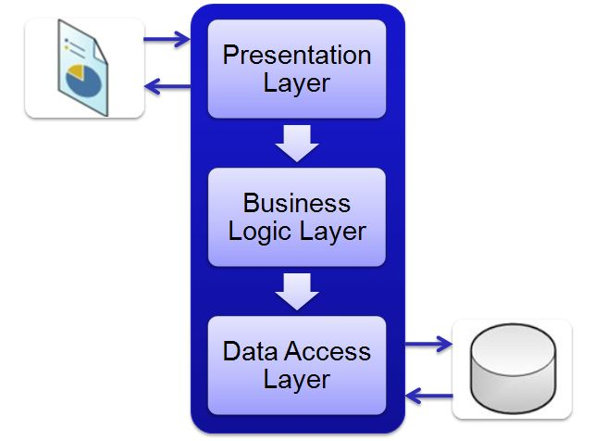
3-Tier Architecture

Question 4: Business Analyst should keep What points in his/her mind before he frames a Question to ask to the Stakeholder (5W 1H – SMART – RACI – 3 Tier Architecture – Use Cases, Use case Specs, Activity Diagrams, Models, Page designs)
Answer: Framing effective questions is key to gathering valuable information, particularly in a business analysis context. The strategy for framing questions should focus on clarity, relevance and purpose. There are some points that you should keep in mind before framing questions, here is how to approach it,
- 5W1H Framework
This framework is a set of questions used for gathering information, analysing situations, or problem-solving. It helps ensure that you cover all aspects of a problem or topic by addressing key details.
W- What is the goal of this project?
W- Who are my primary stakeholders in this project?
W- When is the solution expected to be implemented?
W- Why is this feature necessary for the client?
H- How will this feature be implemented technically?
- SMART Technique
This technique is a goal-setting framework that helps in defining clear and achievable objectives. It ensures that goals are well-defined and measurable.
S (Specific)- Goals should be clear and specific.
M (Measurable)- Goals should be quantifiable.
A (Achievable) – Goals should be realistic and attainable.
R (Relevant)- Goals should be aligned with business objectives.
T (Time Bound)- Goals should have a clear deadline.
- RACI Chart
A RACI Chart is a responsibility assignment matrix that helps clarify roles and responsibilities within a project. It defines who is Responsible, Accountable, Consulted and Informed for each task or decision.
R (Responsible) -The person who is responsible for the task/work.
A (Accountable)-The person who is accountable for the task completion and has decision making authority.
C (Consulted)-The person who need to be consulted for their expertise and feedback.
I (Informed)-The person who need to be kept updated on progress and decisions but aren’t directly involved in the task.

- 3 Tier Architecture
The 3-Tier architecture is a software design pattern that separates the system into three distinct layers or tiers which are Application Layer, Business Layer, Database Layer. These layers help organise the application for better scalability, maintainability and separation of concerns.

- UML diagrams
A set of diagrams used to visually model systems and their components (Use case, Use Case spec, Activity diagram)
Use case- A use case defines a specific interaction between a user (actor) and the system to achieve a goal.
Use case Spec- A use case specification provides detailed descriptions of each use case including actors, steps, Inputs and expected outcomes.
Activity Diagram- An activity diagram illustrates the workflow of activities, decisions and parallel processes in a system, showing the sequence of operations.
- Models
A conceptual representation of a system, process or concept used to understand, visualise real world scenarios.
Data model- It defines how data is structured and related within the system.
Process model- It describes how business processes flow and interact.
Entity relationship model- It visually represents entities and their relationship in a system.

- Screen/ Page designs
It refers to the visual layout and structure of user interfaces, focusing on how elements like test, buttons and images are arranged to enhance usability.
Wireframes- Basic blueprint showing the layout of a screen without design details.
Prototypes- Interactives models stimulating the behaviour and flow of a system.
UI Flow diagrams- It shows how a user navigates through an application or website.

- Sign-offs (Confirmation) should be taken on all documents, diagrams, SDLC stages from responsible stakeholders

- Any information which you gather should fit into any of sections (iv, v, vi, vii) describes otherwise it is just an information or non-functional requirements

Question 5: As a Business Analyst, What Elicitation Techniques you are aware of? (BDRFOWJIPQU)
Answer: Elicitation techniques are methods used by BAs to gather information, requirements and insights from stakeholders. These techniques help in understanding needs, problems and expectations to ensure a successful project outcome. There are 11 elicitation techniques, and they are:
- Brainstorming – It is a group-based technique to generate ideas, solutions or features through open discussion.
- Document Analysis – Reviewing existing documents (e.g., business plans, reports, user manuals) to gather insights and requirements.
- Reverse Engineering – The process of extracting knowledge or design information from anything man-made and re-producing it. It involves disassembling something and analysing its components and working in detail.
- Focus Groups – They are small group discussions to obtain feedback on concepts, ideas or prototypes.
- Observation – It is like watching users interact with systems or processes to identify pain points, inefficiencies or improvements.
- Workshops – A collaborative sessions with stakeholders to define, prioritize and clarify requirements and expectations.
- JAD (Joint Application Development) – A structured workshop format involving key stakeholders, developers and users to define requirements and make decisions collaboratively.
- Interviews – It is a one-on-one or group discussions with stakeholders to gather detailed requirements and insights.
- Prototyping – Creating mock ups or models of systems to gather feedback and refine requirements through iterative testing.
- Questionnaires / Survey – It is a structured forms with predefined questions to collect responses from large group of people.
- Use Case specs – A use case specification provides detailed descriptions of each use case including actors, steps, Inputs and expected outcomes.

Question 6: Which Elicitation Techniques can be used in this Project and Justify your selection of Elicitation Techniques? Prototyping Use case Specs Document Analysis Brainstorming
Answer: Elicitation techniques can be used in this project are as follows:
- Workshops: The project involves multiple stakeholders, including Mr. Henry, the committee and farmers (Peter, Kevin, Ben). It provides a platform for all these stakeholders to come together, discuss their needs and refine project requirements in a collaborative way. This is crucial for gathering diverse inputs on functionality and user experience, ensuring alignment with business goals.
- Prototyping: Since this is an online platform for farmers, a prototype would allow the stakeholders (including farmers who may not be yech-savvy) to interact with an early version of the app. Feedback on prototype will help shape the final design, identify usability issues and ensure the app meets farmers needs before full-scale development.

- Interviews: Interviews with key stakeholders like Mr Henry, the farmers and manufactures are essential to gather detailed and personalised insights. These interviews will help understand specific pain points (e.g., fertilizer procurement, seed buying issues) and requirements. They are especially useful for understanding individual concerns and needs that may not be addressed in group settings like workshops.
- Document Analysis: Reviewing the project proposal, budget (2 Crores INR), CSR initiative details and any relevant documents will ensure that the system is aligned with business goals and the requirements set by the committee. It helps ensure the technical and functional specifications are in line with the business context and any regulatory or funding constraints.
- Focus groups: Focus groups with farmers will provide insights into the features that are most useful to them. It will allow for an in-dept discussion of their challenges with accessing fertilizers, seeds and pesticides and what solutions they expect from the platform. These insights are the key to ensuring the platform servers its purpose effectively.
- Use case Specs: They provide detailed descriptions of user interactions with the system, covering not only the main flows but also exceptions, system responses and pre/post conditions. Given the complexity of an online agriculture product store, this level of details ensures that all possible user actions (browsing, ordering, payments etc) are clearly defined, helping to guide development and testing while ensuring the system meets both functional and user expectations.
- JAD sessions: This session would bring together Mr Henry, Mr Pandu, Mr Dooku and the APT IT Solutions team for in-depth discussions about the system’s functionalities, scope and design. This ensures that the project’s direction is well-aligned with business goals, reducing the risk of scope creep or misunderstanding later in the project.

Question 7: Make suitable Assumptions and identify at least 10 Business Requirements.
Answer: Business Requirements defines what business intends to accomplish and serve as the foundation for designing and developing a system, ensuring it aligns with business objectives.
Business Requirements
BR001: Farmers should be able to search for available products in fertilizers, seeds and pesticides.
BR002: Manufactures should be able to upload and display their products in the application, including product details like name, description, price and quantity.
BR003: Farmers must create an account using their email ID and a secure password to access the application and make purchase.
BR004: Farmers should be able to log in with their email and password to view their order history and buy products.
BR005: The system should allow farmers to add products to a “Buy Later” list before making a purchase.
BR006: The application must provide a secure payment gateway supporting multiple payment methods, including Cash on Delivery (COD), Credit/Debit cards and UPI.
BR007: Upon successful payment, the platform must send an email confirmation to the farmer with the order status and estimated delivery time.
BR008: Farmers should be able to track the delivery status of their order through a delivery tracking system integrated into the application.
BR009: The product catalogue should be easy to navigate and filter by categories (fertilizers, seeds, pesticides) for a better user experience.
BR010: The application should display real-time availability of products, ensuring farmers can see only available products in the catalogue.
BR011: The platform should allow manufacturers to update product details, including inventory quantity, pricing and product description in real-time.
BR012: The platform should be mobile responsive to ensure easy access for farmers in remote areas with limited internet connectivity.

Question 8: List your assumptions
Answers:
- User Authentication: Each user (farmer or manufacturer) needs to authenticate themselves through secure login credentials (email and password).
- Product Availability: Products from manufactures (fertilizers, seeds, pesticides) are regularly updated and managed by the manufacturers.
- Payment Gateway: The payment process is secure, supporting multiple payment methods such as COD, Credit/Debit cards and UPI.
- Delivery Process: Delivery will be tracked through an integrated delivery tracking system providing updates to customers.
- Notification System: The system will send email notifications for order confirmation, payment status and delivery updates.
- Search and Catalogue Management: The product catalogue will allow farmers to search for specific products by category (fertilizers, seeds, pesticides) and also have filtering options to sort products by factors like price, rating and availability.
- User Roles: There are two primary roles farmers (buyers) and Manufactures (sellers). Farmers have browsing, searching and buying capabilities, while manufactures can upload and manage their product details.
- Security: The platform will ensure data security for user information, especially login credentials, payment details and personal data. User account and payment details will be secured through encryption and proper authorization protocols.
- User Interface and Experience: The platform will be user-friendly, mobile responsive and designed to be easy to navigate by farmers, even if they are not familiar with technology.

Question 9: Give Priority 1 to 10 numbers (1 being low priority – 10 being high priority) to these Requirements after discussions with the stakeholders

Answer:
Req ID | Req Name | Req Description | Priority
BR001 | Product Search for farmers | Farmers should be able to search for available products in fertilizers, seeds and pesticides. | 9
BR002 | Product uploaded by manufactures | Manufactures should be able to upload and display their products in the application, including product details like name, description, price and quantity. | 8
BR003 | Farmer’s Account creation | Farmers must create an account using their email ID and a secure password to access the application and make purchase. | 7
BR004 | Login for farmers | Farmers should be able to log in with their email and password to view their order history and buy products. | 8
BR005 | Buy-Later list | The system should allow farmers to add products to a “Buy Later” list before making a purchase. | 6
BR006 | Secure Payment Gateway | The application must provide a secure payment gateway supporting multiple payment methods, including Cash on Delivery (COD), Credit/Debit cards and UPI. | 10
BR007 | Email Order Confirmation | Upon successful payment, the platform must send an email confirmation to the farmer with the order status and estimated delivery time. | 7
BR008 | Delivery Tracking | Farmers should be able to track the delivery status of their order through a delivery tracking system integrated into the application. | 8
BR009 | Easy to Navigate Product Catalogue | The product catalogue should be easy to navigate and filter by categories (fertilizers, seeds, pesticides) for a better user experience. | 7
BR010 | Real-time Product availability | The application should display real-time availability of products, ensuring farmers can see only available products in the catalogue. | 9
BR011 | Manufacturer Product Management | The platform should allow manufacturers to update product details, including inventory quantity, pricing and product description in real-time. | 8
BR012 | Mobile Responsiveness | The platform should be mobile responsive to ensure easy access for farmers in remote areas with limited internet connectivity. | 6

Question 10: Draw use case diagram
Answer:
Use case Diagram is a UML diagram that visually depicts the system’s boundary, the external actors interacting with it and high-level functions (use cases) they perform highlighting relationships like include, exclude and associations between actors and use cases.
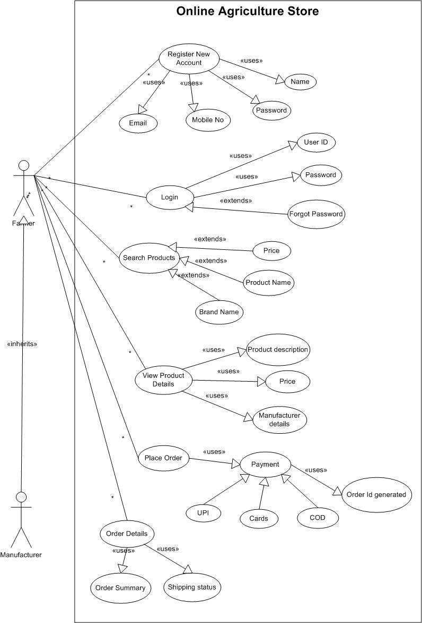
Question 11: Prepare use case specs for all use cases
Answer: Use case specification is a document that explains a single use case in detail, covering its purpose, involved actors, pre conditions, main flow, alternate flow, postconditions, exceptions and any special requirements to fully describe the user-system interaction.
- Use Case 1: Register New Account
Description:
Allows farmers, manufactures to create an account by providing personal details. System validates and stores them in database.
Actors:
Farmer, Manufacturer
Pre-condition:
- User has internet access
- System is running and accessible
Post-Condition:
- User is created and stored with unique identifier
Basic Flow:
- User opens the application.
- User selects “Register”.
- For registration: User provides required details (name, mobile number, email, password).
- System validates details and creates an account.
- For login, User enters credentials.
- System Validates credentials.
- User is redirected to the dashboard.
Alternate Flow:
- User chooses mobile OTP based login
Exceptional Flow:
- If Duplicate email during registration, then prompt to log in.
Assumptions:
Users have unique email Id
Constraints:
Password must meet security
Dependencies:
Authentication service must be available
Inputs:
Name, Password, Mobile number, email
Outputs:
Registration success message
Business Rules:
Unique email id, mobile number verified, password encrypted
Misc Info:
Mobile OTP is valid for 5 minutes
Supports password reset functionality.
Account locked after 3 failed attempts

- Use Case 2: Login
Description:
Enables registered user to access their account
Actors:
Farmers, Manufacturer
Pre-condition:
- User must have valid account credentials
Post-Condition:
- User is logged into the system
Basic Flow:
- User selects “Login”
- System displays login form
- User enters credentials
- System validates credentials
- User logged into account dashboard
Alternate Flow:
- If user enters incorrect password, then allow retry up to 3 attempts
- If user selects forgot password, then it redirects to reset password
Exceptional Flow:
- If Invalid credentials, then shows error message
Assumptions:
User knows credentials
Constraints:
Maximum 3 attempts before temporary lock
Dependencies:
Authentication service, database
Inputs:
User id, Password
Outputs:
Access to account dashboard
Business Rules:
Password encryption during validation
Misc Info:
Supports two factor authentication

- Use Case 3: Search Products
Description:
Farmers can browse all available products in the store.
Actors:
Farmers
Pre-condition:
- User is logged in.
Post-Condition:
- List of products is displayed to the user.
Basic Flow:
- User navigates to the product catalogue.
- System displays search bar with filters such brand name, product name and price.
- User can click a product to view its details.
Alternate Flow:
In case of No products found then it will show “No products available” message
Exceptional Flow:
Search service unavailable
Assumptions:
Products are added up to date to the listing.
Constraints:
System should display products within 3 seconds of request.
Dependencies:
Product database must be available
Inputs:
User typing on Search or using filter/search criteria
Outputs:
List of products with details
Business Rules:
Only registered manufactures can list the products
Misc Info:
Supports pagination for large catalogues
- Use Case 4: View Product Details
Description:
Displays detailed information about a selected product
Actors:
Farmer, Manufacturer
Pre-condition:
- User has selected a product from search results
Post-Condition:
- Product details like product description, price, manufacturer details are displayed
Basic Flow:
- User clicks on a product.
- System fetches details such as product description, price, manufacturer details.
- Details are displayed to the user
Alternate Flow:
- If Manufacturer details is unavailable, then only product description, price are shown
Exceptional Flow:
- If product is no longer available, then system shows “No product found”
Assumptions:
- Product data is complete
Constraints:
- Must display within 3 seconds
Dependencies:
- Product database
Inputs:
Product id
Outputs:
Product details page
Business Rules:
Prices must include applicable taxes
Misc Info:
Product images must be shown in high resolution
- Use Case 5: Place Order
Description:
User selects a product and places an order.
Actors:
Farmer
Pre-condition:
- Farmer is logged in
- Product is available in stock.
Post-Condition:
- Order is created and payment is processed
Basic Flow:
- User selects a product from the catalogue.
- User clicks “Buy now”
- System displays order summary
- User selects payment method and confirms order
- System processes payment
- System generated Order Id
- System confirms order and sends confirmation
Alternate Flow:
- User adds product to cart for later purchase
Exceptional Flow:
- In case of payment failure, it will show error and allow retry
- In case of product out of stock, it will show “out of stock” message and prevent order.
Assumptions:
- Payment gateway is integrated
Constraints:
- Payment must complete within 5 minutes of initiation
Dependencies:
- Inventory and payment services
Inputs:
- Product selection, payment details
Outputs:
- Order confirmation, Order ID
Business Rules:
Order placed for only available products
Misc Info:
Supports Cash on delivery option

- Use Case 6: Make Payment
Description:
Allow user to pay for placed order via UPI, credit/debit cards, COD
Actors:
Farmer, Payment Gateway
Pre-condition:
- Order has been Placed and pending for payment
Post-Condition:
- Payment successful and order is marked as paid if choose to pay online
- Order is marked as pay on delivery and status is updated
Basic Flow:
- User selects payment methods
- If user selects, UPI/pay by card option then system redirects to payment gateway
- User completes payment
- Gateway send success to system
- Order status is updated
Alternate Flow:
- User changes payment method before confirmation
Exceptional Flow:
- If payment fails, then show retry option
Assumptions:
- User has sufficient funds.
Constraints:
- Supports only approved payment methods
Dependencies:
- Bank API’S, Payment Gateway
Inputs:
- Order id, payment details
Outputs:
- Payment Confirmation
Business Rules:
Payment is encrypted
Misc Info:
Supports Cash on delivery

- Use Case 7: Order Details
Description:
Displays detailed information about placed orders and shipping status
Actors:
Farmer
Pre-condition:
- User has placed order
Post-Condition:
- Order details are displayed
Basic Flow:
- User selects Order Details
- System retrieves details including order summary and shipping status.
- Details are displayed
Alternate Flow:
- If order not found, system displays message
Exceptional Flow:
- Database connection lost
Assumptions:
- Order history is maintained.
Constraints:
- Show max 10 orders at once
Dependencies:
- Order management database
Inputs:
- User id, Order Id
Outputs:
- Order detail page
Business Rules:
Display expected delivery date for active orders
Misc Info:
Completed orders archived after 1 year

Question 12: Activity diagrams
Answer: Activity diagram is a UML diagram that illustrates the dynamic flow of control within a process or use case, showing sequential and parallel activities, decisions, merges, start and end points, enabling visualization of the logic and workflow from start to completion.
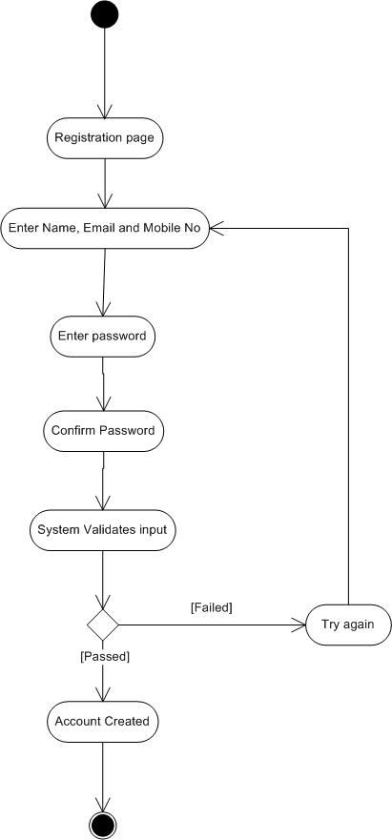
Register New Account
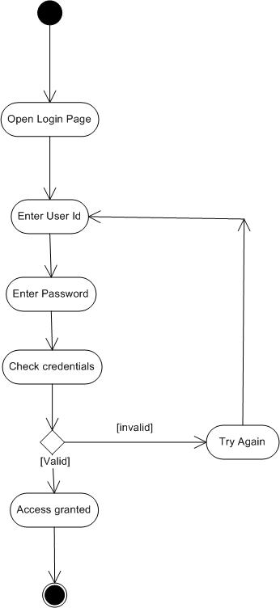
Login into System
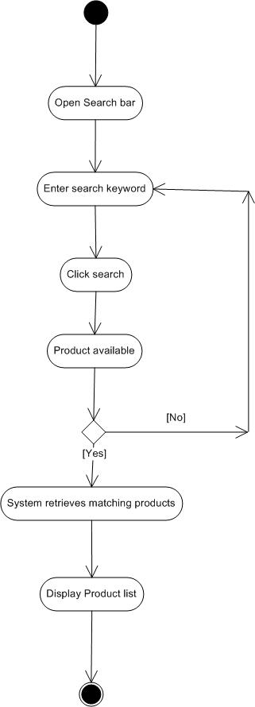
Search Products
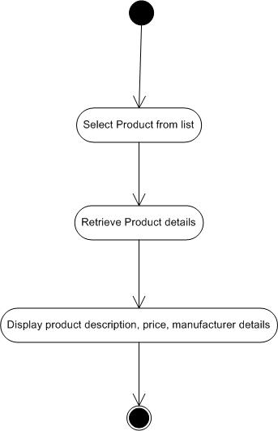
View Product details
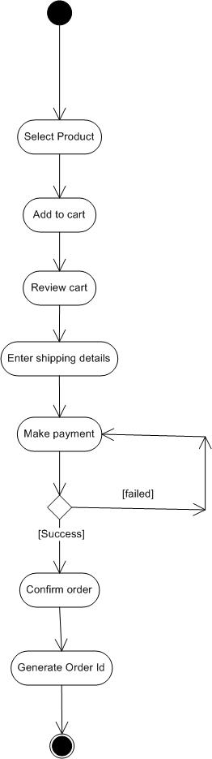
Place Order
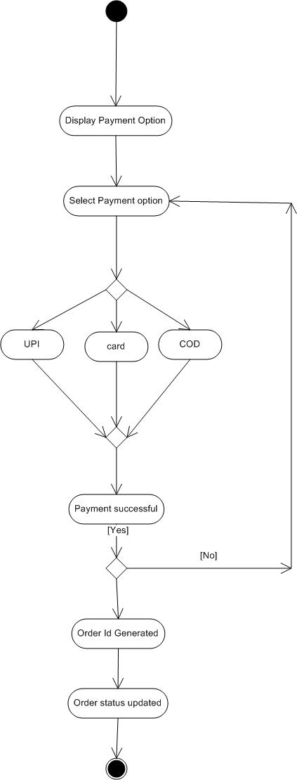
Making Payment
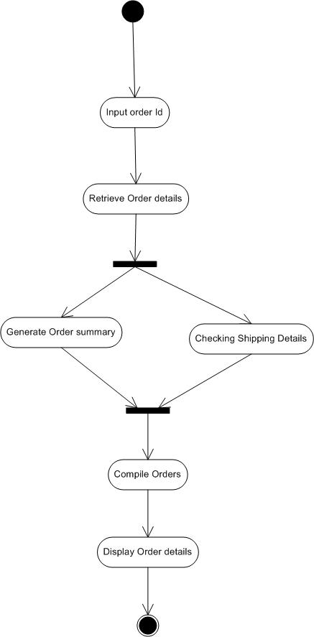
Order Details

