Capstone Project1 – Part -3/3
Question 1. Identify minimum 20 functional requirements.
Answers- This falls under the section on solution requirements. Solution requirements are those requirements that are needed to meet the business requirements. They have been developed through requirement analysis.
Req ID | Req Name | Req Description
FR001 | Account Registration | The user should be able get them registered with the application.
FR002 | User Login | The systems should allow registered users to login.
FR003 | Add to cart | The systems should allow farmers to add items into the cart.
FR004 | Add to wishlist | The system should allow farmers to add items into the wishlist bucket.
FR005 | Password recovery | The system should sent password recovery link to the registered email of the user.
FR006 | Payments Via different modes | The system should allow farmers to pay via different modes.
FR007 | Search products | The system should allow farmers to search products in the application.
FR008 | Add address for delivery | The system should allow farmer to add the delivery address.
FR009 | Customize search option | The system should allow farmers to search products in customized ways like on the basis of use, span life etc.
FR010 | Edit product cart | The system should allow farmers to edit cart before placing the order.
FR011 | Edit delivery address | The system should allow farmers to edit the delivery address before placing the order.
FR012 | Email confirmation | The system should sent email confirmation once farmer placed an order on the registered email id.
FR013 | Order tracking | The system should allow farmers to track the status of their order.
FR014 | Modify product catalogue | The system should allow manufacturers to make changes in the product catalogue.
FR015 | Admin dashboard | The system should admin to manage the overall functionality of the app.
FR016 | Order received confirmation | The system should notify the manufacturers about the orders once they are been placed by the farmers.
FR017 | Accept payments | The system should allow manufacturers to accept payments via different modes.
FR018 | Modify inventory | The system should allow manufacturers to modify the products inventory time to time.
FR019 | Customer support | The system should allow farmers to raise query about any product or for any other issue.
FR020 | Manufacturer/Farmer dashboard | The system should allow manufacturers and farmers to manage/modify their profiles with the help of their dashboards.

Question 2. Make wireframe and prototypes

Answers -

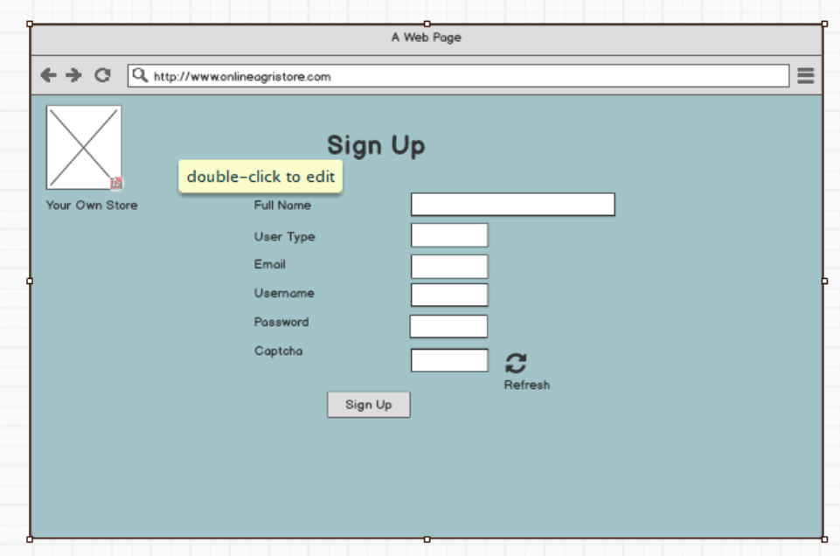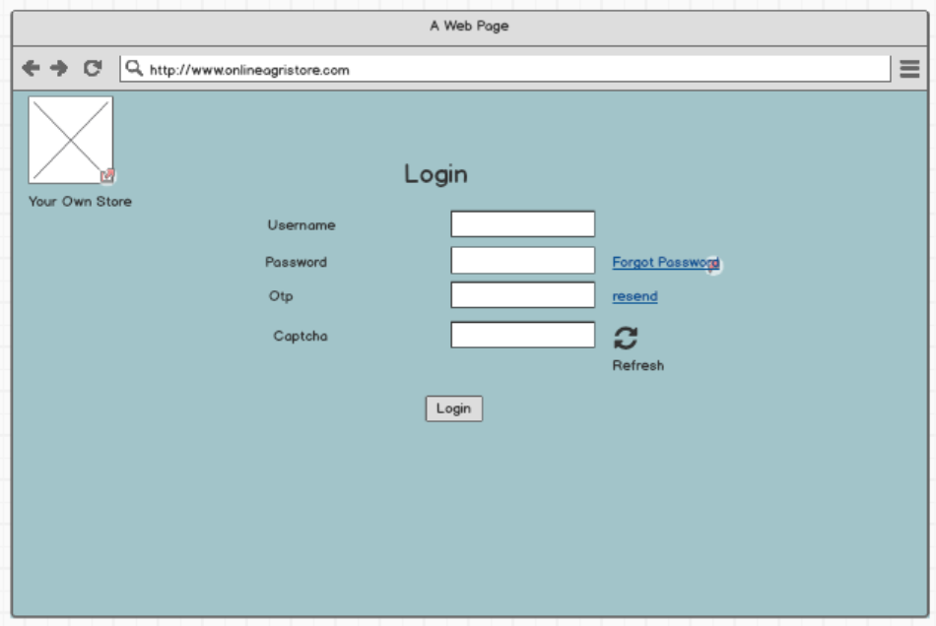

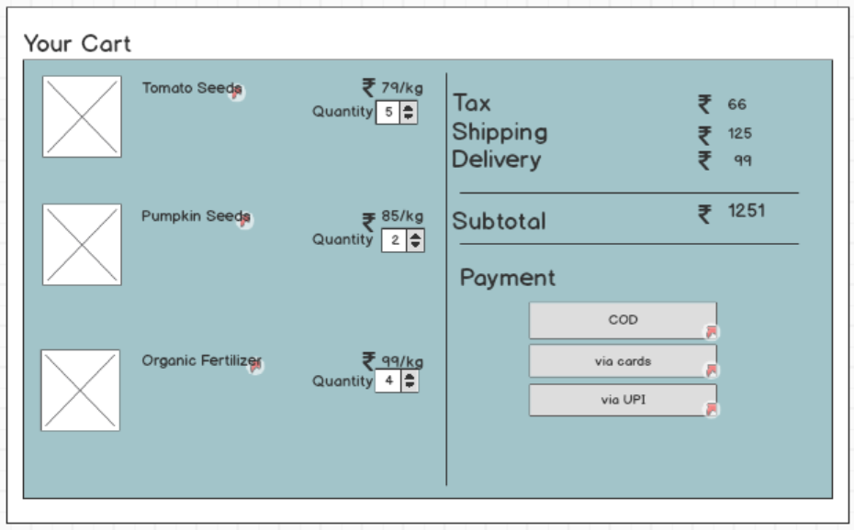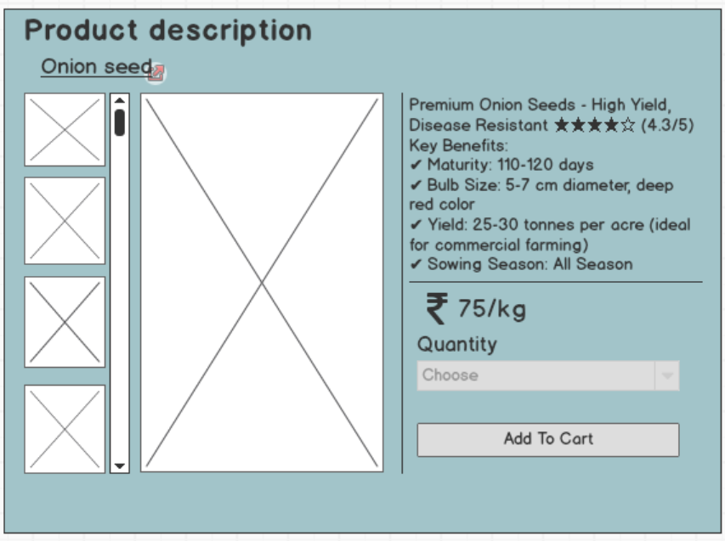

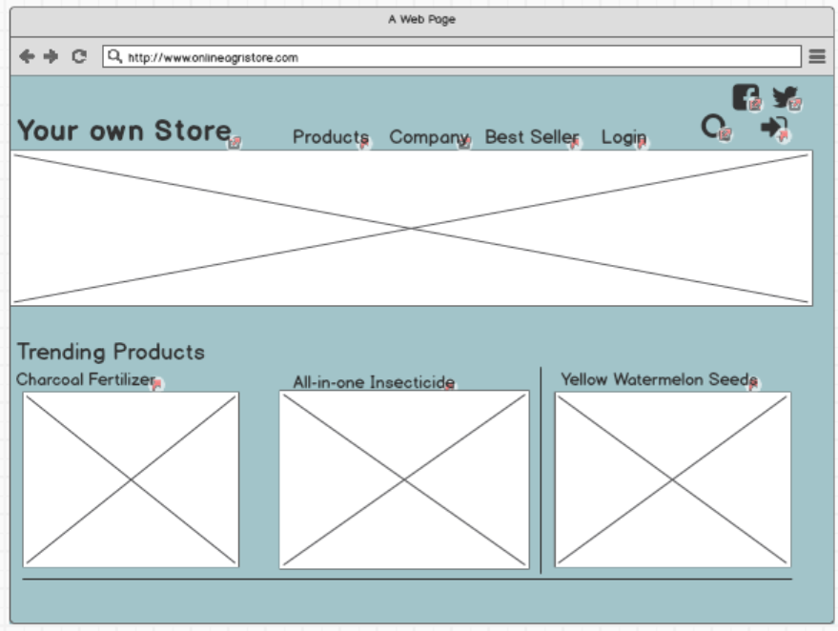
Question 3. Make a note of the Tools, which you are using for above concepts. Tools (Visio, Balsamiq)
Answers –
Ms Visio – It is basically a drawing tool which is used for making dataflow diagrams, organisation charts, UML diagrams, activity diagram etc. It is consist of drag and drop shapes with connectors. Its gives best visualization of diagram for a particular functionality of the application/website.

Balsamiq – It is used for making wireframes and prototype mock-ups. It is consist of different shapes, symbols, logos, labels etc. It’s also comes with sketch diagrams and drag- drop components same like Ms Visio. Its help in understanding the basic layout of page of the website how it will look like.
Ms Visio | Balsamiq
Used to draw diagrams. | Used to wireframes.
Formal diagrams with arrow and different shapes. | Rough sketch of website pages.
Focus on process. | Focus on layout and structure.
Unable to make prototype. | Can create simple clickable prototype.

Question 4. A business analyst’s key responsibilities are to keep track of the requirements and make sure that no requirement is missed. Mr. Henry and peter have approached you regarding the current status of the project. How will you tackle this situation? Prepare RTM

Answers – RTM
The Requirement Traceability Matrix is a document that is used to track the progress of the project. It gives us the rough idea about the project of how much more time it will take to deliver the project on time, and it also shows the real-time progress of what all tasks are done, what all are in process, and what all are yet to be initiated.
Req ID | Req Name | Req Description | Req. gathering | Code | Design | Testing | Deployment | UAT
FR001 | Account Registration | The user should be able get them registered with the application. | Complete | Complete | Complete | Complete | Complete | Incomplete
FR002 | User Login | The systems should allow registered users to login. | Complete | Complete | Complete | Complete | Complete | Incomplete
FR003 | Add to cart | The systems should allow farmers to add items into the cart. | Complete | Complete | Complete | Complete | Complete | Incomplete
FR004 | Add to wishlist | The system should allow farmers to add items into the wishlist bucket. | Complete | Complete | Complete | Complete | Complete | Incomplete
FR005 | Password recovery | The system should sent password recovery link to the registered email of the user. | Complete | Complete | Complete | Complete | Complete | Incomplete
FR006 | Payments Via different modes | The system should allow farmers to pay via different modes. | Complete | Complete | Complete | Complete | Complete | Incomplete
FR007 | Search products | The system should allow farmers to search products in the application. | Complete | Complete | Complete | Complete | Complete | Incomplete
FR008 | Add address for delivery | The system should allow farmer to add the delivery address. | Complete | Complete | Complete | Complete | Complete | Incomplete
FR009 | Customize search option | The system should allow farmers to search products in customized ways like on the basis of use, span life etc. | Complete | Complete | Complete | Complete | Incomplete | Incomplete
FR010 | Edit product cart | The system should allow farmers to edit cart before placing the order. | Complete | Complete | Complete | Incomplete | Incomplete | Incomplete
FR011 | Edit delivery address | The system should allow farmers to edit the delivery address before placing the order. | Complete | Complete | Complete | Incomplete | Incomplete | Incomplete
FR012 | Email confirmation | The system should sent email confirmation once farmer placed an order on the registered email id. | Complete | Complete | Incomplete | Incomplete | Incomplete | Incomplete
FR013 | Order tracking | The system should allow farmers to track the status of their order. | Complete | Complete | Incomplete | Incomplete | Incomplete | Incomplete
FR014 | Modify product catalogue | The system should allow manufacturers to make changes in the product catalogue. | Complete | Complete | Incomplete | Incomplete | Incomplete | Incomplete
FR015 | Admin dashboard | The system should admin to manage the overall functionality of the app. | Complete | Complete | Incomplete | Incomplete | Incomplete | Incomplete
FR016 | Order received confirmation | The system should notify the manufacturers about the orders once they are been placed by the farmers. | Complete | Complete | Incomplete | Incomplete | Incomplete | Incomplete
FR017 | Accept payments | The system should allow manufacturers to accept payments via different modes. | Complete | Complete | Incomplete | Incomplete | Incomplete | Incomplete
FR018 | Modify inventory | The system should allow manufacturers to modify the products inventory time to time. | Incomplete | Incomplete | Incomplete |  | Incomplete | Incomplete
FR019 | Customer support | The system should allow farmers to raise query about any product or for any other issue. | Incomplete | Incomplete | Incomplete | Incomplete | Incomplete | Incomplete
FR020 | Manufacturer/Farmer dashboard | The system should allow manufacturers and farmers to manage/modify their profiles with the help of their dashboards. | Incomplete | Incomplete | Incomplete | Incomplete | Incomplete | Incomplete

Question 5. Prepare 10 Test Case Documents

Answers – Test case document act as a road map for testers to verify each and every functionality of the application under various scenarios.
Test Case ID | AG01TC01 | Test Case Name | Registration
Project ID | AG01 | Project Name | Online Agricultural Store
PM ID | 1234 | PM Name | Rahul
Test Strategy ID | AG01TS01 | Tester ID | TS01
Test Plan ID | AG01TP01 | Tester Name | Victor
Test Schedule ID | AG01TSC01 | Date of Test | 1May, 2025
Scenario | User Registration
Link to that page
Input Data | Enter valid full name.  Enter valid email id.  Create strong password.  Enter valid otp.  Enter valid captcha.  Click submit. | Enter valid full name.  Enter Invalid email id.  Create strong password.  Enter valid otp.  Enter valid captcha.  Click submit. | Enter valid full name.  Enter Invalid email id.  Create strong password.  Enter Invalid otp.  Enter valid captcha.  Click submit.
Expected Behaviour | Successful registration | Error message “Invalid email id” | Error message “invalid otp”
Actual Behaviour | Successful registration | Blank Page | Error message “invalid otp”
Comments
Result | Pass | Fail | Fail

Test Case ID | AG01TC02 | Test Case Name | Login
Project ID | AG01 | Project Name | Online Agricultural Store
PM ID | 1234 | PM Name | Rahul
Test Strategy ID | AG01TS02 | Tester ID | TS01
Test Plan ID | AG01TP02 | Tester Name | Victor
Test Schedule ID | AG01TSC02 | Date of Test | 5May, 2025
Scenario | User Login
Link to that page
Input Data | Enter correct Username.  Enter correct password.  Enter valid otp.  Enter valid captcha.  Click Login. | Enter correct Username.  Enter Incorrect password.  Enter valid otp.  Enter valid captcha.  Click Login. | Enter correct Username.  Enter correct password.  Enter valid otp.  Enter Invalid captcha.  Click Login.
Expected Behaviour | Successful Login. User dashboard should appear. | Error message “Incorrect password” | Error message “invalid captcha”
Actual Behaviour | User dashboard appeared | Error message “Incorrect password” | User redirected to different page.
Comments
Result(Pass/Fail) | Pass | Fail | Fail

Test Case ID | AG01TC03 | Test Case Name | Search a product
Project ID | AG01 | Project Name | Online Agricultural Store
PM ID | 1234 | PM Name | Rahul
Test Strategy ID | AG01TS03 | Tester ID | TS01
Test Plan ID | AG01TP03 | Tester Name | Victor
Test Schedule ID | AG01TSC03 | Date of Test | 10May, 2025
Scenario | Search a product
Link to that page
Input Data | Summer season vegetable seeds. | Farming tools | Fertilizers
Expected Behaviour | At least 10 Vegetables seeds should appear. | At least 15 Farming tools should appear. | All types of fertilizers should appear. (chemical, organic and liquid)
Actual Behaviour | 12 Vegetables seeds appeared. | 15 Farming tools appeared. | Only chemical fertilizers appeared.
Comments
Result(Pass/Fail) | Pass | Pass | Pass

Test Case ID | AG01TC04 | Test Case Name | Add to cart
Project ID | AG01 | Project Name | Online Agricultural Store
PM ID | 1234 | PM Name | Rahul
Test Strategy ID | AG01TS04 | Tester ID | TS01
Test Plan ID | AG01TP04 | Tester Name | Victor
Test Schedule ID | AG01TSC04 | Date of Test | 12May, 2025
Scenario | Product added into the cart
Link to that page
Input Data | Search a product  Select the right item and quantity.  Add into the cart. | Search a product which shows out of stock. | Search a product.  Select the right item and quantity.(Card was full, max. 10 product can be added at a time)
Expected Behaviour | Cart will be updated with right item and right quantity. | Error message “OUT OF STOCK”. | Error message “Cart Full”.
Actual Behaviour | Cart was updated with right item and right quantity. | Error message “OUT OF STOCK”. | Error message “Cart Full”.
Comments
Result(Pass/Fail) | Pass | Fail | Fail

Test Case ID | AG01TC05 | Test Case Name | Payment via UPI
Project ID | AG01 | Project Name | Online Agricultural Store
PM ID | 1234 | PM Name | Rahul
Test Strategy ID | AG01TS05 | Tester ID | TS01
Test Plan ID | AG01TP05 | Tester Name | Victor
Test Schedule ID | AG01TSC05 | Date of Test | 15May, 2025
Scenario | Payment via UPI
Link to that page
Input Data | Entered the correct UPI id.  System will redirect the user to the respective UPI.  User makes the payment. | Entered the incorrect UPI id. | Entered the correct UPI id.  System will redirect the user to the respective UPI.  (Bank server was down)
Expected Behaviour | System will show payment accepted. | Error message “INCORRECT UPI ID”. | Payment page will expires in 2 minutes.
Actual Behaviour | System showed payment accepted. | Error message “INCORRECT UPI ID”. | Payment page was expired in 2 minutes.
Comments
Result(Pass/Fail) | Pass | Fail | Fail

Test Case ID | AG01TC06 | Test Case Name | Payment via card
Project ID | AG01 | Project Name | Online Agricultural Store
PM ID | 1234 | PM Name | Rahul
Test Strategy ID | AG01TS06 | Tester ID | TS02
Test Plan ID | AG01TP06 | Tester Name | Sam
Test Schedule ID | AG01TSC06 | Date of Test | 20May, 2025
Scenario | Payment via Card
Link to that page
Input Data | Entered the correct card detail.  System will accept the card details and will initiate the payment.  User enters the OTP and makes the payment. | Entered the incorrect card details. | Entered the correct card details.  System will accept the card details and will initiate the payment.  (Mobile services were down unable to receive OTP)
Expected Behaviour | System will show payment accepted. | Error message “CARD NOT FOUND”. | Payment page will expires in 2 minutes.
Actual Behaviour | System showed payment accepted. | Error message “CARD NOT FOUND”. | Payment page was expired in 2 minutes.
Comments
Result(Pass/Fail) | Pass | Fail | Fail

Test Case ID | AG01TC07 | Test Case Name | Payment via COD
Project ID | AG01 | Project Name | Online Agricultural Store
PM ID | 1234 | PM Name | Rahul
Test Strategy ID | AG01TS07 | Tester ID | TS02
Test Plan ID | AG01TP07 | Tester Name | Sam
Test Schedule ID | AG01TSC07 | Date of Test | 22May, 2025
Scenario | Payment via COD
Link to that page
Input Data | The user select the items into the cart.  Select the address.  Click on place order.  Select COD as the payment option. | The user select the items into the cart.  Select the address.  Click on place order.  (Some items were not eligible for COD) | The user select the items into the cart.  Select the address.  Click on place order.  (Some products might require partial payment)
Expected Behaviour | System will show payment accepted. | Error message “COD not available for this product”. | Error message “20% need to be paid in advance”
Actual Behaviour | System showed payment accepted. | Error message “COD not available for this product”. | Error message “20% need to be paid in advance”
Comments
Result(Pass/Fail) | Pass | Fail | Fail

Test Case ID | AG01TC08 | Test Case Name | Order Tracking
Project ID | AG01 | Project Name | Online Agricultural Store
PM ID | 1234 | PM Name | Rahul
Test Strategy ID | AG01TS08 | Tester ID | TS02
Test Plan ID | AG01TP08 | Tester Name | Sam
Test Schedule ID | AG01TSC08 | Date of Test | 25May, 2025
Scenario | Order Tracking
Link to that page
Input Data | Select orders option.  Select the particular order.  Click on order tracking. | Select orders option.  Select the particular order.  Click on order tracking.  (order was already delivered) | Select orders option.  Select the particular order.  Click on order tracking.  (order status remains the same for 2 days)
Expected Behaviour | Order live status will be visible. | Order tracking option will be disabled. | The system will give option to contact seller directly.
Actual Behaviour | Order live status was visible. | Order tracking option was disabled. | The system gave the option to contact seller directly.
Comments
Result(Pass/Fail) | Pass | Fail | Fail

Test Case ID | AG01TC09 | Test Case Name | Place order
Project ID | AG01 | Project Name | Online Agricultural Store
PM ID | 1234 | PM Name | Rahul
Test Strategy ID | AG01TS09 | Tester ID | TS02
Test Plan ID | AG01TP09 | Tester Name | Sam
Test Schedule ID | AG01TSC09 | Date of Test | 27May, 2025
Scenario | Place order
Link to that page
Input Data | Select the products and add them into the cart.  Select the address.  Click on Place the order.  Select the mode of payment and make the payment.  Click place order. | Select the products and add them into the cart.  Select the address.  (Some product might not be deliverable at a particular pin code) | Select the products and add them into the cart.  Select the address.  (Some products went out of stock while the user was selecting the address)
Expected Behaviour | System will show order placed. | The system will strike out the products which are undeliverable at the selected pin code. | The system will strike out the products which got out of stock.
Actual Behaviour | System will showed order placed. | The system struck out the products which were undeliverable at the selected pin code. | The system struck out the products that went out of stock.
Comments
Result(Pass/Fail) | Pass | Fail | Fail

Test Case ID | AG01TC10 | Test Case Name | Order cancellation
Project ID | AG01 | Project Name | Online Agricultural Store
PM ID | 1234 | PM Name | Rahul
Test Strategy ID | AG01TS10 | Tester ID | TS02
Test Plan ID | AG01TP10 | Tester Name | Sam
Test Schedule ID | AG01TSC10 | Date of Test | 30May, 2025
Scenario | Order cancellation
Link to that page
Input Data | Select orders option.  Select the particular order.  Click on cancel order. | Select orders option.  Select the particular order.  Click on cancel order.  (The order was already out for delivery) | Select orders option.  Select the particular order.  Click on cancel order.  (The order was already delivered)
Expected Behaviour | System will Order cancelled. | Error message “The order is out for delivery” | Error message “Thiss order has been delivered”
Actual Behaviour | System will showed order placed. | Error message “The order is out for delivery” | Error message “This order has been delivered”
Comments
Result(Pass/Fail) | Pass | Fail | Fail

Question 6. After the requirements are thoroughly explained to the entire project team by business analyst, the Database architects have decided to do the database design and also to represent the in-flow and out-flow of data.

Answer – Database schema is a technical structure that show how data is organised which includes tables, fields, columns and other database objects.

ER Diagram is a visual representation of data that shows the relationship between entities and database.

Entities is an object that or concept about which data is stored in database.

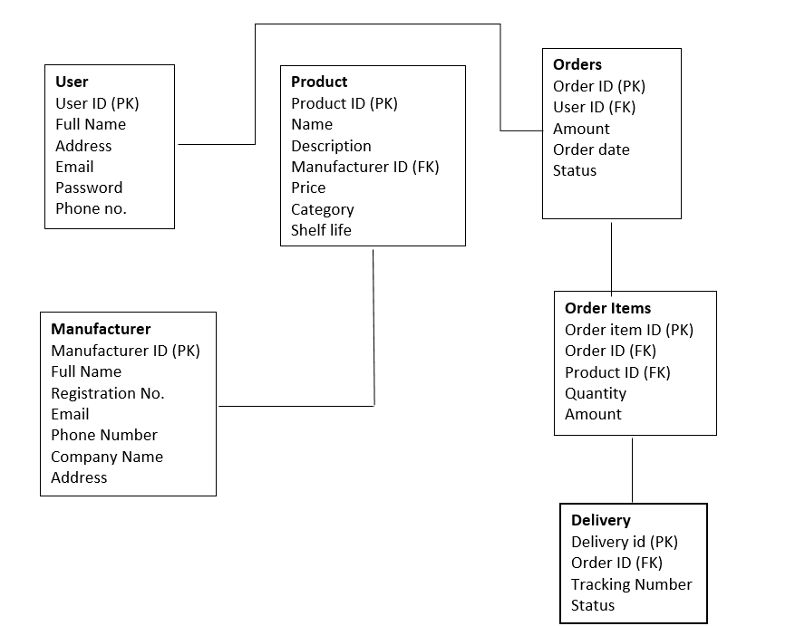

Question 7. What is a data flow diagram? Draw a data flow diagram to represent the in-flow and out-flow of data when a Farmer is placing an order for the product.

Answer – Data flow diagram is the visual representation of how data move through in a system.

It is consist of-
Process- represents by circle which shows the transformation of data.
Data store- represents by 2 parallel lines which indicate where the data is stored.
External Entities- represents by rectangle which shows the source of data being generated.
Data Flow- represents by arrow lines which shows the movement of data between entities, process and database.

Database
Farmer
Order Placing System

Order confirmation

Question 8. Due to change in the Government Taxation structure. We should change the Tax structure. How do you handle change requests in a project?
Answer – A change request, as the name itself depicts, is a request for a certain change in a process, which will be implemented after the approval process.
In this project there is a sudden change in tax structure that was not discussed at the time of requirement gathering. Hence, this change needs to be addressed by the client as well with the project manager and other team members of the project.
This change is necessary and cannot be ignored because it will directly affect the basic functionality of the application/website. There are certain steps that need to be followed, or we can say that there is a process that needs to be followed for entertaining any change request.
Here are the steps-
- Capture and Documents the Change Request
- Do Impact Analysis
- Do Feasibility Study
- Take Approval
- Implement the change
- Test and validate

- Capture and Document the Change Request—Capture and document the request after thorough review. Detailed information needs to be documented, like what the actual change that needs to be addressed is, what all the areas that are going to be affected are, why it is necessary, and the priority of the change request.
As per this change request, the reason why this change request is important is because the government has changed the taxation and no longer has control over it. That’s why it is mandatory to address this change request. The pricing of the products, payment gateways, invoices, and database will get affected by this CR.
- Do Impact Analysis- It is one of the major steps in handling CR, which provides us with the in-depth idea of how the particular CR will impact the system, user, process/project, and business operation.
As per this CR, it will affect the technical aspects of the project, like the API and database. It will also affect the timeline of the project by 2-3 weeks. Moreover, the budget needs to be increased by 5-7 lakhs for development and testing. This impact is liable as it was not addressed at the initial phase of requirement gathering.
- Feasibility Study – As the name itself depicts that CR which is being taken is feasible or not. It helps the CCB (Change Control Board) to decide whether to approve or reject the CR. In this it is important to understand the possibilities of this CR on the basis of technology (like- Hardware, software, trained resources), Budget and Time.
Technology- As per this CR the Company has the hardware and software that align with this CR
Time - It will increase as everything need to be redesigned (database table, coding) again. Also the testing part also take time. Additionally 2-3 weeks more time will be required.
Budget- As the time is being uplifted by 2-3 weeks the budget will also get increased as extra working hours will be required for development and testing.
- Take Approval – In this step approval needs to be taken from CCB (Change Control Board). The CCB is a combined group of stakeholders, and top management of the project are those who decide whether to approve the CR or reject it.

- Implement the change – After taking the appr oval it is important to implement them correctly so that the outcome should be as per the desired one. The developer team need to re-write the code and design team need to re-design the API as per the new taxation structure.

- Test and validate- Last but not the least. In this the testers need to test and validate the functionality of the application/website as per the new taxation structure. If the app/website is working as per the CR or not, if not make the changes and retry it again as this CR is mandatory and need to be fixed.

Question 9. As the project is in process, Ben and Kevin have contacted you. The reason is to inform you that they want the Farmers to sell their crop yields through this application i.e. Farmers should be able to add their crop yields or products and display to general public and should be able to sell them. They also want to introduce Auction system for their Crop yields. As a BA, what will be your response? Is this a change request or an enhancement???
Answer – This will be considered a change request because this requirement was not conveyed at the time of the business requirement. This is something new that was not included in the agreed scope of the project in the initial phase. The standard procedure of handling CR will be followed in fulfilling this requirement. The steps are as follows:
- Document the change request properly—the farmer can display the crops in the auction system. Users can browse and purchase t
- Impact analysis- New coding and design need to be done. A new auction API needs to be created. Budget will also increase as it is a new functionality. Also, the timeline of the project will be increased.
- Feasibility study – Newer codes can be updated. Trained resources are there. The budget needs to increase by 50-70 lakhs, as new software will be required and the team needs to work more on this project as compared to the agreed scope, so the payment for that will also be summed up in the payment for the process. The timeline of the project will also be extended.
- Take Approval- After gathering the requirements and studying them, the same needs to be presented to CCB for the approval. Once the approval is given, convey the CR to the team and work on it accordingly.
Question 10. Come up with estimations – How many Man-hours required
Answers - Man-hours are the number of hours needed by the persons working on the project to finish it on time.
There are 3 types of project-
Small- Up to 500 hours
Medium- Up to 1000 hours
Large- Up to 1500 hours

As the allotted time given for this project is 18 months with the team of 11 members, it will fall under small project.
The two change request which is being given by the client will also add up the time then this project might move into medium project.

Question 11. Project has finally completed all the stages i.e., design, development, testing etc. Now, it is the role of a business analyst to contact the client for testing of the final product and have to successfully complete it. How are you going to handle this situation? And once it is done, what will be the process to close the project? Explain UAT Acceptance process

Answer – UAT (User Acceptance Testing) is the final stage after all the testing is done by the testers as per the agreed scope of the project. As a BA, it is mandatory that the finished application/website should meet all the business requirements of the project. There are certain steps that need to be taken care of and are as follows:
- Planning—Plan for UAT testing for everything that the client asked for in the business requirement and make sure that they met all the possible outcomes as per the agreed scope.
- Designing—Design test cases that align with UAT testing and make sure to take the real-world scenarios so that the app/website is as per the agreed scope.
- UAT Testers—UAT testers (a team of end users) will test the app/website as per the real-world scenarios. Make sure that they know how to run the test cases and understand the actual functionality of the application.
- Bug Fixing—If, in case while performing testing, UAT testers find out something that is not as per the agreed scope, then the same will be conveyed to the technical team so that they can fix that bug.
- UAT Sign-Off— after removing all the bugs, once the UAT tester as well as stakeholders come to a conclusion to make the app/website go live, they sign it off.

Question 11. Explain Project closure document
Answer – The project closure document is the final document that needs to be prepared to formally close the project. It summarizes the key outcomes, lessons learned, and the final details of the project. It also acts as a reference for future projects.
Here are some points that need to be mentioned in the project closure document:
- Project Overview—Project name, project start date and end date, stakeholder names, and a small description about the project need to be mentioned in the document.
- Achievements—the business requirements were achieved; need to mention that also.
- Lesson Learned—identify the possibilities for the upcoming projects and what all lessons/things were learned from this project.
- Quality Assurance—Make sure that the quality product was delivered to the client.
- Resource Utilization—Analyze the resources and utilize them efficiently.
- Risk Management—Analyze the risks and mitigate them at the earliest.
- Challenges—What all challenges were being faced in this project, and how those were resolved need to be mentioned that as well.

S.No | Points to be included | Details
1. | Project Start and End Date | xxx
2. | UAT Sign-off Date | xxx
3. | Project Object  User friendly interface  Best suited online agricultural store  Auction system for farmers  Payment gateways  Other categories | Achieved
4. | Lesson learned | Mandatory CR need to fixes ASAP.
5. | Quality Assuarnce as per discussed with client | Achieved
6. | Resource Utilization  Completed under time and budget | Achieved
7. | Challenges  CR at the last stage of completion | Achieved
8. | Customer Satisfaction | Achieved
9. | Remarks | This project was something new and unique in the market.  Company has gained experience from this for the upcoming projects

