A company is having manufacturing plants and warehouses in various parts of the country. They manufacture ice-cream and milk products. They want to build software to achieve two goals.
• Manage the inventory
• Quickest delivery to the customers
Assignment 1:
- Please make a BRD which can be presented to the client along with complete development and resource plan.
Ans. Business Requirement Document (BRD)
Project Name: Inventory and Delivery Optimization System
Client: [Ice-Cream & Milk Products Company]
Date: July 7, 2025
Prepared by: [ABC Company]

1. Executive Summary / Introduction
This BRD outlines the requirements for a software solution that will enable [Client Name] to efficiently manage inventory across multiple plants and warehouses and ensure optimal delivery of ice-cream and milk products to customers. The system will support end-to-end operations — from stock management to delivery route optimization — with real-time data visibility and actionable insights.

2. Business Objective
- Provide real-time inventory tracking across all manufacturing units and warehouses.
- Minimize order fulfillment time through smart delivery routing and warehouse selection.
- Reduce stock wastage due to overproduction or expiry.
- Improve operational efficiency and enhance customer satisfaction.

3. Background / Current State
Currently, the company:
- Maintains inventory records manually or with disparate tools.
- Faces stock discrepancies, delayed reordering, and limited forecasting.
- Experiences delays in deliveries due to unoptimized routes and poor visibility into logistics operations.
There is no unified platform to manage inventory or plan deliveries, leading to inefficiencies and missed opportunities for optimization.

4. Scope of the Project

In-Scope
- Inventory management (stock tracking, batch & expiry tracking)
- Order processing and warehouse allocation
- Delivery route optimization and fleet management
- Admin dashboard and reporting
- User management and access control

Out-of-Scope
- Financial accounting
- Manufacturing process control
- Cold-chain monitoring (for future consideration)
5. Business Requirements
ID | Requirement Description
BR-01 | Ability to track real-time inventory across all plants and warehouses
BR-02 | Generate low-stock alerts and automatic reorder notifications
BR-03 | Process customer orders and suggest nearest fulfillment location
BR-04 | Optimize delivery routes using traffic-aware maps
BR-05 | Allow warehouse staff to transfer stock between locations
BR-06 | Track delivery status in real time
BR-07 | Provide dashboards and reports for admins and operations team

6. Stakeholder List
Stakeholder Name | Role | Department | Responsibility
Senior Management | Project Sponsor | Executive Team | Budget & Strategic Oversight
Operations Manager | Product Owner | Operations | Feature Prioritization
Warehouse Supervisors | End Users | Warehousing | Daily Inventory Management
Delivery Coordinator | End User | Logistics | Route Planning and Execution
IT Lead | Technical Support Contact | Internal IT | Infrastructure & API Integration
Project Manager | Delivery Owner | Vendor | Timeline & Team Coordination

7. Assumptions and Constraints

Assumptions
- Warehouses and plants will have network access and digital systems for usage.
- Delivery vehicles and routes are managed by the company or integrated partners.
- Google Maps or HERE API access will be provided for route optimization.

Constraints
- Cold-chain tracking is not included in the first phase.
- High-volume data migration from legacy systems may require manual effort.
- Budget limits on third-party API usage.
8. Functional Requirements
FR ID | Functional Requirement
FR-01 | Add, update, and remove product SKUs and batches
FR-02 | View and manage inventory by location, batch, and expiry
FR-03 | Process and allocate orders automatically to nearest available stock
FR-04 | Calculate best delivery route with ETA
FR-05 | Assign drivers and vehicles manually or automatically
FR-06 | Track deliveries via dashboard with real-time updates
FR-07 | Generate reports: stock levels, delivery times, expiry forecasts
FR-08 | Set user roles: admin, warehouse manager, delivery personnel

9. Non-Functional Requirements
NFR ID | Non-Functional Requirement
NFR-01 | System should be available 99.9% of the time
NFR-02 | Support minimum 1,000 concurrent users
NFR-03 | Role-based access with data security and audit logs
NFR-04 | System must scale during peak season with 10x order volume
NFR-05 | Must comply with regional data protection and privacy standards (GDPR/local laws)

10. Development and Resource Plan
Phase | Duration | Deliverables
Requirements & Design | 2 weeks | BRD, Wireframes, Architecture Plan
Backend Development | 3 weeks | API Layer, Inventory Engine
Inventory Module | 3 weeks | Warehouse Interface, Stock Management UI
Order & Delivery Module | 3 weeks | Order Allocation Logic, Routing Integration
Frontend (Admin Portal) | 4 weeks | UI with React / Angular
Mobile App (if any) | 3 weeks | Driver App for Delivery Tracking
Testing & UAT | 2 weeks | QA, User Testing, Bug Fixing
Deployment & Training | 1 week | Go-live + Onboarding

Team Structure
Role | Resource Count | Notes
Project Manager | 1 | Client coordination and delivery
Business Analyst | 1 | Requirements gathering
Backend Developers | 2 | API, database, integration
Frontend Developer | 1 | Dashboard & User Interface
Mobile Developer | 1 | For driver/delivery app (optional)
QA Tester | 1 | Manual & automated testing
DevOps Engineer | 1 | CI/CD and deployment support
UI/UX Designer | 1 | Mockups and usability flows

11. Success Criteria
- Inventory discrepancies reduced by 90% within 3 months
- On-time delivery improved by 80% using optimized routing
- Order fulfillment time reduced to under 3 hours (within local zones)
- Admin and logistics team adoption rate > 90%
- Positive user feedback score of 4.5/5 or above from staff

12. Glossary
Term | Definition
SKU | Stock Keeping Unit – a unique identifier for each product
UAT | User Acceptance Testing
ETA | Estimated Time of Arrival
API | Application Programming Interface – for system integrations
CI/CD | Continuous Integration / Continuous Deployment – DevOps pipeline
Routing Engine | Software component that calculates optimal delivery paths

- Prepare process flow diagram using your imagination.
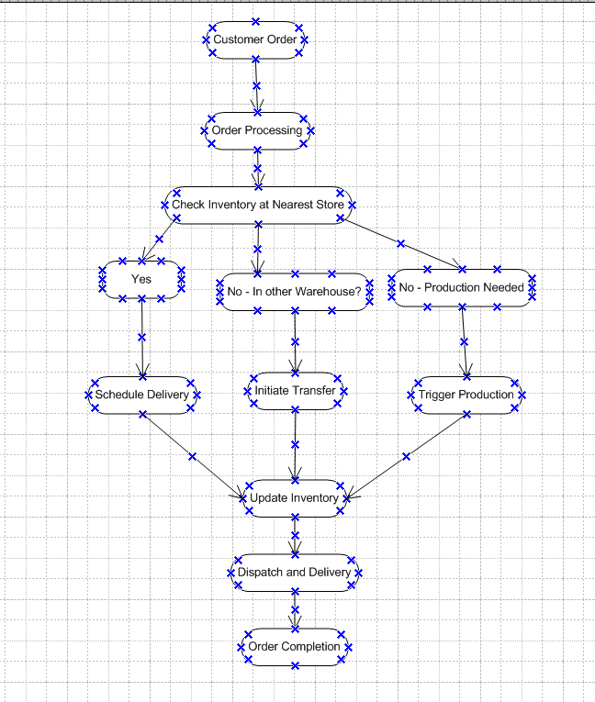

Assignment 2:
- Write an introduction letter to a client introducing yourself as a business analyst in charge of working with the client and his team to start the business understanding process.
Ans.
Subject: Introduction – Business Analyst Assigned to Your Project
Dear [XYZ LTD],
I hope this message finds you well.
My name is Moni, and I’m pleased to introduce myself as the Business Analyst assigned to support you and your team throughout the initial stages of our engagement. I’ll be your primary point of contact as we begin the business understanding phase of the project.
My role will focus on working closely with you to gain a clear and comprehensive understanding of your business goals, challenges, and key requirements. This information will help us ensure that the solutions we develop are well-aligned with your strategic objectives.
Over the next few days, I will be reaching out to schedule our first session where we’ll start gathering insights, discussing current processes, and identifying key stakeholders. Please feel free to share any relevant documentation or background materials ahead of time if available—it will help us hit the ground running.
I’m looking forward to a productive collaboration and to delivering value through a deep understanding of your business needs.
If you have any questions or need to reach me directly, please don’t hesitate to contact me at xyz123@gmail.com or 1234567890
Best regards,
Moni Rani
Business Analyst
ABC Ltd
1234567890
- Prepare a brief BRD and SRS for a project- Horoscope or Ticketing system or online store.
Ans. Below is the Business Requirements Document (BRD) and a Software Requirements Specification (SRS) for a Ticketing System project:

A. Business Requirements Document (BRD) – Ticketing System

1. Project Overview
The Ticketing System is designed to provide users with an easy-to-use platform to browse, book, and manage tickets for various events (concerts, sports, theater, etc.). The system should support both online and mobile access and enable secure transactions.

2. Business Objectives
- Improve customer access to event tickets.
- Increase ticket sales by providing a seamless booking experience.
- Reduce manual workload for event organizers.
- Provide real-time availability and status of events.

3. Key Stakeholders
- Customers (End-users)
- Event Organizers
- Marketing and Sales Teams
- IT and Development Teams
- Customer Support
4. Business Requirements
ID | Requirement Description
BR-01 | The system shall allow users to search for upcoming events.
BR-02 | The system shall allow users to purchase tickets online using multiple payment methods.
BR-03 | The system shall allow users to view and manage their bookings.
BR-04 | Event organizers shall be able to list and manage events.
BR-05 | The system shall provide analytics and reporting dashboards to stakeholders.
BR-06 | The system shall send email/SMS confirmations for ticket purchases.

B. Software Requirements Specification (SRS) – Ticketing System

1. Introduction
The purpose of this document is to define the functional and non-functional requirements of the online Ticketing System. This document will guide the development and validation of the system.

2. Scope
The Ticketing System allows users to search, book, and manage event tickets while allowing organizers to list events and track ticket sales.
3. Functional Requirements
ID | Functional Requirement
FR-01 | Users shall register and log in to their accounts.
FR-02 | Users shall be able to search and filter events by date, category, and location.
FR-03 | Users shall be able to select seats and proceed to checkout.
FR-04 | Users shall receive email confirmations after successful purchases.
FR-05 | Admin users shall manage event listings and ticket inventory.
FR-06 | The system shall handle secure payments through integrated gateways (e.g., PayPal, Stripe).
4.Non-Functional Requirements
ID | Non-Functional Requirement
NFR-01 | The system shall be available 99.9% of the time (high availability).
NFR-02 | The system shall respond to user actions within 2 seconds.
NFR-03 | All user data shall be encrypted and stored securely.
NFR-04 | The system shall be mobile-responsive and accessible across modern browsers.
5. Assumptions and Constraints
- Users must have internet access to use the platform.
- The system will integrate with existing payment gateways and email/SMS APIs.
- Compliance with local data protection regulations is mandatory.

3. Make an ERD of creating a support ticket/Ticketing life cycle.
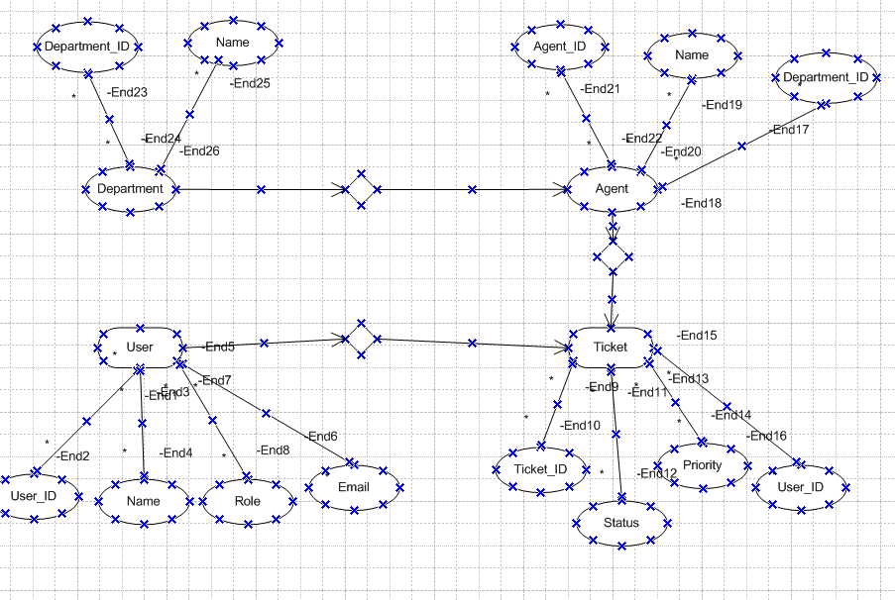

4. User story of shopping from ecommerce.
Ans.
User Story No | Tasks | Priority | Value Statement | BV (₹) | CP | Acceptance Criteria
1 | Implement product search | High | As a user, I want to search products so I can find what I need easily | ₹500 | 3 | Search bar supports keyword input, partial matches, returns relevant products
2 | Enable product filtering | High | As a user, I want to filter products by price, brand, and rating | ₹200 | 2 | Filters apply in real time; multiple filters combinable
3 | Build trade status tracking | Medium | As a user, I want to see trade status so I know what stage it's in | ₹100 | 3 | Status flows: Draft → Sent → Pending Approval → Approved → Booked
4 | Create product detail page | High | As a user, I want to see full product info to make informed decisions | ₹200 | 3 | Shows image, price, description, stock, reviews
5 | Implement add-to-cart | High | As a user, I want to add items to cart to buy multiple products at once | ₹500 | 3 | Cart updates instantly; persists across sessions
6 | Build shopping cart page | High | As a user, I want to view and update cart before checking out | ₹500 | 5 | Allows quantity updates, item removal, and recalculates subtotal
7 | Add guest checkout | Medium | As a guest, I want to checkout without logging in | ₹100 | 2 | Guest inputs email and shipping; receives confirmation
8 | Build checkout process | High | As a user, I want a seamless checkout so I can buy easily | ₹500 | 5 | Steps: Shipping → Payment → Review → Confirm; input validated
9 | Integrate payment gateway | Critical | As a user, I want to pay securely so I trust the site | ₹500 | 8 | Supports cards, wallets; transaction confirmed or failed securely
10 | Build order confirmation page | High | As a user, I want confirmation after checkout | ₹100 | 2 | Order ID shown; email sent; estimated delivery displayed
11 | Create order history section | Medium | As a user, I want to see past orders for tracking and reordering | ₹200 | 3 | Lists previous orders; shows status and reorder button
12 | Enable product reviews | Medium | As a user, I want to read/write reviews for informed buying | ₹100 | 2 | Users post star-rated reviews; visible under product; moderated
13 | Manage shipping addresses | Low | As a user, I want to save/edit addresses to speed up checkout | ₹100 | 3 | Address book in profile; supports multiple addresses
14 | Apply discount coupons | Medium | As a user, I want to apply coupons to reduce cost | ₹200 | 5 | Validates coupons; updates total; handles expired or invalid codes
15 | Setup product categories | High | As a user, I want products grouped by category for easier browsing | ₹200 | 3 | Categories visible in menu; each links to filtered list
16 | Add wishlist feature | Medium | As a user, I want to save products for later | ₹100 | 5 | Logged-in users can add/remove products from wishlist
17 | Notify for price drops | Low | As a user, I want alerts for price drops on wishlist items | ₹50 | 8 | Notification sent via email when price drops
18 | Send order status updates | High | As a user, I want updates as my order progresses | ₹200 | 3 | Email/SMS sent on status: Ordered → Packed → Shipped → Delivered
19 | Enable product comparison | Medium | As a user, I want to compare products side by side | ₹100 | 5 | Compare price, features, reviews of 2–4 products
20 | Enable ratings for delivery | Low | As a user, I want to rate my delivery experience | ₹50 | 2 | Post-delivery rating requested; average scores displayed
21 | Allow product sorting | Low | As a user, I want to sort products by price or popularity | ₹50 | 1 | Sorting options available in listing pages
22 | Mobile responsive UI | Critical | As a user, I want a mobile-friendly experience | ₹500 | 13 | Layout adapts to screen size; touch gestures supported
23 | Implement multi-currency | Medium | As an international user, I want to see prices in my currency | ₹200 | 8 | Currency switcher in header; all prices update accordingly
24 | View estimated delivery time | Medium | As a user, I want to know when my order will arrive | ₹100 | 3 | Delivery estimate based on address and availability
25 | Enable product Q&A | Medium | As a user, I want to ask and answer questions about products | ₹200 | 5 | Users can post questions; sellers or users can reply; moderation in place

