COEPD – Traditional Development
Capstone Project1 – Part -3/3 – 100 Marks - Pass 60 %
12 Questions
Instructions to follow:
1. Copy paste (either image, diagram or text) is not entertained. If done, the document will not be evaluated.
2. After submission of the answers of this prep exam, you should be prepared to attend viva and justify your answers in the prep exams. If in Viva, participant is NOT justifying the answers, Viva will be repeated until Candidates justify 60% correctness.
3. Mentor calls are scheduled only if the participant has submitted their task at least for one time. (Should apply their knowledge in this task first)
4. For attempting prep exams participant should be thorough on the topics using their references.
5. Please format the document properly (Always have a question no., question and answer). 6. Have a consistent format (Font name: Arial/ Calibri -Font size 12, Font Color: Black).
7. Few Questions are related to the case study; check Questions thoroughly before you answer.
8. Answers should be elaborated in detail (*not as per the allotted marks).
9. Please focus on learning and applying the knowledge as this knowledge will be helpful in contributing at your BA job.
10. In the evaluation, students must answer all questions and should be able to justify at least 60% content and correctness of each answer.
Online Agriculture Products Store
Mr. Henry, after being successful as a businessman and has become one of the wealthiest persons in the city. Now, Mr. Henry wants to help others to fulfill their dreams. One day, Mr. Henry went to meet his childhood friends Peter, Kevin and Ben. They live in a remote village and do farming. Mr. Henry asked his friends if they are facing any difficulties in their day-to-day work. Peter told Mr. Henry that he is facing difficulties in procuring fertilizers which are very important for farm. Kevin said that he is also facing the same problem in-case of buying seeds for farming certain crops. Ben raised his concern on lack of pesticides which could help in greatly reducing pests in crops. After listening to all his friends’ problems, Mr. Henry thought that this is a crucial problem faced not only by his friends but also by so many other farmers. So, Mr. Henry decided to make an online agriculture product store to facilitate remote area farmers to buy agriculture products. Through this Online Web / mobile Application, Farmers and Companies (Fertilizers, seeds and pesticides manufacturing Companies) can communicate directly with each other. The main purpose to build this online store is to facilitate farmers to buy seeds, pesticides, and fertilizers from anywhere through internet connectivity. Since new users are involved, Application should be user friendly. This new application should be able to accept the product (fertilizers, seeds, pesticides) details from the manufacturers and should be able to display them to the Farmers. Farmers will browse through these products and select the products what they need and request to buy them and deliver them to Mr. Henry has given this project through his Company SOONY. In SOONY Company, Mr Pandu is Financial Head and Mr Dooku is Project Coordinator. Mr. Henry , Mr Pandu , and Mr Dooku formed one Committee and gave this project to APT IT SOLUTIONS company for Budget 2 Crores INR and 18 months Duration under CSR initiative. Peter, Kevin and Ben are helping the Committee and can be considered as Stakeholders share requirements for the Project. Mr Karthik is the Delivery Head in APT IT SOLUTIONS company and he reached out to Mr Henry through his connects and Bagged this project. APT IT SOLUTIONS company have Talent pool Available for this Project. Mr Vandanam is project Manager, Ms. Juhi is Senior Java Developer, Mr Teyson, Ms Lucie, Mr Tucker, Mr Bravo are Java Developers. Network Admin is Mr Mike and DB Admin is John. Mr Jason and Ms Alekya are the Tester. And you joined this team as a BA.
Fertilizers, seeds, pesticides details from the manufacturers and should be able to display them to the Farmers. To gather the business requirements from the client, you went to SOONY and met Mr. Henry. When Mr. Henry was asked about the project and what are they expecting from the project, Mr. Henry stated that he is expecting to have a login for all its users (fertilizers, seeds, pesticides manufacturers and Farmers) , a product catalog of fertilizers, seeds, pesticides, a search option to search for products, payment process, and delivery tracking. After doing the stakeholder analysis, you have found out that Peter, Kevin, Ben are the key stakeholders and you have scheduled an appointment to meet them. After meeting with them and trying to gather the stakeholder requirements, Kevin said that, a Farmer should be able to browse through the products catalog once they visit the website and need to have a search option so that they can search for any product they need. Peter said that, if a farmer wants to buy any product or add them to buy-later list, they need to login first using their email id and password. If it is a new user, then they can create a new account by submitting their email ID and creating a secure password. Ben added saying that, Farmers needs to have an easy-to-use payment gateway which should include cash-on-delivery (COD), Credit/Debit card and UPI options so that the user’s experience should be better. Kevin mentioned that, a user gets an email confirmation regarding their order status. A delivery tracker to track the whereabouts of their order.
Identify Business Requirements (which includes Stakeholder Requirements) BR001 – Farmers should be able to search for available products in fertilizers, seeds, pesticides
BR002 – Manufacturers should be able to upload and display their products in the application Make suitable Assumptions and identify at least 10 Business Requirements.
List your assumptions Give Priority 1 to 10 numbers (1 being low priority – 10 being high priority) to these Requirements after discussions with the stakeholders
Req ID | Req Name | Req Description | Priority
BR001 | Farmer Search for Products | Farmers should be able to search for available products in fertilizers, seeds, pesticides | 8
BR002 | Manufacturers upload their Products | Manufacturers should be able to upload and display their products in the application | 8

Once the requirements are finalized, as a business analyst, one of the major roles is to act as a liaison between the client and the project team.
To gather the requirements correctly from the client side and then to deliver those requirements to the project team in a way they understand. To make the project team understand the requirements, you need to convert those requirements into UML diagrams and screen mock-ups.
You will draw use case diagram
Prepare use case specs for all use cases and you will all Activity diagrams required
Question 1 – Functional Requirements - 15 Marks
Identify minimum 20 functional requirements
Example:
Functional requirement: When an order is fulfilled, the local printer shall print a packing slip.
Non-Functional Requirement: Packing slips shall be printed on both sides of 4”x 6” white paper, the standard size for packing slips used by local printers.
Req ID | Req Name | Req Description | Priority
FR0001 | Farmer Registration | Farmers should be able to register with the application | 8
FR0002 | Farmer Search for Products | Farmers should be able to search for available products in fertilizers, seeds, pesticides | 8
NFR0101 | Page Loading Time | Each Page should load within 2 seconds time | 9
NFR0102 | WCAG 2.1. | The system must meet Web Content Accessibility Guidelines WCAG 2.1. | 8

- Functional requirements define the specific behaviors, functions, or operations of the system. They describe what the system should do, outlining the necessary tasks, actions or activities it must perform to achieve its objectives.
  Req ID
  Req Name
  Req Description
  Priority
  FR0001
  User Registration
  Farmers should be able to register with the application.
  8
  FR0002
  Manufacturer Registration
  Manufacturers should be able to register.
  8
  FR0003
  Login Authentication
  Users (farmers & manufacturers) can log in securely.
  9
  FR0004
  Browse Catalog
  Farmers can browse fertilizers, seeds, pesticides in catalog view.
  9
  FR0005
  Product Search
  Farmers can search products by keywords.
  9
  BR006
  Product Catalog
  Application must show all available products in catalog view.
  9
  BR007
  Payment Options
  COD, Debit/Credit card, and UPI must be available.
  10
  FR0008
  Add to Cart
  Farmers can add products to shopping cart.
  9
  FR0009
  Wishlist (Buy Later)
  Farmers can save products for future purchase.
  7
  FR0010
  Place Order
  Farmers can place order for products in cart.
  9
  FR0011
  Payment (COD)
  Cash on delivery option available.
  10
  FR0012
  Payment (Online)
  UPI/Debit/Credit card payments supported.
  10
  FR0013
  Order Confirmation Email
  System sends confirmation email after purchase.
  9
  FR0014
  Delivery Tracking
  Farmers can track order progress (Processing, Shipped, Delivered).
  9
  FR0015
  Admin Product Approval
  Admin must approve products before listing.
  8
  FR0016
  Profile Management
  Users can update their personal details.
  7
  FR0017
  Order History
  Farmers can view their past orders.
  8
  FR0018
  Inventory Management
  Manufacturers can update stock levels.
  7
  FR0019
  Notifications
  System sends email/SMS notifications for updates.
  8
  FR0020
  Feedback & Ratings
  Farmers can provide feedback on purchased products.
  6

Non- functional requirements will describe the qualities and attributes of a system, focusing on how the system performs rather than specific behaviors or functions.
Req ID | Req Name | Req Description | Priority
  NFR0101
  Page Loading Time
  Each page should load within 2 seconds.
  9
  NFR0102
  Accessibility (WCAG)
  The system must meet WCAG 2.1 accessibility standards.
  8
  NFR0103
  Security
  Passwords must be encrypted; HTTPS mandatory.
  10
  NFR0104
  Availability
  99.5% uptime required.
  9
  NFR0105
  Scalability
  Must handle at least 10,000 concurrent users.
  8
  NFR0106
  Backup & Recovery
  Daily database backup, 4-hour recovery time.
  7
  NFR0107
  Usability
  Simple UI/UX design for farmers with limited tech knowledge.
  10
  NFR0108
  Compatibility
  Must work on browsers (Chrome, Firefox, Edge) & mobile (Android, iOS).
  8
  NFR0109
  Response Time
  Search & checkout should respond within 3 seconds.
  9
  NFR0110
  Maintainability
  System should allow easy upgrades and bug fixes with modular design.
  7

Question 2–Minimum 5-page designs - 15 Marks
Make wireframe and prototypes
Wireframe using Balsamiq tool
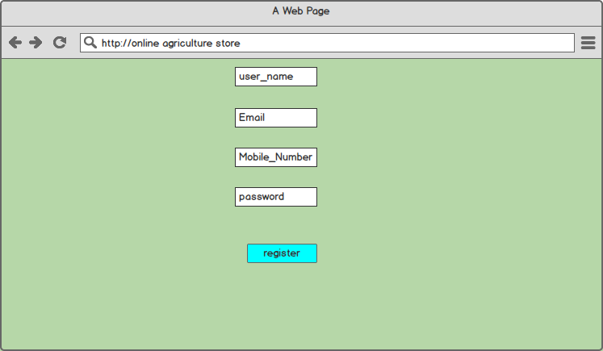
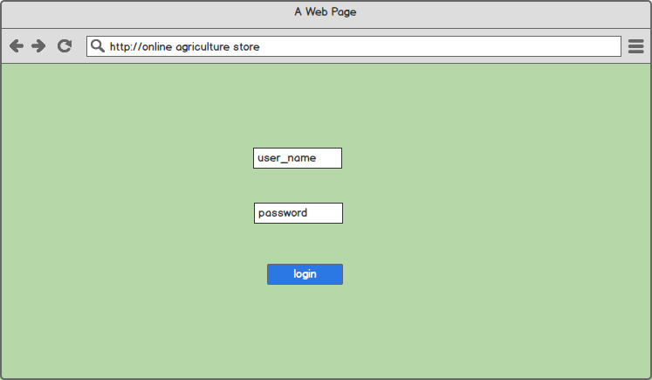
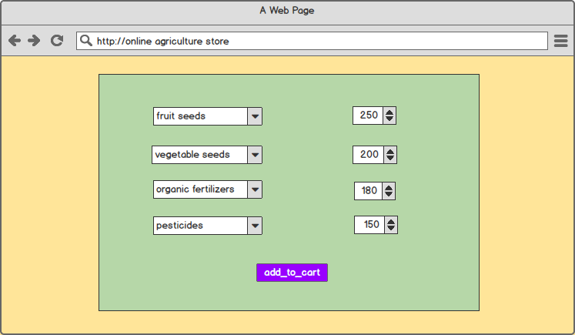
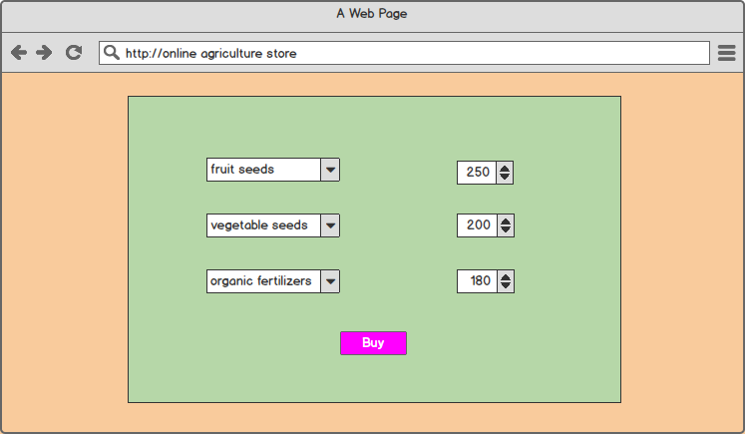
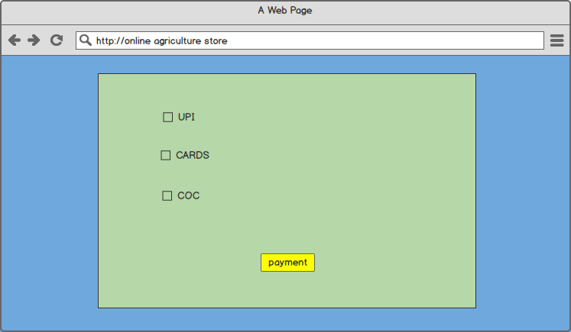
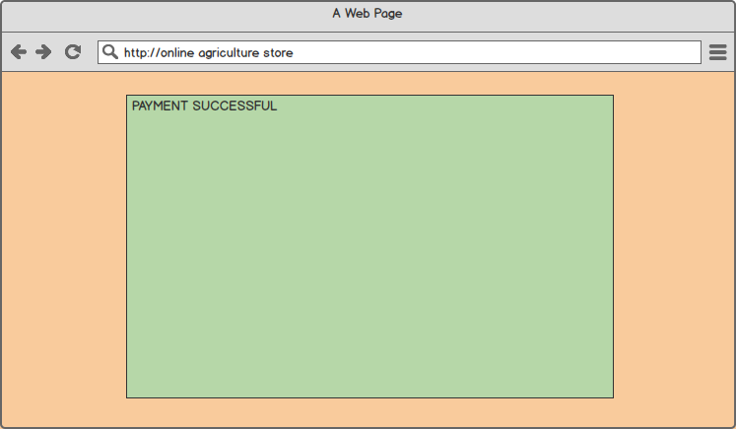
Prototypes using Azure RP
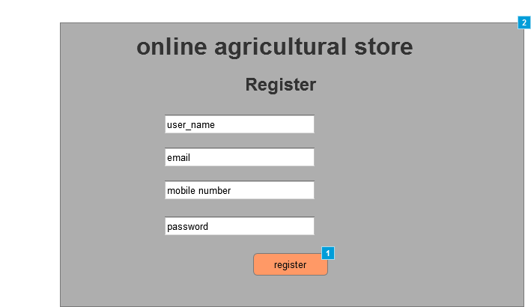
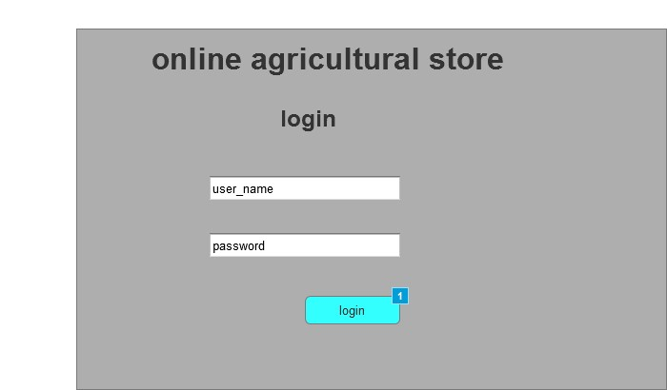
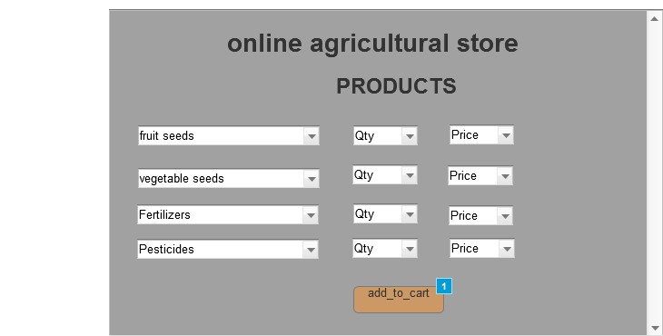
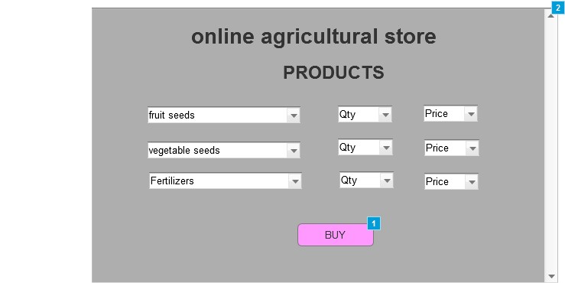
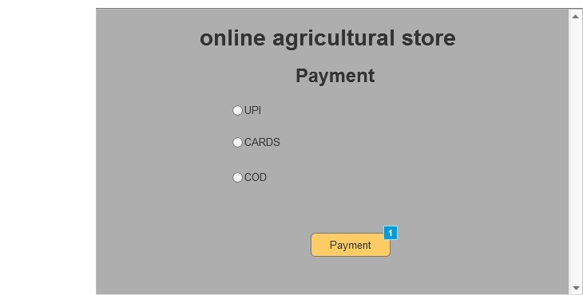
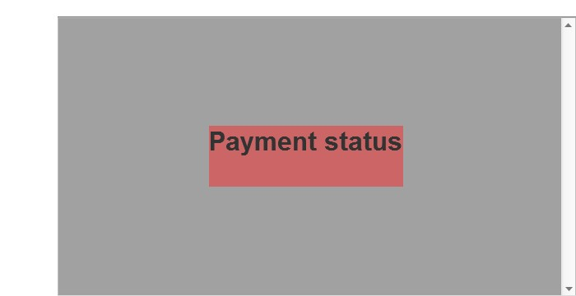
Question 3 – Tools (Visio, Balsamiq) - 15 Marks
Make a note of the Tools, which you are using for above concepts.
Microsoft Visio is a diagramming and vector graphics application used to create diagrams, flowcharts, and other visual representations of complex information.
Balsamiq is a rapid wire framing tool used to create mockups and prototypes of user interfaces.
Axure is a more advanced prototyping tool used to create high-fidelity, interactive wireframes and prototypes for web and mobile applications.
Question 4 – RTM - 6 Marks
A business analyst’s key responsibilities are to keep track of the requirements and make sure that no requirement is missed.
Mr. Henry and peter have approached you regarding the current status of the project. How will you tackle this situation?
Prepare RTM
Req ID | Req Name | Req Description | Design | D1 | T1 | ………. | T4 | UAT
FR0001 | Farmer Registration | Farmers should be able to register with the application
FR0002 | Farmer Search for Products | Farmers should be able to search for available products in fertilizers, seeds, pesticides
NFR0101 | Page Loading Time | Each Page should load within 2 seconds time
NFR0102 | WCAG 2.1. | The system must meet Web Content Accessibility Guidelines WCAG 2.1.

Requirements Traceability Matrix(RTM) is a document to tract the requirements throughout the project lifecycle, ensuring that they are met and that no requirements are overlooked.
Req ID | Req Name | Req Description | Design | D1 | T1 | T2 | T3 | T4 | UAT
  FR0001
  User Registration
  User should be able to register with the application using email & password.
  Yes
  ✓
  ✓
  ✓
  FR0002
  Farmer Login
  Farmers should be able to login securely with registered credentials.
  Yes
  ✓
  ✓
  ✓
  R0003
  Farmer Search for Products
  Farmers should be able to search for available products (fertilizers, seeds, pesticides).
  Yes
  ✓
  ✓
  ✓
  FR0004
  Product Catalog
  Display product catalog with categories & filters.
  Yes
  ✓
  ✓
  ✓
  FR0005
  Add to Cart / Buy Later
  Farmers should be able to add products to cart or wishlist.
  Yes
  ✓
  ✓
  ✓
  FR0006
  Payment Gateway
  Farmers should be able to pay using COD, Debit/Credit Card, or UPI.
  Yes
  ✓
  ✓
  ✓
  ✓
  FR0007
  Order Confirmation
  System should send email confirmation after order is placed.
  Yes
  ✓
  ✓
  ✓
  ✓
  FR0008
  Delivery Tracking
  Farmers should be able to track delivery status (Placed → Dispatched → Delivered).
  Yes
  ✓
  ✓
  ✓
  ✓
  ✓
  NFR0101
  Page Loading Time
  Each page should load within 2 seconds.
  Yes
  ✓
  ✓
  ✓
  ✓
  ✓
  ✓
NFR0102 | WCAG 2.1 Accessibility | System must comply with WCAG 2.1 guidelines for accessibility. | Yes | ✓ | ✓ | ✓ |  |  | ✓

Legend:
- Design: Requirement covered in design (Yes/No)
- D1: Design document mapping
- T1–T4: Test cases across different phases (Unit Testing, Integration Testing, System Testing, etc.)
- UAT: Requirement verified during User Acceptance Testing
Question 5 – 10 Test Case Documents - 10 Marks
Prepare 10 Test Case Documents
A test case document is a detailed outline used by tester to ensure that a software application or system is working as expected.
Test Case ID | TC001
Test Case Name | User Registration
Project ID | AGRI001
Test Strategy ID | TS001
Test Plan ID | TP001
Test Schedule ID | SCH001
Scenario | Verify user registration works correctly.
Link to that page | /register
Input Data | Name, Email, Mobile, Password, Confirm Password
Expected Behaviour | User account is created, confirmation email/SMS sent.
Actual Behaviour | To be tested
Comments / Results | To be filled after testing

Test Case ID | TC002
Test Case Name | User Login
Project ID | AGRI001
Test Strategy ID | TS001
Test Plan ID | TP001
Test Schedule ID | SCH002
Scenario | Verify user login works correctly.
Link to that page | /login
Input Data | Email, Password
Expected Behaviour | User redirected to dashboard/homepage.
Actual Behaviour | To be tested
Comments / Results | To be filled after testing

Test Case ID | TC003
Test Case Name | Product Search
Project ID | AGRI001
Test Strategy ID | TS001
Test Plan ID | TP001
Test Schedule ID | SCH003
Scenario | Verify product search works correctly.
Link to that page | /search
Input Data | Search Keyword: Fertilizer
Expected Behaviour | Relevant products displayed with keyword match.
Actual Behaviour | To be tested
Comments / Results | To be filled after testing

Test Case ID | TC004
Test Case Name | Product Details Page
Project ID | AGRI001
Test Strategy ID | TS001
Test Plan ID | TP001
Test Schedule ID | SCH004
Scenario | Verify product details page works correctly.
Link to that page | /product/{id}
Input Data | Click on Organic Seeds
Expected Behaviour | Product details displayed including description, price, reviews.
Actual Behaviour | To be tested
Comments / Results | To be filled after testing
Test Case ID | TC004
Test Case ID | TC005
Test Case Name | Add to Cart
Project ID | AGRI001
Test Strategy ID | TS001
Test Plan ID | TP001
Test Schedule ID | SCH005
Scenario | Verify add to cart works correctly.
Link to that page | /product/{id}
Input Data | Product: Pesticide, Qty:2
Expected Behaviour | Product added to cart with correct quantity & price.
Actual Behaviour | To be tested
Comments / Results | To be filled after testing

Test Case ID | TC006
Test Case Name | Update Cart Quantity
Project ID | AGRI001
Test Strategy ID | TS001
Test Plan ID | TP001
Test Schedule ID | SCH006
Scenario | Verify update cart quantity works correctly.
Link to that page | /cart
Input Data | Update Qty: 2 → 5
Expected Behaviour | Cart updates total price accordingly.
Actual Behaviour | To be tested
Comments / Results | To be filled after testing

Test Case ID | TC007
Test Case Name | Checkout Process
Project ID | AGRI001
Test Strategy ID | TS001
Test Plan ID | TP001
Test Schedule ID | SCH007
Scenario | Verify checkout process works correctly.
Link to that page | /checkout
Input Data | Address, Payment Method, Delivery Option
Expected Behaviour | Order summary displayed, user proceeds to payment.
Actual Behaviour | To be tested
Comments / Results | To be filled after testing

Test Case ID | TC008
Test Case Name | Payment Gateway Integration
Project ID | AGRI001
Test Strategy ID | TS001
Test Plan ID | TP001
Test Schedule ID | SCH008
Scenario | Verify payment gateway integration works correctly.
Link to that page | /payment
Input Data | Credit Card Details, UPI ID
Expected Behaviour | Payment success confirmation & order ID generated.
Actual Behaviour | To be tested
Comments / Results | To be filled after testing

Test Case ID | TC009
Test Case Name | Order History
Project ID | AGRI001
Test Strategy ID | TS001
Test Plan ID | TP001
Test Schedule ID | SCH009
Scenario | Verify order history works correctly.
Link to that page | /orders
Input Data | Login → My Orders
Expected Behaviour | List of past orders displayed with order ID, status, total.
Actual Behaviour | To be tested
Comments / Results | To be filled after testing

Test Case ID | TC010
Test Case Name | Logout Functionality
Project ID | AGRI001
Test Strategy ID | TS001
Test Plan ID | TP001
Test Schedule ID | SCH010
Scenario | Verify logout functionality works correctly.
Link to that page | /logout
Input Data | Click Logout Button
Expected Behaviour | User redirected to login page, session terminated.
Actual Behaviour | To be tested
Comments / Results | To be filled after testing
Question 6 – DB Design – 8 Marks
After the requirements are thoroughly explained to the entire project team by business analyst, the Database architects have decided to do the database design and also to represent the in-flow and out-flow of data. Draw database schema and ER diagram.
- DB Schema is a blueprint that outlines the structure of a database, including its tables, fields, relationships, constraints, and other characteristics.

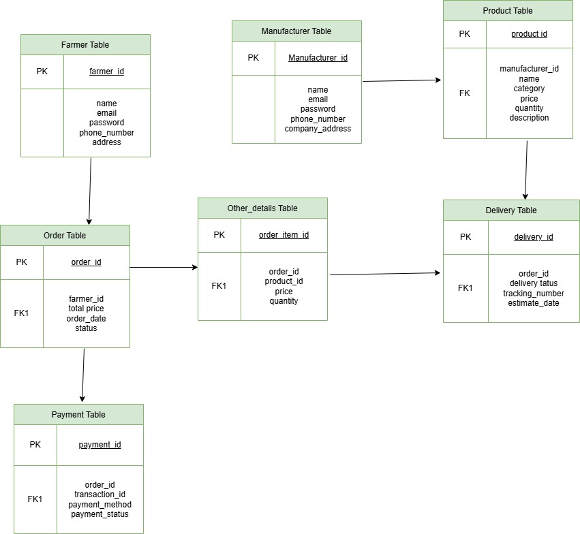

- An Entity-Relationship Diagram (ERD) is a visual representation of the relationships between entities in a database. It depicts the entities (such as tables), attributes (properties or fields), and relationships between them.

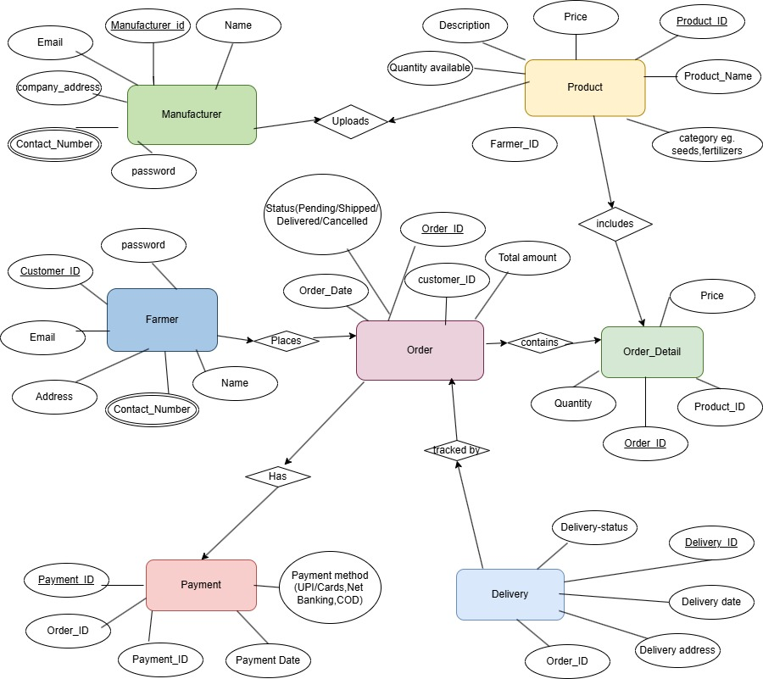

Question 7 – Data Flow Diagram - 3 Marks
What is a data flow diagram? Draw a data flow diagram to represent the in-flow and out-flow of data when a Farmer is placing an order for the product.
- A Data Flow Diagram (DFD) is a graphical representation of the flow of data within a system. It visually shows how data moves from one process to another, how it’s stored, and where it ends up.
- It helps analysts and designers to understand the flow of data within a system, identify potential bottlenecks or inefficiencies, and communicate system requirements to stakeholders.
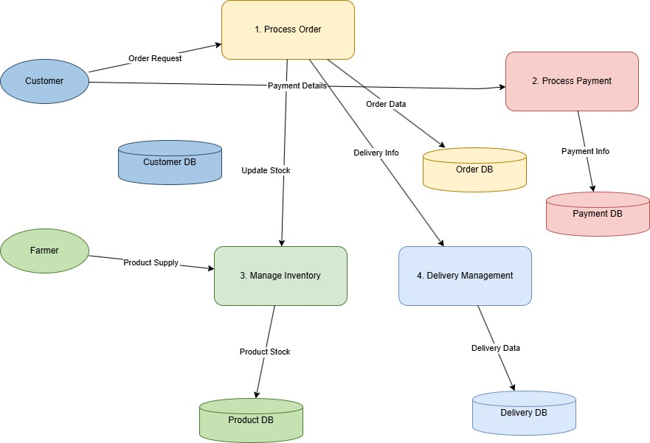
Question 8 – Change Request - 10 Marks
Due to change in the Government Taxation structure, we should change the Tax structure How do you handle change requests in a project?
- A change request is a formal proposal to alter a system, product, or project.
- Understand the scope of change request and document the change request
- Do the impact analysis- project scope, schedule, budget, resources, and risks
- Prioritize change request based on its urgency, importance, impact on project
- Seek approval from the project sponsor for the change request.
- Communicate the change request and its potential impacts to all relevant stakeholders, including the project team.
Question 9 – Change Request Vs an Enhancement - 5 Marks
As the project is in process, Ben and Kevin have contacted you. The reason is to inform you that they want the Farmers to sell their crop yields through this application i.e. Farmers should be able to add their crop yields or products and display to general public and should be able to sell them. They also want to introduce Auction system for their Crop yields. As a BA, what will be your response? Is this a change request or an enhancement???
- In this adding auction to the application would be considered an enhancement as it involves adding new features to the system. As a Business Analyst, you should document the requirements and work with the development team to determine the feasibility and impact of the new features. You should also consider the potential benefits, risks, and costs associated with the enhancements before making any recommendations to the client.
- Handling change requests in a project involves a systematic process to ensure that changes are effectively managed while minimizing disruption to the project’s scope, timeline, and resources. Here are the steps typically followed:
Change Request Identification:
- Identify and document the change request, including specific details of the requested change, the reason for the change, and its potential impact on the project.
Change Impact Analysis:
- Assess the impact of the change on various aspects of the project, such as scope, timeline, cost, resources, and risks. Evaluate feasibility and implications of implementing the change.
Change Evaluation:
- Review the change request with key stakeholders, including project sponsors, clients, and team members. Discuss potential benefits, risks, and trade-offs. Consider objectives, constraints, and priorities.
Change Prioritization:
- Prioritize the change based on urgency, impact, and alignment with project goals. Determine if it must be implemented immediately or scheduled for a future phase.
Change Approval:
- Obtain formal approval from appropriate stakeholders, such as project sponsors or change control boards. Ensure consensus on the change and its implications.
Change Implementation:
- Incorporate the approved change into the project plan, including adjustments to scope, schedule, budget, or resources, as necessary.
Question 10 – Estimations - 6 Marks
Come up with estimations – How many Man hours required for this project? Come up with a number and justify your analysis?
- Man Hours are the required efforts of the resources to complete a project. There are 3 types of projects:
- Small: Upto 500 hours
- Medium: Upto 1000 hours
- Large: Upto 1500 hours
Analysis
- As per the case study, the duration of the project is 18 months and the current team size is around 15. This will come under medium project.
- As the trained resources are available, trainers are not required.
- As the structure of the project is available, new and enhanced infrastructure is not required.
- Manhours Required = Total hours working per day * Total number of members * Total number of days worked over the specific period
- Number of working hours a day = 8 hours
- Number of Resources = 11
- Time period provided = 18 months = 547 days = 78 weeks (including weekends and public holidays)
- Assuming weekends = 156
- Assuming public holidays = 10
- Total = 166
- 547 – 166 = 381 working days
Hence, estimated manhours = 8 hours * 11 resources * 381 days = 33,528 hours
Question 11 – UAT – 6 Marks
Project has finally completed all the stages i.e., design, development, testing etc. Now, it is the role of a business analyst to contact the client for testing of the final product and have to successfully complete it. How are you going to handle this situation? And once it is done, what will be the process to close the project? Explain UAT Acceptance process.
- Planning: In this step, Blue Prints are made to implement UAT testing for every feature that needs to test and minimum standards for accepting the test.
- Designing Here the Test cases are designed to hide all the possibilities of software packages in a real-world environment.
- UAT Testers: A Testing team consists of a end users that meet the criteria for implementing testing.
- They should know the test cases to run and understand the functionalities.
- Bug Fixing: Whatever Bugs are found in the UAT Testing, the development team should work on them and make it software error free.
- Sign Off: After removing all the bugs, the testing team indicates acceptance of the completion of the bugs. In this phase, all the stakeholders come to a conclusion that the software is ready to GO LIVE and sign it off.
Question 12 – Project Closure Document - 6 Marks
Explain Project closure document
A project closure document is a comprehensive report that summarizes the entire project’s lifecycle, outcomes, and lessons learned. It serves as a formal record of the project’s completion and provides important information for future reference.
The document typically includes the following sections:
Project Overview:
Provides an overview of the project, including its objectives, scope, and stakeholders involved. It summarizes the project’s purpose and sets the context for the closure report.
Project Achievements:
Highlights the key achievements and deliverables of the project. It outlines the successful completion of milestones, tasks, and any significant accomplishments that were achieved.
Project Timeline and Budget:
Provides an overview of the project timeline, highlighting the start and end dates, major phases, and milestones. It also includes information on the budget and resource allocation.

