COEPD - Scrum Project Implementation – 100 Marks – Pass is 60%
Instructions to follow:
- Copy paste (either image, diagram or text) is not entertained. If done, the document will not be evaluated.
- After submission of the answers of this prep exam, You should be prepared to attend viva and justify your answers in the prep exams. If in Viva, participant is NOT justifying the answers, Viva will be repeated until Candidates justify 60% correctness.
- Mentor calls are scheduled only if the participant have submitted their task at least for one time.
(should apply their knowledge in this task first)
- For attempting prep exams participant should be thorough on the topics using their references.
- Please format the document properly (Always have a question no., question and answer). 6.Have a consistent format (Font name: Arial/ Calibri -Font size 12, Font Color: Black ).
- Few Questions are related to the case study, check Questions thoroughly before you answer.
- Answers should be elaborated in detail(*not as per the allotted marks).
- Please focus on learning and applying the knowledge as this knowledge will be helpful in contributing at your BA job.
10.In the evaluation, students must answer all questions and should be able to justify at least 60% content and correctness of each answer.

Question 1 – write Agile Manifesto – 8 Marks

Scrum Project Name: Scrum Foods (Foods Delivery Applications)

Scrum Project Description:
Scrum Foods provides fast, reliable online food delivery application targeting customers of all age group offering 24/7 service along with tracking of the delivery real time.
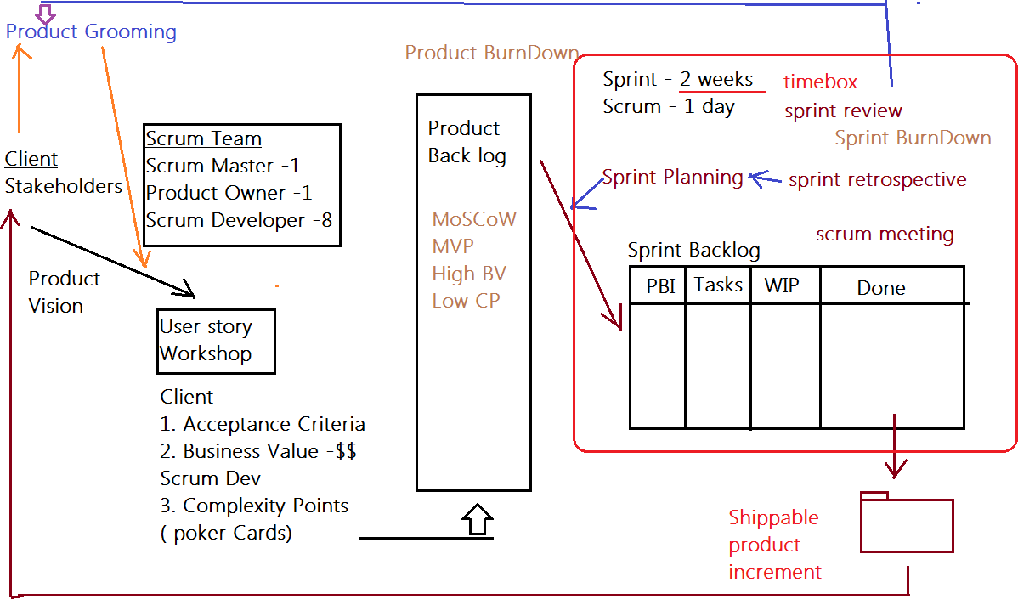

Client: COEPD IT Solutions
Stakeholder List:
1. Business Owner
2. Administrator
3. Regional Administrator
4. Restaurant
5. Delivery boy
6. Customer

Product Vision

– Meeting – Discussion – Document -

Scrum Project Name: Scrum Foods
Venue:
Date: Start Time: End Time: Duration:
Client: COEPD IT Solutions
Stakeholder List:
1. Business Owner
2. Administrator
3. Regional Administrator
4. Restaurant
5. Delivery boy
6. Customer
Scrum Team
Scrum Master: Satya Rathnakar
Product Owner: YOU
Scrum Developer 1: Linesh Vegad
Scrum Developer 2: Yogender
Scrum Developer 3: Gowri
Scrum Developer 4: A.Lakshmikala
Scrum Developer 5: Madhuri
Scrum Developer 6: Varun
Scrum Developer 7: Rakesh
Scrum Developer 8: Rajesh
You are the Product Owner

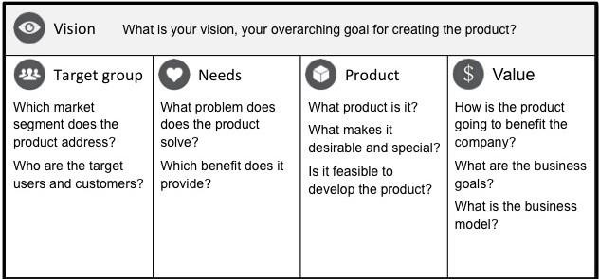

VISION: Customers of any age group who want to have top-rated restaurant’s delicious food in one- go at their doorstep with lighting fast delivery, 24/7 availability and reliable services are SCRUM
FOODS. Unlike any other food delivery app in market, our utmost priority is customer need and customer satisfaction which makes us stand out of any other food delivery app in this industry.
Online food delivery industry is our target segment.  Users/Customers: People who want food deliveries within stipulated time at their required place | Scrum foods provide guaranteed safe food delivery in one-go of top rated licensed restaurants.  Customers can receive with safe packaged food within expected time to clear their hunger. | Scrum foods will be on mobile, tablets and desktop application.  Real time tracking and providing 24/7 services and customer support  Product feasibility can be complex and require attention in every aspect | Open up revenue stream  Be leading online food delivery app in country  Create reputed brand image for other business opportunities.

Product Vision – Description – Notes

Customer: Registration, Login, Search and View restaurants, View restaurant's menu, Order food, Payment, Tracking, Cancel order, Feedback & Rating and Logout.
Delivery Boy: Registration, Login, View orders, Select and accept orders, Order pickup and delivery, Status updates, Payment (COD), View Feedback, Raise Issues, View Deliveries report and revenue generated, Logout.
Restaurants: Registration, Login, View Orders, Delivery Boy Verification, Payment, View Feedback, Raise Issues, View revenue generated through Scrum Food app, Logout.
Regional Admin: Admin Login, Tracking/status, Customer feedback, Managing Regional delivery boys and restaurant, View regional revenue, Issues, Refunds, View payment made to regional restaurant and Logout.
Admin: Login, Managing Regional Admin, Issues, Customer Feedback, Approval/Rejections privileges on restaurants, Delivery boy, Restaurants and Regional Admin requests, Resolve Issues and Logout
Business Owner: Login, Issues, Reports, Update payments for restaurants and delivery boys and Logout

End of Product Vision

User Story Workshop
How to write a User story:
Take a Sticky Note and take a contract color Sketch Pen and write the user story in CAPITAL letters only. Make sure the user story is short, clear and unambiguous and one Scrum Developer can develop in one agreed sprint.
If you come across complex, big User stories… these are called epics. We can divide the epics into Themes and then into User Stories

Finalized User Stories | Count:

USER STORIES

SPRINT-1
User Story No: 1 | Tasks: 2 |  | Priority: HIGHEST
AS A DELIVERY BOY
I WANT TO REGISTER IN SCRUM FOODS SO THAT I CAN DELIVER ORDERS
BV: 500 |  | CP: 02
ACCEPTANCE CRITERIA
Registration Screen
Text Boxes for User Name, Password, Nation ID, Mobile No, Email, Address, Phone Number.
Click on Register Button.
Send Successful Notification to the user

User Story No: 02 | Tasks: 2 |  | Priority: HIGHEST
AS A RESTAURANT OWNER I WANT TO VIEW ORDERS
SO THAT I CAN VIEW THE LIST OF ORDERS
BV: 500 |  | CP: 2
Acceptance Criteria :
View Order, Display List of orders in the tabular Form

User Story No: 3 | Tasks:2 |  | Priority: HIGHEST
AS A CUSTOMER
I WANT TO ADD THE ADDRESS
SO THAT I CAN GET THE ORDER TO MY ADDRESS
BV: 500 |  | CP: 2
Acceptance Criteria :
Text Box to enter.
Business Rules: Within the radius of 5 km

User Story No: 4 | Tasks:2 |  | Priority: HIGHEST
AS A CUSTOMER
I WANT TO SELECT THE PAYMENT MODE
SO THAT I CAN MAKE PAYMENT OF MY CHOICE
BV: 500 |  | CP: 3
Acceptance Criteria :
Display payment modes, radio buttons to select payment modes, payments button.
Business Rule. Can select only one payment mode

User Story No: 5 | Tasks:2 |  | Priority: HIGHEST
AS AN ADMIN
I WANT TO VIEW THE RESTAURANTS
SO THAT I CAN APPROVE THEIR REGISTRATION
BV: 500 |  | CP: 2
ACCEPTANCE CRITERIA
List of restaurant, select Restaurants, verify restaurant details, approve button, reject button, notification to the restaurant.

User Story No: 6 | Tasks:2 |  | Priority: LOW
AS ACUSTOMER
I WANT TO VIEW THE PRICE
SO THAT I CAN ORDER THE FOOD
BV: 50 |  | CP: 1
Acceptance Criteria :
1. Display price in the list of menu items

User Story No:7 | Tasks:2 |  | Priority: LOW
AS A CUSTOMER
I WANT TO VIEW THE CONTACT NUMBER OF DELIVERY BOY SO THAT I CAN CONTACT DELIVERY BOY FOR THE STATUS
BV: 50 |  | CP: 1
Acceptance Criteria :
- Display delivery boy mobile number
- Display delivery boy name in tracking field
- Display delivery boy picture

User Story No: 8 | Tasks:2 |  | Priority: MEDIUM
AS A RESTAURANT OWNER
I WANT TO PROVIDE TIME SLOTS
SO THAT CUSTOMER CAN CHECK OPENING AND CLOSING HOURS
BV: 100 |  | CP: 2
Acceptance Criteria :
- Click on restaurant dashboard
- Add from time to time
- Click on submit
- Display updated successfully

User Story No: 9 | Tasks:2 |  | Priority: HIGH
AS A Business OWNER
I WANT TO VIEW RESTAURANT REVENUE REPORT SO THAT I CAN VIEW THE RESTAURANT’S REVENUE
BV: 200 |  | CP: 3
Acceptance Criteria : Select Reports
Select Revenue Reports Select to and from date Select Region (can select all) Generate Report
Download Report in EXCEL

User Story No: 10 | Tasks: 03 |  | Priority: High
AS A REG ADMIN
I WANT TO MANAGE REGIONAL RESTAURANTS,
SO THAT, I CAN TRACK THE PERFORMANCE OF REGIONAL RESTAURANTS.
BV: 200 |  | CP: 03
Acceptance Criteria :
CLICK ON PERFORMANCE OF RESTAURANTS SELECT FROM DATE TO DATE
CLINCK ON GENERATE REPORT WHICH INCLUSES RESTAURANTS ID, NAME, REVENUE
CLICK ON DOWNLOAD REPORT SHOULD BE IN EXCEL

User Story No: 11 | Tasks: 02 |  | Priority: Medium
AS ADMIN
I WANT TO SEE THE REGIONAL REVENUE REPORTS, SO THAT I CAN VIEW THE REGIONAL PERFORMANCE
BV: 100 |  | CP: 03
Acceptance Criteria :
Select regional dropdown
View performance of each rest of that region in tabular form which includes rest name, revenue, generated
Download in excel or PDF

User Story No: 12 | Tasks: 02 |  | Priority: High
AS A CUSTOMER
I WANT TO CHAT WITH REG ADMIN SO THAT I CAN REQUEST FOR REFUND
BV: 200 |  | CP: 02
Acceptance Criteria :
- BR-ALL MANDATORY
- TEXT BOX FIELDS
- DISPLAY ORDER ID
- TEXT BOX,FOR DESCRIPTION
- SUBMIT BUTTON
- GENERATE ISSUE ID
- DISPLAY SUCCESSFUL

Adding BV and CP to User stories
BV – Business Value
This is not the cost of Development or the complexity of the feature. Business Value is how important is this feature (user Story) to the Business. This is estimated by Scrum Currency Notes. We provide Rs 1000. Rs 500, Rs 100, Rs 50, Rs 20 and Rs 10 Denominations. These estimations are done by the Stakeholders (Clients). If different values are selected by the stakeholders, then discussions will happen, and they agree to one BV value to that user story.

CP – Complexity Points
CP is also known as Story Points (SP). CP is the effort required by the Scrum Developers to develop this feature (user story) using technology. Efforts include time taken to solve the complexity and write the code. CP is estimated by the Scrum Developers by using Poker cards. We provide pokers with values “?”, 1, 2, 3, 5, 8, 13, 20, 40, 100 and BIG. If the entire Project development takes 200 points, then this user story coding effort will be… how many points? … Thinking in this way, Scrum Developers will give CP to the User story. ). If different values are selected by the Scrum Developers, then discussions will happen, and they agree to one CP value to that user story.

Question 2 – User Stories- Acceptance Criteria-BV-CP – 40 Marks
Write minimum 40 User stories and their Acceptance Criteria along with their BV and CP

Question 3– What is epic? Write 2 epics – 5 Marks
Business Value and Complexity Points

Question 4 –What is the difference between BV and CP – 2 Marks

Product Backlog
Your User stories will go into Product Back log

Question 5 –Explain about Sprint– 5 Marks

Sprint Understanding
What is sprint Duration: 2 Weeks - Your sprint Value

Scrum is a subunit of Sprint.
What is scrum Duration: 1 day – Your scrum Value ? PBI: Product Backlog Item
Task: Unit of Work done by 1 Developer in 1 Scrum WIP: Work In Progress
Sprint Backlog

PBI | Tasks | WIP | Done

Question 6 – Explain Product backlog and sprint back log– 5 Marks

Sprint Planning Meeting: All 8 Scrum Developers will gather before the sprint starts and understand how many user stories, they can develop in 1 sprint (2 weeks), and move them from the product Backlog to the sprint Backlog. They take inputs from Sprint Retrospective meeting.
Scrum Meeting – Daily Stand-up Meeting
End of every Scrum, Scrum Developers will participate in Scrum meeting. Here they must answer 3 Questions.
- What task did you work in this scrum?
- What task will you work on next scrum?
- Any Challenges/impediments? When you will complete the user story?

Question 7 – What is impediments log? write 2 impediments – 5 Marks

Impediments Log:
All challenges faced by the team will be logged in this impediments log

Once the Sprint is completed
- From the Done state of the sprint Backlog, we will product Increment and we can deliver it to the client
- Sprint Retrospective meeting: Only the Scrum Developers will participate and will discuss about Challenges faced and come up with lessons learnt. We can use these lessons learnt in Sprint planning meeting to select user stories for the next sprint.
- Sprint Review meeting: All Stakeholders like Scrum Developers, Product owner, Scrum master, Client, 3rd party reviewers will participate. What they discuss is
  - Velocity – How many CP is covered in this sprint

  - Sprint Burn Down Chart

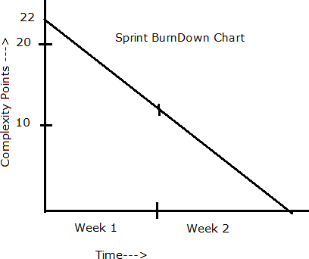

  - Product Burn Down Chart

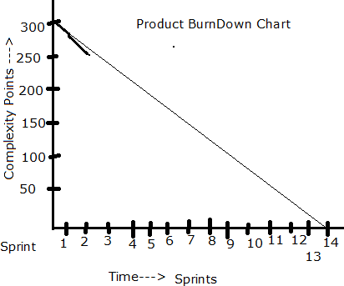

  - Product insights for improvement

Sprint 1
Start Time: 11:00 AM End Time: 13:00 Duration: 2 hrs

Sprint Planning Meeting
Participants
Discussion Points: Discussed on the Sprint Velocity and the BV with the user stories. Discussed with
the associates on resources provided to them and also communicated to the team on sprint duration as well as expectations from the client.
User Stories Selected: 10 (MVP)

Sprint Backlog

PBI | Tasks | WIP | Done
10 | 20 | 0 | 10

Prepare Tasks from PBI
How many Scrums, we will have in this sprint? Allocate Tasks to Developers

Scrum 1
Start Time: End Time: Duration:
Participant and Task Selected

Scrum Meeting
End of every Scrum, Scrum Developers will participate in Scrum meeting. Here they must answer 3 Questions.
- What task did you work in this scrum?
- What task will you work on next scrum?
- Any Challenges/impediments? When you will complete the user story?

Scrum 2
Scrum 3

Scrum 4
Repeat the same activities for all scrums

Sprint 1 – Closing Activities

From the Done state of the sprint Backlog, we will product Increment and we can deliver it to the client What is the Product Increment we made now?

Sprint Retrospective meeting: Only the Scrum Developers will participate and will discuss about Challenges faced and come up with lessons learnt. We can use these lessons learnt in Sprint Planning Meeting to select user stories for the next sprint.
Write here

Sprint Review meeting: All Stakeholders like Scrum Developers, Product owner, Scrum master, Client, 3rd party reviewers will participate. What they discuss is
We as team,
Write here

Question 8 – Explain Velocity of the Team – 1 Marks
Velocity – How many CP is covered in this sprint

Question 9 – Draw Sprint Burn Charts n Product Burn Down Charts– 3 Marks

Sprint Burn down Chart Product Burn down Chart

Question 10 – Explain about Product Grooming – 2 Marks

Product insights for improvement
Used for product grooming

Question 11 – Explain the roles of Scrum Master and Product Owner – 3 Marks
Team Experiences with Sprint 1

Scrum Master:

Product Owner

You acted as Product Owner.
**

Question 12 – Explain all Meetings Conducted in Scrum Project – 8 Marks
**

Question 13 – Explain Sprint Size and Scrum Size– 2 Marks
**

Question 14 – Explain DOR and DOD – 2 Marks
**

Question 15 – Explain Prioritization Techniques and MVP – 3 Marks
**

Question 16 – Difference between Business Analyst n Product Owner – 3 Marks
**

Question 17 – Prepare a sample Resume of 3yrs exp Product Owner – 3 Marks

