04 BA Mock - Case study
Which Method Fits This Case?
For the ice-cream & milk products company:
Since delivery speed and inventory are dynamic and will likely need refinements (route optimization, warehouse stocking, delivery time calculation, etc.), Agile is the better fit.
Agile allows building MVP (Minimum Viable Product) first (like a basic inventory and delivery module), then iterating.
However, since this is a corporate project, the BRD & SRS can still follow a Waterfall-style documentation upfront, but execution can be Agile.
Waterfall Method
When useful:
- Requirements are fixed, stable, and clear from the start.
- Little scope for changes.
- Regulatory or compliance-heavy environments.
Pros:
- Clear documentation (good for BRD, SRS, process flows).
- Easy for client to review progress step-by-step.
Cons:
- Not flexible if requirements change later.
- Delays in delivery of actual usable software (client sees results late).
Agile Method
When useful:
- Requirements are evolving or unclear.
- Continuous feedback from stakeholders is required.
- System needs incremental improvements (e.g., delivery optimization, dashboards).
Pros:
- Faster releases (client sees working features early).
- Flexibility to adjust features based on feedback.
- Better suited for integration with real-time logistics, route optimization, and scaling.
Cons:
- Requires strong collaboration and continuous involvement of client.
- Documentation can be lighter (unless balanced with Agile documentation practices).
Best Approach:
A Hybrid Model:
Use Waterfall for documentation & initial planning (BRD, SRS, ERD, process flows), then Agile for development & delivery.
This way:
- The client gets formal documentation (important for contracts & clarity).
- Development team works in Agile sprints, releasing features step by step.
Assignment 1: BRD for Dairy (Ice-Cream & Milk) Inventory + Quickest Delivery
BRD (Business Requirements Document)
Project Title
Integrated Inventory and Logistics Management System for Ice-Cream and Dairy Products Manufacturer
Executive Summary
This project aims to digitalize and centralize inventory and distribution operations at multiple manufacturing plants and warehouses, ensuring real-time inventory control and efficient customer delivery. The transformation from manual management to automated, data-driven processes will minimize errors, cost, and delivery times, thereby boosting profitability and customer satisfaction.
Project Overview
The company manufactures and distributes ice-cream and milk products through plants and warehouses across the country. The organization intends to build a centralized software system to Manage inventory across plants, warehouses, and distribution points.
Ensure quickest delivery of products to customers by optimizing order allocation and route planning.
1.Business Goals:
- Fast, efficient tracking and resolution of customer/service tickets.
- Reduce response times.
- Improve customer satisfaction.
2. Objectives
- Real-time visibility of stock levels.
- Automated inventory replenishment alerts.
- Smart order allocation from nearest warehouse/plant.
- Route optimization for fastest delivery.
- Improved customer satisfaction and reduced wastage.
3. Key Stakeholders
- Client Sponsor: CEO / Director of Operations
- Business Users: Plant managers, Warehouse managers, Delivery managers
- IT Team: Developers, Testers, Database admins
- End Users: Customers placing orders
4. Key Features / Requirements
- Centralized dashboard for inventory monitoring.
- Stock movement tracking (Plant → Warehouse → Customer).
- Order fulfillment system with location-based delivery logic.
- Integration with transport/logistics partners.
- Mobile app for delivery staff.
- Reporting & analytics (stock, sales, wastage, delivery times).
5. Constraints & Assumptions
- System should support both web and mobile platforms.
- Peak seasonal demand should be handled without downtime.
- Compliance with food safety regulations.
6. KPIs (Key Performance Indicators)
- Inventory Accuracy ≥ 98%
- Delivery SLA ≤ 30 minutes (urban), ≤ 2 hours (rural)
- Wastage Reduction ≥ 15% in 6 months
- Customer Satisfaction ≥ 90% positive feedback
Development & Resource Plan
1. Methodology
- Agile Scrum – 2-week sprints, incremental delivery.
2. Team Structure
- Business Analyst (1) – Requirement gathering, documentation
- Project Manager (1) – Planning, tracking
- Developers (4) – Backend, frontend, mobile app
- UI/UX Designer (1) – User-friendly design
- QA/Testers (2) – Functional & performance testing
- DevOps Engineer (1) – Deployment, monitoring
3. Timeline (High-level)
- Requirement Gathering & BRD: 2 weeks
- Design (UI/UX + Architecture): 2 weeks
- Development: 10–12 weeks
- Testing: 3 weeks
- Deployment & Training: 2 weeks
- Go-live: ~20 weeks total

Process flow diagram :
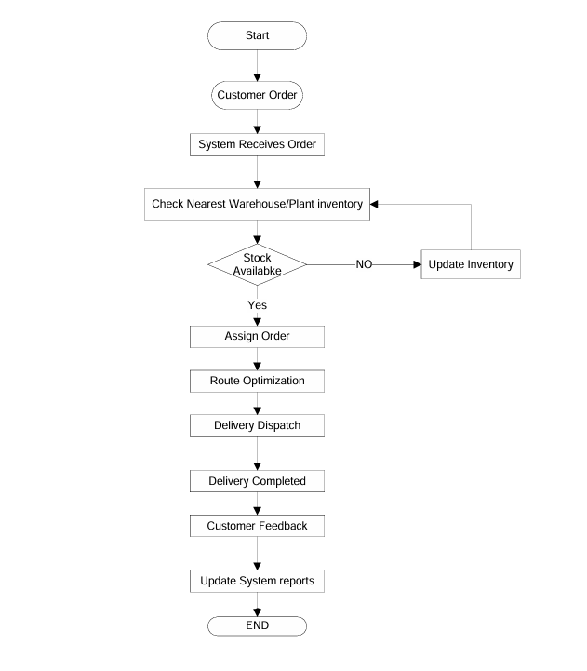
Introduction Letter
Subject: Introduction – Business Analyst for Upcoming Project
Dear Coepd,
I am Likhitha, the Business Analyst assigned to work with you and your team for the upcoming project. My role will be to bridge the gap between your business needs and the technical team, ensuring that the solution we build aligns with your goals.
Over the coming weeks, I will collaborate closely with your stakeholders to gather requirements, document processes, and create structured specifications for development. I look forward to understanding your vision and translating it into a successful solution.

Best Regards,
Likhitha
Business Analyst

Brief BRD Business Requirement Document (BRD)
Project Name: Inventory & Delivery Management System
Project ID: IFD-001
Version ID: 1.0
Author: Business Analyst Team
Date: September 04, 2025
1. Document Revisions
Date | Version | Document Changes
4-Sep-25 | 1 | Initial Draft
2. Approvals
Role | Name | Title
Project Sponsor | Mr. Arvind Rao | CEO
Business Owner | Ms. Likhitha Sharma | COO
Project Manager | Mr. Rajiv Menon | PM
System Architect | Mr. Ajay Kulkarni | Enterprise Architect
Development Lead | Ms. Ritu Agarwal | Tech Lead
UX Lead | Mr. Naveen Patel | UI/UX Specialist
Quality Lead | Ms. Ananya Gupta | QA Lead
Content Lead | Mr. Kiran Das | Documentation Specialist

3. RASCI Chart
Codes Used: R = Responsible, A = Accountable, S = Supports, C = Consulted, I = Informed
Name | Position | R | A | S | C | I
Arvind Rao | CEO (Sponsor) |  | A |  | C | I
Likhitha Sharma | COO (Business Owner) |  | A |  | C | I
Rajiv Menon | Project Manager | R | A |  |  | I
Ajay Kulkarni | Architect | R |  |  | C | I
Development Team | Developers | R |  |  |  | I
QA Team | Testers |  |  | R | C | I
Regional Managers | Stakeholders |  |  |  | C | I
4. Introduction
4.1 Business Goals
  - Enable real-time inventory visibility across all plants and warehouses.
  - Ensure quickest possible delivery of ice-cream and milk products.
  - Reduce manual errors and product wastage.
  - Increase customer satisfaction through timely service.

4.2 Business Objectives
  - Build a centralized software system for inventory management.
  - Automate delivery routing & logistics optimization.
  - Provide mobile access for warehouse and delivery staff.
  - Generate analytical reports for sales, stock, and delivery efficiency.
4.3 Business Rules
  - Inventory must follow FIFO (First In, First Out) method.
  - Expired products cannot be dispatched.
  - Each warehouse must update stock levels daily.
  - Delivery timelines: Milk ≤ 12 hours, Ice-cream ≤ 6 hours.
4.4 Background
Currently, stock is managed manually using spreadsheets, and deliveries are coordinated by calls/emails. This causes delays, stockouts, and customer dissatisfaction. The company aims to adopt a modern IT solution to automate and scale its operations.
4.5 Project Objective
To develop a web and mobile-based Inventory & Delivery Management System that integrates warehouses, manufacturing plants, and logistics, ensuring real-time tracking, minimal wastage, and optimized delivery.
4.6 Project Scope
**In-Scope Functionality:**
  - Inventory management (plants & warehouses)
  - Stock alerts & automated replenishment
  - Delivery scheduling and route optimization
  - Barcode/RFID-based stock tracking
  - Reports & dashboards (sales, wastage, delivery time)
  - User access control & audit logs
**Out-of-Scope Functionality:**
  - E-commerce ordering system
  - Integration with external CRMs (future phase)
  - AI-driven demand forecasting
5. Assumptions
  - Stable internet available at all warehouses.
  - Delivery staff are trained in using mobile app.
  - ERP integration APIs are accessible.
6. Constraints
  - Must comply with FSSAI guidelines for storage/transport.
  - Must maintain 99.9% uptime.
  - Delivery must work in low-network areas.

7. Risks (Detailed)
7.1 Technological Risks
- Risk: Failure of integration with third-party courier APIs (e.g., BlueDart, Delhivery).
- Likelihood: Medium
- Impact: High – Delivery tracking and order status updates may be delayed.
- Mitigation: Build API fallback mechanisms, maintain multiple courier integrations, and enable offline syncing.

- Risk: Server downtime or performance bottlenecks during peak season (summer demand surge).
- Likelihood: High
- Impact: High – Order processing delays, affecting customer satisfaction.
- Mitigation: Cloud-based auto-scaling, load balancing, and database optimization.
7.2 Skills Risks
- Risk: Lack of skilled staff for route optimization algorithm development.
- Likelihood: Medium
- Impact: Medium – Delayed delivery module implementation.
- Mitigation: Hire logistics domain experts, conduct team training, and consider outsourcing critical components.

- Risk: Inadequate training for warehouse staff using the new system.
- Likelihood: High
- Impact: Medium – Errors in stock entry could affect reporting accuracy.
- Mitigation: Provide user-friendly UI, conduct training workshops, and create SOPs (Standard Operating Procedures).
7.3 Political / Regulatory Risks
- Risk: Changes in food safety regulations (FSSAI/ISO compliance).
- Likelihood: Low
- Impact: High – Could require system modifications.
- Mitigation: Continuous monitoring of regulations and flexible system design for compliance updates.

- Risk: Government restrictions on cold chain logistics in certain regions.
- Likelihood: Low
- Impact: Medium – Delivery timelines may be extended.
- Mitigation: Alternative route planning and contracts with multiple logistics providers.

7.4 Business Risks
- Risk: Resistance to change from employees used to manual systems.
- Likelihood: High
- Impact: Medium – Slower adoption and data quality issues.
- Mitigation: Change management strategies, incentives for adoption, continuous support.

- Risk: Loss of revenue due to system downtime in peak season.
- Likelihood: Medium
- Impact: High
- Mitigation: Disaster recovery plan, backup servers, 24/7 support.

7.5 Requirements Risks
- Risk: Incorrect requirement gathering from warehouse managers.
- Likelihood: Medium
- Impact: High – Could lead to system redesign later.
- Mitigation: Conduct multiple requirement workshops, create prototypes, and get sign-offs.

- Risk: Scope creep due to requests for additional features (e.g., e-commerce).
- Likelihood: High
- Impact: Medium – Project delays and cost overrun.
- Mitigation: Strict scope management, phased rollouts, and change request process.

7.6 Environmental Risks
- Risk: Power outages in rural warehouses.
- Likelihood: High
- Impact: Medium – Delayed stock updates.
- Mitigation: Offline mode in mobile app, use of UPS systems.

- Risk: Extreme weather (heat waves/floods) affecting delivery routes.
- Likelihood: Medium
- Impact: High – Spoilage of dairy products.
- Mitigation: Real-time GPS route reallocation, refrigerated trucks, contingency stock in nearby warehouses.
8. Business Process Overview
8.1 Legacy System (AS-IS)
  - Manual inventory tracking via Excel sheets.
  - Delivery orders managed by calls and emails.
  - Lack of real-time visibility, frequent stockouts, and delays.
8.2 Proposed System (TO-BE)
  - Centralized inventory system with barcode scanning.
  - Automated delivery routing using GPS & algorithms.
  - Mobile app for warehouse and delivery staff.
  - Real-time dashboards for managers.
9. Business Requirements
**Functional Requirements:**
- Manage product inventory across multiple plants/warehouses.
- Track stock movement in real-time.
- Automate replenishment alerts.
- Delivery route optimization with GPS tracking.
- User management with role-based access.

**Non-Functional Requirements:**
- System uptime: 99.9%.
- Mobile responsiveness.
- Multi-language support (English + Regional).
- Secure authentication (OAuth/SSO).
10. Appendices
**10.1 List of Acronyms**
  - ERP: Enterprise Resource Planning
  - FIFO: First In First Out
  - GPS: Global Positioning System
**10.2 Glossary of Terms**
Stockout: Situation where product is unavailable
Replenishment: Restocking items automatically
**10.3 Related Documents**
Software Requirement Specification (SRS)
Feasibility Study Report
SRS (Software Requirements Specification) of Project:
Client: IceFresh Dairy Pvt. Ltd.
Project: Inventory & Delivery Management System
Date: September 04, 2025
Record of Revisions
Version | Date of Release / Revision | Prepared / Revised By | Reviewed By | Approved By | Reasons for Revisions
1 | 4-Sep-25 | Business Analyst Team | Project Manager | Client Representative | Initial Draft
1.0 Introduction
1.1 Overview
The purpose of this document is to specify the software requirements for the Inventory and Delivery Management System for IceFresh Dairy Pvt. Ltd. The system will support managing stock levels across multiple plants and warehouses while ensuring the quickest possible delivery to customers.
1.2 Acronyms and Definitions
Term | Description
ERP | Enterprise Resource Planning
SRS | Software Requirements Specification
API | Application Programming Interface
1.3 Operational Requirements
1.3.1 Software Requirements
  - Web application with mobile compatibility
  - Database: MySQL or PostgreSQL
  - Backend: Java/.NET/Python
  - Frontend: Angular/React
1.3.2 Hardware Requirements
  - Minimum server configuration: 16 GB RAM, 8 Core CPU, 500 GB SSD
  - Client system: 4 GB RAM, Dual Core CPU, Internet connectivity
1.4 References
  - Business Proposal
  - Client Requirement Workshops
  - Industry Best Practices
1.5 Design and Implementation Constraints
  - Must comply with food safety regulations
  - Integration with existing ERP systems
  - High availability with 99.9% uptime
  - Scalable architecture
1.6 Assumed Factors That Could Affect Requirements
The system depends on stable internet connectivity across warehouses and plants. External courier service API integration timelines may affect delivery features.
2.0 System Overview
2.1 Current System
Currently, inventory is managed manually through spreadsheets, and deliveries are coordinated via phone calls and emails. This results in delays and errors.
2.2 Proposed System
The proposed system will automate stock tracking, warehouse management, and delivery routing using optimized algorithms. It will provide real-time stock updates, auto-generate delivery schedules, and track shipments.
2.3 Benefits of Proposed System
  - Real-time inventory visibility
  - Reduction in delivery delays
  - Automated replenishment alerts
  - Cost savings due to optimized logistics
  - Improved customer satisfaction
3.0 UI Requirements
The system will have the following modules:
  - Dashboard: Overview of stock and deliveries
  - Inventory Module: Stock management per location
  - Delivery Module: Route optimization & shipment tracking
  - Reports: Sales, delivery efficiency, wastage analysis
  - Admin Panel: User management and role-based access
4.0 Other Parameters
4.1 Acceptance
The client will review and accept the system upon delivery of:
  - Functional Prototypes
  - Fully deployed Application
  - Documentation (Installation/User Manual)
The design and implementation of the Inventory and Delivery Management System must adhere to several constraints:
1. Regulatory Constraints
  - Compliance with FSSAI (Food Safety and Standards Authority of India) guidelines for storage and transportation of dairy products.
  - Adherence to GDPR/Local Data Protection Laws for handling customer and vendor information.
2. Technology Constraints
  - The system must be compatible with existing ERP modules used by the client.
  - The backend must be developed in Java / .NET / Python to ensure scalability.
  - The database must support high concurrency and large datasets (MySQL/PostgreSQL recommended).
3. Operational Constraints
  - The application must support real-time stock updates from multiple warehouses.
  - Mobile application must work in low-network rural areas where warehouses are located.
  - Delivery route optimization should consider perishable product timelines (ice cream has a limited storage duration).
4. Performance Constraints
  - Inventory updates must be reflected within 5 seconds across all connected systems.
  - Delivery allocation algorithms must process orders within 30 seconds for bulk orders.
  - System availability target: 99.9% uptime.
5. Hardware Constraints
  - Servers must run on 16 GB RAM, 8-Core CPU, 500 GB SSD or equivalent cloud resources.
  - Warehouse systems must include barcode/RFID scanners for stock entry.
6. Standards and Conventions
  - RESTful APIs must follow JSON standards for integration.
  - Database naming conventions should align with client’s existing ERP.
  - Coding standards: ISO/IEC 25010 quality model for maintainability and performance.
Several external and internal assumptions could influence the effectiveness of the system:
1. Dependency on External Services
  - Integration with third-party courier APIs (e.g., BlueDart, Delhivery) for tracking shipments may cause delays if their service is unavailable.
  - Payment gateways for online orders must comply with RBI regulations.
2. Infrastructure Assumptions
  - Stable internet connectivity is assumed at all warehouses and plants. If internet disruptions occur, synchronization delays may affect real-time updates.
  - Hardware devices like barcode scanners, GPS trackers, and handheld devices are assumed to be procured and maintained by the client.
3. Business Process Assumptions
  - Warehouses will follow FIFO (First In, First Out) method to avoid expired product dispatch.
  - Delivery staff will be trained to use the mobile app for order tracking and route navigation.
  - Stock entry is assumed to be performed correctly by warehouse staff; errors in data entry may affect reporting.
4. Scalability Assumptions
  - The system is expected to scale for at least 10 manufacturing plants and 50 warehouses.
  - Any expansion beyond this will require additional infrastructure investment.
5. Environmental Factors
  - Power outages in remote warehouses could affect real-time data capture.
  - Extreme weather conditions may affect delivery timelines, requiring contingency planning in the system.

ERD :
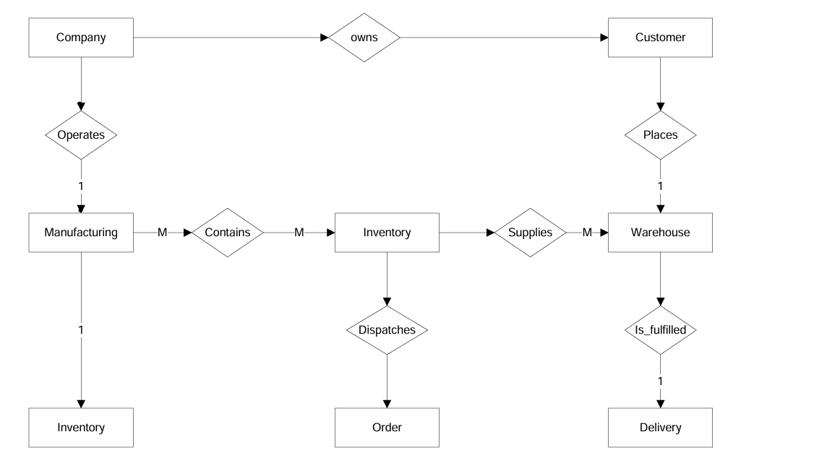
Dataschema of Support Ticket view
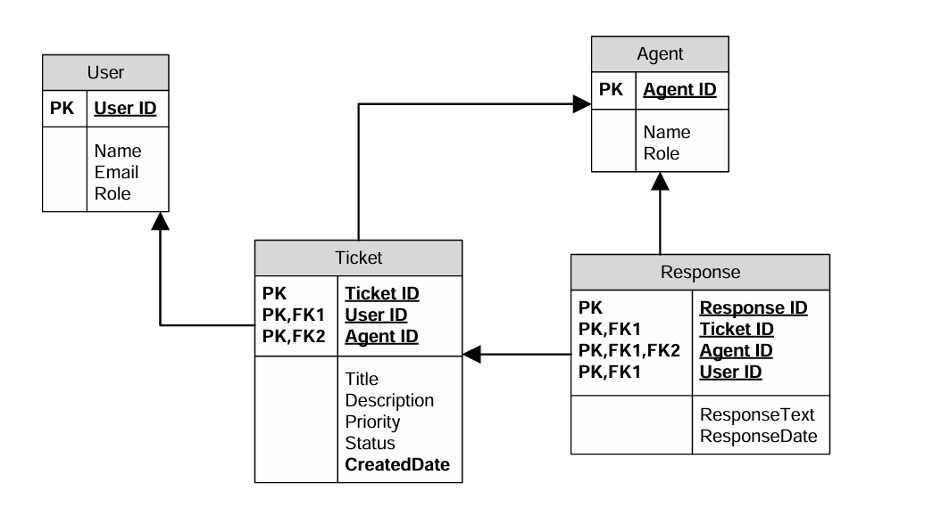
User story of shopping from ecommerce
Sprint 1 – User Account & Product Discovery (Foundations)
User story No : US001 | Task: 1 |  | Priority : Highest
As a New User

I WANT TO register with my email/phone

SO THAT I can create an account and start shopping.
BV : 300 |  | CP : 02
ACCEPTANCE CRITERIA

- User can sign up with email/phone
- Password must be encrypted and validated
- Confirmation email/SMS sent after registration

User story No : US002 | Task: 2 |  | Priority : Highest
As a Registered User

I WANT TO log in securely

SO THAT I can access my account safely.
BV : 300 |  | CP : 05
ACCEPTANCE CRITERIA
- User can log in using email/phone + password
- Incorrect credentials show error message
- Session auto logout after inactivity

User story No : US003 | Task: 3 |  | Priority : Highest
As a Customer

I WANT TO browse all available products

SO THAT I can see what the store offers.
BV : 200 |  | CP : 04
ACCEPTANCE CRITERIA

- Products displayed with name, price, image
- Pagination or scrolling available

User story No : US004 | Task: 4 |  | Priority : Highest
As a Customer

I WANT TO search for products by keyword

SO THAT I can quickly find what I need.
BV : 300 |  | CP : 05
ACCEPTANCE CRITERIA

- Search box available on homepage
- Results displayed within 3 seconds

User story No : US005 | Task: 5 |  | Priority : Highest
As a Customer

I WANT TO filter/sort products

SO THAT I can narrow my choices.
BV : 250 |  | CP : 05
ACCEPTANCE CRITERIA

- Filter by category, brand, price
- Sort by price/popularity

Sprint 2 – Cart & Checkout

User story No : US006 | Task: 1 |  | Priority : Highest
As a Customer

I WANT TO view product details

SO THAT I can make informed decisions.
BV : 250 |  | CP : 05
ACCEPTANCE CRITERIA

- Show description, reviews, availability
- Variant/size selection available

User story No : US007 | Task: 2 |  | Priority : Highest
As a Customer

I WANT TO add products to cart

SO THAT I can purchase later.
BV : 300 |  | CP : 05
ACCEPTANCE CRITERIA

- Item added with correct price & quantity
- Cart icon updates in real time

User story No : US008 | Task: 3 |  | Priority : Highest
As a Customer

I WANT TO modify cart items

SO THAT I can adjust my order.
BV : 250 |  | CP : 05
ACCEPTANCE CRITERIA

- Quantity update reflected in total
- Remove items updates cart

User story No : US009 | Task: 4 |  | Priority : Medium
As a Customer

I WANT TO save items for later

SO THAT I don’t lose track.
BV : 200 |  | CP : 04
ACCEPTANCE CRITERIA
- Wishlist in account
- Move item from wishlist to cart

User story No : US010 | Task: 5 |  | Priority : High
As a Customer

I WANT TO checkout smoothly

SO THAT I can complete my purchase.
BV : 300 |  | CP : 05
ACCEPTANCE CRITERIA

- Multi-step checkout (Address→Payment→Review)
- Guest checkout supported

Sprint 3 – Payments & Order Management
User story No : US011 | Task: 1 |  | Priority : High
As a Customer

I WANT TO save multiple addresses

SO THAT I can choose easily during checkout
BV : 200 |  | CP : 04
ACCEPTANCE CRITERIA
- Add/edit/delete addresses
- Set default address

User story No : US012 | Task: 2 |  | Priority : High
As a Customer

I WANT TO pay securely with multiple methods

SO THAT I can complete purchase safely.
BV : 300 |  | CP : 05
ACCEPTANCE CRITERIA

- Card, UPI, wallet options available
- Transactions encrypted & confirmed

User story No : US013 | Task: 3 |  | Priority : High
As a Customer

I WANT TO receive order confirmation

SO THAT I know my purchase is successful.
BV : 300 |  | CP : 05
ACCEPTANCE CRITERIA

- Email/SMS confirmation sent
- Order summary in My Orders

User story No : US014 | Task: 4 |  | Priority : High
As a Customer

I WANT TO track my order status

SO THAT I know when it will arrive.
BV : 300 |  | CP : 05
ACCEPTANCE CRITERIA

- Statuses: Placed→Shipped→Delivered
- Tracking number available

User story No : US015 | Task: 5 |  | Priority : Medium
As a Customer

I WANT TO cancel my order before shipping

SO THAT I can avoid unwanted purchases.
BV : 200 |  | CP : 04
ACCEPTANCE CRITERIA

- Cancel allowed only in Placed status
- Refund auto-initiated for prepaid

Sprint 4 – Enhancements & Support
User story No : US016 | Task: 1 |  | Priority : Medium
As a Customer

I WANT TO leave reviews

SO THAT I can share my experience.
BV : 200 |  | CP : 04
ACCEPTANCE CRITERIA

- Only verified buyers can review
- Rating & comments allowed

User story No : US017 | Task: 2 |  | Priority : Low
As a Customer

I WANT TO see personalized recommendations

SO THAT I can discover products easily.
BV : 100 |  | CP : 03
ACCEPTANCE CRITERIA

- Recommendations based on history
- Shown on homepage/product page

User story No : US018 | Task: 3 |  | Priority : Medium
As a Customer

I WANT TO get notifications

SO THAT I stay informed about offers/orders.
BV : 200 |  | CP : 04
ACCEPTANCE CRITERIA

- Email/SMS/Push supported
- Order updates real-time

User story No : US019 | Task: 4 |  | Priority : Highest
As a Customer

I WANT TO raise support tickets

SO THAT I can get help when needed.
BV : 300 |  | CP : 05
ACCEPTANCE CRITERIA

- Support chat/ticket form available
- Ticket ID generated for tracking

User story No : US020 | Task: 5 |  | Priority : Highest
As a Customer

I WANT TO return products

SO THAT I can get refund/replacement
BV : 300 |  | CP : 05
ACCEPTANCE CRITERIA

- Return request within policy window
- Refund/replacement after pickup

