CAPSTONE PROJECT 1 – PART 3/3
Question 1
Identidy minimum 20 fuctional requirements
Answer
- Functional requirement defines the specific behaviour, fuctions or operations of a system. They describe what the system should do, outlining the necessary tasks, actions, or activities it must perform to achieve its objectives.
Req ID | Req name | Req description | Priority
FR001 | Farmer registration | Farmers should be able to register with the application by providing their email and creating a secure password. | 10
FR002 | Manufacturer registration | Manufacturer should be able to register with the application. | 10
FR003 | User login | All registered users (farmers and manufacturers) must be able to log in to the application. | 10
FR004 | Product search | Farmers should be able to search for available products (fertilizers, seeds, pesticides) by name, category, or keyword. | 10
FR005 | Product upload | Manufacturer must be able to upload new products, including details such as name, description, price and images. | 10
FR006 | Product display | The application must diplsy a catalog of product with their details for farmers to browse. | 10
FR007 | Add to cart/wishlist | Farmers should be able to add products to a shopping or a “buy later” list. | 5
FR008 | View cart /wishlist | Farmers should be able to view an manage items in their shopping cart or “buy later” list. | 5
FR009 | Checkout process | Farmers should be able to proceed to a checkout process to complete their purchase. | 10
FR010 | Mutliple payment options | The system must support multiple payment methods, including cash on delivery (COD), credit/debit card and UPI. | 10
FR011 | Order placement | The system must be able to process and place an order once the payment is confirmed. | 10
FRO12 | Order confirmation | The system must send an order confirmation email to the farmer after an order is sucessfully placed. | 10
FR013 | Order history | Farmers should be able to view their past and current orders. | 5
FR014 | Order tracking | The system must provide a tracking number or a delivery status tracker for all placed orders. | 5
FR015 | Manufacturer dashboard | Manufacturer should have a dashboard to view their uploaded products and manage their sales. | 10
FR016 | Product management | Manufacturer should be able to edit or delete their uploaded products. | 10
FR017 | User profile management | Users (farmers and manufacturers) should be able to view and update their profile information. | 5
FR018 | Password reset | The system must have a feature to allow users to reset their password. | 5
FR019 | Product filtering | Farmers should be able to filter search results by price range, manufacturer or product type. | 10
FR020 | Order cancellation | Farmers should be able to cancel an order within a specified timeframe. | 5

- Non – functional requirements will describe the qualities and attributes of a system, focusing on how the system perform rather than specific behaviors or functions.
Req ID | Req name | Req description | Priority
NFR001 | Performance | The application’s pages should load with in 2-3 seconds under normal user load. | 10
NFR002 | Security | The system must be protected against common web vulnerabilities, sush as SQL injections and cross -site scripting (XSS). | 10
NFR003 | Scalability | The system should be able to support up to 50,000 concurrent users without significant performance degradation. | 10
NFR004 | Usability | The user interface must be intuitive and user- friendly for all uswer types, especially for farmers who may not be tech -savvy. | 10
NFR005 | Accessibility | The application must comply with web content accessibility guidelines to ensure it is usable by people with disabilities. | 10
NFR006 | Reliability | The system must have a 99.9% uptime, excluding planned maintenanace. | 10
NFR007 | maintainability | The code should be well- documented and modular, allowing for easy updates and bug fixes. | 10
NFR008 | Portability | The application should be compatable with different web browsers (chrome, firefox, edge, safari) and mobile operating system (android and ios). | 5
NFR009 | Data integrity | All user data and product information must be stored securely and accurately, with regular backups to prevent data loss. | 10
NFR010 | Response time | The system must process transactions within 5 seconds of user clicking “place order”. | 10

Question 2
Make wireframes and prototypes

Answer

- Wireframes: it is a basic visual guide that outlines the structure and layout of a websites, application or digital product.
- It’s like a blueprint, showing the arrangement of elements and content without the details of visual design like colors or specific image.
- Low-fidelity wireframes are basic, using simple shapes and lines to outline the structure.
- Mid -fidelity wireframes bridge the gap, offering more detail than low fidelity but less than high fidelity, often including basic UI elements and limited interactivity.
- High -fidelity wireframes are detailed, closely resembling the final product with visual elements and interactive components.
- Prototypes:it is an early sample, model, or version of a product or system that is created to test its design and functionality before it is fully developed and mass-produced.
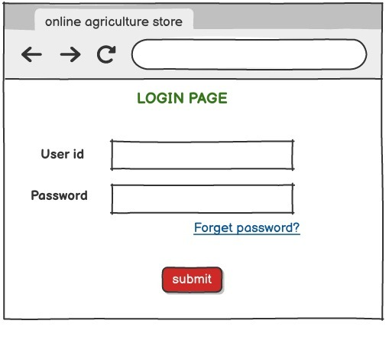

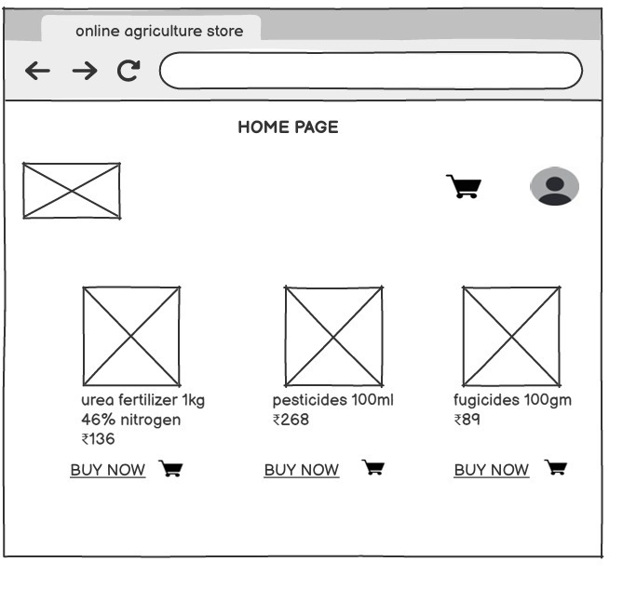

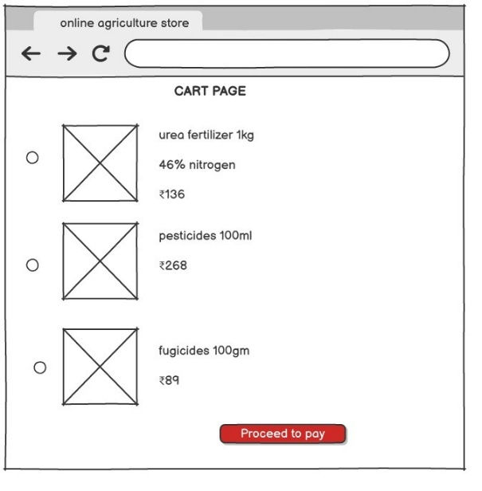

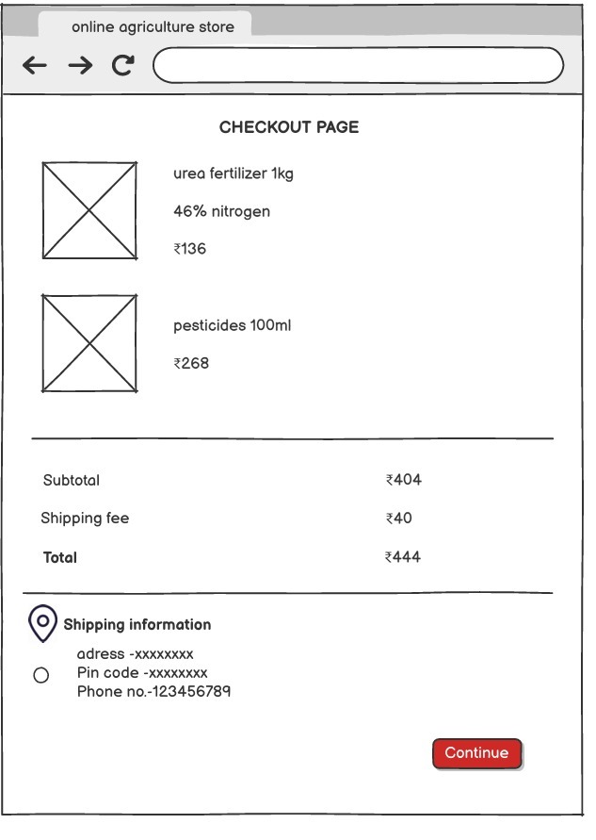

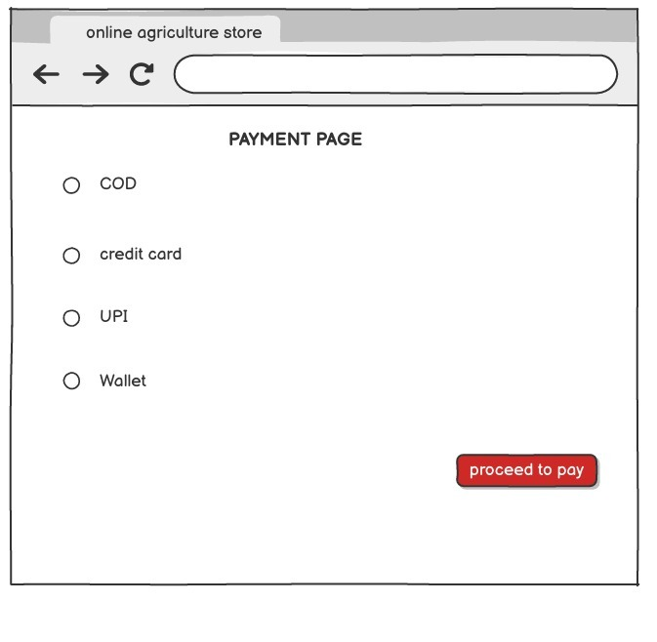HIGH FIDELITY
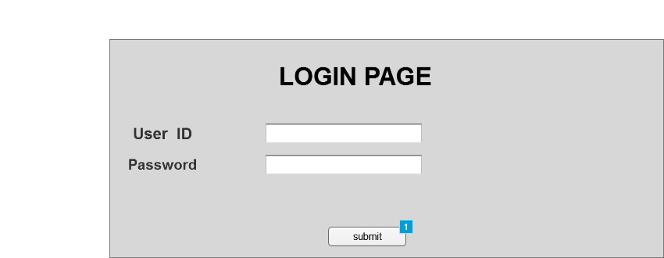
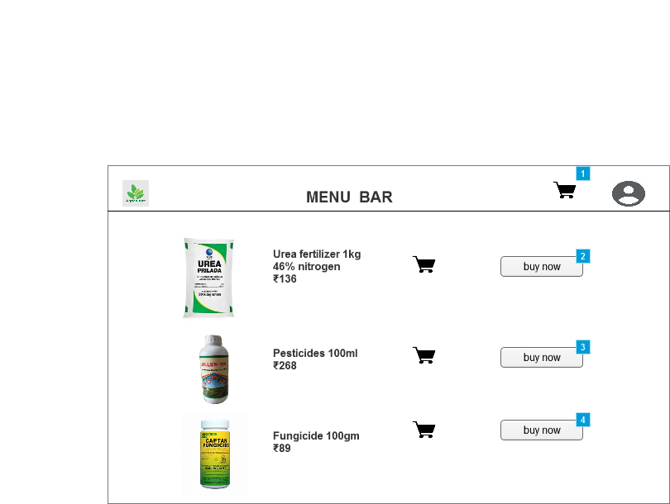
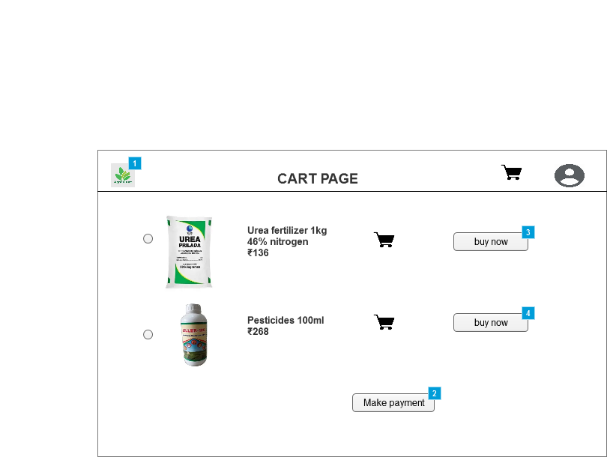
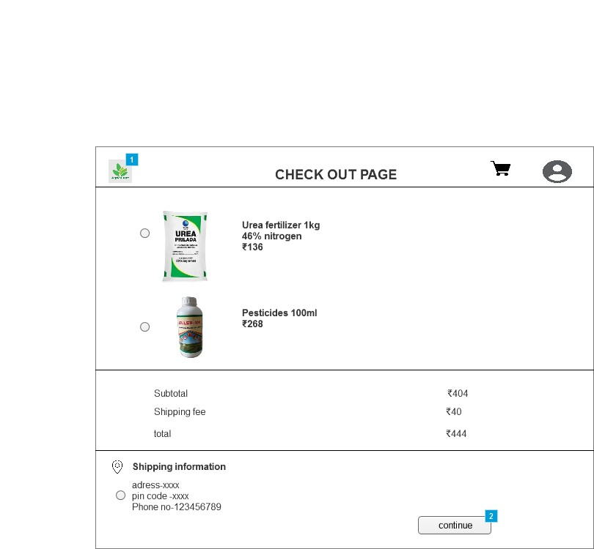

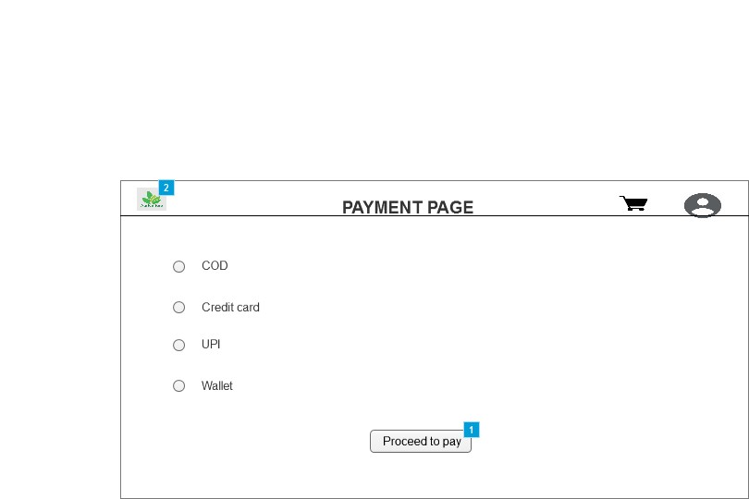
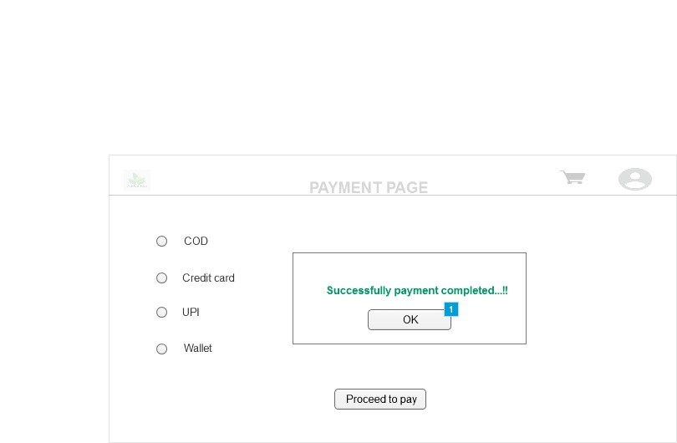
Question 3
Make a note of the tools, which you are using for above concept.
Answer
- Microsoft visio:it is a digramming and vector graphics application used to create diagrams, flowcharts and other visual representation of complex information.
How it works
- Microsoft visio is a versatile diagramming vector graphic application. It operates bay allowing users to drag and drop pre-made shapes from a library onto a canvas.
- These shapes are designed for various types of diagrams including flowcharts, UML diagrams, network diagrams and organizational chart.
- Users can easily connect shapes with lines and connectors and customize the appearance, text and data associated with each element.
Advantages
- Visio offers comprehensive diagramming.
- Gives professional output.
- It helps in creating standardized diagrams.
- Balsamiq: it is a rapid wireframing tool used to create mockups and prototypes of user interfaces.
How it works
- Balsamiq ia a rapid, low-fidelity wireframing tool.
- Its core philosophy is to focus on the structure and content of design rather than the visual details.
Advantages
- Speed and simplicity
- Focus on core functionality
- User friendly
- Axure:is a more advanced prototyping tool used to create high -fidelity, interactive wireframes and prototypes for web and mobile applications.
How it works
- Axure is a powerful, high-fidelity prototyping tool. unlike balsamiq, it allows for the creation of interactive and dynamic prototypes that closely mimic the final product.
- Users can create sophisticated conditional logic, dynamic, panels and complex animations.
- It also supports creating detailed documentation and specifications directly from the protytype, bridging the gap between design and development.
Advantages
- High fidelity interaction.
- Axure supports advanced features like dynamic content, data-driven forms, and conditional logic.
- It can generate detailed specifications and assets, making it easier for developers to build the final product.
Question 4
A bussines analyst’s key responsibilities are to keep track of the requirements and make sure that no requirements are missed.
Mr henry and peter have approached you regarding the current status of the project. How will you tackle this situation?
Answer
- It is a document to track the requirement throughout the project lifecycle, ensuring that they are met and no requirements are overlooked.

Req ID | Req name | Req description | design | code | UT (unit testing) | CT (component testing) | ST (system testing) | SIT | UAT (user acceptance testing)
FR001 | Farmer registration | Farmers should be able to register with the application. | Complete | Complete | Complete | Complete | Complete | Incomplete | Incomplete
FR002 | Farmer search for product | Farmers should be able to search for products. | Complete | Complete | Complete | Complete | Incomplete | Incomplete | Incomplete
FR003 | Manufacturer registration | Manufacturer should be able to register. | Complete | Complete | complete | Incomplete | Incomplete | Incomplete | Incomplete
FR004 | Product upload | Manufacturer should able to upload product. | Complete | Complete | Incomplete | Incomplete | Incomplete | Incomplete | Incomplete
FR005 | User login | All registered user must be able to log in. | Complete | Complete | Complete | Complete | Complete | Complete | Incomplete
FR006 | Add to cart/wishlist | Farmers should be able add products to a cart or list. | Complete | Complete | Complete | Complete | Incomplete | Incomplete | Incomplete
NFR0101 | Page loading time | Pages should load within 2 seconds. | Complete | N/A | Incomplete | Incomplete | Incomplete | Incomplete | Incomplete
NFR0102 | WGAG 2.1. | System must meet web content accessibility guidelines WCAG 2.1. | incomplete | N/A | Incomplete | Incomplete | Incomplete | Incomplete | Incomplete

Question 5
Prepare 10 test case documents
Answer
1.Farmer registration
Test case ID | TC-FR0001-001 | Test case name | Verify successful farmer registration
Project ID | CAPSTONE 1 | Project name | Online agriculture store
Requirement ID | FR0001(farmer registration) | PM name | Mr. vardhan
Test plan ID | TP-01 | Tester name | Mr. jason/Ms. alekya
Test shedule ID | TS-01 | Date of test | xx-xx-xx
Scenario | Successful registration |  | Successful registration
Link to the page | /Register |  | /Register
Input data | Email:user@test | Password: pass123! @#
Expected behaviour | System creates user account and redirects to login
Actual behaviour | After entering correct credentials and clicking login, the succesfully redirects to them to the home dashboard.
Comments | Required correct credentials
Result(pass/fail) | Pass

2.Product search
Test case ID | TC-FR0002-001 | Test case name | Verify product search functionality.
Project ID | CAPSTONE 1 | Project name | Online agriculture product store
Requirement ID | FR0002 | PM name | Mr. vandanam
Test plan ID | TP-02 | Tester name | Mr. jason/Ms. alekya
Test shedule ID | TS-02 | Date of test | xx-xx-xx
Scenario | Search for existing product
Link to the page | /Product
Input data | Search query: “organic fertilizers”
Expected behaviour | system displays relevant search results.
Actual behaviour | After entering query successfully shows the relevant product
Comments | Search the products with product code or through manufacturer name
Result(pass/fail) | pass

3.user login
Test case ID | TC-FR0003-003 | Test case name | Verify successful login with correct credentials
Project ID | CAPSTONE 1 | Project name | Online agriculture product store
Requirement ID | FR0003 | PM name | Mr. vandanam
Test plan ID | TP-03 | Tester name | Mr. jason/Ms. alekya
Test shedule ID | TS-03 | Date of test | xx-xx-xx
Scenario | Login with correct credentials
Link to the page | /Login
Input data | Email: user@test.com, password: pass123! @#
Expected behaviour | User successfully log in and is redirected.
Actual behaviour | User successfully login to home page
Comments | Required an active internet connection.
Result(pass/fail) | pass

4.product upload

Test case ID | TC-FR0004-004 | Test case name | Verify manufcturer product upload
Project ID | CAPSTONE 1 | Project name | Online agriculture product store
Requirement ID | FR0004 | PM name | Mr. vandanam
Test plan ID | TP-04 | Tester name | Mr. jason/Ms. alekya
Test shedule ID | TS-04 | Date of test | xx-xx-xx
Scenario | Manufacturer adds a new product
Link to the page | /manufacturer/upload
Input data | Product name, price, description, image.
Expected behaviour | New product is added to the catalog and visible to farmers.
Actual behaviour | Added products are visible to the farmers
Comments | Manufacturer should add correct details of the products
Result(pass/fail) | pass

5.multiple payment options
Test case ID | TC-FR0005-005 | Test case name | Verify cash on delivery (COD) option
Project ID | CAPSTONE 1 | Project name | Online agriculture product store
Requirement ID | FR0005 | PM name | Mr. vandanam
Test plan ID | TP-05 | Tester name | Mr. jason/Ms. alekya
Test shedule ID | TS-05 | Date of test | xx-xx-xx
Scenario | COD payment option on checkout page
Link to the page | /Checkout
Input data | N/A
Expected behaviour | COD option is present and selectable
Actual behaviour | COD option is selected for payment
Comments | N/A
Result(pass/fail) | pass

6.order placement
Test case ID | TC-FR0006-006 | Test case name | Verify successful order placement
Project ID | CAPSTONE 1 | Project name | Online agriculture product store
Requirement ID | FR0006 | PM name | Mr. vandanam
Test plan ID | TP-06 | Tester name | Mr. jason/Ms. alekya
Test shedule ID | TS-06 | Date of test | xx-xx-xx
Scenario | Placing an order via credit card
Link to the page | /Checkout
Input data | Valid credit card details.
Expected behaviour | Order is placed, and an email confirmation is sent.
Actual behaviour | Successfully order is placed and an SMS, mail confirmation is sent.
Comments | N/A
Result(pass/fail) | pass

7.order tracking
Test case ID | TC-FR0007-007 | Test case name | Verify order tracking
Project ID | CAPSTONE 1 | Project name | Online agriculture product store
Requirement ID | FR0007 | PM name | Mr. vandanam
Test plan ID | TP-07 | Tester name | Mr. jason/Ms. alekya
Test shedule ID | TS-07 | Date of test | xx-xx-xx
Scenario | Tracking an order
Link to the page | /My-orders
Input data | Order ID of a placed order
Expected behaviour | System diplays real time delivery status.
Actual behaviour | System diplsys order status
Comments | N/A
Result(pass/fail) | pass
8.page loading time
Test case ID | TC-FR0008-008 | Test case name | Verify order tracking
Project ID | CAPSTONE 1 | Project name | Online agriculture product store
Requirement ID | FR0008 | PM name | Mr. vandanam
Test plan ID | TP-08 | Tester name | Mr. jason/Ms. alekya
Test shedule ID | TS-08 | Date of test | xx-xx-xx
Scenario | Homepage loading
Link to the page | /Homepage
Input data | N/A
Expected behaviour | Homepage loads within 2 seconds
Actual behaviour | Homepage loads in 2 seconds
Comments | N/A
Result(pass/fail) | pass
9.WCAG 2.1 compliance
Test case ID | TC-FR0009-009 | Test case name | Verify WCAG 2.1 compliance
Project ID | CAPSTONE 1 | Project name | Online agriculture product store
Requirement ID | FR0009 | PM name | Mr. vandanam
Test plan ID | TP-09 | Tester name | Mr. jason/Ms. alekya
Test shedule ID | TS-09 | Date of test | xx-xx-xx
Scenario | Accessibility of form field
Link to the page | /Register
Input data | N/A
Expected behaviour | Form fields are accessible to screen readers
Actual behaviour | Accessible to screen readers
Comments | N/A
Result(pass/fail) | pass

10.manufacturer login page

Test case ID | TC-FR0010-010 | Test case name | Verify manufacturer successful login with correct credentials
Project ID | CAPSTONE 1 | Project name | Online agriculture product store
Requirement ID | FR0010 | PM name | Mr. vandanam
Test plan ID | TP-10 | Tester name | Mr. jason/Ms. alekya
Test shedule ID | TS-10 | Date of test | xx-xx-xx
Scenario | Login with correct credentials
Link to the page | /Login/manufacturer
Input data | Email: user@test.com, password: pass123! @#
Expected behaviour | Manufacturer successfully log in and is redirected.
Actual behaviour | manufacturer successfully login to home page
Comments | Required an active internet connection.
Result(pass/fail) | pass
Question 6
After the requirements are thoroughly explained to the entire project team by business analyst, the Database architects have decided to do the database design and also to represent the in-flow and out-flow of data. Draw database schema and ER diagram
Answer
DB schema is a blueprint that outlines the structure of a database, including its tables, fields, relationships, constraints, and other characteristics.
An entity-relationship diagram (ERD)is a visual representation of the relationships between entities in a database. It depicts the entities (such as tables), attributes (propertiesor fields), and relationships between them.
Entity relationship diagram
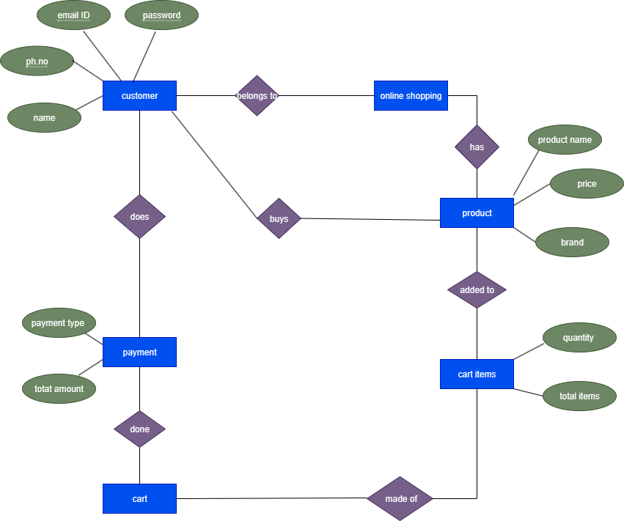

Database diagram
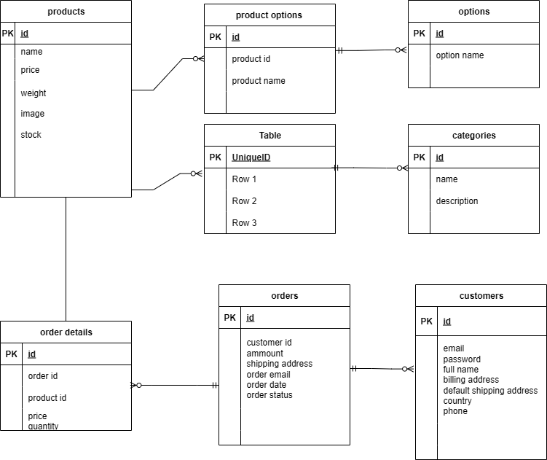
Question 7
What is a data flow diagram? Draw a data flow diagram to represent the in-flow and out-flow of data when a Farmer is placing an order for the product
Answer
- A dataflow diagram (DFD) is a graphical representation of the flow of data within a system. It visually shows how data moves from one process to another, how it’s stored, and where it ends up.
- It helps analysts and designers understand the flow of dat within a system, identify potential bottlenecks or inefficiencies, and communicate requirements to stakeholders.

User side data flow diagram (DFD)
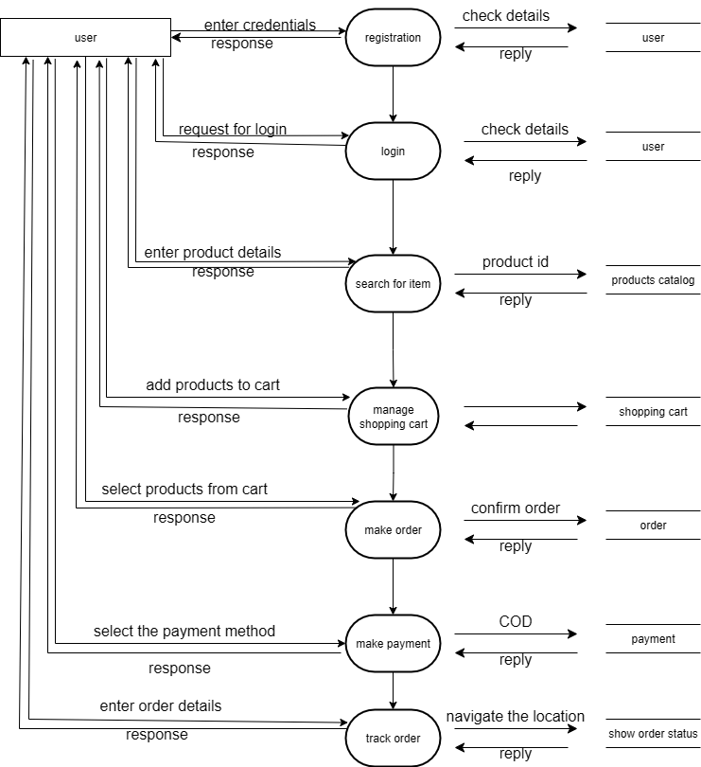
Question 8
Due to change in the Government Taxation structure. we should change the Tax structure How do you handle change requests in a project?
Answer
A change request is a formal proposal to alter a system, product, or project.
The change control process:
1.Change request submission: the request to change the tax structure is submitted in a formal document, detailing what needs to be changed and why (e.g., “implement new 15%VAT on all seed products”)
2.Impact analysis: the business analyst and the project team assess the impact of the change. this involves answering key questions:
- Scope: what system components are affected? (e.g., checkout page, database, reporting tools)
- Cost: much will this cost in terms of new development, testing, and potential delays?
- Timeline: how will this effect the project shedule?
- Risks: what new risks are introduced by this change?
3.Approval: the change request and its impact analysis are presented to a change control based, which typically includes the project manager, client (Mr. Henry), and the key stakeholders.the change control board decides whether to approve, reject or defer the change. if the change is approved, they must also agree on how to adjust the project’s scope, budget, and timeline to accommodate it.
4. Implementation: once approved, the change is formally added to the project plan. The development team implements the changes, and the quality assurance (QA) team test the new tax structure to ensure it works correctly and doest’t break any existing fuctionality.
5.Documentation: all project documents, including the requirements traceability matrix (RTM) and design documents, are updated to reflect the new tax structure, ensuring a clear record of the change.
By following this process, the project team can manage the change in a structured way, keeping all stakeholders informed and preventing the progect from spiraling out of control.
Question 9
As the project is in process, Ben and Kevin have contacted you. The reason is to inform you that they want the Farmers to sell their crop yields through this application i.e. Farmers should be able to add their crop yields or products and display to general public and should be able to sell them. They also want to introduce Auction system for their Crop yields. As a BA, what will be your response?
Is this a change request or an enhancement?
Answer
An enhancement.
This request is an enhancement, not a change request. a chnge request modifies an existing feature, while an enhancement adds a new functionality that was not a part of the original project scope. The initial project was for farmers to buy products from manufacturers. Allowing them to sell their own crops and introducing an auction system is a significant addition that changes the platform’s core purpose.
BA response
As a business analyst, I would respond by:
1.acknowledge and document: thank ben and kevin for the idea and formally document it as potential enhancement.
2.conduct impact analysis: I would then perform an analysis to determine the impact on the project’s scope, budget, and time line. this would involve assessing the effort required to new featurer like a piblic -facing storefront for framers and a complex auction system.
3.present to stakeholders: I would then present the documented enhancement, along with the impact analysis, to the client (Mr. henry) and the project’s chnge control board.
4.recommendation: I would recommend that this new fuctionality be considered for a future phase of the project, as implementing it now would likely cause major delays and go over budget.
Key risks of enhancement
- Timeline delays
- Budget overruns
- Resource strained
- Unclear priorities
Potential benefits
- Expanded revenue streams
- Increase user engagement
- Market leadership
Cost associations
- New features require extensive testing to ensure the work correctly.
- Marketing and pramotion
- Ongoing cost for maintaining new features, including bug fixes, updates, and customer support.

Question 10
Come up with estimations – How many Manhours required
Answer
- Man, hours are the required effort of the resource tp complete a project. these are 3 types of projects:
- Small: upto 500 hours
- Medium: upto 1000 hours
- Large: upto 1500 hours
- Analysis
Based on the information provided in the project case study, the estimated man hours required for this project is up to 1000 hours, classifying it as a medium -sized project.
- Justification:
- Project duration: the project has an expected duration of 18 months.
- Team size: the current team cosists of project manager, senior java developeer, multiple java developers, a network admin, a DB admin, testers and a business analyst, totaling around 15 people. this large team size is typically for a medium- to- large project.
- Project scope: the project involves building a complete e-commerce platform with multiple user roles, various functionalities and both web and mobile interfaces.the complexity of the system supports the classification as a medium -sized project.
- Resource availability: the case study notes that trained resources are available, and new infrastructure is not required. This helps to keep the man hour estimate within the medium range, as it reduces the time and effort needed for training and setup.
Question 11
Project has finally completed all the stages i.e., design, development, testing etc. Now, it is the role of a business analyst to contact the client for testing of the final product and have to successfully complete it. How are you going to handle this situation? And once it is done, what will be the process to close the project?
Explain UAT Acceptance process
Answer
User acceptance testing (UAT): It is the final stage of software development where intended users test the software to ensure it meets real- world business and user needs before release.
UAT process
- Planning: in this step, “blue prints” are made to guide the UAT testing for every feature. these blueprints define the tests and minimum standards for the siftware to be accepted.
- Designing: test case is designed in this phase to cover all the possibilities of the software in a real-world environment.
- UAT testing: the UAT tester are end users who meet the criteria for implementing the testing. they should know which test cases to run and have an understanding of the software’s functionalities.
- Bug fixing: any bug found during UAT testing phase are worked on by the development team to make the software error -free.
- Sign off: after all the bugs are removed, the testing team signals their acceptance that the software’s completion. In this phase, all stakeholders coclude that the software is ready to “GO LIVE” and they sign it off.
Question 12
Explain Project closure document
Answer
- A project closure document, also known as a project closure report – is a formal document that summarizes the key outcomes, lessomns learned, and final details of completed project.
- It serves as a comprehensive record of a project’s accomplishments, challenges, and overall performance, providing valuable insights for stakeholders and future projects.
- Project summary: the project aimed to develop an e-commerce platform connecting farmers with manufacturer to purchase agricultural products like fertilizers, seeds, and pesticides. The project was successfully completed within the allocated budget and achieved its primary objective of creating user friendly and functional web and mobile application.
- Project performance
- UAT sign-off: the client signed off on UAT testing on 24th august 2025, confirming their acceptance of the final product.
- Funding: the total approved funding was rs. 2 crores, with final amount used of Rs 1.5crores
- Customer stisfaction: the project achieved “high” rating for customer satisfaction, and the application was ratyed as “user friendly”
- Escalations: there were 50 escalations throughout the project. These were handled and resolved, and they did not majorly impact the final delivery or quality.
- Overall value: the project delivered significant value to the company, with a 90% positive rating. this includes gaining an edge over competitors, increasing the client base training employees, and securing new projects.
- Achievements
- Functional deliverables: successfully implemented key functionalities including secure payment processing, product categories, and a user-friendly interface.
- Quality assurance: the project successfully passed all internal testing phases and received formal sign -off from the client after UAT, indicating a high-quality product.
- ROI: the project is on track to achieve a positive return on investment within 6 months.
- Lessons learned.
- What went well: the project benefited from a collaborative team and clear communication with client. The early engagement of the business analyst in all phases helped to keep requirement aligned with the final product.
- What could be improved: while handled the number of escalations suggests a need for a more proactive risk mangement strategy to identify and mitigate potential issues earlier in the project lifecycle.
- Future recommendations: the team recommends implementing new features like a farmer-to- public sales module and an auction system in a future project phase to future expand the platform’ s value.
- Resource utilization:
- The project was completed significantly under the budget, this demonstrates effective financial management and resource planning
- The project successfully utilized a large diverse tyeam, the project closure document notes that employees were trained indicating that the project not only utilized existing skills but also contributed top the professional development ot the team.
- The project did not require any new infrastructure. The project closure document confirms that software installed and laptop purchased were achieved indiactind that all necessary tools were acquired and used efficiently.
- Risk management: An overview of the risks identified and how they were handled. potential issues like a change in government tax structure, ensuring a smoother project execution.
- Challenges: A description of any unexpected problems encountered and how the team overcame them.
- The team maintained clear and consistent communication with all stakeholders, leading to high customer satifcation and smoothUAT sign-off.

S.no | Points to include | Details | Reference link
1. | Did the client signed off on the UAT testing |  | Business scope document docx
 | Date of the signoff | 24th august 2025 | Business scope document docx
 | Name of the resource | Ms. Natalia | Business scope document docx
2. | Objectives of the project |  | Business scope document docx
 | User friendliness | Achieved
 | Customer satisfaction | ROI in 6 months
3. | Functionalities worked on
 | Secure payment processing | Achieved
 | Quality assurance | Successfully passed all internal testing phases.
 | Laptop purcahsed | achieved
4. | Infrastructure
 | Software installed | achieved | Finance breakdown docx
5. | Funding |  | Finance breakdown docx
 | Amount approved | Rs 2 crore | Finance breakdown docx
 | Amount used | Rs 1.5 crore
6. | Overall project information
 | Escallations | 50
 | Customer satisfaction | High
7. | Value to the company
 | Positive/Negative | Positive 90%  - Company has gained an edge over the competitors  - Increased clients  - Trained employees  - New project in pipeline

