Business Requirements Document (BRD)

Chapter | Page

1 General Information.................................................................................................................1
1.1 Problem Statement / Business Need.......................................................................................1
1.2 Objective........................................................................................................................……...1
1.3 Audience..................................................................................................................................1
1.4 Artefacts........................................................................................................................………1
1.5 References..............................................................................................................................1
1.6 Acknowledgements.................................................................................................................2
1.6.1 Align BRG Members...............................................................................................................2
1.6.2 Hardlines Task/ Project Group Participants............................................................................2
1.6.3 Global Business Process Modellers (GBPM)..........................................................................3
2 Business Process View............................................................................................................4
2.1 Requirements...........................................................................................................................4
2.1.1 Business Requirements For Hardlines Item Attributes Requirements.....................................5
2.1.2 Technical Requirements (optional)........................................................................................16
2.2 Use Case Actor Descriptions.................................................................................................16
2.3 Use Case Scenario................................................................................................................16
2.3.1 Use Case Diagram.................................................................................................................16
2.3.2 Use Case Description............................................................................................................16
2.4 Activity Diagram.....................................................................................................................17
3 Data View...............................................................................................................................17
3.1 Data Description....................................................................................................................17
3.1.1 Data Description for Hardlines Item enumerated classes......................................................17
3.1.2 Class Diagram Hardlines Trade Item Extension....................................................................19
3.1.3 Class Diagram Enumeration Classes for Hardlines Trade Item Extension…………………..20
4 Examples...............................................................................................................................21
5 Appendices............................................................................................................................22
5.1 Implementation Considerations.............................................................................................22
5.2 Relationship with the EAN.UCC General Business Model (GBM).................................…….22

Business Requirements Document (BRD)
Inventory and Logistics Optimization System for Dairy Manufacturing
Version: 1.0
Date: 2025-08-03
Owner: Digital Transformation Team
Chairperson: TBD
Status: Draft

1. General Information

1.1 Problem Statement / Business Need
The company, operating several manufacturing plants and warehouses across the country, specializes in dairy products such as ice cream and milk. Currently, inventory visibility is limited, and delivery operations are not optimized for speed. This affects product availability and customer satisfaction, particularly for perishable items.

1.2 Objective
To develop an integrated software system that:
- Provides real-time inventory tracking across plants and warehouses.
- Supports dynamic routing and distribution to ensure fastest possible deliveries.
- Improves operational efficiency and customer satisfaction.

1.3 Audience
- Operations Managers
- Supply Chain & Logistics Teams
- IT Development & Support Teams
- Executive Management

1.4 Artefacts
Artefact Name | Artefact Description
BRD v1.0 | This document
Use Case Scenarios | Separate document detailing usage flows (to be created)

1.5 References
- Company’s logistics and warehouse reports (2023–2025)
- Dairy Supply Chain Optimization Practices
- UN/CEFACT standards (for unit of measure)

1.6 Acknowledgements
To be filled in after project team is finalized.

2. Business Process View

2.1 Requirements

2.1.1 Business Requirements
Number | Statement | Rationale
BR1 | The system must maintain real-time inventory updates at all manufacturing and warehouse locations. | To ensure stock visibility and minimize spoilage or stock-outs.
BR2 | The system must track product movements from production to warehouse to delivery. | To support traceability and accountability.
BR3 | The system must generate low-inventory alerts for each product and location. | To enable timely restocking and production planning.
BR4 | The system must recommend the fastest delivery route based on location, inventory availability, and traffic conditions. | To improve delivery speed and reduce logistics costs.
BR5 | The system must integrate with order management and delivery tracking systems. | To enable end-to-end customer fulfillment.
BR6 | The system must provide role-based access to ensure security and data integrity. | To protect sensitive supply chain information.

3. Data View

3.1 Data Description
Data Element | Definition | Type | Mandatory
Product ID | Unique identifier for each product | String | Yes
Inventory Count | Quantity available at each location | Integer | Yes
Warehouse Location | Address or geolocation | String | Yes
Delivery Route | Optimized route path | Text | Optional
Order ID | Unique identifier for customer orders | String | Yes
Delivery ETA | Estimated delivery time | Date & Time | Optional

4. Examples
Example:
Customer in Mumbai orders 10 units of milk. System identifies that Pune warehouse has stock and suggests delivery via Express Route A for a 4-hour ETA.

5. Appendices

5.1 Implementation Considerations
- Ensure data synchronization across distributed warehouses
- Plan for integration with IoT-enabled cold storage for temperature-sensitive items
- Incorporate analytics for demand forecasting

5.2 Relationship with the EAN.UCC General Business Model (GBM)
The solution aligns with GBM's inventory and logistics visibility principles.

2. Prepare a process flow diagram using your imagination.

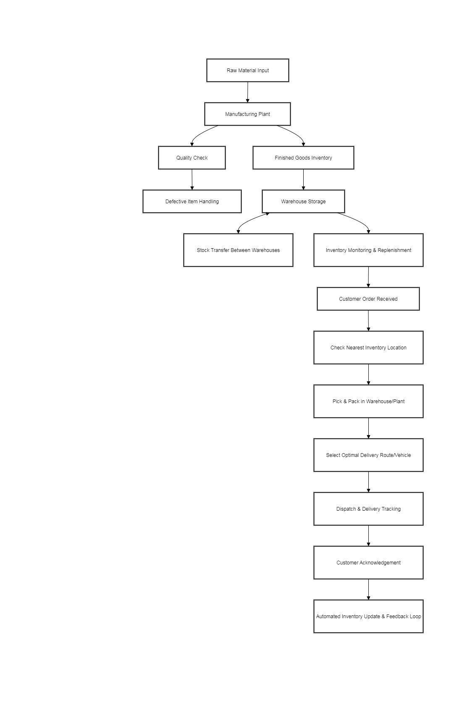
Assignment 2:
1. Write an introduction letter to a client introducing yourself as a business analyst in charge of working with the client and his team to start the business understanding process.

Subject: Introduction – Your Business Analyst Partner
Dear [John],
I hope this message finds you well.
My name is [Debadrita Das], and I am delighted to introduce myself as the business analyst assigned to work closely with you and your team. My primary role will be to facilitate a comprehensive understanding of your business requirements, goals, and challenges as we embark on your project together.
Over the next few weeks, I will be collaborating with you to gather key insights about your organization and processes. This will allow us to identify opportunities, define clear objectives, and ensure that our solutions are tailored to your unique needs. My approach is built on open communication, transparency, and partnership, and I am committed to making this process as smooth and valuable as possible for you.
I look forward to connecting with you soon to discuss your vision and expectations in more detail. Please do not hesitate to reach out if you have any questions or specific topics you would like to address.
Thank you for the opportunity to work with you. I am excited to get started and confident that, together, we will achieve great results.
Best regards,
[Debadrita Das]
Business Analyst
[XYZ pvt LTD]
[deadrita.das@xyz.com]

2. Prepare a brief BRD and SRS for a project- Horoscope or Ticketing system or online store.

Business Requirements Document (BRD)
Project: Bus Booking Application

Document Version: 0.1
Last Updated: January XX, 2025
Prepared By: Business Analyst
Approved By: Delivery Manager

1. Executive Summary
The Bus Booking Application will serve as a digital platform designed to facilitate the booking of bus tickets for users. This application aims to provide a seamless, efficient, and user-friendly system that allows customers to browse routes, select seats, make payments, and manage their bookings.
This document outlines the business requirements for the development of the Bus Booking Application. The primary objective is to enhance customer experience, streamline the booking process, and increase sales for bus operators.

2. Project Scope

2.1 In-Scope Features
The following features are within the scope of the project:

- User Registration & Profile Management
  - New users can register using email, mobile number, or social media accounts.
  - Returning users can log in using their credentials.
  - Users can manage their profile information (e.g., name, email, phone number).
- Bus Route Search
  - Users can search for available bus routes by entering source and destination.
  - Filters can be applied to the search (e.g., date, bus type, departure time).
- Seat Selection
  - Users can select available seats on the bus from a visual seat map.
  - The system will show seat availability in real-time.
- Ticket Booking and Payment
  - Users can proceed to book tickets after selecting the route and seats.
  - Payment options will include credit/debit cards, digital wallets, and other secure payment methods.
  - An automatic email/SMS confirmation will be sent after a successful booking.
- Booking History
  - Users can view their past and upcoming bookings.
  - Ability to cancel bookings with applicable terms and conditions.
- Notifications
  - Users will receive notifications related to booking confirmation, payment status, and reminders.
- Admin Panel
  - Admin users can manage bus routes, schedules, and seat availability.
  - Ability to manage customer data and booking history.
- Reporting & Analytics
  - Admins can generate reports related to bookings, payments, and user statistics.

2.2 Out-of-Scope Features
- Multi-language support.
- Integration with third-party services (e.g., hotels, car rentals).
- Advanced loyalty programs or user rewards.

3. Stakeholders
Role | Name/Department | Responsibilities
Project Manager | [Name] | Oversee project execution and ensure timelines.
Product Owner | [Name] | Define product features and prioritize tasks.
Development Team | [Name(s)] | Develop the mobile and web applications.
Quality Assurance | [Name(s)] | Test and ensure the application meets requirements.
UX/UI Designers | [Name(s)] | Design intuitive and user-friendly interfaces.
Marketing Team | [Name] | Promote the application and drive user adoption.
End Users | Customers | Provide feedback on usability and experience.

4. Business Objectives
The main business objectives of the Bus Booking Application are as follows:
- Enhance User Experience: Provide a simple, user-friendly interface for easy booking.
- Increase Revenue: Drive higher ticket sales through an efficient and accessible platform.
- Reduce Operational Costs: Automate booking processes to reduce dependency on manual tasks.
- Increase Market Reach: Make bus travel more accessible by providing a digital solution.
- Improve Customer Retention: Build trust and loyalty through smooth booking processes and timely notifications.

5. Functional Requirements

5.1 User Registration & Login
- FR1.1: The user should be able to register using their email, mobile number, or social media credentials.
- FR1.2: The system should allow users to recover or reset passwords via email/SMS.
- FR1.3: The user should have the option to update their profile information.

5.2 Bus Route Search & Selection
- FR2.1: Users should be able to search for buses by source, destination, and travel date.
- FR2.2: Filters should be available to sort search results by price, departure time, or bus type.
- FR2.3: The search results should display available buses along with relevant details such as timings and prices.

5.3 Seat Selection
- FR3.1: Users should be able to view an interactive seat map for available seats.
- FR3.2: The system should dynamically update seat availability in real-time.
- FR3.3: Users should be able to choose their preferred seat(s) from the available options.

5.4 Booking & Payment
- FR4.1: Users should be able to proceed with booking after selecting seats.
- FR4.2: The system should integrate with payment gateways for processing payments (e.g., credit/debit card, PayPal, etc.).
- FR4.3: After payment, users should receive a booking confirmation via email and/or SMS.
- FR4.4: The system should allow users to cancel bookings in accordance with cancellation policies.

5.5 Notifications
- FR5.1: The system should send notifications for booking confirmation, payment status, and booking reminders.
- FR5.2: Notifications should be sent via email and/or SMS.

5.6 Admin Panel
- FR6.1: Admins should be able to add, modify, or delete bus routes and schedules.
- FR6.2: Admins should have the ability to manage and view customer bookings.
- FR6.3: Admins should be able to generate reports based on user activity, revenue, and booking statistics.

6. Non-Functional Requirements

6.1 Performance
- The application should support a minimum of 10,000 concurrent users during peak traffic.

6.2 Security
- All sensitive user data (e.g., payment information) should be encrypted using SSL protocols.
- User passwords must be stored in a hashed format with appropriate encryption.
- The system should comply with relevant privacy and data protection regulations (e.g., GDPR).

6.3 Availability & Reliability
- The application should have an uptime of at least 99.5%.
- The system should have automatic backups every 24 hours.

6.4 Scalability
- The platform should be able to scale horizontally to accommodate an increase in users and bus routes.

7. Assumptions
- Users will have internet access to use the application.
- Payment gateways are available and functional in the target regions.
- The bus operators will provide up-to-date route and schedule information.

8. Risks
- Risk 1: Payment gateway failures or downtime.
  - Mitigation: Implement redundant payment gateways and perform regular testing.
- Risk 2: Delays in bus schedule updates from bus operators.
  - Mitigation: Establish clear communication protocols with bus operators.

9. Deliverables
- Functional mobile and web applications (Android, iOS, Web).
- Admin panel for backend management.
- Documentation for user guide and system operations.
- Testing and QA reports.

10. Timeline
Phase | Start Date | End Date
Requirement Gathering | Jan 20, 2025 | Jan 25, 2025
Design | Jan 26, 2025 | Feb 10, 2025
Development | Feb 11, 2025 | Apr 30, 2025
QA Testing | May 1, 2025 | May 15, 2025
Deployment | May 20, 2025 | May 25, 2025

11. Approval
By signing below, the stakeholders confirm that the information provided in this document accurately reflects the business needs for the Bus Booking Application.
Name/Role | Signature | Date
Project Manager
Product Owner
Development Lead
QA Lead

Software Requirements Specification (SRS)

DEFINITION:
A software requirements specification (SRS) is a document that describes what the software will do and how it will be expected to perform. It also describes the functionality the product needs to fulfill all stakeholders (business, users) needs.
PURPOSE:
The purpose of this SRS document is to provide a detailed overview of our software product,
its parameters and goals. This document describes the project's target audience and its user interface, hardware and software requirements. It lays out the functional and non-functional requirements of a system that is used for describing the user interactions.
Template of SRS:
Table of content
- Introduction
  - Purpose
  - Document Conventions
  - Intended Audience and Reading Suggestions
  - Product Scope
  - References
- Overall Description
  - Product Perspective
  - Product Functions
  - User Classes and Characteristics
  - Operating Environment
  - Design and Implementation Constraints
  - User Documentation
  - Assumptions and Dependencies
- External Interface Requirements
  - User Interfaces
  - Hardware Interfaces
  - Software Interfaces
  - Communications Interfaces
- System Features
  - System Features one by one
- Other Nonfunctional Requirements
  - Performance Requirements……………………………….
  - Security Requirements
  - Safety Requirements
  - Software Quality Attributes
  - Business Rules
- Other Requirements.

SRS For e-Ticketing:

Introduction
An electronic ticket, more efficient method of ticket entry, processing and marketing for companies in the airline, railways and other transport and entertainment industries. Many sports, concert venues, and cinemas use electronic ticketing for their events. Electronic tickets, or "eTickets" as they are sometimes referred, are often delivered as PDFs or another downloadable format that can be received via email or through a mobile app. Electronic tickets allow spectators to download their tickets, as opposed to waiting for physical tickets to arrive in the mail. A printed copy of these tickets or a digital copy on a mobile phone should be presented on coming to the venue.

Purpose
This document is intended for the following group of people:
- Developers for the purpose of maintenance and updates of the website.
- Documentation writers.
- Management of the movie theatre.
- Testers.

Scope

This document applies to e-ticketing website of a movie theatre. This software is for designing tickets, managing reservation and creating a unique bar code for every ticket. It allows the user to book a ticket for a movie at a liked theatre and wished time.
The software takes as input the e-mail id or phone number for a primary verification to create an account. Payment should be through online transactions like net banking, or through debit/ credit cards or other UPI’s. So, it also takes input of their choice like either details od net banking, or debit/credit cards, or UPI id.
The software produces an e-ticket as an output. The user can download it in PDF format.
The software is expected to complete in duration of 1 months and the estimated cost is Rs. 10 lakhs.

Definitions, Acronyms, and Abbreviations

SRS Software Requirements Specification.

References
The references for the above software are as follows:

- www.google.co.in
- www.wikipedia.com
- www.academia.edu

Overview

Section 1.0 - Discusses the purpose and scope of the software.
Section 2.0 - Describes the overall functionalities and constraints of the software and user characteristics.
Section 3.0 and 4.0 - Details all the requirements needed to design the software.

The Overall Description

  - Product Perspective

This software allows the user to access different theatres and shows in them through an application. This software also allows to search user’s liked movie and displays the available shows in different theatres. The user is supposed to select wished seats and book them by making an online transaction.

Product Functions
    - Administrators

- Admin should be able to add or delete shows from the site.
- Admin can reject the user if he/she does not accept terms and conditions.
    - Users

- Account: Members are given a provision to check their account’s information and change it.
- Availability: User can search presently available shows or upcoming shows in different theatres.
- Booking: User can book required number of seats by selecting empty seats and then pay for them.
- Transaction: To book the seats they user must pay the total amount including taxes and other charges through online transactions like net banking, or debit/credit cards, or through UPIs. A transaction id is created and given to the user for future purposes.
- Ticketing: A ticket is produced with seat numbers, time and place of show on it and also a QR code.
- Cancellation: User also may unbook the seats and get a 50% cashback excluding taxes.

User Characteristics

There are different kinds of users that will be interacting with the system. The intended users of the software are as follows:
- User 1: An inexperienced customer. This user has little or no experience with electronic means of booking a ticket or not a frequent user of the product. The user will find a friendly portal to use and an easy way to book tickets.
- User 2: An experienced customer. The user has used the portal several times and does most of his/her bookings though online platform. There is only little help session that too at the beginning of the session thus making the booking procedure easy and faster.
- Maintenance Personnel: An administrator of the system should have more knowledge of internal modules of the system and are able to rectify small problems that may arise due to disk crashes, power failures and other catastrophes. Friendly user interface, online help and user guide must be sufficient to educate the users on how to use this product without any problems or difficulties.

Constraint

The major constraints that the project has are as follows:
- The information of all users and shows must be stored in a database that is accessible by the website.
- The number of invalid pin entries attempted must not exceed five. After five unsuccessful login attempts, the user can create a new password by clicking on ‘Forgot password’ and confirm the mail sent to their respected e-mail id.
- The transaction must be successful for the seats to be booked.
- User can access the portal from any device which has good internet connection and internet browsing capacities.

Assumptions and Dependencies

The requirements stated in the SRS could be affected by the following factors:

- One major dependency that the project might face is the changes that need to be incorporated with the changes in the policies regarding different services. As the policies changes the system needs to be updated with the same immediately. A delay in doing the same will result to tremendous loss to the organizers. So, this should be changed as and when required by the developer.

- The project could be largely affected if two different user book same seat at same time. Such condition shall be taken care of.
- At this stage no quantitative measures are imposed on the software in terms of speed and memory although it is implied that all functions will be optimized with respect to speed and memory. It is furthermore assumed that the scope of the package will increase considerably in the future.

System Features
  - Functional requirements

- Registration: If customer wants to book some seats, then he/she must be registered, unregistered user can’t book the seats.
- Login: Customer logins to the system by entering valid email id and password for the seats to be booked.
- Search: The user can search their required shows and check for available seats at different theatres.
- Select: User is allowed to select required number of seats at liked places.
- Payment: Payment is done through net banking or debit/credit cards or through UPI. The seats will be booked and blocked only after a successful payment.
- Receipt Generation: A unique transaction id is generated for future references.
- Ticket Generation: A ticket is produced with seat numbers, time and place of show on it and also a QR code.
- Error handling: If any of the above validation/sequencing flow does not hold true,

4. Other Non-functional Requirements
  - Performance Requirements
The following list provides a brief summary of the performance requirements for the software:

Capacity
The booking portal shall provide customers a 24-hour service.

Dynamic requirements

The initial loading time must not exceed 4 secs under normal server workload and 7 secs under peak workload. Registration and login need password verification which should not exceed 2 secs to login. Time limit to search a show must not cross 3 secs. For the display of available seats server takes a maximum time of 4 secs. For payment render i.e., selection of mode of payment it takes 3-4 secs. For the complete transaction to happen it takes a maximum time of 8 secs and to produce a transaction receipt with a unique transaction id it may take 3-4 secs. And finally, to generate a ticket it should not exceed 5 secs under a normal load and 7 secs under a heavy load.

Quality

The primary objective is to produce quality software. As the quality of a piece of software is difficult to measure quantitatively, the following guidelines will be used when judging the quality of the software:

- Consistency – All code will be consistent with respect to the style. (This is implied when adhering to the standard).
- Test cases – All functionality will be thoroughly tested

Software System Attributes

    - Reliability
      - The system provides storage of all databases on redundant computers with automatic switchover.
      - The reliability of the overall program depends on the reliability of the separate/distinct components. The main pillar of reliability of the system is the backup of the database which is continuously maintained and updated/revised to reflect the most recent changes.

Availability
      - The system should be available at all times, the meaning user can access it using a web browser, only restricted/ prohibited by the downtime/ rest of the server on which the system runs.
      - In case of a hardware failure or database corruption, a replacement page will be shown. Also, in case of a hardware failure or database corruption/ fraud, backups of the database should be retrieved/ obtained from the server and saved by the administrator. Then the service will be restarted. It means 24×7 availability.

Security

      - The system uses SSL (secured socket layer) in all transactions that include any confidential customer information.
      - The system must automatically log out all customers after a period of inactivity.
      - The system should not leave any cookies on the customer's computer containing the user's password.
      - The system's backend servers shall only be accessible to authenticated administers.
      - Sensitive data will be encrypted before being sent over insecure connections like the internet.

Maintainability

A commercial/saleable database is used for maintaining the database and the application server takes care of the site. In case of a failure, a re-initialization of the program will be done.
Furthermore, the software design is being done with modularity in mind so that Maintainability can be done efficiently.

3. Make an ERD of creating a support ticket/Ticketing life cycle.
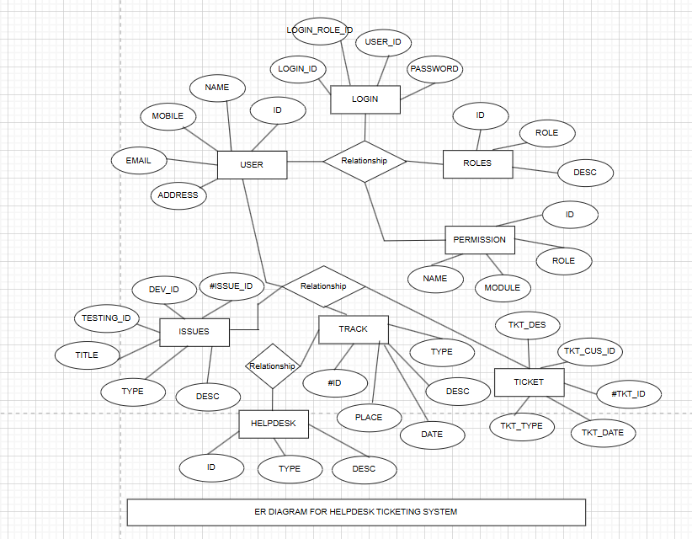

- User story of shopping from ecommerce:

User Stories
User Story No: 01 | Tasks: Ensure secure transactions Priority: Medium
Value statement:
As a shopper, I want to search for products by name or category, so that I can quickly find what I need.
BV: 500 | CP: 2
Acceptance criteria:
System allows product searches and displays relevant results.

User Story No: 02 | Tasks: Improve delivery efficiency Priority: Low
Value statement:
As a new customer, I want to create an account, so that I can make purchases and track orders.
BV: 500 | CP: 5
Acceptance criteria:
Users can register with email and password, and account is created successfully.

User Story No: 03 | Tasks: Boost customer satisfaction Priority: High
Value statement:
As a returning user, I want to login securely, so that I can access my account and order history.
BV: 500 | CP: 5
Acceptance criteria:
System authenticates user credentials and grants access.

User Story No: 04 | Tasks: Streamline payment process Priority: Medium
Value statement:
As a visitor, I want to browse product categories, so that I can see available items and details.
BV: 100 | CP: 2
Acceptance criteria:
Products are displayed with images, prices, and descriptions.

User Story No: 05 | Tasks: Enhance user experience Priority: Low
Value statement:
As a shopper, I want to add items to my cart, so that I can purchase multiple products at once.
BV: 200 | CP: 3
Acceptance criteria:
Items can be added, removed, and quantities updated in cart.

User Story No: 06 | Tasks: Ensure secure transactions Priority: High
Value statement:
As a customer, I want to check out and pay securely, so that I can complete my purchase.
BV: 500 | CP: 5
Acceptance criteria:
Payments are processed securely and order confirmation is provided.

User Story No: 07 | Tasks: Improve delivery efficiency Priority: Medium
Value statement:
As a buyer, I want to receive order confirmation, so that I know my purchase was successful.
BV: 500 | CP: 5
Acceptance criteria:
System sends order confirmation via email and on-screen.

User Story No: 08 | Tasks: Boost customer satisfaction Priority: Low
Value statement:
As a visitor, I want to check out without creating an account, so that I can make quick purchases.
BV: 200 | CP: 3
Acceptance criteria:
Users can checkout as guests and receive confirmation.

User Story No: 09 | Tasks: Streamline payment process Priority: High
Value statement:
As a customer, I want to leave product reviews, so that I can share my feedback and help others.

BV: 100 | CP: 2
Acceptance criteria:
Users can rate and review products.

User Story No: 10 | Tasks: Enhance user experience Priority: Medium
Value statement:
As a user, I want to add products to a wishlist, so that I can save items for later.
BV: 200 | CP: 2
Acceptance criteria:
Wishlist saves selected products for registered users.

User Story No: 11 | Tasks: Ensure secure transactions Priority: Low
Value statement:
As a Customer, I want to add items to my cart, so that I can purchase them later.
BV: 500 | CP: 2
Acceptance criteria:
Items can be added to and removed from cart.

User Story No: 12 | Tasks: Improve delivery efficiency Priority: High
Value statement:
As a Customer, I want to securely pay using UPI, so that I can complete my order conveniently.
BV: 500 | CP: 5
Acceptance criteria:
Payment via UPI is secure and verified.

User Story No: 13 | Tasks: Boost customer satisfaction Priority: Medium
Value statement:
As a Customer, I want to track my order in real-time, so that I know the delivery status.
BV: 500 | CP: 5
Acceptance criteria:
Order tracking shows real-time location updates.

User Story No: 14 | Tasks: Streamline payment process Priority: Low
Value statement:
As a Customer, I want to rate and review products, so that I can share my experience with others.
BV: 100 | CP: 2
Acceptance criteria:
System records and displays customer reviews.

User Story No: 15 | Tasks: Enhance user experience Priority: High
Value statement:
As a Customer, I want to browse products by category, so that I can find what I need easily.
BV: 500 | CP: 5
Acceptance criteria:
System allows category-based navigation.

User Story No: 16 | Tasks: Ensure secure transactions Priority: Medium
Value statement:
As a Customer, I want to add items to my cart, so that I can purchase them later.
BV: 500 | CP: 5
Acceptance criteria:
Items can be added to and removed from cart.

User Story No: 17 | Tasks: Improve delivery efficiency Priority: Low
Value statement:
As a Customer, I want to securely pay using UPI, so that I can complete my order conveniently.
BV: 500 | CP: 5
Acceptance criteria:
Payment via UPI is secure and verified.

User Story No: 18 | Tasks: Boost customer satisfaction Priority: High
Value statement:
As a Customer, I want to track my order in real-time, so that I know the delivery status.
BV: 200 | CP: 3
Acceptance criteria:
Order tracking shows real-time location updates.

User Story No: 19 | Tasks: Streamline payment process Priority: Medium
Value statement:
As a Customer, I want to rate and review products, so that I can share my experience with others.
BV: 100 | CP: 2
Acceptance criteria:
System records and displays customer reviews.

User Story No: 20 | Tasks: Enhance user experience Priority: Low
Value statement:
As a Customer, I want to browse products by category, so that I can find what I need easily.
BV: 200 | CP: 3
Acceptance criteria:
System allows category-based navigation.

User Story No: 21 | Tasks: Ensure secure transactions Priority: High
Value statement:
As a Customer, I want to add items to my cart, so that I can purchase them later.
BV: 500 | CP: 3
Acceptance criteria:
Items can be added to and removed from cart.

User Story No: 22 | Tasks: Improve delivery efficiency Priority: Medium
Value statement:
As a Customer, I want to securely pay using UPI, so that I can complete my order conveniently.
BV: 500 | CP: 5
Acceptance criteria:
Payment via UPI is secure and verified.

User Story No: 23 | Tasks: Boost customer satisfaction Priority: Low
Value statement:
As a Customer, I want to track my order in real-time, so that I know the delivery status.
BV: 200 | CP: 3
Acceptance criteria:
Order tracking shows real-time location updates.

User Story No: 24 | Tasks: Streamline payment process Priority: High
Value statement:
As a Customer, I want to rate and review products, so that I can share my experience with others.
BV: 100 | CP: 1
Acceptance criteria:
System records and displays customer reviews.

User Story No: 25 | Tasks: Enhance user experience Priority: Medium
Value statement:
As a Customer, I want to browse products by category, so that I can find what I need easily.
BV: 200 | CP: 2
Acceptance criteria:
System allows category-based navigation.

User Story No: 26 | Tasks: Ensure secure transactions Priority: Low
Value statement:
As a Customer, I want to add items to my cart, so that I can purchase them later.
BV: 200 | CP: 3
Acceptance criteria:
Items can be added to and removed from cart.

User Story No: 27 | Tasks: Improve delivery efficiency Priority: High
Value statement:
As a Customer, I want to securely pay using UPI, so that I can complete my order conveniently.
BV: 500 | CP: 5
Acceptance criteria:
Payment via UPI is secure and verified.

User Story No: 28 | Tasks: Boost customer satisfaction Priority: Medium
Value statement:
As a Customer, I want to track my order in real-time, so that I know the delivery status.
BV: 200 | CP: 3
Acceptance criteria:
Order tracking shows real-time location updates.

User Story No: 29 | Tasks: Streamline payment process Priority: Low
Value statement:
As a Customer, I want to rate and review products, so that I can share my experience with others.
BV: 200 | CP: 3
Acceptance criteria:
System records and displays customer reviews.

User Story No: 30 | Tasks: Enhance user experience Priority: High
Value statement:
As a Customer, I want to browse products by category, so that I can find what I need easily.
BV: 500 | CP: 5
Acceptance criteria:
System allows category-based navigation.

User Story No: 31 | Tasks: Ensure secure transactions Priority: Medium
Value statement:
As a Customer, I want to add items to my cart, so that I can purchase them later.
BV: 200 | CP: 2
Acceptance criteria:
Items can be added to and removed from cart.

User Story No: 32 | Tasks: Improve delivery efficiency Priority: Low
Value statement:
As a Customer, I want to securely pay using UPI, so that I can complete my order conveniently.
BV: 100 | CP: 1
Acceptance criteria:
Payment via UPI is secure and verified.

User Story No: 33 | Tasks: Boost customer satisfaction Priority: High
Value statement:
As a Customer, I want to track my order in real-time, so that I know the delivery status.
BV: 500 | CP: 5
Acceptance criteria:
Order tracking shows real-time location updates.

User Story No: 34 | Tasks: Streamline payment process Priority: Medium
Value statement:
As a Customer, I want to rate and review products, so that I can share my experience with others.
BV: 200 | CP: 2
Acceptance criteria:
System records and displays customer reviews.

User Story No: 35 | Tasks: Enhance user experience Priority: Low
Value statement:
As a Customer, I want to browse products by category, so that I can find what I need easily.
BV: 200 | CP: 2
Acceptance criteria:
System allows category-based navigation.

User Story No: 36 | Tasks: Ensure secure transactions Priority: High
Value statement:
As a Customer, I want to add items to my cart, so that I can purchase them later.
BV: 500 | CP: 5
Acceptance criteria:
Items can be added to and removed from cart.

User Story No: 37 | Tasks: Improve delivery efficiency Priority: Medium
Value statement:
As a Customer, I want to securely pay using UPI, so that I can complete my order conveniently.
BV: 200 | CP: 3
Acceptance criteria:
Payment via UPI is secure and verified.

User Story No: 38 | Tasks: Boost customer satisfaction Priority: Low
Value statement:
As a Customer, I want to track my order in real-time, so that I know the delivery status.
BV: 100 | CP: 1
Acceptance criteria:
Order tracking shows real-time location updates.

User Story No: 39 | Tasks: Streamline payment process Priority: High
Value statement:
As a Customer, I want to rate and review products, so that I can share my experience with others.
BV: 500 | CP: 5
Acceptance criteria:
System records and displays customer reviews.

User Story No: 40 | Tasks: Enhance user experience Priority: Medium
Value statement:
As a Customer, I want to browse products by category, so that I can find what I need easily.
BV: 500 | CP: 2
Acceptance criteria:
System allows category-based navigation.

