Subject: Introduction as Business Analyst for Inventory & Delivery Management Project
Dear [Client's Name],
I hope this message finds you well.
My name is [Your Name], and I have been assigned as the Business Analyst for your upcoming software initiative aimed at improving inventory management and ensuring the quickest delivery of your ice-cream and milk products. I am delighted to have the opportunity to work closely with you and your team on this important project.
Our primary goal at this stage is to gain a clear and in-depth understanding of your business processes, challenges, and expectations. This will enable us to define accurate system requirements and align the solution with your operational goals across manufacturing plants and warehouses located throughout the country.
Over the next few days, I will be collaborating with your stakeholders to:
- Gather and analyze current workflows,
- Identify pain points and opportunities for improvement,
- Understand system integration and data flow needs,
- Document functional and non-functional requirements.
This initial discovery phase is critical to ensuring the solution we deliver will be both scalable and effective in meeting your objectives.
Please let me know a convenient time to schedule our first requirements gathering session. I look forward to working with you and your team to build a robust and future-ready system.
Thank you, and I am excited to get started.
Warm regards,
[Your Full Name]
Business Analyst
[Your Company Name]
[Email Address] | [Phone Number]

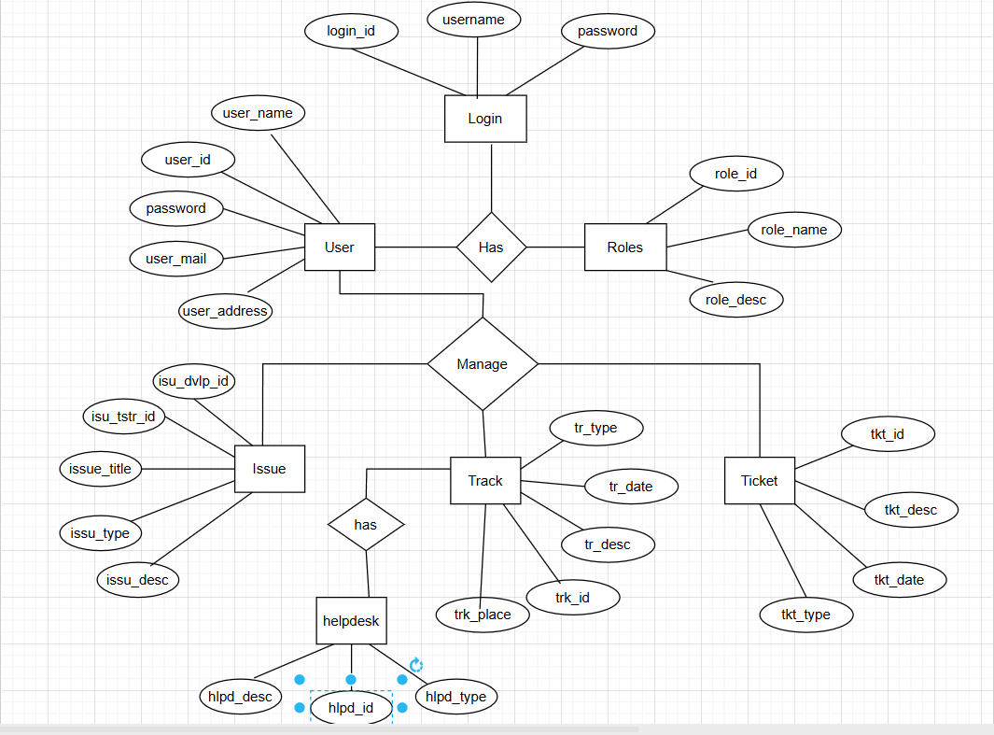

Software Requirements Specification (SRS) – Horoscope App
1. Introduction
The Horoscope App is a mobile and web-based application designed to deliver personalized daily, weekly, and monthly horoscopes to users based on their zodiac signs and astrological profiles. The app leverages astrological algorithms and curated content to offer insights about different aspects of life, such as love, career, health, and finance. Additionally, it provides users with astrology tools like birth chart generation, compatibility analysis, and moon phase updates.
This SRS document outlines the functional and non-functional requirements of the Horoscope App, serving as a reference for all stakeholders including developers, designers, testers, and business analysts. It provides a detailed description of the features, user interfaces, system behavior, and data requirements necessary for successful development and deployment.
1.1. Purpose
The primary purpose of this document is to define and communicate the requirements of the Horoscope App clearly and unambiguously. It ensures that all stakeholders have a mutual understanding of the application's objectives, features, and constraints.
Specifically, the document aims to:
- Define the core features and functionalities of the Horoscope App.
- Specify the user roles and their interactions with the system.
- Serve as a foundation for system design, development, and testing.
- Act as a contractual basis between clients and development teams.
1.2. Project Scope
The scope of the Horoscope App includes the development of a user-friendly and interactive application that offers:
- Daily/Weekly/Monthly Horoscopes for all 12 zodiac signs.
- User Registration & Login with profile creation.
- Zodiac-Based Content Customization based on date of birth.
- Birth Chart/Natal Chart Generator using time, date, and place of birth.
- Astrological Compatibility Reports for relationships and friendships.
- Push Notifications for daily updates and personalized alerts.
- Admin Panel to manage content, users, and horoscope data.

The app will be developed for both Android and iOS platforms, and optionally accessible via a responsive web interface. It will use cloud storage for user data and may integrate third-party APIs for astrology content.
Out of scope: Real-time astrology consultations, tarot reading, or any paid subscription models (in the initial phase).

2. Overall Description
2.1. Product Perspective
The Horoscope App is a standalone mobile and web application, designed to provide astrological predictions and personalized content to end-users. It fits into the Astrology Services domain and may integrate external APIs for planetary calculations or content updates.
The product is a new development and does not depend on any legacy system. However, it will interact with third-party astrology APIs, a cloud database, and notification services (like Firebase Cloud Messaging for push alerts).
The app will have the following components:
- Client Application (Mobile/Web): Front-end interface for users.
- Backend Server: Handles business logic, authentication, and content management.
- Admin Panel: Used by content managers to update horoscope data.
- External Services: APIs for birth chart calculations, planetary positions, etc.
2.2 Key External Interfaces
- User Interface: Mobile/Web interface for users to view horoscopes, charts, and compatibility reports.
- Admin Interface: Web-based panel for managing zodiac content and user feedback.
- External APIs: For real-time astrological data (planet positions, chart generation).
- Notification Service: For sending daily updates and reminders to users.

6. Operating Environment
The Horoscope App will operate in a multi-platform environment, supporting both mobile (Android/iOS) and web platforms, while relying on cloud infrastructure and external astrology APIs. This section outlines the technical environment required for development, deployment, and usage of the application.

6.1 Client-Side Environment
🟢 Mobile App (Android & iOS)
- Android Version: 8.0 (Oreo) and above
- iOS Version: 13.0 and above
- Development Framework: Flutter or React Native (for cross-platform), or native (Kotlin/Swift)
- Required Permissions: Internet, Notifications, Local Storage
🟢 Web Application
- Supported Browsers: Latest versions of Chrome, Firefox, Edge, Safari
- Responsive Design: Compatible with mobile, tablet, and desktop resolutions
- Front-End Framework: React.js, Angular, or Vue.js

6.2 Server-Side Environment
- Operating System: Ubuntu 20.04+ or any Linux-based server
- Web Server: Nginx or Apache
- Backend Framework: Node.js, Django (Python), or Express.js
- Database: PostgreSQL or MongoDB (depending on structure needs)
- Hosting Platform: AWS / Azure / Google Cloud / Firebase
- API Communication: RESTful APIs (secured via HTTPS and tokens)

6.3 Third-Party Integrations
- Astrology APIs: For planetary calculations and birth chart generation
- Notification Services:
  - Firebase Cloud Messaging (FCM) for Android
  - Apple Push Notification Service (APNs) for iOS
- Authentication Providers: Firebase Auth, OAuth2 (Google/Apple login)

6.4 Tools & Dependencies
- Version Control: Git with GitHub or GitLab
- CI/CD Tools: Jenkins, GitHub Actions, or Bitbucket Pipelines
- Monitoring Tools: Firebase Analytics, Google Analytics, or Sentry
- Testing Tools: Selenium, Jest, Postman, JUnit (depending on stack)

4.4 Assumptions and Dependencies
- Users have internet access to receive real-time content.
- Third-party astrology APIs provide accurate and available data.
- Notification services are reliable and integrated with the app platforms.
- Supported platforms include Android (v8.0+), iOS (v13+), and major browsers (for web).
Functional Requirements
- User Management
  - Register/Login via email or social login
  - Store user birth date/time/location
  - Allow profile updates
- Horoscope Display
  - Show daily/weekly/monthly zodiac horoscopes
  - Display personalized horoscopes based on birth details
  - Allow filtering by sign or date
- Push Notifications
  - Send daily horoscope reminders
  - Notify about compatibility updates or special astrological events
- Admin Panel
  - Add/update horoscope content
  - Manage users and subscriptions
  - Analytics dashboard
- Premium Features
  - In-app purchases for premium horoscopes
  - Ad-free experience

3. Non-Functional Requirements
- Performance: Load horoscope content under 2 seconds.
- Scalability: Support up to 1 million users.
- Security: Data encryption for user birth details and login.
- Availability: 99.5% uptime.

4. System Architecture Overview
- Frontend: React Native (for Android/iOS), or React.js (Web)
- Backend: Node.js or Django with REST APIs
- Database: PostgreSQL or MongoDB
- Hosting: AWS / Firebase

7. Business Rules
Business rules define the core logic, constraints, and operational rules the system must adhere to.
Rule ID | Business Rule Description
BR-01 | Users must register using a valid email or social login to access personalized features.
BR-02 | Daily, weekly, and monthly horoscopes are published and updated by Admin only.
BR-03 | Birth chart generation requires valid date, time, and location of birth.
BR-04 | Compatibility results are computed based on predefined zodiac match criteria.
BR-05 | Notifications are sent at 8:00 AM local time daily if enabled by the user.

✅ 8. Functional Requirements
Functional requirements describe the system behavior, features, and functions.
Req ID | Functional Requirement
FR-01 | The system shall allow users to register and log in.
FR-02 | The system shall provide personalized horoscopes based on zodiac sign.
FR-03 | The system shall generate a birth chart based on user input.
FR-04 | The system shall display compatibility between two zodiac signs.
FR-05 | The admin panel shall allow content updates for horoscopes.
FR-06 | The system shall send daily push notifications to users.

✅ 9. Non-Functional Requirements
Non-functional requirements define system qualities such as performance, usability, and security.
NFR ID | Non-Functional Requirement
NFR-01 | The app shall load horoscope content in under 3 seconds.
NFR-02 | The system shall handle up to 10,000 concurrent users.
NFR-03 | The app shall comply with GDPR for user data privacy.
NFR-04 | The app shall be available 99.9% of the time per month.
NFR-05 | The UI shall be intuitive for users aged 16–60.

✅ 10. Use Case Descriptions (Sample Use Cases)

🧾 Use Case 1: View Daily Horoscope
Field | Description
Use Case ID | UC-01
Use Case Name | View Daily Horoscope
Actor | Registered User
Precondition | User is logged in
Main Flow | 1. User opens the app  2. System fetches user zodiac sign  3. System displays daily horoscope
Alternate Flow | If user is not logged in, show generic horoscope
Postcondition | Daily horoscope displayed

🧾 Use Case 2: Generate Birth Chart
Field | Description
Use Case ID | UC-02
Use Case Name | Generate Birth Chart
Actor | Registered User
Precondition | User is logged in and submits birth details
Main Flow | 1. User enters DOB, time, and place  2. System calls astrology API  3. Chart is generated and shown
Alternate Flow | If input is incomplete, show validation message
Postcondition | Chart is generated and saved to profile

🧾 Use Case 3: Admin Updates Horoscope
Field | Description
Use Case ID | UC-03
Use Case Name | Admin Updates Horoscope
Actor | Admin User
Precondition | Admin is logged in to dashboard
Main Flow | 1. Admin selects zodiac sign and time frame  2. Edits horoscope content  3. Saves and publishes
Postcondition | Content is updated and visible to users
11. Data Requirements

11.1 Logical Data Model (ERD)
The Logical Data Model shows entities, attributes, and relationships for the Horoscope App. This is a high-level Entity-Relationship Diagram (ERD) representation (described textually here):
csharp
CopyEdit
[User] ──────< [BirthChart]
|
└─────< [CompatibilityCheck]

[User] ──────< [LoginActivity]

[ZodiacSign] ──────< [HoroscopeContent]

[AdminUser] ──────< [HoroscopeContent]
Entities and Relationships:
- A User can have one or more BirthCharts and CompatibilityChecks.
- A ZodiacSign (12 total) has many HoroscopeContent entries (daily/weekly/monthly).
- An AdminUser creates or updates HoroscopeContent.
- LoginActivity records user access events.

11.2 Data Dictionary
Below is a summary of key entities, attributes, and types:
1. User Table
Field Name | Data Type | Description | Constraints
user_id | UUID | Unique user ID | PK, Auto-generated
name | VARCHAR(50) | User's full name | Not null
email | VARCHAR(100) | Unique email | Unique, Not null
password_hash | TEXT | Encrypted password | Not null
date_of_birth | DATE | User’s birthdate | Not null
gender | VARCHAR(10) | Gender | Optional
time_of_birth | TIME | Time of birth | Optional
place_of_birth | VARCHAR(100) | Location of birth | Optional
created_at | TIMESTAMP | Registration timestamp | Auto-set

2. BirthChart Table
Field Name | Data Type | Description
chart_id | UUID | Unique ID
user_id | UUID | FK to User
planets_pos | JSON | Planet positions
ascendant | VARCHAR(50) | Rising sign
houses | JSON | House placements
generated_at | TIMESTAMP | Chart generation time

3. HoroscopeContent Table
Field Name | Data Type | Description
horoscope_id | UUID | Unique horoscope ID
zodiac_sign | VARCHAR(20) | Aries to Pisces
type | VARCHAR(20) | Daily, Weekly, Monthly
date | DATE | Date of horoscope
content_text | TEXT | Prediction content
created_by | UUID | Admin ID
created_at | TIMESTAMP | Content creation time

4. CompatibilityCheck Table
Field Name | Data Type | Description
compatibility_id | UUID | Unique ID
user_id | UUID | FK to User
partner_sign | VARCHAR(20) | Zodiac of other user
score | INT | Compatibility score (0–100)
description | TEXT | Explanation of match
created_at | TIMESTAMP | When match was calculated

5. AdminUser Table
Field Name | Data Type | Description
admin_id | UUID | Unique admin ID
name | VARCHAR(50) | Admin’s full name
email | VARCHAR(100) | Email address
password_hash | TEXT | Hashed password
role | VARCHAR(20) | Role (editor, superadmin)

6. LoginActivity Table
Field Name | Data Type | Description
activity_id | UUID | Unique login event ID
user_id | UUID | FK to User
timestamp | TIMESTAMP | Login time
device_info | TEXT | Browser or mobile details

11.3 Data Maintenance Requirements
🔄 Data Entry and Validation
- All mandatory fields (e.g., DOB, email) will be validated at the input stage.
- Email must be unique and verified via email confirmation link.
- Date/time values must follow standard formats (YYYY-MM-DD, HH:MM:SS).
🔒 Data Security & Privacy
- Passwords are stored using hashing algorithms (e.g., bcrypt).
- Sensitive fields (DOB, location) are encrypted in storage.
- Access controls are role-based (User vs Admin vs System Admin).
🧹 Data Retention and Cleanup
- Horoscope content will be archived after 1 year.
- Inactive user accounts may be anonymized after 12 months of inactivity.
- Users can request deletion of their personal data (GDPR compliance).
📦 Backups
- Automatic full backups performed daily (stored securely in cloud).
- Admins can restore historical horoscope content via the admin panel.
📊 Auditing
- All content updates and deletions are logged for audit.
- Admin activities are timestamped and linked to their accounts.
12. External Interface Requirements

12.1 User Interface (UI)
The Horoscope App will offer a clean, responsive, and intuitive UI optimized for mobile and web platforms.
Key UI Elements:
- Login/Registration Screen – With social login (Google/Apple) and email/password.
- Dashboard – Displays daily/weekly/monthly horoscopes and zodiac overview.
- Birth Chart Generator – Form for entering DOB, time, and location.
- Compatibility Checker – Interface for entering a partner’s zodiac sign.
- Notifications – Pop-up or banner for horoscope alerts.
- Admin Panel (Web-only) – For content creation/editing, user feedback, and analytics.
UI Design Guidelines:
- Should follow Material Design (Android) and Human Interface Guidelines (iOS).
- Use color-coded icons for each zodiac sign.
- Support dark mode and multi-language support.

12.2 Software Interfaces
The system will interact with internal and external software components via APIs.
Interface | Description
REST API | Used by mobile/web frontends to interact with backend services.
External Astrology API | For generating birth charts and planetary positions.
Firebase Auth | For user authentication and session management.
Firebase Firestore / PostgreSQL | Database for storing all user and content data.

12.3 Communication Interfaces
Interface Type | Description
HTTP/HTTPS | All communication between client and server will use HTTPS for secure data transmission.
Push Notification Service | Firebase Cloud Messaging (FCM) for Android/iOS alerts.
Email Service | Used for user verification, password resets, and feedback responses.

✅ 13. Report Requirements
The Horoscope App will generate the following system and user-facing reports:
Report Name | Description | Format
Daily Horoscope Report | Displayed to users based on their zodiac | In-App View, JSON
Compatibility Report | Generated based on two zodiac signs or user-provided DOBs | PDF / In-App View
User Analytics Report (Admin) | Shows active users, top-used features | Dashboard Charts
Content Management Logs | Tracks admin changes to horoscopes | Admin Log View

✅ 14. Glossary of Terms
Term | Definition
Zodiac Sign | One of the 12 astrological signs assigned based on date of birth.
Birth Chart | An astrological chart based on a person's birth time and place.
Compatibility Report | Astrological analysis between two signs or users.
Admin Panel | Web interface for content management and system monitoring.
API (Application Programming Interface) | Set of functions allowing interaction between components.
FCM (Firebase Cloud Messaging) | Service for sending push notifications to user devices.
REST API | Web-based interface used for client-server communication.

✅ 15. Appendix
A. Tools & Technologies
- Frontend: Flutter, React Native (mobile), React.js (web)
- Backend: Node.js or Django with REST API
- Database: Firebase Firestore / PostgreSQL
- Authentication: Firebase Auth / OAuth2
- Cloud Platform: Google Cloud Platform or AWS
- Astrology API Providers: AstroSeek, Aztro, Prokerala API
B. Standards Followed
- OWASP security best practices
- WCAG 2.1 accessibility compliance
- GDPR and data protection standards
C. Future Enhancements (Optional)
- Add Tarot reading module
- Offer personalized astrology consultations
- Launch premium subscriptions with advanced features

