Waterfall Model Document Part-2

Document 6

Document 7- Screens and pages
Home Page
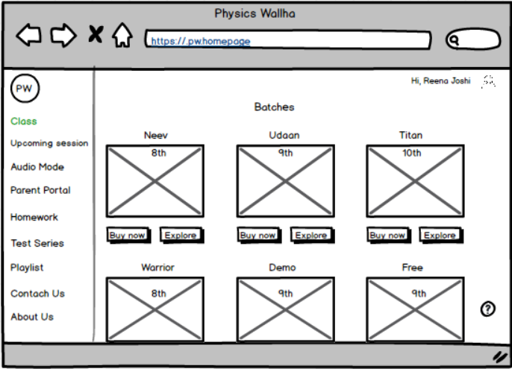

Login Page
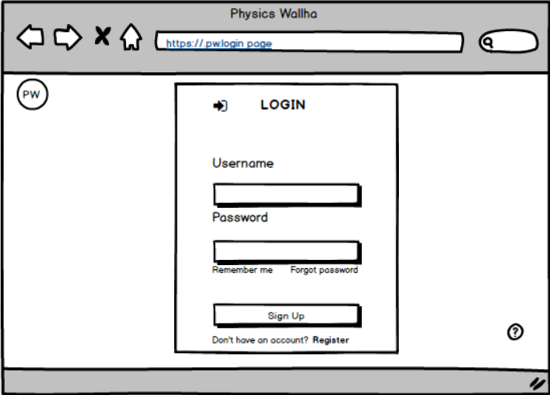

Parent Portal
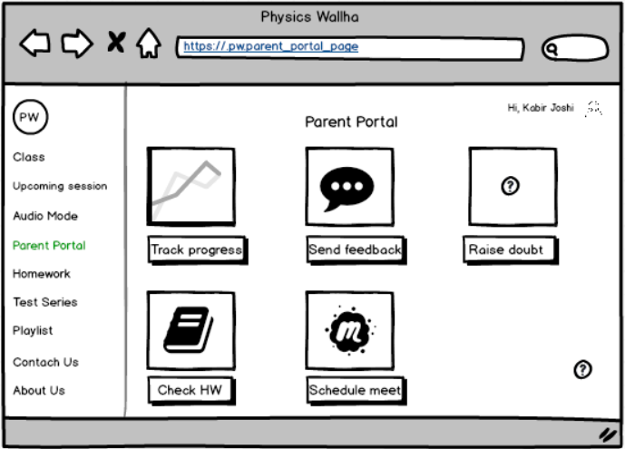

Audio Mode
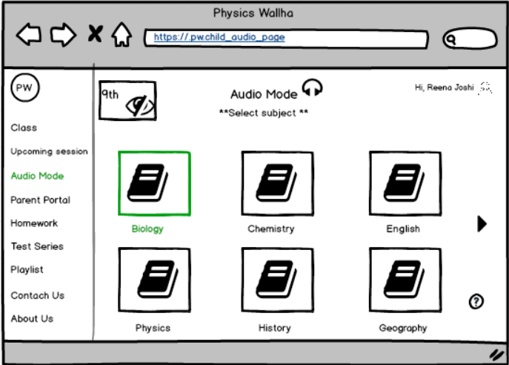

Homework evaluation page
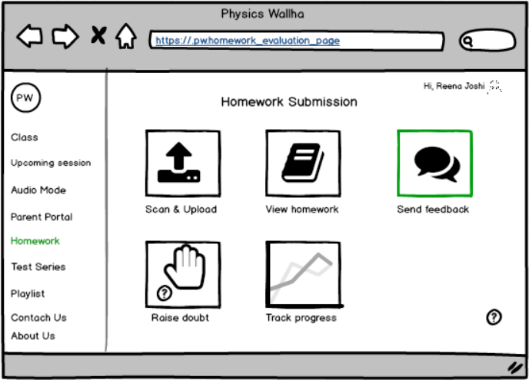

Log out page
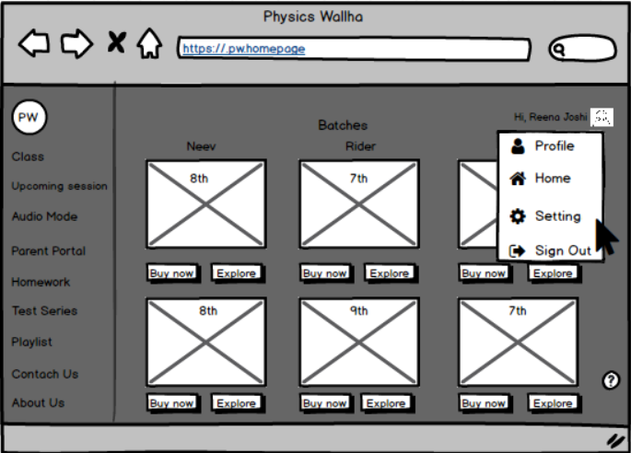

Document 8- Tools-Visio and Axure
During the LMS enhancement project, I actively used Microsoft Visio to create clear and structured AS-IS and TO-BE process flow diagrams, which helped stakeholders visualize existing workflows and proposed system improvements. Visio's swimlane and flowchart tools allowed me to map complex interactions between students, teachers, and parents in an easy-to-understand format. Additionally, I used Axure RP to design interactive wireframes and mockups for key features such as the parent portal, assignment upload interface, and audio reading mode. These prototypes were instrumental in conducting early feedback sessions, aligning the development team with stakeholder expectations, and reducing rework during the design phase.

Document 9- BA experience
1. Requirement Gathering:
I applied the MOSCOW prioritization technique to identify and organize requirements effectively. Since the client was occasionally unavailable during this phase, I proactively coordinated with alternate points of contact from the client side to gather missing information promptly. I validated the collected requirements using the FURPS model and ensured the removal of duplicated or repetitive items. To refine unclear inputs, I used prototyping techniques, which helped stakeholders visualize their needs more clearly.
2. Requirement Analysis:
I created UML diagrams and activity diagrams to depict process flows and system interactions visually. These were shared with the team for feedback, and I made necessary adjustments based on their suggestions. Additionally, I prepared the Business Requirement Specification (BRS) and Software Requirement Specification (SRS) documents to formally capture functional and non-functional requirements.
3. Design Phase:
During the design phase, I worked closely with the QA and development teams to derive test cases from use cases — covering both positive and negative scenarios. I ensured that no test case was missed, recognizing its potential impact on development quality. I also helped in preparing relevant test data and kept the Requirements Traceability Matrix (RTM) updated to ensure all requirements were properly mapped and validated.
4. Development Phase:
I organized and facilitated JAD sessions to bridge communication between stakeholders and the technical team. When conflicts or non-cooperative behavior arose, I handled such situations diplomatically by having one-on-one discussions, emphasizing the importance of collaboration and project impact. I clarified development queries and referred to prepared diagrams to assist developers. I also conducted regular sync meetings and recorded sessions for those who missed them, followed by personalized follow-ups.
5. Testing Phase:
I collaborated with the QA team to ensure high-level testing was conducted using the defined test cases. I coordinated with the client to obtain required test data, updated the RTM, and prepared the client for User Acceptance Testing (UAT). Once UAT was successfully completed, I secured formal sign-off from the client.
6. Deployment Phase:
As part of deployment activities, I shared the finalized RTM and contributed to the project closure documentation. I coordinated the creation and delivery of end-user manuals, planned and conducted training sessions, and ensured active participation from all intended users.

