Document 1: Definition of Done (DoD)

The Definition of Done ensures that every user story, feature or product increment is complete to the required quality before it can be released.
For this project, ICICI Securities CRM trigger & notification automation project, the DoD means:
- Code complete – all development tasks are finished, code is checked in, peer-reviewed and merged into the main branch
- Unit tested – code has passed unit tests with defined coverage (eg – 80%)
- Functional tested – feature validated against acceptance criteria and user story requirements
- Integration tested – code integrated with CRM and notification services like SMS, email, push
- Performance tested – notifications are triggered within agreed SLA response times
- No critical defects – no open severity 1 or 2 defects exist
- Security & compliance – code complies with ICICI’s Infosec policies and RBI guidelines
- Documentation updated – technical documentation, process flows and user manuals updated
- Stakeholder sign-off – product owner has validated the user story against acceptance criteria
- Deployed to staging – feature successfully deployed in staging and UAT environment

Checklist for DoD –
- Code written, peer reviewed and merged into main branch
- Unit tests created & passed (80% coverage minimum)
- Acceptance criteria validated (QA passed)
- Integrated with CRM & notification systems
- Load and performance tested for SLA adherence
- No critical or Sev-1 defects open
- Security compliance and vulnerability scan passed
- Documentation updated technical + user
- Product owner acceptance received
- Feature deployed to staging and UAT successfully

Document 2 – Product Vision

Scrum project name: | ICICI Securities – CRM Trigger & Notification Automation
Venue: | ICICI Securities HQ / Virtual (MS Teams)
Date: | Start time: 01/07/2025 | End time: 30/09/2025 | Duration: 3 months
Client: | ICICI Securities Ltd.
Stakeholder list: | Head of retail banking | Head of CRM operations | Compliance manager
 | IT infrastructure manager | Customer service lead
Scrum team
Scrum master: | Devi Menon
Product owner: | Sachin Bajpai
Scrum Developer 1: | Jaideep
Scrum Developer 2: | Bikram
Scrum Developer 3: | Shefali
Scrum Developer 4: | Neeraj

Vision: The vision is to transform ICICI Securities’ customer engagement strategy by automating CRM triggers and notifications, ensuring that every client receives personalized, timely and compliant communication. The overall goal is to enhance customer satisfaction, increase retention and drive investment activity through seamless digital touchpoints.
Target group –  - ICICI Securities retail and wealth management customers  - Customer service teams handling client onboarding, portfolio updates, and alerts  - Compliance and operations teams | Needs –  - Customers need timely, personalized, and multi-channel notifications (SMS, Email, Push).  - The business needs to reduce manual intervention, ensure regulatory compliance, and improve customer engagement & satisfaction.  - Stakeholders need real-time visibility into communication workflows. | Product –  - CRM Trigger & Notification Automation System integrated with ICICI’s existing CRM.  - Automates sending event-based notifications (account opening, portfolio updates, payment reminders, compliance alerts).  - Provides a dashboard for monitoring, audit, and compliance tracking.  - Scalable, secure, and integrated with third-party APIs | Value –  - Customer Value: Faster updates, improved trust, and seamless digital experience.  - Business Value: Higher customer retention, reduced operational cost, and increased efficiency.  - Strategic Value: Strengthens ICICI’s positioning as a digital-first, customer-centric financial services provider.  - Feasibility: Uses existing CRM and cloud infrastructure; low incremental cost.

Document 3 – User stories

User Story: 1 | Tasks: Capture user registration event from CRM |  | Priority: High
Value statement: Timely onboarding notification
As a user I want to receive a welcome notification after account registration so that I can start using ICICI Securities immediately.
BV: 200 |  | CP: 5
Acceptance criteria: User receives email/SMS within 2 minutes of registration

User Story: 2 | Tasks: Trigger trade confirmation notification |  | Priority: High
Value statement: Ensure transaction transparency
As a user I want to receive instant trade confirmation notifications so that I know my transactions are successful.
BV: 500 |  | CP: 8
Acceptance criteria: Notification sent within 1 minute of trade execution.

User Story: 3 | Tasks: Send portfolio update alerts daily |  | Priority: Medium
Value statement: Provide real-time insights
As a user I want to get daily portfolio value updates so that I can track my investments easily.
BV: 100 |  | CP: 5
Acceptance criteria: Daily notification at 9 AM with accurate portfolio details

User Story: 4 | Tasks: Automate payment due reminders |  | Priority: High
Value statement: Reduce missed payments
As a user I want to receive reminders before payment due dates so that I don’t miss deadlines.
BV: 200 |  | CP: 3
Acceptance criteria: Reminder sent 3 days before due date via SMS/Email

User Story: 5 | Tasks: Alert for unsuccessful trades |  | Priority: High
Value statement: Reduce customer confusion
As a user I want to get notified if my trade fails so that I can take corrective action.
BV: 500 |  | CP: 8
Acceptance criteria: Failure notification sent within 2 minutes of unsuccessful trade

User Story: 6 | Tasks: Notify KYC expiry |  | Priority: High
Value statement: Ensure compliance
As a user I want to receive alerts about upcoming KYC expiry so that I can update my documents on time.
BV: 200 |  | CP: 5
Acceptance criteria: Notification 30, 15, and 7 days before expiry

User Story: 7 | Tasks: Push IPO subscription alerts |  | Priority: Medium
Value statement: Promote new products
As a user I want to receive IPO subscription opening alerts so that I don’t miss investment opportunities.
BV: 100 |  | CP: 5
Acceptance criteria: Notification triggered on IPO opening day

User Story: 8 | Tasks: Trigger margin shortfall alerts |  | Priority: High
Value statement: Reduce trading risk
As a user I want margin shortfall alerts so that I can fund my account and avoid penalties.
BV: 500 |  | CP: 8
Acceptance criteria: Notification when margin falls below threshold

User Story: 9 | Tasks: Send tax statement availability alert |  | Priority: Medium
Value statement: Simplify compliance
As a user I want to get notified when my tax statement is available so that I can download it easily.
BV: 100 |  | CP: 3
Acceptance criteria: Notification triggered within 24 hours of statement generation

User Story: 10 | Tasks: Notify password change activity |  | Priority: High
Value statement: Enhance security
As a user I want to receive alerts for password changes so that I can detect unauthorized activity.
BV: 200 |  | CP: 5
Acceptance criteria: Notification sent immediately after password change

User Story: 11 | Tasks: Enable push notifications in mobile app |  | Priority: Medium
Value statement: Improve engagement
As a user I want push notifications in my mobile app so that I stay updated on-the-go.
BV: 200 |  | CP: 8
Acceptance criteria: Push notifications enabled for at least 3 core events

User Story: 12 | Tasks: Send account lock/unlock notifications |  | Priority: Medium
Value statement: Provide transparency
As a user I want to be notified if my account is locked/unlocked so that I remain aware of account activity.
BV: 100 |  | CP: 3
Acceptance criteria: Notifications sent instantly after status change

User Story: 13 | Tasks: Notify large transaction alerts |  | Priority: High
Value statement: Increase trust & security
As a user I want alerts for large transactions so that I can verify them.
BV: 500 |  | CP: 8
Acceptance criteria: Notification sent for transactions above threshold

User Story: 14 | Tasks: Trigger failed login attempt alerts |  | Priority: High
Value statement: Improve account safety
As a user I want to be notified of failed login attempts so that I can protect my account.
BV: 200 |  | CP: 5
Acceptance criteria: Notification sent after 3 failed login attempts

User Story: 15 | Tasks: Alert on successful loan disbursal |  | Priority: Medium
Value statement: Keep customers informed
As a user I want to get notified after loan disbursal so that I can track funds received.
BV: 100 |  | CP: 3
Acceptance criteria: Notification within 1 hour of disbursal

User Story: 16 | Tasks: Notify mutual fund SIP due |  | Priority: Medium
Value statement: Ensure investment continuity
As a user I want reminders for SIP due dates so that I don’t miss my investments.
BV: 200 |  | CP: 5
Acceptance criteria: Notification 2 days before SIP date

User Story: 17 | Tasks: Send new product launch notifications |  | Priority: Medium
Value statement: Boost cross-selling
As a user I want to receive product launch alerts so that I can explore new offerings.
BV: 100 |  | CP: 5
Acceptance criteria: Notification triggered within 24 hours of launch

User Story: 18 | Tasks: Automate inactivity alerts |  | Priority: Medium
Value statement: Re-engage customers
As a user I want alerts if I don’t use my account for long so that I get reminders to trade again.
BV: 200 |  | CP: 5
Acceptance criteria: Notification triggered after 30 days of inactivity

User Story: 19 | Tasks: Notify system downtime |  | Priority: Medium
Value statement: Manage customer expectations
As a user I want downtime notifications so that I know when services will be unavailable.
BV: 100 |  | CP: 3
Acceptance criteria: Notification sent at least 1 hour before downtime

User Story: 20 | Tasks: Enable notification preferences |  | Priority: High
Value statement: Give user control
As a user I want to set my notification preferences so that I receive only what matters.
BV: 200 |  | CP: 8
Acceptance criteria: User can select channels (SMS/Email/Push) in profile

User Story: 21 | Tasks: Notify stock price alerts |  | Priority: High
Value statement: Drive trading activity
As a user I want price alerts for chosen stocks so that I can act quickly
BV: 500 |  | CP: 13
Acceptance criteria: Alert triggered when stock crosses threshold price

User Story: 22 | Tasks: Alert dividend payout |  | Priority: Medium
Value statement: Improve transparency
As a user I want to be notified when dividends are credited so that I know my returns.
BV: 100 |  | CP: 3
Acceptance criteria: Notification within 1 day of dividend credit

User Story: 23 | Tasks: Notify scheme maturity |  | Priority: Medium
Value statement: Help users plan reinvestment
As a user I want alerts for scheme maturity so that I can reinvest on time.
BV: 200 |  | CP: 5
Acceptance criteria: Notification 7 days before scheme maturity

User Story: 24 | Tasks: Alert failed SIP debit |  | Priority: High
Value statement: Reduce missed investments
As a user I want alerts when SIP debit fails so that I can take corrective action.
BV: 200 |  | CP: 5
Acceptance criteria: Notification within 1 day of failed SIP debit

User Story: 25 | Tasks: Generate summary of notifications |  | Priority: Low
Value statement: Give users a consolidated view
As a user I want a weekly summary of notifications so that I can track all updates in one place.
BV: 100 |  | CP: 3
Acceptance criteria: Weekly email summary sent every Sunday

Document 4 – Agile Product Owner Experience

The PO plays a crucial role in ensuring the product aligns with business goals, customer expectations and regulatory requirements. In the ICICI Securities – CRM trigger & notification automation project, the PO maintained a strong vision of the product by leveraging domain knowledge in financial services and analyzing market needs for automated and complaint communication systems.

Responsibility of the PO
- Market analysis –
  - Analysis of market need – identified customer pain points in delayed notifications, compliance risks and lack of personalization in financial communication.
  - Analysis of similar products in the market – benchmarked competitor systems (eg – HDFC Securities, Kotak Securities) to ensure ICICI’s solution offered a unique advantage through real-time, multi-channel automation.
- Enterprise analysis –
  - Due diligence on the market opportunity – established that automation of CRM triggers could significantly improve customer retention, reduce service costs and increase cross-selling of products.
- Product vision and roadmap –
  - Product vision – Deliver real-time, automated and complaint notifications to improve customer engagement and trust.
  - Product roadmap – Defined high-level features such as onboarding alerts, trade confirmations, KYC reminders, SIP alerts and compliance notifications with phased delivery over multiple sprints.
- Managing product features –
  - Stakeholder management – Balanced priorities among Compliance, IT, Operations and Customer service teams.
  - Prioritization – Applied ROI-driven prioritization – given high business value to compliance related alerts (eg – trade confirmations, KYC expiry) over promotional notifications.
- Managing product backlog –
  - User story prioritization – Ranked user stories based on customer impact and regulatory urgency.
  - Reprioritization – Adjusted backlog when RBI and SEBI introduced new compliance requirements.
  - Epics planning – Grouped features into epics like onboarding notifications, trading alerts, compliance reminders and promotional campaigns.
- Managing overall iteration progress –
  - Sprint progress review – Regularly reviewed sprint burndown charts and velocity to track progress.
  - Reprioritization – Adjusted sprint goals when high-priority compliance changes surfaced.
  - Sprint retrospectives – Collaboration with the scrum team and business analyst to reflect on sprint challenges, such as notification delivery delays and testing API integrations and to define improvements for upcoming sprints.

Learning from the project –
Sprint meetings – From this project, I learnt how to handle different Agile ceremonies, such as –
- Sprint planning meeting – defined sprint goals, discussed backlog priority and aligned team capacity.
- Daily scrim meeting – ensured team coordination, identified blockers and enabled smooth progress.
- Sprint review meeting – demonstrated completed stories to stakeholders, collected feedback and validated acceptance.
- Sprint retrospective meeting – reflected on sprint challenges, identified process improvements and boosted team collaboration.
- Backlog refinement meeting – continuously updated backlog, refined epics and prioritized upcoming user stories.

User story creation – I gained strong expertise in writing effective user stories by including –
- Story no.
- Tasks
- Priority
- Acceptance criteria
- Business value (BV)
- Complexity Points (CP)
This structure ensures that all stories were clear, testable and value driven.

Role of the PO in scrum
- Acted as the liaison between multiple business areas like stakeholders, compliance teams, IT, operations
- Maintained close collaboration with scrum teams to align development efforts with business goals
- Developed a clear product vision of CRM trigger automation and broke into product backlog items
- Ensured transparent communication across business and development teams, keeping all parties informed about progress, risks and value delivery.

Document 5 – Product and sprint backlog and product and sprint burndown charts

- Product Backlog
User story ID | User story | Tasks | Priority | BV | CP | Sprint
US01 | As a user, I want to receive a welcome notification after registration so that I can start using ICICI Securities immediately | Capture registration event, trigger email/SMS | High | 200 | 5 | Sprint 1
US02 | As a user, I want trade confirmation notifications so that I know my transactions are successful | Integrate with trading engine, trigger real-time notification | High | 500 | 8 | Sprint 1
US03 | As a user, I want daily portfolio updates so that I can track my investments | Build scheduler, fetch portfolio data, send notification | Medium | 100 | 5 | Sprint 2
US04 | As a user, I want payment due reminders so that I don’t miss deadlines | Build reminder scheduler, CRM integration | High | 200 | 3 | Sprint 2
US05 | As a user, I want KYC expiry alerts so that I can update documents on time | KYC API integration, notification trigger | High | 200 | 5 | Sprint 3
US06 | As a user, I want margin shortfall alerts so that I can fund my account | Fetch margin data, trigger SMS/email | High | 500 | 8 | Sprint 3
US07 | As a user, I want SIP due reminders so that I don’t miss my investments | SIP schedule integration, notification rules | Medium | 200 | 5 | Sprint 4
US08 | As a user, I want stock price alerts so that I can act quickly | Threshold setup, stock monitoring, notification push | High | 500 | 13 | Sprint 4
US09 | As a user, I want failed login attempt alerts so that I can secure my account | Authentication log capture, trigger alerts | High | 200 | 5 | Sprint 5
US10 | As a user, I want to set my notification preferences so that I receive only what matters | Build preference UI, database mapping, notification filter | High | 200 | 8 | Sprint 5

- Sprint Backlog (Sprint 1)

User Story ID | User Story | Tasks | Owner | Status | Estimated effort (hrs)
US01 | Welcome notification after registration | Registration event capture, notification template design, SMS/email integration | Dev1, Dev2 | In Progress | 20
US02 | Trade confirmation notification | Trade engine integration, API trigger, testing | Dev3, QA | Not Started | 30

Product Burndown chart

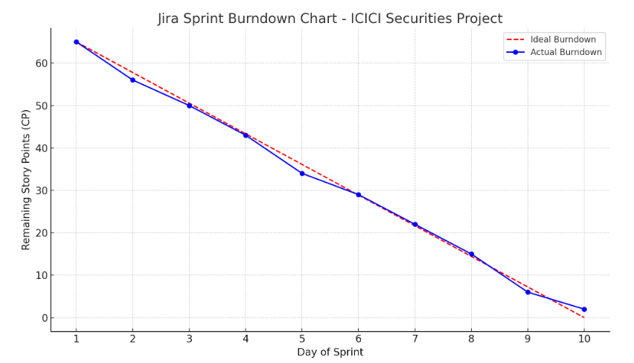

Sprint Burndown chart

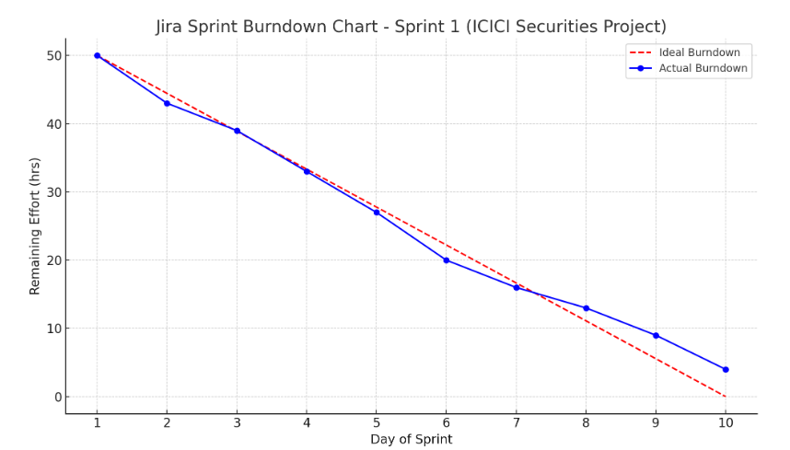

Document 6 – Sprint meetings

Meeting Type 1 – Sprint planning meeting
Date | 01/07/2025
Time | 9:30 AM
Location | ICICI Securities HQ / Virtual (MS Teams)
Prepared by | Scrum Master
Attendees | Product Owner, Scrum Master, Development Team (Developers, QA, Designer), Business Analyst

Agenda topics
Topic | Presenter | Time Allocated
Review product backlog items | Product owner | 20 mins
Define sprint goal | Scrum master & Product owner | 15 mins
Select user stories for sprint | Development team | 25 mins
Break stories into tasks & estimate | Developers & QA | 30 mins

Other information - Ensure stories are INVEST compliant (Independent, Negotiable, Valuable, Estimable, Small, Testable)
Observers | Business stakeholders may join
Resources | Product backlog, Jira/Agile board, velocity chart
Special Notes | Align sprint backlog with compliance/regulatory priorities

Meeting Type 2 – Sprint review meeting
Date | 15/07/2025
Time | 10:00 AM
Location | ICICI Securities HQ / Virtual (MS Teams)
Prepared by | Scrum Master
Attendees | Scrum Team, Product Owner, Key Stakeholders

Sprint status | Things to demo | Quick updates | What’s next
- Sprint Goal achieved or not achieved  - Velocity achieved: [X story points] | - Automated CRM triggers for client onboarding.  - SMS/Email notification flow tested end-to-end.  - Compliance validation on communication templates. | - Integration with SMS gateway completed.  - Push notification APIs pending. | - Plan for next sprint.  - Incorporate feedback from stakeholders.  - Refine backlog items for regulatory approval.

Meeting 3 – Sprint retrospective meeting
Date | 01/08/2025
Time | 10:00 AM
Location | ICICI Securities HQ / Virtual (MS Teams)
Prepared by | Scrum master
Attendees | Product Owner (PO), Scrum Master, Development Team – 3 Developers, 1 QA Engineer, Business Analyst

Agenda | What went well | What didn’t go well | Questions | Reference
- Review sprint goals and outcomes  - Discuss what went well  - Discuss challenges / what didn’t go well  - Capture lessons learned  - Identify action items for next sprint | - Successfully automated customer notification triggers for equity and MF transactions.  - Integrated notification system with ICICI CRM database smoothly.  - Daily stand-ups improved team collaboration and reduced blockers.  - Stakeholder feedback was positive on pilot testing of SMS/email triggers | - Delays in UAT environment setup caused dependency issues.  - Some notification templates required multiple iterations due to compliance checks.  - QA team reported integration testing defects (API timeout issues).  - Coordination gap between CRM and IT infra teams. | - How can we improve template approval process to avoid delays?  - Can we get early access to UAT environment for smoother testing?  - Should we set up dedicated support for infra issues during sprint execution? | - Sprint Backlog – ICICI CRM Trigger & Notification Automation  - Jira Board – Sprint 2 progress tracker  - Confluence – Project Documentation

Meeting type 4 – Daily stand-up meeting
Question | Name/Role | Week | 12/08/2025 | 13/08/2025 | 14/08/2025 | 15/08/2025 | 16/08/2025 | 17/08/2025
 |  | Monday | Tuesday | Wednesday | Thursday | Friday | Saturday | Sunday
What did you do yesterday? | Developer 1 Developer 2 Developer 3 | Developer 1 (Backend): Integrated CRM database with notification service APIs.  Developer 2 (Frontend): Designed UI for notification preferences (email/SMS toggle).  Developer 3 (QA): Prepared test cases for trigger rules and executed unit tests. | Dev 1 (Backend): Completed integration of CRM database with notification APIs.  Dev 2 (Frontend): Built notification preference UI (email/SMS toggle).  Dev 3 (QA): Drafted regression test cases for triggers. | Dev 1: Fixed API timeout for notification service.  Dev 2: Connected UI with backend APIs successfully.  Dev 3: Executed regression testing for equity transaction triggers. | Dev 1: Improved DB query performance by 20%.  Dev 2: Completed UI validation & error-handling.  Dev 3: Validated MF transaction triggers, logged 3 defects. | Dev 1: Assisted QA with API debugging.  Dev 2: Initiated design for push notification feature.  Dev 3: Verified 2 out of 3 reported defects. | Dev 1: Built batch job for bulk trigger processing.  Dev 2: Updated dashboard prototype.  Dev 3: Completed E2E testing for equity notifications. | Dev 1: Configured scheduling logic for batch jobs.  Dev 2: Integrated dashboard backend partially.  Dev 3: Tested MF notification triggers, raised 2 minor bugs.
What will you do today? | Developer 1 Developer 2 Developer 3 | Developer 1 (Backend): Work on fixing API timeout issue during high load testing.  Developer 2 (Frontend): Connect UI with backend APIs and test preference saving.  Developer 3 (QA): Start regression testing for notification templates. | Dev 1 (Backend): Start working on fixing API timeout issue during stress testing.  Dev 2 (Frontend): Connect preference UI with backend service.  Dev 3 (QA): Begin executing unit & integration tests for triggers. | Dev 1: Optimize DB queries for faster trigger execution.  Dev 2: Finalize error-handling on preference UI.  Dev 3: Validate MF transaction notification triggers. | Dev 1: Support QA in debugging API defects.  Dev 2: Work on push notification feature (future enhancement).  Dev 3: Retest defect fixes from yesterday. | Dev 1: Work on batch processing for bulk triggers.  Dev 2: Refine UI for notification summary dashboard.  Dev 3: Begin end-to-end system testing for equity & MF flows. | Dev 1: Fine-tune scheduling for batch jobs.  Dev 2: Integrate dashboard with backend reports.  Dev 3: Continue E2E testing for MF notifications. | Dev 1: Wrap up DB optimization tasks.  Dev 2: Final polish on dashboard UI.  Dev 3: Prepare consolidated QA test report.
What (if any) is blocking your progress? | Developer 1 Developer 2 Developer 3 | Developer 1 (Backend): Waiting for infra team to optimize database server response.  Developer 2 (Frontend): Dependency on approved notification templates from compliance.  Developer 3 (QA): UAT environment access pending from IT operations. | Dev 1: Needs infra team to enable DB monitoring logs.  Dev 2: Dependent on compliance approval for final templates.  Dev 3: UAT environment provisioning delayed. | Dev 1: Requires infra team support for DB load testing.  Dev 2: Waiting for compliance sign-off on SMS template.  Dev 3: Dependent on UAT environment stability. | Dev 1: Still waiting for full DB performance report.  Dev 2: Push notifications scope needs PO approval.  Dev 3: Requires updated defect-fix build. | Dev 1: Need access to production-like test data.  Dev 2: Pending UX inputs for dashboard layout.  Dev 3: Test data for MF transactions incomplete. | Dev 1: Scheduler access from infra team pending.  Dev 2: Report API still unstable.  Dev 3: UAT refresh required for consistent results. | Dev 1: Monitoring tool access not yet provisioned.  Dev 2: Pending PO feedback on dashboard look & feel.  Dev 3: Need clarification on one MF notification use case.

