Renewable Energy Integration
Question 6: Please prepare a use case diagram, activity diagram and a use case specification document?

Answer:
Use Case Diagram

Activity Diagram:

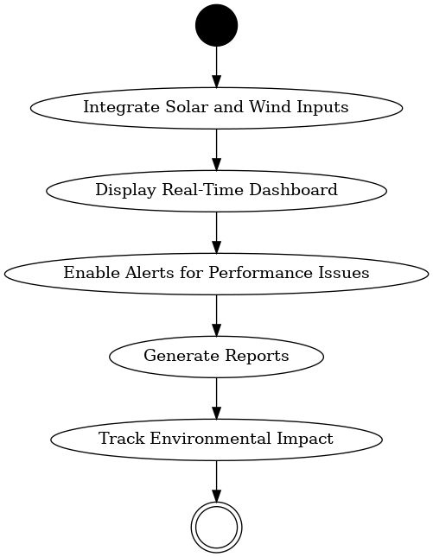

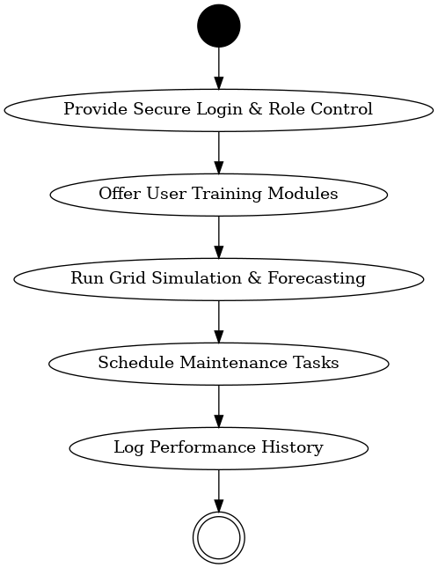
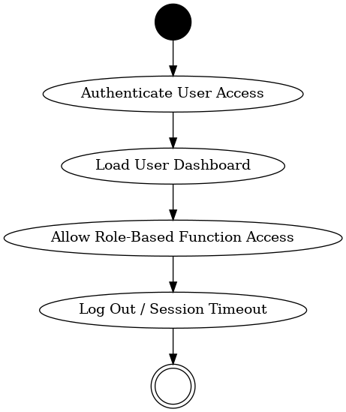

Use Case Name: Display Real-Time Dashboard:
1. Use Case Description:
Provides grid operators with an interface that continuously visualizes power flow, operational status, generation levels, and system alerts.
2. Actors:
- Primary Actors:
  - Grid Operators – monitor system performance and anomalies.
  - System Administrator – configure dashboard settings and access.
- Secondary Actors:
  - Project Manager – tracks system stability via dashboard KPIs.
3. Basic Flow:
- Backend system collects operational metrics.
- APIs transmit data to dashboard every 5 seconds.
- Data is visualized using graphs, meters, and tables.
4. Alternate Flow:
- Cached values are shown if API polling fails briefly (e.g., <60 seconds).
5. Exceptional Flows:
- API is unresponsive >2 min → Dashboard turns red and prompts “Data Stream Unavailable” banner.
6. Pre-Conditions:
- Sensor network and grid systems must be live.
- Dashboard is connected to real-time stream.
7. Post-Conditions:
- Operators see updated status, graphs, and flags.
8. Assumptions:
- API connections are stable and timely.
- Operator permissions are valid.
9. Constraints:
- Display refresh rate capped at every 5 seconds.
- Max dashboard latency: 2 seconds.
10. Dependencies:
- Data ingestion engine, visualization libraries (e.g., D3.js), APIs.
11. Inputs and Outputs:
- Inputs: Metrics from grid (energy flow, battery levels, alerts).
- Outputs: Graphs, live tiles, status banners.
12. Business Rules:
- Critical errors are red and sticky.
- Users must log in to access private modules.
13. Miscellaneous Information:
- Based on BR002, FR0003
- Links to Performance Monitoring System

Use Case Name: Enable Alerts for Performance Issues
1. Use Case Description:
Monitors key grid metrics and instantly alerts teams if anomalies like voltage fluctuation, system fault, or disconnection are detected.
2. Actors:
- Primary Actors:
  - System Monitoring Module – detects issues in real-time.
- Secondary Actors:
  - Operators – respond to alert.
  - Maintenance Team – dispatched if necessary.
3. Basic Flow:
- Metrics like voltage, frequency, latency are tracked.
- Rule engine applies thresholds.
- If deviation is detected, alert is triggered.
- System logs event and notifies stakeholders.
4. Alternate Flow:
- Transient fluctuation auto-corrects and alert is auto-dismissed.
5. Exceptional Flows:
- Notification server is down → alert is queued and escalated via SMS fallback.
6. Pre-Conditions:
- Threshold rules are pre-configured.
- Real-time metrics are flowing.
7. Post-Conditions:
- Alerts are logged, displayed, and optionally acknowledged.
8. Assumptions:
- No configuration errors in alert rules.
- Communication to users is active.
9. Constraints:
- Alerts must be delivered within 60 seconds.
- Max retries: 3 before manual escalation.
10. Dependencies:
- Notification system (email, SMS gateway), monitoring sensors.
11. Inputs and Outputs:
- Inputs: Voltage logs, fault events, rule definitions
- Outputs: Alerts via dashboard/email/SMS
12. Business Rules:
- Alerts must contain timestamp, cause, and severity.
- Auto-clear alerts only if metric stays normal for 5 minutes.
13. Miscellaneous Information:
- FR0005 and BR003
- Based on SCADA monitoring standards

Use Case Name: Generate Reports
1. Use Case Description:
Allows authorized users to export performance, compliance, and energy flow reports for analysis, auditing, or policy review.
2. Actors:
- Primary Actors:
  - Grid Admin – generates scheduled reports.
  - Business Analyst – uses data for analysis and insights.
- Secondary Actors:
  - QA Team – validates data integrity.
  - Sponsor – reviews high-level KPIs.
3. Basic Flow:
- User logs into reporting module.
- Selects report type, filters, format.
- System queries historical data store.
- Report is rendered and exported.
4. Alternate Flow:
- Recurring report: User sets daily/weekly schedule and email delivery.
5. Exceptional Flows:
- No data in selected period → system flags and prompts retry.
6. Pre-Conditions:
- User must be authenticated.
- Reporting engine is online.
7. Post-Conditions:
- Report is saved and available for review.
8. Assumptions:
- All modules correctly log data.
- No corruption in storage layer.
9. Constraints:
- Report generation SLA: under 30 seconds.
- Export formats limited to PDF, Excel, JSON.
10. Dependencies:
- Report generator, DB engine, visualization library.
11. Inputs and Outputs:
- Inputs: Filters (dates, categories), report type.
- Outputs: Downloadable file, dashboard preview.
12. Business Rules:
- Reports must use official government templates for audits.
- User actions on reports must be logged.
13. Miscellaneous Information:
- Based on BR004, FR0006
- Compliant with energy audit standards

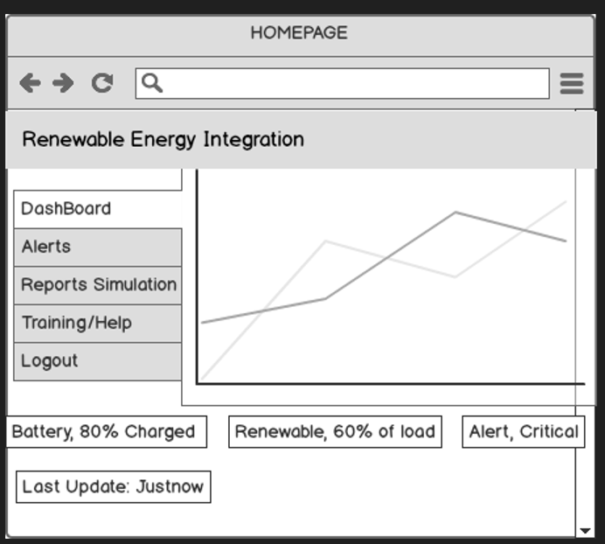

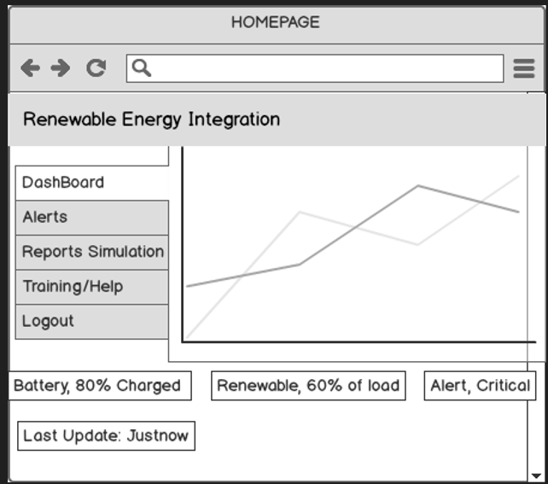
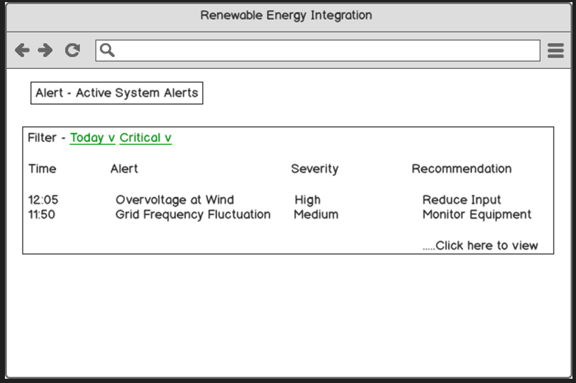

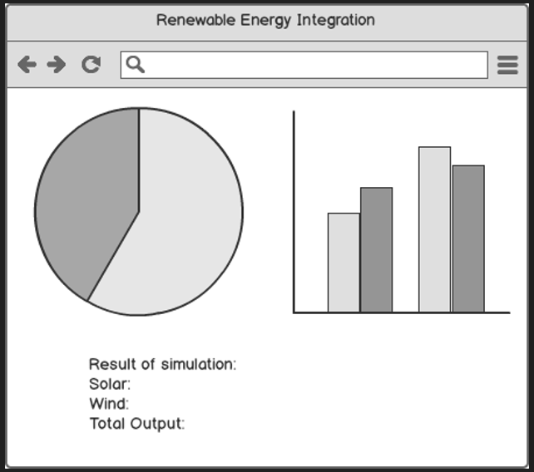
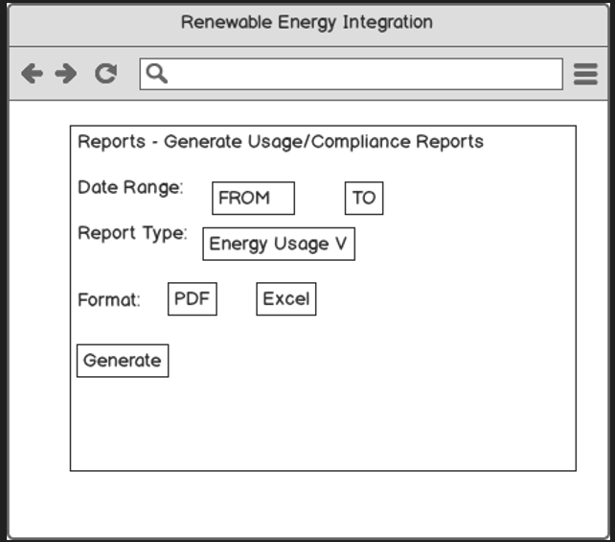

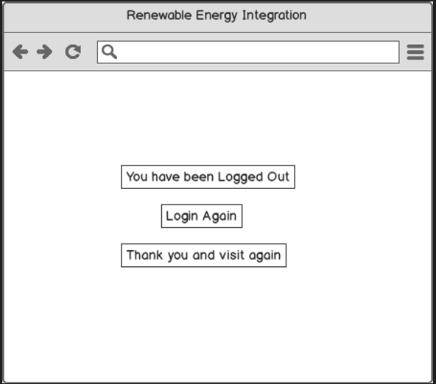

I used Microsoft Visio to draw clear diagrams that show how the new renewable-energy grid will work, and Balsamiq to sketch the web screens that operators will see. Visio helped me map the big ideas—like which parts collect solar power, where we store energy, and how alerts move through the system—so engineers could follow the flow easily. Balsamiq let me make quick, hand-drawn-style wireframes of the login page, real-time dashboard, alert list, and report screen, so managers could click through a simple mock-up and give feedback early. Using both tools kept the project on track: Visio explained the system logic, and Balsamiq showed the user journey.
- Visio: easy “drag-and-drop” shapes, good for big system diagrams, auto-align keeps drawings tidy.
- Balsamiq: fast to sketch screens, looks like a whiteboard, helps get quick approval.
- Benefit: everyone (engineers and managers) saw the same plan from back-end flow to front-end screens.
- Challenge: Visio diagrams can get busy; I grouped items to keep them readable.
- Outcome: fewer re-works and faster sign-off because visuals were clear and shared early.

