A company is having manufacturing plants and warehouses in various parts of the country. They manufacture ice-cream and milk products. They want to build software to achieve two goals.
• Manage the inventory
• Quickest delivery to the customers

Assignment 1

1. Please make a BRD which can be presented to the client along with complete development and resource plan.
A.
Project Title: VeroTrack
Client: XYZ Enterprise Ltd
Author: Srikar

1. Product Revision Documents
Version | Date | Description of Change | Approved by
0.1 | 21-Jun-2025 | Initial draft created | Chaitanya
0.2 | 25-June-2025 | Added functional requirements section | Prabhakar
0.3 | 27-June-2025 | Updated scope and assumptions | Nilgiri
0.4 | 29-June-2025 | Added development and resource plan | Mrudula
0.5 | 1-July- 2025 | Client feedback incorporated | Abhishek
0.1 | 6-July-2025 | Final version approved for release | Rushikesh

2. Approvals
Name | Role | Signature | Date
Morphues | Client Sponsor
Chaitanya | Project Manager
Srikar | Business Analyst
Jaykrishna | Technical Architect
Narayana | Development Lead
Nageshwar | QA lead
Neha | UI/UX Design Lead
Reddy
  Deployment & Support Lead

3. RACI Matrix
Activity | Client Sponsor | Project Manager | Business Analyst | Technical Architect | Development Lead | QA lead | UI/UX Design Lead | Deployment & Support Lead
 | A | R | R | C | C | I | I | I
  Requirements Gathering
 | A | R | R | C | C | I | I | I
  Scope Definition
 | C | A | C | R | I | I | R | I
  System Design
 | I | C | C | I | I | I | R | I
  UI/UX Prototyping
Development | I | A | C | C | R | I | C | I
Integration | I | A | C | R | R | C | I | I
Testing | I | C | I | C | C | R | I | I
Deployment | I | A | I | C | C | C | I | R
 | A | R | R | C | I | C | C | R
  User Training & Handover
 | A | I | I | I | I | I | I | R
  Post-Deployment Support

R = Responsible (does the work)
A = Accountable (final decision-maker, owns task)
C = Consulted (provides input)
I = Informed (kept up to date)
Table of Contents
- Executive Summary
- Business Objectives
- Current Challenges
- Scope of the Project
- Functional Requirements
- Non-Functional Requirements
- Assumptions and Constraints
- Development Plan
- Resource Plan
- Timeline / Milestones

1. Executive Summary
The company operates manufacturing plants and warehouses in various parts of the country, producing ice-cream and milk products. To improve operational efficiency, reduce wastage, and ensure customer satisfaction, the company seeks to develop software with two key goals:
- Efficient management of inventory across all locations.
- Quickest possible delivery to customers.
This document defines the business requirements and outlines the proposed development and resource plan for the project.

2. Business Objectives
- Optimize inventory levels to reduce overstocking, stockouts, and spoilage.
- Provide real-time visibility of inventory across manufacturing plants and warehouses.
- Plan and execute the fastest delivery routes to reach customers quickly and reliably.
- Improve customer satisfaction through timely and accurate deliveries.
- Enable data-driven decision making for production planning and logistics.

3. Current Challenges
- Lack of centralized, real-time inventory tracking.
- Manual processes leading to errors and delays.
- Inefficient delivery routing, causing longer delivery times.
- Spoilage of perishable products due to delays or poor stock rotation.
- Poor visibility into stock levels across multiple warehouses.

4. Scope of the Project
In Scope
- Inventory management module
- Delivery optimization module
- Centralized database
- User interface (web and/or mobile)
- Integration with existing systems (if applicable)
- Reporting and analytics dashboards
- User management and access control
Out of Scope
- Hardware procurement (e.g., handheld scanners)
- Third-party logistics contracting
- Changes to physical warehouse layouts

5. Functional Requirements
5.1 Inventory Management
- Track stock levels in real time across all locations.
- Record receipts, transfers, dispatches, and adjustments.
- Support batch/lot tracking and expiration dates.
- Generate alerts for low stock levels.
- Manage stock transfers between warehouses.
- Provide detailed inventory reports.
5.2 Delivery Optimization
- Capture and manage customer orders.
- Automatically suggest optimal delivery routes.
- Integrate with map/route APIs for real-time traffic data.
- Prioritize deliveries based on product perishability.
- Enable drivers to view routes and update delivery status.
- Generate delivery performance reports.
5.3 User Management
- Role-based access control (admin, warehouse staff, delivery team, etc.).
- Secure login and authentication.
5.4 Reporting & Analytics
- Inventory turnover reports.
- Stock aging and spoilage reports.
- Delivery time and efficiency metrics.
- Order fulfillment rate.

6. Non-Functional Requirements
- High system availability (99% uptime).
- Secure data storage and transmission (encryption).
- Responsive user interface (web/mobile).
- Scalable to support additional warehouses/plants.
- Integration-ready with ERP or accounting systems.
- User-friendly design with minimal training required.

7. Assumptions and Constraints
- Reliable internet connectivity at all warehouse and plant locations.
- Availability of delivery staff to use mobile apps or handheld devices.
- Accurate master data for products and locations.
- Budget and timeline approvals as per plan.

8. Development Plan
8.1 Phases
Phase | Description
Requirements Analysis
  Workshops with client teams to finalize requirements
System Design
  Architecture design, UI/UX mockups
Development
  Coding of modules (inventory, delivery, user management)
Integration & Testing
  Integration with maps/route APIs; system testing
User Acceptance Testing (UAT)
  Client validation and feedback
Deployment
  Rollout to production environment
Training & Handover
  User training and documentation handover
Support & Maintenance | Post-launch support and issue resolution

8.2 Development Methodology
- Agile methodology with 2-week sprints.
- Regular demos and feedback sessions with the client.
- Backlog and issue tracking in project management tools (e.g : Jira)
9. Resource Plan
9.1 Roles and Responsibilities
Role | Responsibilities
  Project Manager
  Overall project delivery, client communication
  Business Analyst
  Requirement gathering, documentation
  Solution Architect
  System design, technology selection
  Front-End Developer(s)
  User interface development
  Back-End Developer(s)
  Database and API development
  Mobile App Developer (optional)
  Mobile app development (if required)
  QA Engineer
  Test planning, execution, bug tracking
  DevOps Engineer
  Deployment, CI/CD setup
  Trainer/Documentation Specialist
  User training, manuals preparation

9.2 Estimated Duration
- Total project duration: ~16–20 weeks
- Team size: ~6–8 core resources (can be scaled as needed)
9.3 Technology Stack (Proposed)
- Front-end: React / Angular (Web), React Native / Flutter (Mobile)
- Back-end: Node.js / Java / Python
- Database: PostgreSQL / MySQL / MongoDB
- Mapping / Routing: Google Maps API / OpenStreetMap
- Hosting: AWS / Azure / GCP
10. Timeline / Milestones
Milestone | Timeline
  Requirements finalization
  Weeks 1–2
  Design completion
  Weeks 3–4
  Development Phase 1 (Inventory)
  Weeks 5–8
  Development Phase 2 (Delivery)
  Weeks 9–12
  Integration & Testing
  Weeks 13–15
  User Acceptance Testing (UAT)
  Weeks 16–17
Deployment
  Week 18
 | Week 19–20
  Training & Handover

2. Prepare process flow diagram using your imagination.
A. 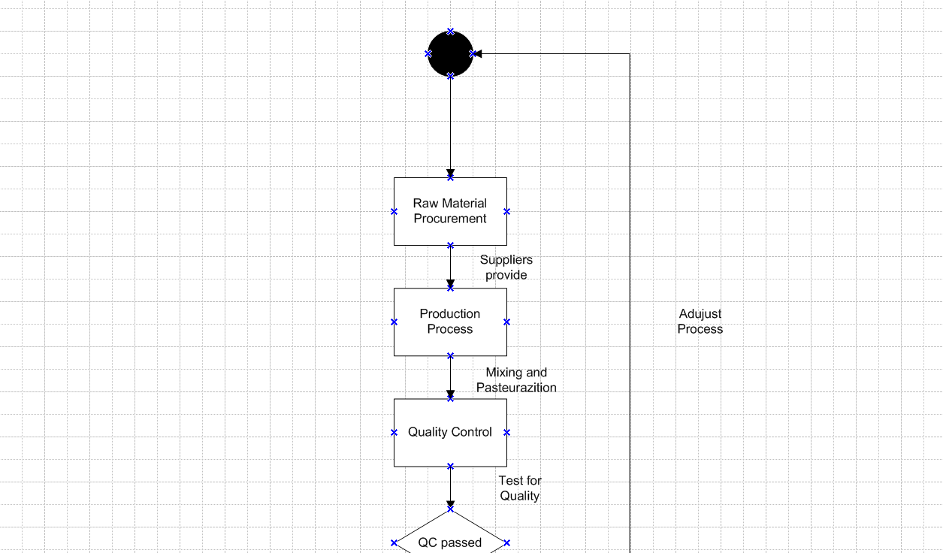
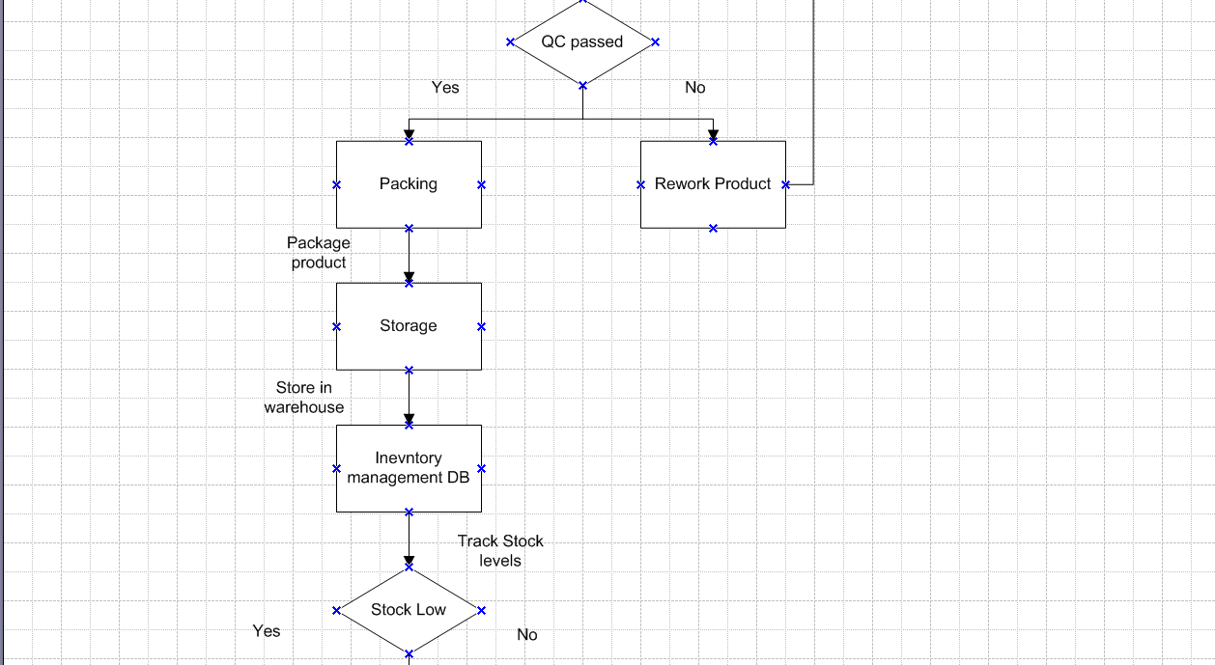
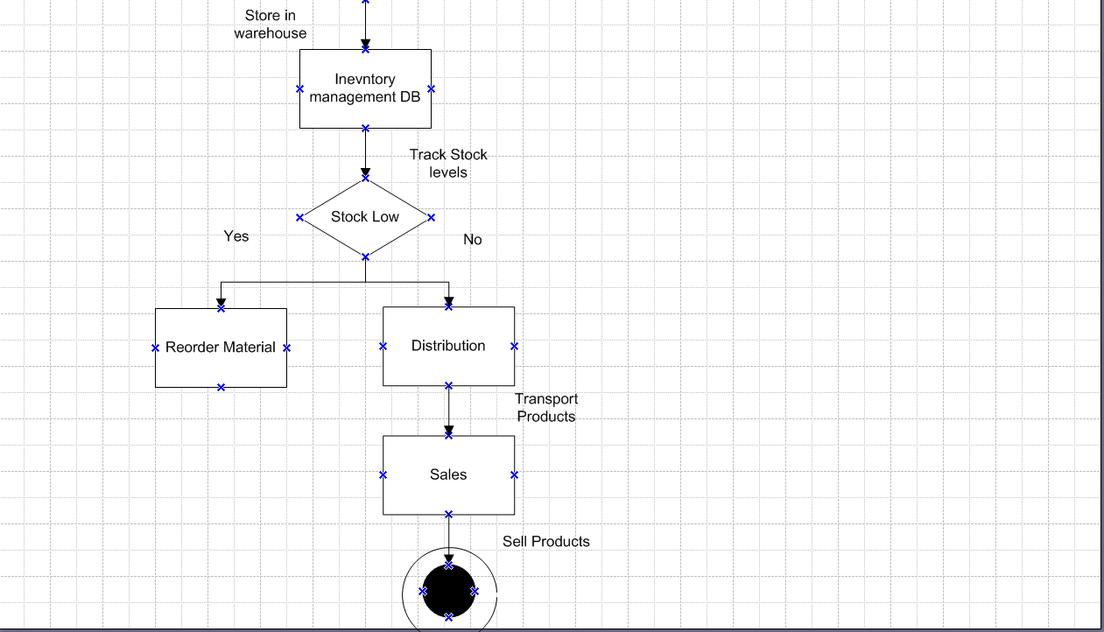

Assignment 2:
1. Write an introduction letter to a client introducing yourself as a business analyst in charge of working with the client and his team to start the business understanding process.
A.
Subject: Introduction – Business Analyst for VeroTrack

Dear XYZ Enterprise Limited,
I hope this message finds you well.
My name is Srikar, and I am the Business Analyst assigned to work with you and your team on the VeroTrack initiative.
I will be your primary point of contact for understanding your business needs, gathering requirements, and ensuring that our solution aligns fully with your goals. My role involves working closely with all relevant stakeholders to capture detailed business processes, challenges, and expectations so we can design and deliver a solution that drives measurable value for your organization.
As we begin the business understanding phase, I look forward to:
- Organizing collaborative workshops and interviews with your team
- Mapping existing processes and identifying pain points
- Defining and prioritizing key requirements and outcomes
- Documenting and validating requirements with all stakeholders
Our goal is to ensure absolute clarity and alignment between your vision and the solution we deliver.
Please feel free to share any materials, process documentation, or preliminary ideas you’d like us to consider at this stage. I will also be reaching out shortly to schedule our initial requirements workshop at your convenience.
Thank you for your time and collaboration. I look forward to working closely with you and your team to make this project a success.
If you have any questions or need any immediate clarification, please don’t hesitate to contact me directly.
Warm regards,
Srikar
Business Analyst
ABC Company
srikar@ba.com
+91 9999999999

2. Prepare a brief BRD and SRS for a project- Horoscope or Ticketing system or online store.
A.
BRD
Project Title: VeroTrack
Client: XYZ Enterprise Ltd
Author: Srikar

1. Product Revision Documents
Version | Date | Description of Change | Approved by
0.1 | 21-Jun-2025 | Initial draft created | Chaitanya
0.2 | 25-June-2025 | Added functional requirements section | Prabhakar
0.3 | 27-June-2025 | Updated scope and assumptions | Nilgiri
0.4 | 29-June-2025 | Added development and resource plan | Mrudula
0.5 | 1-July- 2025 | Client feedback incorporated | Abhishek
0.1 | 6-July-2025 | Final version approved for release | Rushikesh

2. Approvals
Name | Role | Signature | Date
Morphues | Client Sponsor
Chaitanya | Project Manager
Srikar | Business Analyst
Jaykrishna | Technical Architect
Narayana | Development Lead
Nageshwar | QA lead
Neha | UI/UX Design Lead
Reddy
  Deployment & Support Lead

3. RACI Matrix
Activity | Client Sponsor | Project Manager | Business Analyst | Technical Architect | Development Lead | QA lead | UI/UX Design Lead | Deployment & Support Lead
 | A | R | R | C | C | I | I | I
  Requirements Gathering
 | A | R | R | C | C | I | I | I
  Scope Definition
 | C | A | C | R | I | I | R | I
  System Design
 | I | C | C | I | I | I | R | I
  UI/UX Prototyping
Development | I | A | C | C | R | I | C | I
Integration | I | A | C | R | R | C | I | I
Testing | I | C | I | C | C | R | I | I
Deployment | I | A | I | C | C | C | I | R
 | A | R | R | C | I | C | C | R
  User Training & Handover
 | A | I | I | I | I | I | I | R
  Post-Deployment Support

R = Responsible (does the work)
A = Accountable (final decision-maker, owns task)
C = Consulted (provides input)
I = Informed (kept up to date)

Introduction
Project Goal
To design and develop an Online Store platform that allows customers to browse products, place orders online, and pay securely, while enabling the business to manage inventory and orders efficiently.

Background
The company currently sells products only through physical outlets. Customers are demanding online purchasing options. Competitors have online stores offering 24/7 convenience, better choice, and easy payment options.

Business Objectives
- Expand market reach and customer base.
- Offer seamless online shopping experience.
- Improve sales and revenue.
- Reduce manual order entry errors.
- Provide real-time inventory and order tracking.

Business Rules
- Only registered users can place orders.
- Payment must be confirmed before order processing.
- Orders cannot be modified after payment.
- Refunds processed as per company policy.
- Inventory levels updated in real-time after each sale.

Project Objectives
- Launch a user-friendly online store with core shopping features.
- Enable secure online payment processing.
- Provide an admin portal for order and product management.
- Integrate with payment gateway and email notification system.

Project Scope
In-Scope Functionalities
- User Registration and Login
- Product Catalog Management
- Shopping Cart
- Checkout and Payment Integration
- Order Management (Admin)
- Email Notifications

Out-of-Scope Functionalities
- Native Mobile Apps
- Multi-Vendor Marketplace
- Loyalty Programs / Coupons
- Advanced Analytics Dashboard

Assumptions
- Client will provide product images and descriptions.
- Payment gateway account and credentials will be available.
- Hosting and domain budget approved.

Constraints
- Limited development budget.
- Tight timeline (8–10 weeks).
- Dependence on third-party payment gateway.

Dependencies
- Payment gateway integration.
- Email service for notifications.
- Product data supplied by client.
Risks
Risk Category | Description
  Technological Risk
  Integration issues with payment gateway or hosting.
  Skill Risk
  Lack of specialized UI/UX design or payment integration expertise.
  Political Risk
  Regulatory changes in e-commerce or payment compliance.
  Business Risk
  Low customer adoption, competitive pricing pressures.
  Requirements Risk
  Scope creep, unclear requirements.
 | (Operational) Server downtime, data loss, delivery delays.
  Other Risk

Business Process Overview
Legacy System (AS-IS)
- Manual sales through physical store only.
- Orders recorded in notebooks or basic spreadsheets.
- No online visibility of inventory.
- Manual payment handling (cash/card in-store).

Proposed Recommendations (TO-BE)
- Online storefront accessible 24/7.
- Customer self-service for browsing and ordering.
- Integrated payment gateway for secure online payment.
- Automated email confirmations.
- Admin dashboard for managing products and orders.
- Real-time inventory updates.

Business Requirements
Sr. No | Requirement Name | Requirement Description | Priority
BR001 | Order Management | The system should allow customers to place, modify, and cancel orders online. | 9
BR002 | Real-Time Order Tracking | Customers and admins should be able to track the live status of orders and deliveries. | 10
BR003 | Inventory Visibility | Warehouses and manufacturing plants should have real-time access to stock levels. | 8
BR004 | Route Optimization | The system should suggest the fastest delivery route using traffic and location data. | 5
BR005 | Delivery Assignment | Orders should be automatically assigned to the nearest available delivery staff. | 6
BR006 | Centralized Dashboard | All departments should be able to view and manage operations from a single dashboard. | 6
BR007 | Notifications & Alerts | The system should send alerts for low stock, order status, and delivery delays. | 8
BR008 | Customer Feedback Collection | Customers should be able to rate and give feedback after receiving their order. | 4
BR009 | Secure Login and Access | The system should have secure login and different access levels for users and admins. | 3
BR010 | Reporting and Analytics | The system should generate reports on delivery time, sales, and order trends. | 1
Acronyms List
- ERP – Enterprise Resource Planning
- WMS – Warehouse Management System
- SLA – Service Level Agreement
- SKU – Stock Keeping Unit
- ETA – Estimated Time of Arrival
Glossary of Terms
- Supply Chain – The entire process of producing and delivering a product, from raw materials to customer delivery.
- Inventory – A complete list of goods and materials held in stock by a business.
- Dispatch – The process of sending goods from the warehouse to customers or other locations.
- Order Fulfillment – The steps involved in receiving, processing, and delivering customer orders.
- Real-Time Tracking – Monitoring goods or vehicles live as they move through the supply chain.

SRS (Functional and Non-functional requirements)
Project Name | VeroTrack
Customer Name | XYZ Pvt.Ltd
Project Version | 1.O QDSIMP
Project Sponsor | XYZ Pvt.Ltd
Project Manager | Chaitanya
Project initiated date | 01-06-2025

Functional Requirements
Req ID | Requirement Name | Requirement Description | Priority
FR001 | User Registration | The system should allow new users to register with email and phone number. | 10
FR002 | User Login | The system should allow users to log in with their registered credentials. | 8
FR003 | Product Browsing | Users should be able to browse ice-cream and milk products or horoscope/tickets online. | 8
FR004 | Add to Cart | Users should be able to add selected items or services to their cart. | 8
FR005 | Order Placement | Users should be able to place orders after selecting delivery address and payment method. | 9
FR006 | Order Tracking | Users should be able to track the status of their orders or tickets in real time. | 8
FR007 | Ticket Generation | System should allow users to create a support ticket with issue details. | 8
FR008 | Admin Dashboard | Admin should have a dashboard to manage users, orders, tickets, and reports. | 8
FR009 | Notifications | System should send SMS or email alerts for order confirmation and updates. | 8
FR010 | Feedback/Review System | Users should be able to give feedback or rate products/services. | 8
Non- Functional Requirements
Req ID | Requirement Name | Requirement Description
NFR001 | Performance | The system should respond within 2 seconds for user requests. | 9
NFR002 | Scalability | The system should support up to 1 million users at a time. | 10
NFR003 | Security | User data and payment information must be encrypted and secured. | 10
NFR004 | Availability | The system should be available 24/7 with 99.9% uptime. | 10
NFR005 | Usability | The interface should be simple and easy to use for all age groups. | 9
NFR006 | Compatibility | The system should work on desktops, tablets, and mobile phones. | 10
NFR007 | Maintainability | The system should be easy to update or fix without downtime. | 8
NFR008 | Localization | The system should support multiple languages depending on region. | 9
NFR009 | Backup and Recovery | The system should back up data daily and restore it in case of failure. | 10
NFR010 | Compliance | The system must follow data protection laws like GDPR or local IT laws. | 9

3. Make an ERD of creating a support ticket/Ticketing life cycle.
A. 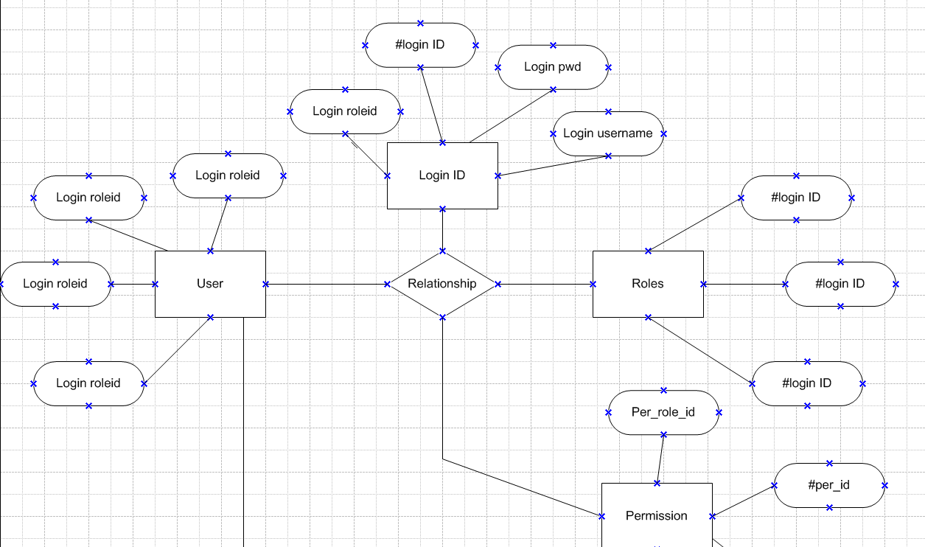
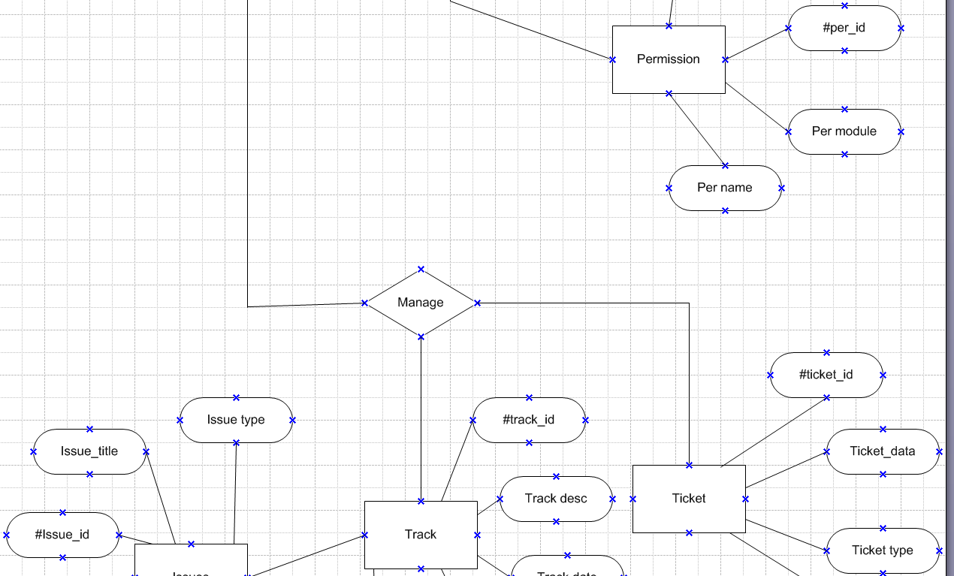
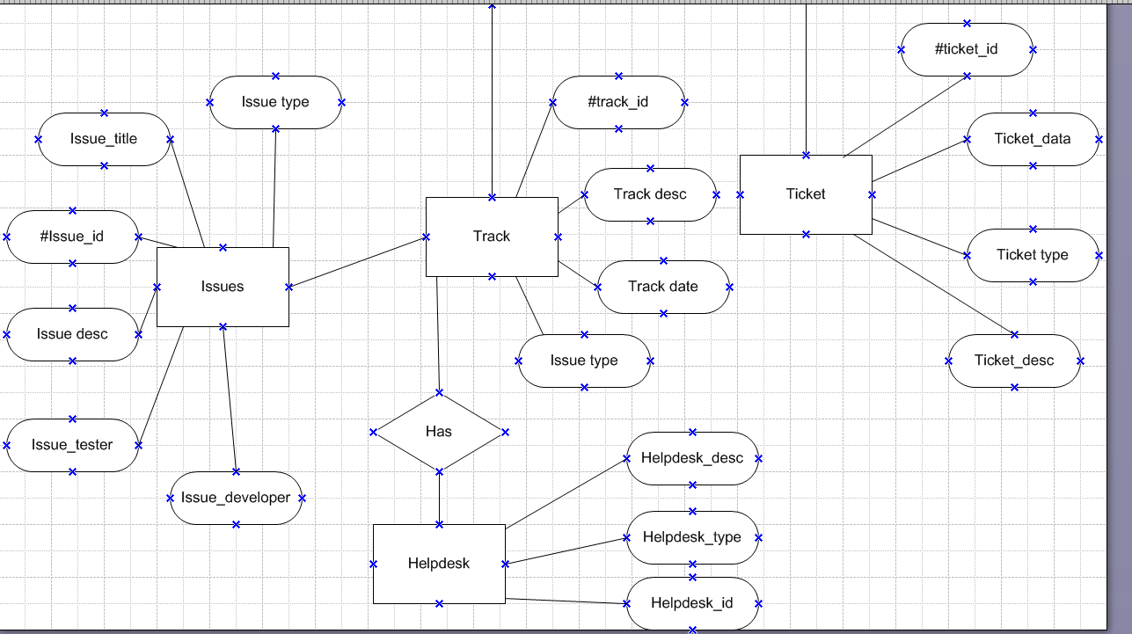

4. User story of shopping from ecommerce.
SPRINT 1
USER STORY- 1 | TASK 2 | PRIORITY : HIGHEST
As a shopper, I want to browse products by category so that I can easily find items that interest me.
BV - 100 | CP - 1
ACCEPTANCE CRITERIA:-Category list is displayed
User can select a category
Products related to the category are shown
SPRINT-1
USER STORY- 2 | TASK 2 | PRIORITY : HIGHEST
As a shopper, I want to search for products by name or keyword so that I can quickly locate specific items.
BV - 100 | CP - 1
ACCEPTANCE CRITERIA:-Search bar is available
User can enter keywords
Relevant products are displayed
SPRINT-1
USER STORY- 3 | TASK 2 | PRIORITY : HIGHEST
As a shopper, I want to filter products by price, brand, and rating so that I can narrow down my options.
BV - 50 | CP - 1
ACCEPTANCE CRITERIA:-Filter options for price, brand, and rating are available ,Selected filters update product list
SPRINT-1
USER STORY- 4 | TASK 2 | PRIORITY : HIGHEST
As a shopper, I want to sort products by price, popularity, or new arrivals so that I can view items in my preferred order.
BV - 100 | CP - 2
ACCEPTANCE CRITERIA:-Sorting options are available
Selected sort updates product list
SPRINT-1
USER STORY- 5 | TASK 2 | PRIORITY : HIGHEST
As a shopper, I want to view detailed product descriptions so that I can make informed purchase decisions
BV - 100 | CP - 3
ACCEPTANCE CRITERIA:-Product details page shows description, specs, and features
SPRINT-1
USER STORY- 6 | TASK 2 | PRIORITY : HIGHEST
As a shopper, I want to see multiple high-quality images of a product so that I can examine it from different angles
BV - 50 | CP - 3
ACCEPTANCE CRITERIA:-Product page displays image gallery
User can view images in larger size
SPRINT-1
USER STORY- 7 | TASK 2 | PRIORITY : HIGHEST
As a shopper, I want to read customer reviews and ratings so that I can understand other buyers’ experiences.
BV - 20 | CP - 6
ACCEPTANCE CRITERIA:-Product page displays reviews and ratings , Reviews are sorted by date or helpfulness
SPRINT-1
USER STORY- 8 | TASK 2 | PRIORITY : HIGHEST
As a shopper, I want to add products to my shopping cart so that I can purchase multiple items in one order.
BV - 100 | CP - 2
ACCEPTANCE CRITERIA:Add to cart button is present,
Cart updates with selected items
SPRINT-1
USER STORY- 9 | TASK 2 | PRIORITY : HIGHEST
As a shopper, I want to view and edit my shopping cart so that I can review and modify my selections before checkout.
BV - 50 | CP - 2
ACCEPTANCE CRITERIA:-Cart page lists all items,
User can update quantity or remove items
SPRINT-1
USER STORY- 10 | TASK 2 | PRIORITY : HIGHEST
As a shopper, I want to update the quantity of items in my cart so that I can buy the exact amount I need.
BV - 100 | CP - 2
ACCEPTANCE CRITERIA:-Quantity selector is available
Cart total updates accordingly
SPRINT-1
USER STORY- 11 | TASK 2 | PRIORITY : HIGHEST
As a shopper, I want to remove items from my cart so that I can change my mind before purchasing.
BV - 100 | CP - 6
ACCEPTANCE CRITERIA:-Remove option is present for each cart item , Cart updates after removal
SPRINT-1
USER STORY- 12 | TASK 2 | PRIORITY : HIGHEST
As a shopper, I want to save products to a wishlist so that I can easily find and buy them later
BV - 20 | CP - 3
ACCEPTANCE CRITERIA:Wishlist button on product page,
Wishlist page displays saved items
SPRINT-1
USER STORY- 13 | TASK 2 | PRIORITY : HIGHEST
As a shopper, I want to apply discount codes or coupons so that I can save money on my purchase.
BV - 100 | CP - 2
ACCEPTANCE CRITERIA:Coupon field at checkout
Discount applied to total if code is valid
SPRINT-1
USER STORY- 14 | TASK 2 | PRIORITY : HIGHEST
As a shopper, I want to see estimated delivery dates so that I know when to expect my order.
BV - 200 | CP - 6
ACCEPTANCE CRITERIA:Estimated delivery shown on product and checkout pages
SPRINT-1
USER STORY- 15 | TASK 2 | PRIORITY : HIGHEST
As a shopper, I want to choose from multiple payment options so that I can pay in the way that suits me best.
BV - 100 | CP - 3
ACCEPTANCE CRITERIA:Payment page lists all supported methods , User can select and use any method
SPRINT-1
USER STORY- 16 | TASK 2 | PRIORITY : HIGHEST
As a shopper, I want to securely save my payment information so that I can check out faster next time.
BV - 50 | CP - 3
ACCEPTANCE CRITERIA:Option to save payment details
Data is securely stored and encrypted
SPRINT-1
USER STORY- 17 | TASK 2 | PRIORITY : HIGHEST
As a shopper, I want to enter and save multiple shipping addresses so that I can ship to different locations.
BV - 100 | CP - 2
ACCEPTANCE CRITERIA:Address book in user profile
Option to add/edit/delete addresses
SPRINT-1
USER STORY- 18 | TASK 2 | PRIORITY : HIGHEST
As a shopper, I want to receive email or SMS notifications about my order so that I stay updated on its status
BV - 100 | CP - 3
ACCEPTANCE CRITERIA:Notifications sent on order, shipping, and delivery
SPRINT-1
USER STORY- 19 | TASK 2 | PRIORITY : HIGHEST
As a shopper, I want to view my order history so that I can reorder or reference previous purchases
BV - 50 | CP - 3
ACCEPTANCE CRITERIA:Order history page in account
Details of each past order
SPRINT-1
USER STORY- 20 | TASK 2 | PRIORITY : HIGHEST
As a shopper, I want to cancel an order before it ships so that I can change my mind.
BV - 20 | CP - 2
ACCEPTANCE CRITERIA:Cancel option available until dispatch, Order status updates after cancellation
SPRINT-1
USER STORY- 21 | TASK 2 | PRIORITY : HIGHEST
As a shopper, I want to initiate a return or exchange so that I can resolve issues with my purchase.
BV - 100 | CP - 3
ACCEPTANCE CRITERIA:Return/exchange option for eligible orders , Confirmation and instructions provided
SPRINT-1
USER STORY- 22 | TASK 2 | PRIORITY : HIGHEST
As a shopper, I want to receive a refund to my original payment method so that I am compensated for returned items
BV - 200 | CP - 6
ACCEPTANCE CRITERIA:Refund processed after return approval Status visible in order history
SPRINT-1
USER STORY- 23 | TASK 2 | PRIORITY : HIGHEST
As a shopper, I want to share product links with friends or family so that I can get their opinions or recommend items.
BV - 100 | CP - 1
ACCEPTANCE CRITERIA:Share button on product pages ,
Options for social media and messaging
SPRINT-1
USER STORY- 24 | TASK 2 | PRIORITY : HIGHEST
As a shopper, I want to subscribe to newsletters so that I can receive updates on new arrivals and special offers
BV - 50 | CP - 1
ACCEPTANCE CRITERIA:Newsletter signup form Confirmation email sent
SPRINT-1
USER STORY- 25 | TASK 2 | PRIORITY : HIGHEST
As a shopper, I want to buy gift cards so that I can give them to others as presents
BV - 20 | CP - 3
ACCEPTANCE CRITERIA:Gift card product available, Customizable value and message
SPRINT-1
USER STORY- 26 | TASK 2 | PRIORITY : HIGHEST
As a shopper, I want to redeem gift cards during checkout so that I can use them for purchases
BV - 50 | CP - 3
ACCEPTANCE CRITERIA:Gift card field at checkout, Balance applied to order total
SPRINT-1
USER STORY- 27 | TASK 2 | PRIORITY : HIGHEST
(As a shopper, I want to view detailed size charts for apparel and shoes so that I can choose the correct size
BV - 50 | CP - 3
ACCEPTANCE CRITERIA:Size chart link on product pages
Chart matches product type
SPRINT-1
USER STORY- 28 | TASK 2 | PRIORITY : HIGHEST
As a shopper, I want to see related products or frequently bought together items so that I can find complementary products.
BV - 100 | CP - 6
ACCEPTANCE CRITERIA: Related items displayed on product page
SPRINT-1
USER STORY- 29 | TASK 2 | PRIORITY : HIGHEST
As a shopper, I want to check product availability in my location so that I can avoid ordering out-of-stock items
BV - 50 | CP - 2
ACCEPTANCE CRITERIA: Availability check by pincode or location , Out-of-stock notice shown
SPRINT-1
USER STORY- 30 | TASK 2 | PRIORITY : HIGHEST
As a shopper, I want to schedule my delivery date and time so that I can receive my order when it’s convenient for me
BV - 50 | CP - 2
ACCEPTANCE CRITERIA: Delivery slot selection at checkout
Confirmation of chosen slot
SPRINT-1
USER STORY- 31 | TASK 2 | PRIORITY : HIGHEST
As a shopper, I want to receive invoices and payment receipts so that I have proof of purchase.
BV - 100 | CP - 2
ACCEPTANCE CRITERIA: Invoice sent via email and downloadable from order history
SPRINT-1
USER STORY- 32 | TASK 2 | PRIORITY : HIGHEST
As a shopper, I want to receive invoices and payment receipts so that I have proof of purchase.
BV - 100 | CP - 3
ACCEPTANCE CRITERIA: Review form available for purchased items, Ratings and comments saved
SPRINT-1
USER STORY- 33 | TASK 2 | PRIORITY : HIGHEST
As a shopper, I want to use a mobile-friendly website or app so that I can shop easily from my phone.
BV - 100 | CP - 2
ACCEPTANCE CRITERIA: Responsive design for all pages, App available for download
SPRINT-1
USER STORY- 34 | TASK 2 | PRIORITY : HIGHEST
As a shopper, I want to receive alerts for price drops on wishlist items so that I can buy them at the best price.
BV - 50 | CP - 3
ACCEPTANCE CRITERIA: Notification sent when wishlist item price decreases
SPRINT-1
USER STORY- 35 | TASK 2 | PRIORITY : HIGHEST
As a shopper, I want to view and update my account details so that my information is always accurate.
BV - 100 | CP - 2
ACCEPTANCE CRITERIA: Profile page for viewing and editing user info
SPRINT-1
USER STORY- 36 | TASK 2 | PRIORITY : HIGHEST
As a shopper, I want to shop in my preferred language and currency so that I have a comfortable shopping experience.
BV - 50 | CP - 5
ACCEPTANCE CRITERIA: Option to select language and currency , All pages and prices update accordingly

SPRINT-1
USER STORY- 37 | TASK 2 | PRIORITY : HIGHEST
As a shopper, I want to receive email or SMS notifications about my order so that I stay updated on its status
BV - 50 | CP - 2
ACCEPTANCE CRITERIA: Notifications sent on order, shipping, and delivery
SPRINT-1
USER STORY- 38 | TASK 2 | PRIORITY : HIGHEST
As a shopper, I want to contact customer support so that I can get help with my orders or products.
BV - 100 | CP - 1
ACCEPTANCE CRITERIA: Support contact options visible , Ticket or chat system available
SPRINT-1
USER STORY- 39 | TASK 2 | PRIORITY : HIGHEST
As a shopper, I want to share product links with friends or family so that I can get their opinions or recommend items.
BV - 50 | CP - 2
ACCEPTANCE CRITERIA: Share button on product pages, Options for social media and messaging
SPRINT-1
USER STORY- 40 | TASK 2 | PRIORITY : HIGHEST
As a shopper, I want to Save my payment method securely so that I have a fast but and secure payment experience.
BV - 20 | CP - 1
ACCEPTANCE CRITERIA: Option to select language and currency , All pages and prices update accordingly

