LIVE PROJECT IDENTIFICATION

WATERFALL PROJECT

QUESTION-1 Business Case Document Template.

- Why is this project initiated?

- Addressing the current Users challenges.

- Supporting the CSR goals.

- Improving technology for Provider Management.

2) What are the current problems?
1- Manual data entry
2- Delayed Updates
3-Compliance Risks

4- Communication Gaps

- With this project how many problems could be saved?

- Manual Data Entry

- Delayed Updates

- Communication Gaps

- Compliance Risks

- Poor Searchability

- What are the sources required?

1-Human Resources
2- Compliance & Security
3 Development Costs
4- Infrastructure Costs
5- Marketing & Launch
6-Legal & Compliance
- What are the changes to adopt this technology?

Organizational Changes
- Digital Mindset Shift: Encourage staff to embrace digital workflows over
manual processes.

- Leadership Buy-In: Secure support from senior management to

prioritize adoption and allocate resources.
Process Transformation
- Standardize Provider Data Collection: Create uniform templates for

provider details and credentials.

- Automate Approval Workflows: Replace manual review with digital

dashboards and notifications.

- Onboarding Protocols: Update onboarding procedures to include digital

profile setup.

Infrastructure & IT Changes
- Integration Planning: Prepare for future integration with EMR, HR, or
scheduling systems.
- Security Enhancements: Implement encryption, access controls, and
audit trails to meet compliance standards.
Training & Support
- Staff Training: Conduct workshops for providers and admins on how to

use the tool.
- Helpdesk Setup: Establish a support system for troubleshooting and user
assistance.
- Documentation: Provide user manuals, FAQs, and video tutorials.

5.Data Governance
- Data Quality Checks: Introduce validation rules to ensure accuracy and
completeness.

- Compliance Monitoring: Regular audits to ensure HIPAA/GDPR
compliance.
- Role-Based Access: Define who can view, edit, or approve provider data.

6. Communication & Change Management
- Internal Campaigns: Promote the benefits of the tool across
departments.

- Feedback Loops: Create channels for users to suggest improvements or
report issues.

- What is the time frame to recover ROI?

- ROI Return on Investments depends on the initial investments,

Operating costs.

Around 2.5 to 3 years it can be recovered if the adoption is

faster. If its low it might take 3 to 4 years.

7)How to identify the stake holders?

Identifying the stake holders are done by using RACI

Matrix (Responsible, Accountable, Consulted, Informed)

Document 2: BA Strategy

Business Analyst Approach Strategy

Initiation & Planning
Understand Business Objectives

  - Review business case, goals, KPIs

  - Identify scope boundaries

Stakeholder Analysis

  - Use RACI Matrix

  - Categorize stakeholders by role, influence, and decision power

Elicitation Techniques

Technique
Interviews
Document Analysis
Workshops
Surveys/Questionnaires
Observation
Prototyping

3. Documentation to Prepare
Document Type | Purpose
Business Requirements Document (BRD) | High-level business needs
Functional Requirements Document (FRD) | Detailed system behaviour
Use Case & User Stories | Agile-friendly requirement breakdown
Process Flow Diagrams / DFDs | Visualize system interactions
ER Diagrams / Data Models | Define data structure and relationships
Traceability Matrix | Map requirements to test cases
Change Request Log | Track scope changes

Sign-Off & Approval Process
Internal Review: Circulate drafts for feedback

Client Review: Present documents in walkthrough sessions

Formal Sign-Off:
Use e-signature tools or approval emails
Attach sign-off sheet with version control

5. Communication Channels
Channel | Purpose
Email | Formal updates, approvals
Slack/Teams | Daily coordination, quick queries
Jira/Confluence | Requirement tracking, documentation
Weekly Reports | Progress updates to stakeholders
Workshops/Demos | Stakeholder alignment

6. Handling Change Requests
- Log request in Change Request Tracker

- Analyse impact on scope, timeline, cost

- Update documentation and notify teams

7. Progress Reporting
- Use Burndown Charts, Sprint Reports, or Dashboard KPIs

Share updates via:

Weekly stakeholder emails

Sprint review meetings

Monthly executive summaries

8. UAT & Client Acceptance
Prepare UAT Test Cases mapped to requirements

Coordinate UAT sessions with client

Capture feedback and defects

Finalize Client Project Acceptance For

Include sign-off, version, and scope confirmation

Document 3- Functional Specifications

Fields | Details
Project Name  Customer Name  Project Version  Project Sponsor  Project Manager  Project Initiation Date | First source Provider Management Tool  Sangeetha  V.22  Krithika  Riya  04-10-2026

Functional Requirement specifications:
Requirement  ID | Requirement Name | Description | Priority
BR 001 | Login | Users should be able to login | 9
BR 002 | Upload Inventory | Uploading Provider Information | 8
BR 003 | View Inventory | Current Inventory Levels | 10
BR 004 | Add Inventory Item | Add New provider Information in the portal | 6
BR 005 | Update the Inventory | Update the details of the providers and their licenses | 9
BR 006 | Notifications | Email Alerts | 8
BR 007 | Delete the Inventory | Delete an item from the Inventory | 7
BR 008 | Search The details | Able to search the details of the provider | 10
BR 009 | Generate the payments | Able to do accurate payments to the providers | 7
BR 10 | Local Language | Multilingual Support | 6

Document 4- Requirement Traceability Matrix
A business analyst’s key responsibilities are to keep track of the

requirements and make sure that no requirement is missed.

RTM- RTM stands for Requirement Traceability Matrix.

It is a document to track the requirements throughout the project

lifecycle, ensuring that they are met and that no requirements are over

looked.

Requirement ID | Requirement Name | Requirement  Description | Design | D1 | T1 | D2 | T2 | UAT
FR001 | Enable login page | Enable secure access to the system | Complete | Complete | Complete | Complete | Incomplete | Incomplete
FR 002 | Provider Form, Validation | System should allow users to create and validate provider profiles | Complete | Complete | Incomplete | Complete | Complete | In complete
FR003 | Automate provider payment calculation | System should calculate provider payments based on contract terms | Complete | Incomplete | Incomplete | Incomplete | Incomplete | Incomplete
FR004 | Provide real-time dashboards and reporting | System should display dashboards for provider status and payment | Complete | Complete | Complete | Complete | Complete | Complete

Document 5- BRD Template

<Project Name >
<Project ID>
<Version ID>
<Author>

Document Revisions .............................................................................................................8
2. Approvals .............................................................................................................................8
3. RASCI Chart for This Document ............................................................................................8
Codes Used in RASCI Chart ...................................................................................................9
RASCI Chart ..........................................................................................................................9
4. Introduction .........................................................................................................................9
4.1. Business Goals ..............................................................................................................9
4.2. Business Objectives .......................................................................................................9
4.3. Business Rules ............................................................................................................. 10
4.4. Background ................................................................................................................. 10
4.5. Project Objective......................................................................................................... 10
4.6. Project Scope .............................................................................................................. 10
4.6.1. In Scope Functionality .......................................................................................... 10
4.6.2. Out Scope Functionality ....................................................................................... 10
5. Assumptions ...................................................................................................................... 10
6. Constraints ......................................................................................................................... 10
7. Risks ................................................................................................................................... 10

Technological Risks ................................................................................................................ 11
Skills Risks .............................................................................................................................. 11
Political Risks ......................................................................................................................... 11
Business Risks ........................................................................................................................ 11
Requirements Risks ............................................................................................................... 11
Other Risks ............................................................................................................................ 1
8. Business Process Overview ................................................................................................ 11
8.1. Legacy System (AS-IS) .................................................................................................. 11
8.2. Proposed Recommendations (TO-BE) ......................................................................... 11
9. Business Requirements ...................................................................................................... 11
10. Appendices ..................................................................................................................... 12
10.1. List of Acronyms ...................................................................................................... 12
10.2. Glossary of Terms .................................................................................................... 12
10.3. Related Documents ................................................................................................. 12

    - Document Revisions

DATE | VERSION NO | DOCUMENT CHANGES
04-10-2025  07-10-2025  10-10-2025  15-10-2025  20-10-2025  25-10-2025 | 0.1  1.1  1.2  1.3  1.4  1.5 | Initial draft – Defined project scope, objectives, and stake holders’ roles.  Added detailed provider data fields (contact details).  Incorporated feedback from finance team on payment workflows.  Finalized requirements document for development handoff.  Included test cases for provider data accuracy and payment triggers.  Revised based on UAT feedback: streamlined approval flow.
2. Approvals

ROLE | NAME | TITLE | SIGNATURE | DATE
Project Sponsor  Business Owner  Project Manager  System Architect  Development Lead | Sangeetha  Manisha  Meera  Viranshu  Salar | Business Analyst  Product Manager  Finance Lead  IT delivery Manger  Compliance Officer | Sangeetha  Manisha  Meera  Viranshu  Salar | 04-10-2025  05-10-2025  07-10-2025  10-10-2025  15-10-2025
3 – RACI MATRIX

The RACI chart identifies the persons who need to be

contacted whenever changes are made to this document.

RACI stands for responsible, accountable, consulted, and

informed. These are the main codes that appear in a RACI

chart, used here to describe the roles played by team

members and stakeholders in the production of the BRD.

They are adapted from charts used to assign roles and

responsibilities during a project. (RACI Can be made for IT

side [Project stakeholder] as mentioned above, apart from

that Can also Be made for Client side [Business Stakeholder]).

NAME | POSITON | * | R | A | S | C | I
Provider Master Table  Provider Master table  Payment Trigger Table  Payment Quality Lead | Business Analyst  Product owner  IT developer  QA Lead | * | 
4. Introduction
4.1 Business Goals

The primary objective of this initiative is to enhance the
digital platform used for managing provider information,
with a focus on improving data accuracy, streamlining
workflows, and ensuring timely payments. This aligns with
the broader organizational goals and operational needs as
outlined below:
  - Improve Organisation Efficiency

  - Ensure Timely Payments to the providers

  - Boosting stake holders Confidence

  - Enhancing Data Quality and Governance

Business Needs –

• A centralized digital repository for provider master data.
• Real-time integration with finance and payment systems.
• Role-based access control for data entry, approval, and audit.
• Automated alerts for missing or outdated provider information.

4.2 Business Objectives
Business Objectives for Mobile LMS (Android & iOS)
  - Expand Access to Learning

  - Enhance Learning Experience

  - Streamline Course Delivery

  - Support Multilingual and Inclusive Learning.

  - Generate Revenue and Insights.
4.3
Business Rules
[List Organization Policies, Procedures]

Organisational Policies-
Data Privacy Policy
Information Security Policy
Acceptance Policy
Management Policy

Procedures -
User Onboarding Procedure
Assessment and Grading Procedure
Payment Procedure
Feedback and support Procedure

Rules and Regulations –
Code of Conduct
Copy Right Compliance
Age Restrictions

4.4 Background

Origin of the Proposal
The project was proposed following a strategic review of
current operations and customer feedback, which revealed
inefficiencies in service delivery and data fragmentation
across platforms. Stakeholders from operations, customer
support, and IT flagged recurring issues that were impacting
user experience and business performance.
- Business Issues Identified.

- Expected Benefits of Implementation

- Limited Visibility

- Customer Complaints

Expected Benefits
- Unified Platform

- Automation

- Improved Data Accuracy

- Scalability

Project Objective

The primary objective of this project is to develop a unified

digital platform that streamlines customer engagement,

order management, and backend operations for improved

business efficiency and user experience. The product will

serve as a scalable, modular solution that integrates

seamlessly with existing systems while addressing current

operational bottlenecks.

Project Scope

In the current project, we are developing a centralized digital
platform that streamlines customer interactions, order
management, and backend operations. The solution is
designed to enhance user experience, improve operational
efficiency, and support scalable business growth.

In Scope Functionality

- Search the provider

- Tracking the details

- Payment Gateway Integration

- Dashboard & Reporting

- Notification System

- Inventory Management

- API Integration Layer

- Admin Panel

- UAT & Feedback Capture.

- Change Request Logging

Out Scope Functionality
Multi-language Support

AI-Based Recommendation Engine

Advanced Loyalty or Rewards Program

Multi-Tenant Architecture

Constraints
Fixed Timelines
Limited Budget
Resource Availability
Technology
Change Management Process
Data Migration Scope

Risks
A risk is something that could affect the success or
failure of a project. Analyse risks regularly as the
project progresses. While you may not be able to avoid
every risk, you can limit each risk’s impact on the
project by preparing for it beforehand. For each risk,
you’ll note the likelihood of its occurrence, the cost
the project if it does occur, and the strategy for
handling the risk.

• Avoid: Don’t store unnecessary personal data.
• Mitigate: Implement encryption, access controls, and
regular security audits.
• Transfer: Use third-party cybersecurity services with
liability coverage.
• Accept: Accept minor risks for low-sensitivity data with
proper monitoring.

Technological Risks
System Downtime or Outages
Integration Failures
Scalability Limitations
Data Loss or Corruption

Requirements Risks

Incomplete or Ambiguous Requirements
Incomplete or Ambiguous Requirements (Scope Creep)
Lack of End-User Involvement

Other Risks

Organizational Change Resistance
Vendor Reliability and Dependency
Legal and Intellectual Property Risks

Business Process Overview
This section describes the overall process flow across each
phase of the digital insurance claims and provider
management system. It ensures clarity for stakeholders,
developers, and analysts by mapping how data and actions
move through the system.

Initiation Phase
Provider Details Management Phase
Claim Submission Phase
Resolution and Payment Phase

Legacy System (AS-IS)
Legacy systems in U.S. healthcare payment processing are often fragmented, manual, and paper-based, leading to delays, errors, and inefficiencies. Here's how the process typically works:
Patient Visit
- Provider delivers care and documents services.
Manual Coding
- Medical coders assign ICD/CPT codes manually.
• Claim Creation
- Claims are created using outdated software or paper forms.
• Claim Submission
- Claims are submitted via fax, mail, or legacy clearinghouses.
• Payer Review
- Insurance companies manually review claims.
• Payment Decision
- Claims are approved, denied, or returned for correction.
• Remittance Advice

- Providers receive paper-based remittance notices.
• Reconciliation
- Staff manually reconcile payments with services rendered.

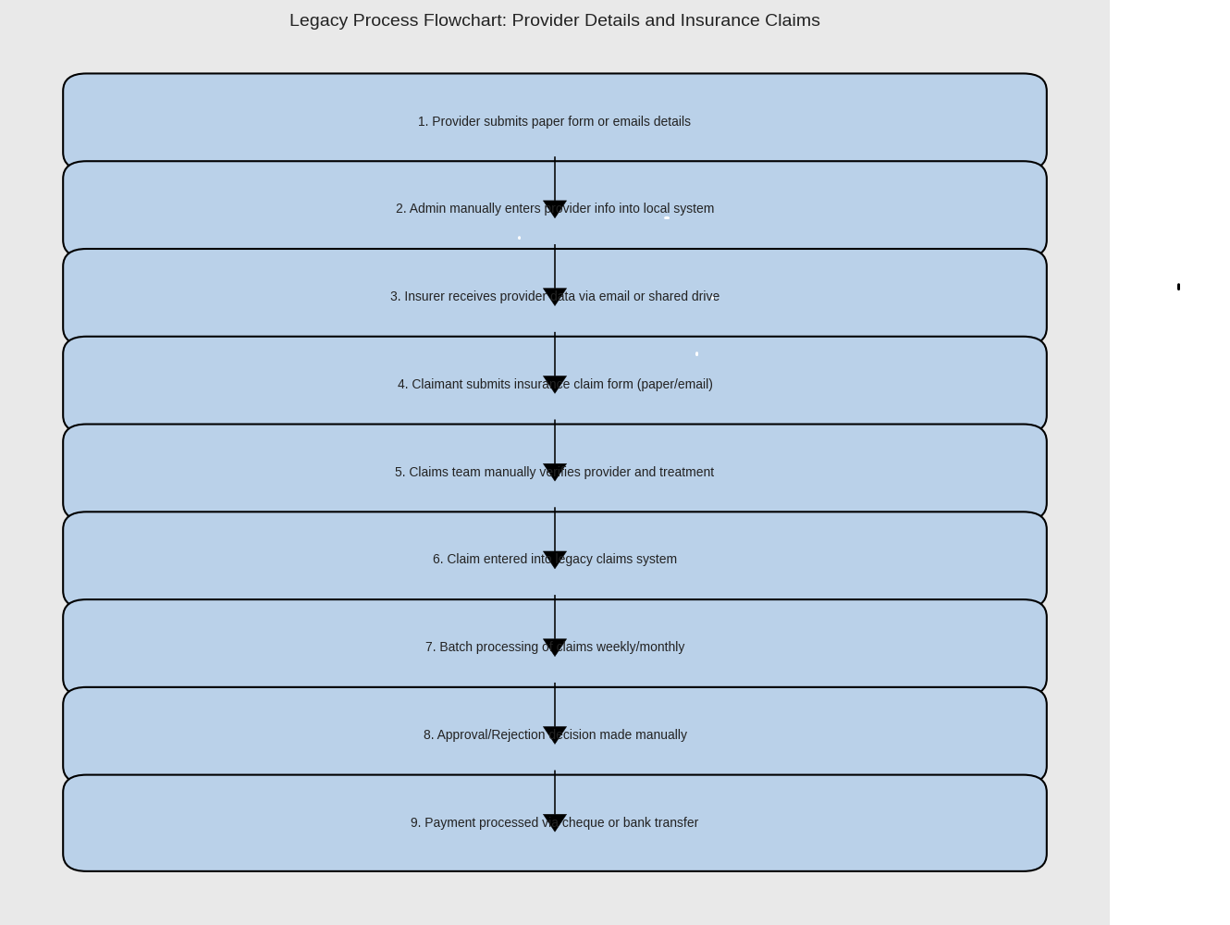

Proposed Recommendations (TO-BE)
• HIPAA-compliant data handling
• Integration with EHR systems
•Real-time claim tracking
• Dashboard for reconciliation and analytics
• AI-powered coding and error detection
• Secure API-based claim submission
• Automated remittance and payment alerts

Faster payment cycles → Improved provider satisfaction
Lower operational costs → Reduced manual intervention
Improved compliance → Adherence to HIPAA, CMS, and
payer regulations
Scalability → Easily onboard new providers and adapt to
policy changes
9. Business Requirements
Functional Requirements

These describe what the system must do:
- Provider Onboarding
  - Capture provider credentials, contracts, and

payment preferences.

  - Validate against NPPES and CAQH databases.

- Claims Submission & Adjudication

  - Accept claims in X12 837 format.

  - Apply payer-specific adjudication rules.

  - Flag incomplete or erroneous claims for correction.

- Payment Processing

  - Automate EFT and check disbursement.

  - Support multiple payment cycles (weekly, bi-

weekly, monthly).

  - Generate 835 remittance advice for reconciliation.

- Dispute Resolution

  - Enable providers to raise payment disputes.

  - Track resolution status and provide audit trail.

- Reporting & Analytics

  - Dashboards for payment trends, denial rates, and

turnaround times.

  - Exportable reports for compliance and audits.

- User Roles & Access

  - Role-based access for payers, providers, and

admins.

Secure login with MFA and audit logging
.

Non-Functional Requirements

These define system qualities:
Performance

  - Process 10,000+ claims per hour with <2s response

time.

- Scalability

  - Support onboarding of 1000+ new providers per

month.

- Security

  - HIPAA-compliant encryption for data at rest and in

transit.

  - Role-based access control and audit logging.

- Availability

  - 99.9% uptime with disaster recovery and failover

support.

- Interoperability

  - FHIR and HL7 support for integration with EMRs

  - and clearinghouses.

Regulatory & Compliance Requirements

  - HIPAA for privacy and security.

  - CMS guidelines for Medicare/Medicaid payments.

  - CAQH CORE operating rules for EFT and ERA.

4. Key Stakeholders
- Providers: Physicians, hospitals, clinics

- Payers: Insurance companies, Medicare/Medicaid

- Clearinghouses: Data intermediaries

- IT & Compliance Teams: Platform governance

Acronym | Full Form
HIPAA | Health Insurance Portability and Accountability Act
CMS | Centers for Medicare & Medicaid Services
EFT | Electronic Funds Transfer
ERA | Electronic Remittance Advice
EDI | Electronic Data Interchange
FHIR | Fast Healthcare Interoperability Resources
NPPES | National Plan and Provider Enumeration System
CAQH | Council for Affordable Quality Healthcare
BRD | Business Requirements Document
TAT | Turnaround Time
MFA | Multi-Factor Authentication

10.2 Glossary of Terms
Term | Definition
Provider | A healthcare professional or organization delivering medical services (e.g., physician, hospital).
Payer | An entity responsible for reimbursing providers for healthcare services (e.g., insurance company, CMS).
Claim | A formal request for payment submitted by a provider to a payer for services rendered.
Adjudication | The process by which a payer reviews and determines the validity and reimbursement of a claim.
Remittance Advice | A document detailing the payment made to a provider, including any adjustments or denials.
Clearinghouse | A third-party intermediary that facilitates the exchange of healthcare data between providers and payers.
Smart Contract | A digital agreement that automatically enforces payment terms based on predefined rules.
Interoperability | The ability of different systems and organizations to exchange and use healthcare data seamlessly.

10.3 Related Documents
- Provider Payment Platform Architecture Overview

- HIPAA Compliance Checklist

- CMS Payment Guidelines (Latest Edition)

- CAQH CORE Operating Rules for EFT & ERA

- User Journey Maps for Provider Portal

- SLA Agreement for Payment Processing

- Stakeholder Analysis & Engagement Plan

