CAPSTONE PROJECT 3

Question 1: Use Case Diagram

Use Case Specification
Use Case Name: Payment application
Description: The use case describes how the bank customer uses the interface to make payment
Actors: Customer, Server
Precondition: 1. Active Internet connection, Active Bank account
Post Condition: Payment successful page to be displayed
Basic Flow: Payment details are correct and payment is done successfully
Alternate Flow:
- Netbanking details are wrong
- UPI Details are wrong
- Card details are wrong
Exceptional Flow:
Assumptions: User has all the payment details handy
Constraints:
Dependencies: Product is added to cart, account is logged in
Input-Outputs: Input- Banking details
Output- Status flag, error
Business Rules-
Mis info

Question 2 Boundary Classes, Controller classes, Entity Classes
In Object-Oriented Analysis and Design (OOAD), especially when using UML and the MVC (Model-View-Controller) pattern, we categorize system components into three types of classes:
1. Entity Classes (Model Layer)
All model classes are represented as entity classes. The model class knows about all the data that need to be displayed. This represents the database (tables in the DB)
Examples:
- customerEntityClass
- cardEntityClass
- cashEntityClass
- netbankingEntityClass
- upiEntityClass

🔹 2. Boundary Classes (View Layer)
The view represents the presentation of the application. The view class is the data required by the query. It is represented as boundary class.
Examples:
- customerPaymentBoundary
- payByCardBoundary
- payByCashBoundary
- payByNBBoundary
- payByUPIBoundary

🔹 3. Controller Classes (Control Layer)
Whenever a user sends request for something then it always goes through the controller. The controller intercepts the request from view and passes it on to the model for appropriate action. After the action has been taken on the data, the controller is responsible for directing the appropriate view to the user.

📌 Example:
- PaymentController

Question 3 Place these classes on a three tier Architecture

  - User Layer
- customerPaymentBoundary
- payByCardBoundary
- payByCashBoundary
- payByNBBoundary
payByUPIBoundary
2. Business Logic Layer
- paymentCOntrollerClass

3.Data Layer
- customerEntityClass
- cardEntityClass
- cashEntityClass
- netbankingEntityClass
- upiEntityClass

Question 4 Domain Model
A domain model is a conceptual representation that defines the structure, relationships, and behavior of entities within a specific problem domain.

Question 5 Sequence Diagram
A sequence diagram is used primarily to show the interactions between classes in the sequential order in which those interactions occur.

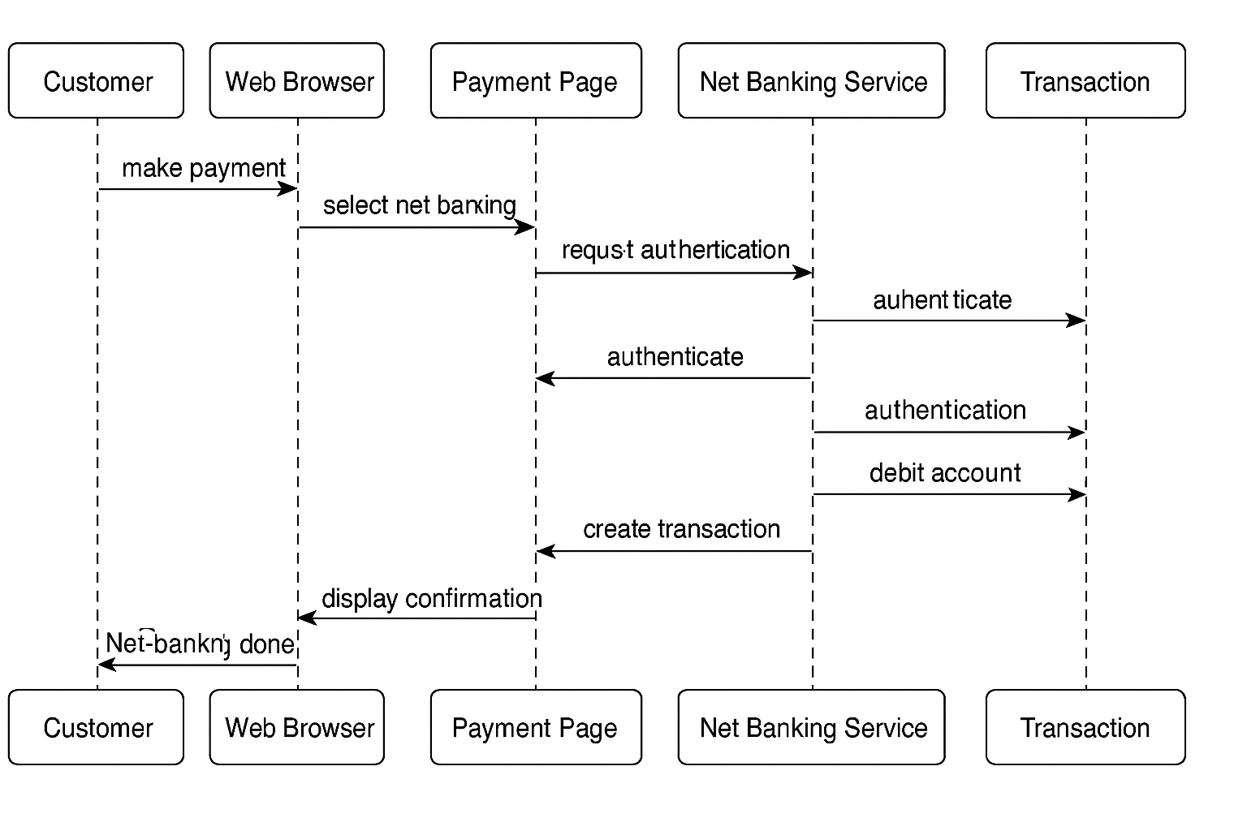

Question 6 Conceptual model

A conceptual model is a high level representation of a system that helps in understanding, visualizing and communicating the essential aspects of domain
It provides a clear and simplified view of domain, making it easier to understand.
Key Elements of a conceptual model:
  - Entities:: Customer, product, order and payment
  - Attributes:: CustomerID, name, email, phone number
  - Relationships:: For example, a customer places and order

Question 7 MVC Architecture
The Model-View-Controller (MVC) framework is an architectural pattern that separates an application into 3 main logical components i.e. Model, View, Controller.
MVC stands for Model - View - Controller.
It is a design pattern that helps in separating an application into three interconnected components.
Component | Description | Example
Model | Manages data, business rules, and logic | Customer, Order, Product
View | UI elements seen by the user (input/output interface) | Login Page, Payment Screen
Controller | Handles user input, acts as a link between Model and View | OrderController, PaymentController

Flow of Control in MVC:
- User interacts with View
- View calls Controller
- Controller updates Model
- Model sends data to View

2. MVC Rules to Derive Classes from Use Case Diagram
  - Combination of one actor and a use case results in one boundary class
  - Combination of two actors and a use case results in two boundary class
  - Combination of three actors and a use case results in three boundary class and so on…
  - Use case result in a controller class
  - Each actor will result in one entity class

Question 8 BA Contributions in project

Waterfall Model – Stages & BA Role
The Waterfall Model is a linear, sequential software development approach. Each phase must be completed before the next begins.

1. Requirement Gathering & Analysis
🎯 Objective: Understand and document what the client needs.
🔹 BA Contributions:
- Conduct stakeholder interviews, workshops, and surveys.
- Elicit functional and non-functional requirements.
- Document Business Requirements Document (BRD).
- Create Use Case Diagrams, Process Flows, Gap Analysis.
- Identify project scope and feasibility.
- Get formal sign-off from the client.
📄 Deliverables:
- BRD / SRS (Software Requirement Specification)
- Requirement Traceability Matrix (RTM)
- Use Cases

2. System Design
🎯 Objective: Define how the system will meet the documented requirements.
🔹 BA Contributions:
- Collaborate with architects and developers to explain requirements.
- Validate system design against the BRD.
- Ensure UI/UX wireframes and prototypes match business expectations.
- Support creation of Entity Relationship Diagrams (ERD) and Data Flow Diagrams (DFD).
📄 Deliverables:
- Review and validate design documents
- Annotated wireframes / screen mockups
- Updated RTM

3. Implementation (Coding)
🎯 Objective: Developers build the actual system.
🔹 BA Contributions:
- Clarify doubts or missing logic for developers.
- Participate in daily/weekly reviews to ensure scope adherence.
- Act as a bridge between business and technical teams.
- Update stakeholders on progress.
📄 Deliverables:
- Change Request (CR) documents if needed
- Mid-development validations
- Functional walk-throughs

4. Testing
🎯 Objective: Verify the system works as per requirements.
🔹 BA Contributions:
- Review and help create test cases (especially for UAT).
- Participate in System Testing, Regression Testing, and UAT.
- Ensure defects are fixed as per business expectations.
- Help users during User Acceptance Testing (UAT).
📄 Deliverables:
- Test Scenarios
- UAT Plan & Sign-off Document
- Defect Reports (with priorities)

5. Deployment
🎯 Objective: Deliver the completed product to the production environment.
🔹 BA Contributions:
- Assist in the Go-Live preparation.
- Coordinate with DevOps/IT team and stakeholders.
- Ensure all business processes are aligned with the final system.
- Prepare training documents/user manuals.
📄 Deliverables:
- Deployment Readiness Checklist
- Training Docs/User Guides
- Handover Document

6. Maintenance & Support
🎯 Objective: Support the live system and handle any issues or improvements.
🔹 BA Contributions:
- Log and analyze change requests or enhancements.
- Gather feedback and suggest system improvements.
- Conduct periodic reviews with stakeholders.
- Monitor system performance against business KPIs.
📄 Deliverables:
- Change Request Logs
- Enhancement Proposals
- Feedback Reports

🧩 Summary Table
Stage | BA Role Summary | Key Documents
Requirements | Gather, analyze, document | BRD, RTM, Use Cases
Design | Validate solution design | Wireframes, ERD, Design Review Notes
Implementation | Support developers | Clarifications, CR Logs
Testing | Support testing, validate requirements | Test Cases, UAT Plan
Deployment | Coordinate Go-Live, train users | Training Docs, Sign-off
Maintenance | Handle changes, feedback | CR Docs, Feedback Reports

Question 9 Conflict Management
Conflict management is the process of resolving conflicts or disagreements between individuals or groups in a constructive manner
Thomas killman technique is used to asses conflict resolution styles and guiding individuals in selecting appropriate strategies to manage conflicts
5 steps of conflict management:
- Identify conflict
- Discuss the details
- Agree with the root problem
- Check for every possible solution for the conflict
- Negotiate the solution to avoid future conflicts

Question 10 Reasons for project failure
🔹 1. Unclear or Incomplete Requirements
- Vague or poorly documented requirements
- Constant changes without proper impact analysis
- Lack of stakeholder involvement during elicitation
🔹 2. Scope Creep
- Adding features without formal change control
- Weak scope management and no boundaries defined
- Overpromising to stakeholders
🔹 3. Lack of Stakeholder Engagement
- Key users or business owners are unavailable or disengaged
- Misalignment between business and IT teams
🔹 4. Poor Communication
- Miscommunication between teams
- Lack of proper documentation or progress reports
- No single point of contact (like a BA or PM)
🔹 5. Inadequate Planning
- No clear project timeline or resource allocation
- Overly optimistic estimates
- Missing risk management plan
🔹 6. Ineffective Leadership or Governance
- Poor project sponsorship or stakeholder leadership
- No escalation or decision-making structure
- Weak project governance or steering committee
🔹 7. Budget Overruns
- Underestimated cost at the start
- Unexpected expenses
- Poor financial tracking or control
🔹 8. Missed Deadlines / Poor Time Management
- Unrealistic deadlines
- Delays due to dependencies or approvals
- Frequent rework due to misunderstood requirements
🔹 9. Technical Failures
- Choosing the wrong technology stack
- Poor system design or architecture
- Inadequate testing leading to critical bugs post-deployment
🔹 10. Lack of Skilled Resources
- Inexperienced or undertrained team
- High resource turnover or poor resource allocation
🔹 11. Ineffective Risk Management
- Ignoring potential risks or mitigation plans
- No contingency planning
- Delayed action on known blockers
🔹 12. Lack of UAT or Poor User Involvement
- UAT not performed or poorly managed
- Users not involved in testing or feedback collection
🔹 13. Resistance to Change
- Users or stakeholders not willing to adopt new systems
- No proper training or change management
🔹 14. Inadequate Testing
- Missing functional/non-functional test coverage
- Skipping regression or integration testing
- Defects found late in production

Question 11 Challenges faced in projects for BA
Unclear or Evolving Requirements
Stakeholders don’t know exactly what they want.
Requirements keep changing without formal change control.
Conflicting expectations from different stakeholders.

2. Limited Stakeholder Availability or Engagement
Stakeholders are busy or unresponsive.
Late feedback or delayed approvals.
Inconsistent participation in meetings/workshops.

🔹 3. Scope Creep
Additional features requested without adjusting timeline/cost.
Pressure to accommodate requests beyond initial scope.
No formal process to control scope changes.

🔹 4. Communication Gaps
Miscommunication between business and technical teams.
Misinterpretation of requirements due to lack of domain knowledge.
Language or cultural barriers in global teams.

🔹 5. Inadequate Domain Knowledge
Difficulty understanding industry-specific processes (e.g., finance, healthcare, agriculture).
Reliance on SMEs for every small detail.

🔹 6. Lack of Proper Documentation
Time pressure leading to skipping key documents like RTM, process flows, or test scenarios.
No version control or tracking of requirement changes.

🔹 7. Conflicting Stakeholder Interests
Different departments have different goals (e.g., marketing vs. IT).
Difficulty in prioritizing requirements.

🔹 8. Limited Access to End Users
Only intermediaries (like managers) are available for requirement gathering.
No direct feedback from those who will actually use the system.

🔹 9. Poorly Defined Acceptance Criteria
Requirements are approved without clear testable conditions.
Leads to confusion during UAT and sign-off delays.

🔹 10. Time Constraints / Unrealistic Deadlines
Not enough time to do proper analysis and validation.
BA is rushed to deliver documents or sign off on requirements.

🔹 11. Ineffective Tools or Processes
Lack of access to proper BA tools (e.g., JIRA, Confluence, Visio, Balsamiq).
Project not following any standard methodology (Waterfall/Agile/Hybrid).

🔹 12. Lack of BA Involvement in All Phases
BA included only during requirements phase and not in testing or post-deployment.
Missed opportunities to validate or clarify scope during design/development.

🔹 13. Technical Constraints
Business requirements cannot be implemented due to technical limitations.
Need to frequently compromise or re-scope.

🔹 14. Resistance to Change
Users reluctant to adopt new systems or processes.
Need for strong change management and communication.

Question 12 Document Naming standards
A document numbering standard is a systematic approach to assigning unique identifiers to various documents created and used throughout the development process
Ex- PROJ12-REQ-1.0-2025-06-25

Question 13 Do’s and Don’ts of a business analyst

S No. | Do’s | Don’ts
1. | Consult an SME for clarification in requirements | Never say No to a client
2. | Go to the client with plain mind with no assumption. Listen carefully and completely until the client is done | There is no word as by default
3. | Try to extract maximum leads to the solution from the client himself | Never imagine anything in terms of GUI
4. | Concentrate on the important requirements | Don’t interrupt the client when he is giving you the problem
5. | Question the existence of the existence | Never try to give solution to the client right away with your previous experience and assumptions

Question 14 Packages and Subsystems
Packages: Collection of components which are not reusable in nature
Ex-- Application development companies work on packages

Subsystems: Collection of components which are reusable in nature.
Ex- Product development companies work on subsystems.

Question 15 Camel Casing and its uses
Camel casing is a naming convention used in computer programming
It is used for naming variables, functions and identifiers
Example:
camelCaseExample

Question 16 Development server
A development server refers to a dedicated environment or server that is used during the software development process
It provides a platform for developers and testers to build, test and debug applications before they are deployed to a production environment
As a BA, we have limited access only
Characteristics:
- Contains in-progress code and modules.
- May have dummy/test data.
- Used by developers, testers, and sometimes BAs.
- Usually mirrors production partially, but not fully secure or stable.
- Common BA Access Rights:
Access Type | Description
🔹 Read-Only Access | BA can view pages, forms, or application modules as they are built.
🔹 Demo/Test Access | BA can perform walkthroughs, test business logic, and validate against requirements.
🔹 Staging Data Access | Access to test or dummy data to simulate business scenarios.
🔹 Access to Logs (sometimes) | Limited access to application logs to trace functional issues (not deep technical logs).
🔹 Access via Frontend/UI only | Most access is through the web interface — not backend, not the codebase.

Question 17 Data Mapping
Data mapping is the process of connecting data from one source to another
Its creating a guide or map that shows how data in one place corresponds to data in another place.
This is especially important when you’re moving data between different system or databases to ensure that the data stays consistent and accurate.
Why is Data Mapping Important?
- Ensures accurate data transfer between systems (e.g., legacy to new system)
- Facilitates ETL (Extract, Transform, Load) processes
- Enables system integration (e.g., CRM to ERP)
- Ensures data consistency and compliance

Question 18 API
Application Programming Interface is a set of rules and tools that allows different software applications to communicate with each other
It defines the methods and data formats that applications can use to request and exchange information
Real-world Example
Let’s say in "Online Agriculture Product Store" application, you are integrating with:
- A U.S.-based payment gateway or
- A partner’s inventory system or
- A third-party order tracking system
These external systems send data via API, such as:
- Date of Order
- Transaction Time
- Delivery Date

🗓️ The Challenge: Date Format Mismatch
Source System (US) | Your System (India)
mm-dd-yyyy format | dd-mm-yyyy format
Example: 06-24-2025 | Expected: 24-06-2025
If not handled, this mismatch can lead to:
- Incorrect order dates
- Data validation errors
- Integration failures

🧠 How Would a Business Analyst Handle This?
✅ Step 1: Identify API Integration Touchpoints
- Determine where the external system sends/receives date data.
- Example: /orderDetails, /paymentInfo, /deliveryStatus

✅ Step 2: Add Date Format Rule to Data Mapping Sheet
Field Name | Source Format (US App) | Target Format (Our App) | Transformation Logic
order_date | mm-dd-yyyy | dd-mm-yyyy | Convert before storing
delivery_date | mm-dd-yyyy | dd-mm-yyyy | Use date converter function

✅ Step 3: Define Transformation Rule (Functional Requirement)
In the API Integration Document or BRD:
"When receiving dates via API, the system must parse and convert any incoming dates from mm-dd-yyyy format to dd-mm-yyyy format before displaying or storing."

✅ Step 4: Collaborate with Dev & Test Team
- Developers will write logic to convert date format using a date parser or formatter.
- Testers will simulate date inputs from the U.S. API and check the conversion.
- You’ll validate that the data is correct and consistent in UI and database.

