Capstone project 3 part 1
Priyanka

Question 1- Use Case Diagram
Answer -

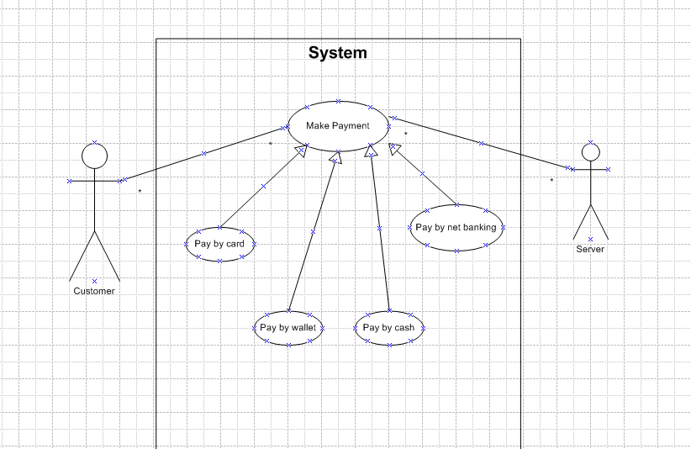

Use Case Specification
Use Case Name: Payment application
Description: The use case describes how the bank customer uses the interface to make payment
Actors: Customer, Server
Precondition: 1. Active Internet connection, Active Bank account
Post Condition: Payment successful page to be displayed
Basic Flow: Payment details are correct and payment is done successfully

Question 2 - . Derive Boundary Classes, Controller classes, Entity Classes

1. Entity Classes (Model Layer)
All model classes are represented as entity classes. The model class knows about all the data that need to be displayed. This represents the database (tables in the DB)
Examples:
- customerEntityClass
- cardEntityClass
- cashEntityClass
- netbankingEntityClass
- upiEntityClass
2. Boundary Classes (View Layer)
The view represents the presentation of the application. The view class is the data required by the query. It is represented as boundary class.
Examples:
- customerPaymentBoundary
- payByCardBoundary
- payByCashBoundary
- payByNBBoundary
- payByUPIBoundary

3. Controller Classes (Control Layer)
Whenever a user sends request for something then it always goes through the controller. The controller intercepts the request from view and passes it on to the model for appropriate action. After the action has been taken on the data, the controller is responsible for directing the appropriate view to the user.

Example:
- PaymentController

Question 3 - Place these classes on a three tier Architecture
Answer -
Tier | Classes Placed | Responsibility
1. Presentation Layer | PaymentUI, CardPaymentUI, WalletPaymentUI, CashPaymentUI, NetBankingUI | Interact with customer/user, collect input data for processing
2. Business Logic Layer | PaymentController, CardPaymentController, WalletPaymentController, CashPaymentController, NetBankingController | Handle payment logic, route the request to the correct payment processor
3. Data/Entity Layer | Customer, Payment, Card, Wallet, BankAccount | Store business-related data, represent domain objects
Question 4 - Domain Model for Customer making payment through Net Banking

Ans: A domain model is a conceptual representation that defines the structure, relationships, and behaviour of entities within a specific problem domain. It shows classes, attributes, and associations relevant to the problem domain—here, Customer making payment via Net Banking.

Key Domain Objects Involved in Net Banking Payment -
Class | Attributes (example) | Responsibility
Customer | customerId, name, email | Represents the user making the payment
Payment | paymentId, amount, date, status | Abstract class representing a payment
NetBankingPayment | transactionId, bankName, accountNumber, IFSC | Specialized payment method via bank
BankAccount | accountNumber, IFSC, balance | Holds customer’s bank details
Transaction | transactionId, amount, timestamp, status | Records the transaction done
Question 5 - sequence diagram
Answer –
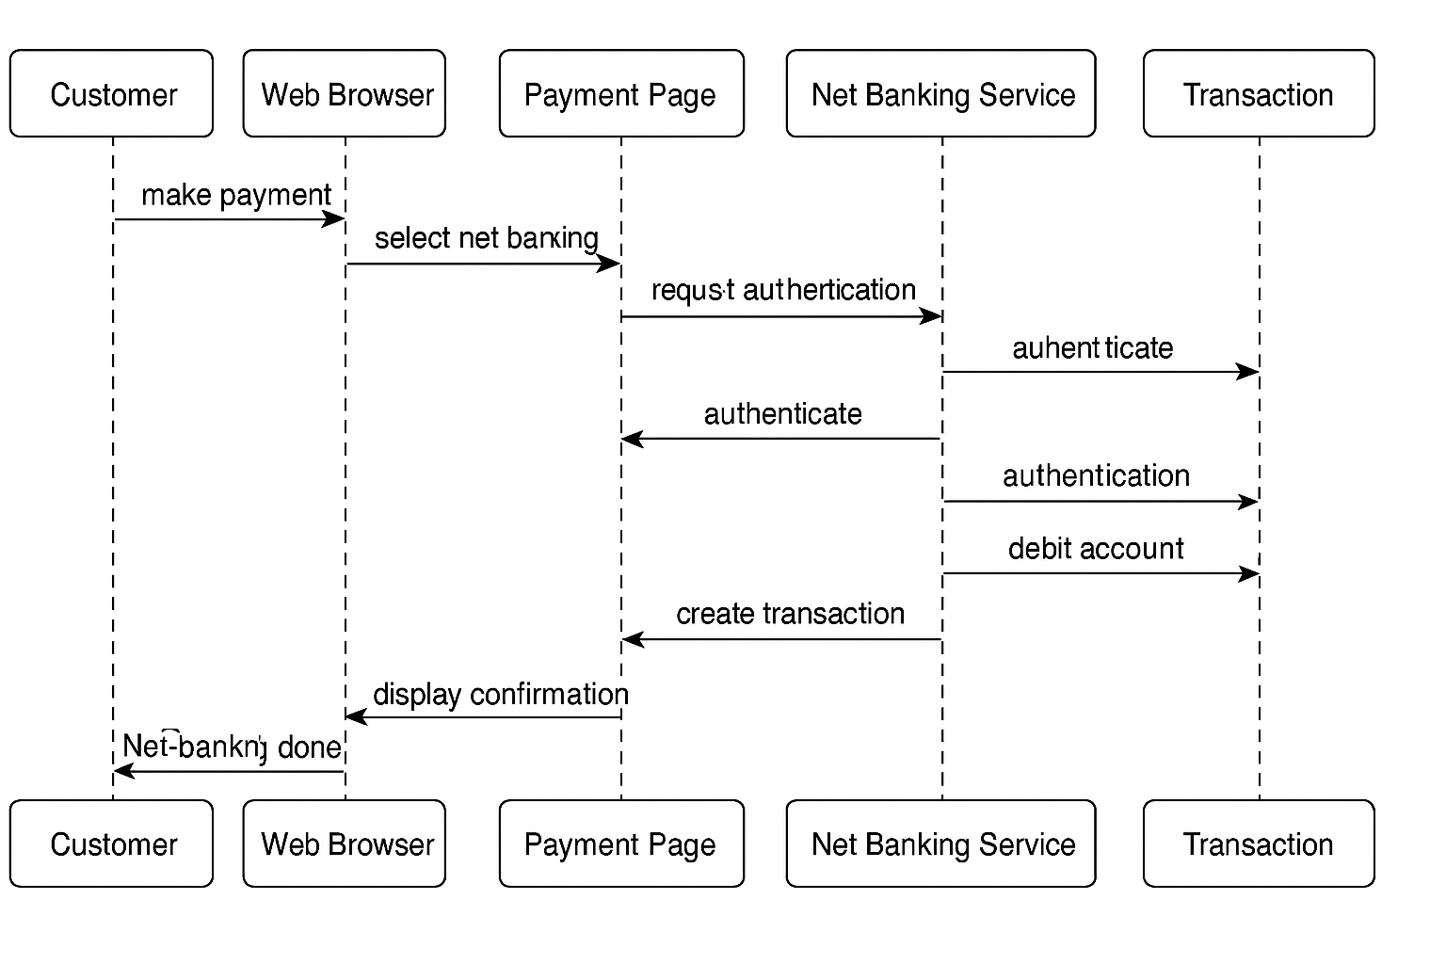

Question 6 - Conceptual Model for this Case
Answer - A Conceptual Model is a high-level representation of key concepts (classes/entities) in the problem domain and their relationships, without technical details like methods, data types, or implementation logic.

It provides a clear and simplified view of domain, making it easier to understand.
Key Elements of a conceptual model:
  - Entities:: Customer, product, order and payment
  - Attributes:: CustomerID, name, email, phone number
  - Relationships:: For example, a customer places and order

Question 7 - What is MVC architecture?

Ans: The Model-View-Controller (MVC) framework is an architectural pattern that separates an application into 3 main logical components i.e. Model, View, Controller.
MVC stands for Model - View - Controller.
It is a design pattern that helps in separating an application into three interconnected components.
Component | Description | Example
Model | Manages data, business rules, and logic | Customer, Order, Product
View | UI elements seen by the user (input/output interface) | Login Page, Payment Screen
Controller | Handles user input, acts as a link between Model and View | OrderController, PaymentController

Flow of Control in MVC:
- User interacts with View
- View calls Controller
- Controller updates Model
- Model sends data to View

MVC Rules to Derive Classes from Use Case Diagram
  - Combination of one actor and a use case results in one boundary class
  - Combination of two actors and a use case results in two boundary class
  - Combination of three actors and a use case results in three boundary class and so on…
  - Use case result in a controller class
  - Each actor will result in one entity class

Question 8 - BA contributions in project (Waterfall Model – all Stages)

Answer - The Waterfall Model is a linear, sequential software development methodology that consists of distinct phases. Each phase must be completed before moving on to the next.

Phase | BA Contributions
1. Requirement Gathering & Analysis | Identify stakeholders and conduct requirement elicitation techniques (interviews, surveys, workshops) 🔹 Gather and document Business Requirements Document (BRD), Functional Requirements (FRD), and Non-functional requirements (NFR) 🔹 Validate and get sign-off from stakeholders
2. System Design | Help translate business requirements into technical specifications 🔹 Participate in review of architecture, data flow diagrams (DFDs), and wireframes 🔹 Ensure business logic is accurately captured in the design
3. Implementation (Development) | Act as a bridge between developers and stakeholders 🔹 Clarify requirements, answer queries, and manage requirement traceability 🔹 Review development progress against requirements
4. Testing | Create/review test cases, test scenarios, and ensure coverage of business rules Coordinate User Acceptance Testing (UAT) 🔹 Identify and log defects or mismatches between requirements and implementation
5. Deployment | Ensure all business requirements are delivered and validated 🔹 Help in training users and creating user manuals or SOPs 🔹 Validate production readiness
6. Maintenance | Track and analyze change requests or enhancement needs 🔹 Help in impact analysis of new changes 🔹 Maintain documentation for future reference and audits

Question 9 - conflict management? Explain using Thomas – Kilmann technique

Ans: Conflict management is the process of resolving conflicts or disagreements between individuals or groups in a constructive manner
Thomas killman technique is used to asses conflict resolution styles and guiding individuals in selecting appropriate strategies to manage conflicts
5 steps of conflict management:
- Identify conflict
- Discuss the details
- Agree with the root problem
- Check for every possible solution for the conflict
- Negotiate the solution to avoid future conflicts

Question 10 - Reasons for project failure
Answer -
Reason | Explanation
Unclear Requirements | Poorly defined or changing requirements lead to misaligned outcomes.
Lack of Stakeholder Engagement | If key stakeholders are not involved, the solution may not meet business needs.
Poor Planning | Inadequate scope, time, or cost planning leads to delays or overspending.
Inadequate Risk Management | Ignoring risks or not planning for them can cause sudden project disruptions.
Communication Gaps | Miscommunication between teams, clients, and vendors leads to confusion and errors.
Weak Leadership or Governance | Lack of direction from project managers or sponsors reduces accountability.
Unrealistic Deadlines | Over-ambitious timelines without capacity analysis often lead to project burnout.
Insufficient Resources | Lack of skilled personnel, tools, or budget can halt progress.
Poor Change Management | Inability to adapt to changes in scope, technology, or market needs causes failure.
Lack of Testing or Quality Control | Inadequate testing can lead to defective or non-functional deliverables.

Question 11 - Challenges faced in projects for BA

Answer -
Challenge | Explanation
Unclear or Evolving Requirements | Stakeholders often struggle to articulate what they need, or they change their minds mid-project, leading to rework.
Lack of Stakeholder Involvement | When business users or decision-makers are not available or engaged, the BA cannot validate or finalize requirements.
Communication Gaps | Miscommunication between business and technical teams can lead to misunderstandings and incorrect implementations.
Scope Creep | Continuous addition of new features without proper impact analysis or approvals leads to delays and cost overruns.
Time Constraints | BAs often have limited time to gather and analyze complex requirements thoroughly.
Conflicting Stakeholder Interests | Different stakeholders may have opposing needs, making it difficult to prioritize and finalize requirements.
Question 12 - Document Naming Standards
A document numbering standard is a systematic approach to assigning unique identifiers to various documents created and used throughout the development process
Ex- PROJ12-REQ-1.0-2025-06-25

Question 13 - Do’s and Don’ts of a Business analyst
Answer - Do’s of a Business Analyst
Do | Explanation
Actively Listen to Stakeholders | Understand their pain points, goals, and expectations clearly.
Document Clear and Complete Requirements | Ensure all business, functional, and non-functional needs are captured accurately.
Facilitate Effective Communication | Maintain continuous and transparent communication between business and technical teams.
Verify and Validate Requirements | Conduct reviews and walkthroughs to ensure correctness.
Maintain Traceability | Keep track of requirements from initiation to implementation.
Don’ts of a Business Analyst
Don’t | Explanation
Make Assumptions | Always clarify requirements instead of guessing.
Ignore Stakeholder Conflicts | Address and resolve conflicting interests promptly.
Overcomplicate Requirements | Avoid using technical jargon or unnecessary complexity.
Delay Feedback or Approvals | Timely reviews are critical to avoid rework.
Lose Focus on Business Goals | Stay aligned with business value and objectives.

Question 14 - Difference between packages and sub-systems

Packages: Collection of components which are not reusable in nature
Ex-- Application development companies work on packages

Subsystems: Collection of components which are reusable in nature.
Ex- Product development companies work on subsystems.

Question 15. What is camel-casing and explain where it will be used-

Answer - Camel-casing is a naming convention in programming and documentation where:
Words are joined together without spaces.
The first word starts in lowercase, and each subsequent word starts with a capital letter.
Where Is Camel-Casing Used
Usage Area | Purpose
Programming Languages (Java, C#, JavaScript) | To define variables, methods, and object names
Database Schema Naming | Table or column names (in modern systems) like orderDate
API Naming Conventions | REST API parameters: getCustomerData(), updateProductList()
Scripting & Automation | Used in tools like PowerShell, Bash scripts, etc.
Documentation Standards | Ensures consistent readability and professionalism
Question 16. Illustrate Development server and what are the accesses does business analyst has?

Answer - A Development Server is a server environment used by the development team to build, test, and integrate code before deployment to production.
accesses does business analyst has
Access | Description
Read-Only Access to Application | To verify feature implementation against requirements
Access to Test Data/Input | To create, update, and verify business scenarios using sample/test data
Access to Logs/Error Reports | To analyze issues and provide detailed feedback to developers
User Interface Validation | Check if UI matches wireframes, labels, and field validation rules
Postman/API Tool (Optional) | For BAs involved in API testing or validation
No Access to Source Code | BA typically doesn't edit code but may access build versions
Question 17. What is Data Mapping

Data mapping is the process of connecting data from one source to another
Its creating a guide or map that shows how data in one place corresponds to data in another place.
This is especially important when you’re moving data between different system or databases to ensure that the data stays consistent and accurate.
Why is Data Mapping Important?
- Ensures accurate data transfer between systems (e.g., legacy to new system)
- Facilitates ETL (Extract, Transform, Load) processes
- Enables system integration (e.g., CRM to ERP)
- Ensures data consistency and compliance

Question 18. What is API. Explain how you would use API integration in the case of your application Date format is dd-mm-yyyy and it is accepting some data from Other Application from US whose Date Format is mm-dd-yyyy 10 Marks

Ans: Application Programming Interface is a set of rules and tools that allows different software applications to communicate with each other
It defines the methods and data formats that applications can use to request and exchange information

Types of APIs:
•REST API (most common – uses HTTP)
•SOAP API
•GraphQL API
What is API Integration?
API Integration is the process of connecting your application with another system via API to send, receive, or process data automatically.
Use Case Scenario: Date Format Issue
Context: •Your Application Date Format: dd-mm-yyyy (Indian Standard)
•External US Application Format: mm-dd-yyyy
Steps to Handle API Integration with Date Format Conversion
Step | Description
API Contract Definition | Clearly define in the API documentation the expected date format on both sides
Use Data Mapping / Transformation Layer | When receiving data, use a middleware (e.g., API Gateway, code logic, or integration tool) to convert mm-dd-yyyy into dd-mm-yyyy before saving or displaying
Implement Date Format Conversion | Use programming logic (e.g., in JavaScript, Python, or Java) to parse and reformat dates

