COEPD – Traditional Development
Capstone Project 1 – Part 3/3
12 Questions
Question 1 – Functional Requirements – 15 Marks
Identify minimum 20 functional requirements.
Answer:
Example:
Functional Requirement: When an order is fulfilled, the local printer shall print a packing slip.
Non-Functional Requirement: Packing slips shall be printed on both sides of 4”x 6” white paper, the standard size for packing slips used by local printers.
Answer:
Functional Requirements define the specific behaviors, functions or operations of a system.
Req ID | Req Name | Req Description | Priority
FR0001 | Farmer Registration | Farmers should be able to register themselves to the website. | 9
FR0002 | Search for Products | Customers should be able to search to search for products on website using keywords. | 8
FR0003 | Log In | Farmers should be able to Login using their email id and password. | 8
FR0004 | Payment Methods | Farmers have options for payment like UPI, Cash on Delivery, and Credit/Debit cards. | 7
FR0005 | Add to Cart | Farmers should be able to add products to the cart. | 8
FR0006 | Tracking | Farmers should be able to track the status of their order. | 9
FR0007 | Email Confirmation | Farmers should be able to receive email confirmation upon successfully payment and order placement. | 8
FR0008 | Address Entry | Farmers should be able to give their address for order delivery. | 7
FR0009 | Product Catalog | Farmers should be able to explore products through product catalog available. | 7
FR0010 | Manage Listing | Farmers should be able to update, add or delete their listed products. | 6
FR0011 | Language Support | Farmers should be able to choose their preferred language. | 9
FR0012 | Wish List | Users should be able to desired products their wish list. | 7
FR0013 | Product Delivery | Users should be able to check the estimated time of delivery for products at their location. | 8
FR0014 | Product Review | Users should be able to check reviews given by other users on a product. | 7
FR0015 | Product Information | Users should be able to read all necessary product information. | 6
FR0016 | Filters | Users should be able to explore products with filters like brand, price, etc. | 8
FR0017 | Notifications | The system should notify users with updates like shipping updates. | 8
FR0018 | Order Returns | Users should be able to place order returns within a stipulated timeframe. | 8
FR0019 | Order Cancellation | User should be able to cancel orders under certain conditions. | 7
FR0020 | Order Placement | Users should be able to place an order for products from the cart. | 8
Non-Functional Requirement will describe the qualities and attributes of a system focusing on how the system performs.
NFR0101 | Page Loading Time | Each page should be able to load within 3 second’s time.
NFR0102 | Payment Receipt | Farmers should receive payment receipt upon successful order through website and email ID.
NFR0103 | WACAG 2.1 | The system must Web Content Accessibility Guidelines WACAG 2.1.
NFR0104 | Interface | The website must have simple user interface and not loaded with too much information.
NFR0105 | Browsers | The website should run seamlessly on all major browsers such as Chrome, Firefox and Brave.
NFR0106 | Data Loss | During website failures there should be no data loss, regular backups must be done.
NFR0107 | User Base | The website must be able to handle 10,000 users at a single time without much hindrance.
NFR0108 | Feedback | The website must be able to collect user feedback upon order delivery or order placement.
NFR0109 | Accessibility | Farmers should be able to access websites almost all of the time. With very less downtime.
NFR0110 | Response Time | The system should respond to users within 3 seconds.

Question 2 – Minimum 5 Page Designs – 15 Marks
Make Wireframe and Prototypes.
Answer:
1. Register User Page 1:
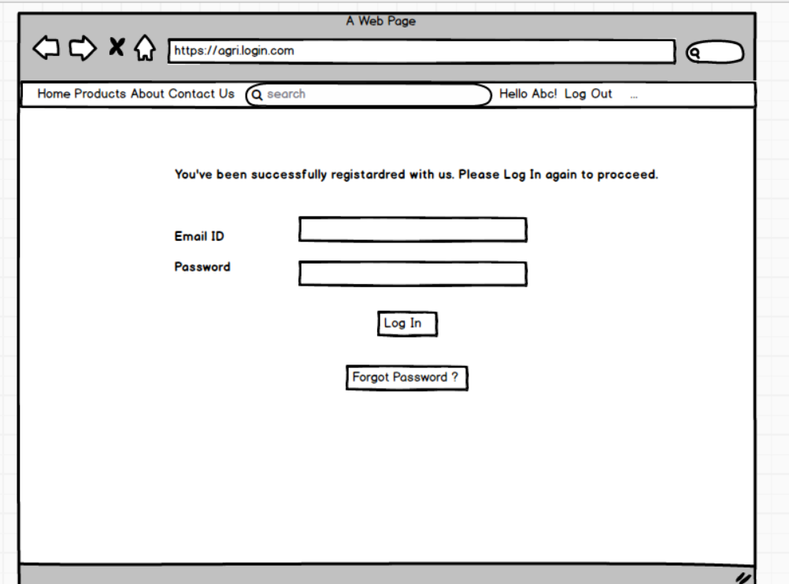

Register User Page 2:
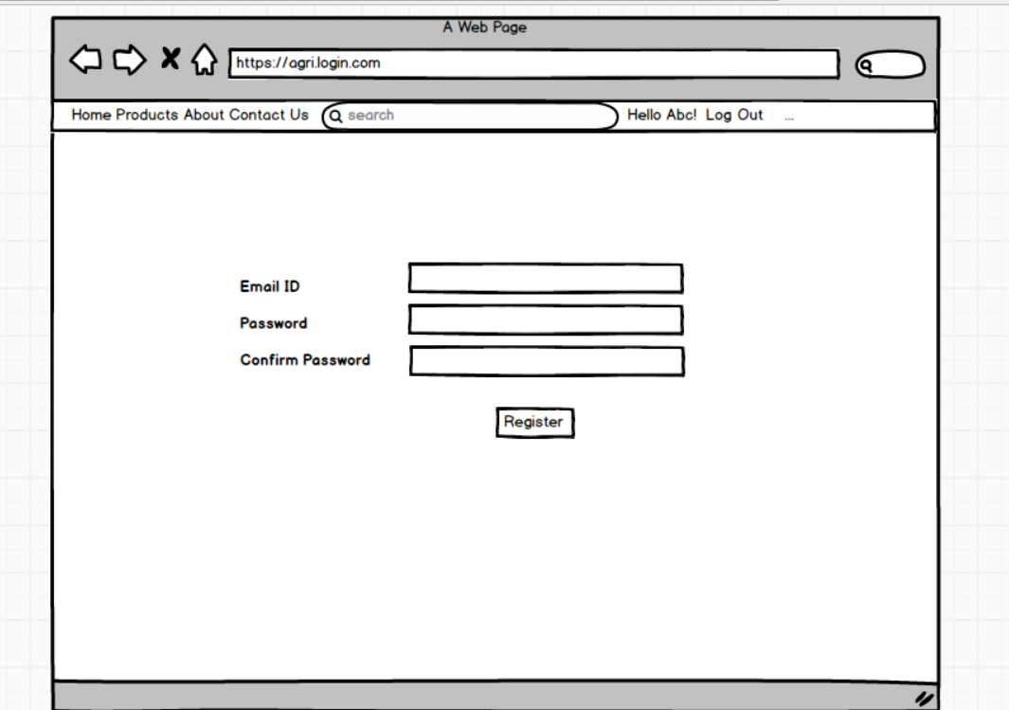

2. Search Products Search 1:
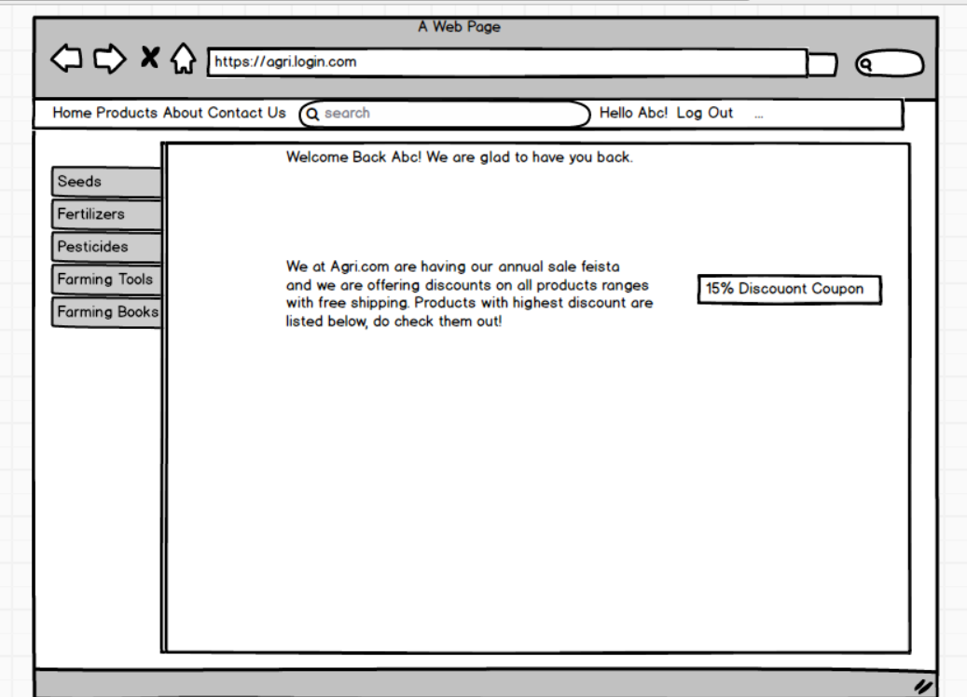

Search Product Search 2:
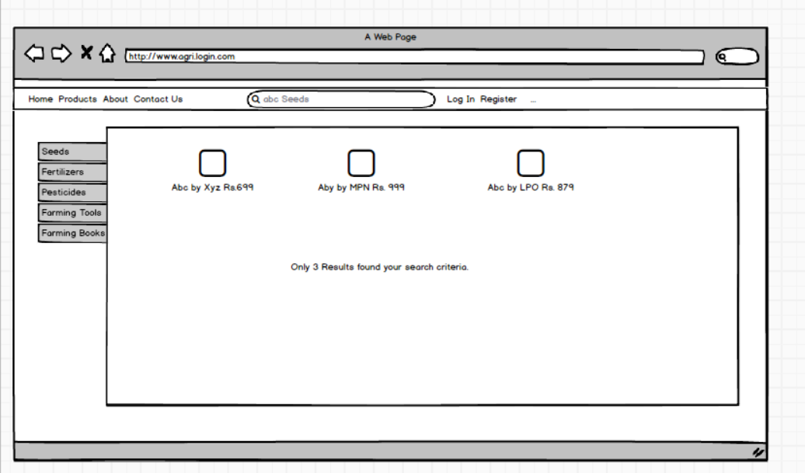

3. Log In Page 1:
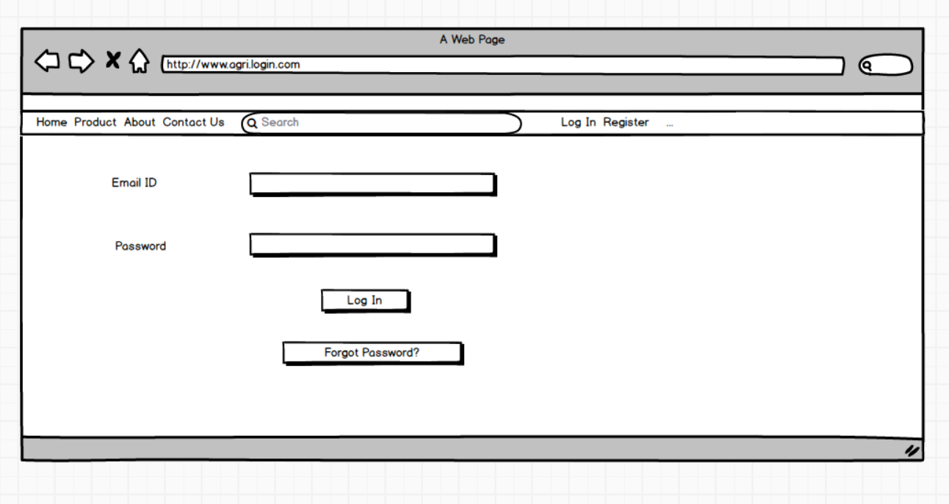

Log In Page 2:
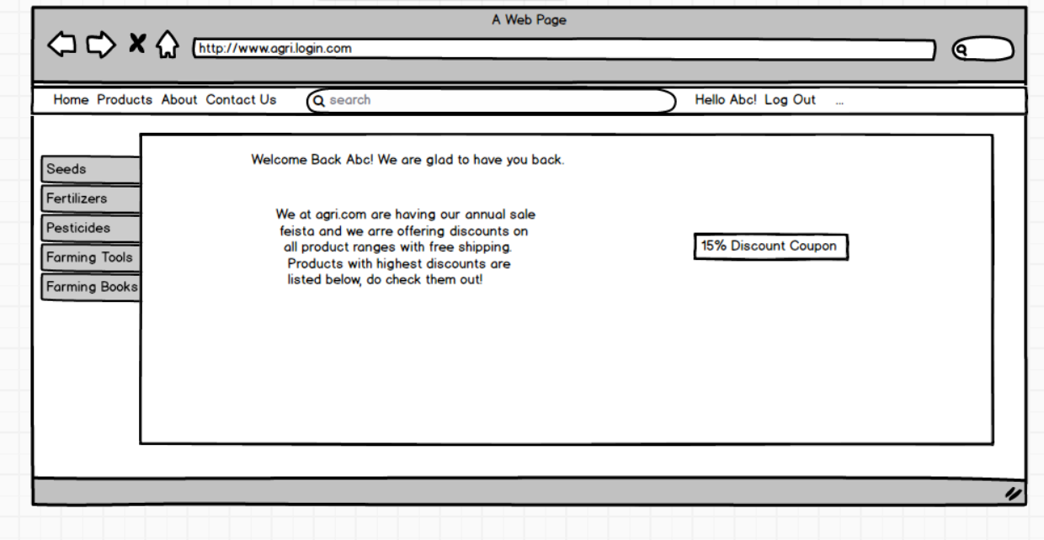

4. Change Password Page 1:
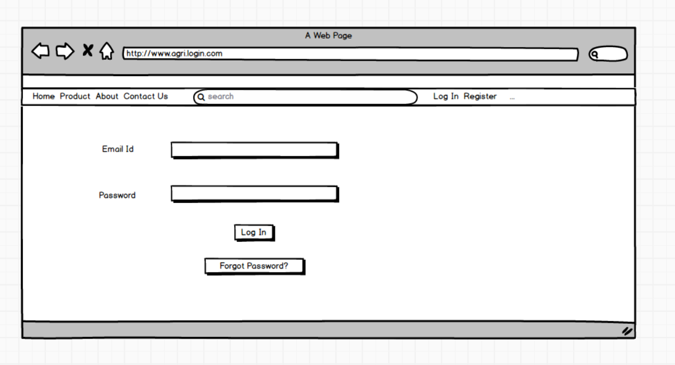

Change Password Page 2:
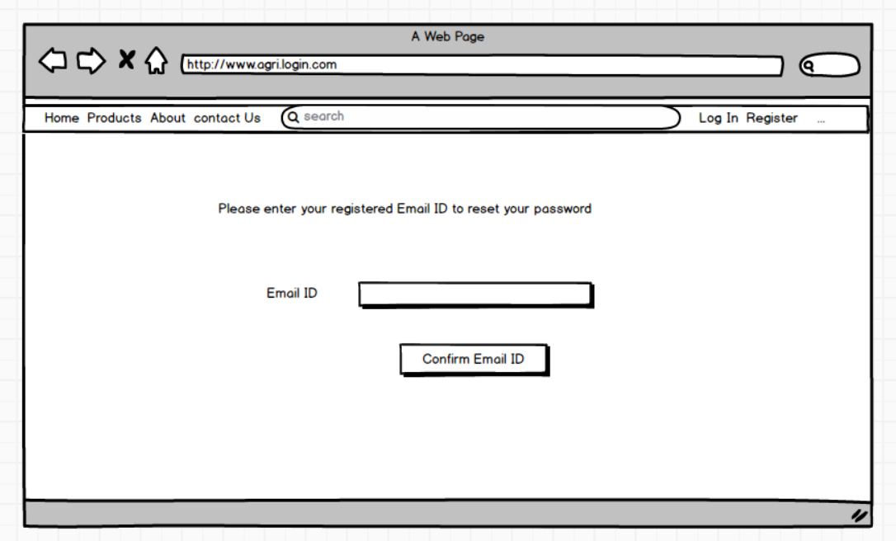

Change Password Page 3:
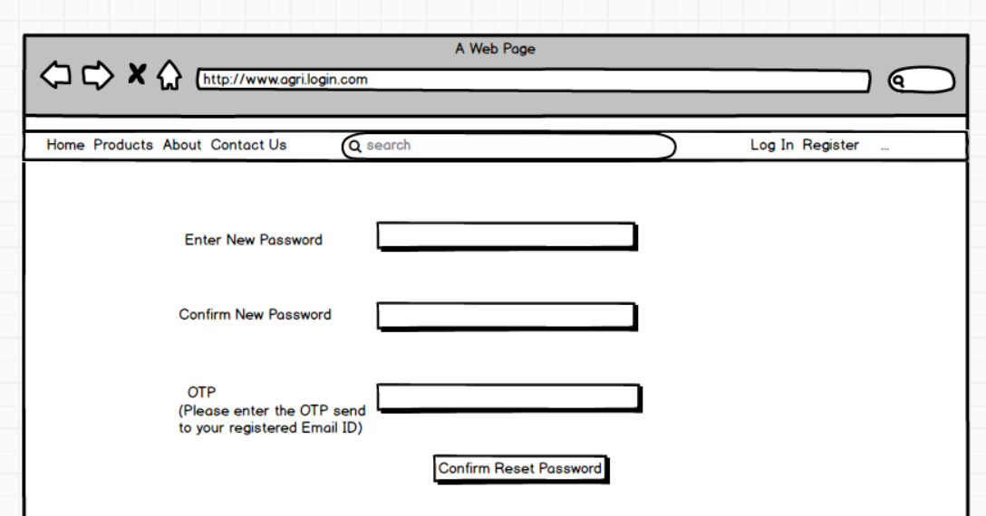

5. Payment Page 1:
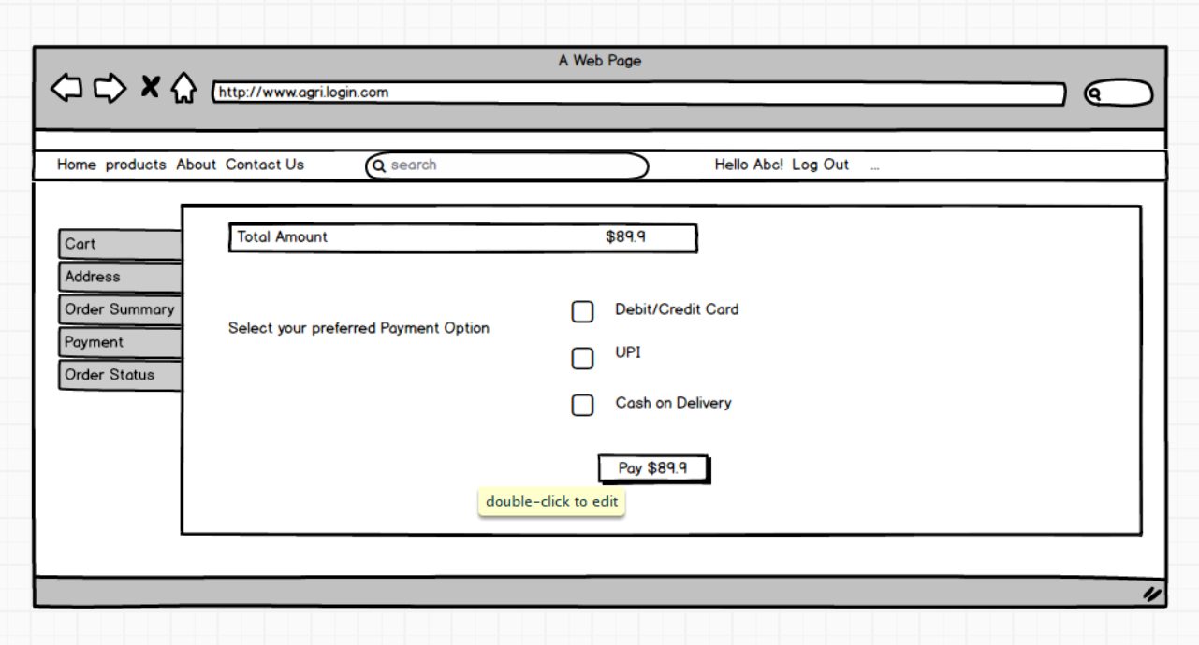

Payment Page 2:
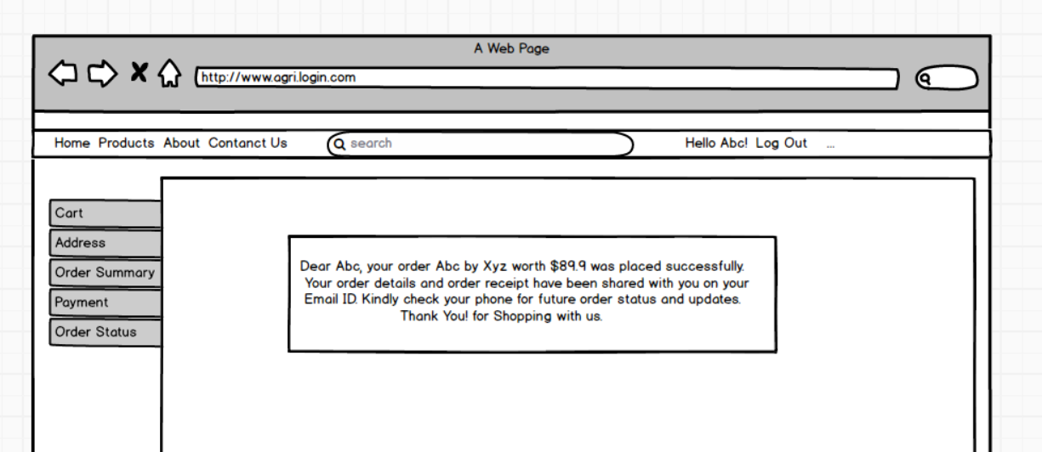

Question 3 – Tools (Visio, Balsamiq) – 15 Marks
Make a note of the Tools, which you are using for above concepts.
Answer:
Microsoft Visio: Microsoft Visio is a tool which lets you transform complicated texts and hard to understand tables into visual diagrams of that information. Such as flowcharts, data flow diagrams, Business Process Modelling etc.
Balsamiq: Balsamiq is rapid wireframing tool used to create mock-ups and prototypes of your idea or concepts for your website or application.
Axure: Axure is a advanced prototyping tool used to create high fidelity interactive mock-ups and prototypes for web and mobile applications.

Question 4 – RTM – 6 Marks
A business analyst’s key responsibilities are to keep track of the requirements and make sure that no requirement is missed.
Mr. Henry and Peter have approached you regarding the current status of the project. How will you tackle this situation?
Answer:
Req ID | Req Name | Req Description | Design | Code | UT | UAT
FR001 | Farmer Registration | Farmers should be able to register themselves to the website. | Complete | Complete | Complete | Incomplete
FR002 | Search Products | Customers should be able to search for product on website using keywords. | Complete | Complete | Complete | Incomplete
FR003 | Log In | Farmers should be able to log in using their email ID and password. | Complete | Complete | Complete | Incomplete
FR004 | Payment Methods | Farmers have options for payment like UPI, COD, Debit/Credit cards. | Complete | Complete | Complete | Incomplete
FR005 | Add to Cart | Farmers should be able to add products to the cart. | Complete | Complete | Complete | Incomplete
FR006 | Tracking | Farmers should be able to track the status of their orders. | Complete | Complete | Complete | Incomplete
FR007 | Email Confirmation | Farmers should be able to receive email confirmation upon successful payment and order placement. | Complete | Complete | Complete | Incomplete
FR008 | Address Entry | Farmers should be able to give their address for order delivery. | Complete | Complete | Complete | Incomplete
FR009 | Product Catalogue | Farmers should be to explore products through the product catalogue. | Complete | Complete | Complete | Incomplete
FR010 | Manage Listing | Manufacturers should be able to update, add, delete their listed products. | Complete | Complete | Complete | Incomplete
FR011 | Language Support | Farmers should be able to choose their preferred language. | Complete | Complete | Complete | Incomplete
FR012 | Wish List | Users should be able to add desired products to their wish list. | Complete | Complete | Complete | Incomplete
FR013 | Product Delivery | Users should be able to check the estimated time of delivery for products at their location. | Complete | Complete | Complete | Incomplete
FR014 | Product Review | Users should be able to check reviews given by other users on a product. | Complete | Complete | Complete | Incomplete
FR015 | Product Information | Users should be able to read all necessary product information. | Complete | Complete | Complete | Incomplete
FR016 | Filters | Users should be able to explore products with filters like brand, price, etc. | Complete | Complete | Complete | Incomplete
FR017 | Notifications | The system should notify users with updates like shipping updates. | Complete | Complete | Complete | Incomplete
FR018 | Order Return | Users should be able to place order returns within a stipulated timeframe. | Complete | Complete | Complete | Incomplete
FR019 | Order Cancellation | Users should be able to cancel orders under certain conditions. | Complete | Complete | Complete | Incomplete
FR020 | Order Placement | Users should be able to place an order for products from the cart. | Complete | Complete | Complete | Incomplete
NFR101 | Page Load Time | Each page load within 3 seconds. | Complete | Complete | Incomplete | Incomplete
NFR102 | Payment Receipt | Farmers should receive payment receipts through the website and email. | Complete | Complete | Incomplete | Incomplete
NFR103 | WCAG 2.1 | The system must meet WCAG 2.1 accessibility guidelines. | Complete | Complete | Incomplete | Incomplete
NFR104 | Interface | The website must have a simple user interface. | Complete | Complete | Incomplete | Incomplete
NFR 105 | Browers | The website should run on major browsers. | Complete | Complete | Incomplete | Incomplete
NFR 106 | Data Loss | There should be no data loss during failures. | Complete | Complete | Incomplete | Incomplete
NFR 107 | User Base | The website should handle up to 10,000 users simultaneously. | Complete | Complete | Incomplete | Incomplete
NFR 108 | Feedback | The website must allow users to provide feedback. | Complete | Complete | Incomplete | Incomplete
NFR 109 | Accessibility | Farmers should be able to access websites with very minimal downtime. | Complete | Complete | Incomplete | Incomplete
NFR 110 | Response Time | The system should respond to users within 3 seconds. | Complete | Complete | Incomplete | Incomplete

Question 5 – 10 Test Case Documents – 10 Marks
Prepare 10 Test Case Documents.
Answer:
1. Test Case Documents: User Registration
Test Case ID |  | TC001 | Test Case Name | User Registration
Project ID |  | PRJ001 | Project Name | Agriculture Products Platform
PM ID |  | PM001 | PM Name | Chanakya
Test Strategy ID |  | TS001 | Tester ID | T001
Test Plan ID |  | TP001 | Tester Name | Nikita
Test Schedule ID |  | TS001 | Date of Test | 30/06/2025
Scenario | Register a new user on the platform
Link to that page | www.abc.com
Input Data | 1. Email  2. Password  3. Confirm Password
Expected Behaviour | User account is created and a confirmation mail is sent.
Actual Behaviour | User account was successfully created and a confirmation mail was sent.
Comment  Result (Pass/Fail) | Test passed without issues  Pass

2. Test Case Document: Product Search
Test Case ID |  | TC001 | Tast Case Name | Product Search
Project ID |  | PRJ001 | Project Name | Agriculture Products Platform
PM ID |  | PM001 | PM Name | Chanakya
Test Strategy ID |  | TS001 | Tester ID | T001
Test Plan ID |  | TP001 | Tester Name | Nikita
Test Schedule ID |  | TS001 | Date of Test | 30/06/2025
Scenario | User is trying to search for a product using keywords on the platform
Link to that Page | www.abc.com
Input Data | Keywords for example “Pesticide”
Expected Behaviour | System shows all the products matching the keywords with all the required details
Actual Behaviour | Products were shown correctly with the given keywords
Comment  Result (Pass/Fail) | Test Passed Successfully  Pass

3. Test Case Document: Log In
Test Case ID |  | TC001 | Test Case Name | Log In
Project ID |  | PRJ001 | Project Name | Agriculture Products Platform
PM ID |  | PM001 | PM Name | Chanakya
Test Strategy ID |  | TS001 | Tester ID | T001
Test Plan ID |  | TP001 | Tester Name | Nikita
Test Schedule ID |  | TS001 | Date of Test | 30/06/2025
Scenario | The user is trying to log in to their account with email and password
Link to that Page | www.abc.com
Input Data | 1. Email ID: abc@gmail.com  2. Password: Abc@1234
Expected Behaviour | User is successfully logged in to their account and redirect to dashboard
Actual Behaviour | User was successfully logged in and redirected to the dashboard
Comment | Test Passed Successfully
Result (Pass/Fail) | Pass

4. Test Case Document: Payment Methods
Test Case ID |  | TC001 | Test Case Name | Payment Methods
Project ID |  | PRJ001 | Project Name | Agriculture Products Platform
PM ID |  | PM001 | PM Name | Chanakya
Test Strategy ID |  | TS001 | Tester ID | T001
Test Plan ID |  | TP001 | Tester Name | Nikita
Test Schedule ID |  | TS001 | Date of Test | 30/06/2025
Scenario | User is trying to process payment for placing an order for which they have to select a payment method.
Link to that Page | www.abc.com
Input Data |  | Option: 1 Cash on Delivery | Option:2 UPI, we need Virtual payment address: abc9983@ybl | Option:3 Case/Debit Card:  Card Number: 1111 2222 9999 8888  Expiry: 09/28  CVV: 945  Card Holder Name: Nikita Sharma
Expected Behaviour |  | For Cash on Delivery the system directs us to successful order confirmation window and order is placed. | For UPI, the system sends a payment request to the UPI app. | For Credit and Debit card, the payment gateway directs us to secure page for OTP input.
Actual Behaviour |  | The Order is placed successfully with Cash on Delivery. | The payment request is received on the UPI app. | The page is directed to the secure OTP page for entering OTP.
Comment |  | Test passed successfully | Test passed successfully | Test passed successfully
Result (Pass/Fail) |  | Pass | Pass | Pass

5. Test Case Document: Add to Cart
Test case ID |  |  | TC001 | Test Case Name | Add to Cart
Project ID |  |  | PRJ001 | Project Name | Agriculture Product Platform
PM ID |  |  | PM001 | PM Name | Chanakya
Test Strategy ID |  |  | TS001 | Tester ID | T001
Test Plan ID |  |  | TP001 | Tester Name | Nikita
Test Schedule ID |  |  | TS001 | Date of Test | 30/06/2025
Scenario |  | User is adding a desired product to the cart.
Link to that Page |  | www.abc.com
Input Data |  | Product ID  Product Quantity
Expected Behaviour | The product will be added successfully to the cart with required quantity, and is reflected in the cart.
Actual Behaviour | Product was successfully added to cart, and the product and quantity is reflected in the cart.
Comment | Test passed successfully
Result (Pass/Fail) | Pass

6. Test Case Document: Track Order
Test Case ID |  | TC001 | Test case Name | Track Order
Project ID |  | PRJ001 | Project Name | Agriculture Products Platform
PM ID |  | PM001 | PM Name | Chanakya
Test Strategy ID |  | TS001 | Tester ID | T001
Test Plan ID |  | TP001 | Tester Name | Nikita
Test Schedule ID |  | TS001 | Date of Test | 30/06/2025
Scenario | The user is trying to track the status of their order.
Link to that Page | www.abc.com
Input Data | Order ID  Tracking ID
Expected Behaviour | System displays the current status and expected time of delivery.
Actual Behaviour | Order status and expected delivery time is shown correctly.
Comment | Test Passed Successfully
Result (Pass/Fail) | Pass

7. Test Case Document: Filter Search
Test Case ID | TC001 | Test Case Name | Filter Search
Project ID | PRJ001 | Project Name | Agriculture Product Platform
PM ID | PM001 | PM Name | Chanakya
Test Strategy ID | TS001 | Tester ID | TS001
Test Plan ID | TP001 | Tester Name | Nikita
Test Schedule ID | TS001 | Date of Test | 30/06/2025
Scenario | User is trying to explore products with filters.
Link to that Page | www.abc.com
Input Data | Filter:  Price: Rs. 1000 – Rs. 3000  Brand: ABC, XYZ
Expected Behaviour | The system displays products which are in price range of Rs. 1000 to Rs. 3000 and belong to ‘ABC’ or ‘XYZ’ brand.
Actual Behaviour | Products between price of 1000 and 3000 rupees belonging to either brands of ABC or XYZ are shown.
Comment | Test Passed Successfully
Result (Pass/Fail) | Pass

8. Test Case Document: Product Cancellation
Test Case ID |  | TC001 | Test Case Name | Product cancellation
Project ID |  | PRJ001 | Project Name | Agriculture Product Platform
PM ID |  | PM001 | PM Name | Chanakya
Test Strategy ID |  | TS001 | Tester ID | T001
Test Plan ID |  | TP001 | Tester Name | Nikita
Test Schedule ID |  | TS001 | Date of Test | 30/06/2025
Scenario | User is trying to cancel an order.
Link to that Page | www.abc.com
Input Data | Order ID  Reasons for cancellation
Expected Behaviour | The system cancels order successfully
Actual Behaviour | The order is cancelled
Comment | Test passed successfully
Result (Pass/Fail) | Pass

9. Test Case Document: Change Price of Listed Product
Test Case ID | TC001 | Test Case Name | Change Price of Listed Product
Project ID | PRJ001 | Project Name | Agriculture Products Platform
PM ID | PM001 | PM Name | Chanakya
Test Strategy ID | TS001 | Tester ID | T001
Test Plan ID | TP001 | Tester Name | Nikita
Test Schedule ID | TS001 | Date of Test | 30/06/2025
Scenario | The manufacturer is trying to change the price of a already listed product.
Link to that Page | www.abc.com
Input Data | Product ID: PABC12  New Price: Rs. 1,500
Expected Behaviour | The system updates the price of the listed product (PABC12) successfully to Rs. 1,500
Actual Behaviour | The price of product is updated successfully
Comment | Test Passed Successfully
Result (Pass/Fail) | Pass

10. Test Case Document: Product Review
Test Case ID |  | TC001 | Test Case Name | Product Review
Project ID |  | PRJ001 | Project Name | Agriculture Products Platform
PM ID |  | PM001 | PM Name | Chanakya
Test Strategy ID |  | TS001 | Tester ID | T001
Test Plan ID |  | TP001 | Tester Name | Nikita
Test Schedule ID |  | TS001 | Date of Test | 30/06/2025
Scenario | User is giving a review for purchased product
Link to that Page | www.abc.com
Input Data | Order ID: ABCZJSS1234  Rating: 4  Comments: The product is good but the packaging was bad
Expected Behaviour | The review will be successfully submitted and shown in the product review section of the ordered product.
Actual Behaviour | Review was submitted successfully and the star rating and comment was shown in the review section of the ordered product.
Comment | Test passed successfully
Result (Pass/ Fail) | Pass

Question 6 – DB Design – 8 Marks
After the requirements are thoroughly explained to the entire project team by business analyst, the database architects have decided to do the database design and also to represents the in-flow and out-flow of data. Draw database schema and ER diagram.
Answer:
Database Schema:
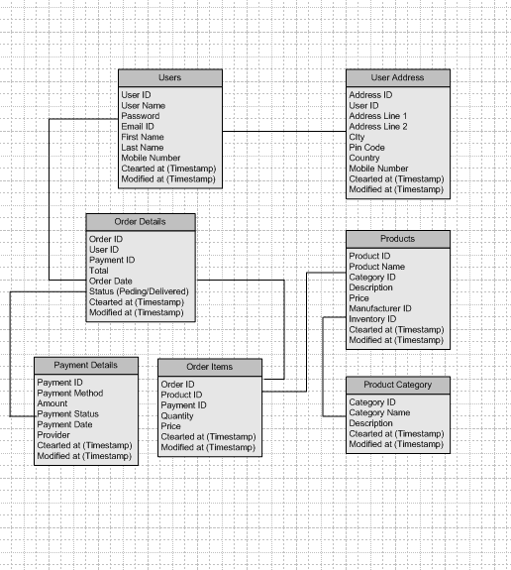

ERD Diagram:
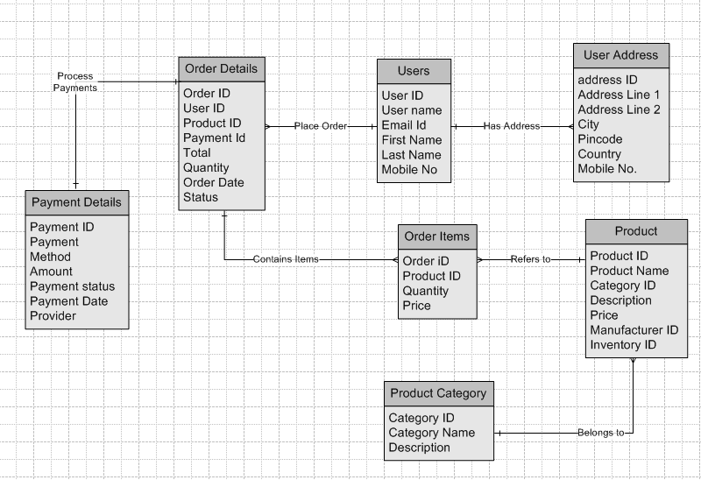

Question 7 – Data Flow Diagram – 3 Marks
What is data flow diagram? Draw a data flow diagram to represent the in-low and out-flow of data when a Farmer is placing an order for the product.
Answer:
Data Flow Diagram
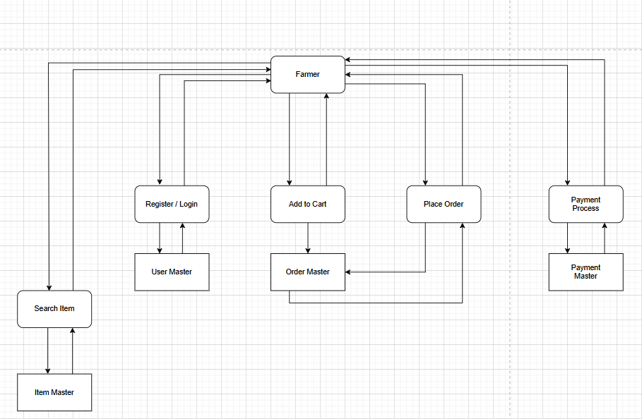

Question 8 – Change Request – 10 Marks
Due to change is the Government Taxation Structure. We should change the Tax Structure how do you handle change requests in a project?
Answer:
Change Request is when the client wants an additional change in any features or functionalities than previously agreed upon deliverables. It will often occur during the SDLC so as a BA (Business analyst) having a plan of action is important. To handle change requests a project we follow the below process:
1. Recording Change Request: We begin by formally recording the change requests to Change Requests Log where we understand the scope of the change.
2. Analyse the Change Request: We do the impact analysis, under which we analyse how the change affects the project’s scope, cost, timeline, resources and risks associated with the change. We do this with PM, Testing Team, BA and Technical Team. The new change requests are also prioritized on the basis of urgency and their impact on the project.
3. Getting Approval: After presenting this analysis to the key stakeholders we seek a formal approval or rejection from them for the change requests. Which we then further communicate to key stakeholders and project teams.
4. Update Requirements: If approved, then documents like BRD and FRD are updated to reflect new change requests. Then with design team we try to integrate or update the new requirements into existing workflows or models.
5. Implementation: The new changes are implemented and system codes are updated. After which we test the new changes, communicate the results and if we get the sign off for PCD then we go live with the system.

Question 9 – Change Requests Vs Enhancement – 5 Marks
As the project is in process, Ben and Kevin have contacted you. The reason is to inform you that they want farmers to sell their crop yields through this application i.e. farmers should be able to sell them. They also want to introduce Auction system for their crop yields. As a BA what will be your response? Is this a change request or an enhancement?
Answer:
This is a request for change request as because this new feature was not defined in the initial scope of the project. It is a change in the functionality.
As a BA I will first clarify the request as an Enhancement, then document the requirements and along with development team will do the impact analysis to see the feasibility. Then I also need to consider the potential risks, benefits, and costs associated with the enhancements.

Question 10 – Estimations – 6 Marks
Come up with Estimations – How many Manhours required.
Answer:
Based on the scope of the project the total man hours estimated is 750 hours, which aligns with the medium sized project duration.
This can be estimated from the project’s duration of 18 months, where we have a team of 15 members who are well trained and do not need any extra training thus saving hours.

Question 11 – UAT – 6 Marks
Project has finally completed all the stages i.e. design, development, testing, etc. Now, it is the role of a business analyst to contact the client for testing of the final product and have to successfully complete it. How are you going to handle this situation? And once it is done what will be the process to close the project? Explain UAT Acceptance process.
Answer:
UAT Acceptance Process ensures that the final software meets the business requirements and is ready for deployment. Below is how this process usually progresses:
1. Planning: It is a detailed plan which defines the scope and objectives of UAT. It also involves identifying features and modules which are to be tested and also setting up criteria for test acceptance.
2. Designing: It involves creating test cases and scenarios to validate functionalities. These scenarios are real-world based scenarios and covers all possible paths within the system.
3. Execution (by UAT Testers): This involves conducting testing by engaging end users in the UAT environment. These end users know the test cases tests are performed on functionalities and usability of the system. Bugs and inconsistencies are recorded during testing.
4. Bug / Fixing: This involves resolving all the issues found during testing by developers. Then retests are conducted to ensure resolutions and make system error free.
5. Sign Off: In it stakeholders validate that the system meets the acceptance criteria and is ready for deployment. Stakeholders review the results and a formal sign off document is prepared. The software is ready to go live.

Question 12 – Project Closure Document – 6 Marks
Explain project closure document.
Answer:
A project closure document also called project closure report is a formal document that summarized the key outcomes, lessons learned, and final details of the completed project. It ensures that all activities have been completed and objectives met.
It is typically created at the end of a project to provide stakeholder knowledge about the project’s achievement, challenges and recommendations for the projects. The main purpose of this document is formal closure, knowledge sharing, and accountability.
Key Points in this document are:
1. Project Overview: Summary of the project, goals, objectives, scope, timeline and budget.
2. Achievements: A list of deliverables and key successes, team efforts and contributions.
3. Lessons Learned: Challenges faced during the project, and were they addressed recommendations for future projects.
4. Quality Assurance: The audits which are conducted to maintain quality standards are met.
5. Resource Allocation: Assessment of resource allocation and usage, team efficiency and resource constraints.
6. Risk Management: Identified risks and how they were mitigated and how effectively they were managed.
7. Challenges: Obstacles faced during the project and how they were tackled.

A basic templated for the Project Closure Document is given below:
S. No. | Points to Include | Details | Reference Link
1. | Did the client sign off on UAT?  Date of the sign-off?  Name of the resource? | Yes/No  09/09/2009  Minakshi | UAT Sign-Off Document
2. | Objective of the project?  User Satisfaction  Functional Completeness | Achieved/Not Achieved  Achieved/Not Achieved | Project Scope Document
3. | Functionalities Worked On  Secure Payment Processing  Managing Listings for Manufacturers | Debit/Credit Card, UPI | Functional Document
4. | Infrastructure  Software Installed  Equipment Purchased | MySQL Database, Apache web browser.  9 Laptops, 3 High performance servers. | Report
5. | Funding  Amount Utilized | Total Budget of 2 cr | Financial Documents
6. | Overall Project Information  Escalations  Customer Satisfaction | 20  High/Moderate/Low
7. | Value to the Company  Other Benefits: | First mover advantage  Increased user base, Company recognition in the industry. | Project outcomes report

