Document 1: Definition of Done
Definition of Done is a team-agreed checklist of criteria that must be met before a backlog item (user story, sprint, or release) is considered complete.
It ensures that deliverables are well-defined, unambiguous, measurable, and agreed-upon by all stakeholders, reflecting both acceptance criteria (customer needs) and quality criteria (technical standards).
Levels of DoD in Agile
User Story DoD – Completion criteria for individual backlog items.
Sprint DoD – Criteria for sprint deliverables.
Release DoD – Criteria for product release readiness.
Checklist for Definition of Done (Applied to GACA – Auto Code Agenda Project)
Acceptance Criteria
- All acceptance criteria of the user story are met.
- Auto-coded agenda reflects correct mapping from MX / MT564 / MT568 messages.
- Business rules for agenda, board recommendations, and proposals are applied.
Quality Criteria
- Produced code builds without errors.
- Unit tests written and passing for all new functionality.
- QA validation complete, no critical or high defects open.
- SIT / Regression executed, results documented.
- UAT feedback incorporated and signed off.
Team & Process Compliance
- Peer code review performed and approved.
- Refactoring completed where necessary.
- UX validation done (if applicable).
- Feature approved by Product Owner.
- Any configuration / build changes documented.
- Process flows and Confluence documentation updated.
Deployment Readiness
- Feature deployed successfully in test environment identical to production.
- Feature tested across required browsers/devices.
- Release notes updated and shared with stakeholders.
Document 2- Product Vision
Scrum Project | GACA Auto Code Agenda Implementation (ICS – Global Proxy Services)
Venue | Broadridge Financial Solutions – Conference Room / Online (MS Teams)
Date | 15th Sept 2025
Start Time: 15:00 | End Time: 16:00 | Duration: 01 hour
Client | Global Proxy Services – Investor Communication Solutions (ICS)
Stakeholder List | Product Owner, Scrum Master, Scrum Team, QA Team, Business Analysts, Compliance Team, Operations Users

Role | Name
Scrum Master | Keeth
Product Owner | Anirudh Gottipamula
Scrum Developer 1 | Rameez Khan
Scrum Developer 2 | Ankitha T
Scrum Developer 3 | Prerana Sharma
Scrum Developer 4 | Md Arif
Scrum Developer 5 | Tousif Uddin

Target Group | Needs | Product | Value
Market Segment: Investor Communication Solutions (ICS) – Global Proxy Services  Target Users: Internal Ops Teams, Corporate Clients, Regulators, Stakeholders | Problem:  Manual agenda entry is time-consuming and delays processing.  Benefit:  Automation improves accuracy, reduces manual effort, and ensures compliance. | Product:  GACA Auto Code Agenda Feature integrated into GACA system.  Speciality:  Automates agenda coding using MX messages & SWIFT MT564/MT568. Feasibility:  Successfully implemented with multiple deployment stages. | Company Benefit:  Faster processing, reduced compliance risks, stronger client trust.  Business Goals:  Reduce manual work by 60–70%, improve operational efficiency.  Business Model:  Better client satisfaction → stronger contracts → reduced operational cost.

Document 3: User stories

User Story: 01 | Tasks: Create edit option - Save updates - Update reports |  | Priority:  Medium
As a Business Analyst, I want to manually edit agendas so that I can customize meeting details before finalization.
BV:50 |  | CP:5
Acceptance Criteria:
User can edit agenda details
Changes saved successfully
Updated agenda visible in reports

User Story: 02 | Tasks: Integrate MX parsing - Map data fields - Deploy & test |  | Priority:  High
As a System User, I want the agenda to be auto-coded using MX messages so that manual entry effort is reduced.
BV: 500 |  | CP: 13
Acceptance Criteria:
Agenda auto-coded via MX
No manual input needed
Matches business rules

User Story: 03 | Tasks: Enable MT 564 input - Validate mapping - Store in DB |  | Priority: High
As a Product Owner, I want the GACA system to support MT 564 messages so that corporate action events are processed automatically.

BV: 200 |  | CP: 8
Acceptance Criteria:
System accepts MT 564
Correctly maps event details
Stores data without errors

User Story: 04 | Tasks: Enable MT 568 input - Validate narrative - Store in DB |  | Priority:  High
As a Product Owner, I want the system to support MT 568 messages so that narrative information about corporate actions is captured.
BV: 200 |  | CP: 8
Acceptance Criteria:
System accepts MT 568
Narrative captured correctly
Data retrievable in agenda

User Story: 05 | Tasks: Add edit functionality - Track changes - Update agenda view |  | Priority:
As a Meeting Administrator, I want board recommendations to be editable so that changes can be reflected before publishing.

BV: 100 |  | CP: 5
Acceptance Criteria:
Admin edits recommendation
Changes saved & tracked
Updated text visible in agenda

User Story: 06 | Tasks: Enable proposal edits - Add save option - Link to agenda |  | Priority:  Medium
As a Manager, I want management proposals to be updated so that the board can review them accurately.
BV: 100 |  | CP: 5
Acceptance Criteria:
Manager can update proposals
Changes saved correctly
Visible in board reports

User Story: 07 | Tasks: Setup environments - Deploy in sequence - Test each stage |  | Priority:  Medium
As a Developer, I want multiple deployment stages (Dev, QA, UAT, Prod) so that the feature can be tested thoroughly before release.

BV: 50 |  | CP: 8
Acceptance Criteria:
✅ Code deploys to Dev, QA, UAT, Prod ✅ Environment stability maintained ✅ All tests pass in each stage

User Story: 08 | Tasks: Write test scripts - Run automation - Log defects |  | Priority:  High
As a QA Tester, I want automated test cases for the auto code agenda feature so that I can validate it works correctly.

BV: 100 |  | CP: 8
Acceptance Criteria:
Automated test cases created
Test scripts run successfully
Errors reported automatically

User Story: 09 | Tasks:  Add change log DB - Track user/time - Generate report |  | Priority:  High
As a Compliance Officer, I want agenda changes to be logged so that audit and compliance requirements are met.

BV: 200 |  | CP: 13
Acceptance Criteria:
All edits logged
Logs show user, time, action
Reports exportable for audit

User Story: 10 | Tasks: Build error handler - Show message UI - Add retry option |  | Priority:  Medium
As a System User, I want real-time error messages if agenda auto-coding fails so that I can correct the issue quickly.

BV: 100 |  | CP: 5
Acceptance Criteria:
Error displayed immediately
Clear explanation provided
Retry option available

User Story: 11 | Tasks: Create status dashboard - Add progress bar - Refresh updates |  | Priority:  Medium
As a Stakeholder, I want status tracking of agenda auto-coding so that I can monitor deployment progress.

BV: 50 |  | CP: 3
Acceptance Criteria:
Status dashboard available
Real-time updates shown
Completed status marked clearly

User Story: 12 | Tasks: Rank backlog items - Sort by ROI - Update JIRA board |  | Priority:  Low
As a Product Owner, I want to prioritize agenda automation stories in the backlog so that the most critical ones are delivered first.

BV: 20 |  | CP: 3
Acceptance Criteria:
Stories sorted by priority
Backlog reflects PO order
Team aligns with priority

User Story: 13 | Tasks: Build notification module - Send email - Add message details |  | Priority:  Medium
As a System User, I want notifications when agenda auto-coding is complete so that I know when data is ready.

BV: 50 |  | CP: 5
Acceptance Criteria:
User receives notification
Message shows agenda details
Delivered via email/system alert

User story No: 14 | Tasks: Schedule review - Present increment - Log feedback |  | Priority: Medium
As a Project Team, I want sprint reviews after every deployment so that feedback is incorporated quickly.
BV: 20 |  | 2
Acceptance criteria:
Sprint review conducted
Stakeholder feedback logged
Action items tracked

User story No: 15 | Tasks: Build reporting module - Compare manual vs auto - Export report |  | Priority:  High
As a Business Analyst, I want the system to generate reports of manually edited vs auto-coded agendas so that I can analyse efficiency gains.
BV: 500 |  | CP: 4
Acceptance criteria:
Report generated
Shows manual vs auto-coded counts
Exportable to Excel/PDF

Document 4: Agile PO Experience
Role of Product Owner
In the GACA application development project, as a Product Owner was to manage requirements, define the product vision, and ensure that the development team delivered features that added business value. Initially, the system required manual editing of agendas, board recommendations, and management proposals, which was time-consuming.
To improve efficiency, I worked with stakeholders and the Scrum Team to introduce a new feature – Auto Code Agenda. This feature automated the agenda creation process using MX messages and ISO formats (MT 564 & MT 568), reducing manual work and increasing accuracy.
Key Responsibilities
- Market & Business Analysis
  - Identified the business need to eliminate manual agenda entry.
  - Compared with existing manual processes and highlighted efficiency gaps.
  - Understood compliance needs related to corporate actions and proxy services.
- Product Vision
  - Defined the product vision to move from manual to automated agenda creation.
  - Prepared a roadmap with incremental deployments (3–4 stages).
  - Ensured the roadmap aligned with stakeholder expectations.
- Managing Product Features
  - Gathered requirements for Auto Code Agenda from business users.
  - Prioritized automation over manual processes based on ROI and time savings.
  - Balanced technical feasibility with business urgency.
- Product Backlog Management
  - Created user stories for Auto Code Agenda.
  - Assigned Business Value (BV) and Complexity Points (CP) to each story.
  - Re-prioritized backlog items across multiple deployment stages.
- Iteration Progress
  - Conducted sprint planning to deliver Auto Code Agenda in phases.
  - Reviewed sprint progress and aligned with stakeholders.
  - Conducted sprint reviews to demo automated agenda creation.
  - Participated in retrospectives to improve future deployments.
Agile Handled
- Sprint Planning: Broke Auto Code Agenda into manageable user stories.
- Daily Scrum: Addressed clarifications for MX, MT 564, MT 568 message handling.
- Sprint Review: Showcased working product increments (agenda auto-generation).
- Retrospective: Captured lessons learned after each deployment stage.
- Backlog Refinement: Updated stories based on stakeholder feedback.
Learning & Contributions
- Gained hands-on experience in automation of corporate agenda processes.
- Learned to manage multi-stage deployments (3–4 phases) successfully.
- Enhanced skills in user story creation, prioritization, and backlog grooming.
- Strengthened collaboration with stakeholders, BAs, and Scrum Team to ensure smooth delivery.
- Ensured business value by reducing manual effort and improving accuracy & compliance.
Document 5: Product and Sprint Backlog & Burndown Charts
Backlog ID | Feature / Epic | Description | Priority | BV | CP
PB-01 | Manual Agenda Editing | Existing functionality (baseline) | Low | 100 | 2
PB-02 | Board Recommendations | Capture & edit board recommendations | Medium | 200 | 2
PB-03 | Management Proposals | Manage proposals manually | Medium | 200 | 2
PB-04 | Auto Code Agenda (MX Integration) | Auto-generate agendas using MX messages | High | 500 | 3
PB-05 | Auto Code Agenda (MT 564 Integration) | Auto-generate agendas using MT 564 | High | 500 | 3
PB-06 | Auto Code Agenda (MT 568 Integration) | Auto-generate agendas using MT 568 | High | 500 | 3
PB-07 | End-to-End Testing & Deployment | Final UAT and multiple deployment stages | High | 500 | 3

Sprint Task ID | Task | Assigned To | Status
SP1-01 | Create user stories for Auto Code Agenda (MX) | PO / BA | Done
SP1-02 | Develop parsing logic for MX messages | Dev Team | In Progress
SP1-03 | Build auto-coding functionality for agendas | Dev Team | To Do
SP1-04 | Test agenda creation with MX data | QA Team | To Do
SP1-05 | Demo feature in Sprint Review | PO / Team | Pending

Product burndown
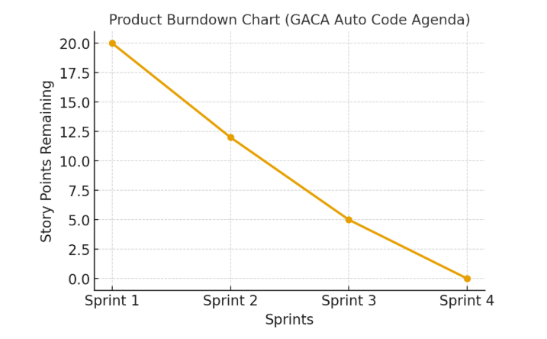
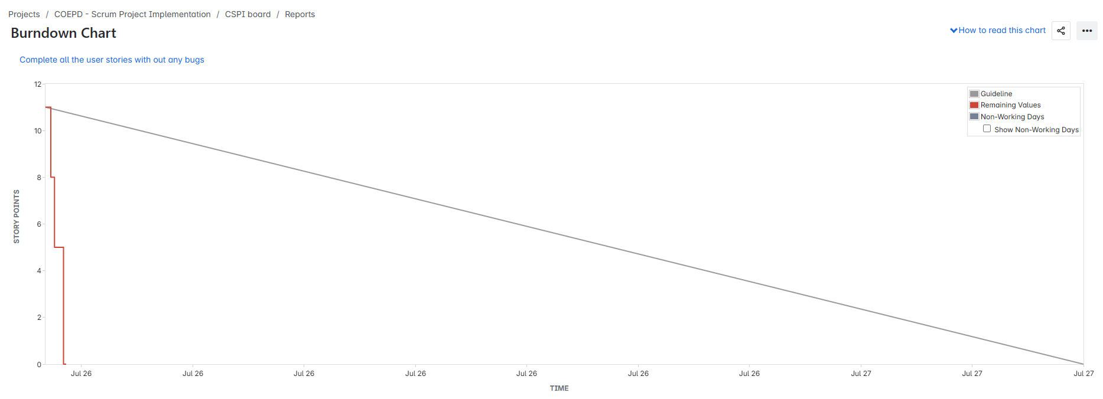
Sprint burndown
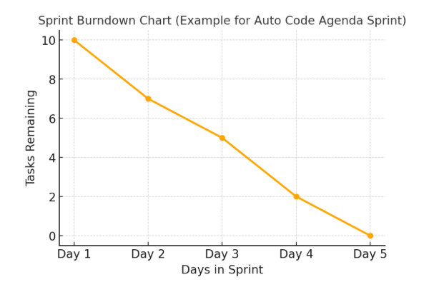
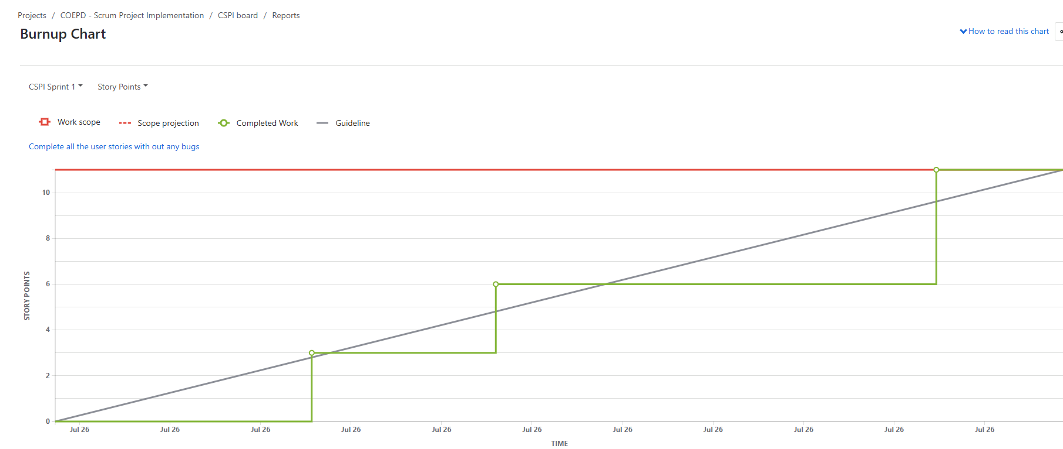
Document 6: Sprint meetings
Meeting Type 1: Sprint Planning meeting
Field | Details
Date | 10-Sep-25
Time | 10:00 AM – 11:30 AM
Location | Online – MS Teams
Prepared By | Business Analyst
Attendees | Product Owner, Scrum Master, Development Team, QA Team

Topic | Presenter | Time allotted
Review Product Backlog (Auto-Code Agenda Feature) | Product Owner | 15 mins
Discuss User Stories & Acceptance Criteria | Business Analyst | 20 mins
Effort Estimation (Story Points) | Development Team | 25 mins
Sprint Goal Definition | Scrum Master | 15 mins
Task Breakdown & Assignment | Development Team | 15 mins

Other Information
Category | Details
Observers | Client Representative
Resources | JIRA, Confluence, MS Teams, MX Messages test environment
Special Notes | New feature “Auto-Code Agenda” introduced with MX messages (MT564, MT568). Multiple deployments (3–4 stages) were required to stabilize feature. Successful deployment completed in previous sprint, focus now on enhancements & bug fixes.

Meeting Type 2: Sprint Review Meeting
Field | Details
Date | 25-Sep-25
Time | 4:00 PM – 5:00 PM
Location | Online – MS Teams
Prepared By | Business Analyst
Attendees | Product Owner, Scrum Master, Development Team, QA Team, Client Stakeholders

Sprint Status | Things to Demo | Quick Updates | What’s Next
Sprint Goal Achieved – Auto-Code Agenda feature deployed successfully with stable MX message integration. | Demo of Auto-Generated Agenda using MX messages (MT564, MT568). End-to-end flow shown from message receipt → parsing → agenda creation. | Minor defects raised during testing resolved. Deployment done in 3–4 phases to ensure stability. | Next Sprint will focus on enhancements – UI improvements for agenda editing, performance optimization, and additional error handling.

Meeting Type 3: Sprint Retrospective Meeting
Field | Details
Date | 26-Sep-25
Time | 3:00 PM – 4:00 PM
Location | Online – MS Teams
Prepared By | Scrum Master
Attendees | Product Owner, Scrum Master, Development Team, QA Team

What went well | What didn’t go well | Questions | Reference
Auto-Code Agenda feature successfully deployed in 3–4 stages. | Delay in parsing and handling MX messages initially. | How can we improve parsing logic earlier in the sprint? | Sprint Backlog & JIRA Board
Good collaboration between BA, Dev & QA teams. | Some UAT defects required multiple re-deployments. | Can regression testing be improved to reduce re-deployments? | UAT Test Cases
Client appreciated the demo of MT564 & MT568 integration. | Coordination between teams during deployments took extra time. | How can communication with client be streamlined? | Retrospective Notes

Meeting Type 4: Daily Stand-up meeting
Question | Name/Role | Monday | Tuesday | Wednesday | Thursday | Friday | Saturday | Sunday
What did you do yesterday? | Developer 1 | Worked on MX message parser (MT564) | Fixed defects in auto-code agenda logic | Reviewed test cases with QA | Updated agenda generation module | Supported deployment stage 2 | N/A | N/A
 | Developer 2 | Set up database scripts for agenda storage | Unit testing of parsing module | Fixed DB indexing issue | Integrated DB with agenda UI | Validated data after deployment | N/A | N/A
 | Developer 3 | Analysed MT568 message handling | Built validation rules | Peer code review | Enhanced error handling | Prepared demo for Sprint Review | N/A | N/A
What will you do today? | Developer 1 | Refactor parsing logic | Validate fixes with QA | Finalize documentation | Support demo prep | Work on enhancements backlog | N/A | N/A
 | Developer 2 | Review defect list | Optimize queries | Prepare deployment checklist | Conduct DB backup | Support Sprint Review demo | N/A | N/A
 | Developer 3 | Write unit test cases | Run regression testing | Assist in deployment validation | Prepare error logs summary | Share lessons learned in retro | N/A | N/A
What (if any) is blocking your progress? | Developer 1 | Delay in MX test message availability | None | None | Need client confirmation on new message rule | None | N/A | N/A
 | Developer 2 | Waiting on updated QA scripts | None | None | Environment downtime | None | N/A | N/A
 | Developer 3 | Dependency on Dev1 parsing logic | None | None | Delay in UAT environment access | None | N/A | N/A

