Nurturing Process – Agile Deliverables –V2D2 August 2024
AGILE DOCUMENTS

Document 1: Definition of Done
Answer :

Document 1: Definition of Done (DoD)

Project Title: ICRM Sales Application with Cloud Telephony Integration
Methodology: Agile – Scrum Framework
Reference: Based on Agile Extension to the BABOK® Guide v2

Definition of Done –
Definition of Done is a checklist of essential criteria that must be fulfilled before a user story or feature is considered “done.” This ensures quality, completeness, and consistency.

In Agile projects, Definition of Done (DoD) is a technique where the entire Scrum team agrees on a clear and common understanding of when a user story or backlog item is considered “complete.”

It ensures that all deliverables meet a standard of quality, functionality, and customer expectations. This shared agreement improves transparency, minimizes rework, and ensures the delivery of potentially shippable product increments.

For the ICRM Sales Application project, which involves the integration of cloud telephony features into ICICI Bank’s internal CRM system, the Definition of Done ensures each functionality (e.g., cloud call, fallback, call status logging) is completed thoroughly and meets business goals like better lead tracking and communication efficiency.

Definition of Done – Checklist
Checklist Item | How It Applies in the ICRM Sales Application
Produced code for presumed functionalities | Code for features like cloud call button, fallback entry, and real-time dashboard updates is written.
Assumptions of User Story met | Assumptions like user having valid lead assigned or internet connection for cloud call are validated.
Project builds without errors | All new modules build successfully in the CI/CD pipeline without errors.
Unit tests written and passing | Developer writes and runs unit tests for functions like API call success/failure and fallback entry.
Project deployed on the test environment identical to production platform | ICRM is deployed on a UAT environment that mimics production to test cloud calling integration.
Tests on devices/browsers listed in the project assumptions passed | The application is tested across devices (desktop, mobile, tablet) and browsers (Chrome, Edge).
Feature ok-ed by UX designer | The placement and flow of the ‘Cloud Call’ button and fallback dialog box are approved by the UI/UX team.
QA performed & issues resolved | QA team executes test cases for successful and failed cloud calls. Bugs are tracked and fixed.
Feature is tested against acceptance criteria | Acceptance criteria like “Cloud call must auto-log status” and “Fallback should be optional” are fulfilled.
Feature ok-ed by Product Owner | PO validates that the feature works end-to-end and solves the identified sales workflow problem.
Refactoring completed | Any duplicate or inefficient code from earlier sprints is cleaned and optimised.
Any configuration or build changes documented | Integration details for Exotel/Twilio APIs and fallback mechanism are added to the configuration guide.
Documentation updated | User manual and training materials for sales staff are updated to reflect new call features.
Peer Code Review performed | Each module is reviewed by at least one other developer to maintain code quality and consistency.

Levels Where DoD Applies:
- User Story Level: Each story (e.g., “As a sales rep, I want to initiate a call from the dashboard…”) must fulfill the DoD items above.
- Sprint Level: Sprint deliverables (e.g., fallback mechanism in Sprint 3) must meet all DoD criteria before closing the sprint.
- Release Level: Final build for Go-Live must also pass all items in DoD to ensure production readiness.

Benefits of Having This DoD
- Prevents partial/incomplete feature delivery
- Reduces chances of miscommunication between BA, PO, QA, and Dev team
- Enhances customer satisfaction by delivering “done” features that work end-to-end
- Supports audit and compliance by ensuring complete documentation and test validation
- Encourages accountability and ownership across the team

Document 2: Product Vision

Scrum Project Name:
ICRM Sales Application – Cloud Telephony Integration

Venue: ICICI Bank Internal Agile Environment
Date: Start Date: 01 August 2025
End Date: 31 October 2025
Duration: 3 Months (6 Sprints of 2 Weeks Each)

Client: ICICI Bank – Retail Sales Division

Stakeholder List
Role | Name
Product Sponsor | Senior VP – Retail Banking
Product Owner | Pradnya Doiphode
Scrum Master | Assigned Internal Agile Coach
End Users | ICICI Field Sales Executives
IT Team | ICRM Backend & Integration Team
QA Team | Internal Quality Assurance Team
Vendor | Cloud Telephony Provider (Exotel/Twilio)

Scrum Team
- Scrum Master: Internal Agile Coach (IT PMO)
- Product Owner: Pradnya Doiphode
- Scrum Developer 1: Front-End Developer (Web)
- Scrum Developer 2: Backend Developer (CRM Integration)
- Scrum Developer 3: API Integration Engineer
- Scrum Developer 4: QA Automation Tester
- Scrum Developer 5: UI/UX Designer

Vision:
To enhance the ICRM Sales Application by integrating cloud telephony and automating the lead follow-up workflow, thereby enabling faster customer engagement, accurate tracking, and improved sales performance for ICICI Bank.

Target Group
Element | Description
Which market segment does the product address? | Banking Sales – specifically ICICI Bank’s retail sales and telecalling operations
Who are the target users and customers? | ICICI sales executives, telecalling agents, and their supervisors/managers

Needs :
Question | Answer
What problem does the product solve? | Eliminates the manual effort of calling customers and updating lead status separately, which causes delays, errors, and poor visibility.
Which benefit does it provide? | Enables real-time cloud-based calling from the dashboard, auto-logging of call status, fallback for failed calls, improved accountability, and better performance insights.

Product:
Question | Answer
What product is it? | A cloud-telephony-integrated ICRM Sales Application
What makes it desirable and special? | It automates the calling workflow, ensures real-time data sync, offers mobile access for field reps, and supports fallback entry.
Is it feasible to develop the product? | Yes – APIs from providers like Exotel/Twilio are available, and integration is already planned in phases. Internal teams and stakeholders are aligned.

Value :
Question | Answer
How is the product going to benefit the company? | Increases lead conversion efficiency, reduces TAT (Turnaround Time), improves follow-up accountability, and enhances the customer experience.
What are the business goals? | - 80% reduction in lead leakage - 30% improvement in contact-to-conversion ratio - 100% training coverage for sales staff
What is the business model? | Internal productivity enhancement tool – cost-saving and ROI-driven. Helps scale sales across products like loans, credit cards, and insurance.

Document 3: User Stories
Answer :

User Stories (ICRM Cloud Telephony Project)

1 . User Story No: US001 :

User Story No: US001 – Manual Fallback Entry | Tasks: Design fallback modal, add status dropdown, remarks field |  | Priority: Medium
Value Statement:

As a sales executive, I want to manually enter the call result when cloud calling fails so that I can still track customer interaction.
BV: 200 |  | CP: 5
Acceptance Criteria:
- Fallback modal appears only when cloud call fails.
- Status dropdown must be selected before saving.
- Remarks field is optional and limited to 250 characters.
- Entry is saved to the lead’s activity log with timestamp.
- Label “Manual Entry” appears in call history view.

2. User Story No: US002

User Story No: US002 – Contactability Dashboard | Tasks: Build dashboard panel, fetch call log data, real-time refresh |  | Priority: High
Value Statement:
As a manager, I want to view live contactability scores so that I can track my team’s performance accurately.

BV: 500 |  | CP: 5
Acceptance Criteria:
- Dashboard updates contactability metrics in real-time.
- Includes filters for date, team, and user level.
- Visual graphs show daily and weekly performance.
- Auto-refresh occurs every 10 seconds.
- Accessible across desktop and mobile.

3.. User Story No: US003 :

User Story No: US003 – Lead Activity Tracker | Tasks: Link call logs with lead profile, show past interactions |  | Priority: Medium
Value Statement:

As a sales executive, I want to view all previous calls and notes for a lead so that I can follow up meaningfully

BV: 200 |  | CP: 5
Acceptance Criteria:
- Shows list of past calls with date and time.
- Includes remarks and call outcomes for each entry.
- Entries are read-only for the user.
- Sorted by most recent activity first.
- Available in both web and mobile formats.

4.. User Story No: US004
User Story No: US004– Mobile Compatibility | Tasks: Optimize UI for mobile, enable calling via app |  | Priority: High
Value Statement:

As a field executive, I want to access ICRM from my mobile so that I can manage leads while travelling
BV: 500 |  | CP: 5
Acceptance Criteria:
- UI is responsive on mobile browsers and app.
- Cloud calling feature works via mobile.
- Data syncs in real-time across devices.
- Dashboard widgets fit mobile screen properly.
- Login/logout process works smoothly on mobile.

5.User Story No: US005:
User Story No: US005– Training Module Integration | Tasks: Add user guide, embed videos, setup FAQ |  | Priority: Low
Value Statement:

As a new user, I want onboarding material in the app so that I can understand how to use the new calling features.

BV: 100 |  | - CP: 3
Acceptance Criteria:
- Help tab contains guide, videos, and FAQ.
- Videos are accessible within the app without redirection.
- FAQ is searchable using keywords.
- Works on both mobile and desktop.
- Help section is always accessible from the dashboard.

6. User Story No: US006:
User Story No: US006– Supervisor Performance View | Tasks: Build supervisor view, filter by team member, call outcomes |  | Priority: Medium
Value Statement:

As a supervisor, I want to see each team member’s call success rate so that I can identify top performers and give support.
BV: 200 |  | - CP: 5
Acceptance Criteria:
- Supervisor dashboard shows user-wise call metrics.
- Allows filtering by date and team.
- View includes success rate as a percentage.
- Graph view available for comparison.
- Access restricted to supervisors only.

7 . User Story No: US007 :
User Story No: US007 – Lead Follow-Up Reminders | Tasks: Add scheduler, push notifications, sync with call outcomes |  | Priority: Medium
Value Statement:
As a sales executive, I want to get follow-up reminders for missed calls so that I don’t forget to re-engage leads.

BV: 200 |  | CP: 3
Acceptance Criteria:
- Missed call automatically adds to follow-up queue.
- Reminders pop up as notifications at scheduled time.
- Executives can reschedule or dismiss reminders.
- Follow-up log is visible on lead profile.
- Notification system works on mobile and desktop.

8 .User Story No: US008:
User Story No: US008 – User Role Permissions | Tasks: Create role-wise access (Executive vs Manager), hide restricted actions |  | Priority: High
Value Statement:

As an admin, I want to define permissions so that users only access features relevant to their role

BV: 500 |  | CP: 3
Acceptance Criteria:
- Executives can only view and update their leads.
- Managers can access team performance reports.
- Role-based access controls implemented in backend.
- Unauthorized actions are hidden from the UI.
- Admins can update roles via settings panel.

9.. User Story No: US009
User Story No: US009– Reports and Downloads | Tasks: Generate call reports (daily/weekly), download CSV, email option |  | Priority: Low
Value Statement:
As a manager, I want to download call activity reports so that I can share them during review meetings.

BV: 100 |  | CP: 5
Acceptance Criteria:
- Reports can be filtered by date range.
- Download available in Excel and PDF.
- Includes agent-wise call count and duration.
- Email option allows direct sharing from app.
- Download access is permission-based.
10 .User Story No: US010
User Story No: US010 – Call Recording Log | Tasks: Capture call duration, record start/end time, and store logs |  | Priority: Medium
Value Statement:
As a manager, I want to track call durations and timestamps so that I can analyze agent efficiency.

BV: 200 |  | CP: 3
Acceptance Criteria:
- Logs include call start and end times.
- Duration is calculated automatically.
- Logs appear in the lead’s activity section.
- Call data can be exported in reports.
- Access is limited to managers and admins.

11. User Story No: US011
User Story No: US011– API Failure Alerts | Tasks: Set up alert system, notify admin if telephony API fails |  | Priority: High
Value Statement:
As a system admin, I want to receive alerts for API failures so that I can take immediate corrective action.

BV: 500 |  | CP: 3
Acceptance Criteria:
- Alert is generated when API call fails.
- Email and dashboard notification sent to admin.
- Includes error code and failure reason.
- Time of failure is logged.
- Alert disappears after issue is resolved.

12. User Story No: US012
User Story No: US012– Data Privacy Consent Capture | Tasks: Show popup for customer consent before call, store response |  | Priority: High
Value Statement:
As a compliance officer, I want to ensure customer consent is taken before recording calls so that we follow regulatory norms.

BV: 500 (high) |  | CP: 5
Acceptance Criteria:
- Consent popup appears before call is placed.
- Call cannot proceed without user’s response.
- Response is logged with timestamp.
- Consent history is stored in lead profile.
- Feature available across all devices.

13 . User Story No: US013 :
User Story No: US013– Retry Option for Failed Calls | Tasks: Add “Retry” button on failed calls, re-initiate API call |  | Priority: Medium
Value Statement:
As a sales rep, I want the option to retry a failed call immediately so that I don’t lose time searching for the lead again.

BV: 200 |  | CP: 3
Acceptance Criteria:
- Retry button appears after failed call.
- Click triggers same API with same lead.
- New attempt is logged in activity history.
- Retry is limited to 3 times per lead.
- Retry button disappears once successful.

14. User Story No: US014
User Story No: US014  – Multi-Product Lead Handling | Tasks: Enable lead categorization (Loan, Credit Card, Insurance), apply filters |  | Priority: Medium
Value Statement:
As a sales executive, I want to filter my leads by product type so that I can manage my tasks more efficiently.

BV: 200 |  | CP: 3
Acceptance Criteria:
- Leads are tagged by product at creation.
- Dashboard filters allow sorting by product type.
- Product tag visible in lead details.
- Filtered results show only relevant leads.
- Report generation supports product-based filters.

Document 4: Agile PO Experience
Answer :

Document 4: Agile Product Owner (PO) Experience

Project: ICRM Sales Application – Cloud Telephony Integration
Role: Product Owner (PO) – Pradnya Doiphode

1. Market Analysis

As the Product Owner, my first responsibility was to understand the market demand and current challenges faced by ICICI Bank’s sales teams. After speaking with stakeholders and reviewing field feedback, I identified the need for automating manual call handling, especially for executives using personal phones to contact leads.

I also studied tools like Exotel and Twilio, which offer cloud telephony services, and verified their relevance to internal banking CRMs. Additionally, I assessed similar CRM enhancements in peer banks to compare features.

2. Enterprise Analysis

I carried out a feasibility study to determine if integrating a telephony system within ICICI’s ICRM was possible.

This included:
- Evaluating the technical architecture of the existing CRM
- Understanding data security and compliance needs
- Confirming that sales executives lacked real-time call tracking, leading to poor conversion visibility

This helped justify the project’s need to higher management and secure necessary approvals.

3. Product Vision and Roadmap
I created a clear Product Vision: 'To integrate a cloud telephony system with ICRM to streamline sales call workflows, automate lead updates, and enable better tracking and conversions.' I prepared a roadmap that included:
- Phase 1: Cloud call feature and auto-logging
- Phase 2: Fallback for failed calls
- Phase 3: Real-time dashboard and performance reporting
- Phase 4: Mobile compatibility for field executives

Each phase was aligned with sprint planning in Agile methodology.

4. Managing Product Features

Managing expectations from both business and IT stakeholders was critical. I prioritized the features based on:
- Impact on user experience (e.g., cloud call button was top priority)
- Compliance and fallback mechanisms for when calls failed
- KPI reporting for sales managers

I used MoSCoW prioritization (Must Have, Should Have, Could Have, Won’t Have) to finalize which epics and features would be part of MVP.

5. Managing Product Backlog

I created and maintained the Product Backlog, starting with epics like:
- Cloud Call Integration
- Manual Call Logging
- Dashboard Enhancements
- Mobile App UI Optimization

Each epic was broken down into user stories with tasks, BV (Business Value), and CP (Complexity Points). I also reprioritized stories based on real-time feedback in sprint reviews or after UAT sessions.

6. Managing Overall Iteration Progress

As PO, I tracked sprint progress through daily stand-ups, Jira boards, and sprint review meetings.

I collaborated with the Scrum Master and team to:
- Remove blockers
- Adjust priorities during Sprint Review
- Analyze completed vs. pending backlog
- Support Sprint Retrospectives to improve planning and delivery

7. Sprint Meeting Participation & Ownership

From this project, I actively participated and gained experience in all key Agile ceremonies:
- Sprint Planning Meeting: Defined sprint goals, clarified scope with the team, and helped estimate story points.
- Daily Scrum Meeting: Attended stand-ups to monitor progress, understand blockers, and align with development.
- Sprint Review Meeting: Demonstrated completed features (e.g., cloud call button, fallback modal), collected feedback from ICICI stakeholders.
- Sprint Retrospective Meeting: Contributed to discussions on what went well or didn’t (e.g., API delay issue).
- Backlog Refinement Meeting: Regularly refined stories, adjusted priorities based on feedback from the field.

8. User Story Ownership and Design

I learned how to write and maintain user stories by including the following components:
- Story No. (e.g., US001: Cloud Call Integration)
- Tasks (e.g., Integrate Exotel API, design button)
- Priority (e.g., High)
- Acceptance Criteria (clear, testable)
- BV (Business Value) and CP (Complexity Points)

These stories helped ensure clarity for the development team and traceability for all stakeholders.

9. Cross-Functional Collaboration
As the PO, I acted as a liaison between stakeholders, users, and the development team. I ensured all team members had a shared understanding of project goals and could align sprint outputs with business needs.

Document 5: Product and sprint backlog and product and sprint burndown
charts

Answer :

Product Backlog

The Product Backlog is a complete list of all features, enhancements, fixes, and technical tasks that need to be delivered in the product. It is dynamic and evolves throughout the project.

Summary:
- Product Backlog = Full list of features for the product
- Sprint Backlog = Work committed for the sprint
- Product Burndown = Tracks total project progress
- Sprint Burndown = Tracks daily sprint progress

Key Points:
- Owned and prioritized by the Product Owner
- Contains user stories, each with tasks, BV (Business Value), CP (Complexity Points), and priority
- Updated regularly during backlog refinement sessions
- Represents the entire scope of the project

Product Backlog

User Story ID | User Story | Tasks | Priority | BV | CP | Sprint
US01 | As a Sales Executive, I want to login securely, so that I can access the CRM portal | UI Design, Development, Unit Testing | High | 500 | 3 | Sprint 1
US02 | As a Sales Executive, I want to view my leads, so that I can know whom to contact | Create API, UI Page, Integration | High | 500 | 5 | Sprint 1
US03 | As a Sales Manager, I want to assign leads to executives, so that work is distributed | UI Screen, Workflow Logic, Testing | High | 500 | 5 | Sprint 1
US04 | As a Sales Executive, I want to update lead status, so that progress is captured | Design Input Form, Develop, Test | Medium | 200 | 5 | Sprint 1
US05 | As a Sales Manager, I want dashboard reports, so that I can monitor performance | Chart design, Report Integration | Medium | 200 | 13 | Sprint 2
US06 | As a Sales Executive, I want to add follow-up notes, so that client history is maintained | Rich Text Box, Backend Store | Medium | 200 | 3 | Sprint 2
US07 | As an Admin, I want to manage user roles, so that access control is maintained | Role Matrix, CRUD Pages | Medium | 200 | 5 | Sprint 2
US08 | As a Sales Executive, I want notification alerts, so that I am reminded to follow-up | Scheduler Logic, Email/SMS Trigger | Low | 100 | 3 | Sprint 3
US09 | As a Sales Manager, I want to filter leads by region, so that I see relevant data | Add Filters, API changes | Low | 100 | 5 | Sprint 3
US10 | As an Executive, I want to reset my password, so that I can regain access when forgotten | Forgot Password Flow, OTP, Mail | Medium | 200 | 5 | Sprint 3

Sprint Backlog
User Story ID | User Story | Tasks | Owner | Status | Estimated Effort (hrs)
US01 | As a Sales Executive, I want to login securely, so that I can access the CRM portal | Design login UI, Develop API, Create user DB, Add validations, Test login flow | Dev1 | In Progress | 12
US02 | As a Sales Executive, I want to view my leads, so that I can know whom to contact | Create leads API, Design list view UI, Integrate API, Add pagination, Test view | Dev2 | Not Started | 16
US03 | As a Sales Manager, I want to assign leads to executives, so that work is distributed | Create assign screen, Build API, Executive dropdown, Assign logic, Testing | Dev3 | In Progress | 14
US04 | As a Sales Executive, I want to update lead status, so that progress is captured | Build status update form, Status API, Remarks box, UI link, Testing | Dev4 | Not Started | 10
US05 | As a Sales Manager, I want dashboard reports, so that I can monitor performance | Design charts, KPI setup, Backend integration, Filters, Testing | Dev2 | Not Started | 18
US06 | As a Sales Executive, I want to add follow-up notes, so that client history is maintained | Notes input box, DB schema update, Auto-save logic, UI and testing | Dev4 | Not Started | 12
US07 | As an Admin, I want to manage user roles, so that access control is maintained | Role matrix creation, CRUD UI, Assign permissions logic, Testing | Dev1 | Not Started | 14
US08 | As a Sales Executive, I want notification alerts, so that I am reminded to follow-up | Setup scheduler, Alert logic, Notification channel config, Retry mechanism | Dev3 | Not Started | 15
US09 | As a Sales Manager, I want to filter leads by region, so that I see relevant data | Add region filter, Modify API, Update UI with dropdown, Test filtering | Dev2 | Not Started | 10
US10 | As an Executive, I want to reset my password, so that I can regain access when forgotten | Forgot password UI, OTP generation, Mailer config, Reset flow, Testing | Dev1 | Not Started | 13

Product Burndown Chart :
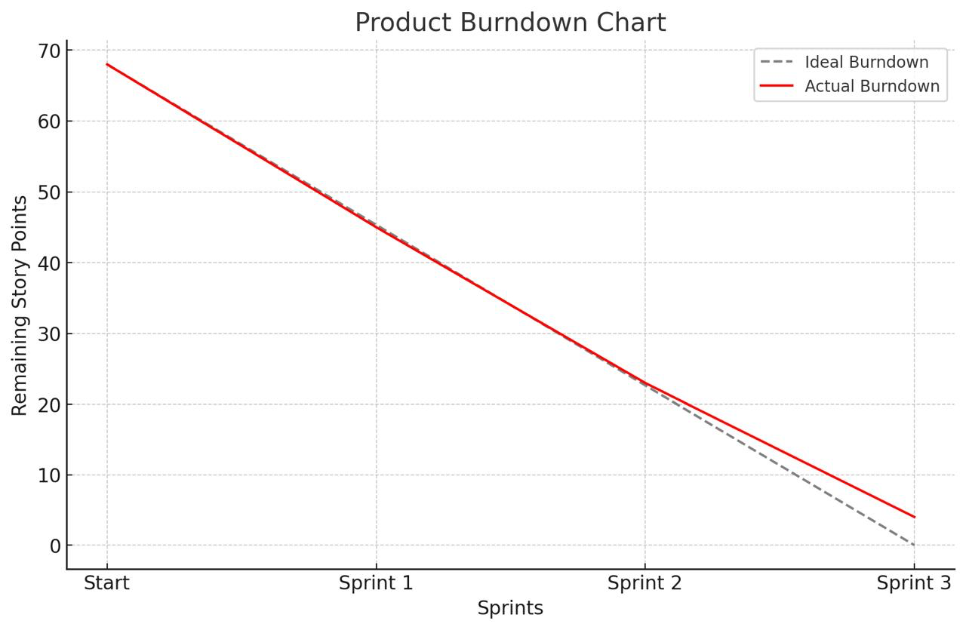

Chart Shows:

- Grey dashed line → Ideal progress
- Red solid line → Actual progress

A Product Burndown Chart tracks the overall progress of the product development. It shows how much scope is remaining against time.
Key Points:
- X-axis: Time (days/sprints)
- Y-axis: Total story points remaining
- Used by PO and stakeholders to track project velocity
- Updated after every sprint

Sprint Burndown Chart

The Sprint Burndown Chart tracks daily progress during a sprint.
This chart compares:
- Ideal Burn – how the team should ideally progress across 5 sprints.
- Actual Burn – actual completion of story points based on entries
Key Points:
X-axis: Sprint days
Y-axis: Remaining story/task points
Shows how fast the team is completing work
Helps identify if the sprint is on track or behind
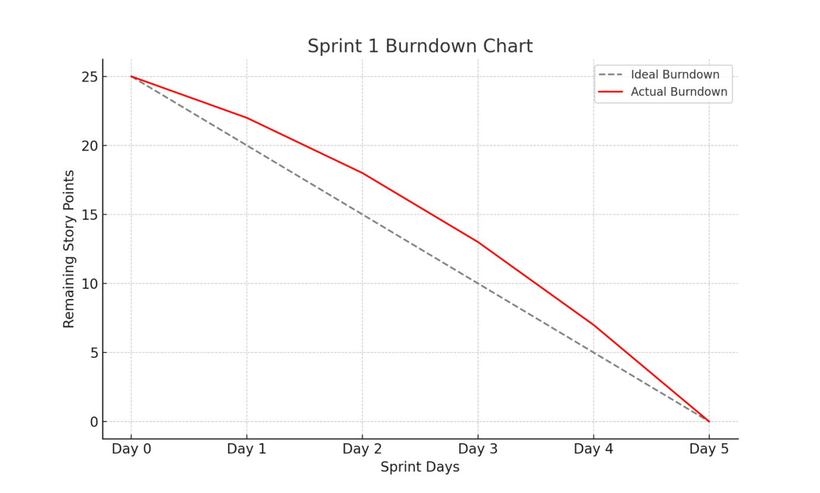

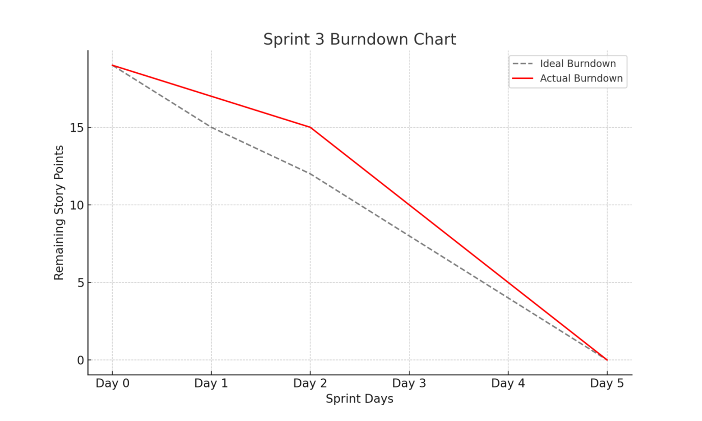

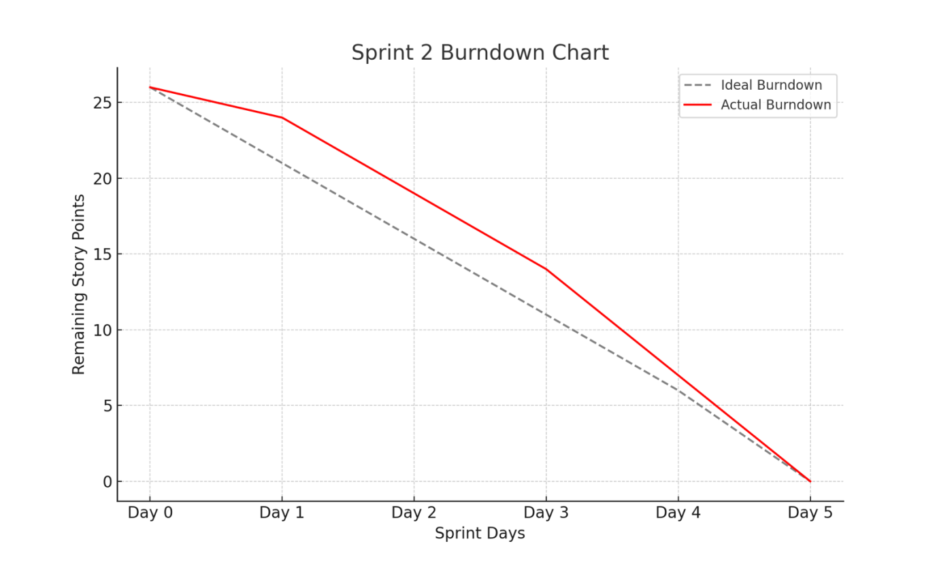

Sprint burndown chart

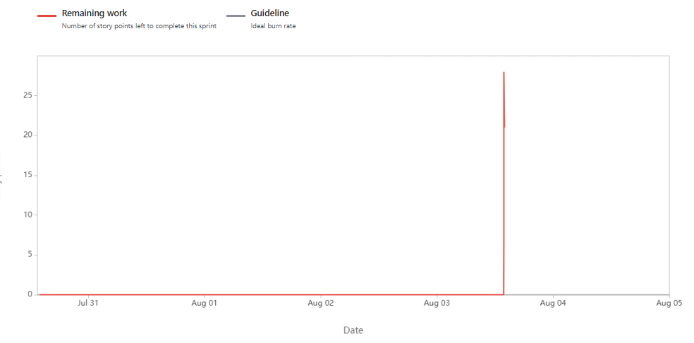

Burnup report
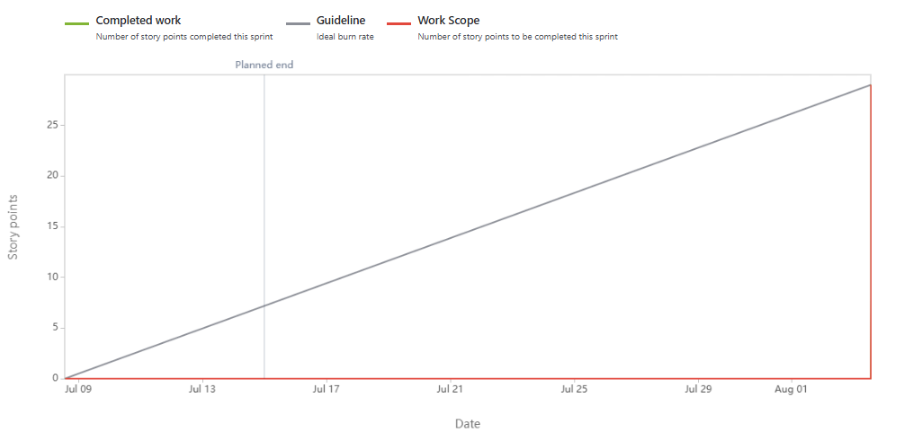

Document 6: Sprint meetings

Answer:

  - Sprint Planning Meeting

Date | 01-07-2025
Time | 10:00 AM – 11:30 AM
Location | Scrum Room 1 / Zoom (Hybrid Setup)
Prepared By | Product Owner
Attendees | Product Owner, Scrum Master, Development Team

Agenda Topics
Topic | Presenter | Time Allotted
Product Backlog Review | Product Owner | 30 mins
Story Prioritization& Selection | Scrum Master | 30 mins
Task Estimation & Sprint Goal | Development Team | 30 mins

Other Information
Observers | Business Analyst, QA Lead
Resources Used | JIRA Sprint Board, Product Backlog Document
Special Notes | Sprint Capacity: 25 Story Points

Meeting Type 2: Sprint Review Meeting
Date | 15-07-2025
Time | 4:00 PM – 5:00 PM
Location | Client Conference Room / Zoom
Prepared By | Scrum Master
Attendees | Scrum Team, Product Owner, Stakeholders

Meeting Sections
Sprint Status | 12 user stories were planned, 10 were completed successfully
Things to Demo | Lead Activity Tracker, Retry Call Button, Contactability Dashboard
Quick Updates | US012 and US014 moved to next sprint due to delay in API integration
What’s Next | Prioritizing Consent Popup and Product Tag Filters in Sprint 2

3. Sprint Retrospective Meeting Table

Date | 16-07-2025
Time | 11:00 AM – 12:00 PM
Location | Scrum Room 2
Prepared By | Scrum Master
Attendees | Scrum Master, Product Owner, Development Team

Agenda Discussion
Agenda | Details
What went well | Most user stories were completed on time; excellent team collaboration and testing.
What didn’t go well | Integration with cloud API caused delays in two user stories.
Questions | How to handle external dependency issues in upcoming sprints?
Reference Documents | Sprint Burndown Chart, Velocity Chart, Daily Stand-Up Tracker

4. Daily Stand-up Meeting Table

Question | Name / Role | Mon | Tue | Wed | Thu | Fri | Sat | Sun
What did you do yesterday? | Dev 1 | Created API | UI Fix | Worked on consent module | Completed testing | Reviewed code | – | –
Dev 2 | UI design | Filter logic | Generated reports | Dashboard check | Fixed bugs | – | –
Dev 3 | Activity Log | Retry button | Data export | Synced data | Help Tab QA | – | –
What will you do today? | Dev 1 | UI testing | Final checks | Send for QA | Resolve issues | – | – | –
Dev 2 | Dashboard QA | Code cleanup | Final validation | – | – | – | –
Dev 3 | QA final pass | Consent popup | Deploy fixes | – | – | – | –
Is anything blocking progress? | Dev 1 | – | API issue | – | – | – | – | –
Dev 2 | – | – | Waiting for design asset | – | – | – | –
Dev 3 | Sync issue | – | – | –

