CAPSTONE PROJECT – SIMILAR CASE STUDY
(Prep 1 – Part 1)

Q.no 1:
Identify Business Process Model for Online Agriculture Store – (Goal, Inputs, Resources, Outputs, Activities, Value created to the end Customer)
Answers:-
A business process modelling is a collection of activities designed to produce a specific output for a particular customer or market.
It has below points:
Goal - To make an online agriculture product store where farmers and companies can communicate directly with each other.
Inputs - Farmer’s data, Agricultural products, Employees, Agriculture expert’s opinion, Portfolio of agriculture products.
Resources – Warehouses, Software, Hardware, Office area, Supply Chain, Expert’s team, 3rd party vendors.
Output – Efficient results, online agricultural platform.
Activities – Excellent customer service and collaboration with other companies, support team to
resolve the queries of the farmers.
Value of end-user – Farmer’s satisfaction through delivery of good products, take feedback from the farmers and try to implement them.

Q.no 2:
Mr Karthik is doing SWOT analysis before he accepts this project. What Aspects he Should consider as Strengths, as Weaknesses, as Opportunity and as Threats.
Answers: -
A SWOT analysis is a strategic planning tool that helps us identify and evaluate internal and external factors, which impacts an organization or an individual. It is used to identify strengths, weaknesses, opportunities, and threats for a project.
Strength –
Agricultural products sent from farmers to distributors.
Good budget and time.
Online shopping, delivery at town in less time.
All products in one place.
Experienced persons are handling with utmost care.
Payment options with details of products.

Opportunity-
This platform can get huge access in market.
We can add value to the product and make life easy.
Earns lots of revenue.
Expand our services.
New market for agriculture field.
Online shopping in town.
Weakness –
Risk if the project doesn’t work good.
Lack of digital awareness.
Lack of knowledge.
Lack of proper communication between farmers and companies.
Threats-
Less chances of digital platforms.
Delivery of products to remote areas.
Need to hire more delivery persons.
If similar product raised in market newly, it will make us down.
Disturb supply if it has floods etc.

Q.no 3:
Mr Karthik is trying to do feasibility study on doing this project in Technology (Java), Please help him with points (HW SW Trained Resources Budget Time frame) to consider in feasibility Study.
Answers:-
Feasibility study is a possibility of doing project with some constraints like technology, budget,
time etc.
Technology used – Database , JAVA (programming language)
Budget- 2 crore
Time – 18 months
Hardware – Servers, Network, Devices.
Software - Operating system, E-commerce, security.

Trained Resources - Availability , capabilities of trained resources with expertise in Java and
web design.

Q.no 4:
Mr Karthik must submit Gap Analysis to Mr Henry to convince to initiate this project. What points (compare
AS-IS existing process with TO-BE future Process) to showcase in the GAP Analysis.
Answers:-
Gap Analysis is a process of comparing a company’s current performance to its desired performance.
Current State:-
Farmers often face difficulty in finding the products.
Farmers need to buy agriculture products directly.
Products not found on time.
Transportation issue.
Shortage of products as it had demand.
Desired State:-
Farmers can buy the products directly from the manufactures at low price.
Online platforms where farmers can buy all products in single place.
It should be farmers understanding language.
Track the products.

Q.no 5:
List down different risk factors that may be involved (BA Risks And process/Project Risks)
Answers : -
Risk analysis is a process of identifying, evaluating, and prioritizing potential risks that could negatively impact a project, business, or activity.
BA Risks:-
- Without knowledge of agriculture industry and needs of farmer’s in remote area.
- Lack of proper communication can make BA not understand the requirements .
- Improper requirements can waste time, cost.
- Manage stakeholders in handling situation.
- As the farmers stay in remote area, we will have difficulty in requirements collection etc.

Project Risks:-
- Limited internet connection as its remote area.
- Delay in products delivery.
- Security risk is also there because the products need to handled with care.
- Bring awareness in farmers to cdonvince them use online platform.
- Online platform should work without any issue.

Q.no 6:
Perform stakeholder analysis (RACI Matrix) to find out the key stakeholders who can take Decisions and Who are the influencers.
Answers:-
RACI Matrix stands for Responsible, Accountable, Consulted and Informed. It is a matrix which shows
the roles and responsibilities of stakeholders in a project.
Below is the RACI Matrix of our project:

Tasks | Project  Sponser | Stake-  holders | Delivery  Head | Project  Manager | Sr.Java  Developer | Java  Developer | Tester | BA
Requirements gathering |  | C |  | A/I |  |  |  | R
Requirements  analysis |  |  |  | I |  |  |  | R
Development |  |  |  | R/A | R/A/C | R
Testing |  |  |  | I | I |  | R | I
Implemen-  tation |  |  | R | I |  |  |  | R
UAT | I |  |  | R/A |  |  |  | I

Mr. Henry – project sponser
Mr Pandu – Finacial Head
Mr Dooku – Project coordinator
Peter, Kevin, Ben – Stakeholders
Mr Karthik – Delivery head
Mr Vandanam – project manager
Ms Juhi – Senior java developer
Mr Teyson , Ms Lucie, Mr Tucker, Mr Bravo – Java Developers
Mr Mike – Network Admin
Mr John – DB Admin
Mr Jason, Ms Alekya – Tester
Kirti Raheja - BA

Q. no 7:
Help Mr Karthik to prepare a business case document.
Answers:-
A business case is a document that explains why a business should invest in a project . It’s used to help decision maker to decide whether to move forward with a project or not.
The application will promote the use of quality products with our online application. Below are the questions:

- Why is this project initiated?

Henry wants to develop a online store where all the farmers can satisfy there needs.

- What are current probleems?

Farmers are not able to buy seeds and pesticides in remote area which are essential for farming.

- What are the resources required?

Seelers, Dealers, Farmers, Investors, Bank, Delivery persons, JAVA developers, managers, BA,
DB admin, Network admin, Tester

- How much changes should be done to make this technology acceptable?
We need man power, Technology, hardware, software products.
- What is the time frame of the project?
18 months is the project duration
- How to identify stakeholders?

Peter, Kevin, Ben are stakeholders. Which we can see in RACI matrix.

Q. no 8:
The Committee of Mr. Henry , Mr Pandu , and Mr Dooku and Mr Karthik are having a discussion on
Project Development Approach.
Mr Karthik explained to Mr. Henry about SDLC. And four methodologies like Sequential Iterative Evolutionary and Agile. Please share your thoughts and clarity on Methodologies.
Answers:-
There are many project development approach. As Mr. Karthik told henry about SDLC methologies.
We have 4 methodologies like Sequential , Iterative, Evolutionary and Agile. Below are the details:
Sequential :-
This is the most common SDLC models, it is also referred to as a linear-sequential life cycle model. Each phase must be completed in its entirety before the next phase can begin. This method is best suited for projects with well-defined requirements, low risk, and predictable outcomes.

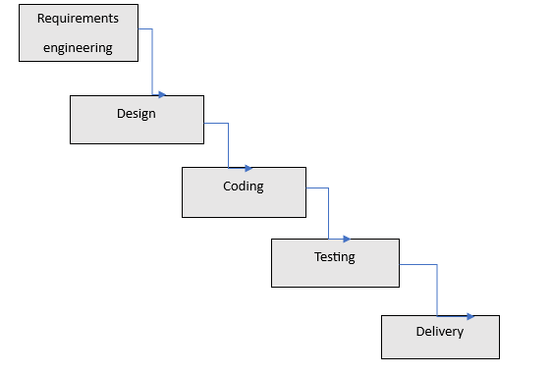

Iterative:-
This methodology involves developing the software in iterations, where each iteration builds upon the previous one. There are Four Project Life cycle Phases namely Inception, Elaboration, Construction, Transition. This method is best suited for projects with complex requirements and high risk.
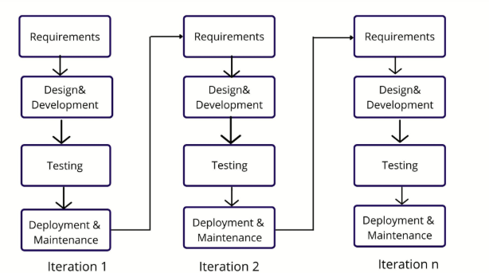

Evolutionary :-
This methodology involves developing a basic version of the software and then incrementally improving it. The spiral model gives more emphases placed on risk analysis.
The spiral model has four phases: Planning, Risk Analysis, Engineering and Evaluation. This method is best suited for projects with rapidly changing requirements and high risk.

Agile :-
This methodology is based on an iterative and incremental approach, and involves close collaboration between the development team and stakeholders. Agile methodology Satisfy the customer through early and continuous delivery of valuable software. This method is best suited for projects with rapidly changing requirements, high risk, and complex environments.

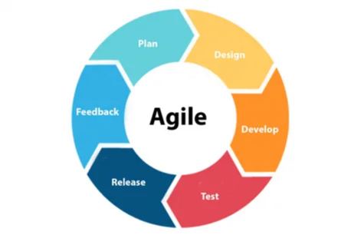

Q .no 9:
They discussed models in SDLC like waterfall RUP Spiral and Scrum . You put forth your understanding on these models

When the APT IT SOLUTIONS company got the project to make this online agriculture product store,
there is a difference of opinion between a couple of SMEs and the project team regarding which
methodology would be more suitable for this project. SMEs are stressing on using the V model and
the project team is leaning more onto the side of waterfall model. As a business analyst, which
methodology do you think would be better for this project?
Answers:-

Waterfall Model:
The Waterfall model is a linear application development model which uses rigid phases. When one phase end the next phase stars.

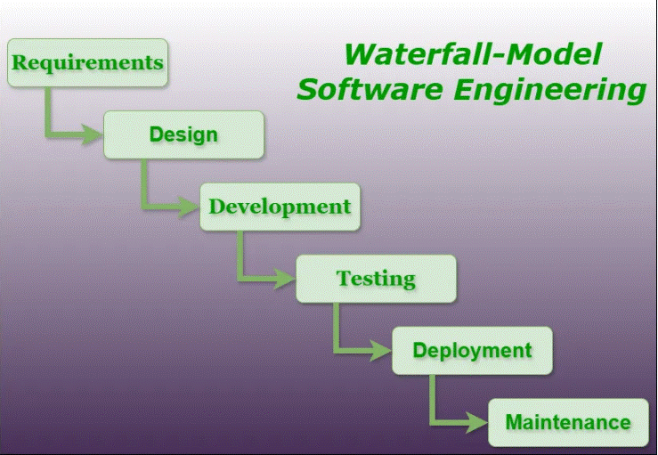

Advantages:
- Easy to Understand
- Individual Processing
- Properly Documented

Disadvantages:
- Limited Flexibility
- No Overlapping of Phases

RUP (RATIONAL UNIFIED PROCESS) :-
It is an agile software development methodology. It has 5 phases (Inception, Elaboration, Construction,Transition,Production)

Inception -
  - Communication and planning are the main ones.
  - Identifies the scope of the project, estimate costs and time required.

Elaboration -
  - Planning and modeling are the main ones.
  - A detailed evaluation and development plan is carried out and diminishes the risks.

Construction -
  - The project is developed and completed.
  - System or source code is created and then testing is done.
  - Coding takes place.

Transition -
  - The final project is released to the public.
  - Transit the project from development into production.
  - Update project documentation.
  - Beta testing is conducted.
  - Defects are removed from the project based on feedback from the public.

Production -
  - The final phase of the model.
  - The project is maintained and updated accordingly.

Advantages :
- RUP provides risk-management support.
- RUP reuses the components, and hence total time duration is less.

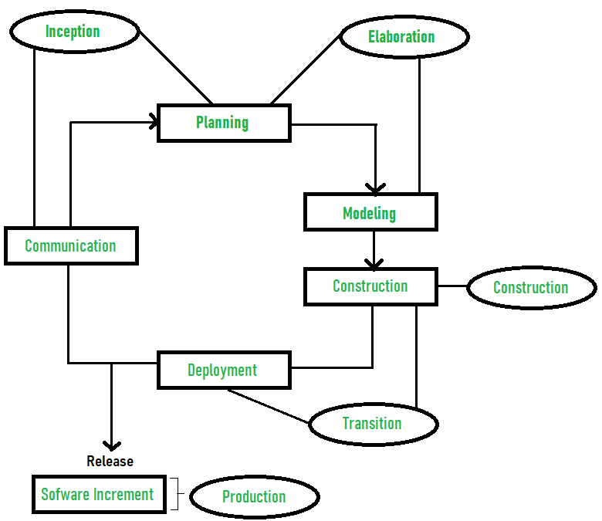

Disadvantages :
- Complex and not properly organized process.
- More dependency on risk management.

Spiral Model: -
The spiral model is one of the most important software development life cycle. It is
combination of waterfall model and iterative models. It provides support for Risk handling.

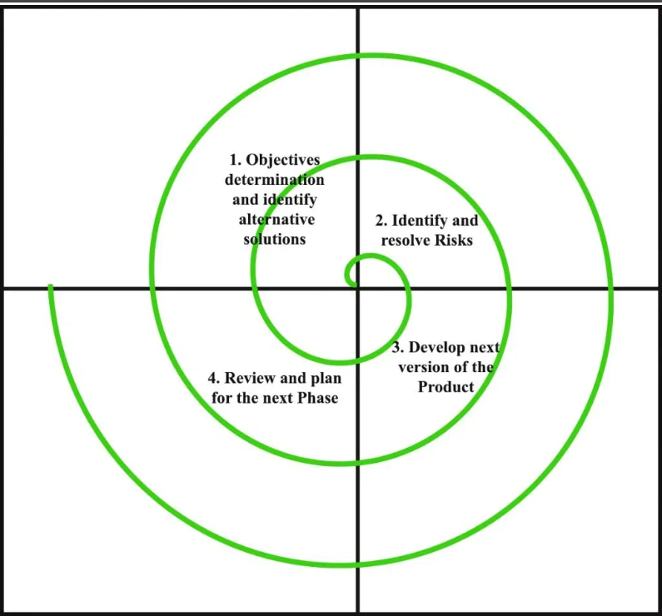

Advantages:
- Risk Handling
- Improved Quality
- Good for large projects
- Flexibility in Requirements

Disadvantages:
- Complex
- Expensive
- Time-Consuming

Scrum Model : -
Scrum is an agile project management framework that teams use to self-organize tasks and work towards a common goal. It is a framework within which people can address complex adaptive problems while the productivity and creativity of delivering products are at the highest possible value.

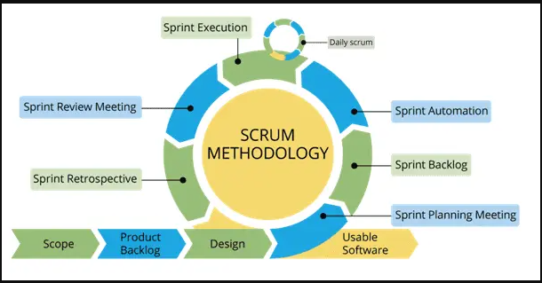

Advantages :
- fast moving and money efficient.
- customer satisfaction is very important.
Disadvantages :
- Scrum framework do not allow changes into their sprint.
- Scrum framework is not fully described model.

Q.no 10 :
Write down the differences between waterfall model and V model.
Answers : -

Aspect | Waterfall model | V-model
Process Flow | Linear and sequential. | Linear with testing phase of each stage .
Testing | Performed after development is complete. | Validation happens along  side verification.
Flexibility | Rigid, changes are hard to accommodate | Slightly better since defects can  be caught earlier.
Documentation  Focus | Emphasizes thorough documentation at each sequential stage to support later phases and hand-offs. | Maintains strong documentation like Waterfall, but aligns it more closely with both development  and corresponding testing  activities for better traceability  and quality control.
Risk  Management | Late discory of defects and risks. | Early detection of risks due to parallel test planning.
Suitable for | Projects with well-defined, fixed requirements. | Projects with clear requirements  and emphasis on quality/testing.

Q.no 11 :
As a BA, state your reason for choosing one model for this project
Answers : -
As a Business Analyst, I recommend the Scrum is the best fit for this project because it’s built around adaptability, collaboration, and delivering value quickly—all essential for creating a user-friendly agriculture marketplace for remote farmers.
Evolving Requirements from Farmers : -
Farmers like Peter, Kevin, and Ben may not know all their needs upfront. As they see the product evolve, they'll provide new insights. Scrum thrives in such environments by encouraging iterative development and feedback after every sprint.
Fast, Incremental Delivery : -
With an 18-month timeline, it’s crucial to start delivering value early. Scrum allows us to release a working piece of the application every few weeks, so features like product listings or order placement can go live well before the project is fully complete.
User-Centric, Flexible Design : -
Since this app is for farmers in remote areas, who might be using smartphones for the first time. Scrum enables quick improvements to design and usability based on real user feedback. This helps ensure the app is intuitive and accessible.
Cross-Functional Team Collaboration : -
Scrum promotes daily stand-up meetings and transparent sprint planning, which keeps everyone aligned and responsive to blockers and updates.
Risk Management and Visibility : -
Scrum ensures continuous testing, stakeholder review, and progress tracking. Mr. Henry, Mr. Pandu, and Mr. Dooku can stay involved without waiting months for a status update, they’ll see real progress every sprint.
Lastly, Scrum enables to work efficiently, collaborate effectively, and deliver consistent progress, while staying flexible and closely aligned with the needs of the very community this solution is designed to support.

Q .no 12:
The Committee of Mr. Henry, Mr Pandu, and Mr Dooku discussed with Mr Karthik and finalised on
the V Model approach (RG, RA, Design, D1, T1, D2, T2, D3, T3, D4, T4 and UAT)

Mr Vandanam is mapped as a PM to this project. He studies this Project and Prepares a Gantt chart
with V Model (RG, RA, Design, D1, T1, D2, T2, D3, T3, D4, T4 and UAT) as development process and the
Resources are PM, BA, Java Developers, testers, DB Admin, NW Admin
Answers : -

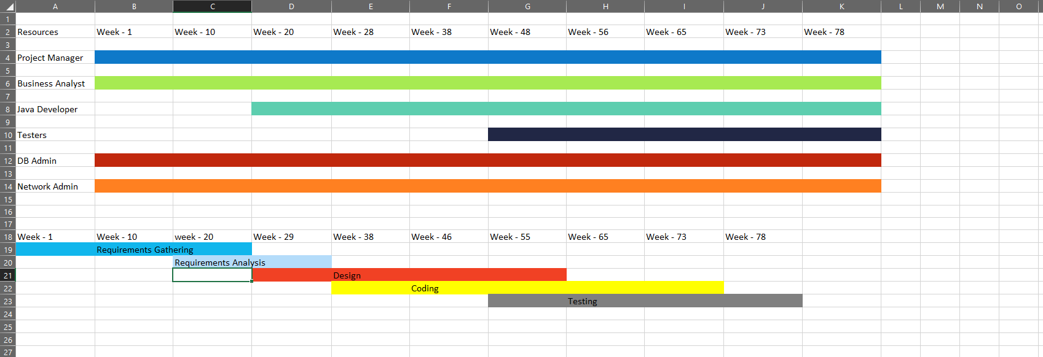

Q.no 13 :
Explain the difference between Fixed Bid and Billing projects.
Answers : -

Fixed Bid Model | Billing Project Model
A fixed bid project is billed using a flat amount, regardless of no. of hours worked. | Billing project is based on no. of hours worked.
Can provide stability to both client and company regarding costs. | Requires details tracking of time spent and resources.
It is preferred when project scope is clearly defined and risks of unexpected changes are low. | Billing models like fixed price, time etc are included.
Good for small projects. | Good for large projects.
It is a specific type of billing project where the prices is fixed. | It refers to any project where client will be invoiced for the work completed.

Q.no 14 :
Prepare Timesheets of a BA in various stages of SDLC.
- Design Timesheet of a BA
- Development Timesheet of a BA
- Testing Timesheet of a BA
- UAT Timesheet of a BA
- Deployment and Implementation Timesheet of a BA
Answers : -
Requirement Gathering Timesheet of BA
Name - Priya Architha Chitti
Designation - Business Analyst
Date | Tasks | In-time | Out-time | Duration (hrs)
23-06-2025 | Identify stakeholders | 09:00 | 18:00 | 9
24-06-2025 | Requirement Elicitation | 10:00 | 18:00 | 8
25-06-2025 | Documenting requirements | 11:00 | 17:00 | 6
26-06-2025 | Prioritizing and documenting | 10:30 | 17:30 | 7.5
Total |  |  |  | 30.5

Requirement Analysis Timesheet of BA
Name - Priya Architha Chitti
Designation - Business Analyst
Date | Tasks | In-time | Out-time | Duration (hrs)
27-06-2025 | Specify the requirements | 09:00 | 16:00 | 7
30-06-2025 | Model the use cases | 09:00 | 18:00 | 9
01-07-2025 | Verify and validate the requirements | 10:30 | 15:30 | 5
02-07-2025 | Documenting business requirements | 09:00 | 18:00 | 9
Total |  |  |  | 30

Design Timesheet of BA
Name - Priya Architha Chitti
Designation - Business Analyst

Date | Tasks | In-time | Out-time | Duration (hrs)
03-07-2025 | Discuss with clients the model | 11:00 | 15:00 | 4
04-07-2025 | Identify the best suitable model based on requirements | 10:00 | 17:00 | 7
07-07-2025 | Verify and validate the requirements | 09:00 | 17:00 | 8
08-07-2025 | Design architecture | 09:00 | 18:00 | 9
Total |  |  |  | 28

Development Timesheet of BA
Name - Priya Architha Chitti
Designation - Business Analyst

Date | Tasks | In-time | Out-time | Duration (hrs)
09-07-2025 | Coordinate with team and check approval of SDLC phases | 10:00 | 17:00 | 7
10-07-2025 | Coordinate with team and get approval of SDLC phases | 10:00 | 18:00 | 8
11-07-2025 | Clarifying the doubts | 11:00 | 16:00 | 5
14-07-2025 | Keeping track of project work | 09:00 | 15:00 | 6
15-07-2025 | Verify and if any change required | 10:00 | 17:30 | 8
Total |  |  |  | 34

Testing Timesheet of BA
Name - Priya Architha Chitti
Designation - Business Analyst
Date | Tasks | In-time | Out-time | Duration (hrs)
16-07-2025 | Check with testing team to create test plans | 10:00 | 17:00 | 7
17-07-2025 | Create and execute the plans | 09:30 | 17:30 | 8
18-07-2025 | Review the test cases | 10:00 | 18:00 | 8
21-07-2025 | Provide clarify if any requirement is needed. | 09:00 | 16:00 | 7
22-07-2025 | Taking signoff from the clients on project acceptance form | 9:00 | 18:00 | 9
Total |  |  |  | 39

UAT Timesheet of BA
Name - Priya Architha Chitti
Designation - Business Analyst
Date | Tasks | In-time | Out-time | Duration (hrs)
23-07-2025 | Develop detail UAT plan | 09:00 | 17:00 | 8
24-07-2025 | Develop test cases | 10:00 | 18:00 | 8
25-07-2025 | Create UAT test cases | 11:30 | 17:30 | 6
28-07-2025 | Prepare test case data | 11:00 | 16:00 | 5
29-07-2025 | Run test case | 10:00 | 16:00 | 6
30-07-2025 | Prepare document of test cases | 09:00 | 18:00 | 9
Total |  |  |  | 42

Deployment and Implementation Timesheet of BA
Name - Priya Architha Chitti
Designation - Business Analyst

Date | Tasks | In-time | Out-time | Duration (hrs)
31-07-2025 | Design RTM and send to clients | 09:00 | 18:00 | 9
01-08-2025 | Complete functional specifications | 10:00 | 16:00 | 6
04-08-2025 | Coordinate UAT to stakeholder | 10:00 | 17:00 | 7
05-08-2025 | Deployment of project | 09:00 | 18:00 | 9
Total |  |  |  | 31

about SDLC. And four methodologies like Sequential Iterative Evolutionary and Agile. Which
are explained below
Four SDLC Methodology
1. Sequential -: This is the most common SDLC models, it is also referred to as a linear-
sequential life cycle model. each phase must be completed in its entirety before the
next phase can begin. This method is best suited for projects with well-defined
requirements, low risk, and predictable outcomes.
2. Iterative -: This methodology involves developing the software in iterations, where
each iteration builds upon the previous one. There are Four Project Life cycle Phases
namely Inception, Elaboration, Construction, Transition. This method is best suited
for projects with complex requirements and high risk.
3. Evolutionary -: This methodology involves developing a basic version of the software
and then incrementally improving it. The spiral model gives more emphases placed

