Q1. Draw a Use Case Diagram

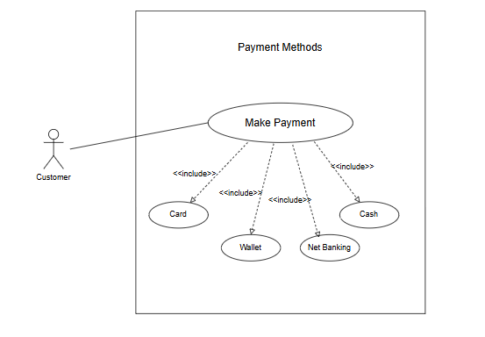

Q2. Derive Boundary Classes, Controller classes, Entity Classes.

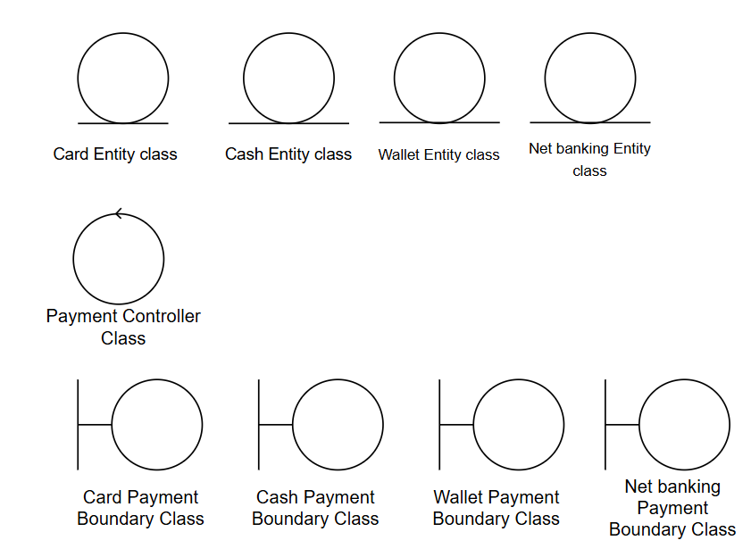

Q3. Place these classes on a three tier Architecture

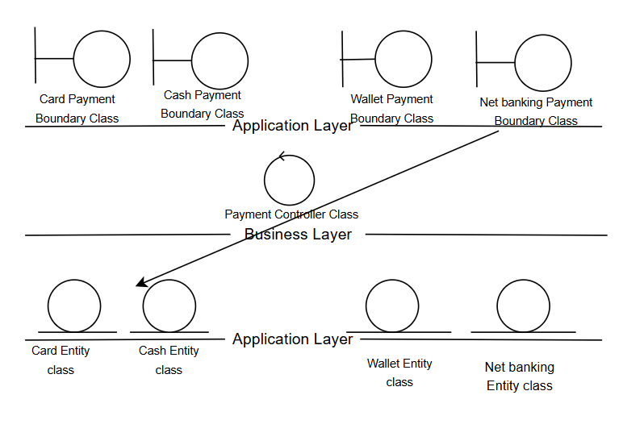
Q4. Explain Domain Model for Customer making payment through Net Banking –
Domain Modelling, also known as Conceptual Modelling, is the process of identifying the main entities (concepts) and their relationships within a specific business problem or system. It focuses on what the system is about, without technical implementation details.
Objective of Domain Model:
- To understand and visualize the real-world objects involved in the system
- To show how those objects are related
- Used in early stages of analysis and design to build a shared understanding between Business Analysts, stakeholders, and developers
In this scenario, a customer places an order and makes payment using the Net Banking option.
Customer ── places ──▶ Order ── has ──▶ Payment ── uses ──▶
NetBankingDetails ── linked to ──▶ Bank
│
▼
Transaction (status)

Q5. Draw a sequence diagram for payment done by Customer Net Banking –
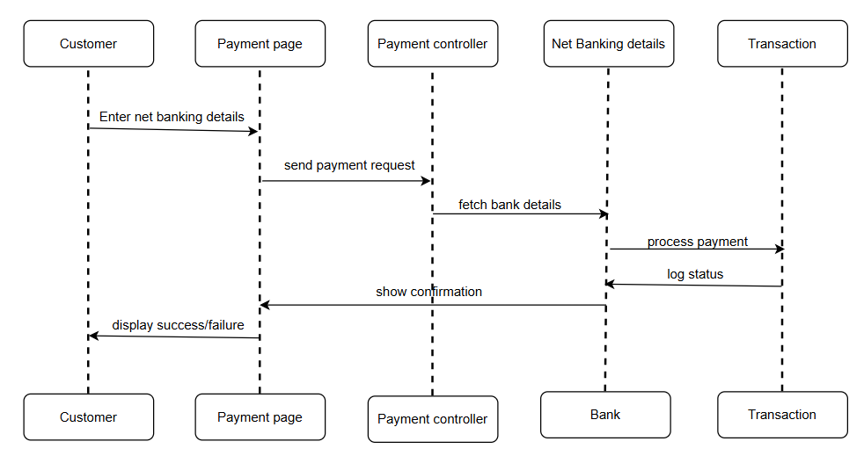

Q6. Explain Conceptual Model for this Case –
A Conceptual Model is a high-level representation that captures the main concepts (objects) and their relationships in a system — without going into technical details. It helps understand what the system is about from a business or domain perspective.
Purpose of a Conceptual Model:
- To identify the key entities (nouns) in the system
- To show how these entities are related
- To visually explain the problem domain in a simple and understandable way
- Used during requirement analysis to ensure all core ideas are captured
For this case - Customer makes a payment using Net Banking.
Key Concepts in the Conceptual Model:
- Customer – the user making the payment
- Order – the item or service being purchased
- Payment – the act of paying
- NetBankingDetails – stores account and bank info
- Bank – external financial system involved
- Transaction – records status (success/fail)

Q7. What is MVC architecture? Explain MVC rules to derive classes from use case diagram and guidelines to place classes in 3-tier architecture –
MVC (Model–View–Controller) is a software architectural pattern used to separate an application into three main components:
- Model – Manages the data and business logic
- View – Handles the user interface
- Controller – Acts as a bridge between Model and View; processes user input and updates both
MVC Rules to Derive Classes from a Use Case Diagram
- Boundary Classes → View Layer (V in MVC)
Represent user interfaces/screens
Handle interactions between the user and the system
Derived from Actors and interfaces in use case diagram
- Controller Classes → Controller Layer (C in MVC)
Handle logic to connect views to models
Manage workflows and business operations
Derived from Use Cases in the diagram
- Entity Classes → Model Layer (M in MVC)
Represent the actual business objects and data
Used for data storage, validation, and business rules
Derived from nouns or objects in use cases
How can we place classes in 3 tire architecture.
Presentation Layer- It contains UI elements and has Boundary Classes
Application Layer – It contains Business logic & process flows and has Controller Classes
Data Layer – It contains Database or data models and has Entity Classes
MVC Architecture Rules
1. Combination of One Actor and a use case results in one Boundary class
2. Combination of Two Actors and a use case results in two Boundary classes
3. Combination of Three Actors and a use case results in Three Boundary classes and so on.
Note: only one primary actor is to be considered with a use case.
4. Use case will result in a controller class
5. Each Actor will result in one entity class

Q8. Explain BA contributions in project (Waterfall Model – all Stages) –
The Waterfall Model is a linear-sequential software development life cycle model where each phase must be completed before moving to the next. It is one of the most traditional approaches to project execution. In this model, the Business Analyst (BA) plays a key role in the early and middle phases and supports other teams throughout the project.
1. Requirements Gathering
Works with clients, stakeholders, and end-users to understand business needs.
Conducts interviews, workshops, and surveys.
Prepares the Business Requirement Document (BRD).
2. Requirements Analysis
Analyses business needs and converts them into functional and non-functional requirements.
Creates Functional Specification (FS/FRS), System Requirement Specification (SRS), and Software Specification Document (SSD).
Helps create the Requirement Traceability Matrix (RTM).
3. Design
Supports the technical team by clarifying business requirements during design decisions.
Validates that design aligns with business goals.
4. Development (Coding)
Assists developers with requirement clarifications.
Ensures that the features being developed match the business needs.
5. Testing
Reviews and helps prepare test cases based on requirements.
Supports User Acceptance Testing (UAT) by coordinating with stakeholders.
Validates that test results match the expected outcomes defined in the RTM.
6. Deployment & Implementation
Verifies that the final build meets all requirements.
Supports deployment planning and documentation.
May assist with user training or go-live support.
7. Maintenance
Supports change requests and issue resolution post-go-live.
Helps gather feedback for future updates or enhancements.

Q9. What is conflict management? Explain using Thomas – Kilmann technique
Conflict Management is the process of identifying and handling conflicts in a constructive way. Conflicts are natural outcomes of change, communication gaps, or differing interests in a team. When managed effectively, conflicts can lead to improved communication, personal and professional growth, and stronger team dynamics.
Managing conflict requires energy, maturity, and open-mindedness, and is all about maintaining relationships while solving the problem.
5 Steps to Conflict Management:
Identify the conflict
Discuss the details
Agree with the root problem
Check for every possible Solution for the conflict Negotiate
The Solution to avoid the future Conflicts
The Thomas–Kilmann Model is one of the most widely used tools for understanding how people handle conflict. It is based on two dimensions:
X-axis: Co-operation (focus on others)
Y-axis: Assertiveness (focus on self)
Steps to Managing Conflicts Effectively:
Identify the conflict - Understand the people and issue involved.
Discuss the details -Use open, honest verbal and written communication.
Agree on the root cause - Make sure everyone understands the real problem.
Explore all possible solutions - Stay open-minded and creative.
Negotiate and finalize the best solution - Ensure both sides are satisfied and prevent future conflicts.

Q10. List down the reasons for project failure
1. Improper Requirement Gathering
If project requirements are not collected correctly at the start, the team may build the wrong product.
It leads to confusion, missed features, and rework.
2. Continuous Change in Requirements
Frequent or uncontrolled changes during development cause delays, budget overruns, and scope creep.
The team keeps reworking instead of progressing.
3. Lack of User Involvement
If end-users are not consulted or included, the final product may not meet their needs.
It results in low user satisfaction or product rejection.
Solution: Conduct user demos, get feedback in every sprint, and involve them during testing.
4. Lack of Executive Support
Without management support, there’s no direction, budget, or authority to remove blockers.
Teams may feel unsupported and demotivated.
5. Unrealistic Expectations
Setting impossible deadlines, budgets, or goals leads to stress, low quality, and missed targets.
It demoralizes the team and affects delivery.
6. Improper Planning
Weak planning results in poor resource allocation, missed dependencies, and no clear direction.
Without a solid roadmap, the project may lose focus or crash midway.

Q11. List the Challenges faced in projects for BA
A Business Analyst (BA) plays a key role in bridging the gap between business and technical teams. However, the role comes with several real-world challenges that can impact the quality and progress of the project.
1. Lack of Training
Many BAs face situations where they are assigned to domains or tools, they are not fully trained in.
Without proper domain knowledge or technical exposure, understanding client needs becomes difficult.
2. Obtaining Sign-off on Requirements
Finalizing and getting approval (sign-off) from stakeholders on requirements is often delayed.
This leads to project delays and scope-related issues if changes are made later.
3. Change Management (Cost & Timelines Impact)
When business requirements change mid-project, it impacts cost, development effort, and delivery timelines.
BAs must evaluate, document, and re-communicate these changes clearly.
4. Coordination Between Developers and Testers
BAs must ensure both development and QA teams understand the same requirement the same way.
Misalignment can cause bugs or rework.
5. Conducting Meetings
Leading productive meetings with multiple stakeholders is challenging, especially when there are conflicting opinions or unclear expectations.
6. Effective Status Reporting
BAs are often responsible for tracking progress and reporting status to stakeholders.
They must ensure that updates are accurate, timely, and clear to support decision-making.
7. Driving Clients for UAT (User Acceptance Testing)
Sometimes, clients delay UAT or provide minimal feedback.
BAs must consistently follow up, clarify expectations, and push for timely approvals.
8. People Management
The BA interacts with clients, developers, testers, product owners, and project managers.
Managing multiple personalities and priorities while maintaining clarity and calmness is a key challenge.
9. Ensuring Overall Project Health
Ultimately, the BA is responsible for ensuring the project stays on track in terms of scope, timeline, and quality.
They play a key role in early risk identification, communication, and issue resolution to ensure successful delivery.

Q12. Write about Document Naming Standards – 4 Marks
Document Naming Standards are important in any project to ensure consistency, clarity, and easy tracking of multiple versions and document types. Using a standard naming convention avoids confusion and helps all team members quickly identify the purpose and version of a file.
Standard Format Used:
[ProjectID][DocumentType]V[x]D[y].ext

[ProjectID] – Unique code or ID assigned to the project
[DocumentType] – Code for the type of document (e.g., BRD = Business Requirements Document, SRS = Software Requirements Specification)
V[x] – Major version number
D[y] – Minor version or date/revision number
.ext – File extension (e.g., .docx, .xlsx)

Q13. What are the Do’s and Don’ts of a Business analyst –
Never say NO to Client. There is NO word called as "BY DEFAULT". Never imagine anything in terms of GUI. Question the existence of existence / question everything in the world ex: what client gives is not always correct. Consult an SME for Clarifications in Requirements Every Problem of Client is unique. No two problems of different Client are same. May be the approach, technology, place of use, local laws may be varied to make them (Problems) to be different. Go to Client with a plain mind with no assumptions. Listen carefully and completely until Client is done and then you can ask your Queries. Please do not interrupt the Client, when he/ She is giving you the problem. Maximum Try to extract the leads to Solution from the Client itself. Never try to give Solutions to Client straight away with your previous experience and assumptions. Try to concentrate on the important and truly required Requirements. Don't be washed away by add on Functionalities or don't imagine solutions on Screen basis.
Q14. Write the difference between packages and sub-systems –
In software design, both packages and subsystems are used to organize and manage components, but they differ in purpose, reusability, and type of development environment where they are used.
Package
- A package is a collection of related components grouped together for a specific functionality.
- It is not reusable in nature; they are created for a specific application only.
- Mostly used by Application Development Companies to build client-specific solutions.
- Example: A payment module developed just for a food delivery app, not used elsewhere.
Subsystem
- A subsystem is a collection of components or modules that are designed to be reused across multiple applications or products.
- It is reusable in nature and often built as a standalone service or module.
- Typically used by Product Development Companies to build core products that can be integrated in different ways.
- Example: A reusable authentication subsystem used across multiple company products.

Q15. What is camel-casing and explain where it will be used-
Method Names are represented by Camel Casing. Camel Casing means Initial word will be all small alphabets and from second word onwards beginning alphabet is Capital and the rest are small.
example- turnRightAndStop
Camel Casing: Entire first word will be in lowercase and subsequent words first letter should be Upper Case. There will be no gap in between words. Example: getEmpld(); turnLeftAndSlowDown();
Uses of camel case
Variable and Function Names
Class or Object Naming
Database Field Names
File Naming in Coding Projects

Q16. Illustrate Development server and what are the accesses does business analyst has?
A Development Server is a separate environment where the development team writes, tests, and integrates code before releasing it to staging or production. It simulates the application behaviour for developers and testers and supports early testing and debugging without affecting the live system.
It usually includes:
- Source code and build files
- Databases for test data
- Integration with other services or APIs
- Unit and component testing capabilities
A Business Analyst (BA) usually has limited but important access to the Development Server for validation, coordination, and documentation purposes.
- Read-Only Access to the Application
  - To verify if features match requirements
  - Perform informal UI review or walkthrough
- Access to Test Data or Screens
  - To check data flow and behaviour for scenarios
- Defect Validation
  - BA may re-check fixed bugs before UAT starts
- Review Logs or Test Results (limited)
  - For writing traceability or impact analysis
- Collaboration with Developers
  - To clarify user stories and review real-time implementation

Q17. What is Data Mapping
Data Mapping is the process of matching data fields from one source to another — usually between two different systems, databases, or formats.
It helps define how data in one structure (Source) corresponds to data in another structure (Target). This is especially important in data migration, system integration, API development, and reporting.
Why is Data Mapping Important?
- Prevents data loss during migration or integration
- Ensures data consistency between systems
- Enables automation in data transformation
- Helps in building data pipelines, APIs, and reports

Q18. What is API. Explain how you would use API integration in the case of your application Date format is dd-mm-yyyy and it is accepting some data from Other Application from US whose Date Format is mm-dd-yyyy 10 Marks
API (Application Programming Interface) is a set of rules and protocols that allows two software applications to communicate with each other.
APIs act like messengers - enabling systems to send and receive data without knowing each other's internal logic. APIs are widely used in modern applications for integration with external services like payment gateways, weather apps, or other third-party systems.

If this external API sends 05-07-2025, your system may read it as:
- US API: May 7, 2025
- Indian App: 5th July, 2025
This causes incorrect date interpretation, which can affect:
- Order placement
- Delivery tracking
- Payment records
Use API Integration and Solve the Date Format Issu
Step 1: Integrate the External API
- Use tools like Postman or code in Java/Python/.NET to make API calls.
- Receive the date field in mm-dd-yyyy format via JSON.
Step 2: Date Format Conversion (Middleware or Controller)
- Before saving or displaying the date in your application, apply date parsing logic to convert the incoming format.
Step 3: Display or Store in Your App Format
- Now the application stores 04-07-2025 (4th July) correctly in Indian format.

