Document 2- Product Vision
Answer-
Scrum Project Name: | Swift Cart – A Modern E-Commerce Platform
Venue | Bangalore
Date: 12-Aug-2024 | Start Time: 10:00 AM | End time: 12:30 | Duration: 2.5 years
Client | Swift Cart Retail Ltd.
Stakeholder list | End Customers  Vendors/Sellers  Warehouse Managers  Logistics Providers  Customer Support Team  Marketing Team  Product Management Team
Scrum Team
Scrum Master: | Sonal Pattaniak
Product Owner: | Priya Verma
Scrum Developer 1: | Asutosh rana
Scrum Developer 2: | Prateek .M
Scrum Developer 3: | Naresh panda
Scrum Developer 4: | Amit raj
Scrum Developer 5: | Sekhar Tripathi

Vision
To develop a scalable, secure, and intuitive E-Commerce platform that provides a seamless online shopping experience to customers while enabling vendors to manage their products, inventory, and orders efficiently.
Target Group
Which market segment does the product address?
Online retail market segment – including fashion, electronics, home goods, personal care, and more.
Who are the target users and customers?
- Online shoppers across India
- Individual and business vendors looking to sell their products
- Logistics and delivery partners
- Internal support and fulfillment teams
Needs
What problem does the product solve?
- Reduces friction in online shopping and product discovery
- Enables sellers to manage catalog and inventory in real time
- Streamlines order tracking, returns, and customer service
Which benefit does it provide?
- One-stop platform for a wide variety of products
- Competitive pricing and faster delivery options
- Simplified vendor onboarding and management tools
Product
What product is it?
A web and mobile e-Commerce platform with admin dashboards, seller panels, customer portals, and integrated payment and delivery modules.
What makes it desirable and special?
- User-centric design with personalized recommendations
- Multi-vendor support
- Integrated logistics and real-time tracking
- Discounts, loyalty programs, and secure payments
Is it feasible to develop the product?
Yes, with the current tech stack (React.js, Node.js, MongoDB, Stripe/Paytm integration) and sprint planning, the MVP can be delivered within 3-4 sprints.
Value
How is the product going to benefit the company?
- Opens a new sales channel with a broad customer base
- Builds a competitive edge through data-driven promotions
- Reduces dependency on physical stores and expands market reach
What are the business goals?
- 10,000 user registrations in the first quarter
- 100+ vendor onboardings in 6 months
- Generate ₹50 lakh in gross merchandise value in the first year
What is the business model?
- Commission per transaction (3–5%)
- Subscription plans for premium seller tools
- Advertisement revenue from featured product listings

Document 3: User stories
Answer-
User Story No: 01 | Tasks: Design registration and login page.  Implement OTP verification.  Configure user authentication. | Priority: High
Value statement:
As a customer,
I want to register and log in securely,
so that I can access my account and shop safely.

Bv: 13 | CP: 05
Acceptance criteria:
Registration via email/phone is successful
OTP verification is mandatory
Secure login and logout flow
Error messages for invalid credentials
User Story No: 02 | Tasks: Create product catalog view  Add category/brand/price filters  Develop search and sort functionality | Priority: High
Value Statement:
As a customer,
I want to browse and search products,
so that I can find items easily.
Bv: 21 | CP: 08
Acceptance criteria:
Product listing is responsive
Filters and sort options work
Search returns relevant results

User Story No: 03 | Tasks: Create detailed product page  Include product description, price, and reviews | Priority: High
Value Statement:
As a customer,
I want to view product details,
so that I can make an informed purchase.
Bv: 13 | CP: 05
Acceptance criteria:
Product info, price, ratings, and images are visible
“Add to Cart” and “Buy Now” buttons present
Shipping and stock info displayed

User Story No: 04 | Tasks: Develop cart management (add, remove, update quantity)  Show real-time price and summary | Priority: High
Value Statement:
As a customer,
I want to manage my shopping cart,
so that I can review products before buying.
Bv: 21 | CP: 08
Acceptance criteria:
Cart shows all added items with quantity
Price updates automatically
Items can be removed or updated

User Story No: 05 | Tasks: Build multi-step checkout  Add address, payment, and confirmation flows | Priority: High
Value Statement:
As a customer,
I want to place an order easily,
so that I can purchase products securely.
Bv: 21 | CP: 13
Acceptance Criteria:
Valid address required
Multiple payment options available
Confirmation page shown after order placed

User Story No: 06 | Tasks: Develop seller dashboard  Enable product upload with price, image, stock | Priority: Medium
Value Statement:
As a vendor,
I want to list my products,
so that I can sell on the platform
Bv: 13 | CP: 08
Acceptance Criteria:
Seller login and dashboard accessible
Product listing form with validations
Admin approval required for listings

User Story No: 07 | Tasks: Enable order tracking  Integrate shipment status updates | Priority: Medium
Value Statement:
As a customer,
I want to track my order,
so that I can stay informed about delivery.
Bv: 08 | CP: 05
Acceptance Criteria:
Tracking shows real-time status
Status includes Processing, Shipped, Delivered
Notifications sent at each update

User Story No: 08 | Tasks: Create review and rating system  Moderate reviews before publishing | Priority: Low
Value Statement:
As a customer,
I want to read and submit reviews,
so that I can make better buying decisions.
Bv: 08 | CP: 03
Acceptance Criteria:
Customers can post reviews after delivery
Reviews include text and star ratings
Admin approval before display

Document 5: Product and sprint backlog and product and sprint burndown charts
Answer- Product Backlog
User Story ID | User Story (Summary) | Tasks | Priority | BV | CP | Sprint
US-01 | User Registration & Login | UI, OTP auth, error handling | High | 13 | 5 | Sprint 1
US-02 | Browse & Search Products | Catalog, filter, search | High | 21 | 8 | Sprint 1
US-03 | Product Detail View | Images, price, description | High | 13 | 5 | Sprint 1
US-04 | Add/Remove Items to Cart | Cart logic, quantity updates | High | 21 | 8 | Sprint 2
US-05 | Checkout Process | Address, payment, confirmation | High | 21 | 13 | Sprint 2
US-06 | Vendor Product Listing Dashboard | Seller portal, product form, admin approval | Medium | 13 | 8 | Sprint 3
US-07 | Order Tracking | Order status, shipment updates | Medium | 8 | 5 | Sprint 3
US-08 | Product Reviews | Ratings, moderation | Low | 8 | 3 | Sprint 3
Sprint Backlog – Sprint 1
User Story ID | User Story (Summary) | Tasks | Owner | Status | Estimated Effort
US-01 | Registration & Login | Auth logic, OTP, UI validation | Developer 1 | In Progress | 5 SP
US-02 | Product Browse & Search | Catalog, filter, search | Developer 2 | Not Started | 8 SP
US-03 | Product Detail Page | Detail layout, data binding | Developer 3 | In Progress | 5 SP
US-04 | Cart Functionality | Add/remove items, quantity updates | Developer 1 | Not Started | 8 SP
US-05 | Checkout Flow | Address, payment gateway, confirmation | Developer 2 | Not Started | 13 SP

Product burndown chart
I included a Release Burndown Chart instead of a Product Burndown because it shows progress across multiple sprints toward our final deliverable. It helped us track how much work remains for the release goal, not just individual sprint progress. This gives better visibility to stakeholders about overall delivery status
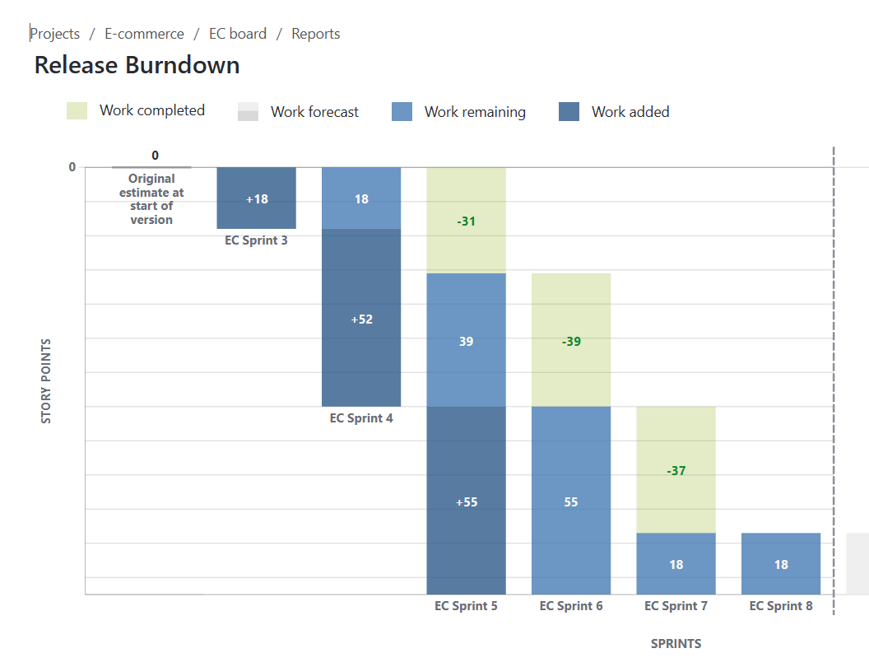
Sprint burndown
A Sprint Burndown Chart is a visual tool in Agile Scrum used to track the amount of work remaining in a sprint on a daily basis. It helps the team and stakeholders see whether the sprint is on track to meet its goal.
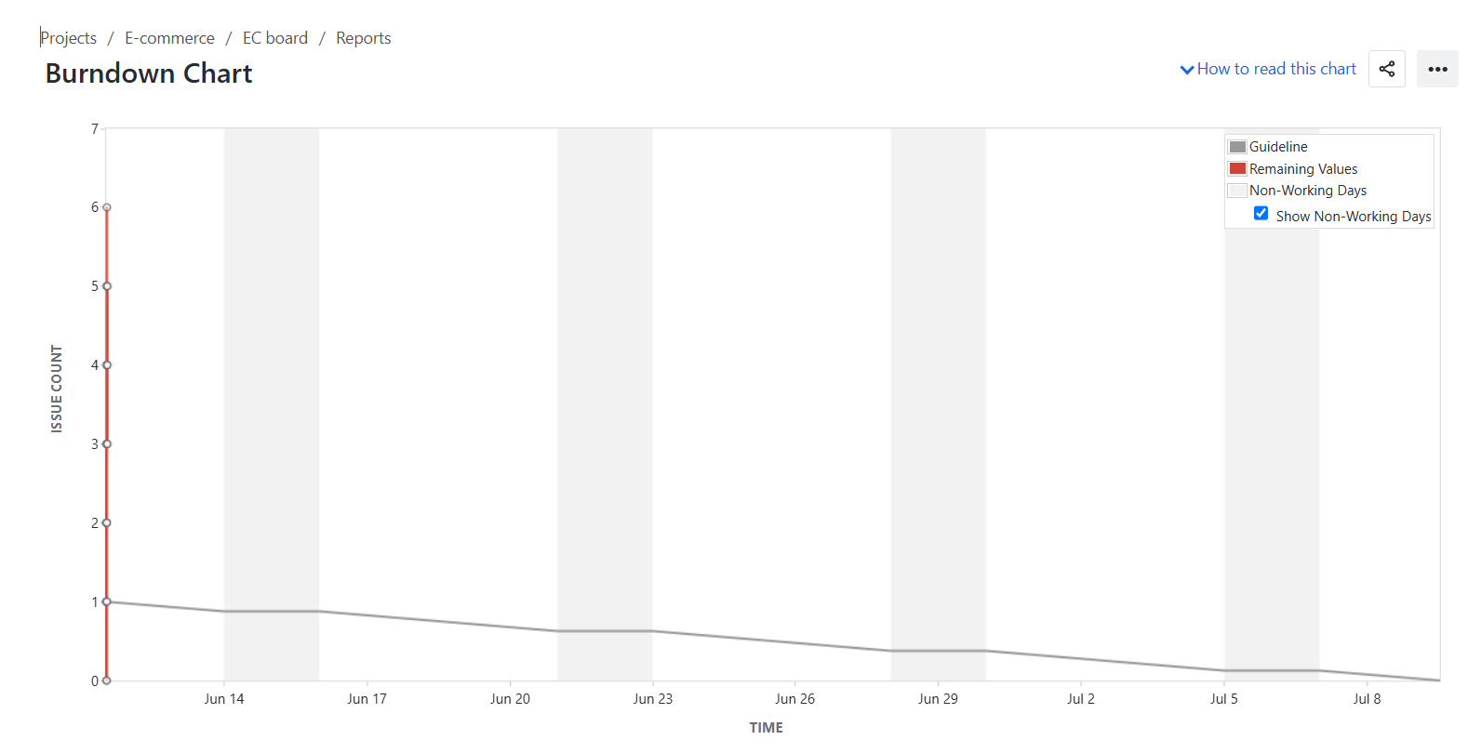

Document 6: Sprint meetings
Answer- Meeting Type 1: Sprint Planning meeting
Date | 01-06-2025
Time | 10:00 AM to 10:30 AM
Location | Zoom Meeting
Prepared by | Sonal, Business Analyst
Attendees | Mr. Rajesh Kumar – Product Owner  Ms. Priya Sharma – Scrum Master  Devendra Jain – Developer 1  Neha Joshi – Developer 2  Akash Mehta – Developer 3
Agenda Topics
Topic | Presenter | Time Allotted
Sprint goal overview | Product owner | 15 Mins
Review of product backlog | Scrum master | 25 Mins
User Story Discussion | BA/ Developer | 25 Mins
Estimation and Capacity Plan | Scrum Master | 15 Mins
Sprint Commitment | Entire Team | 10 Mins

Other Information
Observers | None for this session
Recourses | JIRA Board, Sprint Backlog Sheet, Velocity Charts
Special notes | Devendra will handle UI stories; Neha will work on API integration
Meeting Type 2: Sprint review meeting
Date | 15-06-25
Time | 4:00 PM to :00 PM
Location | Zoom meeting Room
Prepared by | Priya Sharma (Scrum Master)
Attendees | Product Owner, Business Analyst Scrum Master, Developers  Key Stakeholders (Mr. Arvind Rao – Marketing Head, Ms. Sneha Kapoor – QA Lead)

Sprint Status | Things To Demo | Quick updates | What’s Next
8 out of 9 committed stories completed successfully.  1 story deferred due to API dependency | User Registration Form UI (Devendra)  Notification Service Integration (Neha)  Task Dashboard Filters (Akash) | Minor design alignment issue resolved  No critical bugs found during QA testing | Remaining story moved to next sprint  Next sprint will focus on reporting module and analytics dashboard

Meeting Type 3: Sprint retrospective meeting
Date | 16-06-2025
Time | 10:00 AM to 11:00 AM
Location | Microsoft teams
Prepared by | Priya Sharma (Scrum Master)
Attendees | Scrum Master, Product Owner, All Developers, BA

Agenda | What went well | What didn’t go well | Questions | Reference
Review of sprint performance | Team communication was effective | Delay in 3rd party API delivery | Can we plan better for external dependencies? | Previous sprint retrospective notes, updated velocity chart
Capture lessons learned | Sprint goals met on time | Some confusion around story acceptance criteria | Should we include PO in user story walkthroughs?
Improvement planning | Testing completed within timeline

Meeting Type 4: Daily Stand-up meeting
Question | Name/Role | Week “X” (from dd-mm-yyyy to dd-mm-yyyy)
Question | Name/Role | Monday | Tuesday | Wednesday | Thursday | Friday | Saturday | Sunday
What did you do yesterday? | Developer 3 | Completed login UI. | Unit test login page. | Worked on registration. | Fixed CSS issues. | Code review. | - | -
  Developer 1
  Developer 2
What did you do yesterday? |  | Integrated email API. | Set up DB schema. | Wrote API tests. | Fixed validation bugs. | QA support | - | -
What did you do yesterday? |  | Designed dashboard UI | Created filter logic | Connected backend. | Sprint testing | Worked on bug fixes | - | -
What will you do today | Developer 3 | Peer Review | Start registration form | Test registration | Update form logic | Merge PR
  Developer 1
  Developer 2
What will you do today |  | Start OTP logic | Work on email triggers | QA testing | Assist UI dev | Final integration
What will you do today |  | Start analytics UI | Create graph module | Backend logic | Fix reported bugs | Final UI tweaks
What (if any) is blocking your progress | Developer 3 | None | None | API delay | None | None
  Developer 1
  Developer 2
What (if any) is blocking your progress |  | Waiting for test data | None | None | API response delay | API response delay
What (if any) is blocking your progress |  | None | None | None | None | None

