- Functional and non-functional requirement.
Ans- Functional requirement- Functional requirement means what the system or application should do, the necessary tasks, actions or activities it must perform to achieve its objective.
Req ID | Req Name | Req Description
RF001 | Register and create account | User should be able to register with the application
RF002 | Login using user name password | User should be able to login using username and password
RF003 | Browse product by category | User should be able to browse products by category
RF004 | Search for product by name | User should be able to search products by its name
RF005 | Add to cart list | User should be able to add products to the cart
RF006 | Remove items form the cart | User should be able to remove items from the cart
RF007 | Calculate the total price | User should be able to calculate the total price
RF008 | Place an order | User should be able to place an order
RF009 | Send an order confirmation email | User should be able to send an email confirmation
RF0010 | Make payment through multiple options | User should be able to make payment through multiple source
RF0011 | Generate an invoice | User should be able to generate an invoice
RF0012 | Track an order | User should be able to tack an order
RF0013 | Cancel an order | User should be able to cancel an order
RF0014 | View the order history | User should be able to view the order history
RF0015 | Add, edit or delete product | User should be able to add, delete products
RF0016 | Add to wish list | User should be able to add items to Wishlist
RF0017 | Total number of products added in Wishlist | User should be able to calculate total number of products added in the Wishlist
RF0018 | Total amount of Wishlist items | User should be able to see total amount of Wishlist
RF0019 | Logout user automatically | User should be able to logout automatically
RF0020 | Validate user input | User should be able to validate user input

Non-Functional requirement- It will describe how the system should work. It defines qualities and characteristics, attributes of the system.
Req ID | Req Name | Req Description
NFR001 | Performance | The system shall load the home page within 2 seconds
NFR002 | Security | The system shall lock the account after 5 failed login attempts
NFR003 | Usability | The system shall be easy to use for new farmers
NFR004 | Reliability | The system shall be available 99.9% of the time
NFR005 | Maintainability | The system shall have be less maintainable cost
NFR006 | Portability | The application shall run on windows, mac, Android
NFR007 | Compatibility | The web app shall be compatible with chrome, Edge etc
NFR008 | Backup | The system should backup every few hours
NFR009 | Availability | The system shall provide 24/7 availability for the users
NFR0010 | Scalability | The system should increase users without performance loss

- Wireframes and Prototype.
Ans- Wireframe is a simple visual blueprint or sketch of a web page or app screen without any colour and functionality. Like how elements will be arranged like buttons, menu, images. It can be designed on paper with pen or pencil and it is done by BA in almost every projects.
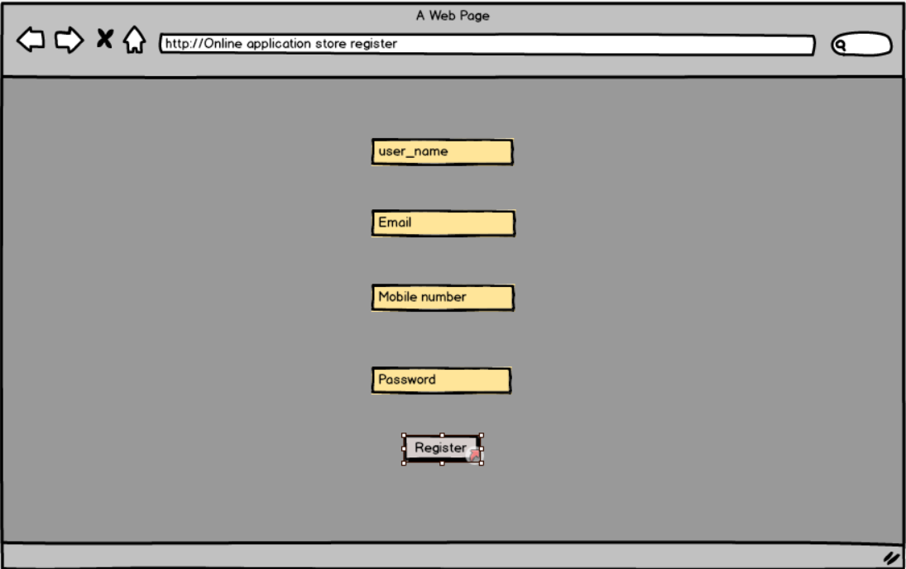
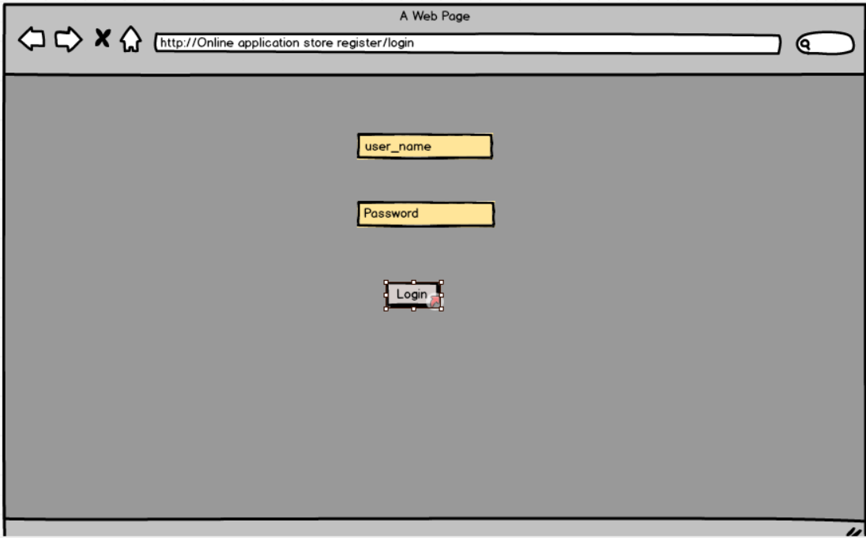
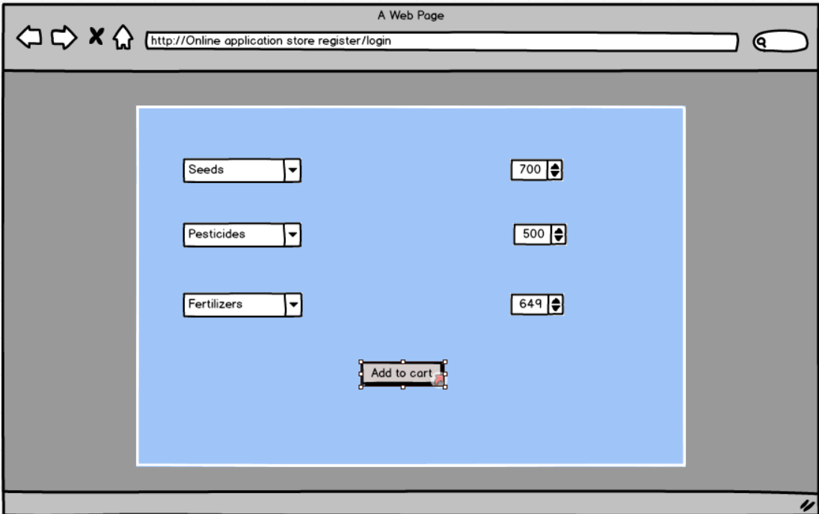
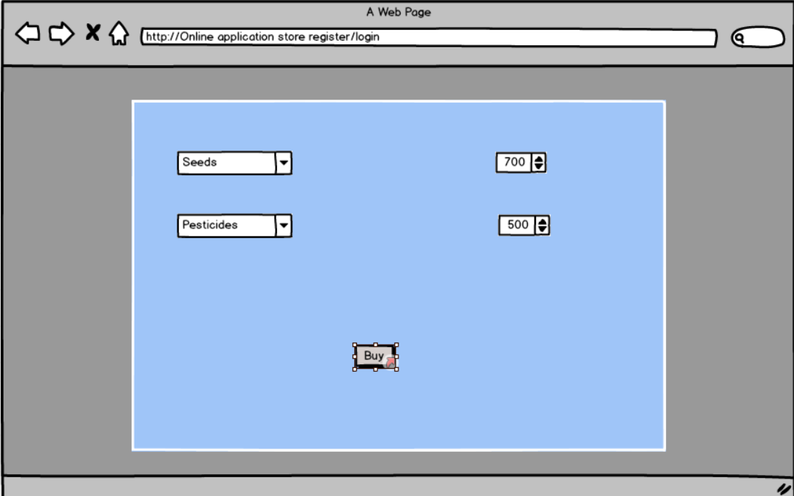
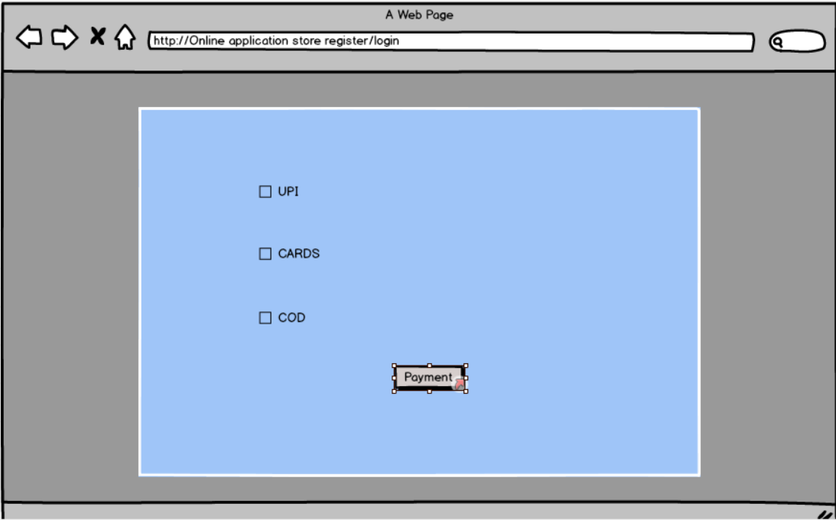
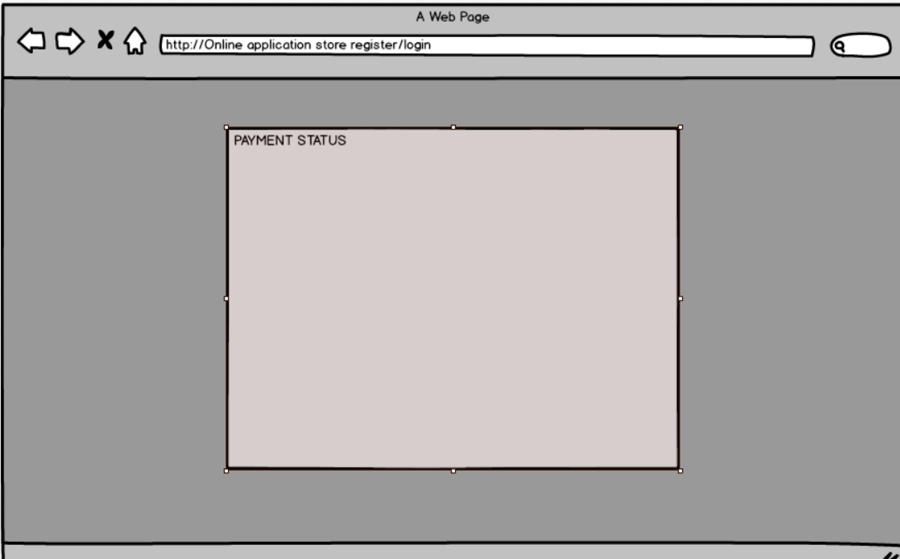

Prototype- It is a sample, model of a product that is built to test a process. It helps to understand how the final system or product will look and how it works.
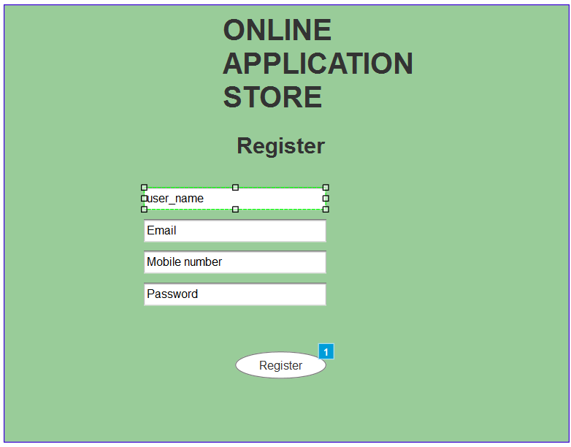
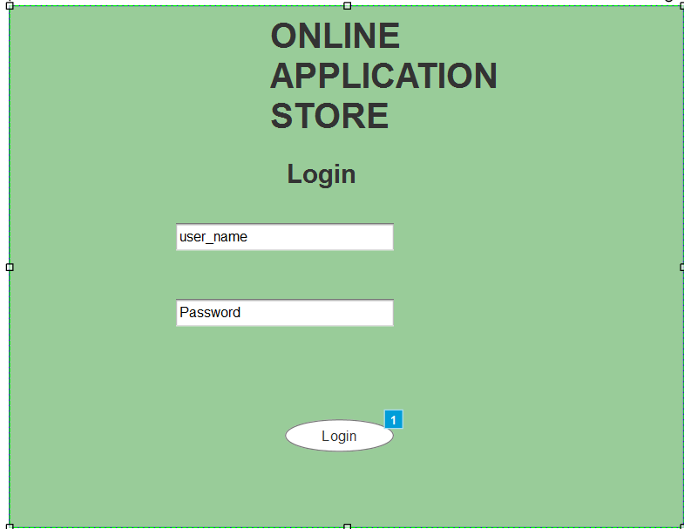
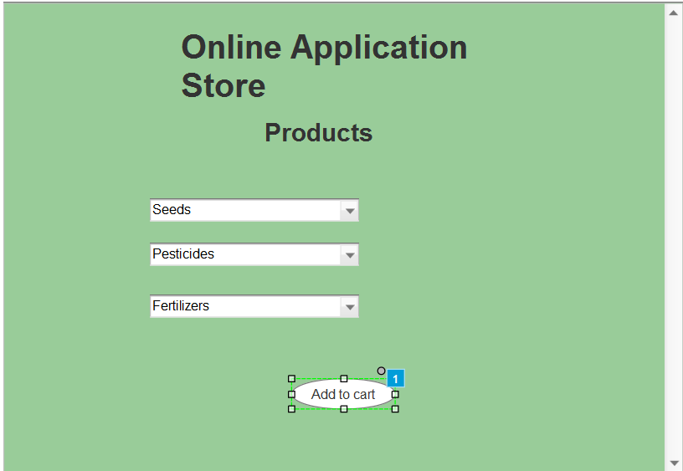
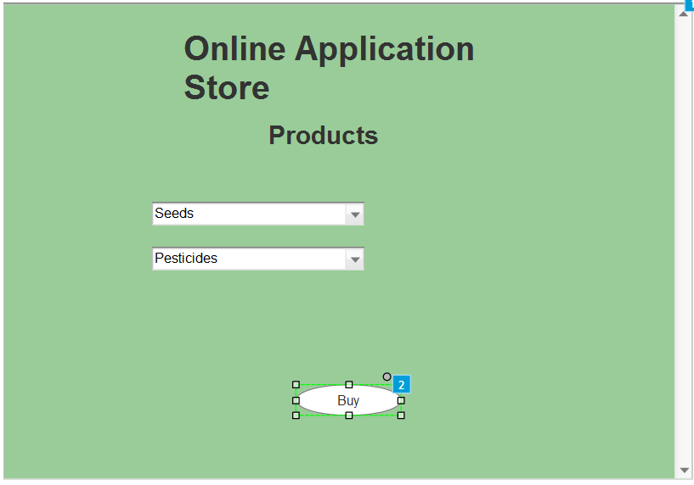
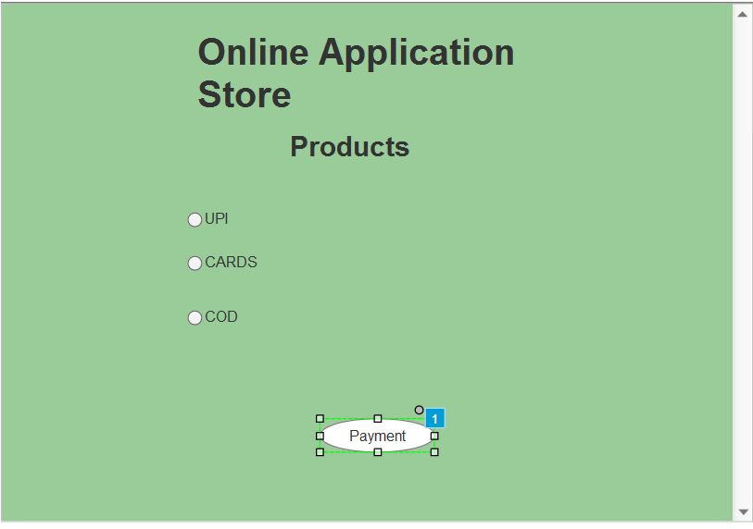
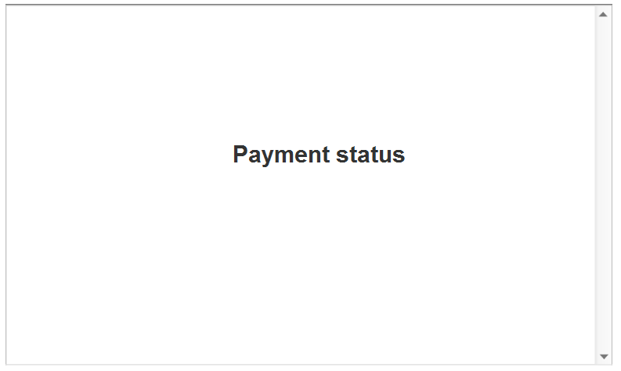

- Note on Tools
Ans- Microsoft Visio
Microsoft visio is diagramming and graphics tools developed by Microsoft. It is used to create UML diagrams, flowcharts like activity diagram easily and visually.
Balsamiq
Balsamiq is used to create wireframes and prototype for user interfaces. It helps BA and developers to create quick focusing on layout and functionality rather then colours and detailed design.
Asure
Asure is advanced prototyping tool used to create interactive wireframes and prototypes for web and mobile application.

- RTM
Ans- RTM is a Requirement Traceability Matrix It is a document which is used by the BA to track the requirements throughout the project lifecycle ensuring that all requirements are covered and no requirements are missed.

Req ID | Req Name | Req Desc | Design | Code | Unit Testing | Component testing | System Testing | SIT | UAT
FR001 | User registration | User should be able to register with the application | Complete | Complete | Complete | Complete | Complete | In progress | In-Com
FR002 | Login using user name password | User should be able to login using username and password | Complete | Complete | Complete | Complete | Complete | In progress | In-Com
FR003 | Browse product by category | User should be able to browse products by category | Complete | Complete | Complete | Complete | Complete | Complete | In-Com
FR004 | Search for product by name | User should be able to search products by its name | Complete | Complete | Complete | Complete | Complete | In progress | In-Com
FR005 | Add to cart list | User should be able to add products to the cart | Complete | Complete | Complete | Complete | In progress | In-Com | In-Com
FR006 | Remove items form the cart | User should be able to remove items from the cart | Complete | Complete | Complete | Complete | In progress | In-Com | In-Com
FR007 | Calculate the total price | User should be able to calculate the total price | Complete | Complete | Complete | In progress | In progress | In-Com | In-Com
FR008 | Place an order | User should be able to place an order | Complete | Complete | Complete | In progress | In progress | In-Com | In-Com
FR009 | Send an order confirmation email | User should be able to send an email confirmation | Complete | Complete | Complete | In progress | In-Com | In-Com | In-Com
FR0010 | Make payment through multiple options | User should be able to make payment through multiple source | Complete | Complete | Complete | In progress | In-Com | In-Com | In-Com
FR0011 | Generate an invoice | User should be able to generate an invoice | Complete | Complete | Complete | In progress | In-Com | In-Com | In-Com
FR0012 | Track an order | User should be able to tack an order | Complete | Complete | Complete | In progress | In-Com | In-Com | In-Com
FR0013 | Cancel an order | User should be able to cancel an order | Complete | Complete | Complete | In progress | In-Com | In-Com | In-Com
FR0014 | View the order history | User should be able to view the order history | Complete | Complete | In progress | In progress | In-Com | In-Com | In-Com
FR0015 | Add, edit or delete product | User should be able to add, delete products | Complete | Complete | Complete | In progress | In-Com | In-Com | In-Com
FR0016 | Add to wish list | User should be able to add items to Wishlist | Complete | Complete | Complete | In progress | In-Com | In-Com | In-Com
FR0017 | Total number of products added in Wishlist | User should be able to calculate total number of products added in the Wishlist | Complete | Complete | In progress | In progress | In-Com | In-Com | In-Com
FR0018 | Total amount of Wishlist items | User should be able to see total amount of Wishlist | Complete | Complete | Complete | In progress | In-Com | In-Com | In-Com
FR0019 | Logout user automatically | User should be able to logout automatically | Complete | Complete | In progress | In progress | In-Com | In-Com | In-Com
FR0020 | Validate user input | User should be able to validate user input | Complete | Complete | In progress | In-Com | In-Com | In-Com | In-Com

- Test Case Document
Ans- The test case document is prepared by the testers or testing department to ensure that application or system is working as expected and BA will be tracking this.
Test 1
Test Case ID |  | TC001 |  |  |  | Test case name |  | Registration
Project ID |  | P001 |  |  |  | Project name |  | SOONY
PM ID |  | PM001 |  |  |  | PM name |  | Mr Vandanam
Test strategy ID |  | TS001 |  |  |  | Tester ID |  | T12345
Test plan ID |  | TP001 |  |  |  | Tester name |  | Jason, Alekya
Test schedule ID |  | TS001 |  |  |  | Date of test |  | 01/01/2025
Scenario |  |  |  | User registration
Link
Input date | Set 1  User name |  | Set 2  User email |  | Set 3  Mobile no. |  | Set 4  Nickname |  | Set 5
Expected behaviour | User account created
Actual behaviour | User account created
Comment
Result | Pass

Test 2
Test Case ID |  | TC002 |  |  |  | Test case name |  | Login
Project ID |  | P002 |  |  |  | Project name |  | SOONY
PM ID |  | PM002 |  |  |  | PM name |  | Mr Vandanam
Test strategy ID |  | TS002 |  |  |  | Tester ID |  | T12345
Test plan ID |  | TP002 |  |  |  | Tester name |  | Jason, Alekya
Test schedule ID |  | TS002 |  |  |  | Date of test |  | 01/01/2025
Scenario |  |  |  | User Login
Link
Input date | Set 1  Email ID |  | Set 2  Password |  | Set 3 |  | Set 4 |  | Set 5
Expected behaviour | Logged-in successfully
Actual behaviour | Logged-in successfully
Comment
Result | Pass

Test 3
Test Case ID |  | TC003 |  |  |  | Test case name |  | Product catlog
Project ID |  | P003 |  |  |  | Project name |  | SOONY
PM ID |  | PM003 |  |  |  | PM name |  | Mr Vandanam
Test strategy ID |  | TS003 |  |  |  | Tester ID |  | T12345
Test plan ID |  | TP003 |  |  |  | Tester name |  | Jason, Alekya
Test schedule ID |  | TS003 |  |  |  | Date of test |  | 01/01/2025
Scenario |  |  |  | Product catlog
Link
Input date | Set 1  Seeds |  | Set 2  Fertilizers |  | Set 3  Pesticides |  | Set 4 |  | Set 5
Expected behaviour | Display products
Actual behaviour | Display products
Comment
Result | Pass

Test 4
Test Case ID |  | TC004 |  |  |  | Test case name |  | Invalid Login
Project ID |  | P004 |  |  |  | Project name |  | SOONY
PM ID |  | PM004 |  |  |  | PM name |  | Mr Vandanam
Test strategy ID |  | TS004 |  |  |  | Tester ID |  | T12345
Test plan ID |  | TP004 |  |  |  | Tester name |  | Jason, Alekya
Test schedule ID |  | TS004 |  |  |  | Date of test |  | 01/01/2025
Scenario |  |  |  | Invalid Login
Link
Input date | Set 1  Wrong email ID |  | Set 2  Wrong password |  | Set 3  Wrong email id and password |  | Set 4 |  | Set 5
Expected behaviour | Invalid login
Actual behaviour | Invalid login
Comment
Result | Pass

Test 5
Test Case ID |  | TC005 |  |  |  | Test case name |  | Add to cart
Project ID |  | P005 |  |  |  | Project name |  | SOONY
PM ID |  | PM005 |  |  |  | PM name |  | Mr Vandanam
Test strategy ID |  | TS005 |  |  |  | Tester ID |  | T12345
Test plan ID |  | TP005 |  |  |  | Tester name |  | Jason, Alekya
Test schedule ID |  | TS005 |  |  |  | Date of test |  | 01/01/2025
Scenario |  |  |  | Add to cart
Link
Input date | Set 1  List of products added to cart |  | Set 2  Total amount |  | Set 3 |  | Set 4 |  | Set 5
Expected behaviour | Display add to cart page
Actual behaviour | Displaying payment page
Comment
Result | Fail

Test 6
Test Case ID |  | TC006 |  |  |  | Test case name |  | Remove from cart
Project ID |  | P006 |  |  |  | Project name |  | SOONY
PM ID |  | PM006 |  |  |  | PM name |  | Mr Vandanam
Test strategy ID |  | TS006 |  |  |  | Tester ID |  | T12345
Test plan ID |  | TP006 |  |  |  | Tester name |  | Jason, Alekya
Test schedule ID |  | TS006 |  |  |  | Date of test |  | 01/01/2025
Scenario |  |  |  | Remove from cart
Link
Input date | Set 1 |  | Set 2 |  | Set 3 |  | Set 4 |  | Set 5
Expected behaviour | Product removed from cart
Actual behaviour | Product not removed from cart
Comment
Result | Fail

Test 7
Test Case ID |  | TC007 |  |  |  | Test case name |  | Wishlist
Project ID |  | P007 |  |  |  | Project name |  | SOONY
PM ID |  | PM007 |  |  |  | PM name |  | Mr Vandanam
Test strategy ID |  | TS007 |  |  |  | Tester ID |  | T12345
Test plan ID |  | TP007 |  |  |  | Tester name |  | Jason, Alekya
Test schedule ID |  | TS007 |  |  |  | Date of test |  | 01/01/2025
Scenario |  |  |  | Add to wish list
Link
Input date | Set 1  Seeds added to wishlist |  | Set 2 |  | Set 3 |  | Set 4 |  | Set 5
Expected behaviour | Product added to wishlist
Actual behaviour | Product added to wishlist
Comment
Result | Pass

Test 8
Test Case ID |  | TC008 |  |  |  | Test case name |  | Checkout
Project ID |  | P008 |  |  |  | Project name |  | SOONY
PM ID |  | PM008 |  |  |  | PM name |  | Mr Vandanam
Test strategy ID |  | TS008 |  |  |  | Tester ID |  | T12345
Test plan ID |  | TP008 |  |  |  | Tester name |  | Jason, Alekya
Test schedule ID |  | TS008 |  |  |  | Date of test |  | 01/01/2025
Scenario |  |  |  | Checkout process
Link
Input date | Set 1  User logged in |  | Set 2  Products in cart |  | Set 3  Address |  | Set 4  Payment method |  | Set 5
Expected behaviour | Order confirmation
Actual behaviour | Order confirmation
Comment
Result | Pass

Test 9
Test Case ID |  | TC009 |  |  |  | Test case name |  | Payment
Project ID |  | P009 |  |  |  | Project name |  | SOONY
PM ID |  | PM009 |  |  |  | PM name |  | Mr Vandanam
Test strategy ID |  | TS009 |  |  |  | Tester ID |  | T12345
Test plan ID |  | TP009 |  |  |  | Tester name |  | Jason, Alekya
Test schedule ID |  | TS009 |  |  |  | Date of test |  | 01/01/2025
Scenario |  |  |  | Payment successful
Link
Input date | Set 1  Address |  | Set 2  Payment method |  | Set 3 |  | Set 4 |  | Set 5
Expected behaviour | Verify successful payment
Actual behaviour | Verify successful payment
Comment
Result | Pass

Test 10
Test Case ID |  | TC0010 |  |  |  | Test case name |  | History
Project ID |  | P0010 |  |  |  | Project name |  | SOONY
PM ID |  | PM0010 |  |  |  | PM name |  | Mr Vandanam
Test strategy ID |  | TS0010 |  |  |  | Tester ID |  | T12345
Test plan ID |  | TP0010 |  |  |  | Tester name |  | Jason, Alekya
Test schedule ID |  | TS0010 |  |  |  | Date of test |  | 01/01/2025
Scenario |  |  |  | Order history
Link
Input date | Set 1  Payment confirmation |  | Set 2 |  | Set 3 |  | Set 4 |  | Set 5
Expected behaviour | Order shown with date and status
Actual behaviour | Order shown with date and status
Comment
Result | Pass

- DB schema and ER diagram
Ans- Database scheme is the structure or blueprint of a database. If defines how data is organised, how the tables are related and how constraints apply to the data.
Entity Relationship diagram is a visual representation of the relationship between entities in the database
DB Schema + Entity Relationship diagram = DB Design
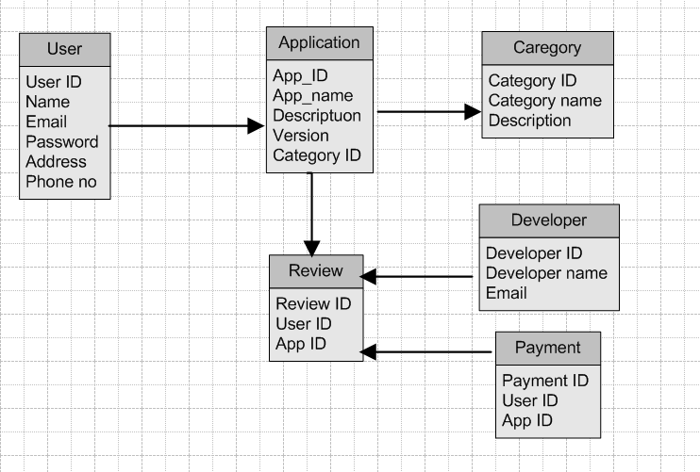

- Data flow diagram
Ans- It is graphical representation of the flow of data within a system. It visually shows how data flows from one process to another, how it is stored and where its ends up.
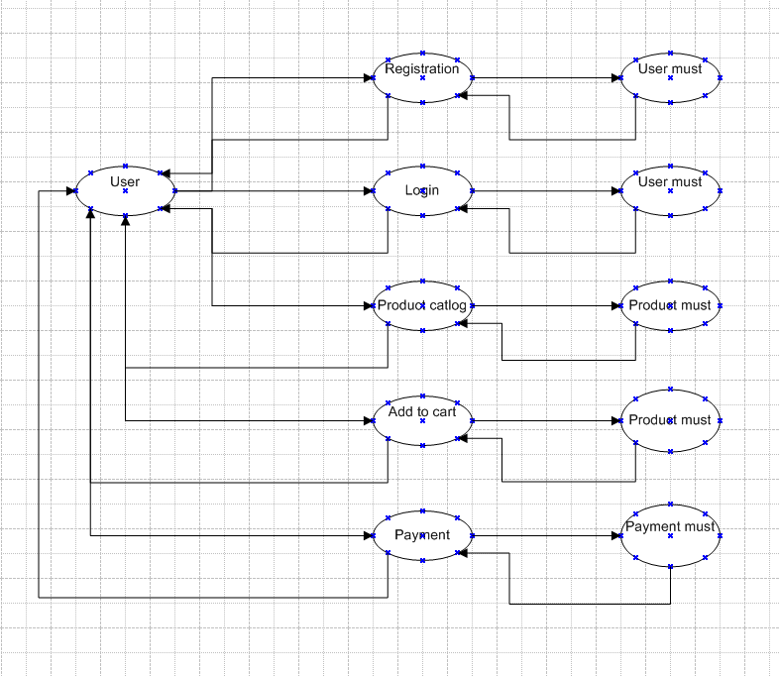

- Change request
Ans Change request is formal way of changing the system or product requested by the stakeholders. It is a process of adding one more feature to an existing feature.
Firstly BA should understand the scope of change request and he should document the change request
Then he should do the analysis like budget, scope, resources, risks.
Then he should prioritize the change request based on the urgency and importance.
Then he should take the approval from the project spencers for the change request
Then communicate the change request and its impact to all relevant stakeholders including project team.

- Change request or enhancement
Ans In this case, adding crops in the application from formers and auction system for their crops yields would be considered as enhancement as it involves adding new features to the system.
As a BA, I should document the requirement and work with the development team to implement the new feature. I should also consider potential benefits, risks, costs associated with it.

- Estimations
Ans There are 3 types of projects
Small- Upto 500 hours
Medium- Upto 1000 hours
Large- Upto 1500 hours
Analysis
As per case study, the duration of the project is 18 months and the team size is 11 members. This will come under medium project.
Manhours calculation
18 months project = 547 days
After excluding weekends and holidays total will be 430 days
8 hours in a day so 430*8= 3440 hours
So per person will work 3440 hours to finish the project.

- Explain UAT process
Ans UAT is User Acceptance Test. Once Design, code, UT, CT, ST, SIT is completed UAT process will happen. Here there will be multiple process, they are.
Planning Here, blueprints are made to implement UAT for every feature that needs to test.
Designing Here test cases are designed to hide all the possibilities of software
UAT Tester The end users meet the criteria for implementing testing. They should know how the test case will run and they should know their functionalities
Bug Fixing When the bugs are found Here, whatever bugs are found in the UAT testing it should be fixed by development team and make it error free.
Sign off After all the above process, the stakeholder comes to a conclusion that the software is ready to GO LIVE.

- Project Closure document
Ans It is also known as project closure report. It is a formal document that summarizes outcomes, lessen learned, and final details of a completed project. It serves a record of the projects challenges, overall performance, providing valuable insights for stakeholders and future projects.
Points to be included in the project closure document:
Project overview: Creating the online application for formers to help them with their needs
Achievements: Helping formers with seeds, fertilizers, pesticides at their door step
Lessons learned: We would have finished the project with less time and with less budget.
Quality assurance: The application will run smoothly without any problem and with less maintenance.
Resources utilization: Testes, Developers, DB admins, Network admins
Risk management: No risk
Challenges: No challenges faced.

SL NO | Points to include | Details | Ref link
1 | Did the client signoff on the UAT testing
 | Date of the4 signoff | 12/10/2024
 | Name of the resources | Mr. Henry
2 | Objective of the project
 | User friendly | Achieved
 | Customer satisfaction | ROI in 6 months
 | More categories | Achieved
 | Fast delivery | Achieved
 | Budget friendly products | Achieved
3 | Functionalities worked on
 | Secure payment processing | Achieved
 | Categories | Achieved
4 | Infrastructure
 | software’s installed | Achieved
 | Laptops purchased | Achieved
5 | Funding
 | Amount proposed | 2 crore
 | Amount used | 1.5 crore
6 | Overall project information
 | Escalations | 10
 | Customer satisfaction | High
7 | Value to the company
 | Positive/Negative | Positive  Increased clients  Trained employees  New project in pipeline

