Question 1 – Functional Requirements -Identify minimum 20 functional requirements
Req Id | Req Name | Req Description | Priority
FR001 | Farmer registration | Farmer should be able to register in the application by clicking on farmer login tab | 10
FR002 | Farmer login | Farmer should be able to login to the application | 9
FR003 | Farmer product browse | Farmer should be able to browse all the available products | 7
FR004 | Farmer product search | Farmer should be able to search for the required products | 7
FR005 | Forget password | Farmer should be able to generate new password using the forget password tab | 4
FR006 | Supplier registration | Supplier should be able to register themselves on the application by clicking on the supplier registration tab | 10
FR007 | Supplier login | Supplier should be able to login to the application | 9
FR008 | Buy product | Farmer should be able to buy the selected products by clicking on the checkout tab | 7
FR009 | Buy later list | Farmer can add the products to buy later by clicking on the add to cart tab | 3
FR010 | Payment | Farmer should be able to make the payment through any one mode by selecting the options among cash on delivery (COD), debit/Credit card, UPI and click on the payment tab to initiate the payment | 9
FR011 | Email Confirmation | Farmer should be able to receive the purchase invoice and order id on registered email id post payment is done successfully | 2
FR012 | Delivery tracking | Famer should be able to track the delivery by clicking on the track order tab and entering the order id | 6
FR013 | Order return | Farmer should be able to return the order by clicking on the return tab if does not meet the farmers expectation | 3
FR014 | Checking if product being delivered | Farmer should be able to check by entering the pin code of the location whether the product delivery is available to that location | 3
FR015 | Check order history | Farmer should be able to check all the previous order by clicking on the order history tab | 1
FR016 | Farmer logout | Farmer should be able to logout of the application by clicking on the logout tab | 10
FR017 | Supplier add product | Supplier should be able to add product in the product catalogue by entering product name, price, type, specifications | 9
FR018 | Farmer cancel order | Farmer should be able to cancel the order by clicking on the cancel order tab | 4
FR019 | Farmer compare products | Farmer should be able to compare maximum 3 products by clicking on add to compare tab | 6
FR020 | Farmer check offers | Farmer should be able to check ongoing offers and discounts by clicking the offers tab | 7

Question 2–Minimum 5page designs -Make wireframe and prototypes
OAPS Page Designs.bmpr

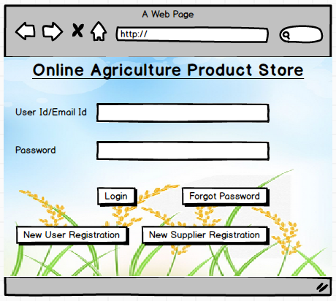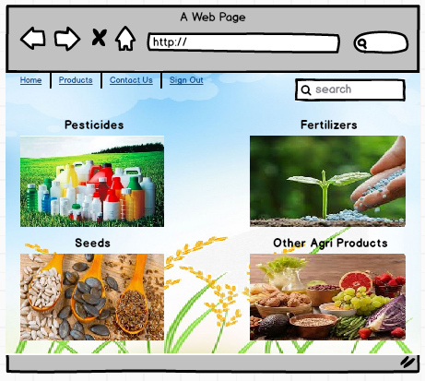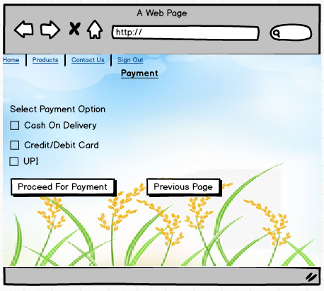
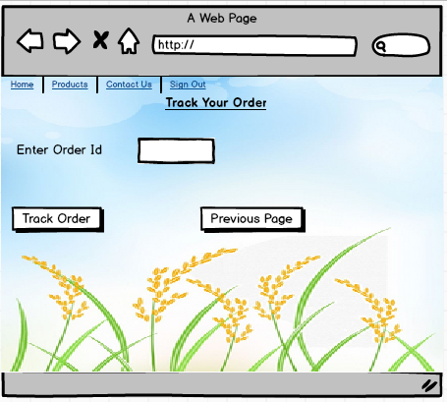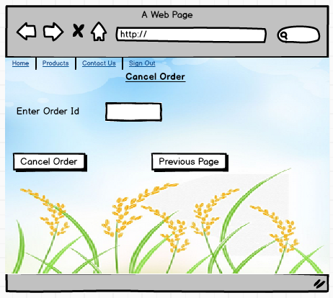

Question 3 – Tools (Visio, Balsamiq) -Make a note of the Tools, which you are using for above concepts.
Visio lets you transform business requirements that are difficult to understand for the project stakeholder into visual diagram that communicates the flow and business goal to be achieved at a glance. As a Business Analyst we mainly use Visio to draw Use Case diagrams and Activity diagrams.
Balsamiq is a tool that helps to fulfil the requirements of wireframing, collaboration and creativity. Generally, it is used to draw sample prototypes of the software and present to the client and post approval same can be used to understand and design the final product.

Question 4 – RTM -A business analyst’s key responsibilities are to keep track of the requirements and make sure that no requirement is missed. Mr. Henry and peter have approached you regarding the current status of the project. How will you tackle this situation? Prepare RTM
RTM is maintained to track the progress of the requirements. Please refer the link for the RTM
Complete RTM is attached in the link for reference RTM agricu.xlsx
Question 5 – 10 Test Case Documents – Prepare 10 Test Case Documents
Test Case Id | PR1122BS001 | Test Case Name | Verify the registration
Project Id | PR1122 | Project Name | Online Agriculture Products Store
PM Id | 1989 | PM Name | Mr. Vandanam
Test Strategy Id | PR1122BS002 | Tester Id | 1991
Test Plan Id | PR1122BS002 | Tester Name | Mr. XYZ
Test Schedule Id | PR1122BS002 | Date of Test | 03/06/2023
Scenario | Online Agriculture Products Store. In that user does the registration. And get popup message user registration successful
Link to that page
 | Set 1 |  | Set 2
Pre-requisite | User has valid email id
Input Data | user@omail.com, User@1234
Output Data | Registration successful popup message
Expected Behaviour | User registration successful
Actual Behaviour | User registration successful
Comment | Test run successfully
Test Result | Pass

Test Case Id | PR1122BS001 | Test Case Name | Farmer login
Project Id | PR1122 | Project Name | Online Agriculture Products Store
PM Id | 1989 | PM Name | Mr. Vandanam
Test Strategy Id | PR1122BS002 | Tester Id | 1991
Test Plan Id | PR1122BS002 | Tester Name | Mr. XYZ
Test Schedule Id | PR1122BS002 | Date of Test | 03/06/2023
Scenario | Online Agriculture Products Store. In that farmer login using email id and password. And gets redirected to the home page
Link to that page
 | Set 1 |  | Set 2
Pre-requisite | Farmer already registered
Input Data | user@omail.com, User@1234
Output Data | Application homepage
Expected Behaviour | Login successful
Actual Behaviour | Login successful
Comment | Test run successfully
Test Result | Pass

Test Case Id | PR1122BS001 | Test Case Name | Farmer login
Project Id | PR1122 | Project Name | Online Agriculture Products Store
PM Id | 1989 | PM Name | Mr. Vandanam
Test Strategy Id | PR1122BS002 | Tester Id | 1991
Test Plan Id | PR1122BS002 | Tester Name | Mr. XYZ
Test Schedule Id | PR1122BS002 | Date of Test | 03/06/2023
Scenario | Online Agriculture Products Store. In that farmer login using user id and wrong password. And gets message incorrect password
Link to that page
 | Set 1 |  | Set 2
Pre-requisite | Farmer already registered
Input Data | user@omail.com, User@1235
Output Data | Incorrect password error message
Expected Behaviour | Login unsuccessful
Actual Behaviour | Login unsuccessful
Comment | Test run successfully
Test Result | Pass

Test Case Id | PR1122BS001 | Test Case Name | Farmer login
Project Id | PR1122 | Project Name | Online Agriculture Products Store
PM Id | 1989 | PM Name | Mr. Vandanam
Test Strategy Id | PR1122BS002 | Tester Id | 1991
Test Plan Id | PR1122BS002 | Tester Name | Mr. XYZ
Test Schedule Id | PR1122BS002 | Date of Test | 03/06/2023
Scenario | Online Agriculture Products Store. In that farmer login using wrong user id and password. And gets message incorrect email id
Link to that page
 | Set 1 |  | Set 2
Pre-requisite | Farmer already registered
Input Data | user1@omail.com, User@1234
Output Data | Incorrect email id error message
Expected Behaviour | Login unsuccessful
Actual Behaviour | Login unsuccessful
Comment | Test run successfully
Test Result | Pass

Test Case Id | PR1122BS001 | Test Case Name | Farmer payment
Project Id | PR1122 | Project Name | Online Agriculture Products Store
PM Id | 1989 | PM Name | Mr. Vandanam
Test Strategy Id | PR1122BS002 | Tester Id | 1991
Test Plan Id | PR1122BS002 | Tester Name | Mr. XYZ
Test Schedule Id | PR1122BS002 | Date of Test | 03/06/2023
Scenario | Online Agriculture Products Store. In that farmer click on payment and select credit card option and enter all details correctly. And gets message Payment successful and invoice sent to registered email id
Link to that page
 | Set 1 |  | Set 2
Pre-requisite | Farmer already logged in
Input Data | xxxxxxxxxxxx1234, 01/01, 012, 456789
Output Data | Payment successful and invoice sent to registered email id
Expected Behaviour | Payment successful
Actual Behaviour | Payment successful
Comment | Test run successfully
Test Result | Pass

Test Case Id | PR1122BS001 | Test Case Name | Farmer payment
Project Id | PR1122 | Project Name | Online Agriculture Products Store
PM Id | 1989 | PM Name | Mr. Vandanam
Test Strategy Id | PR1122BS002 | Tester Id | 1991
Test Plan Id | PR1122BS002 | Tester Name | Mr. XYZ
Test Schedule Id | PR1122BS002 | Date of Test | 03/06/2023
Scenario | Online Agriculture Products Store. In that farmer click on payment and select credit card option and enter details wrong. And gets message Incorrect card details please retry
Link to that page
 | Set 1 |  | Set 2
Pre-requisite | Farmer already logged in
Input Data | xxxxxxxxxxxx1234, 01/01, 022, 456789
Output Data | Incorrect card details please retry message
Expected Behaviour | Payment unsuccessful
Actual Behaviour | Payment unsuccessful
Comment | Test run successfully
Test Result | Pass

Test Case Id | PR1122BS001 | Test Case Name | Farmer forget password
Project Id | PR1122 | Project Name | Online Agriculture Products Store
PM Id | 1989 | PM Name | Mr. Vandanam
Test Strategy Id | PR1122BS002 | Tester Id | 1991
Test Plan Id | PR1122BS002 | Tester Name | Mr. XYZ
Test Schedule Id | PR1122BS002 | Date of Test | 03/06/2023
Scenario | Online Agriculture Products Store. In that farmer click forget password and enters registered email id. And gets message Password reset link sent to registered email id
Link to that page
 | Set 1 |  | Set 2
Pre-requisite | Farmer already registered
Input Data | user@omail.com
Output Data | Password reset link sent to registered email id
Expected Behaviour | Password reset link sent
Actual Behaviour | Password reset link sent
Comment | Test run successfully
Test Result | Pass

Test Case Id | PR1122BS001 | Test Case Name | Farmer forget password
Project Id | PR1122 | Project Name | Online Agriculture Products Store
PM Id | 1989 | PM Name | Mr. Vandanam
Test Strategy Id | PR1122BS002 | Tester Id | 1991
Test Plan Id | PR1122BS002 | Tester Name | Mr. XYZ
Test Schedule Id | PR1122BS002 | Date of Test | 03/06/2023
Scenario | Online Agriculture Products Store. In that farmer click forget password and enters incorrect email id. And gets message Invalid email id/ email id not registered
Link to that page
 | Set 1 |  | Set 2
Pre-requisite | Farmer already registered
Input Data | user1@omail.com
Output Data | Invalid email id/ email id not registered error message
Expected Behaviour | Password reset link not sent
Actual Behaviour | Password reset link not sent
Comment | Test run successfully
Test Result | Pass

Test Case Id | PR1122BS001 | Test Case Name | Farmer cancel order
Project Id | PR1122 | Project Name | Online Agriculture Products Store
PM Id | 1989 | PM Name | Mr. Vandanam
Test Strategy Id | PR1122BS002 | Tester Id | 1991
Test Plan Id | PR1122BS002 | Tester Name | Mr. XYZ
Test Schedule Id | PR1122BS002 | Date of Test | 03/06/2023
Scenario | Online Agriculture Products Store. In that farmer click on cancel order and enter correct order id. And gets message Order cancelled and payment will be reversed within 7 working days
Link to that page
 | Set 1 |  | Set 2
Pre-requisite | Farmer logged in and have order id
Input Data | Order1234
Output Data | Order cancelled and payment will be reversed within 7 working days message
Expected Behaviour | Order cancelation successful
Actual Behaviour | Order cancelation successful
Comment | Test run successfully
Test Result | Pass

Test Case Id | PR1122BS001 | Test Case Name | Farmer cancel order
Project Id | PR1122 | Project Name | Online Agriculture Products Store
PM Id | 1989 | PM Name | Mr. Vandanam
Test Strategy Id | PR1122BS002 | Tester Id | 1991
Test Plan Id | PR1122BS002 | Tester Name | Mr. XYZ
Test Schedule Id | PR1122BS002 | Date of Test | 03/06/2023
Scenario | Online Agriculture Products Store. In that farmer click on cancel order and enter incorrect order id. And gets message Please enter correct order id
Link to that page
 | Set 1 |  | Set 2
Pre-requisite | Farmer logged in and have order id
Input Data | Order1235
Output Data | Please enter correct order id message
Expected Behaviour | Order cancelation unsuccessful
Actual Behaviour | Order cancelation unsuccessful
Comment | Test run successfully
Test Result | Pass
Question 6 – DB Design - After the requirements are thoroughly explained to the entire project team by business analyst, the Database architects have decided to do the database design and also to represent the in-flow and out-flow of data. Draw database schema and ER diagram
Entity Relation (ER) Diagram: An ER diagram is a type of flowchart that illustrates how entities such as people, objects or concepts are related to each other. It is a high-level design model.
Also, you can say ER diagram is visual representation of how data are related to each other.
Database Schema: It refers to a structure that represents relationships among the data and defines how information is stored in the database.

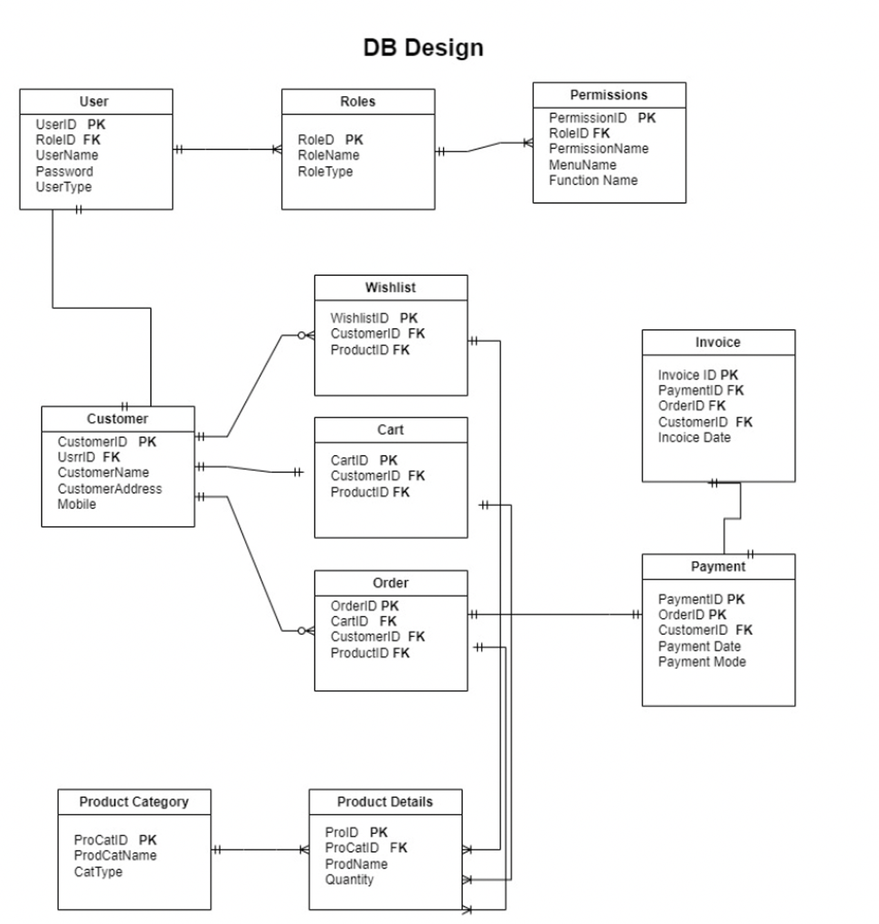

Question 7 – Data Flow Diagram -What is a data flow diagram? Draw a data flow diagram to represent the in-flow and out-flow of data when a Farmer is placing an order for the product
Data Flow Diagram is nothing but visual representation of flow of data or information within a system.
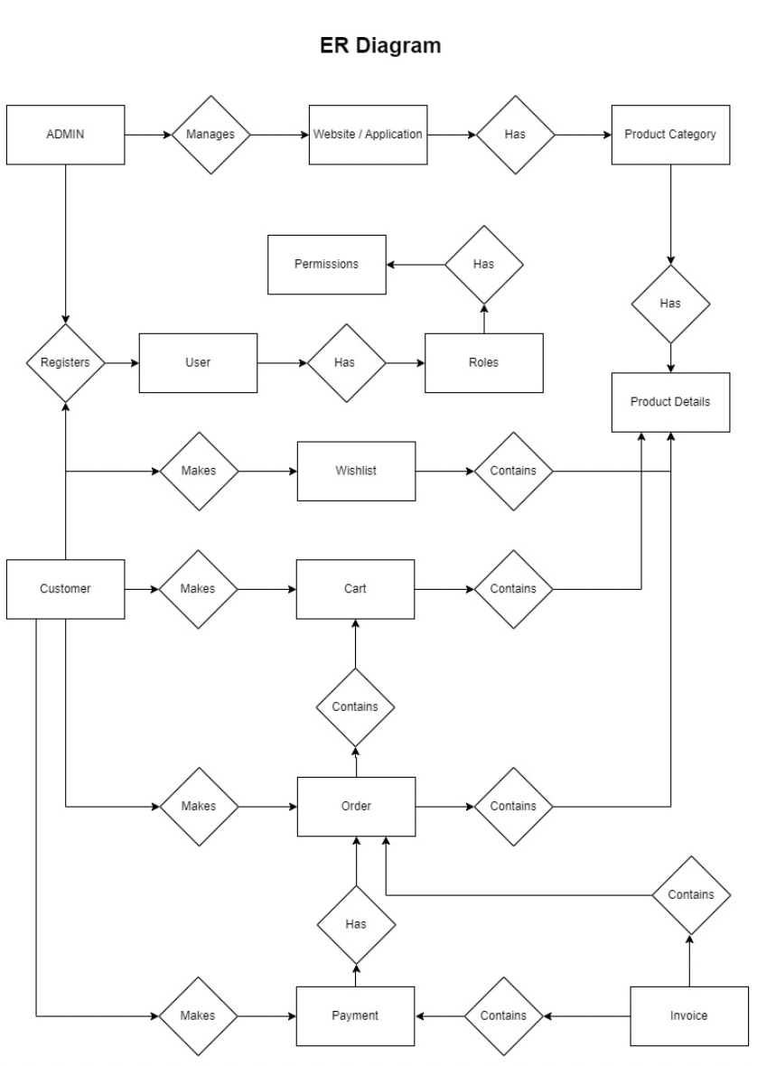
Question 8 – Change Request -Due to change in the Government Taxation structure. we should change the Tax structure How do you handle change requests in a project?
Handling change requests in a project involves a systematic approach to ensure that changes are properly evaluated, documented, and implemented while minimizing disruption to the project's progress. Here's a step-by-step guide on how to handle change requests effectively:

Initiation:
➢Change requests can come from various sources, such as stakeholders, team members, or external factors like regulatory changes.
➢When a change request is identified, it should be documented along with details such as the reason for the change, its impact on the project, and any proposed solutions.

Documentation:
➢Create a change request form or template to capture all relevant information about the proposed change.
➢Include details such as the nature of the change, its priority, justification, estimated impact on the project timeline, budget, and resources required.

Evaluation:
➢Assess the impact of the change on the project objectives, scope, schedule, budget, and risks.
➢Evaluate the feasibility of implementing the change within the project constraints.
➢Involve key stakeholders, including the project sponsor, in the evaluation process to ensure alignment with project goals.

Approval:
➢Present the change request, along with the evaluation findings, to the project sponsor or change control board for approval.
➢Obtain formal approval before proceeding with implementing the change.
➢If the change is approved, update project documentation, including the project plan, requirements, and any relevant deliverables.

Implementation:
➢Once approved, communicate the approved change to the project team and stakeholders.
➢Assign responsibilities for implementing the change and monitor progress closely.
➢Update project schedules, budgets, and resource allocations as needed to accommodate the change.
Testing and Validation:
➢Conduct testing to ensure that the implemented change meets the specified requirements and does not introduce any unintended side effects.
➢Validate the change with stakeholders to confirm that it meets their expectations and addresses the initial need.
Documentation and Closure:
➢Document the details of the implemented change, including any lessons learned or best practices identified during the process.
➢Close the change request formally, updating project documentation and communicating the closure to relevant stakeholders.
➢Archive all documentation related to the change request for future reference.
Question 9 – Change Request Vs an Enhancement
As a Business Analyst, my response to Ben and Kevin's request would involve analysing whether their suggestion constitutes a change request or an enhancement to the existing project scope. Here's how I would approach the situation:
➢If the proposed features significantly alter the project's scope, objectives, or deliverables, I would classify the request as a change request. This would involve formal documentation, evaluation, and approval processes as outlined earlier.
➢If the requested features complement the project's original goals and do not substantially impact the project's timeline, budget, or resources, I would consider them as enhancements. These enhancements could be incorporated into the project through collaboration with the
development team and stakeholders.
Based on my analysis and consultation with stakeholders, I would provide a recommendation to the project committee regarding how to proceed with Ben and Kevin's request.
I would outline the potential implications, benefits, and risks associated with implementing the proposed changes and offer suggestions for prioritization based on project objectives and constraints.
Ultimately, my goal as a Business Analyst would be to ensure that any decisions regarding the inclusion of new features or changes to the project scope are made thoughtfully, with a focus on maximizing value for stakeholders while maintaining project integrity and success.

Question 9 – Change Request Vs an Enhancement -As the project is in process, Ben and Kevin have contacted you. The reason is to inform you that they want the Farmers to sell their crop yields through this application i.e. Farmers should be able to add their crop yields or products and display to general public and should be able to sell them. They also want to introduce Auction system for their Crop yields. As a BA, what will be your response? Is this a change request or an enhancement???
A Change Request (CR) is requesting some change in the existing set of business requirements.
An Enhancement in a project means adding new feature to the project.
In this above-mentioned situation. it is an Enhancement Request.
The process of handling an Enhancement Request is same to that of a Change Request. Firstly, we need to do the feasibility study then we need to do the impact analysis and lastly, we need to carry out the effort estimation and if the enhancement is being added to the project the it should be taken care that it should not affect the scope of the project.
Question 10 – Estimations -Come up with estimations – How many Manhours required
Formula to calculate manhours is
Manhours = No of employees* No of weeks* 40
Sample Estimation:
Type of Resources | Weeks | No of Resources | Manhours | Fees Per Hour(Rs) | Estimation
Business Analyst | 12 | 1 | 480 | 1000 | 480000
Developers | 30 | 4 | 4800 | 1000 | 4800000
Design | 20 | 2 | 1600 | 1000 | 1600000
Tester | 10 | 2 | 800 | 900 | 720000
Total | 72 | 9 | 7680 | 3900 | 7600000

There will be database servers to be purchased, other tools to be purchased, PM, DBA, NWA fess etc estimations to be covered also.
Question 11 – UAT –Project has finally completed all the stages i.e., design, development, testing etc. Now, it is the role of a business analyst to contact the client for testing of the final product and have to successfully complete it. How are you going to handle this situation? And once it is done, what will be the process to close the project? Explain UAT Acceptance process
User Acceptance Test (UAT) is the final step before implementing and deploying the software in the real world. As the name suggests UAT should be performed by the real time users to verify if the application is meeting the business objective. Post testing BA needs to approach the client for the UAT. It is one of the most important steps before the application deployment as it will help us to understand whether the application will be able to handle the day to day uses and scenarios in the real world.

Role of BA in UAT
- Identifying the UAT Tester: BA should connect with the client to identify the UAT testers. UAT testers can be Active Users or they can be Passive Users.
- Planning UAT Tests: BA along with the Testers should design UAT test cases. UAT test cases are different from normal test cases as later one is focused on finding the defects in the application whereas the former one is focused on how the system will actually function or respond in real world.
- Determining when to do UAT: Planning the right time to perform the UAT is very important so that if any issue is identified it can be rectified within the scope of the project. BA should work with the developers and tester to determine the right time to perform UAT.
- Delivering Business Objectives Through UAT: BA should be actively participating in the UAT phase to ensure that the business objectives are being met.

Question 12 – Project Closure Document -Explain Project closure document
Project Closure Document is the last deliverable submitted at the end of the project. It measures the overall success of the project.
Steps to create a Project Closure Document:
- Label the document: It should consist of the project name, project manager name, involved team details.
- Overview of the project: It consists of the complete summary of the project, purpose of the project, procedures used, issues faced, how the issues were addressed.
- Project accomplishments, outcomes and results: It mentions the key performance indicators (KPI) of the project, project completion date.
- Scope of the project: It mentions the goal of the project, tasks and deadlines of the project.
- Performance analysis: It contains the performance of the team in completing the project.

