AGILE – DELIVERABLES
Document 1: Definition of Done
As per Agile Extension to the BABOK Guide v2, the Definition of Done (DoD) is shared agreement within the Scrum Team about the list of criteria must be completed before a backlog item such as user stories, sprint or release is considered as “done”.
This ensures transparency, alignment and consistent quality across all deliverables of the e-Treasury Bill Automation project.
Checklist for DoD
- User Story Level
- Acceptance criteria of the user stories are fully met.
- Business rules (e.g., approval hierarchy, fund availability validation) implemented and verified.
- Code is written, reviewed and integrated without errors.
- Unit tests are created with minimum coverage agreed say about 80%
- QA has tested the feature and all critical defects are resolved.
- Feature works across required browsers/devices (portal access for DDOs, Treasury Officers)
- Feature reviewed and accepted by the Product Owner.
- Relevant configuration details and database changes documented.

- Sprint Level
- All committed user stories in the sprint backlog meet the Definition of Done.
- End-to-end functionality demonstrated successfully in the Sprint Review (e.g., bill submission to approval flow).
- Regression Testing performed to ensure existing features are not broken.
- Updated sprint documentation using JIRA.
- Code deployed to a test environment identical to production to test the functionalities.

- Release Level
- All prioritization features for the release are completed and meet quality standards.
- System integration with banks and external services tested and verified.]
- Security compliance checks (SSL certificates, access control, audit trail) completed.
- Performance testing is passed (e.g., bill processing time within acceptable limits)
- Training materials and user documentation prepared for Drawing and Disbursing Officers (DDOs), Treasury Officers (TOs), and Vendors.
- Release signed off by Product Owner and key stakeholders (Finance Department).

Document 2: Product Vision
The product vision for the e-Treasury Bill Automation System is to digitize the entire treasury bill lifecycle covering submission, verification, approval and disbursement into a seamless, transparent and efficient process. It aims to reduce delays, minimize manual errors and provide real-time tracking for all stakeholders. By integrating with banks and enabling digital records, the system strengthens financial governance, ensures timely payments and improves service delivery for government departments and vendors.

Scrum Project Name: | e-Treasury Bill Automation System
Venue: | Finance Department – Treasury Office, Kolkata
Date: | 01-09-2025
Start Time: | 10:00AM
End Time: | 12:00 PM
Duration: | 2 Hours
Client: | West Bengal Finance Department
Stakeholder List: | - Treasury Officers (TOs)  - Drawing & Disbursing Officers (DDOs)  - Finance Department Officials  - Vendors/Suppliers  - Banks  - Audit & Compliance Department
 | Scrum Team
Scrum Master: | Ms Saakshi Dugar
Product Owner: | Ms Sunita Acharya
Scrum Developer 1: | Mr Rahul Bose
Scrum Developer 2: | Mr Yug Mishra
Scrum Developer 3: | Mr Mayukh Bose
Scrum Developer 4: | Ms Sameera Reddy
Scrum Developer 5: | Mr Karthik

Document 3: User Stories
User Story No: US1 | Tasks: Submit a treasury bill online |  | Priority: Highest
Value Statement:
As a DDO,
I want to submit bills digitally
So that I can avoid manual paperwork and speed up processing.
BV: 10 |  | CP: 5
Acceptance Criteria:
- System allows uploading of bill details and supporting document
- Bill submission generates a unique reference ID
- Confirmation message sent to DDO

User Story No: US2 | Tasks: Validate bill details automatically |  | Priority: Highest
Value Statement:
As a treasury officer,
I want the system to validate mandatory fields
So that I can reduce errors in bill submissions.
BV: 8 |  | CP: 3
Acceptance Criteria:
- System highlights missing or invalid fields.
- Bills with missing info cannot be submitted.
- Validation report is shown instantly.

User Story No: US3 | Tasks: Approve bills online |  | Priority: Highest
Value Statement:
As a treasury officer,
I want to approve bills digitally
So that I can eliminate manual approval delays.
BV: 10 |  | CP: 5
Acceptance Criteria:
- Officer can review bill details and attachments online.
- Approval/Rejection is logged with timestamp.
- Notification sent to DDO.

User Story No: US4 | Tasks: Track bill status in real-time |  | Priority: High
Value Statement:
As a vendor,
I want to check the real-time status of my bill
so that I know when payment will be received.
BV: 7 |  | CP: 4
Acceptance Criteria:
- Status updates reflect submission, approval, processing and payment.
- Vendors can log in with bill ID

User Story No: US5 | Tasks: Receive notification on updates |  | Priority: High
Value Statement:
As a DDO,
I want email/SMS notification on bill status
so that I stay informed about approvals or rejections
BV: 6 |  | CP: 3
Acceptance Criteria:
- Notification triggered on submission, approval, rejection and payment.
- Notification content includes bill ID and next steps.

User Story No: US6 | Tasks: Upload supporting documents securely |  | Priority: High
Value Statement:
As a DDO,
I want to attach scanned bills and invoices
so that treasury officers can verify records digitally.
BV: 6 |  | CP: 3
Acceptance Criteria:
- System supports PDF/JPEG uploads.
- Files are encrypted and stored securely.
- Upload confirmation is displayed.

User Story No: US7 | Tasks: Reject bills with remarks |  | Priority: High
Value Statement:
As a treasury officer,
I want to reject bill with comments
So that DDOs can correct and resubmit quickly
BV: 5 |  | CP: 3
Acceptance Criteria:
- Rejection must include remarks.
- Rejected bills return to DOO’s dashboard

User Story No: US8 | Tasks: Digital signature/approval |  | Priority: Highest
Value Statement:
As a treasury officer,
I want to sign bills digitally
So that the process remains complaint and paperless
BV: 7 |  | CP: 5
Acceptance Criteria:
- Bills can be digitally signed with secure certificates.
- System verifies authenticity of the signature.

User Story No: US9 | Tasks: Integration with banks for disbursement |  | Priority: Highest
Value Statement:
As a vendor,
I want my payment processed directly via bank integration
So that I receive funds quickly.
BV: 9 |  | CP: 8
Acceptance Criteria:
- Approved bills trigger fund disbursement.
- Payment confirmation available in system.

User Story No: US10 | Tasks: Audit trail for all transactions |  | Priority: High
Value Statement:
As an auditor,
I want a digital log of all bill actions
So that I can verify compliance.
BV: 5 |  | CP: 5
Acceptance Criteria:
- Every action logged with user, date and time.
- Logs cannot be modified.

User Story No: US11 | Tasks: Dashboard for DDOs |  | Priority: High
Value Statement:
As a DDO,
I want dashboard view of all bills
So that I can track pending, approval and rejected submission.
BV: 5 |  | CP: 4
Acceptance Criteria:
- Dashboard displays bill summary and status.
- Can filter by date, status and amount.

User Story No: US12 | Tasks: Dashboard for Treasury Officers |  | Priority: High
Value Statement:
As a treasury officer,
I want a consolidated dashboard
So that I can prioritize pending bills.
BV: 4 |  | CP: 4
Acceptance Criteria:
- Pending bills shown with priority indicators.
- Officers can filter and sort.

User Story No: US13 | Tasks: Search functionality |  | Priority: Medium
Value Statement:
As a user,
I want to search bills by ID, date or department
so that I can find records easily.
BV: 2 |  | CP: 2
Acceptance Criteria:
- Search supports multiple parameters.
- Results display bill details and status.

User Story No: US14 | Tasks: Generate reports |  | Priority: Medium
Value Statement:
As a finance officer,
I want to generate monthly reports
So that I can review fund utilization.
BV: 3 |  | CP: 3
Acceptance Criteria:
- Reports available in PDF/Excel formats.
- Reports include bill counts, amounts and statuses.

User Story No: US15 | Tasks: Role-based access |  | Priority: High
Value Statement:
As an admin,
I want to assign role-based access
so that data remains secure
BV: 3 |  | CP: 4
Acceptance Criteria:
- Roles include DDO, Treasury Officer, Vendor, Admin.
- Users only access their permitted features.

User Story No: US16 | Tasks: Mobile access |  | Priority: Medium
Value Statement:
As a DDO,
I want to access the system on mobile
So that I can track bills anytime
BV: 2 |  | CP: 3
Acceptance Criteria:
- Mobile-responsive interface.
- Notification available on mobile.

User Story No: US17 | Tasks: Bills history tracking |  | Priority: Medium
Value Statement:
As a DDO,
I want to view the history of each bill
So that I can understand its journey.
BV: 2 |  | CP: 2
Acceptance Criteria:
- Timeline view of each bill’s status changes.
- Remarks and approval visible.

User Story No: US18 | Tasks: Secure login with 2FA |  | Priority: High
Value Statement:
As a user,
I want to secure login with 2FA
so that my account remains safe.
BV: 3 |  | CP: 3
Acceptance Criteria:
- Login requires password + OTP
- OTP delivered via email/SMS

User Story No: US19 | Tasks: Bulk bill upload |  | Priority: Medium
Value Statement:
As a DDO,
I want to upload multiple bills at once
So that I save time
BV: 2 |  | CP: 3
Acceptance Criteria:
- System accepts bulk uploads in Excel/PDF.
- Errors highlighted per record.

User Story No: US20 | Tasks: SLA compliance alerts |  | Priority: Medium
Value Statement:
As a finance officer,
I want alerts for SLA breaches
so that I can act quickly
BV: 2 |  | CP: 3
Acceptance Criteria:
- Alerts triggered when processing exceed SLA.
- Escalation sent to higher authorities.

User Story No: US21 | Tasks: Bill submission |  | Priority: Medium
Value Statement:
As a DDO,
I want to resubmit rejected bills easily
So that I don’t start from scratch.
BV: 2 |  | CP: 2
Acceptance Criteria:
- Rejected bills allow edits and resubmission.
- Old remarks retained for reference.

User Story No: US22 | Tasks: Vendor portal access |  | Priority: Medium
Value Statement:
As a vendor,
I want portal access
So that I can track my payment status.
BV: 2 |  | CP: 2
Acceptance Criteria:
- Vendors log in with unique credentials
- Dashboard shows pending and paid bills.

User Story No: US23 | Tasks: Configurable workflows |  | Priority: Low
Value Statement:
As an admin,
I want configurable approval workflows
So that the system adapts to departmental needs.
BV: 1 |  | CP: 4
Acceptance Criteria:
- Workflows can be set by department or bill type.
- Changes logged in system

User Story No: US24 | Tasks: Payment confirmation to vendors |  | Priority: Medium
Value Statement:
As a vendor,
I want payment confirmation notifications
So that I know funds are credited.
BV: 2 |  | CP: 2
Acceptance Criteria:
- Notifications triggered after successful disbursement.
- Includes transaction ID and date.

User Story No: US25 | Tasks: Archival of old bills |  | Priority: Low
Value Statement:
As a finance officer,
I want old bills archived digitally
So that I can free system storage and maintain compliance.
BV: 1 |  | CP: 2
Acceptance Criteria:
- Bills older than 5 years moved to archive.
- Archived bills retrievable when needed.

Document 4: Agile Product Owner Experience
Project: e-Treasury Bill Automation System
Role of the Product Owner
The Product Owner in this project acted as the bridge between stakeholders (DDOs, Treasury Officers, Finance Department, Vendors) and the Scrum Team. With knowledge of government financial workflows treasury operations, the PO ensured that the product vision was aligned with stakeholder needs and regulatory compliance.
Responsibilities of the Product Owner in the Project
- Market / Domain Analysis
- Analysed the existing treasury process (manual + limited digitization)
- Assessed the demand for automation to reduce turnaround time, errors and inefficiencies.
- Studied similar e-governance financial systems for reference.
- Enterprise Analysis
- Conducted due diligence on opportunities to enhance transparency in government payments.
- Ensured the solution aligned with government digital initiatives and compliance standards.
- Product Vision and Roadmap
- Defined the vision by digitizing the treasury bill lifecycle for faster, transparent and accountable processing.
- Created a roadmap that included high-level featured like bill submission, approval workflows, bank integration, real-time tracking and dashboards.
- Managing Product Features
- Collected requirements from stakeholders (DDOs, Treasury Officers, Finance Department, Vendors).
- Prioritizes features based on critically, ROI and stakeholder need.
- Balanced between compliance requirements and user convenience.
- Managing Product Backlog
- Maintained and refined the product backlog in JIRA.
- Prioritized epics and user stories using Business Value (BV) via $100 technique and Complexity Points (CP) via Planning Poker.
- Re-prioritized backlog items as per changing stakeholder inputs.
- Managing Iteration Progress
- Facilitated sprint planning, ensuring the team icked the right stories aligned with sprint goals.
- Participated in daily scrums, monitoring progress and removing blockers with the Scrum Master.
- Conducted sprint reviews with stakeholders to demo increments and capture feedback.
- Engaged in retrospectives with BA and team to improve delivery.

Meetings Handled by the PO
- Sprint Planning
- Daily Scrum
- Sprint Review
- Sprint Retrospective
- Backlog Refinement
User Story Management
- Created and refined user stories including:
- Stories
- Tasks
- Priority
- Acceptance Criteria
- BV & CP values.

Key Learning as PO from this Project
- How to align a vision with evolving government financial requirements.
- Importance of stakeholder collaboration to prioritize value-driven features.
- Practical experience with Agile ceremonies and backlog management in JIRA.
- Balancing compliance-driven needs with user friendly design.
- Delivery working increments of automation that improved transparency and efficiency.

Document 5: Product and sprint backlog and product and sprint burndown charts
Product Backlog
User story ID | User story | Tasks | Priority | BV | CP | Sprint
US1 | As a DDO,  I want to submit bills digitally  So that I can avoid manual paperwork and speed up processing | Submit a treasury bill online | Highest | 10 | 5 | Sprint 1
US2 | As a treasury officer,  I want the system to validate mandatory fields  So that I can reduce errors in bill submissions. | Validate bill details automatically | Highest | 8 | 3 | Sprint 1
US3 | As a treasury officer,  I want to approve bills digitally  So that I can eliminate manual approval delays. | Approve bills online | Highest | 10 | 5 | Sprint 2
US4 | As a vendor,  I want to check the real-time status of my bill  so that I know when payment will be received | Track bill status in real-time | High | 7 | 4 | Sprint 3
US5 | As a DDO,  I want email/SMS notification on bill status  so that I stay informed about approvals or rejections | Receive notification on updates | High | 6 | 3 | Sprint 2
US6 | As a DDO,  I want to attach scanned bills and invoices  so that treasury officers can verify records digitally | Upload supporting documents securely | High | 6 | 3 | Sprint 1
US7 | As a treasury officer,  I want to reject bill with comments  So that DDOs can correct and resubmit quickly | Reject bills with remarks | High | 5 | 3 | Sprint 1
US8 | As a treasury officer,  I want to sign bills digitally  So that the process remains complaint and paperless | Digital signature/approval | Highest | 7 | 5 | Sprint 2
US9 | As a vendor,  I want my payment processed directly via bank integration  So that I receive funds quickly | Integration with banks for disbursement | Highest | 9 | 8 | Sprint 3
US10 | As an auditor,  I want a digital log of all bill actions  So that I can verify compliance | Audit trail for all transactions | High | 5 | 5 | Sprint 4
US11 | As a DDO,  I want dashboard view of all bills  So that I can track pending, approval and rejected submission | Dashboard for DDOs | High | 5 | 4 | Sprint 2
US12 | As a treasury officer,  I want a consolidated dashboard  So that I can prioritize pending bills | Dashboard for Treasury Officers | High | 4 | 4 | Sprint 2
US13 | As a user,  I want to search bills by ID, date or department  so that I can find records easily | Search functionality | Medium | 2 | 2 | Sprint 4
US14 | As a finance officer,  I want to generate monthly reports  So that I can review fund utilization | Generate reports | Medium | 3 | 3 | Sprint 4
US15 | As an admin,  I want to assign role-based access  so that data remains secure | Role-based access | High | 3 | 4 | Sprint 4
US16 | As a DDO,  I want to access the system on mobile  So that I can track bills anytime | Mobile access | Medium | 2 | 3 | Sprint 3
US17 | As a DDO,  I want to view the history of each bill  So that I can understand its journey | Bills history tracking | Medium | 2 | 2 | Sprint 4
US18 | As a user,  I want to secure login with 2FA  so that my account remains safe | Secure login with 2FA | High | 3 | 3 | Sprint 4
US19 | As a DDO,  I want to upload multiple bills at once  So that I save time | Bulk bill upload | Medium | 2 | 3 | Sprint 4
US20 | As a finance officer,  I want alerts for SLA breaches  so that I can act quickly | SLA compliance alerts | Medium | 2 | 3 | Sprint 4
US21 | As a DDO,  I want to resubmit rejected bills easily  So that I don’t start from scratch | Bill submission | Medium | 2 | 2 | Sprint 1
US22 | As a vendor,  I want portal access  So that I can track my payment status | Vendor portal access | Medium | 2 | 2 | Sprint 3
US23 | As an admin,  I want configurable approval workflows  So that the system adapts to departmental needs | Configurable workflows | Low | 1 | 4 | Sprint 4
US24 | As a vendor,  I want payment confirmation notifications  So that I know funds are credited | Payment confirmation to vendors | Medium | 2 | 2 | Sprint 3
US25 | As a finance officer,  I want old bills archived digitally  So that I can free system storage and maintain compliance | Archival of old bills | Low | 1 | 2 | Sprint 4

Sprint Backlog
Sprint 1
User story ID | User story | Tasks | Owner | Status | Estimated Effort (CP)
US1 | As a DDO,  I want to submit bills digitally  So that I can avoid manual paperwork and speed up processing | Submit a treasury bill online | Mr Karthik | Done | 5
US2 | As a treasury officer,  I want the system to validate mandatory fields  So that I can reduce errors in bill submissions. | Validate bill details automatically | Mr Rahul Bose | Done | 3
US3 | As a DDO,  I want to attach scanned bills and invoices  so that treasury officers can verify records digitally | Upload supporting documents securely | Mr Karthik | Done | 3
US4 | As a treasury officer,  I want to reject bill with comments  So that DDOs can correct and resubmit quickly | Reject bills with remarks | Mr Rahul Bose | Done | 3
US5 | As a DDO,  I want to resubmit rejected bills easily  So that I don’t start from scratch | Bill submission | Mr Karthik | Done | 2

Sprint Burn Up Chart
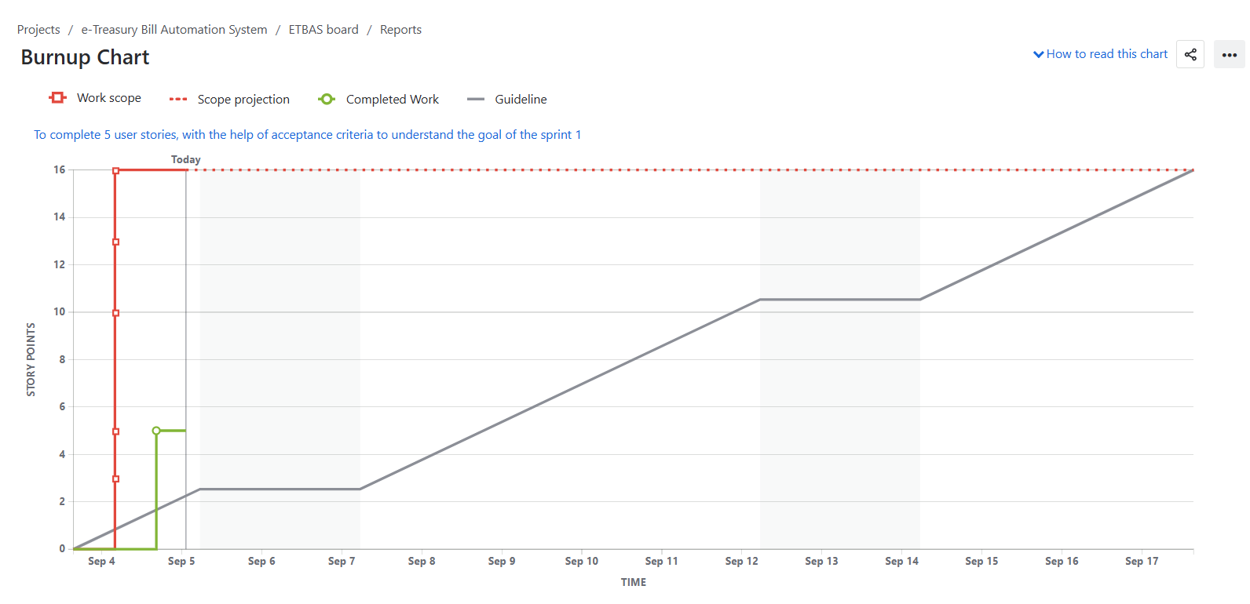
Sprint Burn Down Chart
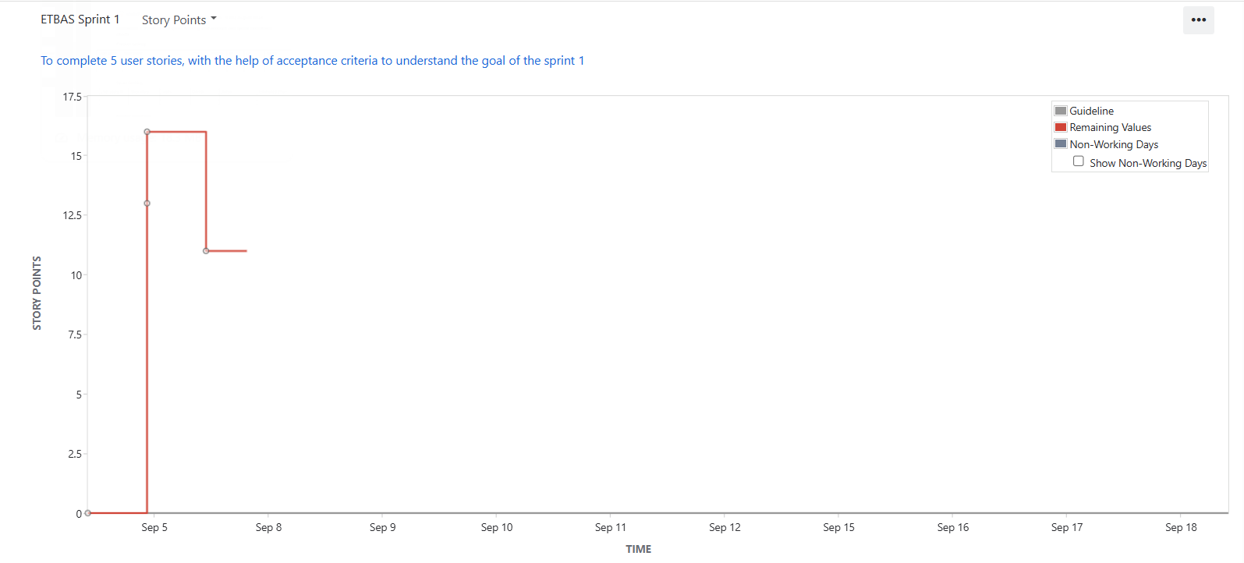

Document 6: Sprint Meetings
Meeting Type 1: Sprint Planning Meeting
Date | 04-09-2025
Time | 10:00AM – 12:00PM
Location | Zoom Meeting
Prepared By | Business Analyst
Attendees | Product Owner, Scrum Master, Developers, Testers, Business Analyst

Agenda Topics
Topic | Presenter | Time allotted
Product Backlog Review | Product Owner | 20 min
Prioritisation & Sprint Goal | Product Owner & Scrum Master | 30 min
User Story Breakdown (US1, US2, US6, US7, US21) | Developers & BA | 40 min
Task Estimation | Development Team | 20 min
Sprint Commitment & DoD | Scrum Master | 10 min

Other Information
Observers | Treasury Officers (Domain SME)
Resources | JIRA, Product Vision Document, DoD checklist
Special Notes | Sprint duration = 2 weeks

Meeting Type 2: Sprint review meeting
Date | 18-09-2025
Time | 10:00 AM-12:00 PM
Location | Zoom Meeting
Prepared By | Scrum Master
Attendees | Scrum Team, Stakeholders (TO, DDO, Finance Officer)

Sprint Status | Things to demo | Quick Updates | What’s next
5 User stories completed | - Online Bill submission (US1)  - Auto validation of Bills (US2)  - Upload of Supporting Documents (US6)  - Rejection workflow with remarks (US7)  - Resubmission of rejected Bill (US21) | Resubmission of rejected bills (US21) partially done, will be carried over to sprint 2 | Start Sprint 2 (Approval Workflow, Notifications, Audit Trail)

Metting Type 3: Sprint retrospective meeting
Date | 18-09-2025
Time | 4:00 PM-5:00 PM
Location | Zoom Meeting
Prepared By | Scrum Master
Attendees | Product Owner, BA, Scrum Master, Development Team

Agenda | What went well | What didn’t go well | Questions | Reference
Sprint Retrospective | Online Bill Submission (US1) and Auto Validation (US2) completed successfully | Resubmission of rejected bills (US21) not fully completed, carried forward | How can we better estimate effort for complex stories? | Sprint 1 backlog items
 | Supporting Documents uploaded (US6) and rejection workflow (US7) demo went well. | Burn down chart was regular (worked bunched at start, slow later) | Can we spread tasks more evenly across sprint days? | Sprint burndown chart
 | Team collaboration and communication were strong. | Testing started late, causing last-minute pressure | Should QA be involved earlier during development? | QA notes and testing logs

Meeting Type 4: Daily Stand-up meeting
Question | Name/Role | Week “1” (from 04-09-2025)
 |  | Monday | Tuesday | Wednesday | Thursday | Friday
What did you do yesterday? | Mr Karthik  Ms Sameera Reddy | Set up DB schema (US1)  Prepared Test (US2) | Developed API for bill submission (US1)  Ran field validation (US2) | Integrated with UI (US1)  Reported 3 bugs (US2) | Peer code review (US1)  Re-tested fixes (US2) | Marked US1 as Done  Closed US2
What will you do today? | Mr Rahul Bose  Ms Sunita Acharya | Start upload UI.  Clarified acceptance criteria with DDO | Add file encryption.  Collected feedback from TO. | Integrated with backend.  Updated JIRA backlog | Test Upload with sample files.  Prepared sprint report | Deliver feature for QA.  Ready for Sprint
What is blocking your progress? | Mr Karthik | Waiting for rejection workflow (US21) | Dependency on US7 completion | Working on bug fixes. | Dependencies clarified | Start implementation.

