COEPD – Prep Exam 3 –Part 1/2

18 Questions - 100 Marks – Pass 60%

Instructions to follow:
- Copy paste (either image, diagram or text) is not entertained. If done, the document will not be evaluated.
- After submission of the answers of this prep exam, you should be prepared to attend viva and justify your answers in the prep exams. If in Viva, participant is NOT justifying the answers, Viva will be repeated until Candidates justify 60% correctness.
- Mentor calls are scheduled only if the participant have submitted their task at least for one time.
(should apply their knowledge in this task first)
- For attempting prep exams participant should be thorough on the topics using their references.
- Please format the document properly (Always have a question no., question and answer).
- Have a consistent format (Font name: Arial/ Calibri -Font size 12, Font Color: Black).
- Few Questions are related to the case study, check Questions thoroughly before you answer.
- Answers should be elaborated in detail (not as per the allotted marks).
- Please focus on learning and applying the knowledge as this knowledge will be helpful in contributing at your BA job.
- In the evaluation, students must answer all questions and should be able to justify at least 60% content and correctness of each answer.
Case Study 1 (Q1-Q6 → 24 Marks)
A customer can make a payment either by Card or by Wallet or by Cash or by Net banking. Q1. Draw a Use Case Diagram - 4 Marks
Q2. Derive Boundary Classes, Controller classes, Entity Classes. - 4 Marks Q3. Place these classes on a three tier Architecture. - 4 Marks
Q4. Explain Domain Model for Customer making payment through Net Banking - 4 Marks Q5. Draw a sequence diagram for payment done by Customer Net Banking - 4 Marks
Q6. Explain Conceptual Model for this Case - 4 Marks
Q7. What is MVC architecture? Explain MVC rules to derive classes from use case diagram and guidelines to place classes in 3-tier architecture - 8 Marks
Q8. Explain BA contributions in project (Waterfall Model – all Stages) – 8 Marks
Q9. What is conflict management? Explain using Thomas – Kilmann technique – 6 Marks Q10. List down the reasons for project failure – 6 Marks
Q11. List the Challenges faced in projects for BA – 6 Marks Q12. Write about Document Naming Standards – 4 Marks
Q13. What are the Do’s and Don’ts of a Business analyst – 6 Marks
Q14. Write the difference between packages and sub-systems – 4 Marks Q15. What is camel-casing and explain where it will be used- 6 Marks
Q16. Illustrate Development server and what are the accesses does business analyst has? -6 Marks
Q17. What is Data Mapping 6 Marks
Q18. What is API. Explain how you would use API integration in the case of your application Date format is dd-mm-yyyy and it is accepting some data from Other Application from US whose Date Format is mm-dd-yyyy 10 Marks

Answer
Q1. Draw a Use Case Diagram - 4 Marks

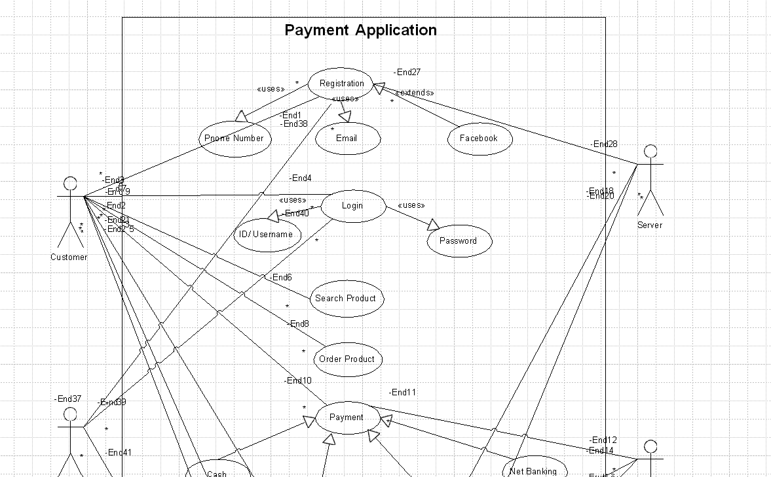

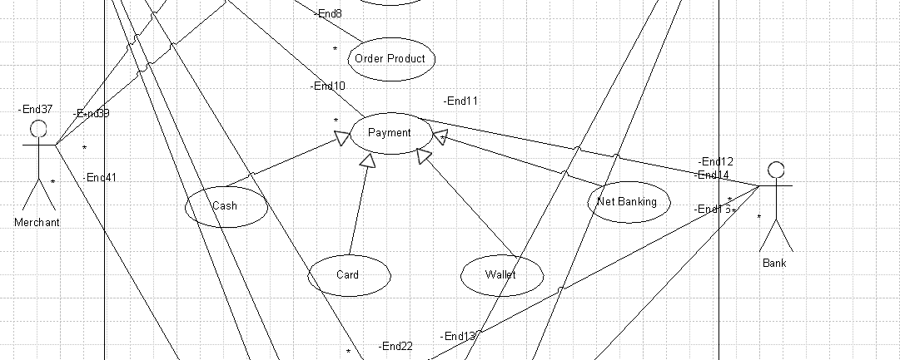

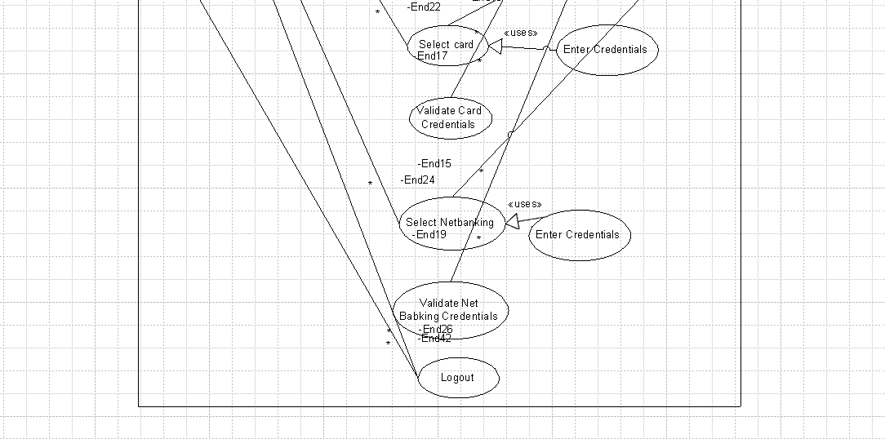

2. Derive Boundary Classes, Controller classes, Entity Classes. - 4 Marks
Ans:-

Type of Class | Purpose | Examples
Boundary Classes | Act as the interface between the system and external actors (users/systems). | Login Page, Search Form, Product Page, Checkout Screen
Controller Classes | Handle user input, manage application flow, and connect boundary & entity classes. | Login Controller, Order Controller, Search Controller, Payment Controller
Entity Classes |  | User, Product, Order, Invoice, Member, Transaction
  Represent core business objects and contain business logic & data.

Q3. Place these classes on a three tier Architecture. - 4 Marks
Ans:-

Layer Name |  | Example Classes
  Description
Application Layer | Manages user interaction, UI components, and input/output. | Boundary Classes – Login Page, Product Search Form, Checkout Screen,
Business Logic Layer | Handles core logic, processes user input, and coordinates between layers. | Controller Classes – Login Controller, Order Controller, Payment Controller
Data Layer | Stores and manages persistent data and business objects | Entity Classes – User, Product, Order, Invoice

Q4. Explain Domain Model for Customer making payment through Net Banking - 4 Marks

A Domain Model is a conceptual representation of the real-world entities, their attributes, and relationships within a specific business domain. It helps in understanding how different objects interact in a system, especially during software design.
Purpose of a Domain Model:
The main goal of a domain model is to visually describe the business process in an object-oriented way. It helps developers, testers, and stakeholders understand the system better. It also acts as a blueprint during the development phase.
Components of a Domain Model:
- Entities (Objects): These are the main business objects like Customer, Bank Account, Payment, Transaction.
- Attributes: These describe properties of the entities like customer ID, account Number, Payment Amount, transaction Date.
- Relationships: These show how entities are connected, such as a Customer initiates a Payment, Payment is linked to a Bank Account, and results in a Transaction.
Example – Net Banking Payment:
When a customer wants to pay through net banking:
- The Customer logs in to the system.
- Selects Net Banking as the payment mode.
- Enters their Bank Account details.
- Makes a Payment.
- The system verifies the account and creates a Transaction record.

Bank
PK | Bank Name
Location
Branch Code

Customer

PK | Customer ID
Customer Name
Contact Detail
Address Detail
Account NO

Payment

PK | Payment ID
Amount
Payment Date
Status
Account
PK | Account No
Type
Balance
Account Holder name

Authentication
PK | User Name
Password
OTP

Net Banking Service
PK | Authentication
Fund Transfer
Transaction History
Fund Management

PK | Transaction
Recipient
Amount
Timestamp

Q5. Draw a sequence diagram for payment done by Customer Net Banking - 4 Marks

Ans:- A sequence diagram is a type of Unified Modelling Language (UML) diagram that illustrates how objects in a system interact with one another over time. It visually represents the sequence of messages exchanged between these
objects, typically during a particular use case or scenario. Sequence diagrams are used in software development, especially during the design phase, to
model and document the behavior of systems.

Uses Of Sequence Diagram are in Modelling Use Cases, Explaining System Interactions, Validating Requirements, Design and Documentation and Debugging and Maintenance.

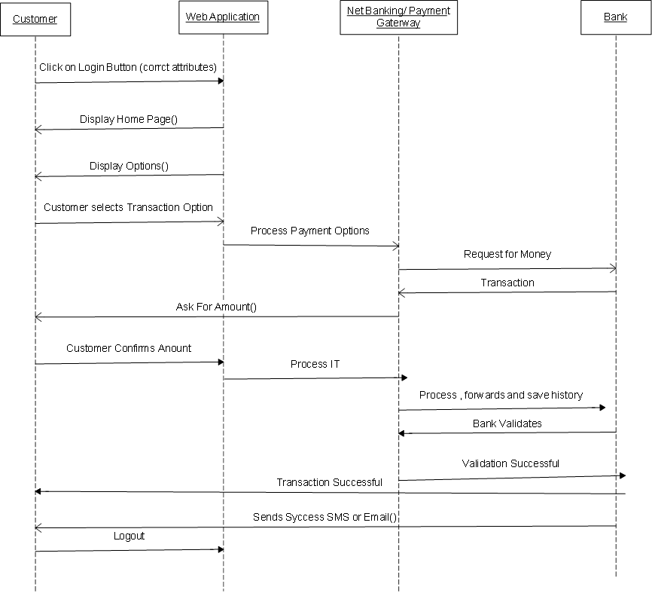

Q6. Explain Conceptual Model for this Case - 4 Marks

Ans:- A conceptual model is a simplified, abstract representation of a system, process, or phenomenon. It is used to visualize, understand, and communicate how different components of a system interact with one another. Conceptual models are widely employed in various fields,

including engineering, software development, environmental science, and business, to clarify complex systems.

A conceptual model for net banking represents the high-level structure of how customers interact with an online banking system. It highlights the key entities, processes, and relationships without delving into technical implementation
details. Here's an explanation of its components within the context of net banking
Components of a Conceptual Model For NetBanking
1 -Entities/Objects- Customer, Bank System, Accounts, Transactions, Third Parties
- Attributes/Properties
Customer: User ID, name, authentication credentials (e.g., password or OTP). Accounts: Account number, balance, account type (savings or checking).
Transactions: Transaction ID, amount, type (credit or debit), timestamp.
- Relationships
A customer can have one or more accounts.
Accounts are linked to the bank system for management.
A transaction is initiated by the customer and affects one or more accounts. Third parties are linked for payments and external transfers.
- Processes/Functions
Login/Authentication: Customers log in using secure credentials.
Account Management: View account details, download statements, etc. Transactions
Customer Support: Interaction with support systems for resolving queries. Notifications: Alerts for successful transactions, low balance, etc.
- Boundaries/Scope-

Included: Customer interactions, transaction processing, and third-party integrations.
Excluded: Internal technical processes (e.g., server management, database operations).
- Inputs and Outputs
Inputs: Customer credentials, transaction details (amount, payee), and instructions.
Outputs: Account balance, transaction receipts, and notifications.
- Assumptions and Constraints
Customers must have internet access and valid login credentials. Transactions are subject to daily limits and bank regulations.
Third-party payments depend on external system availability.

Conceptual Model Representation
  - Customer → Bank System: The customer accesses the system via a secure login.
  - Bank System → Customer Accounts: Provides details of linked accounts.
  - Customer → Transactions: Initiates operations like fund transfers or bill payments.
  - Bank System → Third Parties: Facilitates payments through secure APIs.
  - Bank System → Notifications: Sends confirmation messages to the customer

Q7. What is MVC architecture? Explain MVC rules to derive classes from use case diagram and guidelines to place classes in 3-tier architecture - 8 Marks

Ans: MVC (Model-View-Controller) is a design architecture used in software development to separate the business logic, user interface, and data. This helps in managing complexity, improving code reusability, and making the system easier to maintain.

Components of MVC:
- Model (Entity Classes):
  - Represents data and business logic.
  - Example: Customer, Product, Order, Payment.
- View (Boundary Classes):
  - Represents UI elements the user interacts with.
  - Example: Login Page, Product Listing Page, Payment Page.
- Controller (Control Classes):
  - Acts as a middle layer between View and Model.
  - Handles user input, processes it, and updates the Model or View.
  - Example: Order Controller, Payment Controller.

Rules to Derive Classes from Use Case Diagram:
Type of Class | Derivation Rule
Boundary Class | One boundary class per actor–use case interaction.
Control Class | One control class per use case or complex sequence of actions.
Entity Class | One entity class per main business object (often from nouns in use cases).

Guidelines to Place Classes in 3-Tier Architecture:
Tier | Class Type | Responsibility
Application Layer | Boundary Class | Handle user inputs, display information, UI interaction.
Business Logic Layer (BLL) | Control Class | Process inputs, enforce rules, make decisions, coordinate between view and data.
Data Layer (DAL) | Entity Class | Define and manage data structure, represent database tables or business objects.
Example:
In an online agriculture store:
- View (Boundary): Farmer Login Page
- Controller: Login Controller – handles login requests
- Model (Entity): Farmer – stores farmer's name, ID, contact info

Q8. Explain BA contributions in project (Waterfall Model – all Stages) – 8 Marks

Ans:- The Waterfall Model is a sequential Software Development Life Cycle (SDLC) model where the project flows step-by-step like a waterfall – once one phase is completed, the next begins. It’s linear and structured, best for projects with clear requirement.

Stages | Activities | Attributes & Resources
Attributes & Resources | Enterprise Analysis – SWOT analysis, GAP analysis, market research, feasibility study,  root cause analysis, decision analysis, strategy analysis, enterprise architectural framework, project scope, business case writing and risk  analysis. | Business case  SOW(statement of work) PO(Purchase order)  Sr. BA, Business architects presale  consultants
Planning, Estimation & Assessment | - Understand assumption and constraints along business rule and business goals.  - Plan packages for big projects.  - Understand the project plan from PM  - BA conducts stakeholder analysis  Plan BA approach strategy for this project. | PM  Sr. BA
Req. Gathering | - Stakeholders identify and document  - Client gives BRD or BA prepares BRD by interacting with clients by brainstorming, document analysis, reverse interviews, workshops, focus groups, observation and questionaries  - Prototyping can be used by BA to make the client to give more specific req.  - Sort gathered req.  - Prioritize req.- MOSCOW  Validate Req- FURPS | BRD  BA  PM
Req. Analysis | - Draw UML Diagrams (use case and Activity diagrams)  - Prepare functional req. from business req.  - All architects comes up with technical req (SSD)  - SRS will have functional req and technical req.  - Takes signoff on SRS from client . SRS is the first legal binding Doc between the business and the technical team  - BA prepared RTM from SRS before design phase starts.  - BA traces how req are dealt in each phase of  - development life cycle from design till UAT. | Functional Req Specification  SSD SRS RTM BA PM  Solution -Architect  DB-Architect  NW-Architect
Design | - From use case diagram, test manager or BA will prepare test cases.  - Communicate with client on the design and solution document (update status to client and then understand how solution would look like)  - BA will initiate the preparation of end user manuals.  - Updates RTM  - From use case diagram solution-Architect recommends architecture of the IT solution  - DB Architect uses persistence classes (entity classes) and comes up with ER diagram or DB schema  - GUI Designer will look into transient classes (boundary classes) and designs all possible  screens for the IT solution | Solution Document Design Document -HDD- ADD  BA PM  Solution -Architect DB- Architect  NW-Architect GUI-Architect Test Manager
Coding | - BA organizes JAD sessions  - BA clarifies queries of technical team during coding  - Developers refers diagram and  transient(controller classes) of BA and code their unit  - Update end user manuals  - Update RTM  - Conducts regular status meetings with  technical team and the client and tuning client  for participation in UAT | LDD-CDD  Application  Development Team BA  PM
Testing | - BA prepares test cases from use cases or assists test manager to do so  - BA performs high level testing  - BA prepares client for UAT  - Test data is requested by BA from client  - Updaters and End User Manuals  - Updates RTM  - Take sign off from Client on Client Project acceptance Form | Test concerning documents Application with less errors  Testing Team  BA  PM  Client
Deployment &  implementation | - Forward RTM to client or the PM which should be attached to the project closure report  - Coordinates to complete and share end user manuals  - Plans and organizes training sessions for end users  Prepares lessons learned from this project

Q9. What is conflict management? Explain using Thomas – Kilmann technique – 6 Marks

Ans:- Conflict management is the process of identifying and addressing
disagreements or disputes in a constructive way to ensure effective resolution and maintain positive relationships. It focuses on understanding the underlying issues, promoting communication, and finding mutually acceptable solutions while minimizing negative impacts.
Thomas-Kilmann Conflict Management Model
The Thomas-Kilmann Technique, often referred to as the Thomas-Kilmann Conflict Mode Instrument (TKI), is a tool designed to help individuals and
organizations understand how they handle conflicts and improve their conflict management skills.
Developed by Kenneth W. Thomas and Ralph H. Kilmann in the 1970s, the technique identifies five distinct conflict-handling styles based on
two dimensions:
- Assertiveness: The degree to which a person seeks to satisfy their own concerns.
- Cooperativeness: The degree to which a person seeks to satisfy the concerns of others.
Effective conflict management involves recognizing the existence of conflicts, actively listening to the concerns of all the parties involved, seeking common ground, and working towards collaborative solutions that meet the needs of everyone.

The Five Conflict-Handling Modes
- Competing: High Assertiveness, Low Cooperativeness Focus on Winning the conflict or achieving personal goals, often at the expense of others. Example: A manager imposing a decision without consulting the team. Use: In emergencies or when a decisive stance is necessary.
- Collaborating: High Assertiveness, High Cooperativeness Focus on Working together to find a win-win solution that satisfies all parties.
Example: A team brainstorming solutions to meet everyone's needs. Use:
When the issue is complex, and a creative or integrative solution is possible.
- Compromising: Moderate Assertiveness, Moderate Cooperativeness Focus on Finding a middle ground where each party gives up something.
Example: Two coworkers agreeing to share resources equally despite differing priorities. Use: When time is limited, and an acceptable, balanced resolution is needed.
- Avoiding: Low Assertiveness, Low Cooperativeness Focus on Withdrawing from or sidestepping the conflict. Example: A person
ignoring a minor disagreement to focus on bigger priorities. Use: When the conflict is trivial or emotions are too high to resolve it constructively.
- Accommodating: Low Assertiveness, High Cooperativeness Focus on Prioritizing the other person’s needs over one’s own. Example: Agreeing to a colleague’s preference for the sake of harmony. Use: When maintaining relationships is more important than the outcome.

Q10. List down the reasons for project failure – 6 Marks

Ans:- Reasons for Failure of Project
- Improper Requirements Gathering - Failure to gather accurate, complete, and clear requirements from stakeholders can lead to the development of a product or solution that doesn’t meet the project's needs. Consequences can be Deliverables may not solve the actual
problems or align with user expectations. Increased costs and timelines due to rework.
- Continuous Change in Requirements - Frequent and unplanned changes to project requirements, also known as scope creep, disrupt the project timeline, budget, and overall focus. Consequences can be Delays in

project delivery as teams must adapt to the new requirements. Budget overruns due to additional work and resource allocation. Decreased
team morale due to constant shifts in priorities.
- Lack of User Involvement - When end-users or primary stakeholders are not engaged during project planning, development, or testing phases, the project may fail to address their needs. Consequences can be
Deliverables may be irrelevant or unusable for the intended audience. Resistance to adoption, as users feel excluded from the process.
Additional costs to modify the product post-launch to fit user expectations.
- Lack of Executive Support - Without strong backing from senior leadership, projects often lack the authority, resources, and direction needed for success. Consequences can be Insufficient funding and
resources to execute the project effectively. Difficulty resolving conflicts or making critical decisions.
- Unrealistic Expectations - Unrealistic expectations regarding timelines, budgets, or deliverables can put undue pressure on the project team and set the project up for failure. Consequences can be Missed deadlines and deliverables due to overestimated capabilities or underestimated
complexities. Poor-quality outcomes due to rushed work. Frustration and burnout among team members.
- Improper Planning - Insufficient or flawed planning leads to a lack of clarity on objectives, resources, schedules, and risks, increasing the
likelihood of project failure. Consequences can be Misaligned priorities and inefficient use of resources. Overlooked risks that cause delays or additional expenses. Difficulty tracking progress and identifying bottlenecks.
- External Factors - Shifts in market demand, competition, or customer preferences. Budget cuts or economic downturns impacting funding. Unforeseen compliance requirements or legal challenges.

Q11. List the Challenges faced in projects for BA – 6 Marks

Ans:- Challenges faced by BA in a Project
- Unclear or Evolving Requirements - Stakeholders may not have a clear vision of what they want, leading to ambiguous or incomplete
requirements. Frequent changes in requirements during the project lifecycle (scope creep) create rework and delays.

- Lack of Stakeholder Engagement - Stakeholders may be unresponsive or unavailable, making it difficult to gather input and validate requirements. Differences in priorities among stakeholders can lead to conflicts or delays in decision-making.
- Communication Gaps - Miscommunication or lack of a shared
understanding between technical teams and non-technical stakeholders.
Difficulty in translating business needs into technical specifications and vice versa.
- Time Constraints - Limited time to gather and analyze requirements thoroughly. Tight project deadlines leave little room for addressing unforeseen issues or changes.
- Changing Business Priorities - Organizational or market changes can shift project priorities, rendering earlier requirements irrelevant.
Adjusting to new business goals can disrupt planned deliverables and timelines.
- Managing Expectations- Stakeholders may have unrealistic expectations regarding timelines, budgets, or deliverables. Balancing diverse and sometimes conflicting stakeholder needs while aligning them with
project goals.
- Technical Limitations - Constraints in technology or existing systems may limit the feasibility of proposed solutions. Lack of technical understanding among stakeholders can complicate discussions about system capabilities.
- Resource Limitations - Insufficient access to subject matter experts (SMEs), tools, or data needed for analysis. Limited budget or team capacity to implement all requested features or changes.
- Resistance to Change - Stakeholders or end-users may resist adopting new systems or processes due to fear of disruption or lack of training. Convincing stakeholders of the value and necessity of proposed solutions can be challenging.
- Documentation Challenges - Maintaining comprehensive and up-to-
Date documentation amid frequent changes. Balancing the level of details required for stakeholders bursas technical teams.

Q12. Write about Document Naming Standards – 4 Marks

Ans:- A document naming standard is systematic approach to assigning unique identification to various documents created and used throughout the
development process. It ensures that everyone in an organization can easily find, recognize, and understand the contents or purpose of a file based on its name alone.
Key Elements of a Document Naming Standard
- Descriptive Name: The file name should indicate the document's contents, purpose, or version.
- Date Format: Including dates in a consistent format (e.g., YYYY-MM-DD) helps track versions or updates.
- Version Control: Including version numbers or indicators like "v1" or "FINAL" helps track document revisions.
- Project or Department Prefixes: Including project names, department codes, or client initials can identify documents relevant to specific teams or clients.
- Underscores or Hyphens for Separation: Use underscores or hyphens instead of spaces to improve compatibility with different systems.
All documents will be named using some standards like [Project ID][Document Type]V[X]D[Y].ex
Components:
  - [Project Name]: The name of the project or code, e.g., "Project Phoenix"
  - [Document Type]: The type of document, such as "Proposal," "Report," "Meeting Notes," or "Invoice"
  - [Date]: The date in YYYY-MM-DD format
  - [Version]: The document version, e.g., "v1", "v2", or "FINAL"
  - [File Extension]: The file extension, such as .docx, .pdf, or .xlsx

Proposal Document
ProjectPhoenix_Proposal_2023-09-12_v1.docx

Project Report
ProjectPhoenix_Report_2023-10-01_FINAL

Q13. What are the Do’s and Don’ts of a Business analyst – 6 Marks

Ans:- DO’s and DONT’s of a Business Analyst
Never say NO to client
Never imagine anything in terms of GUI There is NO word called as “By Default”
Consult an SME for clarifications in Requirements
Question the existence of existence/question in the world. What client gives is not always correct.
Every problem of client is unique. No two problem of different client are same. May be approach, technology, place of use, local laws may be varied to make them to be different.
Go to client with plain with no assumption. Listen carefully until client is done and then you can ask your queries. Please do not interrupt client, when he/she is giving you the problem.
Maximum try to extract the leads of solution from the client itself. Never try to give solution to client straight away with your previous experience and assumption.
Try to concentrate on the important and truly requirement .
Don’t be washed away by add on functionalities or don’t imagine solutions on screen basis.

Q14. Write the difference between packages and sub-systems – 4 Marks

Ans: - Packages and subsystem
Package:- Collection of Components which are not reusable in nature. A package is a grouping mechanism that organizes elements such as classes,
interfaces, or other packages into a logical collection. It is commonly used in software design to modularize systems for better manageability and reusability. Packages are Used in Unified Modelling Language (UML) and Programming.

Subsystems:- Collection of Components which are reusable in nature. A subsystem represents a higher-level component or functional unit within a system that encapsulates a set of related functionalities or services. It is essentially a smaller system within a larger system. Purpose of Subsystems are Modularity, Encapsulation and Scalability

 | Packages | Subsystem
Purpose | Group related components for organization and reuse. | Represent a functional unit within the system.
Scope | Logical grouping within a system. | Functional grouping with well-  defined interfaces.
Encapsulation | Can provide limited encapsulation. | Stronger encapsulation of functionality
Interaction | May not directly interact with external components. | Interacts with other subsystems or the main system
Usage Example | Grouping classes in a library. | A module like "Payment  Processing."

Q15. What is camel-casing and explain where it will be used- 6 Marks

Ans: Camel Casing - Camel casing is a naming convention in which words are concatenated without spaces, and each word after the first begins with a capital letter. The name resembles the humps of a camel, hence the term
"camel case."
There are two primary forms of camel casing:
- Lower Camel Case - The first letter of the first word is lowercase, and the first letter of subsequent words is uppercase.
Example: employee Name, total Price, calculate Salary
- Upper Camel Case (also known as Pascal Case)- The first letter of every word, including the first, is uppercase.
Example: EmployeeName, Total Price, Calculate Salary

Camel casing is one of the most widely used conventions in modern
programming, particularly in languages that emphasize object-oriented design.

Its structured readability makes it an essential part of clean code practices. It promotes consistency within the codebase and improves collaboration among team members. Camel casing is commonly used in programming, particularly in languages like Java, C#, JavaScript, and Python.

Q16. Illustrate Development server and what are the accesses does business analyst has? -6

Ans:- Development Server
A development server is an environment used during the software
development process where code is written, tested, and debugged before moving to staging or production servers. It is specifically designed for
developers and teams to collaborate on building and refining software.
Accesses a Business Analyst (BA) Might Have on a Development Server
The access levels of a BA to a development server depend on the organization's policies, the BA's role, and the project requirements. Typically, a BA has limited or read-only access, focusing on observation, validation, and documentation rather than active development.
- Read-Only Access- View application builds, features, and workflows as implemented on the server. Useful for verifying that requirements are correctly translated into functionality.
- Test Data Management- Ability to create, modify, or analyze test data for functional validation. This is crucial for conducting user acceptance testing (UAT).
- Log or Debugging Access (Limited)- Access to logs to check system behavior during requirements validation. Example: Observing error codes or transaction logs to identify issues.
- Testing Access- Execute test cases to validate features against business requirements. Often through frontend interfaces or testing tools connected to the server.
- Report or Issue Tracking- Use integrated tools (like Jira, Bugzilla, or Azure DevOps) to report issues or track progress based on observations in the development server.

What BAs Typically Don’t Have server

  - Write or Admin Access: BAs generally don’t have permissions to alter configurations, deploy code, or make changes to the development.
  - Database Control: Limited or no access to directly modify databases; any data-related tasks are typically handled through predefined interfaces.

  - Write or Admin Access: BAs generally don’t have permissions to alter configurations, deploy code, or make changes to the developmen
  - Database Control: Limited or no access to directly modify databases; any data-related tasks are typically handled through predefined interfaces.

Q17. What is Data Mapping 6 Marks

Ans:- Data Mapping:-
Data mapping is the process of creating a connection or relationship between data fields from one source to corresponding data fields in a target system. It ensures that data is correctly transformed and transferred between systems, formats, or databases, maintaining its structure, meaning, and usability.
Data mapping is crucial in various operations, including data integration,
migration, transformation, and warehousing. The goal is to ensure seamless communication and compatibility between different systems or databases.

Applications of Data Mapping are-
Data Integration - Combining data from multiple sources into a unified system or database.
Data Migration - Transferring data from one system to another, often during system upgrades or replacements
Data Transformation - Converting data into a different format or structure during the mapping process.
Data Warehousing - Preparing and mapping data for storage in a data warehouse for analysis and reporting.

Types of Data Mapping
- Manual Mapping- Performed by humans using tools like spreadsheets or data visualization tools. Suitable for small datasets or straightforward mappings.
- Automated Mapping-Uses specialized tools or scripts to automatically map data between systems. Ideal for large-scale or complex projects.

- Schema Mapping- Focuses on aligning the schemas (structures) of the source and target databases. Example: Mapping tables, columns, and relationships between relational databases.
- Field-to-Field Mapping -Maps individual fields in the source to their corresponding fields in the target. Example: Mapping Employee in source to Employee ID in the target.

Q18. What is API. Explain how you would use API integration in the case of your application Date format is dd-mm-yyyy and it is accepting some data from Other Application from US whose Date Format is mm-dd-yyyy 10 Marks

Ans:- Application Programming Interface (API)
An API (Application Programming Interface) is a set of rules, protocols, and tools that allows different software applications to communicate and interact with each other. APIs provide a standardized way for one application to request and exchange data or functionality from another application or service.

How API Integration Works
API integration connects two or more applications by allowing them to exchange data or functionalities. This involves:
- Understanding API Documentation - Review the source application's API documentation to understand available endpoints, request/response
formats, and authentication.
- Establishing Connection - Use programming languages like Python, Java, or tools like Postman to interact with the API.
- Sending Requests - Use HTTP methods like GET, POST, PUT, and DELETE to interact with the API.
- Handling Responses - Parse the response data (often JSON or XML) and process it in your application.

Case: Handling Date Format in API Integration
Your application (App A) uses the date format DD-MM-YYYY. It needs to
integrate with another application (App B) from the US, which uses the date format MM-DD-YYYY. Both applications share data through an API.
Establish API Communication: Set up an API communication between your application and the other application to exchange data.

Data Formatting: When sending date data from your application to the other application, convert the date from the dd-mm-yyyy format to the mm-dd-yyyy format. This can be achieved by extracting the day, month, and year components from the date and rearranging them according to the target
format.
Data Parsing: When receiving date data from the other application, parse the mm-dd-yyyy formatted date into your application’s dd-mm-yyyy format. Again you will need to extract the day, month, and year components and rearrange them accordingly.
Data Validation: perform data validation and ensure that the converted date remains valid after the format conversion. Check for edge cases, such as invalid dated or date ranges that might be affected by the format conversion, and handles them appropriately.

