Nurturing Process – Agile Deliverables
Data Mining Curriculum Mapping System

Document 1: Definition of Done
Project Name: Currimap – Curriculum Mapping & Academic Data Intelligence Platform
Project Methodology: Agile Scrum
Reference: As per Agile Extension to the BABOK® Guide v2

As Per Agile Extension to the BABOK® Guide v2, Definition of Done is a technique where the team agrees on, and prominently displays, a list of criteria which must be met before a backlog item is considered done.
That is the team has to create a well-defined, unambiguous, measurable, agreed-upon, and shared Definition of Done between all team members.

In Currimap, the DoD applies at multiple levels:
- User Story Level
- Sprint Level
- Release Level

Checklist for DOD:
No. | Checklist Item
1 | All acceptance criteria of the user story are fulfilled
2 | Assumptions mentioned in the user story are validated
3 | Code is developed for the required functionality
4 | Code compiles and the project builds without errors
5 | Unit tests are written and successfully passing
6 | Code is deployed on the test environment, which mirrors production
7 | Feature works across supported devices/browsers as per scope
8 | UX/UI design validated and approved by UX Designer (if applicable)
9 | QA team has tested the feature thoroughly, and bugs are resolved
10 | Feature is tested against defined acceptance criteria
11 | Product Owner (PO) has reviewed and approved the feature
12 | Refactoring is completed (if needed)
13 | Any build/configuration changes are documented
14 | Documentation (user guide/help/tech notes) is updated
15 | Peer Code Review completed by at least one team member

Document 2- Product Vision
Scrum Project Name: | Currimap – Curriculum Mapping System
Venue: | Dr Rajendra Gode IT&R college Conference Room
Date: | 15 June 2025
Start time: | 10:00 AM
End time: | 12:00 PM
Duration: | 2 Hours
Client: | DRGIT&R Academic Council
Stakeholder list: | Prof. Kavita More (HOD – Computer Dept.)
 | Prof. Rahul Deshmukh (Curriculum Coordinator)
 | Dr. Meena Patil (NBA& NAAC Committee)
 | Prof. Abhay Jagtap (Faculty – IT Dept.)

Scrum Team:
Scrum Master: | Mr. Vandanam (APT IT Solutions – Project Manager)
Product Owner: | Rashmi Asole (APT IT Solutions – Business Analyst)
Scrum Developer 1: | Juhi Verma (Senior Java Developer)
Scrum Developer 2: | Alex Mehra (Frontend Developer)
Scrum Developer 3: | Jason Roy (QA Engineer)
Scrum Developer 4: | John Peter (DB Administrator)
Scrum Developer 5: | Mike Anthony (Network & Infra Support)

Vision Table for CurriMap Project
Target Group | Engineering colleges and universities following Outcome-Based Education (OBE) - Faculty members from departments like Computer, IT, AIML, Civil, Mechanical, and Electronics - Heads of Departments (HODs), Academic Coordinators, NAAC/NBA Committee Members
Needs | - Manual curriculum mapping is time-consuming, inconsistent, and error-prone - Lack of centralized and visual tracking for CO–PO–PSO mapping and attainment - Difficulty in preparing NBA/NAAC documentation efficiently - Need for insights based on student performance data
Product | - CurriMap: A centralized academic data intelligence platform for curriculum mapping - Automates CO–PO–PSO mapping, Bloom’s taxonomy tagging, and attainment analysis - Uses Python-based ETL for importing and cleaning academic performance data - Dashboard reporting, audit tracking, and outcome analysis features
Value | - Helps DRGIT&R maintain OBE compliance and accreditation readiness (NBA/NAAC) - Saves time, reduces duplication, and minimizes manual efforts - Supports data-driven decision-making for curriculum enhancement - Demonstrates institutional quality and transparency to regulatory bodies

Document 3: User stories
Module1-User Registration & Login
User Story No 1 | Task:  1.Design registration form  2.Validate user inputs  3.Connect to database  4.Send confirmation email | Priority: High
Value statement:
As a faculty member,
I want to register into the Currimap system,
so that I can log in and access curriculum mapping features.
BV . ₹1000 | CP 3
Acceptance Criteria
- Registration form includes Name, Email, Department, Password.
- User input Validation.
- Password is encrypted in Database.
- Faculty receives confirmation message after registration.

User Story No 2 | Task:  1.Create login form  2.Implement authentication logic  3.Validate credentials against DB  4.Maintain session | Priority High
Value statement:
As a faculty member,
I want to securely log into the system,
so that I can access my personalized dashboard.
BV . ₹1000 | CP 2
Acceptance Criteria
- Email and password validated against database
- Error message for invalid credentials
- Option for "forgot password" included

Module2- CO Management

User Story No 3 | Task:  1. Design CO input form  2. Add input validation  3. Save COs to database  4.Display existing CO for add/ delete | Priority High
Value statement:
As a faculty member,
I want to define/enter and save Course Outcomes (COs) for my subject,
so that I can proceed with mapping and attainment analysis.
BV . ₹1000 | CP 4
Acceptance Criteria
- Faculty can define up to 6 COs per subject
- Each CO is uniquely coded (CO1, CO2, etc.)
- Form validates input before submission
- COs are stored, listed, and editable

User Story No 4 | Task:  - Allow editing of saved COs  - Load old value for editing  - Save updated data | Priority High
Value statement:
As a faculty member,
I want to update an already defined CO,
so that I can correct or improve its definition..
BV . ₹1000 | CP 4
Acceptance Criteria
- Faculty can select and edit any CO
- Previous data loads into form
- Edited CO is saved with update record

Module 3: CO–PO–PSO Mapping
User Story No 5 | Task:  - Design CO–PO mapping screen (matrix/grid)  - Fetch COs and POs dynamically  - Allow checkbox selection for mapping  - Save mapping in database | Priority High
Value statement:
As a faculty member,
I want to map Course Outcomes (COs) to Program Outcomes (POs),
so that I can demonstrate curriculum alignment.
BV . ₹1000 | CP 5
Acceptance Criteria
- CO–PO mapping matrix displayed
- Multiple POs can be selected per CO
- Duplicate mappings are prevented
- Mappings are saved and editable

User Story No 6 | Task:  - Same UI for PSO mapping  - Validate selection before save  - Store mapping in relational format | Priority High
Value statement:
As a faculty member,
I want to map COs to Program Specific Outcomes (PSOs),
so that I can meet program-level objectives.
BV . ₹500 | CP 4
Acceptance Criteria
- Dropdown or matrix view shows PSOs
- Faculty can map each CO to 1+ PSOs
- Mapping data is stored and displayed for future use

User Story No 7 | Task:  - Create a view-only matrix for review  - Load saved mappings from DB  - Display editable state if user has permissions | Priority Medium
Value statement:
As a faculty member,
I want to view and edit my CO–PO–PSO mappings,
so that I can make corrections if needed.
BV . ₹500 | CP 4
Acceptance Criteria
- View saved mappings by subject
- Edit button enables changes
- Only the creator or admin can edit mappings

Module 4: Assessment Data Upload (ETL Integration)-

User Story No 8 | Task:  - Design upload interface (CSV/Excel)  - Add file validation rules  - Store file temporarily for processing  - Display upload status | Priority: High
Value statement:
As a faculty member,
I want to upload internal assessment data in CSV/Excel format,
so that the system can use it to calculate CO/PO attainment.
BV . ₹1000 | CP 6
Acceptance Criteria
- Only .csv or .xlsx formats accepted
- Error message shown for wrong file types
- Upload form includes subject & assessment type
- Faculty receives upload success/failure status

User Story No 9 | Task:  - Build ETL script using Pandas and Open PyXL  - Extract marks from uploaded sheet  - Transform data: clean, validate, normalize  - Load into database | Priority: High
Value statement:
As a faculty member,
I want to extract, transform, and load student data into the system,
so that clean, structured data is available for analytics.
BV . ₹1000 | CP 7
Acceptance Criteria
- Blank or invalid rows are skipped during load
- Roll numbers, CO marks, and assessment types are parsed correctly
- Logs created for errors and success counts
- Loaded data reflects in reports module
User Story No 10 | Task  - Display list of uploaded files with timestamp  - Allow faculty to delete or re-upload  - Store history for audits | Priority: Medium
Value statement:
As a faculty member,
I want to view my previously uploaded assessment files.
so that I can track, re-upload, or delete incorrect ones.
BV . ₹500 | CP 4
Acceptance Criteria
- Faculty can delete or re-upload any file
- Deleted files no longer affect reports

User Story No 11 | Task:  - Design upload interface (CSV/Excel)  - Add file validation rules  - Store file temporarily for processing  - Display upload status | Priority: High
Value statement:
As a faculty member,
I want to upload internal assessment data in CSV/Excel format,
so that the system can use it to calculate CO/PO attainment.
BV . ₹1000 | CP 6
Acceptance Criteria
- Only .csv or .xlsx formats accepted
- Error message shown for wrong file types
- Upload form includes subject & assessment type
- Faculty receives upload success/failure status

Module 5: Attainment Calculation
User Story No 12 | Task:  - Fetch uploaded assessment data from DB  - Apply predefined attainment calculation formulas  - Store calculated attainment values  - Display subject-wise results | Priority: High
Value statement:
As a faculty member,
I want the system to calculate CO attainment automatically,
so that I can assess whether students are meeting learning objectives.
BV . ₹1000 | CP 6
Acceptance Criteria
- System uses uploaded internal marks and feedback
- Attainment is calculated using formula: Direct + Indirect (e.g., 80:20)
- Result is visible per subject and per CO
- Values stored and reused for reporting

User Story No 13 | Task:  - Extend logic to aggregate PO attainment  - Calculate PO scores based on CO–PO mappings  - Apply weighted average if needed  - Save per-program attainment | | Priority: High
Value statement:
As a faculty member or HOD,
I want to view the calculated PO attainment,
so that I can measure program-level academic success.
BV . ₹1000 | CP 6
Acceptance Criteria
- PO attainment derived from CO–PO mappings
- Calculations follow NBA/NAAC norms
- Result visible for each PO with score (%)
- Downloadable as part of program-level report

User Story No 14 | Task:  - Tag each attainment result with academic year & semester  - Enable filters for year, dept, subject  - Display current and historical comparisons | Priority: Medium
Value statement:
As a HOD or committee member,
I want to view attainment data semester-wise,
so that I can identify trends and track academic progress.
BV . ₹100 | CP 5
Acceptance Criteria
- Attainment data is grouped by semester and subject
- Filters for department, faculty, course name
- Comparison graph for previous and current year

Module 6: Dashboard & Visualization-
These user stories focus on enabling faculty and HODs to view curriculum mapping progress, attainment status, and alerts through dynamic dashboards.
User Story No 15 | Task:  - Design dashboard layout with widgets  - Fetch key metrics from backend (e.g., CO PO attainment)  - Display interactive charts (bar/pie/line)  - Make it responsive for web devices | Priority:  High
Value statement:
As a faculty member,
I want a dashboard that shows CO/PO attainment and mapping status,
so that I can easily monitor subject progress.
BV . ₹1000 | CP 5
Acceptance Criteria
- Dashboard includes total COs defined, CO–PO mapped %
- Charts show CO attainment levels (graph/pie)
- Faculty can filter by semester and subject
- Color indicators highlight missing data or low attainment

User Story No 16 | Task:  - Add HOD-level filters (faculty, subject, year)  - Include program summary cards (PO-wise)  - Enable drill-down to individual course stats | Priority:  Medium
Value statement:
As a Head of Department,
I want a consolidated dashboard for all subjects,
so that I can review academic outcomes department-wise.
BV . ₹500 | CP 6
Acceptance Criteria
- Summary view shows attainment per PO
- Dropdown filters by faculty name, semester, course
- Drill-down to course-level data with graphs

User Story No 17 | Task:  - Show real-time alerts for missing COs or uploads  - Display color-coded warning indicators  - Notify faculty via dashboard | Priority:  Medium
Value statement:
As a faculty member,
I want to receive alerts about pending or incomplete entries,
so that I can take action before final report generation.
BV 100 | CP 4
Acceptance Criteria- Alerts for CO not defined.
Colour codes Red(Urgent), Yellow(Pending),Green(ok)
Notification pop up after login.

Module 7: Report Generation & Export
User Story No 18 | Task:  - Design report generation screen  - Fetch subject-wise CO attainment data  - Structure into preformatted template  - Export to PDF/Excel | Priority:  High
Value statement:
As a faculty member,
I want to generate course-level CO attainment reports,
so that I can submit them during academic reviews or audits.
BV . ₹1000 | CP 7
Acceptance Criteria
- Faculty selects subject, semester
- Report includes COs, mapped POs/PSOs, attainment %
- Exportable in PDF and Excel formats
- Download link available on screen

User Story No 19 | Task:  - Extend report to include PO-level data  - Format PO attainment summary table  - Include graphical representation (if enabled) | Priority:  High
Value statement:
As a HOD or program coordinator,
I want to generate department-level PO attainment reports.
BV . ₹1000 | CP 6
Acceptance Criteria
- PO-wise summary of CO contributions
- Attainment values and threshold indicators
- Optional visual (bar chart) of attainment per PO
- NAAC/NBA-ready template formatting

User Story No 20 | Task:  - Maintain download history for audit  - Add timestamp & user log  - Restrict access to own reports only | Priority:  Medium
Value statement:
As a faculty member or admin,
I want to view the history of report downloads,
so that I can maintain documentation for future audits.
BV Rs 500 | CP 6
Acceptance Criteria
- Logged-in user sees their download history
- Includes report type, date, subject
- Admins can view all reports by faculty

Module 8: Admin Feature.
User Story No 21 | Task:  - Create user role management interface  - Assign roles (Faculty, HOD, Admin)  - Set access permissions  - Save role data in DB | Priority:  High
Value statement:
As an admin,
I want to assign specific roles and access levels to users,
so that faculty and HODs can only access relevant features..
BV . ₹1000 | CP 5
Acceptance Criteria
- Admin can assign or modify roles for users
- Unauthorized actions are blocked based on role
- Roles define access to mapping, reports, and dashboards

User Story No 22 | Task:  View full list of registered users  Filter users by department and role  Enable/disable user access  Store activity status | Priority:  Medium
Value statement:
As an admin,
I want to manage user access and visibility,
so that only active faculty can use the system.
BV . ₹500 | CP 4
Acceptance Criteria
- Admin can deactivate/reactivate users
- List shows role, department, last login
- Inactive users cannot log in

Module 9: Notifications & Alerts
User Story No 23 | Task:  - Develop notification engine.  - Configure alert types (missing COs, data not uploaded, low attainment)  - Display alerts on faculty dashboard  - Mark notifications as read/unread | Priority:  High
Value statement:
As a faculty member,
I want to receive automatic alerts for missing or pending tasks,
so that I can take action before deadlines.
BV Rs500 | CP 4
Acceptance Criteria
- Alerts shown when COs not defined, data not uploaded
- Messages appear on login dashboard
- Red/yellow color indicators for urgency
- Alerts can be marked read/unread

User Story No 24 | Task:  - Enable HOD/admin to broadcast announcements  - Display message to all selected users | Priority:  Medium
Value statement:
As a HOD or admin,
I want to send messages or alerts to specific faculty or departments,
so that I can remind them of data uploads or meetings.
BV 100 | CP 3
Acceptance Criteria
- Admin can select recipient list by role/department
- Faculty sees messages on login screen

Module 11: Audit & Logging
User Story No 25 | Task:  - Track all user actions (create, edit, delete)  - Log entries with user ID.  - Store logs in secure backend  - Display log history to admin only | Priority:  Medium
Value statement:
As an admin,
I want to track user activities like CO uploads, mapping edits, and report downloads,
so that I can ensure accountability and trace changes during audits.
BV Rs 500 | CP 5
Acceptance Criteria
- All changes to CO/PO mappings, uploads, and logins are logged
- Logs include user ID, action, time,
- Only admin can access logs

User Story No 26 | Task:  - Enable activity filtering by date, user, and module  - Create log export option (CSV/PDF) | Priority:  Medium
Value statement:
As an admin or audit team member,
I want to filter and export activity logs,
so that I can present accurate evidence during curriculum audits.
BV rs 500 | CP 4
Acceptance Criteria
- Logs are searchable and filterable
- Export button generates CSV or PDF

Document 4: Agile PO Experience
In the Currimap project, the Product Owner (PO) involved in shaping the product from vision to delivery. With a deep understanding of the academic domain and institutional needs , the PO ensured that the platform aligned with real curriculum mapping and accreditation requirements.

- Responsibilities of PO in a project
- Market Analysis:
The PO analysed the educational technology , reviewed existing tools used in curriculum outcome tracking, and identified the gap for an ETL-integrated system used for engineering colleges under Outcome-Based Education (OBE) guidelines.

- Enterprise Analysis:
The Product Owner carefully studied the academic problems faced by the college. They spoke with faculty members and important stakeholders to understand the real issues. Based on these discussions, they confirmed that there was a strong need for a single system that could help all departments—like Computer, IT, AIML, Mechanical, Civil, and Electronics—manage and track their curriculum outcomes in one place.

- Product Vision & Roadmap:
The Product Owner crafted a product vision focused on academic intelligence, automation of CO–PO mapping, and simplified reporting for NBA/NAAC. A high-level roadmap was created including modules like login, CO definition, mapping, ETL data uploading, attainment calculation, dashboards, and audit logs.

- Managing Product Features:
The PO continuously interacted with faculty and committee members to capture and refine needs, prioritized modules based on academic cycles, and ensured the inclusion of data mining and ETL as value-add components.

- Managing the Product Backlog:
The PO, along with scrum master, broke down major features into epics and user stories. Stories were prioritized by business value (BV) and complexity points (CP) in sprint review.

- Managing Iteration Progress:
As part of the Agile Scrum team, the PO actively participated in sprint ceremonies or events:
- Sprint Planning: Decided which user stories to include based on development capacity and academic urgency.
- Daily Stand-ups: Monitored progress and unblocked issues where needed.
- Sprint Review: Collected feedback from stakeholders and demonstrated completed features.
- Sprint Retrospective: Collaborated with the BA and developers to reflect on process improvements and prepare better for the next sprint.

- Learnings from My Role as Product Owner in the Currimap Project
From this project, I gained hands-on experience in handling Scrum ceremonies and contributing effectively as a Product Owner within an Agile team.
- Sprint Meetings I Handled and Participated In:
- Sprint Planning Meeting:
Planned which user stories would be taken up in the sprint, based on priority and team capacity.
- Daily Scrum Meeting:
Attended short daily check-ins to monitor progress, address roadblocks, and support the development team.
- Sprint Review Meeting:
Presented completed features to stakeholders, gathered feedback, and validated outcomes.
- Sprint Retrospective Meeting:
Reflected with the team on what went well and what could be improved in the next sprint.
- Backlog Refinement Meeting:
Reviewed, added, updated, and reprioritized user stories based on stakeholder feedback and project needs.
- User Story Creation – I Learned to Include the Following in Each Story:
- Story No. – A unique ID for tracking
- Tasks – Subtasks or action points to complete the story
- Priority – How important the story is (High/Medium/Low)
- Acceptance Criteria – Conditions to confirm the story is “done”
- BV (Business Value) – Importance of the feature to stakeholders
- CP (Complexity Points) – Effort required to implement the feature

- Role of the Product Owner (PO):
In Scrum, I served as a liaison between stakeholders and the Scrum team. My role was to:
- Communicate with faculty, HODs, and institutional coordinators to gather real academic needs.
- Work closely with the Scrum team to ensure their work matched stakeholder expectations.
- Develop a clear product vision and define product features based on real problems
- Break down the features into epics and user stories.
- Continuously prioritize the product backlog to ensure valuable features are delivered first.

Document 5: Product and sprint backlog and product and sprint burndown charts

Product Backlog:
User Story ID | User story | Tasks | Priority | BV | CP | Sprint
US01 | As a faculty, I want to register and log in so that I can access the Currimap. | 3 | Highest | 80 | 5 | Sprint 1
US02 | As a faculty, I want to define COs for my course so that I can track student outcomes. | 4 | High | 60 | 8 | Sprint 1
US03 | As a faculty, I want to map COs to POs and PSOs so that curriculum aligns with OBE. | 3 | High | 70 | 6 | Sprint 2
US04 | As an admin, I want to upload assessment data via ETL so that we can analyze performance. | 5 | Highest | 90 | 10 | Sprint 2
US05 | As a HOD, I want to view CO-PO attainment reports so that I can evaluate department performance. | 3 | Medium | 65 | 7 | Sprint 3

Sprint Backlog (Sprint 1)
User Story ID | User story | Task | Owner | STatus | Estimated Effort
US01 | Faculty Login and Registration | 3 | Developer 1 | In progress | 12 Hrs
US01 | Define CO | 4 | Developer 2 | Not started | 14Hrs

Product & Sprint Burndown Chart
Sprint 1
Date - June 1st, 2025 to June 15th, 2025
Sprint1 goal - Implement faculty registration
Task:
1.Design registration form
2.Validate user inputs
3.Connect to database
The red line shows how much work remains in the sprint. The grey line shows the ideal progress rate.
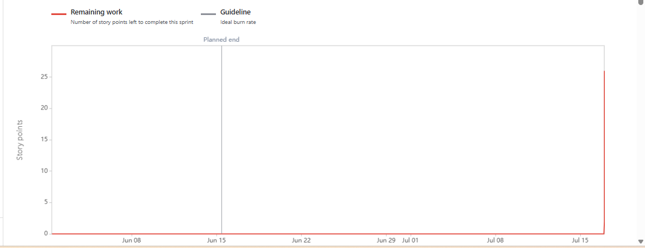

Sprint 2
Date - April 25th, 2025 to May 9th, 2025
Sprint2 goal - Map COs to POs/PSOs and create department-wise subject management for academic structure support.
The red line shows how much work remains in the sprint. The grey line shows the ideal progress rate.

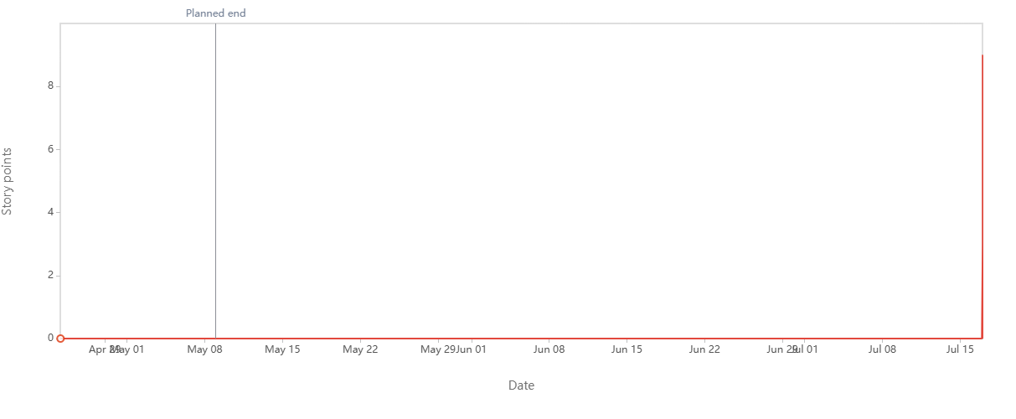

Date - April 25th, 2025 to May 9th, 2025
Sprint2 goal - Map COs to POs/PSOs and create department-wise subject management for academic structure support.
The distance between lines is the amount of work remaining. Examine the Work scope line to identify scope creep.
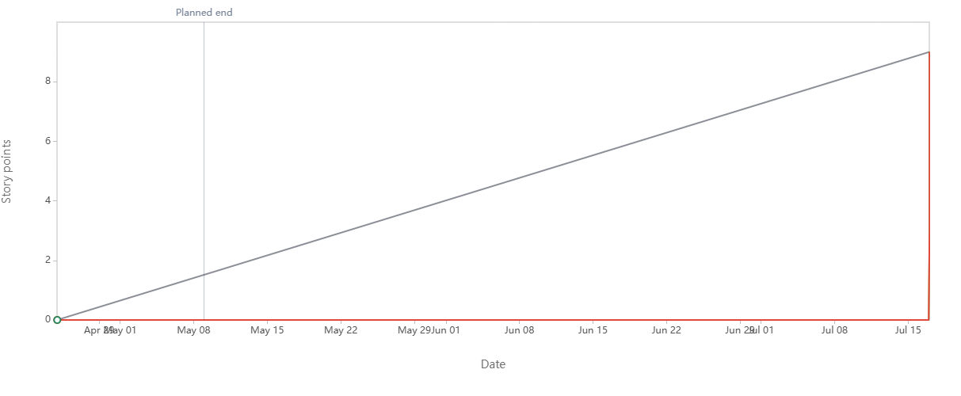

Product Burndown chart
Day | Ideal Burndown (hrs) | Remaining Effort (hrs) | Completed Tasks | Remaining Tasks
1 | 250 | 250 | 0 | 25
2 | 238 | 240 | 1 | 24
3 | 225 | 230 | 1 | 23
4 | 213 | 220 | 2 | 21
5 | 200 | 205 | 1 | 20
6 | 188 | 190 | 2 | 18
7 | 175 | 175 | 1 | 17
8 | 163 | 160 | 2 | 15
9 | 150 | 145 | 1 | 14
10 | 138 | 130 | 2 | 12
11 | 125 | 115 | 1 | 11
12 | 113 | 100 | 2 | 9
13 | 100 | 85 | 1 | 8
14 | 88 | 70 | 1 | 7
15 | 75 | 55 | 1 | 6
16 | 63 | 40 | 1 | 5
17 | 50 | 30 | 1 | 4
18 | 38 | 20 | 1 | 3
19 | 25 | 10 | 1 | 2
20 | 13 | 5 | 2 | 0
21 | 0 | 0 | 2 | 0

Document 6: Sprint meetings
Field | What to Fill
Date | The date of the Sprint Planning Meeting (e.g., 15-July-2025)
Time | Start time of the meeting (e.g., 10:00 AM)
Location | Virtual (Zoom/MS Teams) or physical (Meeting Room 2, DRGIT&R)
Prepared By | The person preparing the meeting document (e.g., Product Owner or BA)
Attendees | List Scrum Master, Product Owner, Developers, Stakeholders, etc.

Agenda Topics
Topic | Presenter | Time Allotted
Sprint Goal & Scope | Scrum Master | 15 mins
Review of Product Backlog Items | Product Owner | 20 mins
Estimation of User Stories | Scrum Developers | 25 mins
Sprint Backlog Finalization | Scrum Team | 15 mins
Risks & Dependencies Discussion | Scrum Master/Team | 10 mins

Other Information
Field | What to Fill
Observers | Faculty member(s), SME(s), or committee observer (if any)
Resources | Sprint Backlog Document, User Story Sheet, Estimation Tools (e.g., Planning Poker)
Special Notes | Add notes like: “Focus is on Module 1: Faculty Login and CO-PO Mapping Module.”

Meeting Type 2: Sprint review meeting
Field | What to Fill (Example for Currimap Sprint 2)
Date | 13-July-2025
Time | 3:00 PM to 4:00 PM
Location | Conference Room – DRGIT&R
Prepared By | Rashmi Asole – Business Analyst
Attendees | Scrum Master, Product Owner, Faculty, Developers, QA Testers, Stakeholders

Sprint Review Table
Sprint Status | Things to Demo | Quick Updates | What’s Next
Sprint 2 – Completed 5 user stories | Faculty CO-PO Mapping screen, Editable Curriculum Grid | Minor bugs found in UI, fixed during the sprint | Sprint 3 will focus on PO Mapping Reports
All stories delivered on time | Curriculum Mapping flow working with sample subject data | Faculty feedback: add filtering by academic year | Prepare data sets for department-wise report generation
1 story deferred due to dependency | Admin Feature: Managing & Linking Subjects with Course Codes | Backend enhancements done for subject data ETL | More integration with Outcome-Based Education Metrics

Meeting Type 3: Sprint retrospective meeting
Date | 13-07-2025
Time | 04:00 PM – 05:00 PM
Location | APT IT SOLUTIONS Meeting Room
Prepared By | Rashmi Asole
Attendees | BA, Developers, Testers, PO, Scrum Master

Agenda | What went well | What didn’t go well | Questions | Reference
Sprint 2 Review & Feedback | Faculty login and registration completed.-  - Module 2 UI tested successfully. | Data import for assessment module delayed.-  - Few bugs in outcome linking logic. | Can we break Module 4 into sub-stories for next sprint? | Sprint 2 Review Summary
Planning for next sprint (Sprint 3) | Backlog items are clearly prioritized.- Dependencies are identified. | Resource availability was not consistent mid-sprint. | Can tester get access to staging environment sooner? | Sprint 3 Backlog

Meeting Type 4: Daily Stand-up meeting
Question | Name/Role | Week -2 (from 06-07-2025 to 12-07-2025)
Question | Name/Role | Monday | Tuesday | Wednesday | Thursday | Friday
What did you do yesterday? | Dev1 | Setup login logic | Integrated DB | Tested Login | UI | -
What did you do yesterday? | Dev2 | Created registration form | Validation | Backend for registration | Linked API | -
What did you do yesterday? | Tester | - | - | Reviewed Login Test cases | Executed UI Test cases | Bug Reporting
What will You do today | Dev1 | Login Functionality | Debug Login error | Complete Testing | Final review | -
What will You do today | Dev2 | Build endpoint | Test with UI | Connect to DB | Validate Flows | -
What will You do today | Tester | Prepare test plan | Quick Testing | Test Login | Report Issues | --
What (if any) is blocking your progress? | Dev1 | No | No | Yes (API Delay) | - | -
What (if any) is blocking your progress? | Dev2 | NO | Yes( Database Schema not final) | Resolved | -- | -
What (if any) is blocking your progress? | Tester | - | Need staging URL | Got Access | - | -

