Capstone project : prep 3- Part 1
Q1 . A customer can make a payment either by Card or by Wallet or by Cash or by Net banking. Q1. Draw a Use Case Diagram - 4 Marks
Ans :
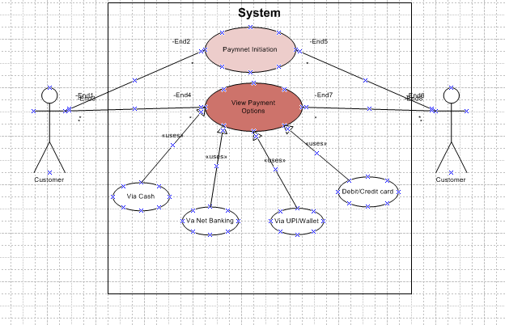
Q 2. Derive Boundary Classes, Controller classes, Entity Classes. - 4 Marks
Ans : A customer makes a payment using Card, Wallet, Cash, or Net Banking.
- Boundary Classes :
-These represent interfaces between the system and external actors (e.g., users, devices).
-It Represents core business data
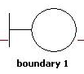
- Customer – stores customer details
- Payment – stores payment amount, mode, status
- Transaction – stores transaction reference, time
- Account – for Net Banking/card details

- Controller Classes : Interface between system and actor:
These handle the workflow or business logic triggered by the user input via boundary classes.
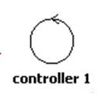
- Payment Page – where customer enters payment details
- Card Form, Wallet Form, Cash Form, Net Banking Form – specific interfaces for each payment mo

- Entity Classes : Handles business logic and coordination:
These represent business objects or data models that store system data.

- Payment Controller – manages payment flow
- Card Payment Processor, Wallet Payment Processor, etc. – for each payment type
- Transaction Manager – validates and confirms transactions

Q.3 Place these classes on a three tier Architecture. - 4 Marks
Ans :
Three-Tier Architecture with Class Placement :
- Presentation Tier (Client/UI Layer) :
Responsible for interacting with the user (Customer)
- Boundary Classes:
  - Customer UI
  - Payment Form
  - Payment Option Selector

- Application Tier (Business Logic Layer) :
Coordinates payment logic, handles request routing and control flow

Controller Classes:
PaymentController
PaymentProcessor
- Data Tier (Database Layer)
Contains business entities and manages data
Entity Classes:
• Customer
• Payment
• CardPayment
• WalletPayment
Tier | Classes
Presentation Tier | CustomerUI, PaymentForm, PaymentOptionSelector
Application Tier | PaymentController, PaymentProcessor
Data Tier | Customer, Payment, CardPayment, WalletPayment, CashPayment, NetBankingPayment

Q 4. Explain Domain Model for Customer making payment through Net Banking - 4 Marks
Ans :
A Domain Model shows the main things (real-world objects) involved in the system and how they are connected.

Explanation in Simple Terms:

When a Customer wants to pay using Net Banking, the system involves:
Explained in basic terms with tables, primary keys, foreign keys, and relationships.
1. Table: Customer
Column Name | Data Type | Description
customer_id | INT (PK) | Unique ID for customer
name | VARCHAR | Customer's name
email | VARCHAR | Customer's email

Primary Key: customer_id

2. Table: Payment
Column Name | Data Type | Description
payment_id | INT (PK) | Unique ID for payment
customer_id | INT (FK) | Links to Customer
amount | DECIMAL | Payment amount
payment_date | DATE | Date of payment
payment_type | VARCHAR | Type of payment (e.g., NetBanking)

Primary Key: payment_id
Foreign Key: customer_id → Customer(customer_id)

3. Table: NetBankingPayment
Column Name | Data Type | Description
netbanking_id | INT (PK) | Unique ID for netbanking payment
payment_id | INT (FK) | Links to Payment
bank_id | INT (FK) | Links to Bank
account_number | VARCHAR | Customer's account number
ifsc_code | VARCHAR | IFSC code of the bank
Primary Key: netbanking_id
Foreign Keys:
- payment_id → Payment(payment_id)
- bank_id → Bank(bank_id)

4. Table: Bank
Column Name | Data Type | Description
bank_id | INT (PK) | Unique ID for bank
bank_name | VARCHAR | Name of the bank
branch_name | VARCHAR | Bank branch
Primary Key: bank_id
Visual Format :

Customer (PK: customer_id)

↓

Payment (PK: payment_id, FK: customer_id)

↓

NetBankingPayment (PK: netbanking_id, FK: payment_id, FK: bank_id)

↓

Bank (PK: bank_id)

Relationships Summary:
- One Customer → can make many Payments
- One Payment → can be done via one NetBankingPayment
- One NetBankingPayment → is linked to one Bank

Q5. Draw a sequence diagram for payment done by Customer Net Banking - 4 Marks
Ans :

Definition:
A Sequence Diagram shows how objects interact with each other step-by-step over time.
It shows who sends messages, what actions happen, and in what order during a process
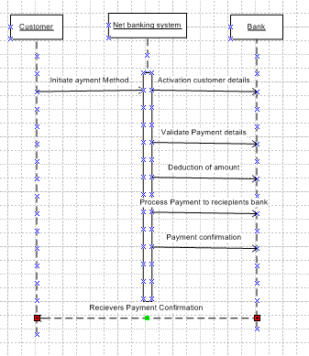
Q6. Explain Conceptual Model for this Case - 4 Marks
Ans :
A conceptual model shows the main parts of a system (called entities) and how they are related to each other. It doesn’t show technical details like how it’s built — it’s just a simple diagram or idea to understand the system.

In Our Case (Customer Making Payment):
We want to show how a customer makes a payment, and what different types of payments are possible.

Main Parts (Entities):
- Customer – A person who is paying
👉 Has details like: name, phone number, email
- Payment – The actual payment made
👉 Has: how much was paid, when, and by which method
- Card – If customer pays by card
👉 Has: card number, card type, expiry
- Wallet – If customer uses wallet (like Paytm, PhonePe)
👉 Has: wallet name, current balance
- Net Banking – If customer pays by online bank
👉 Has: bank name, account number
- Cash – Just means payment was done in cash
👉 No extra details needed

Relationships:
- One customer can make many payments
- One payment is made using only one method (Card or Wallet or Cash or Net Banking)
- Customer can have multiple cards, wallets, bank accounts
Customer --> makes --> Payment
Payment --> done using --> Card / Wallet / Net Banking / Cash

Simple Example:
- Customer "Ravi" pays ₹500
- He uses his HDFC NetBanking
- So:
  - One Customer (Ravi)
  - One Payment (₹500)
  - One Net Banking method (HDFC)
Q7. What is MVC architecture? Explain MVC rules to derive classes from use case diagram and guidelines to place classes in 3-tier architecture - 8 Marks
Ans :
MVC means Model - View - Controller.
It is a way to build software by separating work into 3 parts:
- Model – Handles data and rules
- View – What the user sees (screens/UI)
- Controller – Takes user input, controls what happens next
How to Find Classes from Use Case Diagram (MVC Rules) :
When you look at a use case diagram, follow these rules:
- Boundary Class → Screen or form used by the user
👉 Example: PaymentScreen
- Controller Class → Handles user's actions
👉 Example: PaymentController
- Entity Class → Stores real data
👉 Example: Customer, Payment
How to Place Classes in 3-Tier Architecture :
3-tier architecture has 3 layers:
Layer | What to Place Here
1. UI Layer | Boundary Classes (screens)
2. Logic Layer | Controller Classes (actions)
3. Data Layer | Entity Classes (data)

Example:
If a customer pays online:
- View (UI): Payment screen
- Controller: Takes input and calls payment process
- Model: Stores customer and payment details
3-Tier Architecture – Where to Place Classes
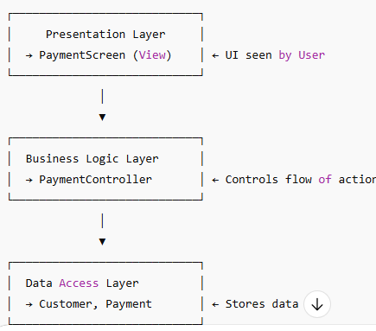
Q8. Explain BA contributions in project (Waterfall Model – all Stages) – 8 Marks
Ans :
Stage | What BA Does (Activities) | Documents / Things Used (Artifacts & Resources)
Pre-Project | - Understand the problem- Help create the business idea | - Business idea note- Business case
Planning | - Help plan what the project will do- Find and list important people (stakeholders) | - Project plan- Stakeholder list
Project Initiation | - Collect high-level needs- Help define project goals | - Vision document- Summary of needs
Requirement Gathering | - Talk to users and clients- Write down all detailed needs | - BRD (Business Requirement Document)- Requirement list
Requirement Analysis | - Check if needs are correct- Help sort and prioritize needs | - FRD (Functional Document)- Use cases- Diagrams
Design | - Help design team understand the needs- Review design plans | - Design documents- Screen mockups
Development | - Answer developer questions- Make sure they build the right thing | - Notes- Emails/messages with clarifications
Testing | - Check test cases- Help with bugs and issues- Make sure needs are tested | - Test case checklist- Bug list- RTM (Traceability)
User Acceptance Testing (UAT) | - Arrange testing with users- Collect user feedback- Help fix issues | - UAT plan- Feedback notes- Approval sign-off
Q9. What is conflict management? Explain using Thomas – Kilmann technique – 6 Marks
Ans :
Conflict management means handling disagreements or problems between people in a team or organization in a good way.
The goal is to solve the issue without harming work or relationships.
Conflict management solves a problems or fights between people in a team in a good and peaceful way, so work doesn’t get affected.

Thomas–Kilmann Conflict Management Technique
This model shows 5 ways to handle conflict, based on two things:
- Assertiveness (how much you try to get your own way)
- Cooperativeness (how much you care about others’ needs)
Style | Simple Meaning | When to Use
Competing | I win, you lose | In urgent situations
Collaborating | We both win | When both people’s needs are important
Compromising | Both give up something | When quick middle solution is needed
Avoiding | Ignore the fight | When the issue is small or can wait
Accommodating | You win, I lose | When the other person’s need is bigger

Conclusion:
The Thomas–Kilmann model helps BAs and teams choose the right way to manage conflicts based on the situation. Good conflict management improves teamwork and project success.
Q10. List down the reasons for project failure – 6 Marks
Ans :
Here are some common reasons why projects fail:
- Unclear Requirements
– If the goals and needs are not clearly defined from the start.
- Poor Planning
– If time, budget, or tasks are not planned properly.
- Lack of Communication
– When team members or stakeholders don’t share important updates.
- Scope Creep
– When new features are added without proper control, causing delays.
- Weak Leadership or Team Issues
– If the project manager or team is not skilled or lacks coordination.
- Poor Risk Management
– If possible problems are not predicted and handled in time.
These reasons can lead to missed deadlines, low quality, or incomplete projects.
Q11. List the Challenges faced in projects for BA – 6 Marks
Ans :
- Unclear Requirements
– Stakeholders don’t know or change what they want often.
- Changing Requirements
– Frequent changes during the project make tracking difficult.
- Lack of Stakeholder Involvement
– Stakeholders are not available for meetings or reviews.
- Communication Gaps
– Misunderstanding between business, developers, and testers.
- Time Constraints
– Less time to gather or analyze requirements properly.
- Tool or Technology Limitations
– Difficulty in using tools or working with outdated systems.
- These challenges can affect requirement quality, project timelines, and final product success.

Q12. Write about Document Naming Standards – 4 Marks
Ans : Document Naming Standards are rules for giving names to project documents in a clear, consistent way.

Why Naming Standards are Important:
- Helps in easy searching and tracking documents
- Avoids confusion between versions
- Maintains professional and organized records

What a Good Document Name Should Include:
- Project Name or Code – e.g., CRM
- Document Type – e.g., BRD, FRD, Minutes
- Version Number – e.g., v1.0, v2.1
- Date (optional) – e.g., 2025-06-28
- Author or Department (optional) – e.g., BA_Team

Example:
CRM_BRD_v1.2_2025-06-28.docx
This ensures everyone in the team can easily find, understand, and use the correct document.
Q13. What are the Do’s and Don’ts of a Business analyst – 6 Marks
Ans :
Do’s | Don’ts
Listen carefully to stakeholders to understand real needs. | Don’t assume you understand the requirement without asking.
Ask questions to clarify requirements and remove confusion. | Don’t ignore stakeholders’ input, even if it seems minor.
Document requirements clearly using BRD, FRD, use cases, etc. | Don’t delay documentation or skip updates after changes.
Keep communication open with developers, testers, and clients. | Don’t use complex language that business users can’t understand.
Validate requirements with users to ensure accuracy. | Don’t make decisions alone without team or stakeholder discussion.
Keep learning about tools, techniques, and business domains. | Don’t resist feedback—improvements come from collaboration.
Q14. Write the difference between packages and sub-systems – 4 Marks
Ans :
Aspect | Packages | Sub-systems
Definition | A group of related classes or components | A set of related packages that work together as a system
Size | Smaller in size, more focused | Larger, made up of multiple packages
Purpose | To organize related functionality | To represent a major part or module of the full system
Dependency | May depend on other packages | May work independently or connect with other sub-systems
A class is a basic building block in object-oriented design.
It represents one object or thing with data and functions.
Example: Customer, Payment, Order
A package is a group of related classes kept together.
It helps to organize and manage the system better.
Example: A Payment package may include Card, Wallet, and BankTransfer classes.
Q15. What is camel-casing and explain where it will be used- 6 Marks
Ans :
Camel-casing is a way of writing names without spaces, where each new word starts with a capital letter.
- It is called "camel case" because the capital letters look like the humps of a camel

Examples:
- customerName
- paymentMethod
- orderTotalAmount

Types of Camel-Casing:
- Lower Camel Case: Starts with small letter → userName, accountNumber
- Upper Camel Case (also called Pascal Case): Starts with capital letter → UserName, AccountNumber
Use Area | Example
Variable names | customerAge, totalAmount
Method/function names | getDetails(), calculateTax()
Class names | Customer, InvoiceDetails
Database fields (optional) | orderDate, paymentMode

Conclusion:
Camel-casing is widely used in programming and documentation to make names clear, readable, and standardized without using spaces.
Q16. Illustrate Development server and what are the accesses does business analyst has? -6
Ans :
A development server is a testing environment where developers build and test software before it goes to production.
- It is not live, so mistakes or testing won’t affect real users.
- It helps in writing, checking, and improving code safely.

Key Features of Development Server:
- Used for coding, testing, and debugging
- May have sample/test data
- Supports multiple changes before final release
- Can be reset or updated often
Access Type | Purpose for BA
Read Access | To view system behavior, screen layout, and data
UAT Support Access | To support testers during UAT
Test Data Entry (sometimes) | To add or update test scenarios
Error/Issue Tracking Tools | Use tools like JIRA to log bugs found on server
Reports Access | To validate reports or outputs from test runs
Note: A BA usually does not have coding access. Their role is to observe, validate, and support testing.

Conclusion:
A development server helps teams test new features. A Business Analyst uses it to validate requirements, check workflows, and support testers, but does not modify code.
Q17. What is Data Mapping 6 Marks
Ans :
Data Mapping is the process of matching data from one source to another.
It shows how data fields in one system or file relate to fields in another.

Example:
If you're moving data from an old system to a new one:
Old System Field | New System Field
Cust_Name | CustomerFullName
DOB | DateOfBirth
Mob_No | PhoneNumber
Here, Data Mapping tells which old field goes into which new field.

Why is Data Mapping Important?
- Helps in data migration between systems
- Ensures correct and clean data transfer
- Used in reporting, integration, and ETL (Extract, Transform, Load) processes
- Prevents data loss or mismatch

Where BA uses Data Mapping:
- During system integration
- In requirement documents for developers
- While working on data migration projects
- To support report and database design

Conclusion:
Data Mapping ensures the right data goes to the right place when transferring or connecting systems. It is a key task for Business Analysts in data-heavy projects.
Q18. What is API. Explain how you would use API integration in the case of your application Date format is dd-mm-yyyy and it is accepting some data from Other Application from US whose Date Format is mm-dd-yyyy 10 Marks
Ans :

What is API?
API stands for Application Programming Interface.
It is a way for two software applications to talk to each other and share data.
- Example: A payment app can use an API to get user details from another system.
- It acts like a messenger between two different software systems.

What is API Integration?
API Integration means connecting two applications so they can exchange data automatically using APIs.
Case: Date Format Issue in API Integration

Scenario:
- Your application accepts date in format: dd-mm-yyyy
- Another application (from US) sends date as mm-dd-yyyy
- Example: 05-06-2025
  - Your app sees this as 5th June 2025
  - US app meant 6th May 2025

Problem:
This date mismatch can lead to wrong data being saved or displayed.
Step | Action
1. Understand API Format | Check the date format used by the other system (e.g., mm-dd-yyyy)
2. Data Mapping | Map incoming fields correctly and identify which ones need format change
3. Use Date Conversion | Write logic to convert mm-dd-yyyy to dd-mm-yyyy before saving
4. Validation | Add validation rules to reject wrong formats
5. Testing | Test integration with sample US dates
6. Documentation | Clearly mention date format expectations in the API documentation

Conclusion:
API helps connect two applications.
In this case, a BA should ensure proper data mapping and conversion so that date formats don’t create confusion and data remains accurate.

