Document 1: Definition of Done
What is Definition of Done?
In Agile, the Definition of Done (DoD) is a shared agreement within the team that defines what it means for a backlog item like user story, sprint, or release to be considered truly done. It ensures there is no uncertainty, helps set a quality benchmark, and creates a shared understanding of completion across developers, testers, product owners, and stakeholders.
Levels of DoD in Agile: The DoD can exist at multiple levels in the project:
- User Story Level – Ensures an individual story meets acceptance and quality criteria.
- Sprint Level – Ensures all committed stories are integrated, tested, and shippable by sprint end.
- Release Level – Ensures the system is stable, integrated, documented, and deployable into production.
Why Definition of Done Matters in Agile
- Creates transparency between the team and stakeholders.
- Prevents half-done stories from being accepted.
- Ensures quality, usability, and maintainability are built into the process.
- Provides a consistent benchmark across sprints and releases.

Definition of Done (DoD) for HireSmart 360 ATS across the three Agile levels — User Story, Sprint, and Release
User Story: Each backlog item must meet the following:
Acceptance Criteria:
- Story meets all defined acceptance criteria and business rules.
- Candidate or recruiter can actually perform the intended action Example- apply for job, shortlist candidate.
- Notifications or confirmations are triggered correctly.
- Approved by Product Owner.
Quality Criteria
- Code written, reviewed, and merged into the main branch.
- Unit and functional tests pass.
- No critical bugs left unresolved.
- Deployed successfully in test environment.
- Documentation updated for the feature.
Sprint Level: At the end of every sprint, the increment should be potentially transferable.
Acceptance Criteria
- All sprint backlog stories are complete and integrated.
- Candidate → Recruiter → HR flows within the sprint work end-to-end.
- Sprint review/demo conducted and signed off by stakeholders.

Quality Criteria
- QA testing completed; no major defects remain.
- UX validated with design guidelines through Balsamiq mockups.
- Sprint documentation, release notes, and user guides updated.
Release Level: At release level, the system must be production-ready and deliver end-to-end value.
Acceptance Criteria
- End-to-end recruitment workflow works: Candidate → Recruiter → HR → Offer → Onboarding.
- UAT completed and approved by HR leadership.
- Sponsor and Product Owner approve the release for production.
Quality Criteria
- Performance testing completed.
- Security and compliance checks passed.
- Data migration completed and validated.
- Training delivered to recruiters, HR, and IT staff.
- Support processes in place for go-live.
- Monitoring set up for production environment.

Document 2- Product Vision
HireSmart 360 – Agile Project Overview
Meeting Details

Name | HireSmart 360 – Agile Sprint Planning & Vision Discussion
Venue | Client Office / Virtual (MS Teams)
Date | 25-Aug-25
Start time | 10:00 AM
End time | 11:30 AM
Client | HR Leadership Team
Duration | 90 minutes
Stakeholder list | HR Director, Recruitment Manager, IT Manager, Change Manager, Business Analyst, Implementation Partner Lead

Scrum Team

Scrum Master | Utsav G
Product Owner | Chitresh Bhatia
Scrum Developer 1 | Prince B(UI Developer)
Scrum Developer 2 | Rajeev Patnaik(Backend Developer)
Scrum Developer 3 | Rahul Bhatia (Database Integration-HRIS, Email, Notifications)
Scrum Developer 4 | Saif Pathan(QA / Test Automation)
Scrum Developer 5 | Sanjeev Kumar(UX/UI Designer)

Vision
Our vision with HireSmart 360 is to create a modern, easy-to-use recruitment platform that makes hiring faster, smarter, and more transparent. We want to simplify the candidate journey, reduce manual work for recruiters, and give HR leadership real-time insights into hiring performance.

Target Group and Needs
Target Group | Recruiters, HR Teams, and Job searching Candidates
Needs | Centralized recruitment system, smooth candidate experience, dashboards for leadership

Market Segment, Users, and Customers
Market Segment | Corporate HR departments, mid-to-large enterprises, scalable for hiring firms
Users and Customers | Users: Candidates, Recruiters, HR Managers | Customers: HR Leadership

Problem & Benefits
Problem Solved | Current hiring is slow, scattered, and manual. The ATS automates workflows, integrates screening, and provides visibility.
Benefits | For Candidates: smooth journey | For Recruiters: one-stop dashboard | For HR: transparency and reduced time-to-hire

Product Definition
What Product Is It? | An Applicant Tracking System (ATS) designed for usability and intelligence in recruitment.
Why It’s Special | Candidate-centric design, resume parsing, recruiter workflows, analytics

Company Benefits & Business Goals
Company Benefits | Reduced time-to-hire, lower drop-offs, increased recruiter productivity, better insights
Business Goals | Faster recruitment, improved candidate experience, standardization, data-driven HR decisions

Feasibility & Business Model
Feasibility | Yes – scalable, cost-effective
Business Model | One-time implementation cost + optional add-ons

3. Document 3: User stories
User Story:1 | Tasks No. 1 | Priority: Highest
As a candidate, I want to log in securely using email id/credentials
so that I can access job listings and manage my profile.
Business Value (BV): 500 | Complexity Points (CP): 34
ACCEPTANCE CRITERIA- Candidate can log in with valid credentials.
-Invalid credentials show error message.
-SSO option works with corporate login.

User Story:2 | Tasks No. 1 | Priority:Highest
As an candidate, I want to view all open job positions.
so that I can choose and apply for suitable roles.
Business Value (BV): 500 | Complexity Points (CP): 21
ACCEPTANCE CRITERIA- Candidate sees a list of active jobs.
Jobs can be filtered by location, department, role.
Expired jobs are not displayed.

User Story:3 | Tasks No. 2 | Priority:Highest
As a candidate
I want to apply for a job online.
so that I can submit my interest and details.
Business Value (BV): 200 | Complexity Points (CP): 8
ACCEPTANCE CRITERIA- Candidate can click “Apply” and submit form.
-Mandatory fields validated.
-Success message displayed.

User Story:4 | Tasks No. 2 | Priority:Highest
As a candidate I want to upload my resume in PDF/DOCX format.
so that I can share my qualifications with recruiters.
Business Value (BV): 200 | Complexity Points (CP): 13
ACCEPTANCE CRITERIA-
-Only PDF/DOCX accepted.
-File size max 5MB.
-Error message for invalid files.

User Story:5 | Tasks No. 3 | Priority:Highest
As a candidate, I want to receive a confirmation email after applying.
so that I can be sure my application was received.
Business Value (BV): 500 | Complexity Points (CP): 34
ACCEPTANCE CRITERIA-
-Email sent within 2 minutes of application.
-Contains job title and submission date.

User Story:6 | Tasks No. 3 | Priority:Highest
As a recruiter, I want to view all applications in one dashboard.
so that I can screen and manage them efficiently.
Business Value (BV): 500 | Complexity Points (CP): 21
ACCEPTANCE CRITERIA-
-Dashboard displays candidate name, job applied, status.
-Recruiter can sort and filter applications.

User Story:7 | Tasks No. 4 | Priority:Highest
As a recruiter, I want to shortlist candidates from dashboard.
so that I can progress them to the interview stage.
Business Value (BV): 200 | Complexity Points (CP): 5
ACCEPTANCE CRITERIA-
-Recruiter can mark candidates as shortlisted.
-Status updated in real time.

User Story:8 | Tasks No. 5 | Priority:Highest
As a recruiter, I want to schedule interviews via ATS.
so that I can avoid manual emails and errors.
Business Value (BV): 500 | Complexity Points (CP): 8
ACCEPTANCE CRITERIA-
-Recruiter selects date/time and invites candidate.
-Calendar invite auto-sent to candidate and panel.

User Story:9 | Tasks No. 5 | Priority:Highest
As a Recruiter,
I want to generate an offer letter template.
so that I can quickly send offers to selected candidates.
Business Value (BV): 500 | Complexity Points (CP): 5
ACCEPTANCE CRITERIA-
-Offer auto-populates candidate details.
-Can be exported as PDF.

User Story:10 | Tasks No. 5 | Priority:Highest
As a HR Leader, I want to view reports on time-to-hire, drop-offs, and recruiter productivity.
so that I can optimize the hiring process.
Business Value (BV): 2000 | Complexity Points (CP): 8
ACCEPTANCE CRITERIA-
-Dashboard shows time-to-hire and drop-off rate.
-Data can be filtered by department or job role.

User Story:11 | Tasks No. 4 | Priority: Medium
As a candidate, I want to edit my profile details so that I can keep my information accurate.
so that I can access job listings and manage my profile.
Business Value (BV): 50 | Complexity Points (CP): 3
ACCEPTANCE CRITERIA- Candidate can update name, email, experience, and save changes successfully.

User Story:12 | Tasks No. 4 | Priority: Medium
As an candidate, I want to filter jobs by location, skills, and experience so that I find relevant roles quickly.
Business Value (BV): 100 | Complexity Points (CP): 5
ACCEPTANCE CRITERIA- Jobs displayed match filter criteria.

User Story:13 | Tasks No. 3 | Priority: Medium
As a recruiter, I want to see all applications in one dashboard so that I can manage candidates efficiently.
Business Value (BV): 200 | Complexity Points (CP): 8
ACCEPTANCE CRITERIA- Dashboard displays real-time data of applications.

User Story:14 | Tasks No. 4 | Priority: Medium
As a candidate, I want email updates when my application status changes so that I stay informed.
Business Value (BV): 100 | Complexity Points (CP): 5
ACCEPTANCE CRITERIA- Notifications triggered on status change.

User Story:15 | Tasks No. 5 | Priority: Medium
As a system, I want to parse resumes into structured fields so that recruiters can quickly view candidate skills.
Business Value (BV): 50 | Complexity Points (CP): 2
ACCEPTANCE CRITERIA- Resume details correctly mapped into fields.

User Story:16 | Tasks No. 2 | Priority:Highest
As an admin, I want to approve job postings before they go live so that we maintain quality standards.
Business Value (BV): 500 | Complexity Points (CP): 13
ACCEPTANCE CRITERIA- Posting remains pending until admin approves.

User Story:17 | Tasks No. 5 | Priority:Lowest
As a recruiter, I want to view communication logs with candidates so that I avoid repeating questions.
Business Value (BV): 20 | Complexity Points (CP): 2
ACCEPTANCE CRITERIA-All past emails and notes visible in candidate profile.

User Story:18 | Tasks No. 6 | Priority:Lowest
As a candidate, I want to withdraw my application so that I can manage my job search.
Business Value (BV): 50 | Complexity Points (CP): 3
ACCEPTANCE CRITERIA-Candidate can withdraw and recruiter is notified.

User Story:18 | Tasks No. 6 | Priority:Lowest
As a recruiter, I want to add private notes to candidate profiles so that I can share insights with my team.
Business Value (BV): 50 | Complexity Points (CP): 3
ACCEPTANCE CRITERIA-Notes remain private to recruiters only

User Story:19 | Tasks No. 5 | Priority:Medium
As a user, I want two factor authentication while logging in so that my account is protected.
Business Value (BV): 100 | Complexity Points (CP): 8
ACCEPTANCE CRITERIA-Login requires OTP verification.

User Story:20 | Tasks No. 2 | Priority:Highest
As a recruiter, I want to schedule interviews from the ATS so that I don’t switch tools.
Business Value (BV): 500 | Complexity Points (CP): 2
ACCEPTANCE CRITERIA-Calendar invites sent to both parties.

User Story:21 | Tasks No. 2 | Priority:Highest
As a system, I want to detect duplicate resumes so that recruiter’s database remains clean.
Business Value (BV): 500 | Complexity Points (CP): 2
ACCEPTANCE CRITERIA-Alerts shown for duplicate upload.

User Story:22 | Tasks No. 4 | Priority:Medium
As an employee, I want to refer candidates so that I can help recruit talent.
Business Value (BV): 200 | Complexity Points (CP): 5
ACCEPTANCE CRITERIA-Referral link generates and recruiter is notified.

User Story:23 | Tasks No. 5 | Priority:Medium
As a recruiter, I want to see skill match scores so that I prioritize strong candidates.
Business Value (BV): 100 | Complexity Points (CP): 8
ACCEPTANCE CRITERIA-Score shown against job requirements.

User Story:24 | Tasks No. 4 | Priority:Medium
As a candidate, I want to apply via mobile so that I can apply on-the-go.
Business Value (BV): 200 | Complexity Points (CP): 5
ACCEPTANCE CRITERIA-Portal works smoothly on mobile browsers.

User Story:25 | Tasks No. 2 | Priority: High
As an admin, I want to assign different roles so that access is restricted appropriately.
Business Value (BV): 200 | Complexity Points (CP): 5
ACCEPTANCE CRITERIA-Recruiter cannot perform admin tasks.

User Story:27 | Tasks No. 2 | Priority:Medium
As a recruiter, I want an analytics dashboard so that I track time-to-hire and applicant trends.
Business Value (BV): 200 | Complexity Points (CP): 5
ACCEPTANCE CRITERIA-Dashboard displays live recruitment metrics.

User Story:29 | Tasks No. 1 | Priority:Medium
As a candidate, I want to view the portal in my preferred language so that I apply comfortably.
Business Value (BV): 100 | Complexity Points (CP): 8
ACCEPTANCE CRITERIA-Language switch works for all screens.

User Story:30 | Tasks No. 3 | Priority:Medium
As a candidate, I want to see my application status in real-time so that I know next steps.
Business Value (BV): 100 | Complexity Points (CP): 8
ACCEPTANCE CRITERIA-Status updates reflect recruiter actions instantly.

Document 4: Agile PO Experience
Agile Product Owner Experience – Hire Smart 360 ATS*
1. Market & Business Analysis:
• Identified business need to streamline and automate recruitment workflows.
• Gap Analysis. Compared manual hiring processes with proposed ATS automation to highlight efficiency gaps.
• Understood compliance and reporting requirements to align with HR and industry standards.

2. Product Vision
• Established a vision of Hire Smart 360 as a one-stop automated recruitment platform reducing manual effort and improving candidate experience.
• Prepared product roadmap with phased deployments (3–4 releases) covering candidate application automation, job requisition approvals, AI-based resume screening, and analytics dashboards.
• Ensured the roadmap aligned with HR stakeholders’ strategic goals to hire faster, reduce costs, and improve candidate quality.

3. Managing Product Features:
• Gathered requirements for Hire Smart 360 from HR and recruitment teams.
• Prioritized automation features such as candidate shortlisting, job postings, and reporting dashboards.
• Balanced technical feasibility with urgent HR needs like reducing time-to-hire.

4. Product Backlog Management
• Created detailed user stories for Hire Smart 360.
• Assigned Business Value (BV) and Complexity Points (CP) for each user story to guide sprint planning.
• Continuously updated the backlog based on feedback from HR stakeholders and market needs.

5. Iteration Progress
• Planned iterative releases focusing on delivering high-value features in early sprints. Conducted sprint planning to deliver features incrementally.
• Conducted sprint reviews and sprint progress with HR and IT stakeholders to showcase working increments like the candidate portal and recruiter dashboard.
• Participated in retrospectives to capture lessons learned and improve delivery.
• Shared progress updates regularly with stakeholders to maintain alignment.

6. Agile Practices Handled
• Sprint Planning – Broke features into manageable user stories.
• Daily Scrum – Discussed blockers, progress, and clarifications on tasks.
• Sprint Review – Showcased product increments (e.g., job posting automation).
• Retrospective – Captured lessons learned for continuous improvement.
• Backlog Refinement – Updated and refined stories based on HR and stakeholder feedback.

7. Learning & Contributions
• Hands-on experience in automating end-to-end recruitment processes.
• Successfully managed multi-stage ATS deployment.
• Enhanced expertise in user story writing, prioritization, and backlog grooming.
• Strengthened collaboration with HR stakeholders, developers, and Scrum team.
• Ensured measurable business value by improving hiring efficiency, reducing manual work, and enhancing compliance.

Document 5: Product and sprint backlog and product and sprint burndown charts

Product Backlog:
User Story ID | User Story | Tasks | Priority | BV | CP | Sprint
1 | Candidate Login | Design login page, build authentication API, enable SSO, test cases | High | 500 | 3 | 1
2 | View Job Listings | Create job listing UI, integrate job DB, filters (location/role), QA | High | 500 | 2 | 1
3 | Apply for Job | Build application form, mandatory field validation, success message | High | 500 | 3 | 2
4 | Upload Resume | Resume upload UI, backend storage, file validation, error messages | High | 50 | 2 | 2
5 | Application Confirmation Email | Email service setup, template design, trigger on apply, test email | High | 100 | 2 | 2
6 | Recruiter Dashboard | Dashboard UI, candidate list integration, filtering, sorting | High | 1000 | 5 | 3
7 | Shortlist Candidate | Add shortlist button, status update workflow, recruiter validation | High | 500 | 3 | 3
8 | Schedule Interviews | Calendar integration, scheduling form, email invites, reminders | High | 50 | 4 | 4
9 | Generate Offer Letter | Offer template builder, auto-fill candidate details, export to PDF | Medium | 500 | 3 | 4
10 | Reports & Analytics | Dashboard charts, filters by dept/role, recruiter productivity view | Medium | 2000 | 5 | 5

Sprint Backlog – Sprint 1 (Candidate Onboarding)
User Story ID | User Story | Tasks | Owner | Status | Estimated Effort
1 | Candidate Login | Create login UI, backend API, SSO integration, write unit tests | Dev 1, Dev 2 | In Progress | 20 hrs
2 | View Job Listings | Build job listing page, integrate job DB, implement filters, QA test | Dev 3, QA | Not Started | 18 hrs

Sprint Backlog – Sprint 2 (Application Submission)
User Story ID | User Story | Tasks | Owner | Status | Estimated Effort
3 | Apply for Job | Application form UI, validation rules, backend API, unit tests | Dev 1, Dev 2 | Not Started | 22 hrs
4 | Upload Resume | Resume upload UI, backend storage, file validation, error checks | Dev 3, Dev 4 | Not Started | 20 hrs
5 | Application Confirmation Email | Setup email service, design templates, test triggers | Dev 2, QA | Not Started | 15 hrs

Sprint burndown chart:
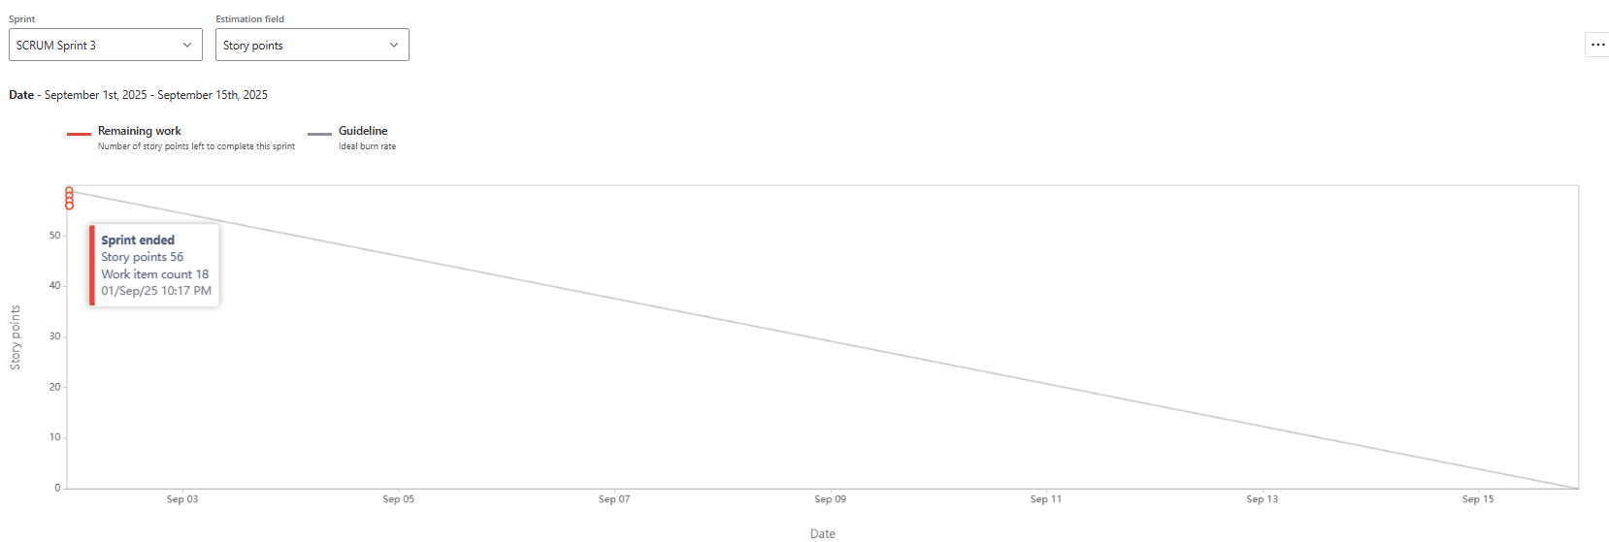

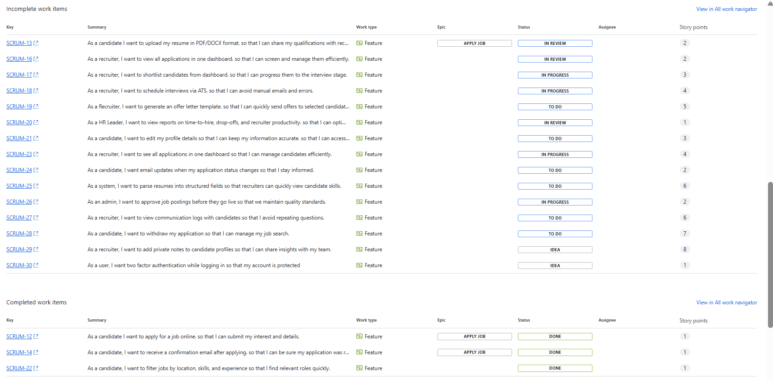

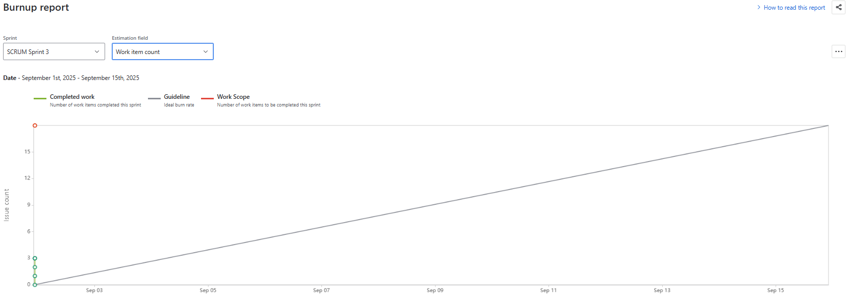

Document 6: Sprint meetings

Meeting Type 1: Sprint Planning Meeting
Date | 25th Aug 2025
Time | 10:00 AM – 11:30 AM
Location | Virtual (MS Teams)
Prepared By | Product Owner
Attendees | Scrum Master, Product Owner, Scrum Developers, HR Stakeholder

Agenda Topics
Topic | Presenter | Time Allotted
Sprint Goal Overview | Product Owner | 30 min
Review prioritized backlog items (User Story ID 1, 2, 3) | Scrum Master + PO | 60 min
Technical discussion (login API, job listing DB) | Dev 2, Dev 3 | 60 min
Task breakdown & estimation | Scrum Developers | 30 min
Final sprint commitment | Scrum Team | 30 min

Other Information
Observers | HR Director (for initial feedback)
Resources | Jira backlog, Figma mockups, technical architecture doc
Special Notes | Focus on Candidate login, Job Listings, Apply for Job (User Story ID 1–3)

Meeting Type 2: Daily Scrum Meeting
Date: 26th Aug 2025
Time: 10:00 AM – 10:45 AM
Location: Virtual (MS Teams)
Prepared By: Scrum Master
Attendees: Scrum Master, Product Owner, Scrum Developers

Topic | Presenter | Time Alloted
Yesterday’s progress update on candidate login module & job listing page | Scrum Master, Developers | 15mins
Today’s planned tasks: Resume upload testing, integration of job search filter, API testing for Apply Now button | Scrum Master, Developers, QA Testers | 15mins
Issues in candidate registration form validation | Scrum Master | 15mins

Meeting Type 3: Sprint Review Meeting
Date | 26th Aug 2025
Time | 10:00 AM – 11:00 AM
Location | Virtual (MS Teams)
Prepared By | Scrum Master
Attendees | Scrum Team, Product Owner, HR Stakeholders

Sprint Status | Things to Demo | Quick Updates | What’s Next
Completed Candidate login(Id-1),  View Job Listings (id-2)  Partial Apply for Job(id-3) | Login with email/SSO,  Job listings with filters. | API delays, DB schema updates done, validation pending. | Next sprint: Resume Upload,  Confirmation Email, finish Apply for Job.

Meeting Type 4: Sprint Retrospective Meeting
Date: 30th Aug 2025
Time: 4:00 PM – 5:30 PM
Location: Virtual (MS Teams)
Prepared By: Scrum Master
Attendees: Scrum Master, Product Owner, Scrum Developers, HR Stakeholder

Topic | Presenter | Time Allotted
Review of Sprint achievements: Candidate login & profile creation completed, Job listing integrated, Basic application flow tested | Product Owner | 20 min
What went well: Collaboration on login API, successful integration of candidate profile page with DB | Scrum Developers | 20 min
What could be improved: UI design in job listing | Scrum Master | 20 min
Action items for next sprint: Automate resume screening, improve error handling in job application submission, prepare demo for HR stakeholders | Scrum Team | 20 min
Agreement on improvements and closure | Scrum Master | 10 min

