Question 1. 4 Quarterly Audits are planned Q1 , Q2, Q3, Q4 for this Project What is your knowledge on how these Audits will happen for a BA ?

Answer 1. 1. Documentation Review
- Ensure all BA artifacts are complete, up-to-date, and traceable:
- BRD, FRD, Change Requests
- Minutes of Meeting, Sign-offs
- User Stories, Process Flows (AS-IS/TO-BE)

- Auditors check for version control, stakeholder approvals, and alignment with business goals.

2. Requirements Traceability Matrix (RTM)
- Maintain and present an RTM linking business requirements to functional requirements, test cases, and UAT results.
- RTM helps show that all requirements were delivered and validated.

3. Change Request Tracking
- Ensure all change requests are properly logged, analyzed for impact, and approved by relevant stakeholders.
- Audit verifies there’s no scope creep and that proper impact analysis was done.

4. Stakeholder Communication Logs
- Demonstrate consistent and traceable communication:
- Emails, JIRA comments, Confluence updates
- Meeting follow-ups with action items
- These help show stakeholder involvement and transparency.

5. UAT Audit Trail
- Provide documentation of User Acceptance Testing (UAT):
- Test cases created, executed
- Defects logged and resolved
- UAT Sign-off from users

6. Compliance & Regulatory Alignment
- In the banking/finance domain, ensure requirements meet:
- KYC/AML/CDD regulations
- Internal audit & risk policies
- Any applicable data privacy or financial compliance standards

7. Agile/Wave Reviews (if Agile is followed)
- Sprint-wise delivery and retrospectives may be reviewed.
- User stories’ completeness and sign-offs are verified from JIRA/Confluence.

Question 2. Before the Project is going to Kick Start, The Committee asked Mr Karthik to submit BA Approach Strategy Write BA Approach strategy (As a business analyst, what are the steps that you would need to follow to complete a project – What Elicitation Techniques to apply, how to do Stakeholder Analysis RACI/ILS, What Documents to Write, What process to follow to Sign off on the Documents, How to take Approvals from the Client, What Communication Channels to establish n implement, How to Handle Change Requests, How to update the progress of the project to the Stakeholders, How to take signoff on the UAT- Client Project Acceptance Form )
Your Team
Project Manager - Mr Vandanam Senior Java Developer - Ms. Juhi
Java Developers - Mr Teyson, Ms Lucie, Mr Tucker, Mr Bravo Network Admin - Mr Mike
DB Admin - Mr John
Testers - Mr Jason and Ms Alekya
BA - You
Technical Team have assembled to discuss on the Project approach and have finalised to follow 3-tier architecture for this project.

Answer 2. Business Analyst (BA) Approach Strategy that we can submit, addressing each component required by the Committee:

1. Steps to Follow to Complete the Project as a Business Analyst
- Planning
  - Understand the project scope and objectives.
  - Define BA deliverables, timelines, and collaboration expectations.
  - Identify and analyse stakeholders.
  - Set up the communication and governance structure.
- Requirement Elicitation
  - Conduct workshops, interviews, and brainstorming sessions.
  - Gather functional, non-functional, and technical requirements.
- Requirement Analysis
  - Document business, user, and system requirements.
  - Conduct gap analysis, feasibility analysis, and impact assessment.
  - Define use cases, process flows, and data models.
- Validation & Sign-Off
  - Review requirements with stakeholders.
  - Get formal sign-off on Business Requirement Document (BRD), Functional Requirement Specification (FRS), and any other deliverables.
- Support Development & Testing
  - Assist developers and testers in understanding the requirements.
  - Participate in sprint planning (if Agile) or walkthroughs.
  - Facilitate clarifications and requirement traceability.
- UAT Planning and Execution
  - Prepare UAT test scenarios and scripts.
  - Coordinate UAT with client stakeholders.
  - Track defects and feedback.
- Project Closure
  - Collect client acceptance on the UAT and final deliverables.
  - Archive documents and lessons learned.

2. Elicitation Techniques to Apply
- Stakeholder Interviews – 1:1 detailed discussions.
- Workshops – Group discussions for brainstorming and consensus.
- Document Analysis – Review existing documentation.
- Surveys/Questionnaires – For distributed stakeholders.
- Prototyping/Mock-ups – Visual aids for clarity.
- Observation/Job Shadowing – To understand real-time user tasks.
- Use Case & Process Modeling – Visual representation of requirements.

3. Stakeholder Analysis – RACI Matrix / ILS
RACI Matrix Example:
Activity / Deliverable | BA (You) | PM (Vandanam) | Dev (Juhi & Team) | Testers | Client | DBA/Net Admin
Requirement Gathering | R | A | C | C | I | C
BRD/FRS Preparation | R | A | C | I | C | C
Technical Design Review | C | A | R | I | I | R
UAT Planning & Execution | R | A | I | R | C | I
Change Request Handling | R | A | C | C | C | C
Final Project Acceptance | C | A | I | I | R | I
- R – Responsible, A – Accountable, C – Consulted, I – Informed

4. Documents to Write
- Business Requirements Document (BRD)
- Functional Requirement Specification (FRS)
- Use Case Document
- Process Flow Diagrams (BPMN/Visio)
- User Stories (if Agile)
- Data Dictionary
- Traceability Matrix
- Change Request Form
- UAT Plan & Scenarios
- Client Project Acceptance Form

5. Process to Follow to Sign Off on the Documents
- Submit draft version for internal review.
- Conduct walk-through sessions with stakeholders.
- Incorporate feedback and update the document.
- Final review with client stakeholders.
- Get formal sign-off via:
  - Email confirmation.
  - Document version control with e-signature (PDF).
  - Use of tools like SharePoint/Confluence for tracking approvals.

6. How to Take Approvals from the Client
- Share final version through official email or documentation platform.
- Schedule a review meeting with the client for clarifications.
- Capture verbal approvals in meeting minutes (MoM).
- Request written confirmation via email or approval tools (DocuSign, Adobe Sign).
- Maintain a version-controlled approval tracker.

7. Communication Channels to Establish and Implement
- Daily Stand-Ups / Scrum Meetings – Team coordination.
- Weekly Status Meetings – Project progress with PM & Client.
- Email – Formal communication and document exchange.
- Instant Messaging (MS Teams, Slack) – Quick collaboration.
- Project Management Tool (JIRA/Confluence/Trello) – Task tracking, document sharing.
- Status Dashboards – High-level project tracking.
- Meeting Minutes Documentation – After each meeting.

8. How to Handle Change Requests
- Log request in Change Request Tracker.
- Assess impact on:
  - Requirements
  - Timeline
  - Cost
  - Resources
- Conduct impact analysis with PM & Technical Team.
- Present the impact and recommendation to the client.
- On client approval, update:
  - BRD/FRS
  - Timeline
  - RACI matrix (if required)
- Communicate change to the team.

9. How to Update Project Progress to Stakeholders
- Weekly status reports (email or dashboard).
- Project dashboard with real-time updates (JIRA/Excel).
- Milestone tracking and risk/issues log.
- Monthly steering committee meetings (for high-level stakeholders).
- Use traffic light (RAG) status indicators:
  - Red – At Risk
  - Amber – Delayed but manageable
  - Green – On Track

10. How to Take Sign-Off on UAT - Client Project Acceptance Form
- Prepare and share UAT Test Scenarios and Scripts.
- Coordinate UAT execution with client testers.
- Document results and capture defects/feedback.
- Ensure all critical and high-severity issues are resolved.
- Share UAT Summary Report and Results Log.
- Provide Client Project Acceptance Form with:
  - Summary of scope delivered
  - UAT results
  - Sign-off confirmation
- Obtain formal acceptance and client signature.
Question 3. Explain and illustrate 3-tier architecture?

Answer 3. Layers of 3-Tier Architecture
- Presentation Layer (Client Tier)
  - Role: User interface
  - Examples: Web pages, mobile apps, desktop GUI
  - Responsibility: Displays data to users and sends user inputs to the application layer.
- Application Layer (Logic Tier / Middle Tier)
  - Role: Business logic
  - Examples: Web servers, APIs, backend services (Node.js, Java, Python, etc.)
  - Responsibility: Processes user requests, applies business rules, and connects the presentation and data layers.
- Data Layer (Database Tier)
  - Role: Data storage and management
  - Examples: SQL databases (MySQL, PostgreSQL), NoSQL databases (MongoDB)
  - Responsibility: Stores, retrieves, and manages data accessed by the application layer.

Benefits of 3-Tier Architecture
Separation of concerns: Each layer handles a specific task.
Scalability: Tiers can be scaled independently.
Maintainability: Easier to manage and update each layer.
Security: Data and logic are not directly exposed to the client.

Question 4. Business Analyst should keep What points in his/her mind before he frames a Question to ask to
the Stakeholder
( 5W 1H – SMART – RACI – 3 Tier Architecture – Use Cases, Use case Specs, Activity
Diagrams,Models, Page designs)

Answer 5. 1. 5W 1H Approach (Fundamental Questioning Technique)
Who are the stakeholders, users, or impacted parties?
What is the goal, process, problem, or requirement?
When is this needed (timing, deadlines, frequency)?
Where will this be used or applied?
Why is this important or necessary?
How will it be implemented or executed?
Purpose: Ensures holistic understanding and helps avoid missed requirements.

2. SMART Criteria (for Requirements & Goals)
Make sure your questions are designed to elicit SMART answers:
Specific – Clear and unambiguous
Measurable – Quantifiable or verifiable
Achievable – Realistic within resources
Relevant – Aligned to business needs
Time-bound – Includes a timeline or due date
Example: “What specific outcome are you expecting from this feature by Q3?”

3. RACI Matrix Awareness (Roles & Responsibilities)
Keep stakeholder roles in mind:
Who is Responsible?
Who is Accountable?
Who should be Consulted?
Who needs to be Informed?
Purpose: Ask targeted questions to the right people and avoid duplication or miscommunication.

4. 3-Tier Architecture Understanding
Frame questions considering:
Presentation Layer: What will the user see/interact with?
Application Layer: What logic or rules must apply?
Data Layer: What data is needed or stored?
Example: “Will this data be entered by users or fetched from an existing system?”

5. Use Cases & Supporting Artifacts
When discussing processes or features, align your questions with:
Use Cases – What does the user need to achieve?
Use Case Specifications – Preconditions, triggers, flows
Activity Diagrams – What are the steps involved?
Wireframes/Page Designs – What should the user interface look like?

Question 5. As a Business Analyst, What Elicitation Techniques you are aware of? (BDRFOWJIPQU)

Answer 5. Elicitation Techniques – BDRFOWJIPQU
Letter | Technique | Description
B | Brainstorming | Group idea-generation technique used to explore solutions or opportunities.
D | Document Analysis | Reviewing existing documentation (e.g., SOPs, reports) to extract useful info.
R | Reverse Engineering | This technique that can extract implemented requirements from the software code.
F | Focus Groups | Sessions with selected users or experts to discuss expectations and experiences.
O | Observation | Watching users perform tasks to understand workflows and pain points.
W | Workshops | Interactive meetings for cross-functional collaboration on requirements.
J | JAD | This technique is an extended, facilitated Workshop. It involves collaboration between stakeholders and system analysts to identify needs or requirements in a concentrated and focused effort.
I | Interviews | One-on-one or group discussions to gather detailed individual perspectives.
P | Prototyping | Creating mockups or wireframes to visualize requirements and get early feedback.
Q | Questionnaires (Surveys) | Used to collect data from a larger audience when time is limited.
U | User Task Analysis | Breaking down and studying user tasks to understand goals and challenges.

How to Choose the Right Technique:
- Early stage? Use interviews, document analysis, or job shadowing.
- Need creative input? Use brainstorming or workshops.
- Large user base? Use surveys or focus groups.
- Need visual clarity? Use prototyping or task analysis.
- Want cross-functional input? Use requirements workshops or observation.
Question 6. Which Elicitation Techniques can be used in this Project and Justify your selection of Elicitation Techniques?
Prototyping
Use case Specs
Document Analysis
Brainstorming

Fertilizers, seeds, pesticides details from the manufacturers and should be able to display them to the Farmers. To gather the business requirements from the client, you went to SOONY and met Mr. Henry. When Mr. Henry was asked about the project and what are they expecting from the project, Mr. Henry stated that he is expecting to have a login for all its users (fertilizers, seeds, pesticides manufacturers and Farmers) , a product catalog of fertilizers, seeds, pesticides, a search option to search for products, payment process, and delivery tracking. After doing the stakeholder analysis, you have found out that Peter, Kevin, Ben are the key stakeholders and you have scheduled an appointment to meet them. After meeting with them and trying to gather the stakeholder requirements, Kevin said that, a Farmer should be able to browse through the products catalog once they visit the website and need to have a search option so that they can search for any product they need. Peter said that, if a farmer wants to buy any product or add them to buy-later list, they need to login first using their email id and password. If it is a new user, then they can create a new account by submitting their email ID and creating a secure password. Ben added saying that, Farmers needs to have an easy-to-use payment gateway which should include cash-on-delivery (COD), Credit/Debit card and UPI options so that the user’s experience should be better. Kevin mentioned that, a user gets an email confirmation regarding their order status. A delivery tracker to track the whereabouts of their order.
Identify Business Requirements (which includes Stakeholder Requirements)
BR001 – Farmers should be able to search for available products in fertilizers, seeds, pesticides
BR002 – Manufacturers should be able to upload and display their products in the application.

Answer 6. Identified Business Requirements
BR001 – Farmers should be able to search for available products in fertilizers, seeds, pesticides.
BR002 – Manufacturers should be able to upload and display their products in the application.

Recommended Elicitation Techniques and Justification

1. Document Analysis
Why? To review existing business processes, regulations, or application mockups if any.
How it helps? Helps understand legacy systems or market practices around agricultural products (e.g., compliance, product info standards).
Justified Use: Understanding format and type of product data manufacturers currently maintain.

2. Interviews
Why? Direct interaction with stakeholders like Mr. Henry, Peter, Kevin, and Ben.
How it helps? Extracts detailed expectations, pain points, and preferences.
Justified Use: Each stakeholder shared individual requirements (login process, product browsing, payment gateway, order tracking).

3. Prototyping
Why? Visualizing features such as login flow, product catalog UI, payment screens, and delivery tracking.
How it helps? Encourages feedback by allowing stakeholders to interact with early mockups.
Justified Use: Ben emphasized user-friendly experience; prototyping helps validate that visually.

4. Use Case Specifications
Why? To define how each user type (Farmer, Manufacturer) interacts with the system.
How it helps? Documents functional requirements like login, product search, and order placement.
Justified Use: Peter and Kevin's inputs translate well into structured use cases (e.g., "Search Product," "Login/Register," "Track Order").

5. Brainstorming
Why? To gather ideas from all stakeholders about optional features or enhancements.
How it helps? Encourages collaboration, uncovers innovative features (e.g., personalized recommendations, farmer reviews).
Justified Use: Multiple stakeholders are involved, and a collaborative session can reveal future expectations.

Technique | Why Used | Justification in Context
Document Analysis | Understand current product details, regulatory or operational documents | Manufacturers’ data like fertilizer types, pesticide info, etc.
Interviews | Gather stakeholder expectations directly | Used to extract detailed login, search, payment, and delivery features
Prototyping | Visual feedback on UI and UX | Helps validate user-friendliness (especially for farmers, per Ben's input)
Use Case Specs | Define step-by-step interactions for system features | Farmers browsing/searching, manufacturers uploading, users registering and ordering
Brainstorming | Explore additional functionality and feature improvements | Can be used after initial requirements gathering with all key stakeholders

Question 7. Make suitable Assumptions and identify at least 10 Business Requirements.

Answer 7. Assumptions:
- The platform will be a web-based application accessible via mobile and desktop.
- Users will include farmers (buyers) and manufacturers (sellers).
- The application supports multi-product categories (fertilizers, seeds, pesticides).
- There will be a secure login and registration system for all users.
- Product and order details will be tracked and stored in a central database.
- The platform will have basic e-commerce functionality, including a cart, payment, and delivery tracking.
- Users will receive email notifications for key actions like order confirmation and delivery updates.
- The system will offer search functionality with filters by product type, price, etc.
- Payment integration will include COD, UPI, credit/debit card options.
- Admin users will manage product approvals and monitor platform activity.

Identified Business Requirements:

ID | Business Requirement
BR001 | Farmers should be able to browse and search products (fertilizers, seeds, pesticides).
BR002 | Farmers should be able to create a secure account and login/logout using their credentials.
BR003 | New users (farmers or manufacturers) should be able to register by providing an email and password.
BR004 | Manufacturers should be able to upload and manage their products (add, edit, delete).
BR005 | Farmers should be able to add products to a cart or wishlist (buy-later list).
BR006 | Farmers should be able to place orders using multiple payment options: COD, UPI, credit/debit cards.
BR007 | Farmers should be able to track their order status via a delivery tracking interface.
BR008 | The system should send email confirmations for registration, order placement, and delivery updates.
BR009 | Products should be organized in a catalog format, viewable by category with price and description.
BR010 | An admin panel should allow system administrators to approve products and monitor user activity.

Question 8. List your assumptions.

Answer 8. List of Assumptions
    - Platform Type
The application will be a web-based platform, accessible via both desktop and mobile browsers.
    - User Types
There are at least two types of users:
- Farmers (end-users/buyers)
- Manufacturers (product suppliers/sellers)

    - User Authentication
All users (farmers and manufacturers) must register and log in using a valid email ID and password to access personalized features (e.g., product uploads or purchases).

    - Product Categories
The platform will support three major categories of agricultural products:
- Fertilizers
- Seeds
- Pesticides

    - Product Management
Manufacturers will be allowed to upload and manage their product listings, including details like name, category, price, quantity, and description.

    - Search and Filter Options
Farmers should be able to search for products and apply filters such as product category, price range, or manufacturer.

    - Shopping Features
Farmers will have the ability to add products to a cart or a "Buy Later" list (wishlist).

    - Payment Integration
The platform will support multiple payment methods, including:

- Cash on Delivery (COD)
- Credit/Debit Cards
- UPI (Unified Payments Interface)

    - Order Tracking
Farmers will have access to order tracking features to monitor shipping and delivery status.

    - Email Notifications
The system will send email notifications for:

- Registration and login
- Order confirmation
- Delivery status updates

    - Admin Involvement
There will be a system admin who approves or moderates product uploads and monitors user activities for quality control.

    - Security and Privacy
All user data will be stored securely and will comply with basic data privacy standards.

Question 9. Give Priority 1 to 10 numbers ( 1 being low priority – 10 being high priority) to these Requirements after discussions with the stakeholders
Req ID | Req Name | Req Description | Priority
BR001 | Farmer Search for Products | Farmers should be able to search for available products in fertilizers, seeds, pesticides | 8
BR002 | Manufacturers upload their Products | Manufacturers should be able to upload and display their products in the application | 8

Once the requirements are finalized, as a business analyst, one of the major roles is to act as a
liaison between the client and the project team. To gather the requirements correctly from the
client side and then to deliver those requirements to the project team in a way they understand. To make the project team understand the requirements, you need to convert those requirements into UML diagrams and screen mock-ups.

Answer 9. Based on the requirement descriptions provided in the image and the context, here is a Priority Assignment (1–10) for each business requirement after assumed stakeholder discussions:
Req ID | Req Name | Req Description | Priority (1 = Low, 10 = High) | Justification
BR001 | Farmer Search for Products | Farmers should be able to search for available products (fertilizers, seeds, etc.) | 8 | Essential for product discovery by end users.
BR002 | Manufacturers upload Products | Manufacturers should be able to upload and display their products. | 8 | Enables supply side – critical for product availability.
BR003 | User Registration/Login | All users must be able to register and log in to use system features. | 10 | Mandatory for secure and personalized access.
BR004 | Product Catalog | Products should be organized and browsable with filters and details. | 7 | Important for enhancing product discoverability and UX.
BR005 | Shopping Cart/Wishlist | Farmers can add products to cart or a buy-later list. | 6 | Supports purchase decisions, not immediately critical.
BR006 | Payment Gateway | Farmers can pay via COD, UPI, or cards. | 9 | Directly tied to business transactions.
BR007 | Order Tracking | Users can track the status and location of their orders. | 7 | Important for post-purchase experience.
BR008 | Email Notifications | System sends order confirmation, delivery updates, etc. | 6 | Enhances communication, not a blocker if missing.
BR009 | Admin Approval of Products | Admin should review and approve product listings. | 5 | Useful for quality control, not user-facing priority.
BR010 | User Profile Management | Users can view/edit their profile and saved details. | 4 | Important for long-term use, but not immediately critical.

Next Steps for the Business Analyst:
As per your scenario, now that requirements and priorities are established:
Translate Requirements into:

- UML Diagrams:

- Use Case Diagrams (e.g., "Farmer Searches Product")
- Activity Diagrams (e.g., "Order Placement Process")
- Class Diagrams (optional, for system architecture)

- Screen Mockups (Wireframes):

- Login/Registration Page
- Product Catalog/Search Results Page
- Cart and Checkout Flow
- Order Tracking Interface

Question 10. Draw use case diagram.
Answer 10. Below is the Use- Case diagram prepared in Draw.io.

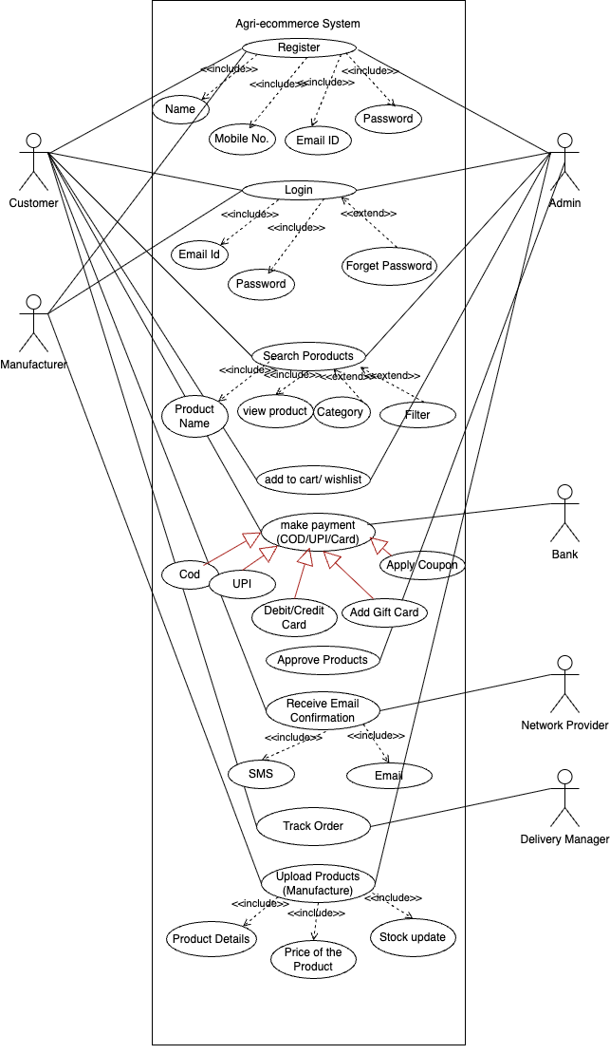

Question 11. Prepare use case specs for all use cases.

Answer 11. Use Case 1: Register
- Use Case Name: Register
- Use Case ID: UC001
- Actor: Customer, Manufacturer, Admin
- Goals: To allow new users to register by submitting personal details.
- Pre-condition: User is not registered on the platform.
- Post Condition: User registration is successful and user credentials are stored.
Main Flow:
- User selects "Register".
- System prompts for Name, Mobile No., Email ID, and Password.
- User enters all fields.
- System validates and stores details.
- User registration is confirmed.
Alternative Flow:
- If user email/mobile already exists, system displays “User Already Exists” message.
Exceptional Flow:
- Invalid format of Email or Password → Show error.
- Server error during form submission → Try again message.
Assumptions:
- System has internet access and database is available.
- All fields are mandatory.

Use Case 2: Login
- Use Case Name: Login
- Use Case ID: UC002
- Actor: Customer, Manufacturer, Admin
- Goals: To allow registered users to log in.
- Pre-condition: User must be registered.
- Post Condition: User session is initiated.
Main Flow:
- User enters email and password.
- System authenticates credentials.
- If valid, login is successful.
Alternative Flow:
- Forgot Password (Extended Flow): User is redirected to reset password.
Exceptional Flow:
- Incorrect email/password → Show “Invalid credentials”.
- 3 failed attempts → Lock account temporarily.
Assumptions:
- Password is case-sensitive.
- Authentication service is working.

Use Case 3: Search Products
- Use Case Name: Search Products
- Use Case ID: UC003
- Actor: Customer, Manufacturer, Admin
- Goals: Allow users to search products by name, category, or filter.
- Pre-condition: User is logged in.
- Post Condition: Products matching criteria are displayed.
Main Flow:
- User enters search term or selects category/filter.
- System searches the product database.
- Results are displayed.
Alternative Flow:
- No results found → System shows “No matching items”.
Exceptional Flow:
- Search API or DB not responding → Show error message.
Assumptions:
- Product catalog is regularly updated.

Use Case 4: Make Payment (COD/UPI/Card)
- Use Case Name: Make Payment
- Use Case ID: UC004
- Actor: Customer, Bank
- Goals: To complete a secure transaction using selected payment mode.
- Pre-condition: Products are added to cart.
- Post Condition: Payment is successful and order is placed.
Main Flow:
- Customer clicks "Checkout".
- Selects payment method: COD, UPI, Debit/Credit Card.
- If online, enters details or scans QR.
- Transaction is processed via Bank.
- Confirmation page shown.
Alternative Flow:
- Apply Coupon or Add Gift Card (Extend use cases).
Exceptional Flow:
- Transaction fails due to insufficient funds or timeout.
- Wrong card details entered.
Assumptions:
- Bank servers and payment gateway are up.
- User has a valid payment method.

Use Case 5: Upload Products
- Use Case Name: Upload Products
- Use Case ID: UC005
- Actor: Manufacturer
- Goals: To add products with details, pricing, and stock info.
- Pre-condition: Manufacturer is logged in.
- Post Condition: Product submitted for admin approval.
Main Flow:
- Manufacturer clicks “Upload Product”.
- Fills in product details, price, stock.
- Submits the form.
- System stores product for review.
Alternative Flow:
- Save as draft before submission.
Exceptional Flow:
- File size too large, unsupported format, or server error.
Assumptions:
- Manufacturer is verified.
- Product categories are predefined.

Question 12. Activity diagrams

Answer 12. See below

Activity Diagram to Register Profile: -

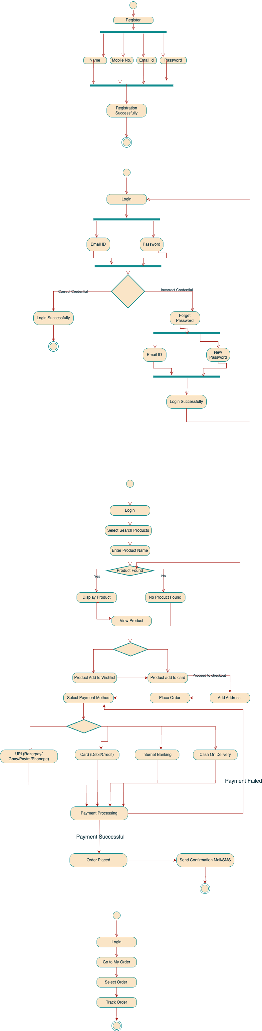
Activity Diagram for Login Process: -
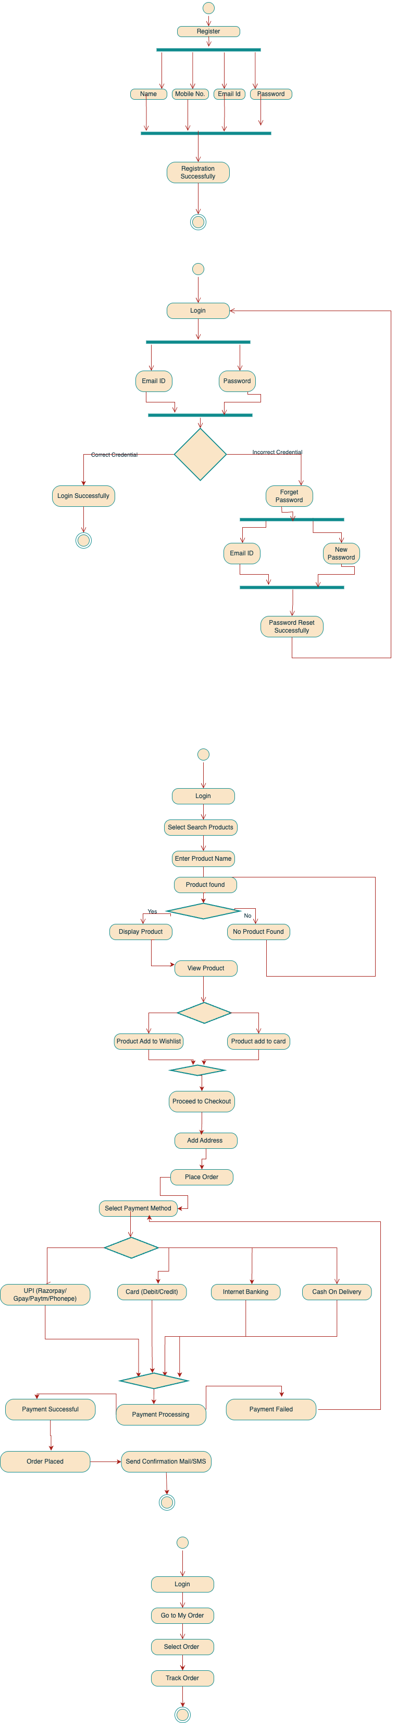
Activity Diagram for Select/Search/Add_to_Wishlist/Add_to_Cart Product & Payment: -

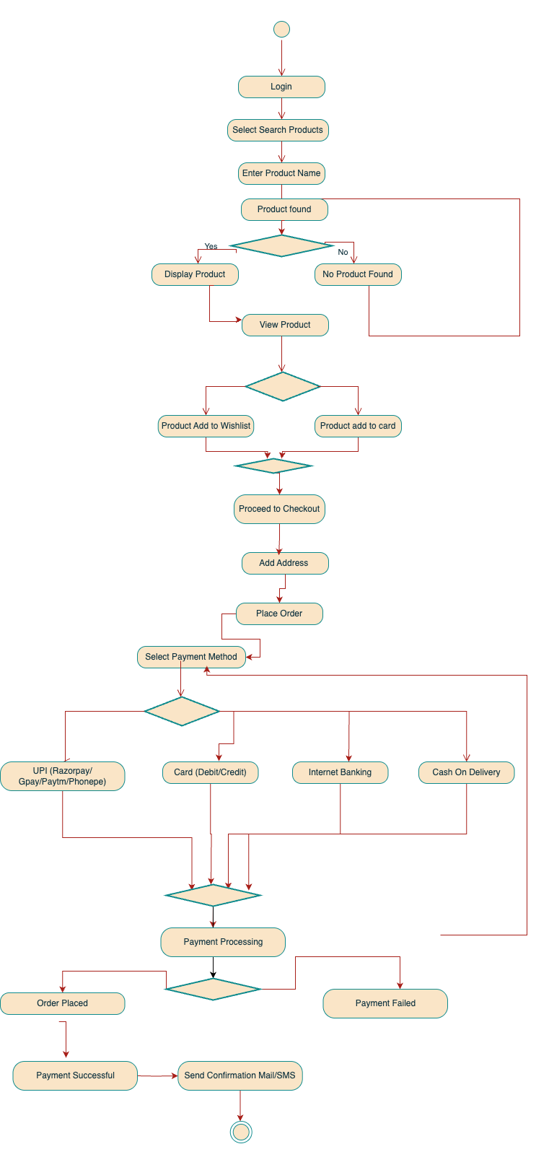

Activity Diagram for Tracking Order: -

