Capstone Prep 1 Part 2
Stage | Quarter 1 Audit Report (Requirement Gathering Phase)
Completed | Week 1-10
Check List | BRD  Stakeholder identification
Team Meeting
Interviews
 | Elicitation Results Reports
Stage | Quarter 3 Audit Report (Design Phase)
Completed | Week 21-60
Check List | Utilization of tools  Stakeholder MCM
JAD Session report
End user prep
Developer MOM
Client signoff
 | Update team with project progress
Stage | Quarter 2 Audit Report (Requirement Analysis Phase)
Completed | Week 11-20
Check List | UML Diagram  Requirement Prioritization
RTM Document
Client Meeting progress update
Functional requirement mapping
Client Signoff
 | Communicate with team with project update
Stage | Quarter 4 Audit Report (Testing Phase)
Completed | 61-72
Check List | Test Case Summary  Deployment Doc Prep
End User Document
Testing Report
Debugging Report
Client Signoff end software
 | Email team with project update
- Audit Reports

2. BA APPROACH STRATEGY
1.ELICITATION TECHNIQUES TO APPLY:
- BRAINSTORMING: It can be done either individually or in groups. Ideas collected can then be reviewed or analyzed and where relevant included within the system requirements. It is used in identifying all possible solutions to problems and simplifies the details of opportunities.
- REVERSE ENGINEERING: It is generally done for migration projects. It extracts implemented requirements from the software group.
- JOINT APPLICATION DEVELOPMENT (JAD): It is an extended, facilitated workshop. It involves collaboration between stake holders and system analysts to identify needs or requirements in a concentrated and focused effort.
- DOCUMENT ANALYSIS: it is one of the compulsory elicitation techniques for any project. Evaluating the documentation of a present system can assist when making AS-IS process documents
- FOCUS GROUPS: it is meant to elicit ideas and attitudes about a specific product, service or opportunity in an interactive group environment.
- OBSERVATION: Observing, shadowing users or even doing part of their job can provide information of existing processes, inputs and outputs.
- INTERVIEW: It is a systematic approach to elicit information from a person or a group of people.

2. RACI Matrix
RESPONSIBLE
ACCOUNTBALE
CONSULTED
INFORMED
Karthik | Delivery Head | Email:Karthik@123.com  Phone:91123412132  Reach Out: 8am – 8pm IST | 7am – 5pm  IST
Juhi | Sr. Java dev | Email:Juhi@123.com  Phone:91123412132  Reach Out: 8am – 8pm IST | 7am – 5pm  IST
Teyson | Java dev | Email:Teyson@123.com  Phone:91123412132  Reach Out: 8am – 8pm IST | 7am – 5pm  IST
Lucie | Java dev | Email: Lucie @123.com  Phone:91123412132  Reach Out: 8am – 8pm IST | 7am – 5pm  IST
Tucker | Java dev | Email: Tucker @123.com  Phone:91123412132  Reach Out: 8am – 8pm IST | 7am – 5pm  IST
Bravo | Java dev | Email: Bravo @123.com  Phone:91123412132  Reach Out: 8am – 8pm IST | 7am – 5pm  IST
Jason | Tester | Email: Jason @123.com  Phone:91123412132  Reach Out: 8am – 8pm IST | 7am – 5pm  IST
Alekya | Tester | Email: Alekya @123.com  Phone:91123412132  Reach Out: 8am – 8pm IST | 7am – 5pm  IST
Abdul | BA | Email: Abdul @123.com  Phone:91123412132  Reach Out: 8am – 8pm IST | 7am – 5pm  IST
Dooku | Project Coordinator | Email: Dooku @123.com  Phone:91123412132  Reach Out: 8am – 8pm IST | 7am – 5pm  IST
Vandanam | Project Manager | Email: Vandanam @123.com  Phone:91123412132  Reach Out: 8am – 8pm IST | 7am – 5pm  IST
Peter | Helping Committee | Email: Peter @123.com  Phone:91123412132  Reach Out: 8am – 8pm IST | 7am – 5pm  IST
Ben | Helping Committee | Email: Ben @123.com  Phone:91123412132  Reach Out: 8am – 8pm IST | 7am – 5pm  IST
Kevin | Helping Committee | Email: Kevin @123.com  Phone:91123412132  Reach Out: 8am – 8pm IST | 7am – 5pm  IST
Mike | Network Admin | Email: Mike @123.com  Phone:91123412132  Reach Out: 8am – 8pm IST | 7am – 5pm  IST
John | Database Admin | Email: John @123.com  Phone:91123412132  Reach Out: 8am – 8pm IST | 7am – 5pm  IST
Henry | Sponsor | Email: Henry @123.com  Phone:91123412132  Reach Out: 8am – 8pm IST | 7am – 5pm  IST
Pandu | Financial Head | Email: Pandu @123.com  Phone:91123412132  Reach Out: 8am – 8pm IST | 7am – 5pm  IST

- DOCUMENTS
BUSSINESS REQUIREMENTS DOCUMENT
- Objective: To create a user-friendly and easily accessible e-commerce platform.
- Business Scope: A platform where farmers can purchase farming products
- Business Needs:
Expertise for requirements gathering
Excellent Network
Trained personnel
Backup
Storage
- Expected outcomes:
- An efficient and transparent application that helps the farmers.
- A faster and secure payment gateway for easy and hassle-free transactions.
FUNCTIONAL REQUIREMENT DOCUMENT
Functional requirements documents (FRDs) describe what the software should do and how users will use it.
- User verification
- Payment processing
- Report generation
- Processing and storing data
- Error handling
- Data security
4. PROCESS TO FOLLOW FOR SIGNING OFF A DOCUMENT:
- Plan for sign-off
- Prepare the document
- Manage the review process
- Obtain formal sign-off
- Follow-up after sign-off
5. APPROVALS FROM THE CLIENT IS DONE BY:
- Share file with reviewers
- Get feedback and discuss ideas for improvements
- Develop and share a new version
- Repeat until an approval is achieved
6.COMMUNICATION CHANNELS TO ESTABLISH:
A. ORAL COMMUNICATION:
Includes stakeholder meetings, workshops, presentations and interviews
B. WRITTEN COMMUNICATION
Includes E-mails, instant messaging and project management tools.
C. VISUAL COMMUNICATION
Includes diagrams and flowcharts, mockups and prototypes.
IMPLEMENTATION:
- Identify stakeholders
- Define the message and channel
- Establish communication schedule
- Use templates for consistency
- Encourage feedback
7.STEPS TO HANDLE CHANGE REQUESTS:
- Initially BA documents the change request.
- BA analyzes the change request
- The project manager provides approval if BA needs to move further in analyzing the change request.
- Changes are made only if its complex.
- BA helps the stakeholders to understand the impact of change.
- Successful change efforts are made by the BA.

8. PROGRESS UPDATE TO STAKEHOLDER:
- Set up a formal communication plan for stakeholder updates.
- Schedule regular, targeted status reports and meetings.
- Monitor project progress and identify risks.
- Share clear updates on milestones, challenges, and KPIs.

9. TO GET UAT SIGN OFF:
- Create a project for each UAT Test.
- Assign tasks, set timelines, and distribute work to team members.
- Work with stakeholders to design and develop tests.
- Categorize tasks to monitor progress.
- Enable notifications for updates.

3. Three Tier Architecture
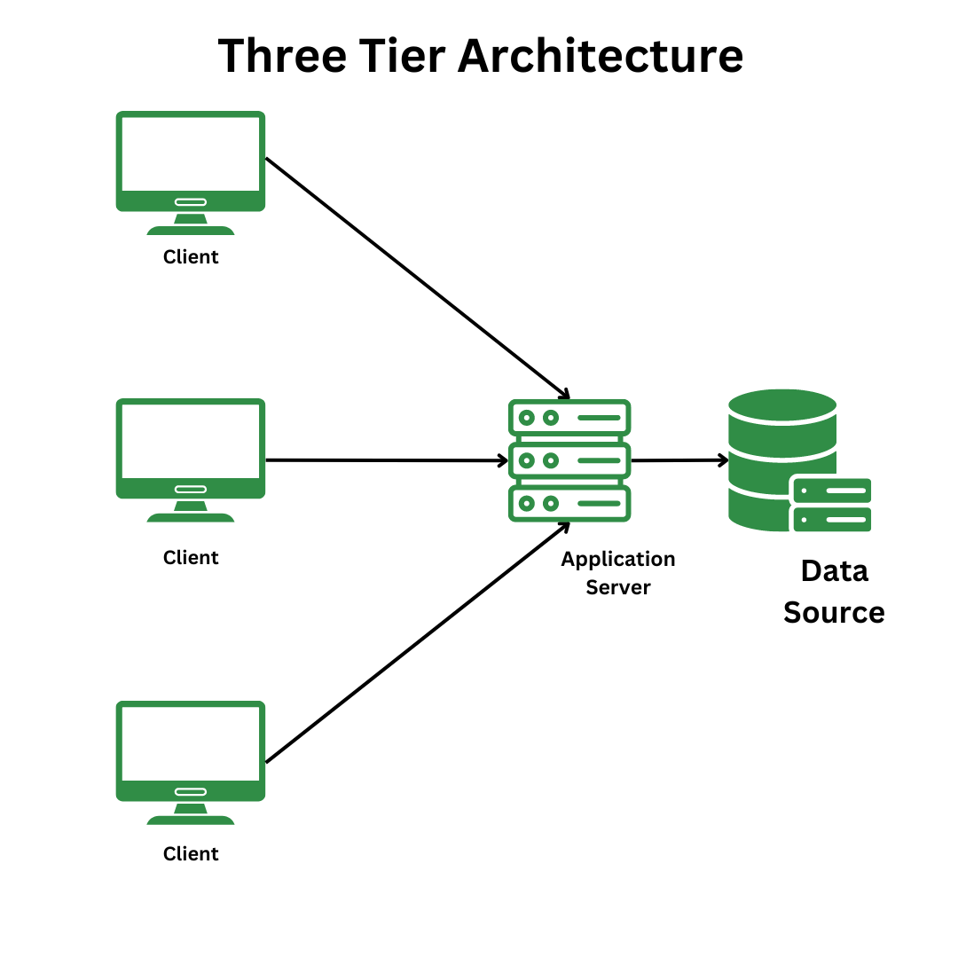
It is software designing pattern used for implementation of components. Divided into 3 tiers:
CLIENT TIER (APPLICATION LAYER): Topmost layer of architecture. Only frontend part is implemented, i.e., interaction with system occurs. It handles User Interface components like screens and pages.
BUSINESS LOGIC LAYER: It contains the core logic of the application. Acts as intermediary layer between the application and database layer. EX: Printer, payment gateway
DATABASE TIER: Data collected from the client is checked for verification. Responsible for storing and retrieving data. EX: SQL database

- 5W1H
- Who will be the stakeholders?
- What kind of requirements?
- When should the project be completed?
- Where will the project be complete?
- Why are we initiating the project?
- How does this project resolve the current problem?
SMART
- Specific goal for this project is to create an e-commerce platform for farmers.
- Measuring the project’s progress can be done by the Gnatt chart
- Attaining the project within timeline which is 18 months and with budget of 2cr
- Relevance of this project meets the requirements of the farmers purchasing products online
- Time bound of this project is 18 months to be fully completed
RACI
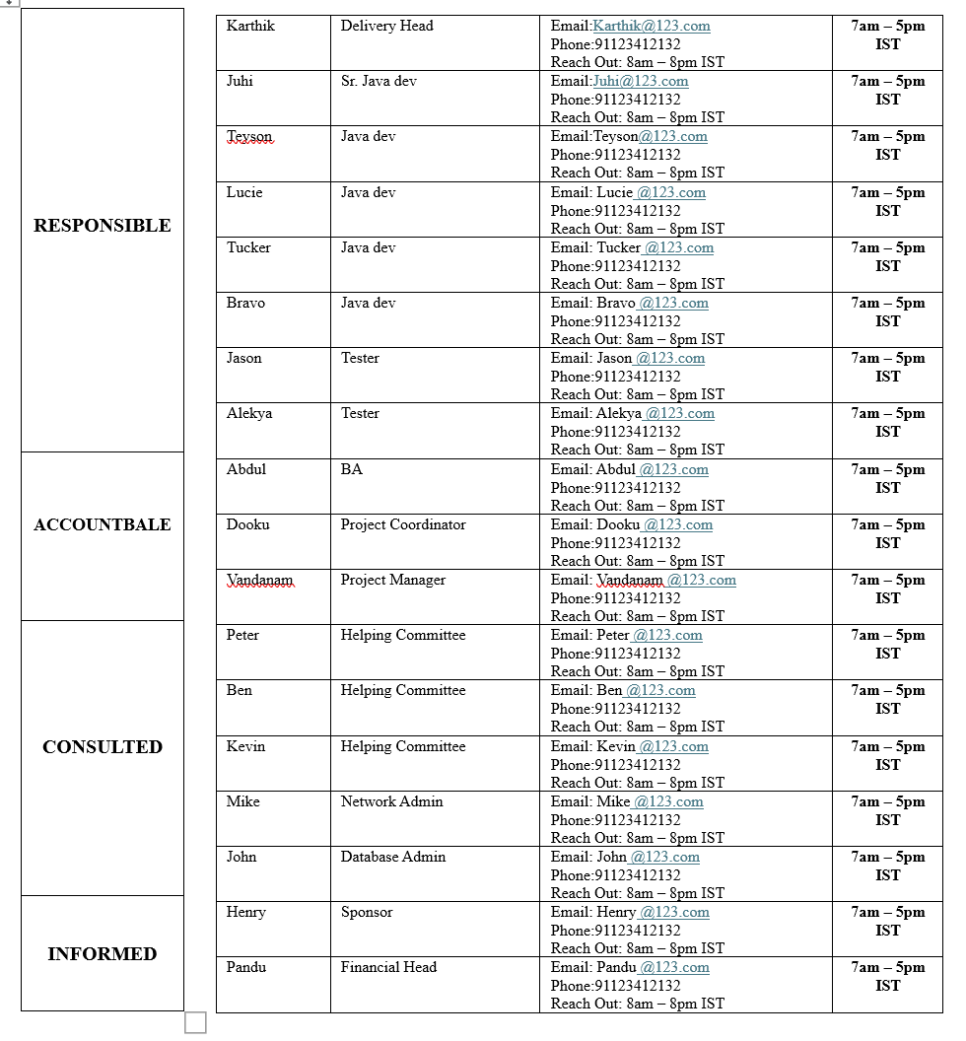

UML
- Standardized way of modeling and diagrams which aid in team communication for the project

- ELICITATION TECHNIQUES:
BRAINSTORMING:
It can be done either individually or in groups. Ideas collected can then be reviewed or analyzed and where relevant included within the system requirements. It is used in identifying all possible solutions to problems and simplifies the details of opportunities.
REVERSE ENGINEERING:
It is generally done for migration projects. It extracts implemented requirements from the software group. Two categories include:
- BLACK BOX REVERSE ENGINEERING: The system/ product is studied without examining its internal structure.
- WHITE BOX REVERSE ENGINEERING: The inner workings of the system/product are studied.
JOINT APPLICATION DEVELOPMENT (JAD):
It is an extended, facilitated workshop. It involves collaboration between stake holders and system analysts to identify needs or requirements in a concentrated and focused effort.
DOCUMENT ANALYSIS:
It is one of the compulsory elicitation techniques for any project. Evaluating the documentation of a present system can assist when making AS-IS process documents
FOCUS GROUPS:
It is meant to elicit ideas and attitudes about a specific product, service or opportunity in an interactive group environment.
OBSERVATION:
Observing, shadowing users or even doing part of their job can provide information of existing processes, inputs and outputs.
Two basic approaches are:
- PASSIVE / INVISIBLE: In this approach, the BA observes the subject matter expert working through the business routine and not asking questions.
- ACTIVE/VISIBLE: In this approach, the BA observes the current process and takes notes he/she may dialog with the workers.
INTERVIEW:
It is a systematic approach to elicit information from a person or a group of people.
Interviews of users and stakeholders are important in creating successful software.
PROTOTYPING:
Prototyping is a key method for gathering requirements, involving the creation of an interactive system model to get stakeholder feedback. It helps users visualize features, spot missing requirements, and refine design through ongoing feedback.
QUESTIONNAIRE:
It can be useful for obtaining limited system requirements details from users/stakeholders who have minor input or are geographically remote. The design of the questionnaire and type of questions are important and can influence the answers, so care is needed.
WORKSHOPS:
It tends to be of a defined duration, rather than outcome and may need to be briefly repeated to clarify or obtain further details.
USE CASE SPECS:
A use case specification is a detailed textual description of how a user (actor) interacts with a system to achieve a specific goal, outlining the functional requirements from the user's perspective. It includes an actor's goal, preconditions, the basic flow (successful path), post-conditions, and any alternative or exceptional flows, providing a blueprint for developers and testers.
- I would choose BRAINSTORMING as an elicitation technique for the current project.
- Brainstorming would help us gather information from different aspects.
- This helps identify farmers' requirements, guiding efficient software development.
- Through this technique we can come up with innovative ideas and requirements.
- It could be efficient for stakeholders to define their requirements.

- Assumed Business Requirements
BR001- Users should be able to purchase fertilizers, seeds, and pesticides
BR002- Users should be able to browse product catalog
BR003- Users should be able to login
BR004- Users need to enter payment information
BR005- Users need to input shipping information
BR006- New users should be able to create user id & Password
BR007- Manufacturers should be able to upload new products in catalog
BR008- Users should be able to reset password if forgotten
BR009- Manufacturers should be able to update prices for users
BR010- Users should be able to choose payment methods

- Assumptions
Assumption 1. Users can login using a social media account (Google, Facebook, X, Instagram)
Assumption 2. The user has prior knowledge of farm material such as seeds, fertilizers, pesticides
Assumption 3. The development team needs to design the app to be user friendly based on user base
Assumption 4. Users require a secured payment processing method
Assumption 5. Users’ data needs to be secured due to increased competition

- Project Requirements Priority
Req ID | Req Name | Req Description | Priority Level
BR001 | Users able to purchase | Users can go through the process to finalize order to make purchase | 4
BR002 | Users able to browse product catalog | Users can see all available products for sale | 3
BR003 | Users Login | Existing users’ login with their user id & password | 2
BR004 | Users enter payment information | Users enter card info or bank info | 5
BR005 | Users enter shipping information | Users enter shipping address where products will be received | 7
BR006 | New users create id & password | Users enter their info to create new user id and password | 1
BR007 | Manufacture upload products | Manufacture ability to upload new products | 9
BR008 | Users need to reset password | User’s ability to reset forgotten password if account locked | 8
BR009 | Manufacture update pricing | Manufacture updates new pricing for farmers to purchase product at | 10
BR010 | Users choose payment method | Users can choose between card payment or bank account payment | 6

- Use Case Diagram
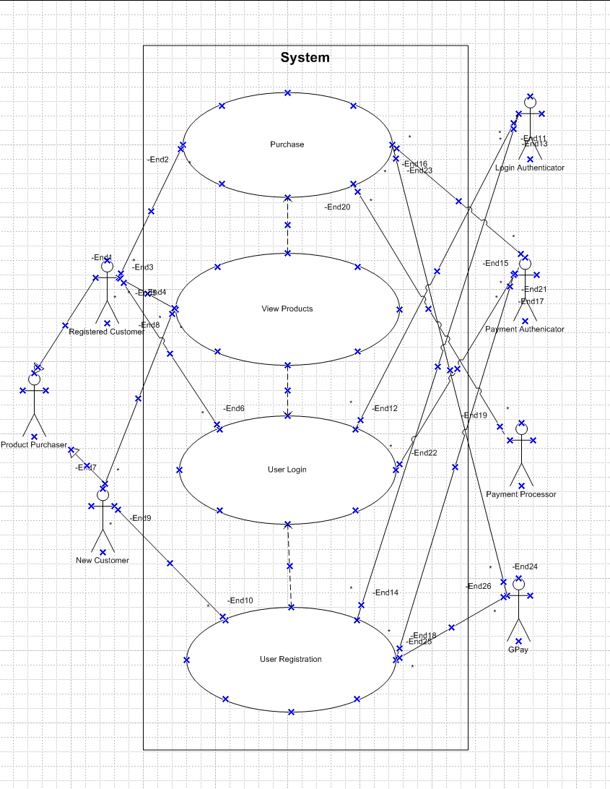

11. Use Case Specification Document
Use Case ID | UC001
Use Case Name | Purchase from online e-commerce platform
Created By | Abdul Moosani | Last Updated Date | Oct 25, 2025
Date Created | Oct 06, 2025 | Last Revision Date | Oct 20, 2025
Actor | Purchaser, New Customer, Existing Customer
Description | The use case describes user id creation to purchase product
Pre-Condition | User not able to purchase before registration
Past-Condition | Successfully able to purchase products after user login
Normal Flow of Events | Step 1: System defaults the user to product catalog  Step 2: User directed to registration form  Step 3: The system automatically authenticates user credentials for purchasing  Step 4: System navigates user to add products to cart  Step 5: System provides user with multiple payment options after User clicks on “make payment  Step 6: System navigates users to confirmation page after payment successfully completed  Step 7: Basic Flow Ends Here
Alternative Flow | Step 1: The user cannot login with their credentials and will be redirected to enter correct user id & Password  Step 2: The user will be redirected to alternate page to reset password or user id after multiple failed login attempts  Step 3: The user will be instructed to enter email to reset password  Step 4: Reset Link will be sent to email with instructions  Step 5: User clicks the link and resets password  Step 6: User will be redirected to enter login again with new password  Step 7: User successfully completes login
Exception | The User forgets the email entered during registration
Frequency of Use | High Frequency
Assumptions | User remembers initial registration info

- Activity Diagram

