Decode the case study
Project idea: To develop a website Online Agriculture Products Store. The application should be available in Website and Mobile application.
Current needs: Easy to navigate, have a contemporary look, and process payments quickly.
Overview of the project: It's an e-Commerce-based project. There is a existing application present but the current project would like to take the inputs from the current one and work on the new one.
Current problems: Decline of sales, Nonuser friendly, unable to handle the competition Know the team.
Question 1 – Functional Requirements
Below complete list of 20 Functional Requirements (FRs)
Req ID | Req Name | Req Description | Priority
FR0001 | Farmer Registration | Farmers should be able to register with the application using email and password | 8
FR0002 | Farmer Search for Products | Farmers should be able to search for products in fertilizers, seeds, and pesticides | 8
FR0003 | Manufacturer Registration | Manufacturers should be able to register using business details and contact information | 8
FR0004 | User Login/Logout | Users (Farmers & Manufacturers) should be able to securely log in and log out | 10
FR0005 | Product Catalog Browsing | Farmers should be able to browse categorized product catalogs | 9
FR0006 | Add to Cart | Farmers should be able to add products to the shopping cart | 8
FR0007 | Add to Buy-Later List | Farmers should be able to add products to a “Buy Later” or wish list | 7
FR0008 | View Product Details | Users should be able to view detailed product info including name, description, price, etc. | 9
FR0009 | Upload Product | Manufacturers should be able to upload products with necessary details and images | 9
FR0010 | Edit/Delete Product | Manufacturers should be able to modify or delete their uploaded products | 7
FR0011 | Place Order | Farmers should be able to place an order for selected products | 10
FR0012 | Payment Gateway Integration | System should support UPI, Credit/Debit Card, and Cash on Delivery (COD) | 10
FR0013 | Order Confirmation | System should send an order confirmation email after successful purchase | 9
FR0014 | Order History | Farmers should be able to view their past orders and details | 7
FR0015 | Delivery Tracking | Farmers should be able to track their order delivery status using tracking ID | 9
FR0016 | Forgot Password | Users should be able to reset their password via email link | 8
FR0017 | Product Filters | Farmers should be able to filter products by price, brand, type, and rating | 6
FR0018 | Review & Rating (Optional) | Farmers should be able to rate and review purchased products (future enhancement) | 5
FR0019 | Admin Panel | Admin should be able to manage users, orders, and moderate product listings | 6
FR0020 | Role-Based Access Control | System should enforce roles and permissions (Farmer vs Manufacturer vs Admin) | 6

Below complete list of 10 Non-Functional Requirements (NFRs)
Req ID | Req Name | Req Description | Priority
NFR0101 | Page Loading Time | Each page in the application should load within 2 seconds under normal network conditions | 9
NFR0102 | WCAG 2.1 Compliance | The application must comply with Web Content Accessibility Guidelines (WCAG) 2.1 for accessibility | 8
NFR0103 | Availability | The system should be available 99.9% of the time (excluding planned maintenance) | 9
NFR0104 | Scalability | The system should be able to scale to handle 10,000+ concurrent users during peak times | 8
NFR0105 | Data Security | All user data (including passwords and payments) must be stored securely with encryption | 10
NFR0106 | Backup and Recovery | The system must perform daily backups and support data recovery within 4 hours of data loss | 7
NFR0107 | Mobile Responsiveness | The application must be fully responsive and accessible on smartphones and tablets | 9
NFR0108 | Browser Compatibility | The platform must support major browsers (Chrome, Firefox, Safari, Edge) in their last 2 versions | 7
NFR0109 | Transaction Logging | All transactions (product uploads, orders, payments) must be logged with timestamps | 8
NFR0110 | Session Timeout | User sessions should timeout after 15 minutes of inactivity for security purposes | 8

Question 2–Minimum 5 page designs
Page 1: Homepage
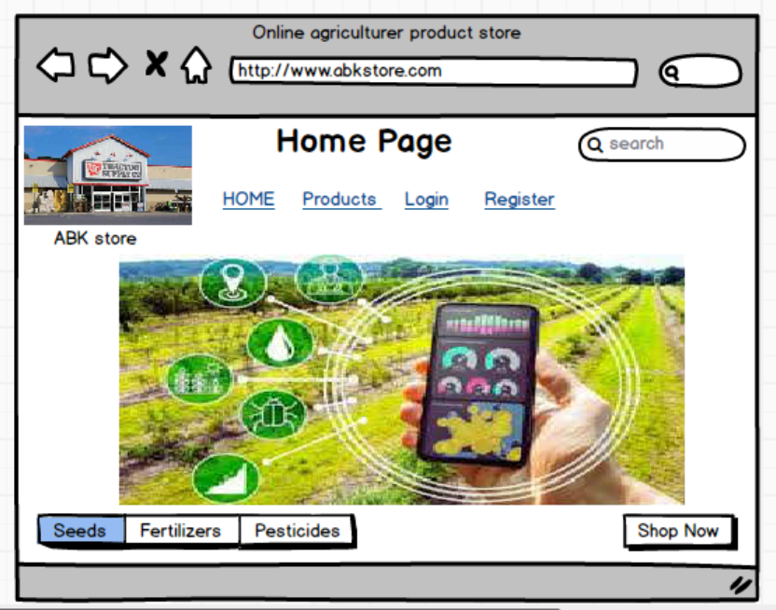
Page 2: Product Listing Page
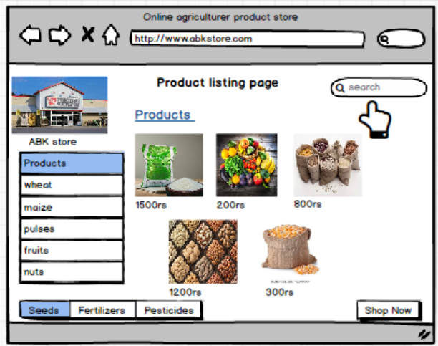
Page 3: Product Details Page
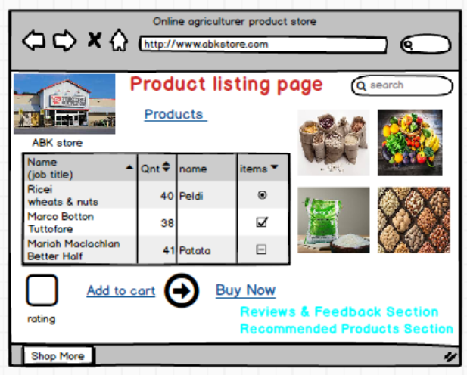
Page 4.Login / Registration Page
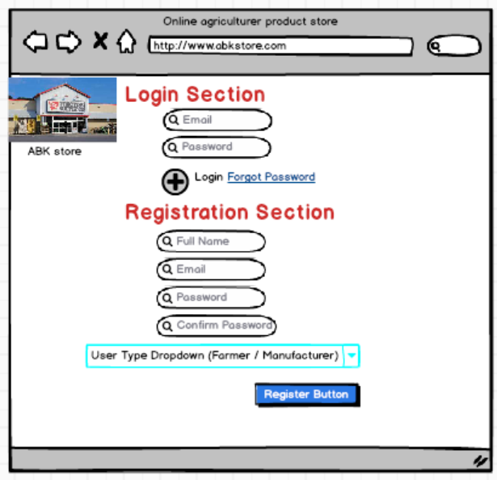
Page 5: Checkout & Payment Page
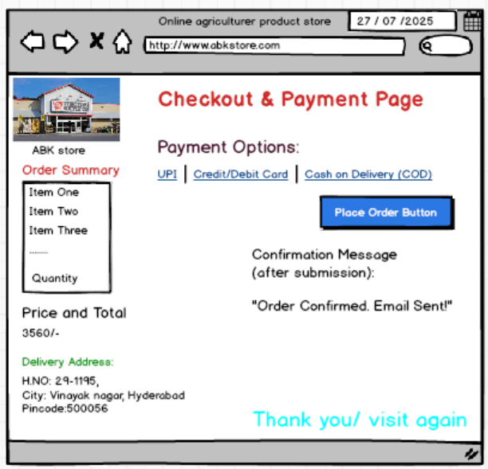
Question 3 – Tools (Visio, Balsamiq)
Visio → Use Case Diagrams, Activity Diagrams, Flow Diagrams
Balsamiq → Home page, product listing, login, product detail, and checkout
For creating the wireframes, use case diagrams, activity diagrams, and other BA deliverables for the Online Agriculture Products Store, the following tools are recommended:
Tool Name | Purpose | Why Used
Microsoft Visio | Creating UML diagrams like Use Case Diagrams, Activity Diagrams, and Flowcharts. | Industry-standard tool for visual modeling
Balsamiq Wireframes | Designing low-fidelity wireframes for the website/app UI. | Simple drag-and-drop interface to create mockups quickly

The Above I used Balsamiq Tool, why because:
Fast and easy to use for quick prototyping
Ideal for brainstorming layout and UX ideas
Allows manufactures and farmers to understand functionality early
Question 4 – RTM
The Requirements Traceability Matrix (RTM) is a document that helps track and ensure that all business requirements are:
- Captured
- Mapped to design, development, testing, and deployment phases
- Not missed throughout the project lifecycle
It ensures alignment between requirements and deliverables
Sample RTM for Online Agriculture Products Store
Req ID | Requirement Description | Design Spec Ref | Developer Assigned | Test Case ID | Status
BR001 | Farmer should be able to search products | UI-001 | Ms. Lucie | TC001 | In Progress
BR002 | Manufacturers upload their products | UI-002 | Mr. Bravo | TC002 | Completed
BR003 | Farmer login and registration | UI-003 | Ms. Juhi | TC003 | Completed
BR004 | Product catalog browsing | UI-004 | Mr. Tucker | TC004 | In Progress
BR005 | Payment gateway with UPI, COD, Cards | PAY-001 | Mr. Teyson | TC005 | Pending
BR006 | Email confirmation for order | EMAIL-001 | Mr. Bravo | TC006 | Pending
BR007 | Delivery tracking | TRACK-001 | Mr. Tucker | TC007 | Not Started

Req ID | Req Name | Req Description | Design | D1 | T1 | T2 | T3 | T4 | UAT | Status
FR0001 | Farmer Registration | Farmers should be able to register with the application | ✔️ UI-001 | ✔️ | ✔️ | ✔️ |  |  |  | ✅ Completed
FR0002 | Farmer Search for Products | Farmers should be able to search for available products in fertilizers, seeds, pesticides | ✔️ UI-002 | ✔️ | ✔️ |  |  |  |  | ⏳ In Progress
NFR0101 | Page Loading Time | Each page should load within 2 seconds | ✔️ PERF-001 |  |  |  |  |  |  | ⏳ Pending
NFR0102 | WCAG 2.1 Compliance | System must meet Web Content Accessibility Guidelines (WCAG 2.1) | ✔️ ACC-001 |  |  |  |  |  |  | ⏳ Pending
- Design: Documented and approved design reference
- D1: Development Phase 1 complete
- T1–T4: Different levels of testing (unit, integration, system, regression)
- UAT: User Acceptance Testing
Question 5 – 10 Test Case Documents
A test case is a set of steps that tell you how to check if something works properly in an application
Test Case 1: Farmer Registration
Test Case ID | TC001
Description | Verify that a farmer can register with valid email and password
Preconditions | User is on the Registration Page
Test Steps | 1. Enter email, password, confirm password2. Select user type as Farmer3. Click Register
Expected Result | Registration is successful and a confirmation email is sent
Status | Pass / Fail

Test Case 2: Farmer Login
Test Case ID | TC002
Description | Verify login functionality with valid credentials
Preconditions | User is registered
Test Steps | 1. Enter email and password2. Click Login
Expected Result | User is redirected to dashboard/home page
Status | Pass / Fail

Test Case 3: Search Product by Name
Test Case ID | TC003
Description | Verify that the farmer can search for a product by keyword
Preconditions | User is logged in
Test Steps | 1. Type keyword in search bar2. Click Search
Expected Result | Matching product list is displayed
Status | Pass / Fail

Test Case 4: Filter Products by Category
Test Case ID | TC004
Description | Verify product filters by category (Fertilizers, Seeds, Pesticides)
Preconditions | Products exist in the system
Test Steps | 1. Select a category filter2. Click Apply
Expected Result | Only products of selected category are displayed
Status | Pass / Fail

Test Case 5: Add Product to Wishlist (Buy Later)
Test Case ID | TC005
Description | Verify that a product can be added to wishlist
Preconditions | User is logged in
Test Steps | 1. Browse a product2. Click “Add to Buy Later”
Expected Result | Product is added to wishlist
Status | Pass / Fail

Test Case 6: Add Product to Cart
Test Case ID | TC006
Description | Verify that user can add a product to cart
Preconditions | User is logged in and viewing product
Test Steps | 1. Click on product2. Click “Add to Cart”
Expected Result | Product is added to shopping cart
Status | Pass / Fail

Test Case 7: Place Order with UPI Payment
Test Case ID | TC007
Description | Verify that UPI payment method works during checkout
Preconditions | Product is in cart, user is logged in
Test Steps | 1. Go to cart2. Click Checkout3. Select UPI4. Enter UPI ID5. Confirm
Expected Result | Order is placed and confirmation is shown
Status | Pass / Fail

Test Case 8: Page Load Time (Performance)
Test Case ID | TC008
Description | Verify that each page loads within 2 seconds
Preconditions | None
Test Steps | 1. Open home page2. Measure time using browser tools
Expected Result | Page loads within 2 seconds
Status | Pass / Fail

Test Case 9: Email Confirmation After Order
Test Case ID | TC009
Description | Verify that confirmation email is sent after order
Preconditions | Order is placed successfully
Test Steps | 1. Place order2. Check email inbox
Expected Result | Email confirmation is received with order summary
Status | Pass / Fail

Test Case 10: Accessibility – WCAG 2.1 Compliance
Test Case ID | TC010
Description | Verify key accessibility features (alt tags, keyboard navigation, contrast)
Preconditions | Page is loaded
Test Steps | 1. Use screen reader and keyboard only2. Try to navigate entire page
Expected Result | Page complies with WCAG 2.1 standards
Status | Pass / Fail

Question 6 – DB Design
Table Name | Key Fields
Farmer | FarmerID (PK), Name, Email, Password
Manufacturer | ManufacturerID (PK), CompanyName, Email, Password
Product | ProductID (PK), Name, Price, Stock, CategoryID (FK), ManufacturerID (FK)
Order | OrderID (PK), FarmerID (FK), OrderDate, TotalAmount
OrderItem | OrderItemID (PK), OrderID (FK), ProductID (FK), Quantity, Price
Payment | PaymentID (PK), OrderID (FK), PaymentMethod, PaymentStatus
Delivery | DeliveryID (PK), OrderID (FK), Status, EstimatedDate

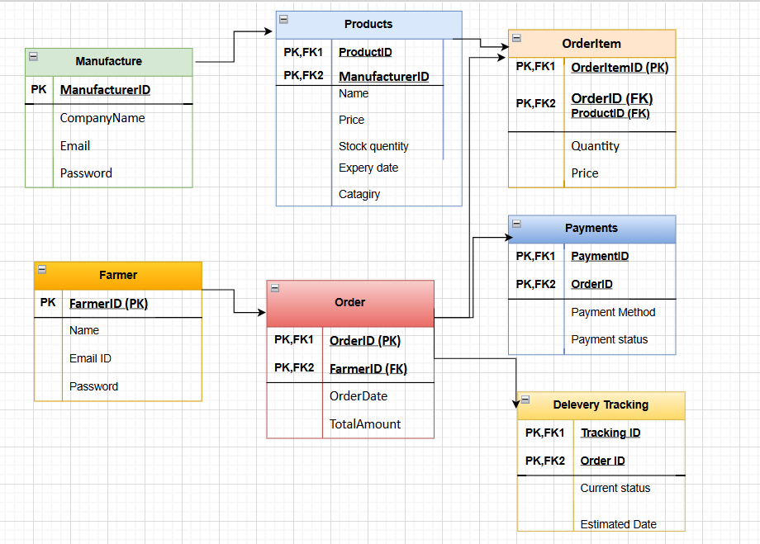
Entity Relationships:
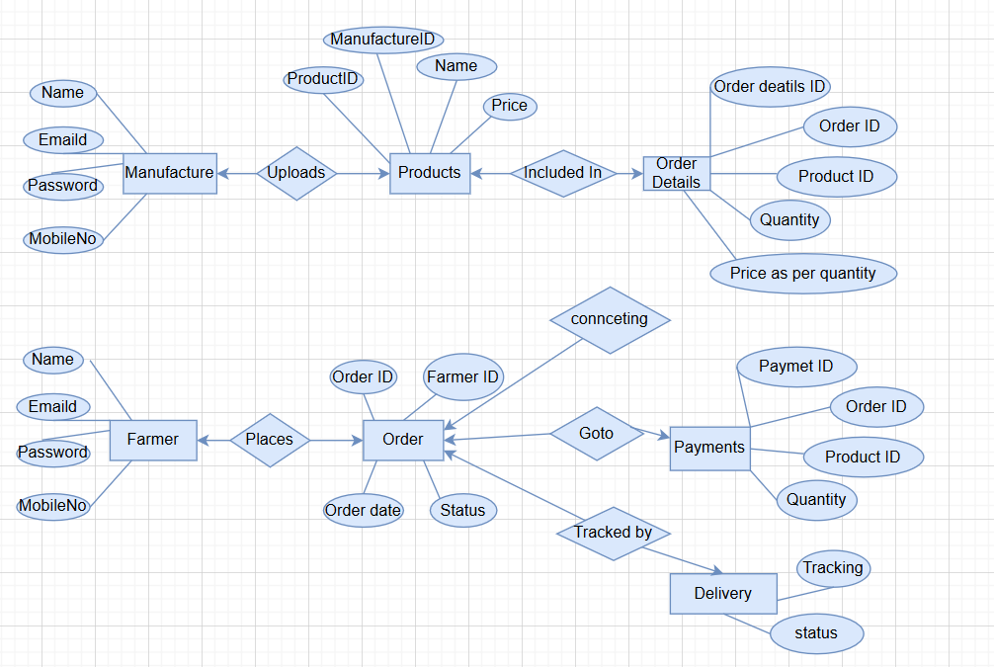

Question 7 – Data Flow Diagram
Data Flow Description:
- Farmer → [Login & Browse Products] → Product List ← Product Database
- Farmer → [Add to Cart]
- Farmer → [Place Order] → Order Details saved in → Order Database
- Farmer → [Make Payment] → Payment Info → Payment Database
- System → [Send Order Confirmation] → Email/SMS → Farmer
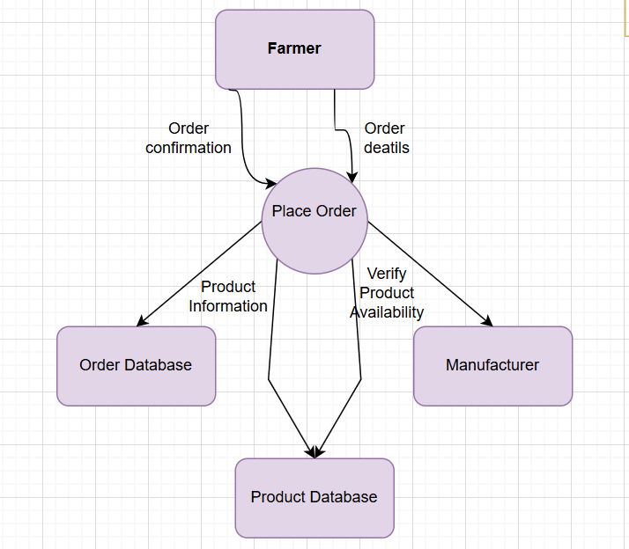
Question 8 – Change Request
Steps to Handle a Change Request – Tax Structure Update Example
1. Identify and Receive the Change Request
- Source: Government Notification or Regulatory Body
- Raised by: Stakeholder (e.g., Mr. Henry or Finance Head Mr. Pandu)
- Example: "Update GST from 12% to 18% for Pesticides category"
2. Document the Change Request
Prepare a formal Change Request document with:
- Change Request ID (e.g., CR-002)
- Description: "Revise tax logic in product billing module as per new government structure"
- Reason: "Compliance with new tax law"
3. Impact Analysis
As a BA, collaborate with:
- Tech Team: What modules are impacted? (e.g., Product, Order, Invoice)
- Testers: What test cases need updates?
- Finance Team: Any pricing or invoice format changes?
- PM: Timeline, cost, and delivery impact
4. Get Approval from the Change Control Board / Key Stakeholders
Present findings and get approval from:
- Client Stakeholders (e.g., Mr. Henry, Mr. Pandu)
- Project Manager (Mr. Vandanam)
- Financial compliance personnel (if needed)
5. Update Project Artifacts
- Update BRD/FRD to reflect new tax structure
- Modify RTM to include this as a new or updated requirement
- Update Test Case documents (e.g., new tax % validation)
6. Communicate to the Team
- Hold a short meeting or send official communication
- Inform developers, testers, and QA about changes
7. Track and Validate the Implementation
- Ensure the change is implemented as expected
- Verify using test cases
- Validate during UAT with stakeholders
Sample Entry in Change Request Log
Field | Value
CR ID | CR-002
Title | Update Tax Structure as per Government Changes
Raised By | Mr. Pandu (Financial Head)
Reason | Regulatory compliance
Impact | Affects billing, pricing, invoice generation
Effort Estimate | 16 hours (Dev), 8 hours (Testing)
Status | Approved
Implemented On | TBD (post testing)

Question 9 – Change Request Vs an Enhancement
Change Request:
A Change Request refers to a modification in existing requirements or functionality
Enhancement:
An Enhancement refers to a new feature or functionality that was not originally planned in the project scope
Scenario: Ben & Kevin’s Request
Farmers should be able to sell their crop yields through the app, display them to the general public, and use an auction system
Step-by-step Professional Response:
- Acknowledge the Request
Thank you, Ben and Kevin, for your input. That’s an excellent idea to empower farmers further by letting them sell their yields directly
- Clarify the Nature of the Request
Since this functionality wasn’t part of the initial project scope, it will be treated as an enhancement
- Document the Enhancement Request
Prepare an Enhancement Request Form including: Description of the feature, Who requested it, Business justification, Expected outcome/benefits, Potential users (general public)
- Conduct Impact Analysis
- Technical impact: New modules needed (e.g., Seller Dashboard, Auction Engine)
- Database changes: New tables for Crop Listings, Bids, Buyer Info
- Timeline: Does it affect the 18-month delivery schedule?
- Budget: Additional cost (above the 2 Crore INR CSR budget)
- Present to Key Stakeholders
- Discuss with Mr. Henry, Mr. Pandu, Mr. Dooku
- PM (Mr. Vandanam) needs to assess feasibility with the dev team
- Decision Time
If stakeholders approve:
- Add as Phase 2 or create a separate mini-project
- Update BRD, RTM, and timelines accordingly
- Communicate and Track
- Inform all stakeholders
- Add enhancement to change/enhancement tracker
- Monitor development and testing progress
Enhancement Request
Field | Description
Enhancement ID | ENH-001
Title | Enable Farmers to Sell Crops & Use Auction System
Raised By | Ben and Kevin
Date | 18-Jul-25
Description | Farmers can list their crop yields for sale and initiate online auctions
Impact | High – new module required, affects front-end, DB, and buyer user role
Recommendation | Move to Phase 2 or seek additional CSR funding
Status | Under Review / Approved / Deferred

This is an Enhancement, not a Change Request
This is an enhancement because the original application was designed only for farmers to buy agricultural products. Adding features like selling crop yields and auctioning them to the public introduces entirely new modules, user roles, and workflows not covered in the initial requirements
Question 10 – Estimations
Effort Estimation Table (High-Level)
Activity / Module |  | Role(s) Involved | Est. Hours
Requirements Gathering & Analysis |  | BA | 40 hrs
UI Design & Mockups |  | BA / Designer (wireframes) | 30 hrs
Use Case & UML Documentation |  | BA | 20 hrs
Frontend Development |  | Java Developers | 200 hrs
Backend Development (APIs) |  | Java Developers | 220 hrs
Payment Gateway Integration |  | Java Developer | 40 hrs
Email & Notification System |  | Java Developer | 20 hrs
Delivery Tracking Module |  | Java Developer | 30 hrs
Authentication & Security |  | Java Developer / Network Admin | 30 hrs
Database Schema Design |  | DB Admin | 40 hrs
Database Implementation |  | DB Admin | 40 hrs
Admin Panel (For Approval Mgmt.) |  | Java Developer | 40 hrs
Testing (Functional, UAT, etc.) |  | Testers | 80 hrs
Deployment |  | Network Admin / DevOps | 20 hrs
Project Coordination |  | Project Manager | 40 hrs
Buffer (10%) |  | All Roles | 90 hrs

Question 11 – UAT
- Coordinate between the client (Mr. Henry, Peter, Kevin, Ben) and the project team
- Ensure all features work as per the approved Business Requirements
- Facilitate real-world testing by end-users (farmers, manufacturers)
UAT Acceptance Process
Step | Activity | Owner
1 | Prepare UAT Plan & Test Cases | BA
2 | Share Test Environment Access | Dev/PM
3 | Execute Test Cases with End Users | BA + Client
4 | Log Defects / Track Fixes | BA + QA
5 | Retest (if needed) | QA
6 | Prepare UAT Summary Report | BA
7 | Client Signs UAT Document | Client (Mr. Henry)

Project Closure Process
Step | Task
1 | Prepare UAT Sign-Off Document
2 | Prepare Project Closure Report (what was done, delivered, final budget, lessons learned)
3 | Conduct Final Client Meeting
4 | Handover all project documents (BRD, FRD, Diagrams, Credentials)
5 | Archive documents in your organization
6 | Release resources from the project
7 | Thank stakeholders & collect feedback/testimonials
8 | Final invoice & payment processing (if applicable)

Question 12 – Project Closure Document
The Project Closure Document is a formal report that confirms the completion of the project, summarizes the entire journey, and ensures all deliverables have been met as agreed
It is usually prepared by the Business Analyst or Project Manager and signed off by the client and internal stakeholders
Purpose of the Project Closure Document
- Confirms that the project is formally completed
- Lists what was delivered vs what was planned
- Records any pending issues or lessons learned
- Ensures all handover is complete
- Provides closure for billing, payments, and team offboarding
Contents of a Project Closure Document
Section | Description
1. Project Overview | Brief summary of the project goals, timeline, and budget
2. Project Objectives & Scope | Restate the original objectives and scope of the project
3. Deliverables Summary | List of final deliverables (BRD, software modules, documents, etc.)
4. UAT Completion & Sign-Off | Confirm UAT was done and signed off by the client
5. Outstanding Issues (if any) | Any unresolved issues or features moved to future phase
6. Lessons Learned | What went well, challenges faced, improvements for next time
7. Final Budget Summary | Cost estimate vs actual spending
8. Project Team Release Plan | List of team members released from project duties
9. Handover Details | Admin credentials, documents, user manuals, code repositories, etc.
10. Client Sign-Off | Section for client’s signature to confirm project completion

What Happens After Closure Document?
- All project documents are archived
- Team members are released
- Final invoices are processed
- Support/Maintenance phase begins (if applicable)

