Question 1 – Functional Requirements
Req ID | Req Name | Req Description | Priority
FR0001 | Farmer Registration | Farmers should be able to register using an email address and password. | 8
FR0002 | Farmer Login | Farmers should be able to log in with valid credentials. | 9
FR0003 | Manufacturer Registration | Manufacturers should be able to register using an email address and password. | 8
FR0004 | Manufacturer Login | Manufacturers should be able to log in with valid credentials. | 9
FR0005 | Search Products | Farmers should be able to search products using keywords and filters (category, price, etc.). | 8
FR0006 | View Product Catalog | Farmers can browse the product catalog with images, prices, and details. | 10
FR0007 | Add to Cart | Farmers should be able to add selected products to the shopping cart. | 8
FR0008 | Buy Later | Farmers can add products to a buy-later/wishlist list. | 7
FR0009 | Place Order | Farmers should be able to place an order for selected items. | 10
FR0010 | Payment Integration | Farmers should be able to make payments via UPI, COD, Debit/Credit card. | 10
FR0011 | Generate Invoice | The system should generate an invoice once payment confirmation is received. | 8
FR0012 | Order Confirmation Email | The system should send confirmation emails with order details. | 9
FR0013 | Delivery Tracking | Farmers should be able to track the delivery status of their orders. | 9
FR0014 | Manufacturer Upload Products | Manufacturers should upload product details (name, price, quantity, image). | 9
FR0015 | Manufacturer Edit Products | Manufacturers should be able to update or delete their listed products. | 7
FR0016 | Admin Manage Users | Admin should add, remove, or block users (Farmers/Manufacturers). | 8
FR0017 | Admin Manage Products | Admin should approve or reject products uploaded by manufacturers. | 9
FR0018 | Reports | The system should generate reports (e.g., sales, orders, active farmers, etc.). | 6
FR0019 | Notifications | The system should notify users (via email/SMS) about delivery updates. | 7
FR0020 | Profile Management | Farmers and Manufacturers should update their profiles (including name, address, and contact details). | 7

Req ID | Req Name | Req Description | Priority
NFR0101 | Page Loading Time | Each page should load within 2 seconds. | 9
NFR0102 | Accessibility | The system must comply with the WCAG 2.1 guidelines. | 8
NFR0103 | Security | Data must be encrypted (using SSL, password hashing, and secure payments). | 10
NFR0104 | Availability | The system should have 99.5% uptime. | 9
NFR0105 | Scalability | The system should support at least 10,000 concurrent users. | 8
NFR0106 | Usability | The application should have a farmer-friendly UI with simple navigation. | 9
NFR0107 | Compatibility | The application should work on mobile devices (iOS, Android) and web browsers. | 8

Question 2–Minimum 5-page designs
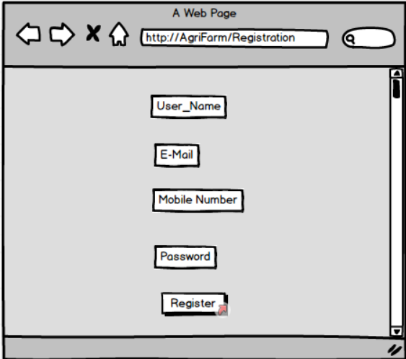
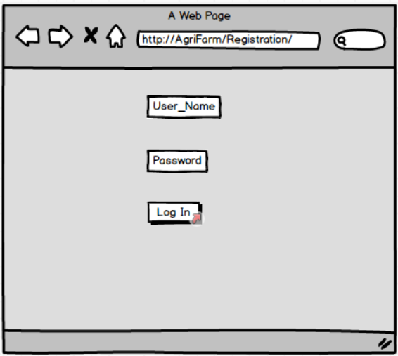
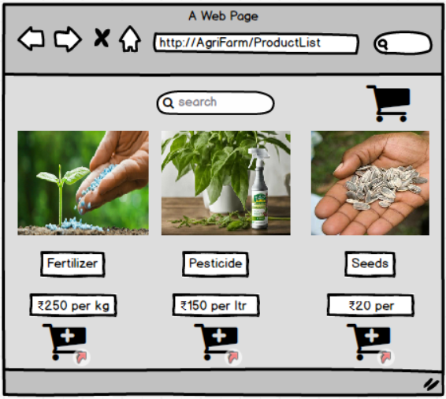
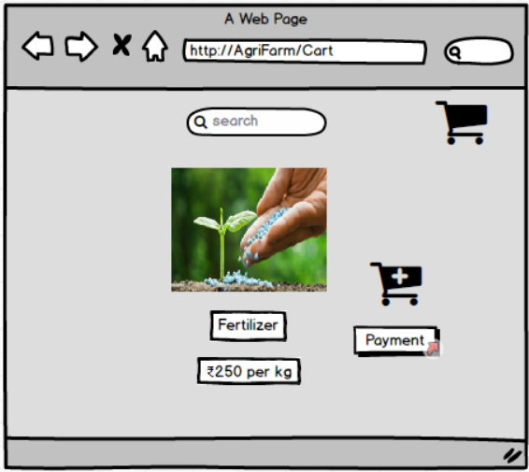
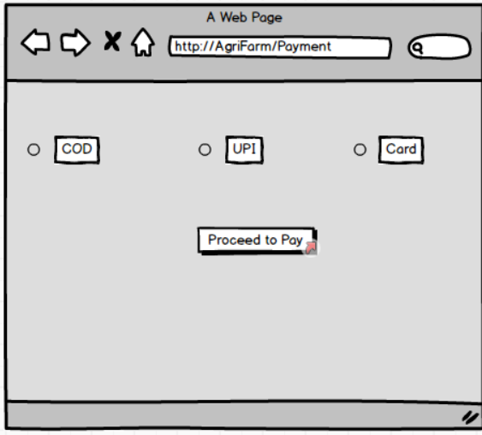
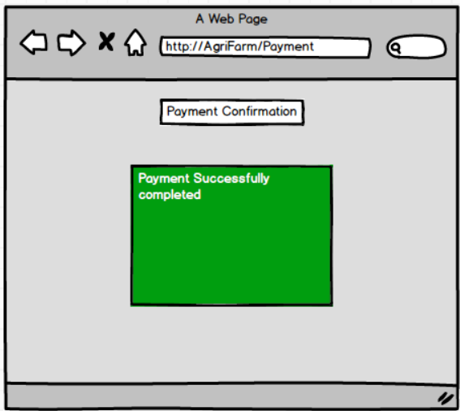
C:\Users\basiv\OneDrive\Desktop\NewProject.bmpr
Question 3 – Tools:
Tools Used
- Microsoft Visio
  - Used for creating UML Diagrams (Use Case, Activity, Sequence Diagrams).
  - Helps in structured modelling of system requirements and workflows.
  - Widely accepted in corporate environments for requirement documentation.
- Balsamiq Mock-ups
  - Used for Low-Fidelity Wireframes.
  - Provides quick sketch-style designs for application pages.
  - Makes it easy to collaborate with stakeholders during the requirement gathering phase.
- Axure RP
  - Used for High-Fidelity Prototypes.
  - Enables creation of interactive, clickable prototypes simulating real application behaviour.
  - Useful for demonstrating the user journey and validating user experience before development.
Question 4 – RTM
Req ID | Req Name | Req Description | Design | Code | UT | CT | ST | SIT | UAT
FR0001 | Farmer Registration | Farmers should be able to register with the application | ✔ | ✔ | ✔ | ✔ | ✔ | ✔ | ✔
FR0002 | Farmer Search Products | Farmers should be able to search for available products in fertilizers, seeds, pesticides | ✔ | ✔ | ✔ | ✔ | ✔ | ✔ | ✔
FR0003 | Product Upload | Manufacturers should be able to upload and display their products | ✔ | ✔ | ✔ | ✔ | ✔ | ✔ | ✔
FR0004 | Add to Cart | Farmers should be able to add selected products to cart | ✔ | ✔ | ✔ | ✔ | ✔ | ✔ | ✔
FR0005 | Payment Gateway | Farmers should be able to make payments via COD, UPI, Debit/Credit card | ✔ | ✔ | ✔ | ✔ | ✔ | ✔ | ✔
FR0006 | Delivery Tracking | Farmers should be able to track their delivery status | ✔ | ✔ | ✔ | ✔ | ✔ | ✔ | ✔
FR0007 | Order Confirmation | Farmers should receive email/SMS confirmation of their orders | ✔ | ✔ | ✔ | ✔ | ✔ | ✔ | ✔
NFR0101 | Page Loading Time | Each page should load within 2 seconds | ✔ | ✔ | ✔ | ✔ | ✔ | ✔ | ✔
NFR0102 | WCAG 2.1 Compliance | The system must meet Web Content Accessibility Guidelines WCAG 2.1 | ✔ | ✔ | ✔ | ✔ | ✔ | ✔ | ✔

Question 5 – 10 Test Case Documents
Project Name | Online Agriculture Products Store
Project ID | PROJ001
Project Manager | Mr. Vandanam
PM ID | PM001
Test Strategy ID | TS001
Test Plan ID | TP001
Test Schedule ID | SCH001
Date of Test | 28-Sep-25
Test Case ID | Test Case Name | Module | Tester ID | Tester Name | Precondition | Test Steps | Expected Result | Expected Behaviour | Actual Behaviour | Comments | Result (Pass/Fail) | Page Link
TC001 | Farmer Registration | User Management | TST001 | Mr. Jason | User not registered | 1. Open application  2. Click Register  3. Enter details  4. Submit | User account created & confirmation email sent | User should be able to register and receive confirmation email | User successfully registered and received confirmation email | Registration working as expected | Pass | www.agrifarm.com/register
TC002 | Farmer Login | User Management | TST002 | Ms. Alekya | User registered | 1. Open application  2. Enter Email & Password  3. Click Login | User logged in & redirected to Home Page | User should log in successfully and access Home Page | User logged in and navigated to Home Page | Login working correctly | Pass | www.agrifarm.com/login
TC003 | Invalid Login | User Management | TST001 | Mr. Jason | User registered | 1. Open application  2. Enter invalid credentials  3. Click Login | System displays 'Invalid Credentials' error | User should get error message for invalid credentials | System displayed error message for wrong credentials | Error handling works correctly | Pass | www.agrifarm.com/invalid
TC004 | Product Search | Product Catalog | TST002 | Ms. Alekya | Products exist in database | 1. Login  2. Enter product name in search bar  3. Click Search | Search results display matching products | Search should display accurate matching products | Search results displayed correctly | Product search functioning properly | Pass | www.agrifarm.com/products
TC005 | Product Upload by Manufacturer | Manufacturer Dashboard | TST001 | Mr. Jason | Manufacturer logged in | 1. Login  2. Navigate to Upload Product  3. Enter details  4. Submit | Product visible in catalog | Uploaded product should appear in catalog for farmers | Product successfully uploaded and visible | Upload feature working as expected | Pass | www.agrifarm.com/upload
TC006 | Add to Cart | Shopping Cart | TST002 | Ms. Alekya | User logged in, products available | 1. Login  2. Search product  3. Add to Cart | Product added to cart with correct quantity & price | Product should be correctly added to cart | Product added with correct quantity and price | Cart functionality validated | Pass | www.agrifarm.com/cart
TC007 | Payment – COD | Checkout/Payment | TST001 | Mr. Jason | Cart has items | 1. Proceed to checkout  2. Select COD  3. Confirm order | Order placed successfully with COD | Payment should be processed via COD | Order placed successfully using COD | COD payment method working fine | Pass | www.agrifarm.com/checkout
TC008 | Payment – UPI | Checkout/Payment | TST002 | Ms. Alekya | Cart has items | 1. Proceed to checkout  2. Select UPI  3. Enter UPI & pay | Payment successful & confirmation displayed | Payment should be successfully completed via UPI | Payment processed successfully via UPI | UPI payment verified | Pass | www.agrifarm.com/checkout
TC009 | Order Confirmation Email | Notifications | TST001 | Mr. Jason | Valid order placed | 1. Place order  2. Check email | Confirmation email received | User should receive order confirmation email | Email received with correct order details | Notification system working | Pass | www.agrifarm.com/orders
TC010 | Delivery Tracking | Orders | TST002 | Ms. Alekya | Order already placed | 1. Login  2. Navigate My Orders  3. Select Order  4. Track | Delivery status displayed | User should be able to see real-time order status | Delivery status updated correctly and visible | Tracking functionality verified | Pass | www.agrifarm.com/orders/track

Online_Agriculture_Test_Cases.xlsx
Question 6 – DB Design
DB Scheme + Entity Relationship Diagram = DB Design
Database design (DB design) is the process of structuring and organizing data in a way that it can be efficiently stored, accessed, and managed in a database system. It defines how data is stored, related, and accessed to support the application’s requirements.
DB Scheme is a blueprint that outlines the structure of a database, including its tables, fields, relationships, constraints, and other characteristics.
An Entity Relationship Diagram is a visual representation of the relationship between entities in a database. It depicts the entities, attributes, and relationships between them.
Question 7 – Data Flow Diagram
Question 8 – Change Request
Change Request Handling Process
- Initiation of Change Request
  - The stakeholder (e.g., Mr. Henry or Finance Head Mr. Pandu) raises a formal Change Request (CR).
  - The CR is logged in the Change Request Register with details like CR ID, date, raised by, and reason.
- Impact Analysis
  - The Business Analyst evaluates how the new tax structure impacts business rules, database tables, and modules such as billing, invoicing, and payment.
  - The Development and Testing teams estimate the required effort, cost, and timeline.
  - An Impact Assessment Document (IAD) is prepared.
- Approval Process
  - The CR is reviewed by the Change Control Board (CCB), consisting of Mr. Henry, Mr. Pandu, and Project Manager Mr. Vandanam.
  - Upon approval, the CR is assigned a priority and scheduled for implementation.
- Implementation
  - The development team updates tax computation logic and related database fields.
  - The testing team performs Regression Testing and UAT (User Acceptance Testing) to ensure the new tax rules work correctly.
- Documentation & Communication
  - All related documents such as the Requirements Traceability Matrix (RTM), Functional Specification Document (FSD), and Test Cases are updated.
  - The change is communicated to all stakeholders.
- Closure
  - Once validated, the CR status is changed to “Closed” in the register, and the updated module is deployed to production.
Question 9 – Change Request Vs an Enhancement
Change Request:
A Change Request (CR) is a formal proposal to modify a project, product, process, or system. It is typically used in project management, software development, and various industries to handle modifications and improvements. A Change Request can arise at any point during a project's lifecycle, whether it’s due to new requirements, unforeseen issues, or the need for compliance with updated regulations (for example, a government taxation change).
Enhancement:
Enhancements refer to improvements or additions made to the software after its initial release. These changes are aimed at increasing the software’s value, performance, or functionality based on evolving business needs, user feedback, or technological advances. Enhancements can be part of the regular software maintenance cycle or occur as part of a new version or update.

Business Analyst’s Response:
As a Business Analyst, my response to Ben and Kevin’s request would be to classify it as an Enhancement rather than a Change Request.
A change request typically involves modifications to existing functionality or requirements, while an enhancement introduces new features or capabilities that were not initially specified.
In this case, the request to allow Farmers to add their crop yields, display them to the general public, and enable selling through the application represents an Enhancement, because it introduces new functionality beyond the initial scope of the project. Additionally, the introduction of an Auction system for crop yields adds another layer of functionality and complexity to the application.

Steps to Handle the Enhancement Request:
- Requirement Gathering:
Meet with Ben and Kevin to collect detailed requirements for the new functionality. Understand the process for farmers to upload, manage, and sell their crops, and how the auction system will function.
- Impact Analysis:
Analyze the impact of these enhancements on the existing project scope, cost, schedule, and technical infrastructure. Assess database, UI, and integration impacts.
- Stakeholder Analysis:
Identify and involve key stakeholders (Mr. Henry, Project Manager, Developers, Testers, etc.) to gather their input and align expectations.
- Documentation and Communication:
Document the new requirements, update the Functional Specification Document (FSD) and Scope Statement, and communicate the proposed changes to all stakeholders.
- Evaluation and Prioritization:
Evaluate the business value and prioritize this enhancement against other project deliverables to decide if it should be included in the current release or a future phase.
- Planning and Execution:
Once approved, update the project plan, timeline, and resources. Collaborate with the development and testing teams to design, build, and validate the new modules through proper testing and User Acceptance Testing (UAT).
Question 10 – Estimations
Estimation in Software Development Life Cycle refers to the process of predicting the resources (time, cost, effort) required to complete a software development project or specific tasks within that project. It is a crucial activity during the planning phase of the SDLC, helping to set realistic expectations, allocate resources efficiently, and determine the overall feasibility of the project.
Man-hours Estimation in software development refers to the process of calculating the total amount of human effort required to complete a specific task, module, or entire project. It is generally expressed in terms of hours and is essential for accurate planning, budgeting, and scheduling. It enables project managers and stakeholders to estimate timelines, resource needs, and overall project effort effectively.
Types of Projects on the Basis of Man-Hours
- Small Project – Up to 500 Man-Hours
- Medium Project – Up to 1,000 Man-Hours
- Large Project – Up to 1,500 Man-Hours
Man-Hour Estimation Formula
Manhours Required = Total Working Hours per Day × Total Number of Members × Total Working Days
Given Data
- Number of Working Hours per Day: 8 hours
- Number of Resources: 12
- Time Period Provided: 18 months = 547 days = 78 weeks (including weekends and public holidays)
- Assumed Weekends: 156 days
- Assumed Public Holidays: 10 days
- Total Non-Working Days: 166 days
- Total Working Days = 547 – 166 = 381 working days
Calculation
Estimated Manhours = 8 hours × 12 resources × 381 days
= 36,576 Man-Hours Required
Conclusion
Based on the above estimation, the Online Agriculture Products Store Project will require approximately 36,576 man-hours over a span of 18 months.
This categorizes the project as a Large Project, indicating significant effort, coordination, and resource allocation to achieve successful completion within the planned timeframe.
Question 11 – UAT
As a Business Analyst, once the project has successfully completed all previous stages such as design, development, and system testing, I would handle the UAT phase in the following manner:
- Preparation for UAT:
  - Coordinate with the client to identify UAT testers (business users or representatives).
  - Ensure that the UAT environment is properly set up and mirrors the production environment.
  - Review all functional and business requirement documents to prepare UAT test cases.
  - Provide a UAT Test Plan outlining objectives, scope, timelines, entry/exit criteria, and roles.
- Execution of UAT:
  - Facilitate UAT kick-off meetings with the client and key stakeholders.
  - Support users during the testing phase by clarifying business requirements and addressing any issues raised.
  - Log defects or change requests identified during testing and coordinate with the development team for resolution.
  - Ensure that all critical issues are fixed and retested before UAT closure.
- UAT Sign-off and Project Closure:
  - Once all test cases are successfully executed and approved by the client, obtain a formal UAT sign-off document.
  - Conduct a UAT review meeting to confirm client satisfaction and finalize deliverables.
  - Prepare a Project Closure Report summarizing scope completion, deliverables, and client approval.
  - Ensure all project documentation, code, and credentials are handed over to the client or maintenance team.
  - Officially close the project after receiving client confirmation and management approval.
UAT Acceptance Process
The UAT Acceptance Process involves the following steps:
- Planning: Define objectives, entry/exit criteria, scope, and schedule for UAT.
- Preparation: Develop UAT scenarios and test cases based on business requirements.
- Execution: Conduct UAT by end users; record results and defects.
- Defect Management: Track, resolve, and retest defects.
- Sign-Off: Obtain final client approval confirming that the system meets all business and functional requirements.
- Project Closure: Handover documentation, release the final product, and complete administrative closure.
Question 12 – Project Closure Document
1. Project Overview
The Online Agriculture Products Store project was initiated by Mr. Henry under the CSR initiative of SOONY Company to support farmers in remote areas by providing an online platform to buy and sell agricultural products such as fertilizers, seeds, and pesticides.
The application connects farmers with manufacturers, allowing them to interact directly, purchase inputs, and track their deliveries easily.
During the project, an enhancement was introduced — enabling farmers to sell their crop yields and participate in auction-based sales, thus improving the platform’s overall value.
The project was managed by APT IT Solutions under the leadership of Project Manager Mr. Vandanam with a multidisciplinary team including developers, testers, network and database administrators, and you as the Business Analyst.
2. Achievements
- Successfully delivered a fully functional web and mobile application for farmers and manufacturers.
- Implemented secure login, registration, search, and order modules.
- Added payment gateway with COD, card, and UPI options.
- Integrated delivery tracking and email confirmation for order updates.
- Managed enhancement requests (Farmer Selling and Auction System) without impacting delivery timelines.
- Received client acceptance post User Acceptance Testing (UAT) with positive feedback.
3. Lessons Learned
- Continuous stakeholder engagement ensured timely validation of requirements.
- Maintaining a requirement traceability matrix (RTM) helped avoid missed requirements.
- Early risk identification and mitigation reduced project delays.
- Regular stand-up meetings improved team communication and reduced rework.
- User-centric design simplified usability for rural farmers.
4. Quality Assurance
- All modules underwent Unit Testing, Integration Testing, System Testing, and UAT.
- Quality checks ensured compliance with WCAG 2.1 accessibility standards and security protocols.
- All reported defects were resolved and revalidated before deployment.
- Test cases and results were documented and approved by testers Mr. Jason and Ms. Alekya.
5. Resource Utilization
- Total team members: 12
- Duration: 18 months (381 working days)
- Total working hours per day: 8
- Estimated Man-hours: 8 × 12 × 381 = 36,576 hours
- Resources were optimally utilized across BA, design, development, and testing phases.
6. Risk Management
- Identified potential risks like requirement changes, data migration errors, and payment gateway integration delays.
- Regular reviews and a risk log ensured timely mitigation.
- No major risk impacted project delivery or quality standards.
- Enhancement features were handled through controlled Change Management Process.
7. Challenges
- Managing scope creep due to enhancement requests.
- Ensuring system performance with increased data from multiple manufacturers.
- Coordinating between distributed teams across modules.
- Handling multi-environment testing (web and mobile) efficiently.
8. Conclusion
The Online Agriculture Products Store project successfully met all business objectives and client expectations.
All modules were completed, tested, and accepted through the UAT process conducted with Mr. Henry and stakeholders (Peter, Kevin, and Ben).
The project is officially closed, with all deliverables handed over to SOONY Company. Documentation, credentials, and maintenance handover have been completed as per company policy.
The project has achieved its primary goal — empowering farmers through technology and improving access to agricultural products and markets.

