PROJECT: CERT ISSUE
AUTHOR: VENKATESH DHANANA

Document 6: Please prepare a use case diagram, activity diagram and a use case specification document
Use Case Diagram:
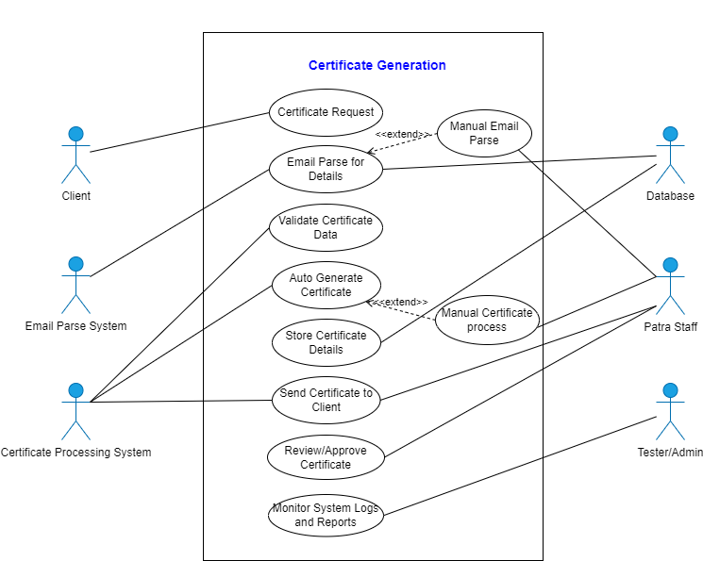

Activity Diagram:
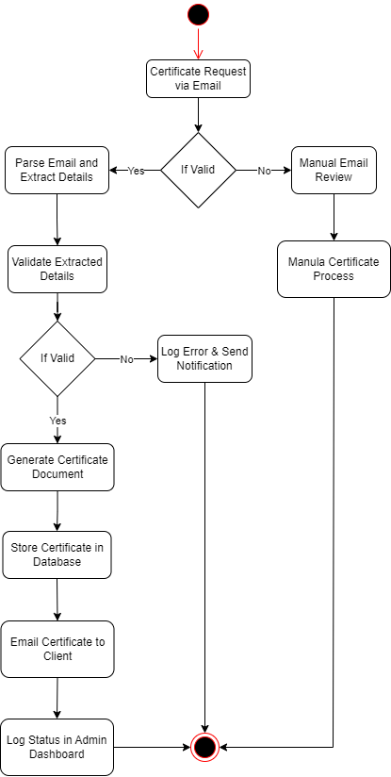

Use Case Specification Document:
Use Case ID: UC001
Use Case Name: Generate Certificate
Use Case Description: This use case describes the process of parsing certificate requests, validating data, generating the certificate and emailing it to the client.
Actor: Client, Email Parser, Certificate System, Admin (Patra Staff)
Preconditions:
1. Active Internet
2. System should be up and running
4. Valid email received with complete certificate details.
Post conditions: Certificate is generated, stored and sent to the client. Status is logged.
Basic Flow:
1. System receives email with certificate details.
2. Email Parser extracts key data (vendor, coverage dates, type, nominee, etc.).
3. Data is validated by the system.
4. Certificate is generated in PDF format.
5. Certificate is saved in the database.
6. System emails the certificate to the respective client.
7. System logs the transaction in the dashboard.
Alternate Flows:
1. Invalid Data Detected: System logs the issue and alerts the admin for manual certificate process.
2. Email Parsing Fails: Email marked for manual review.
Exceptions:
1. System timeout
2. Email server not reachable
3. Missing mandatory fields

Document 7: Screens and pages
Screen 1: Login Page to Cert Issue Application
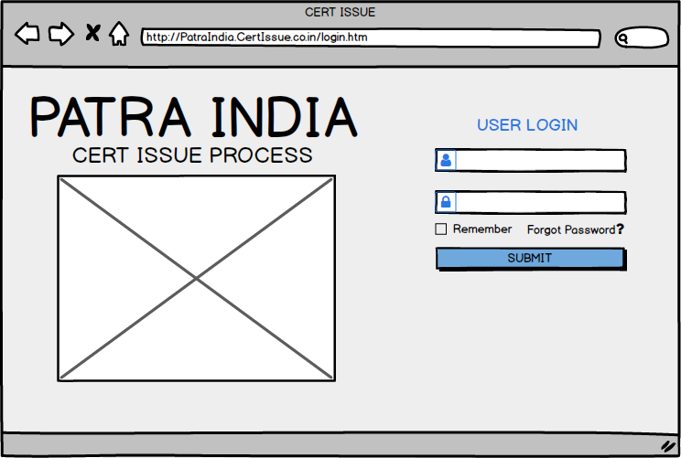
Screen 2: Home Page
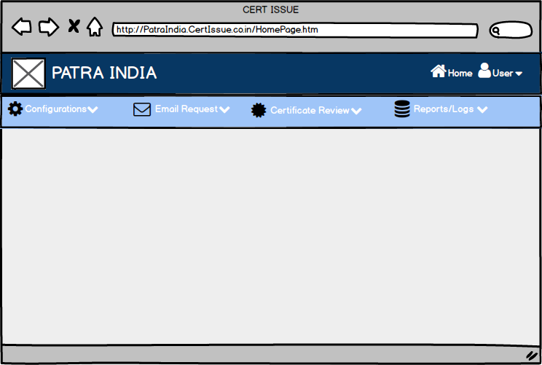
Screen 3: Configuration page
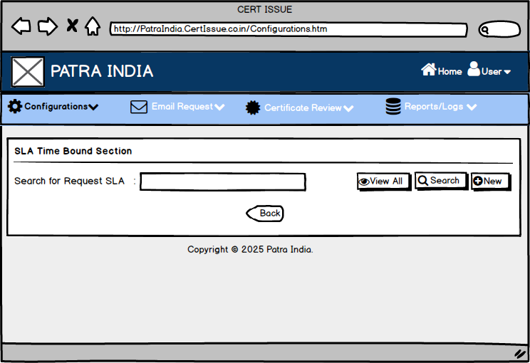
Screen 4: New Configuration creation
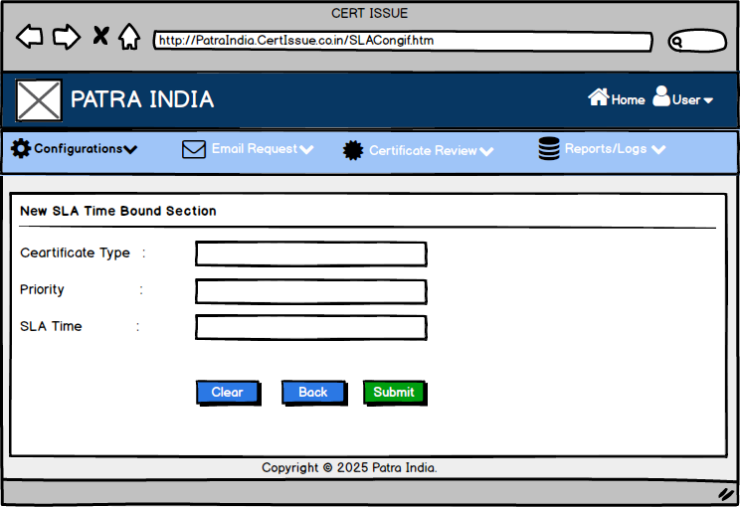
Screen 5: Email Request Dashboard – status of requests received
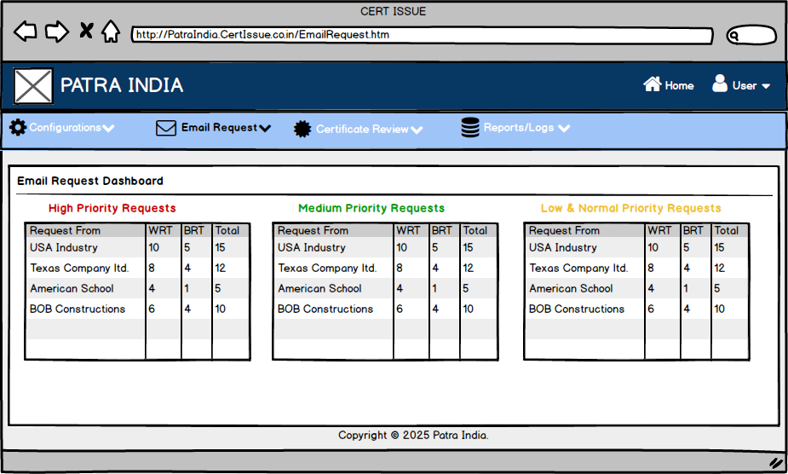
Screen 6: List of Requests by clicking on count from dashboard
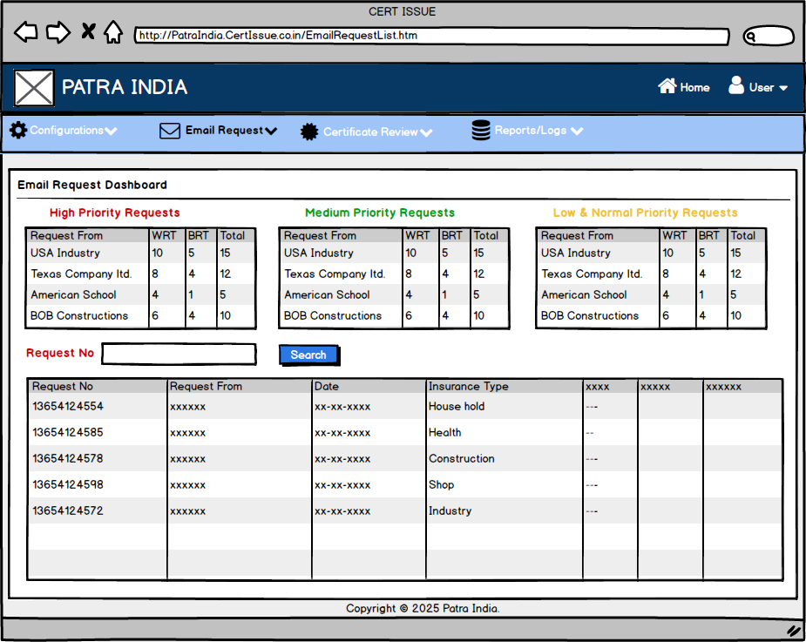
Screen 7: Preview of Email received from client
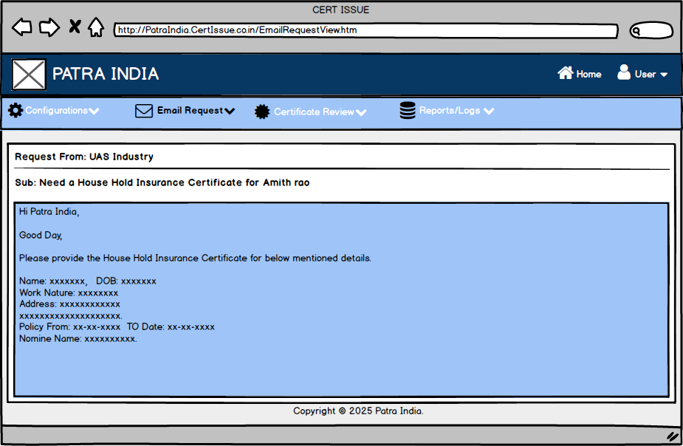
Screen 8: Certificates ready to deliver review dashboard
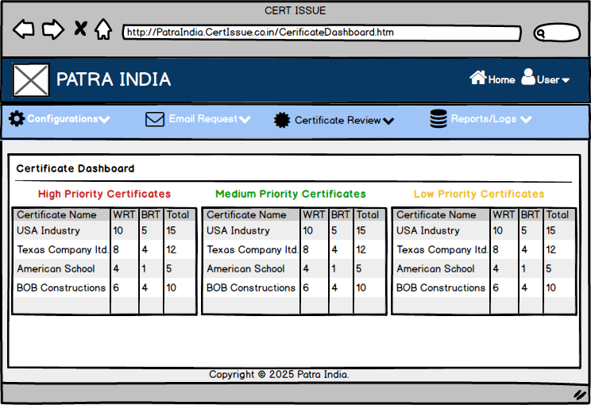

Screen 9: List of certificates available for Review
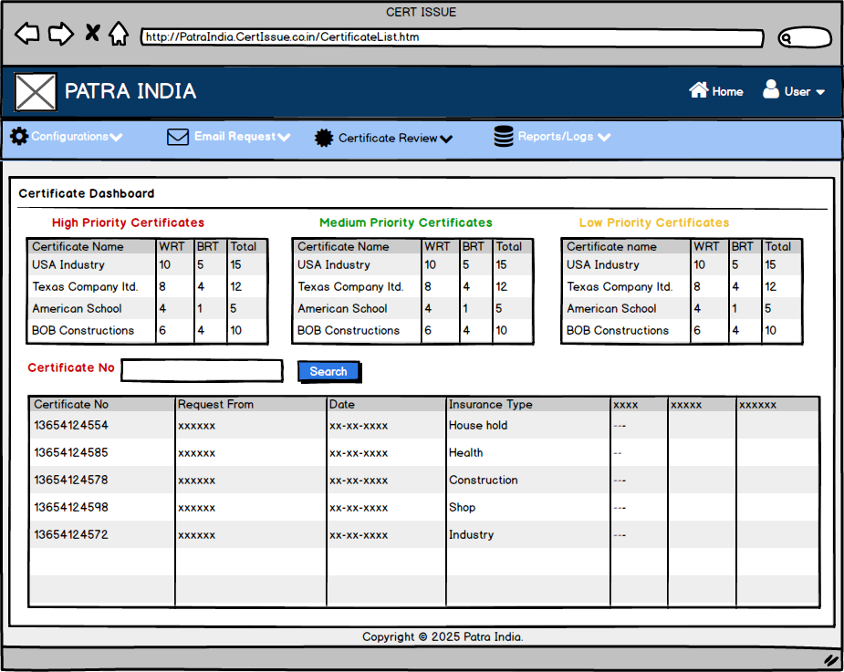

Screen 10: Certificate preview
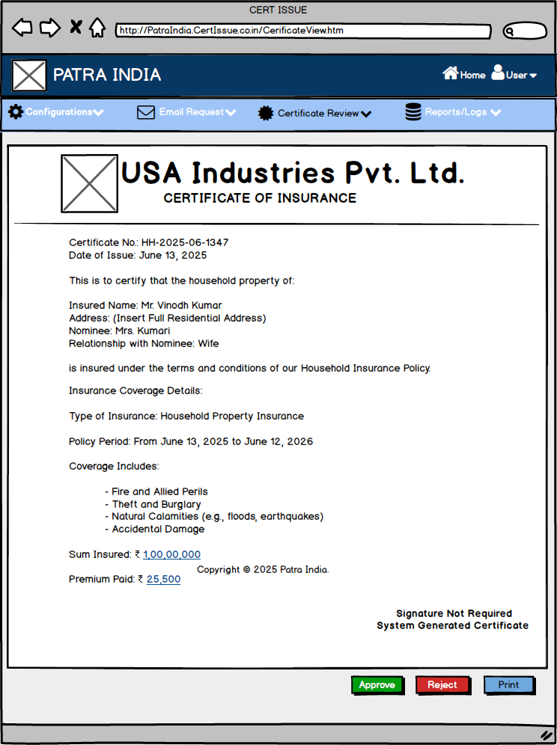

Screen 11: Report page for requests received
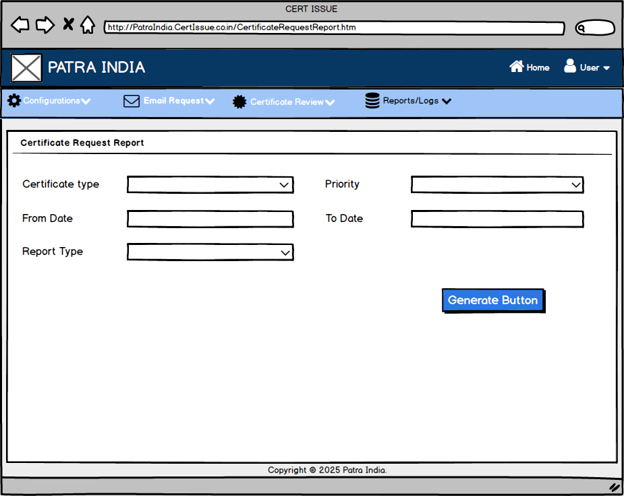
Screen 12: Report page for Failed Requests
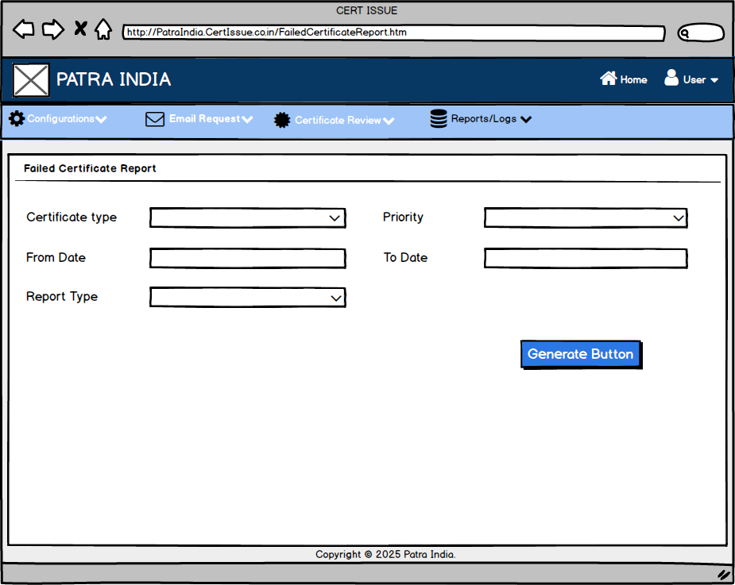
Document 8: Tools-Visio and Axure
As a Business Analyst on the Cert Issue Project, I extensively utilized Microsoft Visio and Axure RP to design and communicate critical system artefacts.
Using Visio, I created detailed UML diagrams such as use case diagrams, activity diagrams, and data flow diagrams to visually represent the system's functional flow and interactions between various components like the email parser, certificate engine and database. These diagrams helped stakeholders quickly grasp the process automation roadmap and ensured alignment across teams.
Additionally, I employed Axure RP to build interactive wireframes and prototypes of the proposed admin and certificate management interfaces. This allowed the development and QA teams to visualize the system's user experience early on, enabling effective feedback collection and minimizing rework during later development phases.
Both tools played a vital role in enhancing clarity, stakeholder engagement and the overall success of the project’s planning phase.

Document 9: BA experience
My experience as BA in following phases:
1. Requirement gathering: During the Requirement Gathering phase of the Cert Issue Project, I played a key role in ensuring that all business needs were captured accurately and efficiently.
- To gather requirements, we used MOSCOW technique:
To prioritize the requirements effectively, I applied the MoSCoW technique, which helped classify them as Must-haves, Should-haves, Could-haves, and Won’t-haves.

- Client is not available for some period of time during this phase. So as a BA i need to source out point of contacts from his side and get the information ASAP:
Due to intermittent client unavailability, I proactively identified and engaged alternate points of contact on the client side to avoid delays and ensure continuous information flow.
- I validate the requirements using FURPS technique:
To validate and structure the collected requirements, I used the FURPS model (Functionality, Usability, Reliability, Performance, and Supportability), which helped in refining the scope and identifying any quality gaps.
- There are many requirements which are duplicated or repeated. We need to remove them immediately:
During analysis, I encountered several duplicate and redundant requirements, which I promptly filtered out to maintain a clean and actionable backlog.
- Prototyping is used to give more specific requirements:
I used prototyping techniques using tools like Axure to provide visual representations of the system, which significantly helped the client articulate more specific and practical requirements.

2. Requirement Analysis: In the Requirement Analysis phase of the Cert Issue Project, I focused on translating the gathered requirements into structured and visual representations to ensure a shared understanding across all stakeholders.
- We need to draw UML diagrams to visually describe the requirements:
I created detailed UML diagrams, including use case diagrams and activity diagrams, to depict system behaviour and process flows clearly.
- Activity diagrams also used to describe the process flow:
These visuals played a crucial role in aligning the development, testing, and database teams.
- Communicate the diagrams to team. Some team members might not agree with them and might make changes. As a BA we need to consider the points and make modifications:
During internal walkthroughs, some team members raised valid suggestions or concerns, which I carefully considered and incorporated to refine the diagrams further.
- Prepare BRS and SRS:
I prepared comprehensive Business Requirement Specification (BRS) and Software Requirement Specification (SRS) documents. These artefacts served as foundational references throughout the design and development stages, ensuring clarity, traceability and alignment with business goals.

3. Design: In the Design phase of the Cert Issue Project, I was actively involved in bridging the gap between functional requirements and technical implementation.
- From the use case diagrams, we prepare test cases:
Based on the finalized use case diagrams, I collaborated with the testing team to derive comprehensive test cases, ensuring both positive and negative scenarios were covered.
- Communicate with client on design and solution documents:
I coordinated with the client to review and finalize design and solution documents, incorporating feedback to ensure alignment with their expectations.
- Write negative test cases as well along with positive test cases:
Based on the finalized use case diagrams, I collaborated with the testing team to derive comprehensive test cases, I meticulously wrote both positive and negative test cases to validate not only expected behaviours but also how the system handled invalid inputs, exceptions and boundary conditions.
- Do not miss a single test case. It might have huge impact on project development in later stages:
I emphasized the importance of not missing any test case, as even minor oversights can significantly impact development and lead to costly rework later in the lifecycle.
- Prepare test data for testing:
I was responsible for preparing test data that reflected real-world scenarios to validate the system's robustness.
- Update RTM. This is just as we need to make sure that all the requirements are met:
Throughout this phase, I diligently maintained and updated the Requirements Traceability Matrix (RTM) to confirm that all requirements were accurately mapped to corresponding design elements and test cases, ensuring complete coverage and traceability.

4. Development: During the Development phase, I was actively involved in ensuring that the technical implementation aligned with business expectations.
- Organized JAD sessions:
As a BA, I played a key role in organizing and facilitating JAD (Joint Application Development) sessions to bridge the communication gap between the client and technical teams during the development phase of the Cert Issue Project. These sessions were instrumental in gathering real-time feedback, clarifying complex business logic and ensuring alignment on system functionalities.
- Clarifying queries of tech team during coding:
I consistently clarified technical queries raised by developers during coding by referencing validated requirements, UML diagrams and use case documentation.
- There might be some team members who doesn't agree with the concept or who doesn’t cooperate during JAD sessions. As a BA I handle the situation gently and had one on one discussion with them. Explained how their actions are going to affect the project. Setup healthy environment within the team:
As a BA, I encountered situations during JAD sessions where certain team members were either uncooperative or disagreed with the proposed concepts. Recognizing the importance of team cohesion, I handled these situations diplomatically and professionally. I initiated one-on-one discussions with the concerned individuals to understand their perspectives, address their concerns and explain how their resistance could potentially impact the project timeline, quality and stakeholder trust. By fostering open communication and emphasizing the collective project goals, I was able to resolve conflicts and establish a healthy, collaborative environment within the team, ensuring that everyone remained aligned and motivated throughout the development process.
- Referred diagrams to code the Unit:
By referencing validated requirements, UML diagrams and use case documentation helped ensure that the coding adhered strictly to business logic.
- Conduct regular meetings with technical team and client which is challenging. Some team members might not be available for the meeting. Recording the session and providing that to missed one and having one to one discussion later with that missed person is all I need to do:
Conducting regular meetings with both the client and technical teams posed logistical challenges, especially when some members were unavailable. I addressed this by recording sessions, sharing them promptly, and following up with one-on-one discussions to keep everyone aligned and informed.

5. Testing: In the Testing phase, I was responsible for ensuring complete and accurate validation of the system against business requirements.
- Prepare test cases from use cases:
I prepared detailed test cases derived from approved use cases and engaged in high-level testing to verify system behavior before formal QA cycles.
- Perform high level testing:
I prepare high-level testing from approved use cases to verify system behaviour before sending to QA team.
- Test data is requested by BA from client:
I coordinated with the client to gather realistic test data, which was essential for validating real-time use scenarios.
- Updated RTM:
Throughout testing, I kept the Requirements Traceability Matrix (RTM) updated to confirm full coverage and ensure no requirement was overlooked.
- Take signoff from client:
Once the test cases are prepared and validated on real time data, I facilitate for the sign-off process by the client after successful validation.
- Prepare client for UAT:
Once the test cases and data validations are done I prepared them thoroughly for User Acceptance Testing (UAT) by providing walkthroughs, test scripts and support, ensuring a smooth transition from system testing to production readiness.

6. Deployment: During the Deployment phase, I ensured a smooth transition from development to operational readiness by managing key Business Analyst responsibilities.
- Forwarded RTM to client which should be attached to project closure document:
I forwarded the updated Requirements Traceability Matrix (RTM) to the client, which served as a critical artefact and was attached to the project closure document for formal sign-off.
- Coordinates to complete and share end user manuals:
I coordinated with the technical and documentation teams to compile and deliver comprehensive end-user manuals, ensuring that users had clear, step-by-step guidance on how to use the system effectively.
- Plans and organizes training sessions:
I took the lead in planning and organizing training sessions for end users and stakeholders, make sure all the developed features are show cased to the end users as per their requirement and got confirmation.
- Make sure all the candidates attend the meeting:
I schedule sessions to accommodate availability and ensuring full attendance by following up with individual participants. This helped promote adoption and confidence in the new system, ensuring the deployment was successful from both technical and user perspectives.

