Checklist for DOD:
• Produced code for presumed functionalities: Code adhere to code standards, code follows best practices
• Assumptions of User Story met: user story is well defined and understood documented and validated
• Project builds without errors: Project build needs to be created and deployed without any errors.
• Unit tests written and passing: Test cases cover edge cases and common scenarios which has to be tested by dev team before they handover the build to QA team
• Project deployed on the test environment identical to production platform: The data and the configuration changes has to be consistent across both the environments
• Tests on devices/browsers listed in the project assumptions passed: Cross browser testing has to be done across the application to check if there is compatibility across screens
• Feature ok-ed by UX designer: Design has to be consistent across the screens and the sign off has to be given by UX designers
• QA performed & issues resolved: QA team has to perform their QA task on the environment and make sure that all the issues are resolved
• Feature is tested against acceptance criteria: Based on the acceptance criteria shared by the stakeholders the feature will be tested and signoff will be given
• Feature ok-ed by Product Owner: usability testing is conducted and design consistency is checked
• Refactoring completed: Coding standards to be maintained which increases the code quality and maintainability
• Any configuration or build changes documented: All configuration and build changes has to be documented in confluence where everyone can access it
• Documentation updated: All the files related to product has to be updated like README and product specification
• Peer Code Review performed: Final code review has to be conducted by dev lead and stakeholder and code freezing is done post which the product will be deployed to production

Vision: To connect multiple agent to core and make the users notified on the activities happening on agent
The product Basically addresses the banking sectors  The target users are the customers of the bank who uses ATM machines to withdraw cash everyday | This feature basically solves the issues of sending updates to multiple agent machines using a single core also it helps the user to keep track on the current systems changes made using alerts  It basically helps the users to control and manage multiple agents also the user gets updated on the crucial activities of the product | Its an endpoint management tool  Well sitting at one location the user can update multiple agents which is the endpoint which basically helps the people go hassle free  Yes its feasible to do it | Cost incurred in managing users reduces  To manage multiple endpoints
Product vision:

User story 1:
User story :1 | Task : 1 | Priority: HIGH
As a user
I want to connect a satellite to the core
So that I can manage multiple endpoints
BV : 500 | CP: 4
Acceptance Criteria:

Install the core device, login to the application using the login credentials of the user
Install the endpoints from core

User Story 2:
User story:2 | Task 2 | Priority: MEDIUM
As a user
I want to receive the alert notifications of satellite sync and agent updates
So that I can keep track on the list of softwares installed to respective agents
BV: 200 | CP: 1
Acceptance Criteria

Install the core, login to the application using the credentials and install agent
Assign software’s to respective agents
Install satellite server, and perform synchronization

From this project I have learned how to handle sprint meetings such as
➢ Sprint planning meeting: which requirement can be undertaken and can be delivered withing the scrum framework
➢ Daily scrum meeting: This will basically last for 10 mins where each team member will tell what they have finished and what they are working on right now
➢ Sprint review meeting: Sprint review meeting is basically done to showcase the feature to the stakeholder and get the feedback. Based on the feedback the product will further go for any changes or it will pickup task from the product backlog
➢ Sprint retrospective meeting: This will be conducted at the end of the sprint to discuss what went well and what went wrong and what are the learnings from the previous sprint
➢ Backlog refinement meeting: The product owner and the scrum team look at the remaining product backlogs. The product owner prioritizes product backlog

Product Burn down chart:

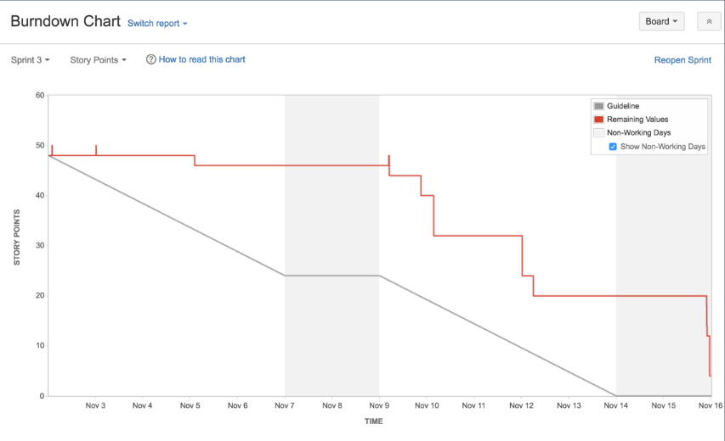

Product and sprint backlog:
Product backlog sis the list of all new feature, bug fixes, infrastructure changes that the team may deliver in order to achieve a better outcome
User Story ID | User Story | Task | Priority | BV | CP | Sprint
US001 | As a user I want to login and check the user Details | - Create login UI  - Implement user authentication  - Test login | HIGH | 500 | 1 | 2
US002 | As a user I want to create a group for the endpoints and deploy updates only to the group | - Login to the application from the core server  - Deploy agent servers  - Deploy satellite server  - Create groups for all the agent servers from satellite  - Assign applications only to that group | HIGH | 500 | 2 | 2
US003 | As a user I want to sent notify or dtm jobs only to the specific groups to apply the updates | - Login to the application from the core server  - Deploy agent servers  - Deploy satellite server  - Create groups for all the agent servers from satellite  - Assign applications only to that group  - Launch DTM or notify jobs to install the application on the agent machines | MEDIUM | 300 | 1 | 2

Sprint backlog:
A sprint backlog is a list of tasks, user stories, and goals a development team commits to completing in a single sprint

User Story ID | User Story | Task | Priority | BV | CP | Sprint
US001 | As a user I want to connect multiple agents to the core | - Install core server  - Login using a valid user ID  - Install agents  - Install satellite  - Set the priority in CSDB editor  - Create groups in satellite | HIGH | 500 | 4 | 1
US002 | As a user I want to receive alert notifications on the actions performed | - Login to the application  - Assign updates to agent server  - Perform satellite sync  - Run notify job to install the application in agent  - Should receive alerts for satellite synchronization and software installation | MEDIUM | 200 | 1 | 1

Sprint meetings:
Date | 17-10-2025
Time | 10.00 AM
Location
Prepared by | Rohith
Attendees | Arun, Dhilip, Dave, Kiran

Agenda topics:
Topic | Presenter | Time Alloted
Alert notification | Dhilip | 30 mins
Satellite synchronization | Kiran | 30 mins

Meeting type2 Sprint review meeting:
Date | 30-10-2025
Time | 10.00 AM
Location | Conference hall
Prepared by | Rohith
Attendees | Arun, dhilip, kiran, chris, Rahul, Krupa, Ram. Dave

Sprint status | Things to demo | Quick updates | Whats next
DONE | Satellite synchronization | All features are enabled | Deploy in liv env
DONE | Alert notification | All features are enabled | Deploy in live env

Meeting type2 Sprint retrospective meeting:
Date | 31-10-2025
Time | 10:00 AM
Location | Conference hall
Prepared by | Rohith
Attendees | Arun, dhilip, kiran, chris, Rahul, Krupa, Ram. Dave

Agenda | What went well | What didn’t go well | Questions | Reference
 | All sprint backlogs were covered | Proper unit testing was done | UAT and unit testing has to be completed | SME

Meeting type 4: Daily standup meeting

Question | role | Weeks from (20.10.2025 to 25.10.2025)
Question | role | Monday | Tuesday | Wednesday | Thursday | Friday
What did you do yesterday | Developer1  Developer2  Developer3 | Have worked on alert and notification | Working on satellite alerts | Working on satellite alert scheduler | Working on update alert scheduler | Working on satellite synchronization
What will you do today | Developer1  Developer2  Developer3 | Working on satellite alerts | Working on satellite alert scheduler | Working on update alert scheduler | Working on satellite synchronization | Working on satellite synchronization scheduler
What is blocking your progress | Developer1  Developer2  Developer3 | Nothing | defects | Nothing | defects | defects

