- 4 Quarterly Audits are planned Q1, Q2, Q3, Q4 for this Project What is your knowledge on how these Audits will happen for a BA?
Audit: A project audit is a formal, systematic, and independent review of a project's performance, processes, and outcomes to determine its adherence to defined objectives, standards, budget, and timeline.
Quarterly audit: A quarterly audit in a project is a systematic, independent review conducted every three months to assess how well a project is adhering to its objectives, budget, timeline, and quality standards.
Internal Audit: It is conducted by own organization.
External Audit: Done by client representatives or independent auditors.
Stage | Q1 Requirement Gathering
Completed | Week 1 - 12
Checklist | Stakeholder identification
Checklist | Requirements documented
Checklist | Meeting minutes recorded
Checklist | Sign-offs received
Checklist | Version control maintained

Stage | Q2 Requirement Analysis
Completed | Week 13 - 20
Checklist | Use case diagrams prepared
Checklist | Requirements categorized
Checklist | Documents for client sign off
Checklist | RTM document
Checklist | Email communication

Stage | Q3 Design
Completed | Week 20 - 30
Checklist | Functional specs finalized
Checklist | Wireframes/mock-ups created
Checklist | Utilization Tools
Checklist | Validation rules defined
Checklist | Design walkthrough done with stakeholder

Stage | Q4 Development and Testing
Completed | Week 30 - 42
Checklist | Requirements clarifications provided
Checklist | BRD updates if needed
Checklist | BA-JIRA tickets closed with proper remarks
Checklist | Test cases reviewed
Checklist | Defect notes maintained
- Before the Project is going to Kick Start, The Committee asked Mr Karthik to submit BA Approach Strategy Write BA Approach strategy
Write BA Approach strategy (As a business analyst, what are the steps that you would need to follow to complete a project – What Elicitation Techniques to apply, how to do Stakeholder Analysis RACI/ILS, What Documents to Write, What process to follow to Sign off on the Documents, How to take Approvals from the Client, What Communication Channels to establish n implement, How to Handle Change Requests, How to update the progress of the project to the Stakeholders, How to take signoff on the UAT- Client Project Acceptance Form
What Elicitation Techniques to apply?
Purpose of this technique is to understand the expectations of the users, identify the problems in existing solution, discover the requirements.
As the business analyst, I will be using the combination of elicitation technique to make sure the requirements are captured correctly. To begin with I will conduct Brainstorming session with farmers and stakeholders. The purpose of this activity is to openly discuss their challenges, generate fresh ideas.
I will prepare the prototypes of the application. This will help stakeholder to visualize how the application will look before development. Initially I will create a low fidelity wireframe to represent the structure and navigation. Late will move on to high fidelity prototypes that demonstrate the exact layout and workflow.
I will also be using the use case specification technique, here I will document the findings through use case specification. Each use case will have an actor that interacts with the system. These specification will guide developers, tester and stakeholder, ensuring that system behaviour is fully understood.
How to do Stakeholder Analysis RACI/ILS?
The purpose of the stakeholder analysis is to identify all the people and groups who are impacted by the project, understand their roles, influence, and level of involvement and how thy will participate in the project.
- Internal stakeholder:
  - Mr. Vandanam – Project manager
  - Ms. Juhi – Sr. Java developer
  - Mr. Teyson, Ms. Lucie, Mr. Tucker, Mr. Bravo – Java Developers
  - Mr. Mike – Network admin
  - Mr. John – DB admin
  - Mr. Jason, Ms. Alekya – Tester
  - Sneha – Business Analyst
- External Stakeholder:
  - Mr. Henry – Businessman
  - Mr. Pandu – Financial head
  - Mr. Dooku – Project coordinator
  - Peter, Kevin and Ben – Stakeholders
RACI Matrix: It is used to define roles and responsibilities in the project.
- R – Responsible: People who performs the work.
- A – Accountable: Person who owns the decision.
- C – Consulted: People who gives input or feedback.
- I – Informed: People who are kept updated on progress but not directly involved.
Task | Mr. Henry (Project Sponsor) | Mr. Pandu (Financial head) | Mr. Doku  (Project coordinator) | Mr. Karthik (Delivery head) | Mr. Vandanam  (Project manager) | Ms. Juhi  (Sr. Java developer) | Mr. Teyson, Ms. Lucie  ,Mr. Tucker, Mr. Bravo  (Java Developers) | Mr. Mike (Network Admin) | Mr. John (DB Admin) | Mr. Jason, Ms. Alekya  (Tester) | Peter, Kevin, Ben | Sneha  (Business Analyst)
Requirement  Gathering | A | C | C | I | C | I | I | I | I | I | C | R
Requirement  Analysis | C | I | C | I | C | C | C | C | C | I | C | R
Development | I | I | I | I | A | R | R | C | C | I | I | I
Testing | I | I | I | I | C | I | I | I | I | R | I | I
UAT | A | I | C | I | C | I | I | I | I | C | C | R

What documents to write?
BA creates structured documents to define, track and approve requirements.
- Business Case Document: Explain why this project is needed, the problem is solved, benefits, costs, ROI.
- Business Requirement Document (BRD): It describes the business needs.
- Software Requirement Specification (SRS): Detailed, technical translation of BRD into functional + non-functional requirements.
- Requirement Traceability Matrix (RTM): Maps each business requirement → functional requirement → test case → UAT → sign-off → Ensures nothing is missed.
- Use Case Specification: Each functionality written in use case format: actors, preconditions, steps, postconditions.
- Functional Specification Document (FSD) / System Requirement Document (SRD): Explains how the system will work in detail, often with data models, process flows.
- Change Request Document (CRD): If farmers/committee request new features, CR log is maintained to track approvals and impacts on budget/timeline.
What process to follow to Sign off on the Documents?
- Document Preparation: As a BA I will prepare the document and ensure all the requirements are clearly written .
- Internal Review: Before sending it to the client/committee, share the draft with the Project Manager and Technical Team for validation.
- Stakeholder Review: Circulate the document to relevant stakeholder and conduct the walkthrough session to explain the document and gather feedback.
- Document Finalization: Update the document based on review feedback.
- Sign-off: Send the final version to stakeholders with a Sign-off Request Mail.
How to take Approvals from the Client?
- Share finalized BRD/FRS via mail or repository.
- Use a client-specific approval form.
- Include version control, signature space, and comments section.
What Communication Channels to establish n implement
- Email communication: For all formal updates, document circulation, and approvals.
- Status meetings: Scheduled with the Project Manager and Committee to share progress and risks.
- Daily Standups: Quick updates within the team to track progress.
- Shared repository: (SharePoint, Confluence, Jira) for storing all signed-off documents, minutes of meetings, and version history.
How to Handle Change Requests
- Check if it is a defect from previous installations. If it is a defect raise it as a bug. If it is not a defect then do the impact analysis, feasibility study and effort estimation.
- First, I will log the change request in a Change Request Register whenever a new request comes from the client or stakeholders.
- Then, I will analyze the impact of the change on scope, budget, and timeline.
- I will document the details of the change request including description, reason, priority, and impact analysis.
- Next, I will present the change request to the client/committee for review and approval.
- If the change is approved, I will update the documents (BRD, SRS, RTM) accordingly and communicate the updates to all stakeholders.
- If the change is rejected, I will record the decision and communicate it clearly to avoid future conflicts.
- Finally, I will ensure that all approved change requests are traceable during development and testing, and reflected in UAT.
How to update the progress of the project to the Stakeholder?
- I will prepare weekly status reports capturing completed tasks, ongoing work, upcoming tasks, and risks.
- These reports will be shared through email with all key stakeholders.
- I will also conduct weekly status meetings with the project team and committee to discuss progress in detail.
- n case of urgent updates or risks, I will use instant communication channels (MS Teams/phone call) to keep stakeholders immediately informed.
How to take signoff on the UAT?
Project Sheet Sign off
Version Date: */**/****
Project Name: Online Agriculture Product Store
Project Goals:
1. To help the farmers and manufactures connect with each other
2. To facilitate farmers to buy seeds, fertilizers, pesticides from anywhere and get them delivered in the remote area.
Project Manager: Mr. Vandanam | Sponsor: Mr. Henry
Start Date: April 1st, 2025 | Planned Budget: INR 2 crores
Planned Completion Date: August 15th, 2025 | Actual Budget:
Actual Completion Date: | Variance:
Duration: 18 Months
Days Past the planned completion date:
Project Deliverables
By signing this document, I acknowledge that I have delivered all the stated deliveries per the agreed plan and acceptance criteria.  Project Manager Signature:  Date: **/**/*** | By signing this document, I acknowledge that I have received all the stated deliverables as per the agreed plan and acceptance criteria  Sponsor Signature:  Date: **/**/***
Remarks:

- Explain and illustrate 3-tier architecture?
3-tier architecture: 3-tier architecture is a client-server software architecture pattern that separates the application into three distinct layers:
Presentation Tier (UI)
Application Tier (Business Logic)
Data Tier (Database Layer)
- Presentation Tier (User Interface):
This layer is responsible for the user interface and how users interact with the application. It handles displaying information, receiving user input, and managing navigation.
  - User interacts via website/mobile app.
  - View products, Login/Register, Add to cart, Checkout
- Application Tier (Logic Tier):
This tier contains the core business logic of the application. It processes data, performs calculations, and implements business rules.
Validating login credentials, managing cart sessions, Processing orders
- Data Tier (Database Tier):
This layer manages and stores the application's data. It handles data access, storage, and ensures data integrity.
User data, Product catalogue, Orders and payment history
Benefits:
- Scalability:
Each tier can be scaled independently to handle varying loads and user traffic, according to architectural resources.
- Maintainability:
Changes in one tier can be made without affecting the others, simplifying maintenance and updates.
- Flexibility:
Allows for the use of different technologies and platforms for each tier.
- Security:
Separation of data access from the user interface can improve security, according to software architecture articles.

- Business Analyst should keep What points in his/her mind before he frames a Question to ask to the Stakeholder (5W 1H – SMART – RACI – 3 Tier Architecture – Use Cases, Use case Specs, Activity Diagrams, Models, Page designs).
5W1H: is a problem solving and question framing technique that stands for Who, What, When, Where, Why and How. It is used to gather information, avoid miscommunication and ensure requirement traceability.
  - Who: Who are the stakeholders involved? Who will use the system?
  - What: What are the requirements? What functionalities should a system have?
  - When: When should the certain task be completed?
  - Where: Where will the application be used?
  - How: How will the system be used? How will the data flow? How will the payment be initiated?
SMART is a framework for setting clear, realistic goal. It ensures that objectives are Specific, Measurable, Achievable, Relevant, Time-bound.
  - Specific: Goals should be clear addressing what needs to be achieved. Should allow adding quantity, view cart, remove item
  - Measurable: Measuring a process for attaining a goal at each phase. Can we track how many times item was added to the cart?
  - Achievable: Goal must be realistic given the resources and constraint. Is it feasible to support all payment types?
  - Relevant: Goal should be align with the business objectives and be meaningful. Does this improve shopping experience for farmers?
  - Time-bound: Every goal needs a deadline. Can we deliver this feature in 1 week?
RACI: It is a responsibility assignment model that defines roles and responsibilities in a project.
- Responsible: This is the person or group who actually performs the task or activity. They are the ones doing the work.
- Accountable: This is the person who is ultimately answerable for the correct and thorough completion of the task or deliverable. This person ensures the work gets done and has the "ownership" of the task.
- Consulted: These are the individuals or groups whose opinions and input are sought before a decision or action is taken. They provide expertise or guidance
- Informed: These are the individuals or groups who need to be kept in the loop about the progress and status of the task or activity, but do not need to be actively involved in the work itself.
3-tier architecture:
  - Presentation Tier (User Interface):
This layer is responsible for the user interface and how users interact with the application. It handles displaying information, receiving user input, and managing navigation. UI/Frontend
  - Application Tier (Logic Tier):
This tier contains the core business logic of the application. It processes data, performs calculations, and implements business rules. Processes data, logic, validations
  - Data Tier (Database Tier):
This layer manages and stores the application's data. It handles data access, storage, and ensures data integrity. Database, data storage and retrieval.
Use Case: Use case describe how user interacts with the system to achieve specific goals.
Use Case Specification: It provides more detailed and structured description of a use case. It includes Actors, Preconditions, Steps/flows (main + alternate), Postconditions and exception ensuring behavior is well defined.
Activity Diagram: It is a visual representation of series of actions in a system. It is basically a flow chart to represent the flow from one activity to another.
Models: Models are abstract representation of real word process or system. Conceptual model, Data model, Physical model.
Page Design: also called as Wireframes or UI are visual representation of system. They show placement of key elements like buttons, text, search bar, images.

- As a Business Analyst, What Elicitation Techniques you are aware of? (BDRFOWJIPQU)
  - Brainstorming: It is used to gather ideas, solutions or requirements from a group of stakeholders. The primary goal of stakeholder is to generate a wide range of ideas.
  - Document Analysis: Reviewing existing documents, manuals, and records to extract useful information. This technique is used when we need to understand the current state of system and understand gaps in documentations, processes or existing solutions.
  - Reverse Engineering: Analyzing an existing product or system to understand its functionality and requirements. Two types of reverse engineering:
  - Black box reverse engineering: analyze the external behavior of the product without any knowledge of its internal components or workings. They observe the inputs and outputs of the product to determine its functionality.
  - White box reverse engineering: The inner working of system is studied (analysing and understanding code).
- Focus Group: by using focus group you can get information about the project, service from a group. It includes the subject matter expert.
- Observations: Shadowing users as they perform tasks. It is used to capture real-time behaviours and uncover hidden requirements in existing processes.
- Workshops: Group discussion involving stakeholders from different teams. Early in the project to understand stakeholder expectations and gather domain knowledge. It is done to align multiple stakeholders, resolve conflicts, or brainstorm new ideas collaboratively
- JAD (Joint Application Development): Facilitated workshops involving both business stakeholders and IT teams to design and review solutions. JAD sessions are used for more complex system and where we want decision quickly.
- Interviews: One-on-one conversions with stakeholder to gather information. It is used in early projects to understand stakeholder expectations and gather domain knowledge. If interviewer has pre defined set of questions it is called structured interview. If interview is not having any format or specific questions its unstructured interview.
- Prototyping: Presenting mock UI screens or low/high fidelity models. It is used to validate ideas, clarify unclear requirements, and reduce misunderstandings early.
- Questionnaire: Structured set of questions sent to a larger audience. To collect input from many users at once—especially useful for dispersed or remote stakeholders.
- Use case Specs: A visual method to organize user stories to depict the complete user journey. It is a description of a specific interaction between the user and the product to reach goal.

- What Elicitation Techniques can be used in this Project and Justify your selection of Elicitation Techniques?
    - Brainstorming: A group activity to quickly share and collect many ideas. Multiple stakeholders (farmers, manufacturers, platform admins) will have unique needs, and brainstorming can capture them in one session before prioritization. Encourages contributions from all groups, even quiet participants. Surfaces innovative ideas. Lays a foundation for requirement prioritization in workshops or follow-up meetings.
    - Use Case Specifications: Detailed documents that describe how a user interacts with the system to achieve a goal, including preconditions, flows, exceptions, and postconditions. The system has multiple key actions (e.g., login, search product, add to cart, make payment) with different paths for different actors (farmers, manufacturers). Clearly captures step-by-step interactions. Helps developers understand required system responses for normal, alternate, and error cases. Ensures nothing is missed in functional coverage, especially for critical flows like payments.
    - Prototyping: Building a simple working model or mock-up of the system’s interface to help stakeholders visualize requirements.
Many farmers and manufacturers might struggle to express technical requirements in words. A clickable prototype of the homepage, product catalog, cart, and payment flow can help them see what the system will look like. Helps farmers confirm if product categories, filters, and payment screens match their needs. Saves time by identifying missing or misunderstood features early. Reduces rework during development.

- Make suitable Assumptions and identify at least 10 Business Requirements
Business requirements: Business requirements describe what the business needs to achieve in order to deliver value to its customers, stakeholders, or users. They are goals, objectives, and outcomes that the project or solution must fulfil.
  - BR001 –
Farmers should be able to search for available products in fertilizers, seeds, and pesticides using keywords or filters.
  - BR002 –
Farmers should be able to browse the complete catalog of fertilizers, seeds, and pesticides without logging in.
  - BR003 –
Manufacturers should be able to upload and display their products in the application with product images, details, and prices.
  - BR004 –
The system should provide account registration for new users (Farmers, Manufacturers, Admins) with email ID and secure password creation.
  - BR005 –
The system should provide a secure login for registered users with credential validation.
  - BR006 –
Farmers should be able to add products to a shopping cart for purchase.
  - BR007 –
Farmers should be able to save products in a "buy later" list or Wishlist for future purchase.
  - BR008 –
The system should provide payment through Cash on Delivery (COD), Credit/Debit Card, and UPI.
  - BR009 –
The system should confirm payment success/failure and notify the user immediately.
  - BR010 –The system should send order confirmation emails to Farmers after a successful purchase.
  - BR011 –
The system should provide an order tracking feature to track delivery status and shipment location.
  - BR012 –
Farmers should be able to cancel an order before it is shipped.
  - BR013 –
Manufacturers should have their own dashboard to manage products, prices, and stock levels.
  - BR014 –
Farmers should be able to rate and review purchased products.
  - BR015 –
Admin should be able to monitor all users, orders, payments, and resolve disputes.

- List your assumptions?
  - All the user have stable internet connection.
  - Manufacturers will provide accurate and updated details (name, price, stock, description) for their products.
  - The platform will be available in a common language understandable to most users (e.g., English or local language).
  - Customer support will be available during working hours for payment or order issues.
  - Order status updates will be sent via email.
  - Product search will be keyword-based.
  - The payment gateway will support UPI, cards, and COD securely with necessary compliance

- Give Priority 1 to 10 numbers (1 being low priority – 10 being high priority) to these Requirements after discussions with the stakeholders

Req ID | Req Name | Req Description | Priority
BR001 | Farmer Search for Products | Farmers should be able to search for available products in fertilizers, seeds, pesticides. | 8
BR002 | Manufacturers Upload their Products | Manufacturers should be able to upload and display their products in the application. | 8
BR003 | User Registration | New users should be able to create an account with email ID and password. | 9
BR004 | User Login | Users should be able to log in using registered email and password. | 9
BR005 | Product Catalog Browsing | Farmers should be able to browse fertilizers, seeds, and pesticides without logging in. | 7
BR006 | Add to Cart | Farmers should be able to add selected products to the cart for purchase. | 9
BR007 | Payment Gateway – UPI | Payment via UPI should be available for farmers. | 10
BR008 | Payment Gateway – Card | Payment via Credit/Debit cards should be available for farmers. | 10
BR009 | Payment Gateway – COD | Cash-on-delivery payment option should be available for farmers. | 9
BR010 | Order Confirmation Email | System should send email confirmation after an order is placed. | 7
BR011 | Delivery Tracking | Farmers should be able to track the status and location of their delivery. | 9
BR012 | Product Details Page | Product details page should display description, price, manufacturer name, and availability. | 8
BR013 | Search Filter & Sorting | Farmers should be able to filter products by category, price, and manufacturer. | 6
BR014 | Manufacturer Verification | Manufacturers must be verified before listing products. | 8
BR015 | Cart Management | Farmers should be able to update quantities or remove products from the cart before payment. | 7

- Draw use case diagram
Use case diagram: It is a high-level diagram. The main purpose is to identify the requirements. It is actor specific. It describes how external user interacts with the system.

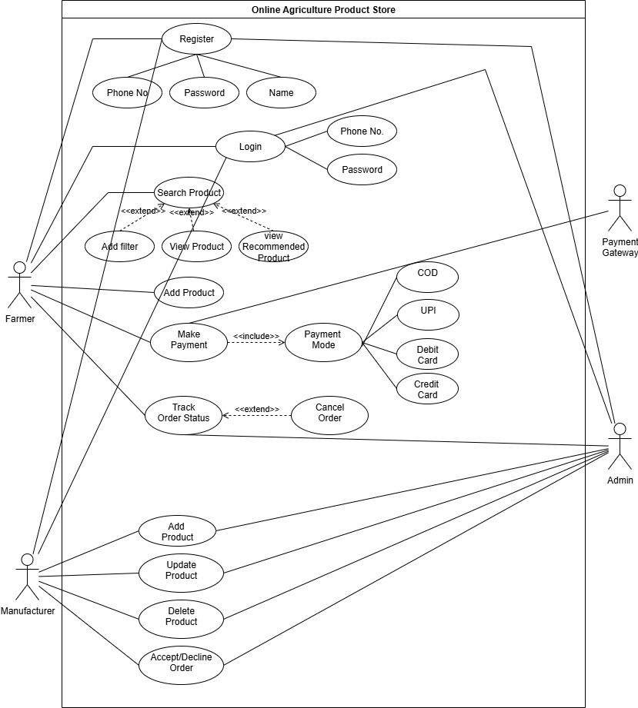

- Prepare use case specs for all use cases
It is a textual representation of how user interacts with the use cases. It outlines the steps involved in a use case, including different scenarios (main flow, alternative flows) and pre/post-conditions, to ensure the system behaves as expected from the user's perspective. It helps bridge the gap between business needs and technical implementation. It includes sections like
- Use Case ID and Name: Unique identifier and descriptive title.
- Description: A brief overview of the use case.
- Actors: Entities that interact with the system.
- Pre-conditions: Conditions that must be met before the use case can begin.
- Main flow: A step-by-step description of the typical interaction.
- Alternative Flows: Possible deviations from the main flow, including error handling.
- Post-conditions: Conditions that are true after the use case is completed successfully.
- Use case document to “Register New Account”
Use case ID | UC001
Use Case Name | Register New Account
Created By | Sneha | Last Updated By | July 10th, 2025
Date Created | May 1st, 2025 | Last Revision Date | July 30th,2025
Actor | Farmers, Manufacturers, Admin
Description | This use case describes how unregistered user registers on the website.
Pre-Condition | 1. Network Stability  2. Valid Email Id/Mobile Number
Post-Condition | The user is successfully registered and redirected to the login page.
Normal Flow of events | 1. User clicks on Register New option.  2. Registration form opens.  3. User fills all mandatory details (Personal details, email/mobile number, password) and submit the form.  4. System verifies and stores data.  5. A message is shown as registration successful  6. User is directed to login page.
Alternate Flow | 1. If email/mobile number already exist then a message is shown  2. If password is weak a message is displayed.
Exceptions | 1. Server downtime or internet failure.  2. Form submission error due to validation failure.
Frequency of Use | Moderate
Assumptions | User has not registered before

- Use case document to “Login” the website
Use case ID | UC002
Use Case Name | Login
Created By | Sneha | Last Updated By | July 10th, 2025
Date Created | May 1st, 2025 | Last Revision Date | July 30th,2025
Actor | Farmers, Manufacturers, Admin
Description | This use case allows user to login on the website.
Pre-Condition | 1. User must be registered  2. User should have valid credentials
Post-Condition | User is logged in and redirected to their dashboard.
Normal Flow of events | 1. User accesses login page  2. User enters phone number and password  3. Click Login.  4. System validates credentials  5. Upon success, user is redirected to dashboard
Alternate Flow | 1. Forgot password flow is triggered.  2. OTP can be used during login.
Exceptions | 1. Server downtime or internet failure.  2. Invalid credentials.
Frequency of Use | High
Assumptions | User is already registered and have valid credentials.

- Use Case document for “searching product” on the website
Use case ID | UC003
Use Case Name | Browse Product
Created By | Sneha | Last Updated By | July 10th, 2025
Date Created | May 1st, 2025 | Last Revision Date | July 30th,2025
Actor | Farmers
Description | This use case allows user browse for the list of agricultural products.
Pre-Condition | None
Post-Condition | List of agricultural products is displayed
Normal Flow of events | 1. User clicks on 'Browse Product'.  2. System shows product catalogue.  3. User can optionally filter products
Alternate Flow | If no products available, system shows "no results found".
Exceptions | Product catalogue not loading due to system error
Frequency of Use | High
Assumptions | 1. Products exist in the catalogue.  2. User knows how to apply filter and search for products.

- Use Case document for “Add product to cart” on the website
Use case ID | UC004
Use Case Name | Add Product
Created By | Sneha | Last Updated By | July 10th, 2025
Date Created | May 1st, 2025 | Last Revision Date | July 30th,2025
Actor | Farmers
Description | This use case allows user to add the product to the cart
Pre-Condition | 1. User must be logged in.  2. User already have looked for the product
Post-Condition | Product is successfully added to the cart.
Normal Flow of events | 1. Farmer selects a product from the catalogue.  2. Clicks 'Add to Cart' button.  3. System confirms product is added.
Alternate Flow | Product is already in cart (increase quantity).
Exceptions | 1. System error while adding to cart.  2. Product is out of stock.
Frequency of Use | High
Assumptions | Product is available and in stock.

- Use Case document for “Payment”
Use case ID | UC005
Use Case Name | Make Payment
Created By | Sneha | Last Updated By | July 10th, 2025
Date Created | May 1st, 2025 | Last Revision Date | July 30th,2025
Actor | Farmers
Description | This use case describes how the user makes a payment for selected products.
Pre-Condition | 1. User must be logged in.  2. Cart should have at least 1 product.
Post-Condition | Payment confirmation and order placed.
Normal Flow of events | 1. User selects 'Make Payment'.  2. System shows available payment modes (<> Payment Mode).  3. User selects UPI / Card / Net Banking.  4. Payment is processed and confirmed.
Alternate Flow | 1. User cancels payment midway.  2. Retry payment after failure.
Exceptions | 1. Payment gateway timeout.  2. Card declined.
Frequency of Use | High
Assumptions | 1. User has knowledge of making Payments online  2. User has sufficient bank balance.

- Activity diagrams
  - Registration Page
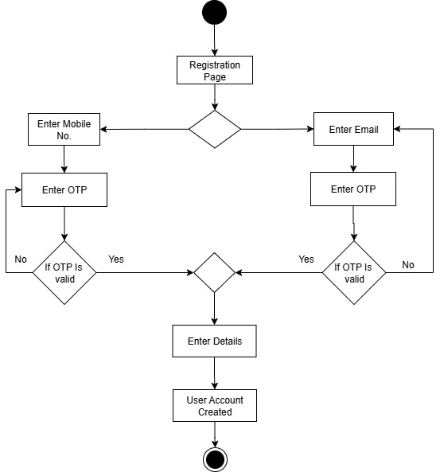
Login Page
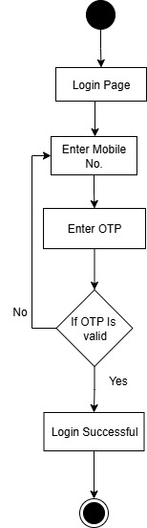
Search
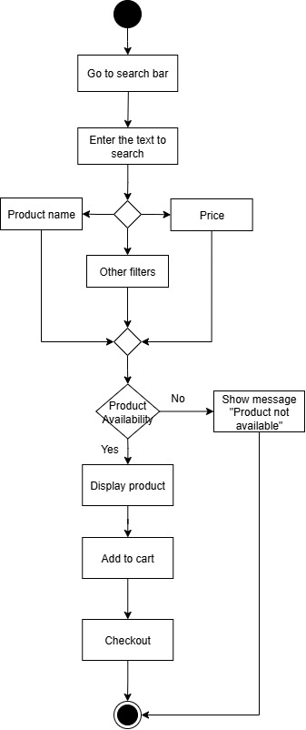

Order
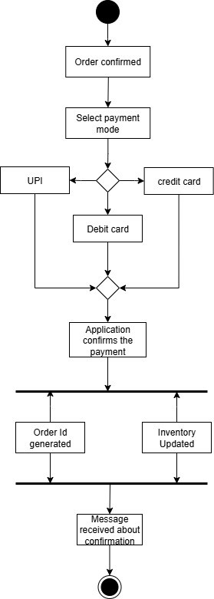

Order cancellation

