Document 6
Use case, Activity diagram and use case specification

+-
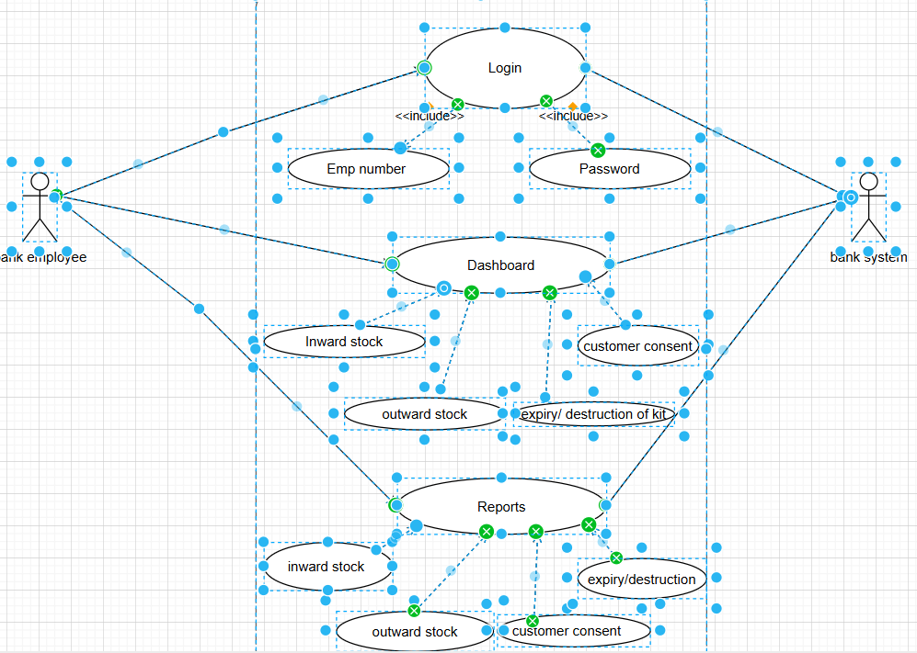

USE CASE SPECIFICATION

Section | Details
Use Case Name | Deliverable Management System (DLMS)
Use Case Description | Process of searching a customer, validating kit availability & expiry, capturing consent, assigning the welcome kit, and updating stock in real time.
Primary Actor | Branch Staff / Operations Executive
Secondary Actors | Customer, Inventory System, Audit & Compliance System
Pre-Conditions | Staff is authenticated; Customer exists; Kit stock updated in system.
Post-Conditions | Kit assigned; Stock updated; Receipt generated; Audit log captured.
Assumptions | Customer provides valid ID; Devices for consent capture function; Internet connectivity.
Constraints | Consent mandatory; Expired kits cannot be issued; Real-time update required.
Dependencies | Core Banking System, Inventory DB, Audit Module, Network Availability
Inputs | Customer ID, Kit Serial Number, Consent (signature/photo)
Outputs | Issuance Receipt, Updated Inventory Count, Audit Trail
Business Rules | 1. Expired kits cannot be issued.  2. Consent is mandatory.  3. Each kit has a unique serial number.  4. Real-time stock update.  5. One kit per customer unless approved.

Flows
Flow Type | Description
Basic Flow | 1. Staff logs in.  2. Searches customer.  3. System displays details.  4. Staff selects “Issue Kit”.  5. System shows stock & expiry.  6. Staff selects valid kit.  7. Consent captured.  8. System validates consent.  9. System assigns kit.  10. Stock updates real time.  11. Receipt generated.  12. Audit log updated.
Alternate Flows | A1 Customer Not Found: Staff retries or aborts.  A2 Multiple Kits: Staff selects alternative kit.
Exceptional Flows | E1 No Stock: System aborts process.  E2 Kit Expired: System blocks expired kits.  E3 Consent Invalid: Recapture or abort.  E4 Technical Error: System logs error; staff retries.

Document 7
Screens and Pages

Document 8
Tools- Visio and Axure

I have gained hands-on experience using both Microsoft Visio and Axure for business analysis and UI/UX documentation.
With Visio, I frequently created process flows, use case diagrams, data flow diagrams, and organizational charts to clearly communicate system behaviors and business processes to stakeholders. Its drag-and-drop interface and wide template library made it efficient for producing clean, professional diagrams.
Axure, on the other hand, has been especially useful for building interactive wireframes and prototypes. I used it to simulate user journeys, validate requirements, and gather early feedback from business users and developers. The ability to add interactions, dynamic panels, helped translate requirements into functional, visual prototypes.

Document 9
My experience as a BA in following phases

Waterfall model project is divided into difference stages, below are the contrib ution of the BA in each stage:

Requirement gathering and analysis
- Conduct stakeholder interviews, workshops, surveys, and document analysis.
- Identify business needs, gaps, and problems.
- Define scope and business objectives
- Prepare detailed Business Requirements Document (BRD) and Functional requirement document (FRD)
- Create use cases, process flows, data flow diagrams, business rules, etc.
- Identify constraints, assumptions, and dependencies.
- Prioritize requirements (MoSCoW,)

Design Phase
(Although design is owned by architects & developers, BA supports heavily.)
- Clarify requirements for developers and architects.
- Participate in design walkthroughs to ensure design aligns with business needs.
- Ensure non-functional requirements (NFRs) are captured (e.g., security, performance).
- Support creation of data models, UI wireframes, and system behaviour diagrams.
- Verify that business rules are correctly implemented in the design.
Development:
(BA is not coding, but supports the team through requirement clarifications.)
- Clarify doubts from developers during coding.
- Organize JAD session.
- Update requirements if there are changes (with proper change control).
- Conduct requirement traceability mapping (RTM) to track development progress.
- Review developed components conceptually to ensure alignment with requirements.
- Participate in daily stand-ups (if hybrid waterfall) or regular review meetings.

Testing:
(BA is heavily involved.)
- Prepare test scenarios and review test cases to ensure coverage.
- Validate test cases trace back to requirements using RTM.
- Support QA team in identifying expected behavior.
- Perform User Acceptance Testing (UAT) Prep:
- Create UAT plan and scripts.
- Guide business users in UAT.
- Help triage defects:
Analyze whether issue is requirement gap, design issue, or development bug.
Approve final changes needed before deployment.

Deployment:
- Support release planning and go-live activities.
- Ensure all documentation is updated (BRD, FSD, RTM, user manuals).
- Train end users or create training content.
- Validate that solution meets the business objectives defined in initial phases.

